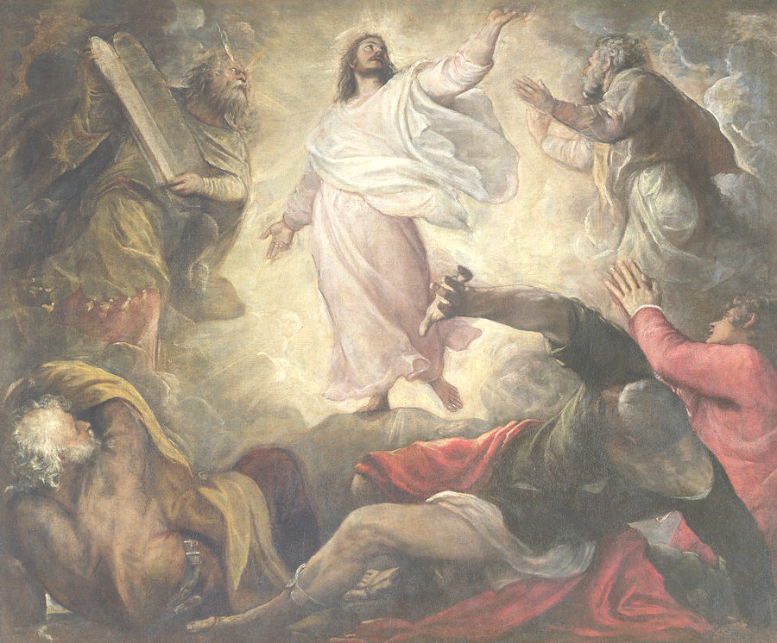

Christ Lutheran Church
The Feast of the Transfiguration
+ February 14, 2021 +

The Feast of the Transfiguration
+ February 14, 2021 +

Take Up Your Cross



We welcome our members and guests to Christ Lutheran today,
and pray God’s richest blessings upon you during this time of worship!

All members and our guests are asked to complete the
worship attendance pads which can be found on each pew.
Guests are also asked to sign the guest register found in the Narthex.
We are so glad to have you worshiping with us today!

LARGE PRINT worship folders are available
at the usher stand at the back of the nave.

WELCOME:
“The Transfiguration is the summer lightning of the coming Resurrection. Also, of our own resurrection, for we too are to partake of that transfigured life. To be saved means to share in the life of Christ. We too shall rise again, and our bodies will be transformed by the spirit, which itself is transformed by God. […] Such is the ‘Eternal Life’ in which we believe. Actually, ‘eternal’ life has nothing to do with the length of that life; it is not the opposite of transitory life. Perhaps we come closest to the truth when we define it as life which participates in the life of God.”
– Romano Guardini, The Lord
The Lord’s Supper

In preparation for reception of the Lord’s Supper (Holy Communion), it is important that we review and understand what the Bible teaches regarding this sacrament:
The Bible teaches that Jesus gives us His very body and blood along with bread and wine in Holy Communion, and that these are means by which He forgives our sins, and strengthens us for daily living, and draws us into closer fellowship with Him and other believers. The Bible also teaches us to examine ourselves prior to receiving the meal. For those receiving Holy Communion, examine yourself with these questions:
Do I believe that I am a sinner and I am sorry for my sins?
Do I believe that Jesus Christ is God’s Son and my personal Savior?
Do I believe that Christ’s true body and blood are present in this holy meal for my forgiveness?
Do I truly intend with the help of God to correct my sinful life?
According to Christ’s Word in the Holy Scriptures, and in confession with the true Christian faith, at Christ Lutheran we observe the practice of closed communion. We believe that all who commune must confess the same holy faith, as Holy Scripture teaches. Since one’s church affiliation indicates an individual’s confession of faith, we ask that only those who have been instructed in the above teaching and are confirmed members of The Lutheran Church – Missouri Synod commune. If you have not been instructed in this teaching on Holy Communion, are in doubt, or hold a different confession of faith, you are still welcome to come forward and cross your arms to indicate that you would like a blessing.

Divine Service I

Preservice Music

The congregation may use this time for prayer and meditation.

Processional Hymn ’Tis Good, Lord, to Be Here #414

The congregation stands to face the back of the church.
As the processional cross passes, the congregation turns to face the cross.

Confession & Absolution

The sign of the cross may be made by all in remembrance of their Baptism.

P In the name of the Father and of the T Son and of the Holy Spirit.
C Amen.

P If we say we have no sin, we deceive ourselves, and the truth is not in us.
C But if we confess our sins, God, who is faithful and just, will forgive our sins and cleanse us from all unrighteousness.
Silence for reflection on God's Word and for self-examination.
P Let us then confess our sins to God our Father.
C Most merciful God, we confess that we are by nature sinful and unclean. We have sinned against You in thought, word, and deed, by what we have done, and by what we have left undone. We have not loved You with our whole heart; we have not loved our neighbors as ourselves. We justly deserve Your present and eternal punishment. For the sake of Your Son, Jesus Christ, have mercy on us. Forgive us, renew us, and lead us, so that we may delight in Your will and walk in Your ways to the glory of Your holy name. Amen.
P Almighty God in His mercy has given His Son to die for you and forgives you all your sins. As a called and ordained servant of Christ, and by His authority, I therefore forgive you all your sins in the name of the Father and of the T the Son, and of the Holy Spirit.
C Amen.

Service of the Word

Introit: Dominus regnavit Psalm 99:1-5; Ant. Psalm 99:9
Exalt the Lord our God, and worship at his holy | mountain;*
for the Lord our God is | holy!
The Lord reigns; let the peoples | tremble!*
He sits enthroned upon the cherubim; let the | earth quake!
The Lord is great in | Zion;*
he is exalted over all the | peoples.
Let them praise your great and | awesome name!*
Ho- | ly is he!
The King in his might loves | justice.*
You have established equity; you have executed justice and righteousness in | Jacob.
Exalt the Lord our God; worship at his | footstool!*
Ho- | ly is he!
Glory be to the Father and | to the Son*
and to the Holy | Spirit;
as it was in the be- | ginning,*
is now, and will be forever. | Amen.
Exalt the Lord our God, and worship at his holy | mountain;*
for the Lord our God is | holy!

Kyrie Mark 10:47

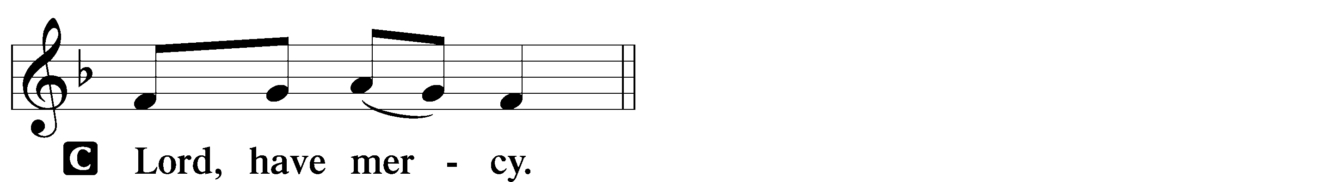
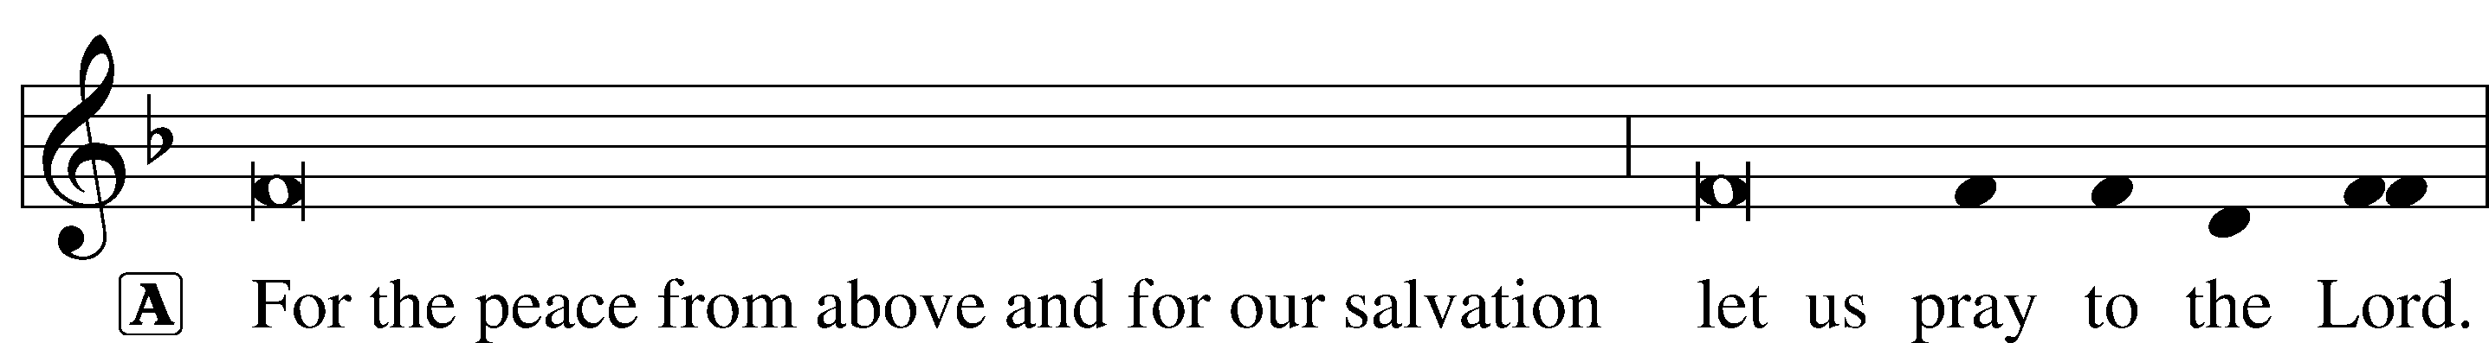

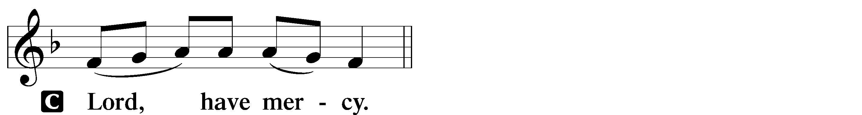
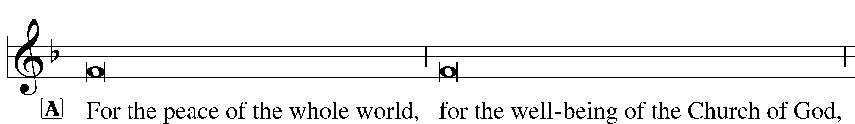

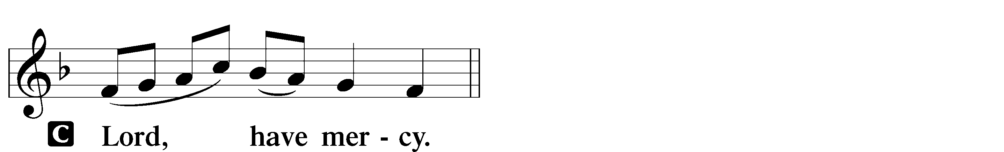
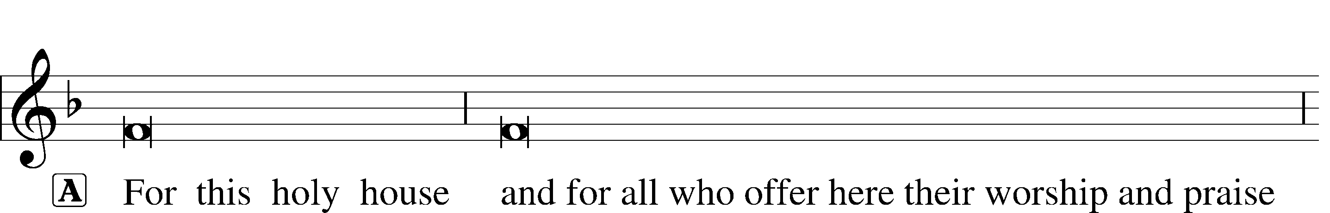

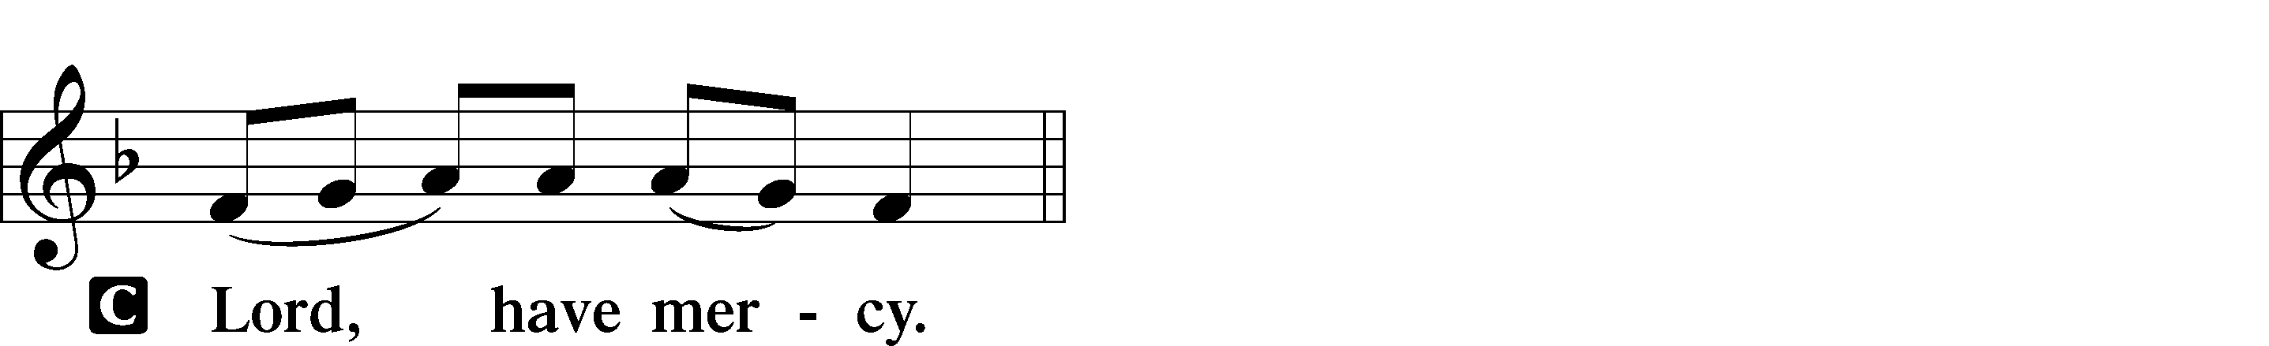
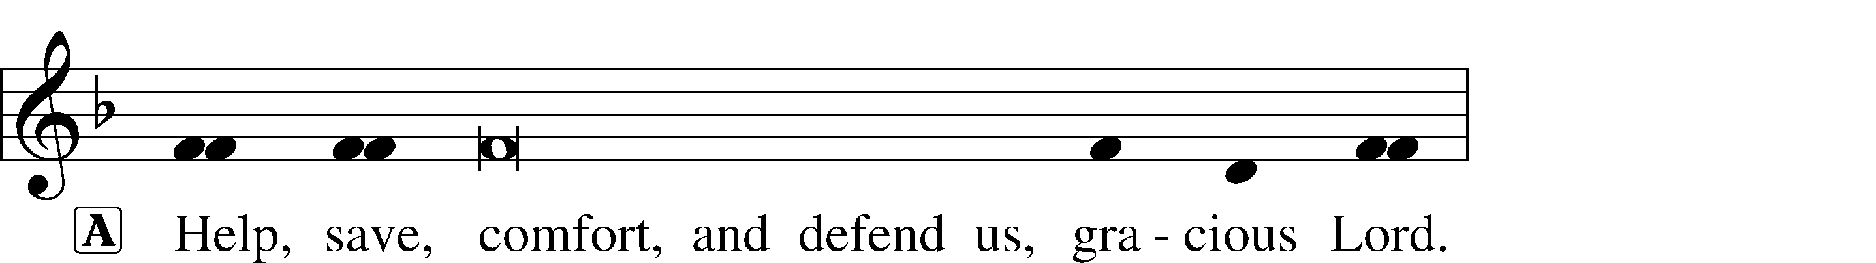

Gloria in Excelsis Luke 2:14; John 1:29
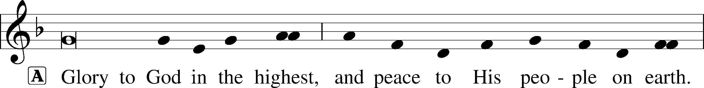
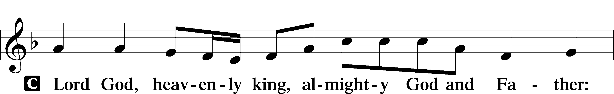
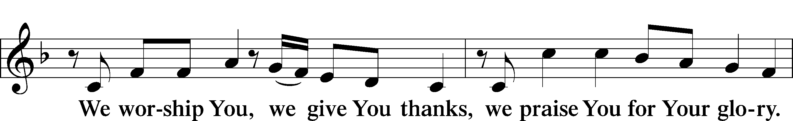
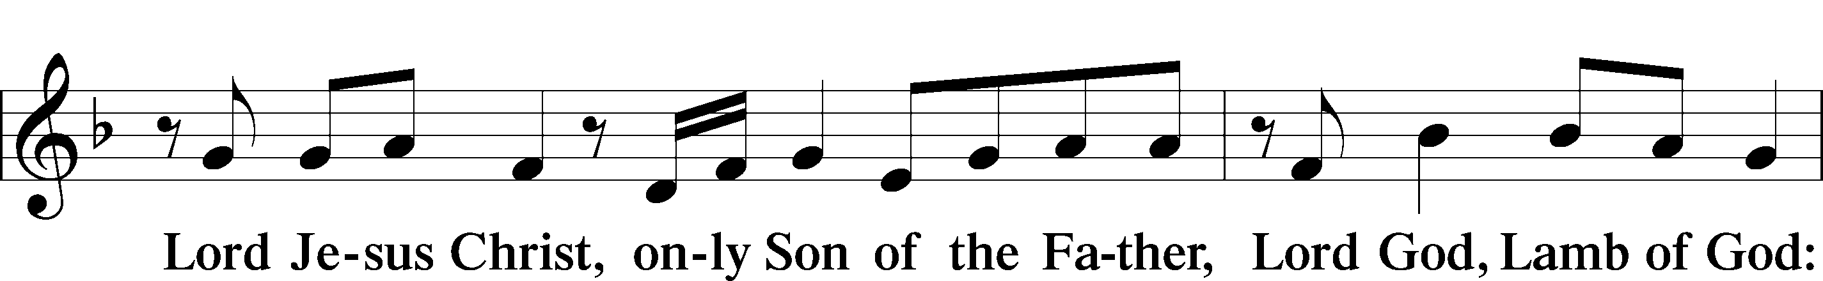
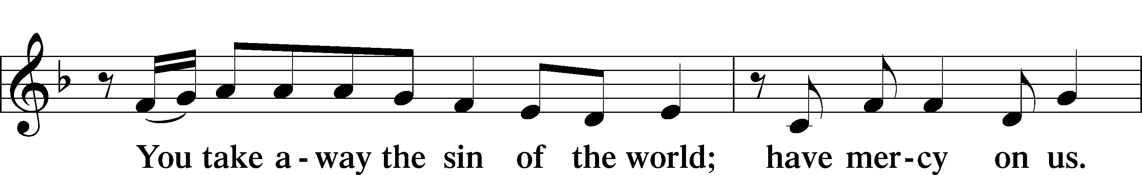
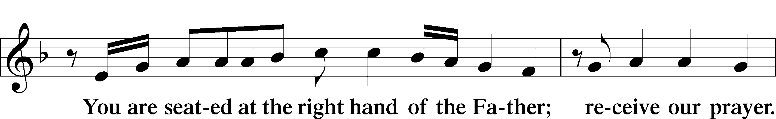
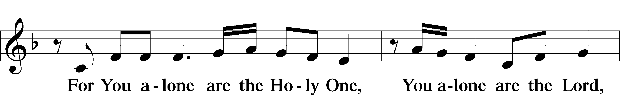
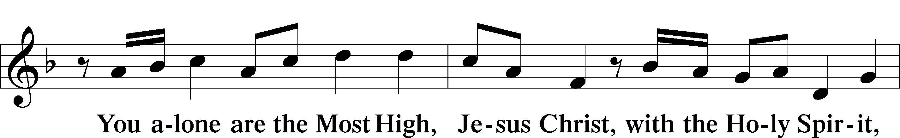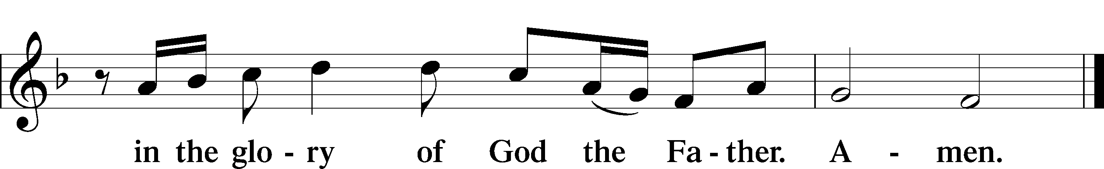
Salutation and Collect of the Day

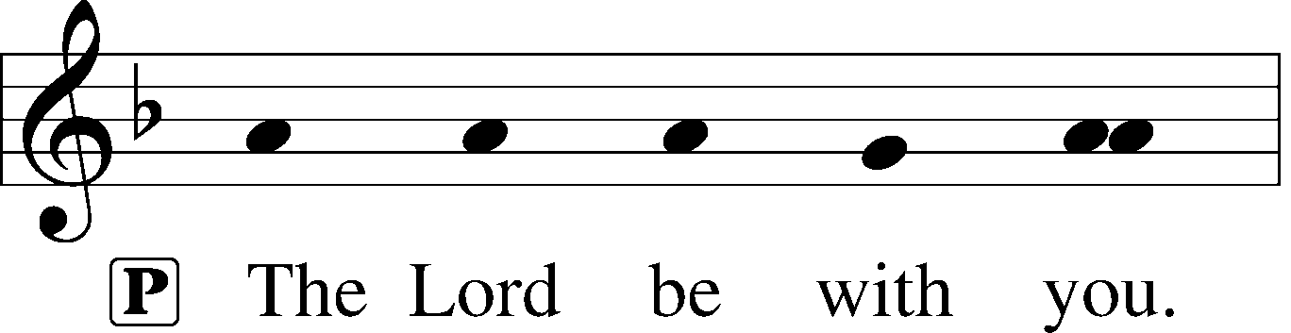
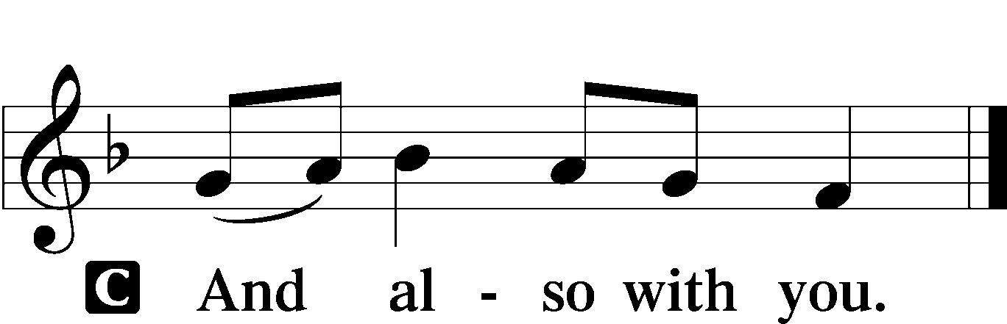

P Let us pray.
O God, in the glorious transfiguration of Your beloved Son You confirmed the mysteries of the faith by the testimony of Moses and Elijah. In the voice that came from the bright cloud You wonderfully foreshowed our adoption by grace. Mercifully make us co-heirs with the King in His glory and bring us to the fullness of our inheritance in heaven; through the same Jesus Christ, our Lord, who lives and reigns with You and the Holy Spirit, one God, now and forever.
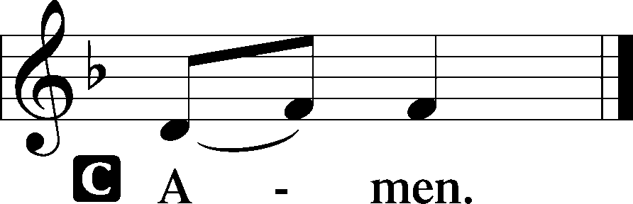

Please be seated

Old Testament Exodus 34:29-35
When Moses came down from Mount Sinai, with the two tablets of the testimony in his hand as he came down from the mountain, Moses did not know that the skin of his face shone because he had been talking with God. Aaron and all the people of Israel saw Moses, and behold, the skin of his face shone, and they were afraid to come near him. But Moses called to them, and Aaron and all the leaders of the congregation returned to him, and Moses talked with them. Afterward all the people of Israel came near, and he commanded them all that the Lord had spoken with him in Mount Sinai. And when Moses had finished speaking with them, he put a veil over his face.
Whenever Moses went in before the Lord to speak with him, he would remove the veil, until he came out. And when he came out and told the people of Israel what he was commanded, the people of Israel would see the face of Moses, that the skin of Moses’ face was shining. And Moses would put the veil over his face again, until he went in to speak with him.
A This is the Word of the Lord.
C Thanks be to God.

Gradual Psalm 117:1-2; 96:8
Praise the Lord, all | nations!*
Extol him, all | peoples!
For great is his steadfast | love toward us,*
and the faithfulness of the Lord endures for- | ever.
Ascribe to the Lord the glory | due his name;*
bring an offering, and come in- | to his courts!

Epistle 2 Corinthians 3:12-13; 4:1-6
Since we have such a hope, we are very bold, not like Moses, who would put a veil over his face so that the Israelites might not gaze at the outcome of what was being brought to an end.
Therefore, having this ministry by the mercy of God, we do not lose heart. But we have renounced disgraceful, underhanded ways. We refuse to practice cunning or to tamper with God’s word, but by the open statement of the truth we would commend ourselves to everyone’s conscience in the sight of God. And even if our gospel is veiled, it is veiled only to those who are perishing. In their case the god of this world has blinded the minds of the unbelievers, to keep them from seeing the light of the gospel of the glory of Christ, who is the image of God. For what we proclaim is not ourselves, but Jesus Christ as Lord, with ourselves as your servants for Jesus’ sake. For God, who said, “Let light shine out of darkness,” has shone in our hearts to give the light of the knowledge of the glory of God in the face of Jesus Christ.
A This is the Word of the Lord.
C Thanks be to God.

Please stand

Gospel Procession
As the Word of God is brought down into the congregation, so our Lord Jesus Christ comes and speaks graciously in the midst of His people.
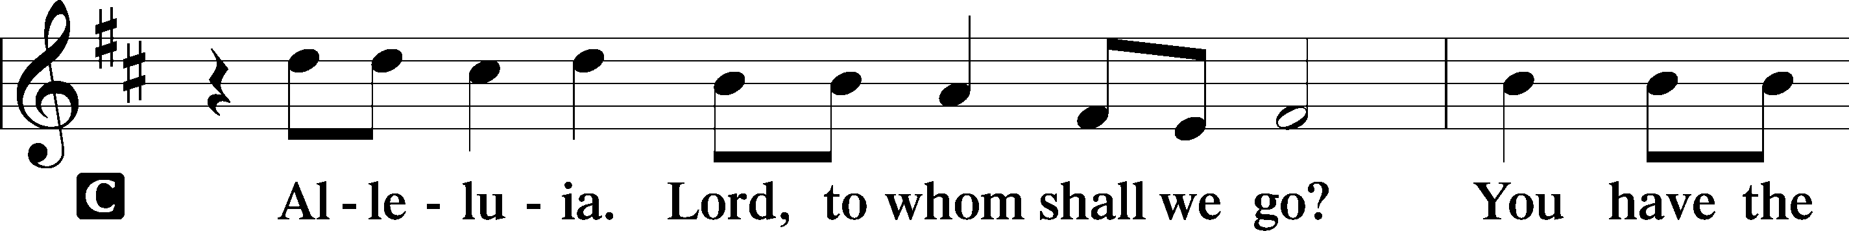
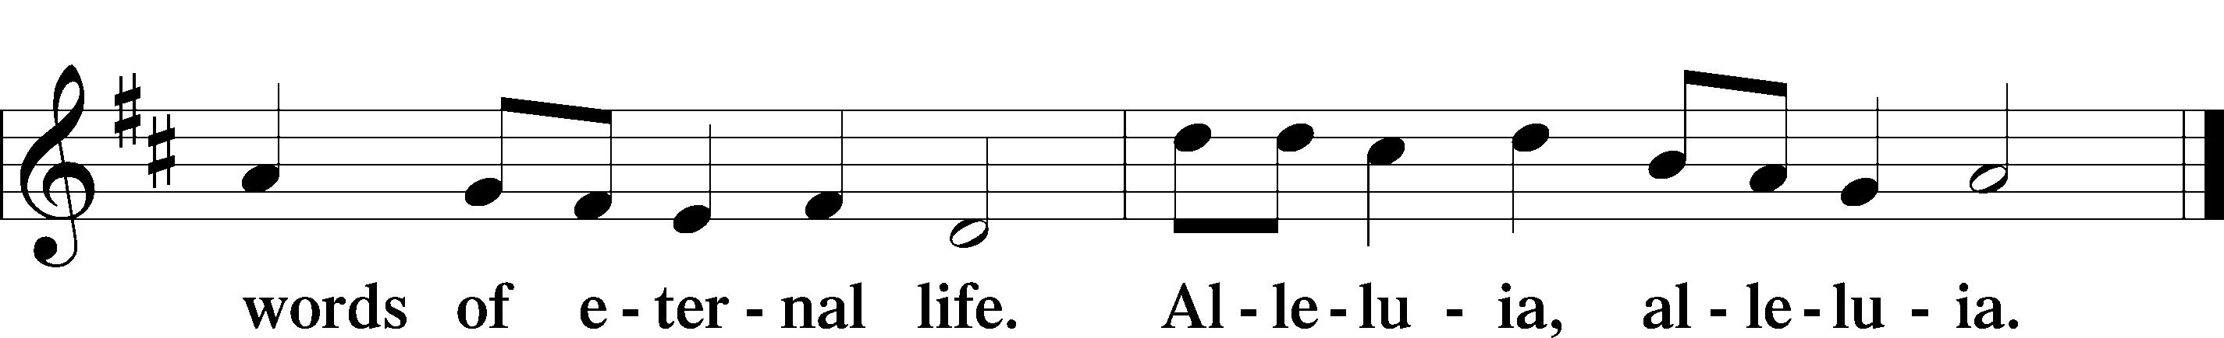

Holy Gospel Mark 9:2-9

P The Holy T Gospel according to St. Mark, the ninth chapter.

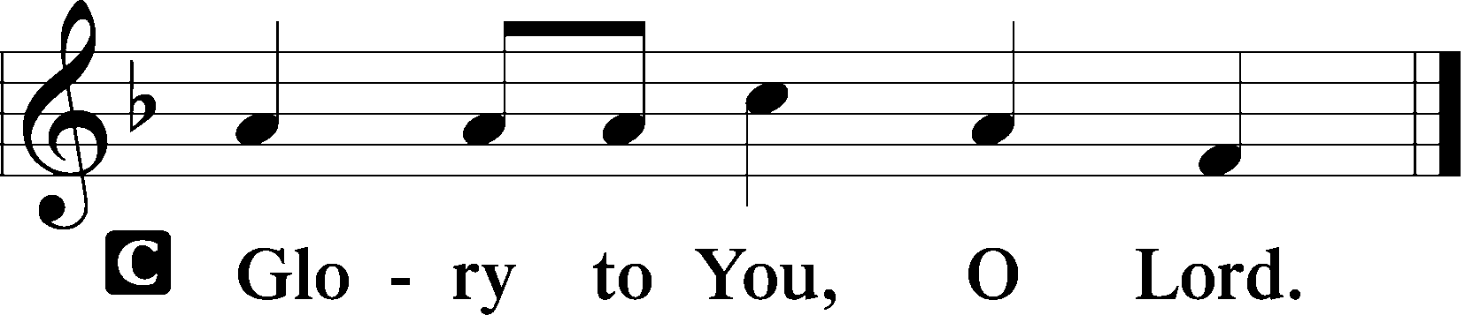
And after six days Jesus took with him Peter and James and John, and led them up a high mountain by themselves. And he was transfigured before them, and his clothes became radiant, intensely white, as no one on earth could bleach them. And there appeared to them Elijah with Moses, and they were talking with Jesus. And Peter said to Jesus, “Rabbi, it is good that we are here. Let us make three tents, one for you and one for Moses and one for Elijah.” For he did not know what to say, for they were terrified. And a cloud overshadowed them, and a voice came out of the cloud, “This is my beloved Son; listen to him.” And suddenly, looking around, they no longer saw anyone with them but Jesus only.
And as they were coming down the mountain, he charged them to tell no one what they had seen, until the Son of Man had risen from the dead.
P This is the Gospel of the Lord.
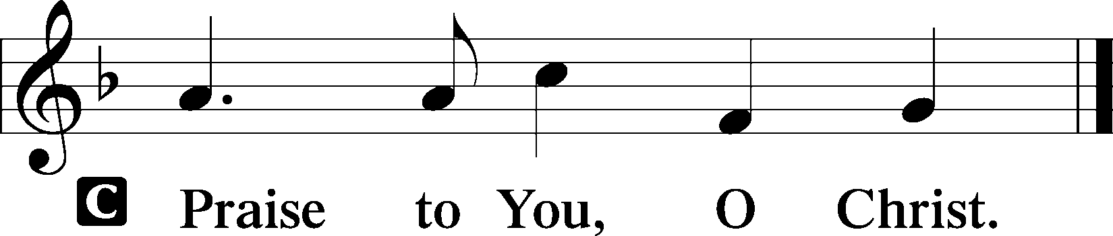

Please be seated

Office Hymn O Wondrous Type, O Vision Fair #413

Sermon The Glory of the Lord

Please stand

Nicene Creed

C I believe in one God, (Rom 10:10; Deut 6:4)
the Father Almighty, (Mt 6:9; Ex 6:3)
maker of heaven and earth (Gen 1:1; Jn 1:1)
and of all things visible and invisible. (Col 1:16)
And in one Lord Jesus Christ, (Rom 10:9)
the only-begotten Son of God, (Jn 3:16; Mt 16:16)
begotten of His Father before all worlds, (Jn 1:2)
God of God, Light of Light, (Jn 17:22; Jn 8:12; Jn 1:1)
very God of very God, (Col 2:9) begotten, not made, (Jn 1:2)
being of one substance with the Father, (Jn 10:30)
by whom all things were made; (Heb 1:2; Jn 1:3)
who for us men and for our salvation (1 Tim 2:4; Rom 3:23)
came down from heaven (Jn 6:41; Lk 15:20)
and was incarnate by the Holy Spirit of the virgin Mary (Lk 1:34-35)
and was made man; (Jn 1:14)
and was crucified also for us under Pontius Pilate. (Mk 15:25; Jn 19:16-18)
He suffered and was buried. (Jn 19:1-3; Lk 23:53)
And the third day He rose again according to the Scriptures (1 Cor 15:4; Lk 24:6)
and ascended into heaven (Acts 1:9)
and sits at the right hand of the Father. (Acts 7:55)
And He will come again with glory (Mt 26:64)
to judge both the living and the dead, (Acts 10:42; Mt 3:12)
whose kingdom will have no end. (2 Pt 1:11)
And I believe in the Holy Spirit, (Jn 14:26; Gen 1:2; Acts 2:38)
the Lord and giver of life, (Gen 1:2; Jn 3:6)
who proceeds from the Father and the Son, (Jn 15:26)
who with the Father and the Son together is worshiped and glorified, (Mt 3:16-17)
who spoke by the prophets. (Eze 11:5)
And I believe in one holy Christian and apostolic Church, (1 Pt 2:5; Eph 2:19-22)
I acknowledge one Baptism for the remission of sins, (Eph 4:5)
and I look for the resurrection of the dead (1 Cor 15:35-49; 1 Thess 4:13-18)
and the life T of the world to come. (Mk 10:29-30; Mt 10:40-42)
Amen. (Ps 106:48)
Us men means all people.
Christian: the ancient text reads “catholic,” meaning the whole Church as it confesses the wholeness of Christian doctrine

Prayer of the Church
After each petition of the prayer:
Pastor: Lord, in Your mercy,
People: Hear our prayer.
For comfort, health and recovery: Helen Gray, Lisa Gray, Joshua Hathcock, Jerry Mutter, Ruth Osburn, John Sandberg, Larry Taylor;
For those who are ill or distressed: Stan Acey, Jenalee Adams, Layne Bagley, Rose Bagley, Shirley Bagley, W.L. Bagley, Sarah Bowman, Mimi Bradley, Richard Bradley, Deloris Brent, Martha Brown, Nathan Brown, Tina Burke, Wayne Burke, Paula Burkhalter, Bobby Carroll, Arthur Collins, James E. Cookston, Joan Cowards, Belinda Cowards-Gonzales, Robert (Andy) Evers, Michele Rae Fowler, Randy Fowler, Parker Haines, Dan Hansen, Paul Hansen, Tim Hansen, Valerie Henderson, Sharon Holleman, Beth Jarratt, Elaine Johnson, Joslyn Jones, Steve Kennedy, Arlene Kleinschmidt, John Koster, Sandra Landers, Katelyn Lawing, Peggy Lucky, Paul McCullough, Jerry McIntyre, Jerry McMahan, Edlia Miller, Elaine Monaghan, Lindberg Moore, Jerry Mutter, Don Ochs, Mildred Odom, Deborah-Annette Ried, Elmira Roever, Jon Sandberg, Noah Schultz, Johnnie Pearl Smiley, Bob Smith, Sam Schneider, Sherri Smith, Deborah Springer, Betty Venator, Leonard Watson, Dana Weaver, Cynthia Widlitze, Carol Wright, Jimmy Wright, Marshall Wright, Barbara Zeigler;
For college and graduate students: Sara Fields, Jonathan Kettler, Roselynn Nelson, Will Nelson;
For military servants and their families: Gabriel Escude, James (Glen) Hansford, Holden Hathcock, Christopher Martin, William Nelson, Steven Tatum, John Weidner Jr.;
For foreign missionaries: especially those serving in Spain;
This week’s prayer family: The Agent Family and their loved ones.

Please be seated

Offering

Please stand

Offertory Psalm 116:12-13, 17-19
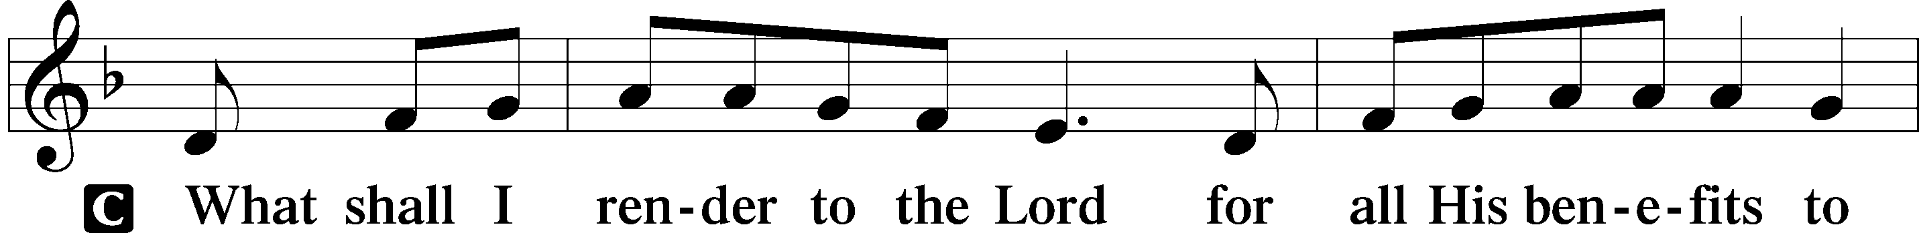
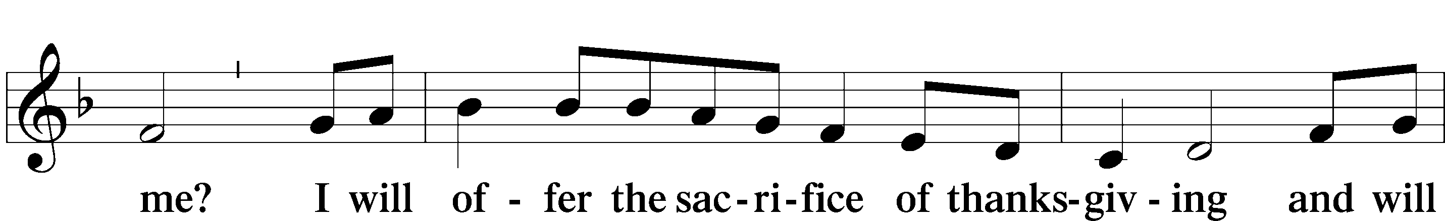
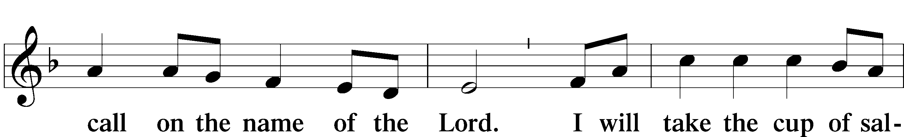
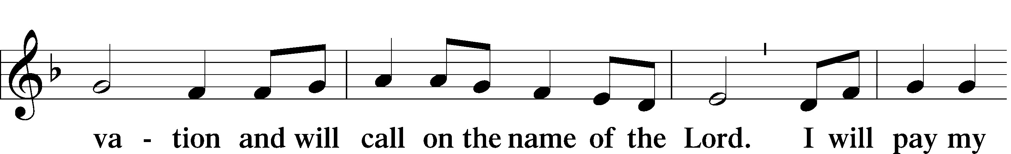

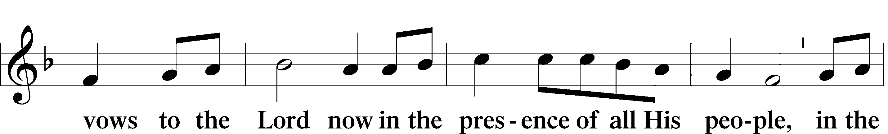

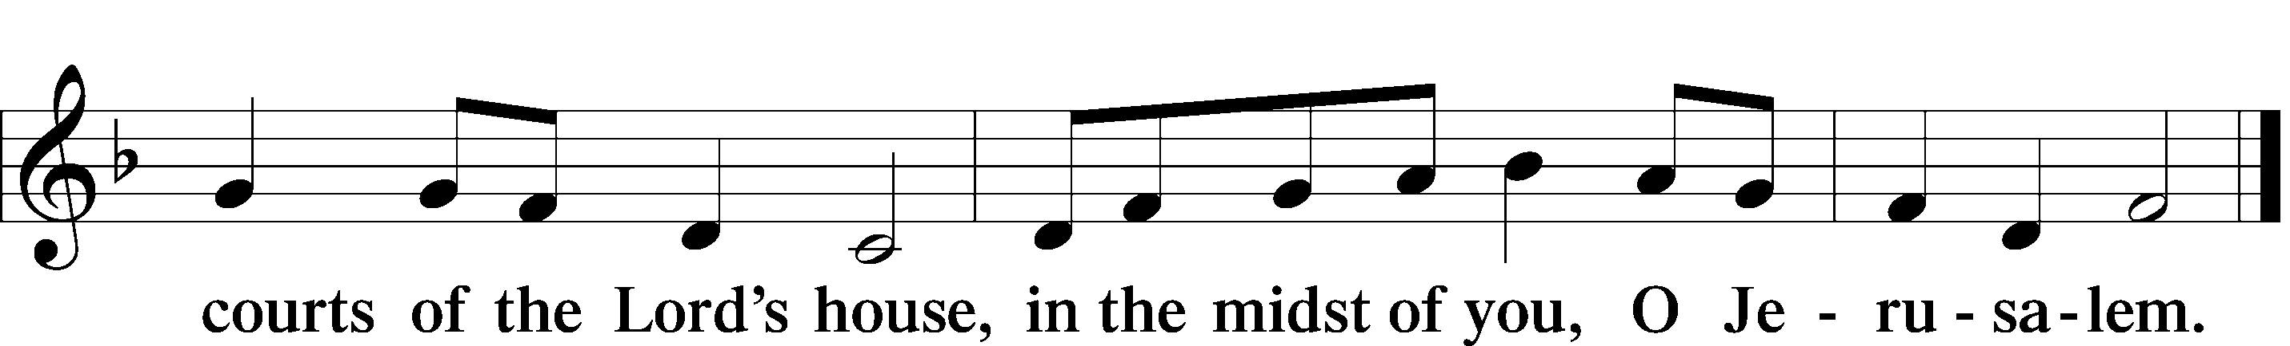
Service of the Sacrament

Preface 2 Timothy 4:22; [Colossians 3:1]; [Psalm 136]





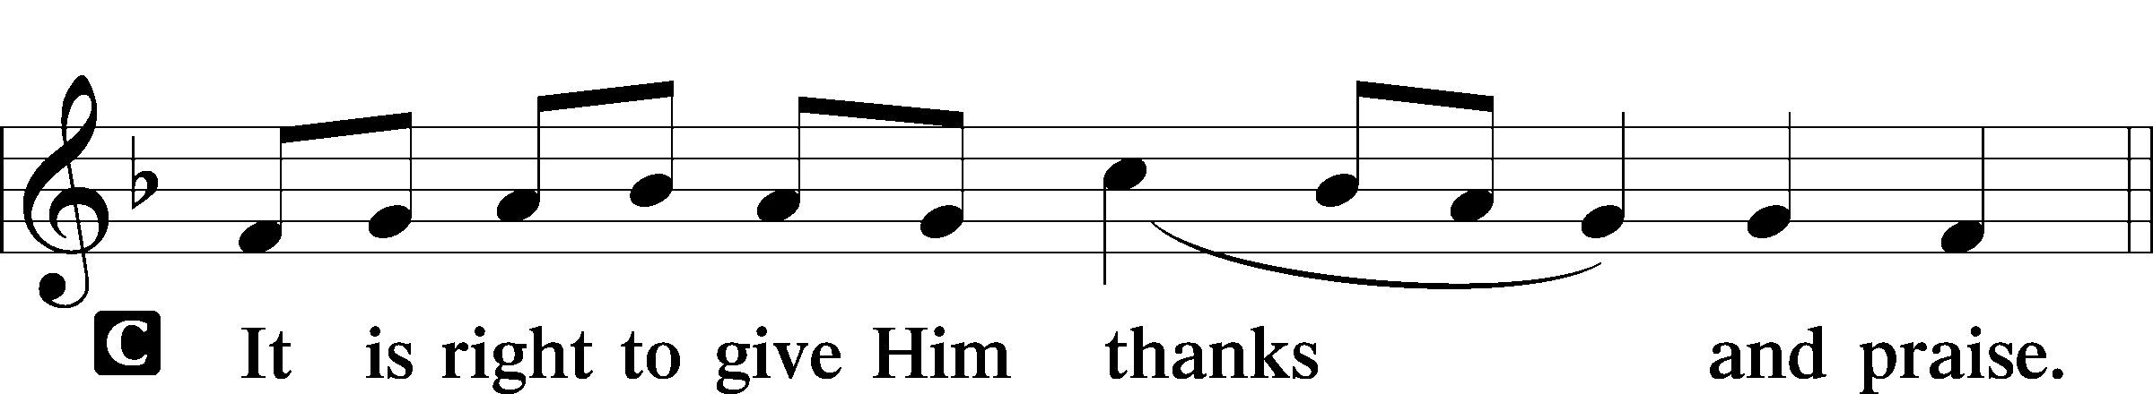

P It is truly good, right, and salutary that we should at all times and in all places give thanks to You, holy Lord, almighty Father, everlasting God, through Jesus Christ, our Lord, who at His transfiguration revealed His glory to His disciples that they might be strengthened to proclaim His cross and resurrection and with all the faithful look forward to the glory of life everlasting. Therefore with angels and archangels and with all the company of heaven we laud and magnify Your glorious name, evermore praising You and saying:

Sanctus Isaiah 6:3; Matthew 21:9
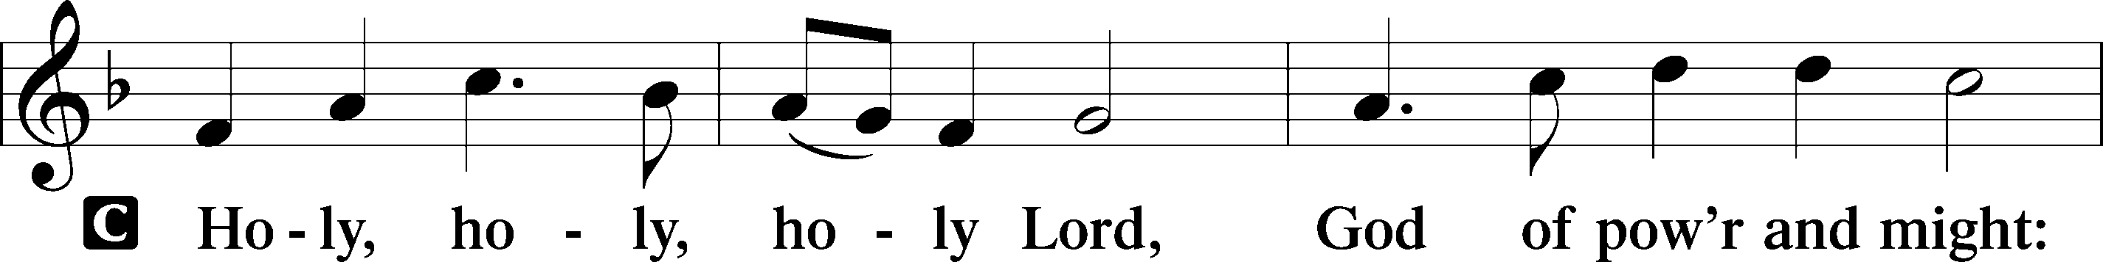
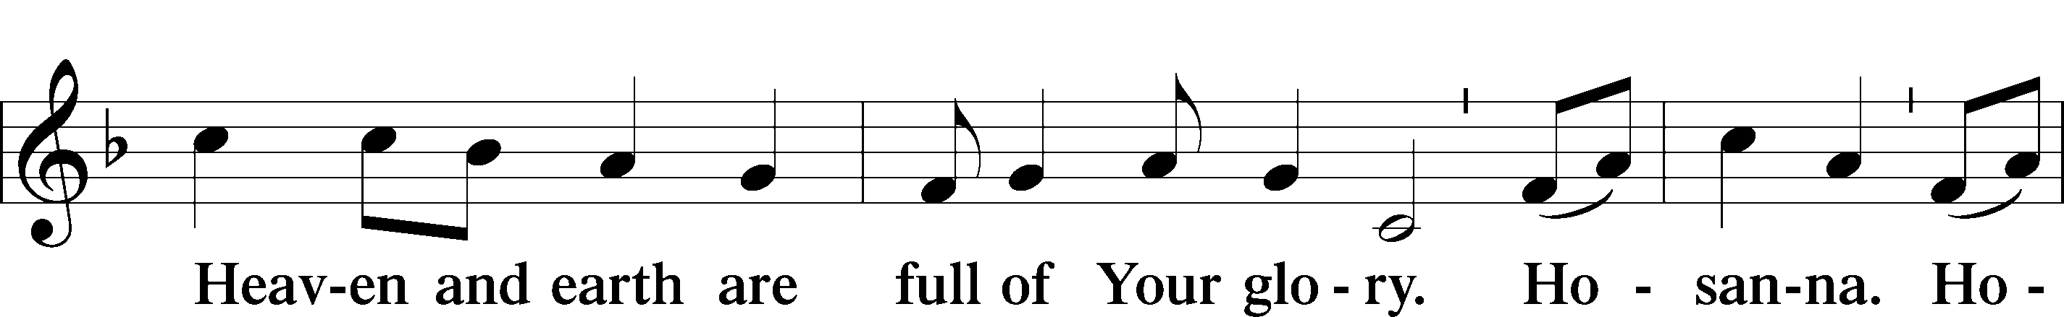
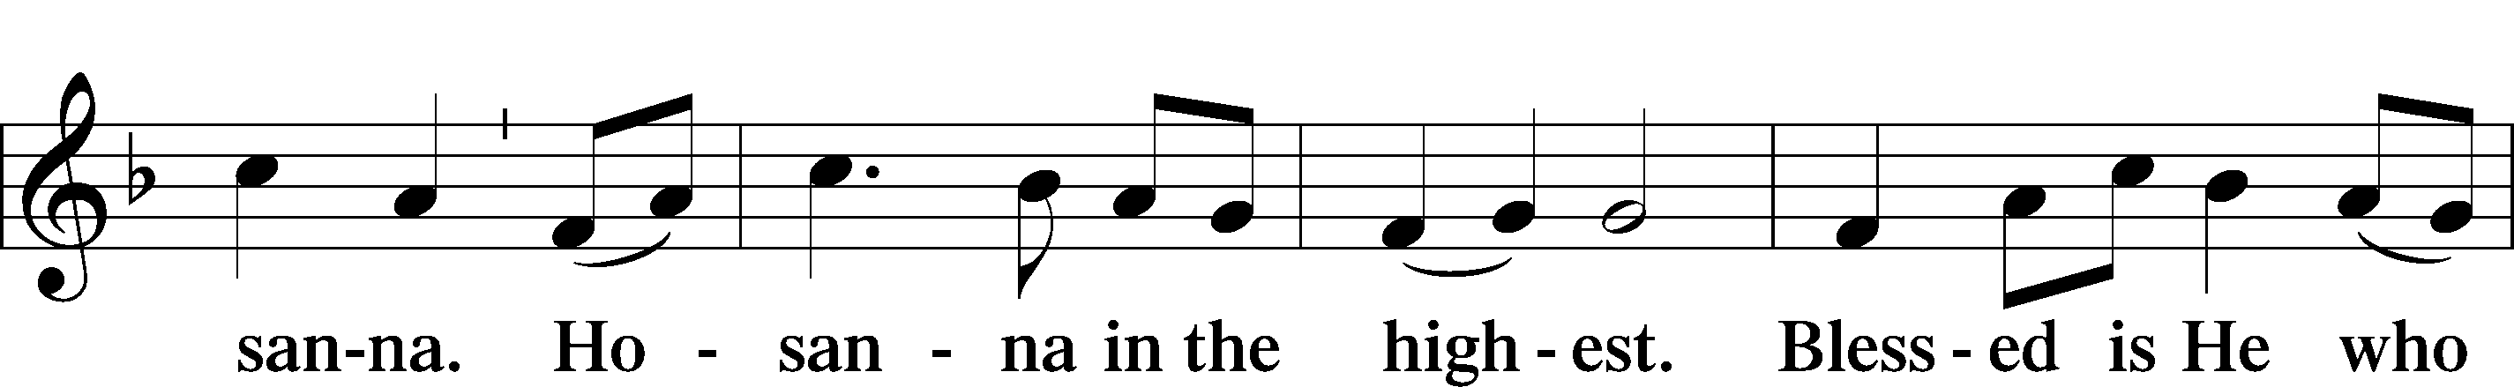
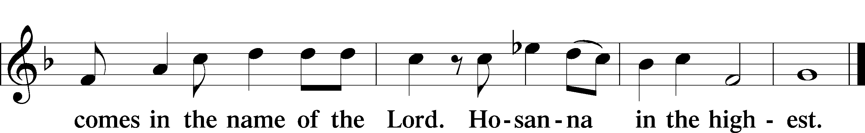

P Blessed are You, Lord of heaven and earth, for You have had mercy on those whom You created and sent Your only-begotten Son into our flesh to bear our sin and be our Savior. With repentant joy we receive the salvation accomplished for us by the all-availing sacrifice of His body and His blood on the cross.
Gathered in the name and the remembrance of Jesus, we beg You, O Lord, to forgive, renew, and strengthen us with Your Word and Spirit. Grant us faithfully to eat His body and drink His blood as He bids us do in His own testament. Gather us together, we pray, from the ends of the earth to celebrate with all the faithful the marriage feast of the Lamb in His kingdom, which has no end. Graciously receive our prayers; deliver and preserve us. To You alone, O Father, be all glory, honor, and worship, with the Son and the Holy Spirit, one God, now and forever.

Lord’s Prayer Matthew 6:9-13
P Lord, remember us in Your kingdom and teach us to pray:
C Our Father who art in heaven,
Hallowed be Thy name,
Thy kingdom come,
Thy will be done on earth as it is in heaven;
Give us this day our daily bread;
And forgive us our trespasses as we forgive those who trespass against us;
And lead us not into temptation,
But deliver T us from evil.
For Thine is the kingdom and the power and the glory forever and ever. Amen.

The Words of Our Lord Matthew 26:26–28
P Our Lord Jesus Christ, on the night when He was betrayed, took bread, and when He had given thanks, He broke it and gave it to the disciples and said: “Take, eat; this is My T body, which is given for you. This do in remembrance of Me.”
In the same way also He took the cup after supper, and when He had given thanks, He gave it to them, saying: “Drink of it, all of you; this cup is the new testament in My T blood, which is shed for you for the forgiveness of sins. This do, as often as you drink it, in remembrance of Me.”

Pax Domini John 20:19
P The peace T of the Lord be with you always.


Agnus Dei John 1:29
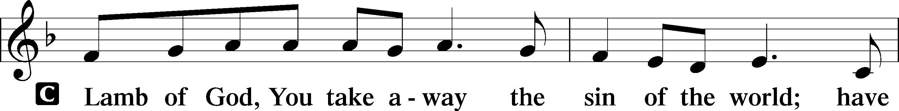
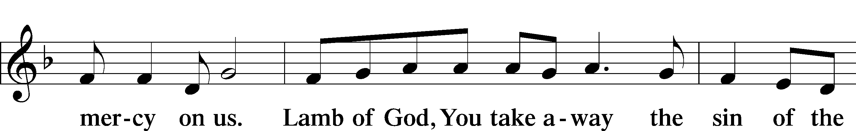
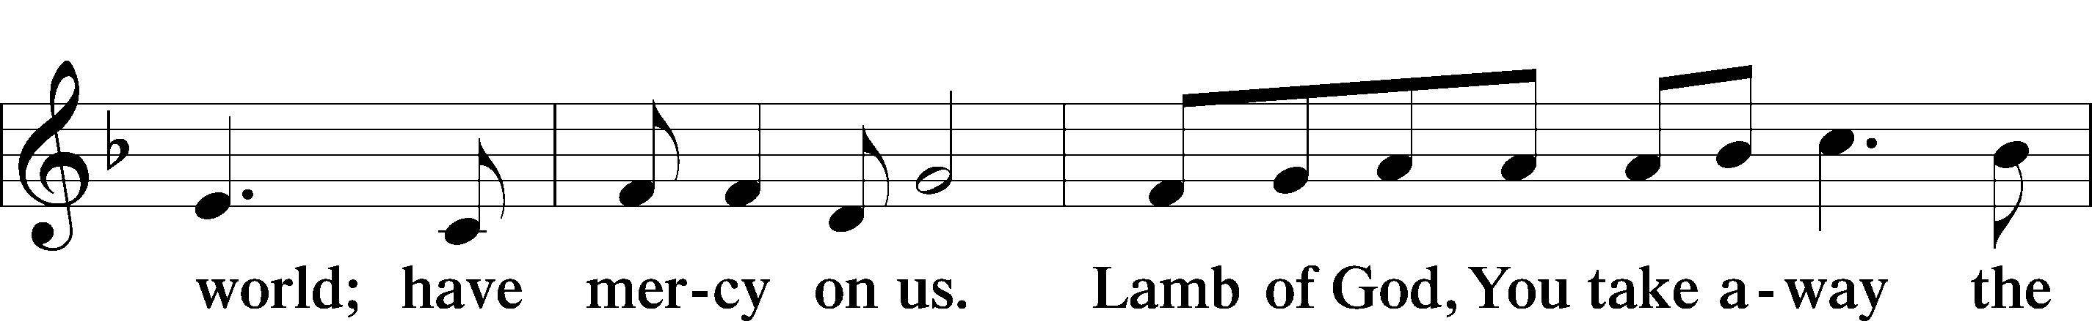
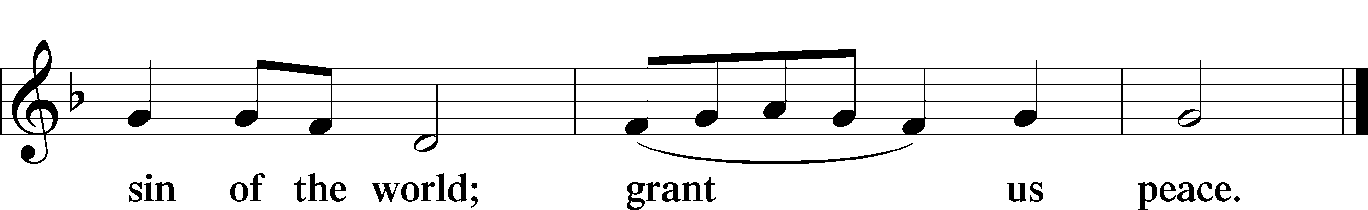
Please be seated

Distribution of the Sacrament
All who are members in good standing of the Lutheran Church - Missouri Synod and have introduced themselves to the pastor are welcome to partake of the Holy Communion at Christ Lutheran. If you have not spoken to the pastor, but would like to receive the Lord's blessing, you may still come to the rail and kneel, crossing one arm over the other in the shape of an 'X'. This symbolizes that one is marked by the cross and Triune name of Almighty God.

Distribution Hymns
Here, O My Lord, I See Thee Face to Face #631

Please stand following distribution of communion

Nunc Dimittis Luke 2:29-32
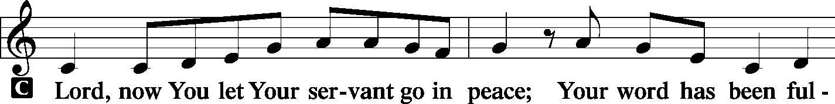
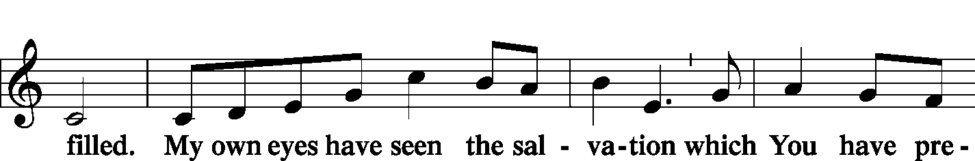
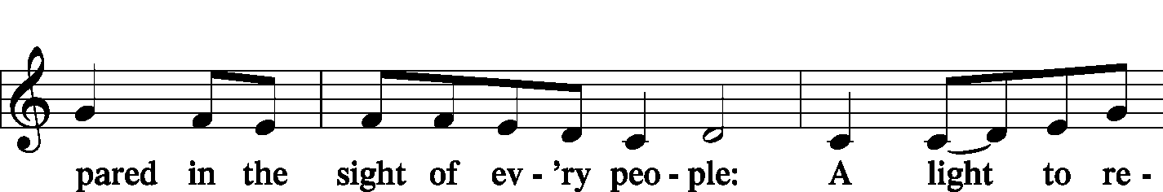
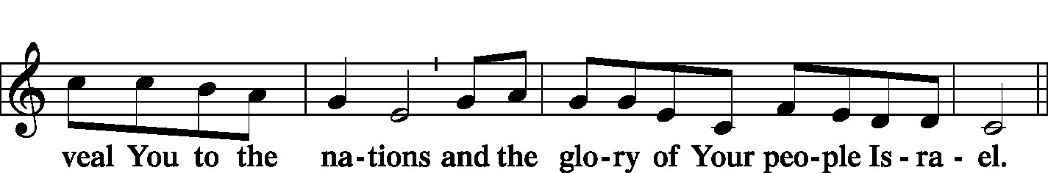
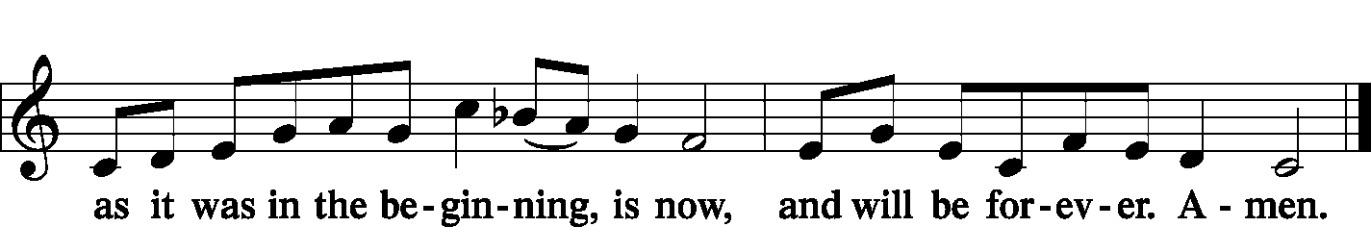
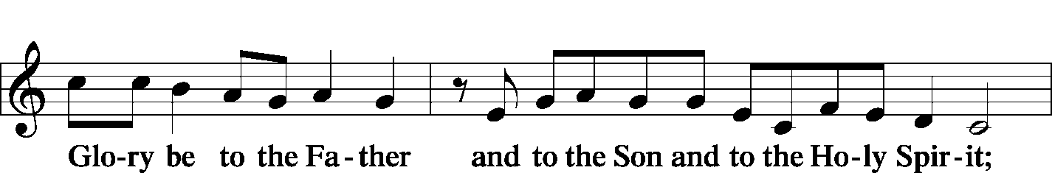

Post-Communion Collect
A Let us pray.

O God the Father, the fountain and source of all goodness, who in loving-kindness sent Your only-begotten Son into the flesh, we thank You that for His sake You have given us pardon and peace in this Sacrament, and we ask You not to forsake Your children but always to rule our hearts and minds by Your Holy Spirit that we may be enabled constantly to serve You; through Jesus Christ, Your Son, our Lord, who lives and reigns with You and the Holy Spirit, one God, now and forever.

Benediction Numbers 6:24–26
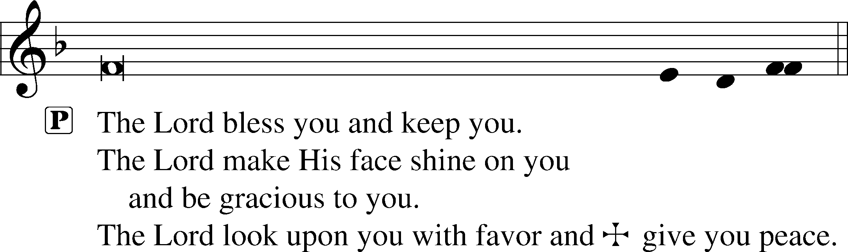

Closing Hymn Alleluia, Song of Gladness #417

Divine Service, Setting One from Lutheran Service Book © 2006 Concordia Publishing House. Reprinted with permission. Unless otherwise indicated, all scripture quotations are from The Holy Bible, English Standard Version, copyright © 2001 by Crossway Bibles, a division of Good News Publishers. Used by permission. All rights reserved. Created by Lutheran Service Builder © 2006 Concordia Publishing House.

Serving Today:
Celebrant: Rev. George Fields Lector: Eric Held, Gary Atchley
Cantor: Rush Agent Organist: Sr. Sara Fields
Interpreter: Denee Smith
Ushers: Allen Goodlett, Mark Ochs; Bruce Bodkin, Roger Fuhrer
Altar Flowers: This morning’s altar flowers are given for the glory of God by Keith and Anita Martin.

Ash Wednesday Services: Lent is drawing nigh. Ash Wednesday services will be held this Wednesday at 10:30 a.m. and 7:00 p.m.

Lenten Vespers: Join us throughout this penitential season as we gather weekly to meditate upon the Passion of Our Lord. Vespers will be held on Wednesday nights at 7:00 beginning March 3.

Lenten Dinners: Throughout our sojourn in Lent, we will gather at 6:00 p.m. on Wednesdays (beginning March 3) for food and fellowship before weekly Vespers. Look for an email sign-up sheet from Sister Sara if you are interested in contributing food or helping with set-up/clean-up. Thank you!

Bible Study Returns! Finally, after almost a year of hiatus, Adult Sunday School will resume next week! To accommodate social distancing, we will meet in the sanctuary—and truly, what sanctuary it will be to dwell in the study of the Scriptures once more! Join us next Sunday at 9:15 a.m.!

Readings for next Sunday, February 21st, the First Sunday in Lent:
Introit Ps. 91:9-13; Psalm 25:1-10; Genesis 22:1-18; James 1:12-18; Mark 1:9-15.

This week at Christ Lutheran Church: February 15 – February 21

Wednesday 10:30 a.m. Ash Wednesday Matins with Imposition of Ashes
7:00 p.m. Ash Wednesday Vespers with Imposition of Ashes
Thursday 9:30 p.m. LifeLight: Ezekiel (Session 4)
Friday 6:30 a.m. Bible Study @ Christ Lutheran, Breakfast @ Broadstreet
Sunday 8:00 a.m. Divine Service (Mask-Only) – The First Sunday in Lent
9:15 a.m. Sunday School for All Ages
10:30 a.m. Divine Service – The First Sunday in Lent



YOUR LIFELINE TO THE LUTHERAN WORLDVIEW…You can listen to in-depth teachings on interesting subjects like:

The Word “Mercy” in the Bible, The Rise & Triumph of the Modern Self, Surrogacy, Faith That Engages the Culture and more…

Issues, Etc. is a radio talk show produced by Lutheran Public Radio and hosted by LCMS Pastor Todd Wilken. You can listen to what you want when you want at www.issuesetc.org. Simply click on “Listen”, choose “On Demand”, then select from the vast array of speakers and topics available in the archives.

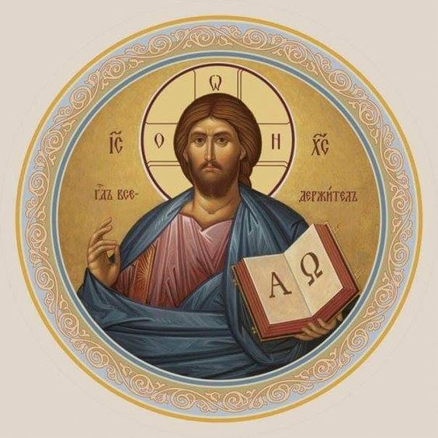

Christ Lutheran Church
The Lutheran Church—Missouri Synod
4423 I-55 North, Jackson, MS 39206-6102
Church phone: (601) 366-2055
www.ChristLutheranJacksonMS.org

Matthew 26:26-29; Mark 14:22-25; Luke 22:14-20, 1 Corinthians 11:23
Matthew 26:28; 1 John 1:7; 1 Peter 1:18-19
1 Corinthians 11:28-32
1 Corinthians 10:17; 1 Corinthians 11:26

