Christ Lutheran Church

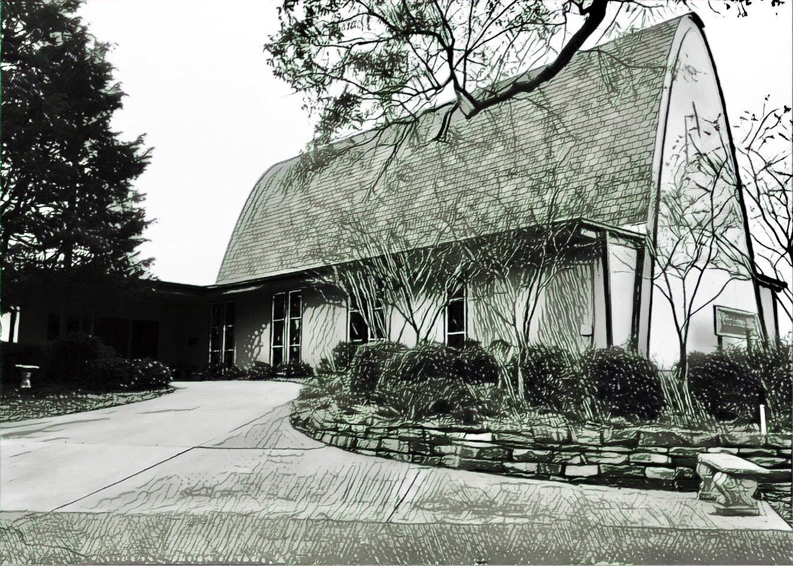

Rev. George Fields, Pastor
Sr. Sara Fields, Deaconess
Divine Service Each Week with Holy Communion: 10:30 a.m.
Sunday School for all ages: 9:15 a.m.
4423 I-55 North, Jackson, MS 39206-6102 – (601) 366-2055
www.christlutheranjacksonms.org

The Second Sunday in Lent
+ February 28, 2021 +

Behold



We welcome our members and guests to Christ Lutheran today,
and pray God’s richest blessings upon you during this time of worship!

All members and our guests are asked to complete the
worship attendance pads which can be found on each pew.
Guests are also asked to sign the guest register found in the Narthex.
We are so glad to have you worshiping with us today!

LARGE PRINT worship folders are available
at the usher stand at the back of the nave.

WELCOME:
“Christianity is greatest when it is hated by the world.”
– St. Ignatius of Antioch
The Lord’s Supper

In preparation for reception of the Lord’s Supper (Holy Communion), it is important that we review and understand what the Bible teaches regarding this sacrament:
The Bible teaches that Jesus gives us His very body and blood along with bread and wine in Holy Communion, and that these are means by which He forgives our sins, and strengthens us for daily living, and draws us into closer fellowship with Him and other believers. The Bible also teaches us to examine ourselves prior to receiving the meal. For those receiving Holy Communion, examine yourself with these questions:
Do I believe that I am a sinner and I am sorry for my sins?
Do I believe that Jesus Christ is God’s Son and my personal Savior?
Do I believe that Christ’s true body and blood are present in this holy meal for my forgiveness?
Do I truly intend with the help of God to correct my sinful life?
According to Christ’s Word in the Holy Scriptures, and in confession with the true Christian faith, at Christ Lutheran we observe the practice of closed communion. We believe that all who commune must confess the same holy faith, as Holy Scripture teaches. Since one’s church affiliation indicates an individual’s confession of faith, we ask that only those who have been instructed in the above teaching and are confirmed members of The Lutheran Church – Missouri Synod commune. If you have not been instructed in this teaching on Holy Communion, are in doubt, or hold a different confession of faith, you are still welcome to come forward and cross your arms to indicate that you would like a blessing.

Divine Service II

Preservice Music

The congregation may use this time for prayer and meditation.

Opening Hymn Jesus, Grant that Balm and Healing #421

Confession & Absolution
The sign of the cross may be made by all in remembrance of your Baptism.

P In the name of the Father and of the T Son and of the Holy Spirit.
C Amen.

P If we say we have no sin, we deceive ourselves, and the truth is not in us.
C But if we confess our sins, God, who is faithful and just, will forgive our sins and cleanse us from all unrighteousness.

Silence for reflection on God's Word and for self-examination.

P Let us then confess our sins to God our Father.
C Most merciful God, we confess that we are by nature sinful and unclean. We have sinned against You in thought, word, and deed, by what we have done and by what we have left undone. We have not loved You with our whole heart; we have not loved our neighbors as ourselves. We justly deserve Your present and eternal punishment. For the sake of Your Son, Jesus Christ, have mercy on us. Forgive us, renew us, and lead us, so that we may delight in Your will and walk in Your ways to the glory of Your holy name. Amen.

P Almighty God in His mercy has given His Son to die for you and for His sake forgives you all your sins. As a called and ordained servant of Christ, and by His authority, I therefore forgive you all your sins in the name of the Father and of the T Son and of the Holy Spirit.
C Amen.

Service of the Word

Introit: Non nobis, Domine Psalm 115:11-13, 18; Ant. Psalm 25:6
Remember your mercy, O Lord, and your | steadfast love,*
for they have been | from of old.
You who fear the Lord, trust | in the Lord!*
He is their help | and their shield.
The Lord has remembered us; he will | bless us;*
he will bless the house of Israel; he will bless the house of | Aaron;
he will bless those who | fear the Lord,*
both the small | and the great.
We will | bless the Lord*
from this time forth and forevermore. | Praise the Lord!
Glory be to the Father and | to the Son*
and to the Holy | Spirit;
as it was in the be- | ginning,*
is now, and will be forever. | Amen.
Remember your mercy, O Lord, and your | steadfast love,*
for they have been | from of old.

Kyrie Mark 10:47

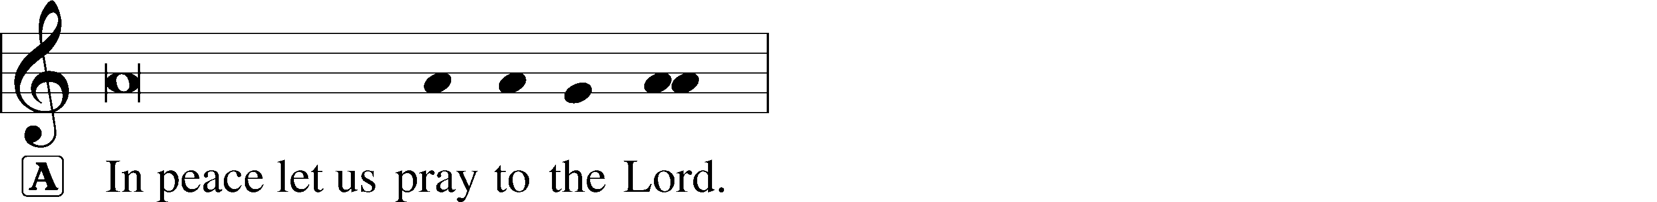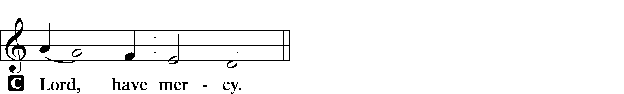

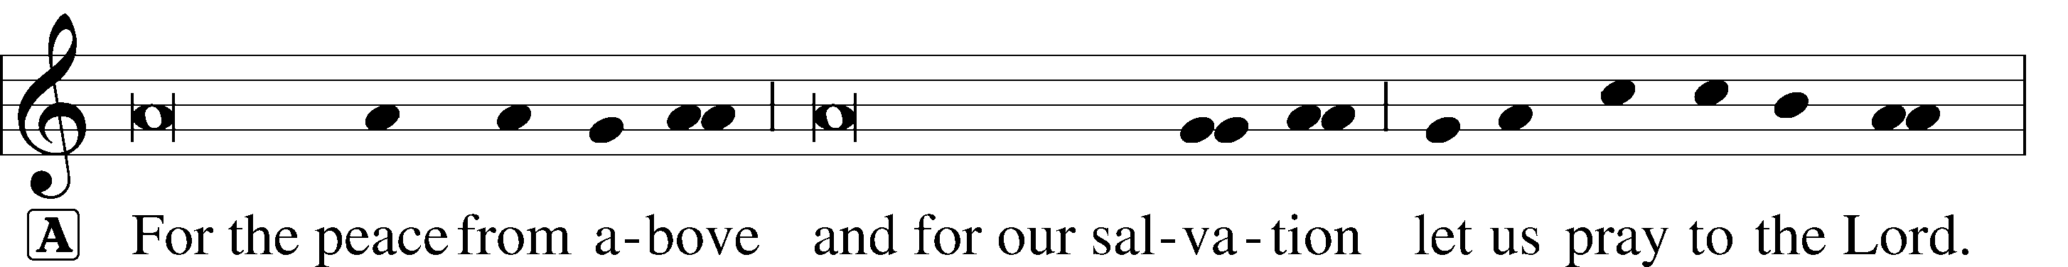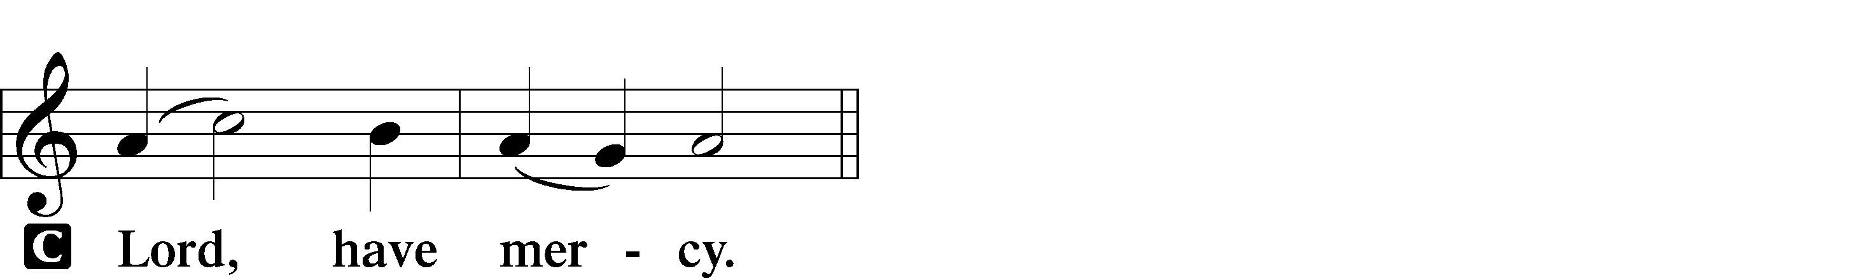
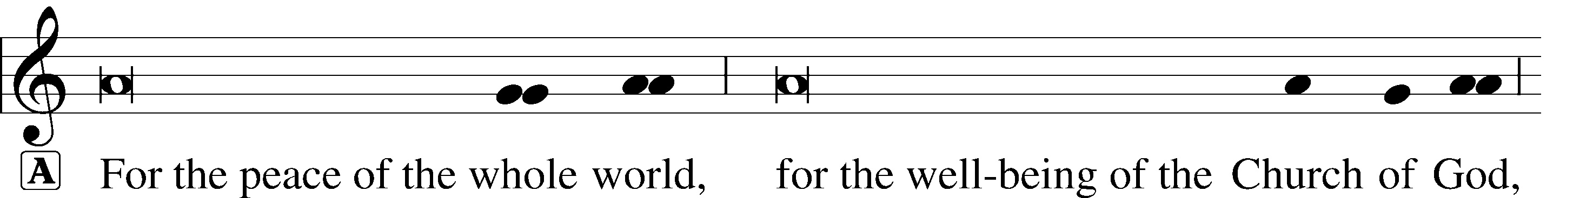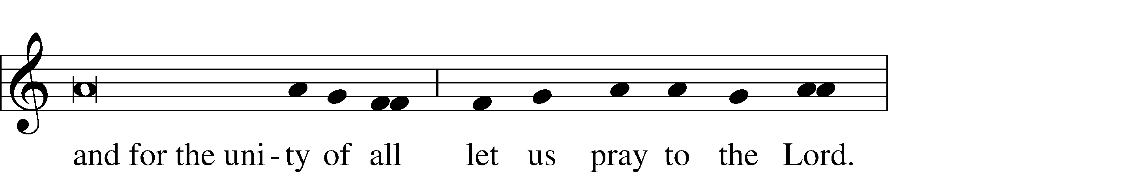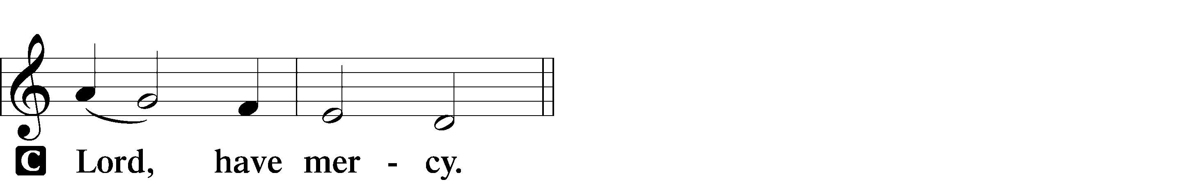
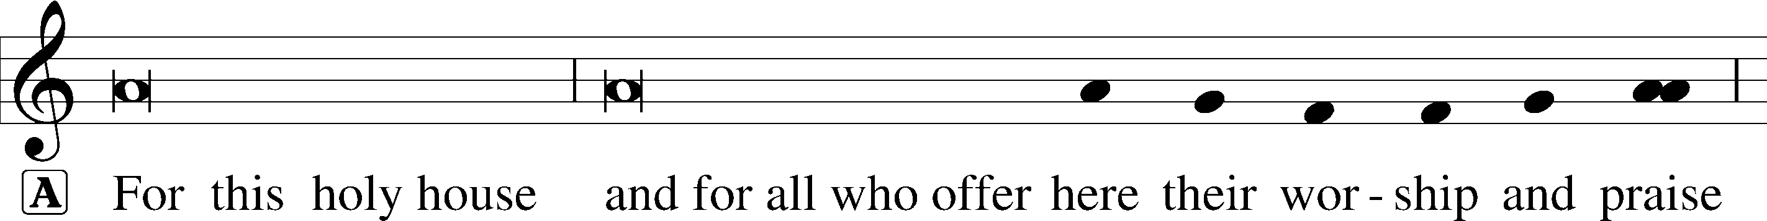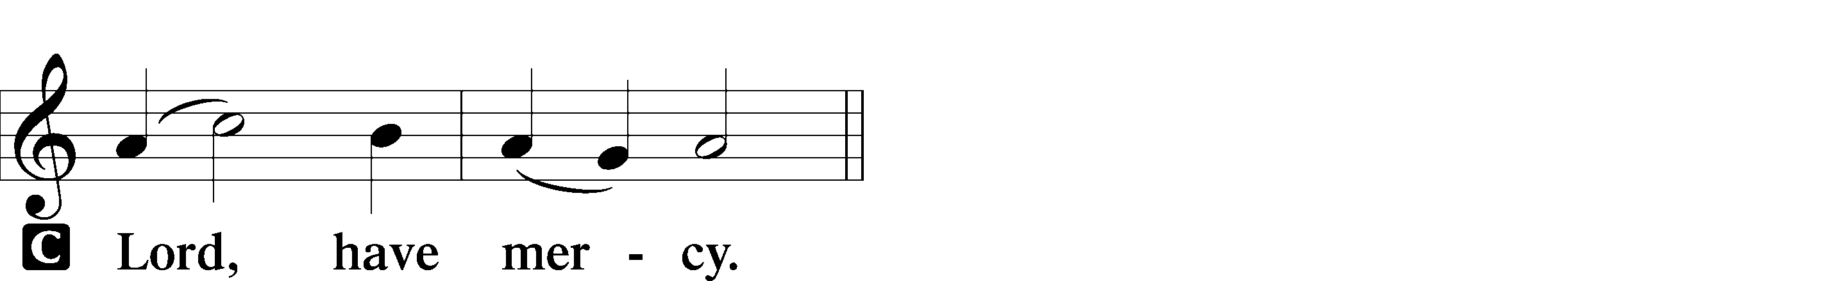


Salutation and Collect of the Day

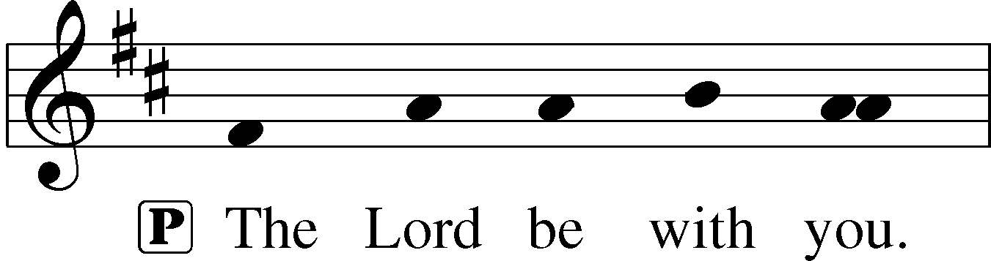
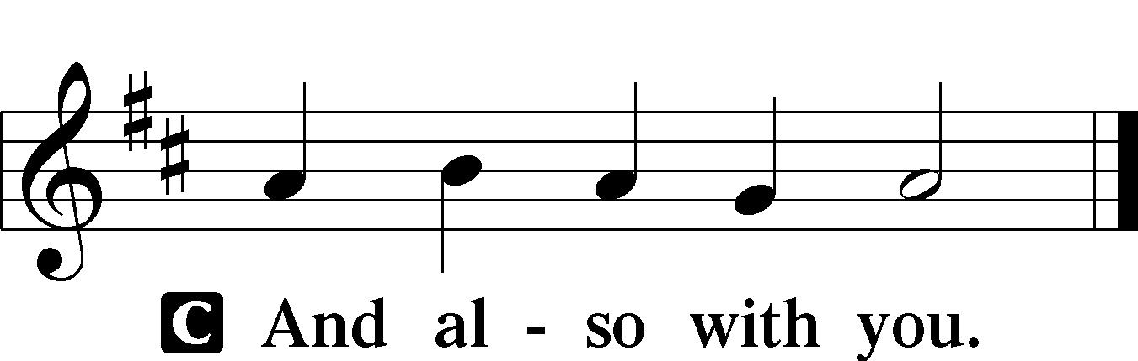
P Let us pray.
O God, You see that of ourselves we have no strength. By Your mighty power defend us from all adversities that may happen to the body and from all evil thoughts that may assault and hurt the soul; through Jesus Christ, Your Son, our Lord, who lives and reigns with You and the Holy Spirit, one God, now and forever.

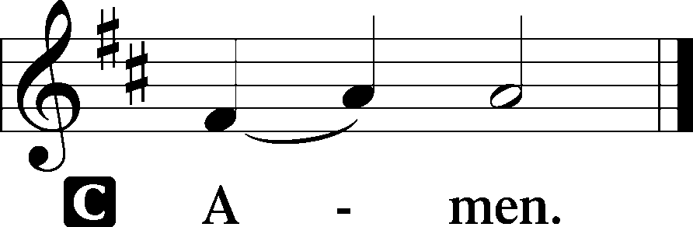

Please be seated

Old Testament Reading Genesis 17:1-7, 15-16
When Abram was ninety-nine years old the Lord appeared to Abram and said to him, “I am God Almighty; walk before me, and be blameless, that I may make my covenant between me and you, and may multiply you greatly.” Then Abram fell on his face. And God said to him, “Behold, my covenant is with you, and you shall be the father of a multitude of nations. No longer shall your name be called Abram, but your name shall be Abraham, for I have made you the father of a multitude of nations. I will make you exceedingly fruitful, and I will make you into nations, and kings shall come from you. And I will establish my covenant between me and you and your offspring after you throughout their generations for an everlasting covenant, to be God to you and to your offspring after you.
And God said to Abraham, “As for Sarai your wife, you shall not call her name Sarai, but Sarah shall be her name. I will bless her, and moreover, I will give you a son by her. I will bless her, and she shall become nations; kings of peoples shall come from her.”
A This is the Word of the Lord.
C Thanks be to God.
Gradual Hebrews 12:2
[O come, let us fix our eyes on] | Jesus,*
the founder and perfecter | of our faith,
who for the joy that was set before him endured the cross, despis- | ing the shame,*
and is seated at the right hand of the | throne of God.

Epistle Romans 5:1-11
Therefore, since we have been justified by faith, we have peace with God through our Lord Jesus Christ. Through him we have also obtained access by faith into this grace in which we stand, and we rejoice in hope of the glory of God. More than that, we rejoice in our sufferings, knowing that suffering produces endurance, and endurance produces character, and character produces hope, and hope does not put us to shame, because God’s love has been poured into our hearts through the Holy Spirit who has been given to us.
For while we were still weak, at the right time Christ died for the ungodly. For one will scarcely die for a righteous person—though perhaps for a good person one would dare even to die— but God shows his love for us in that while we were still sinners, Christ died for us. Since, therefore, we have now been justified by his blood, much more shall we be saved by him from the wrath of God. For if while we were enemies we were reconciled to God by the death of his Son, much more, now that we are reconciled, shall we be saved by his life. More than that, we also rejoice in God through our Lord Jesus Christ, through whom we have now received reconciliation.
A This is the Word of the Lord.
C Thanks be to God.

Tract
Oh give thanks to the Lord, for | he is good,*
for his steadfast love endures for- | ever!
Who can utter the mighty deeds | of the Lord,*
or declare | all his praise?
Blessed are they who observe | justice,*
who do righteousness | at all time!
Remember me, O Lord, when you show favor to your | people;*
help me when you | save them.
Please stand

Holy Gospel Mark 8:27-38
P The Holy T Gospel according to St. Mark, the eighth chapter.

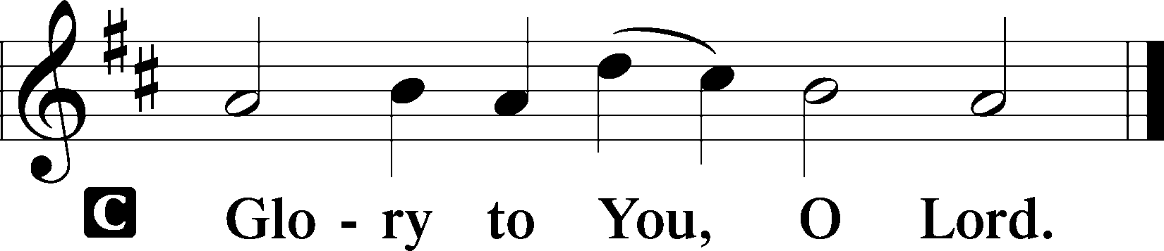
And Jesus went on with his disciples to the villages of Caesarea Philippi. And on the way he asked his disciples, “Who do people say that I am?” And they told him, “John the Baptist; and others say, Elijah; and others, one of the prophets.” And he asked them, “But who do you say that I am?” Peter answered him, “You are the Christ.” And he strictly charged them to tell no one about him.
And he began to teach them that the Son of Man must suffer many things and be rejected by the elders and the chief priests and the scribes and be killed, and after three days rise again. And he said this plainly. And Peter took him aside and began to rebuke him. But turning and seeing his disciples, he rebuked Peter and said, “Get behind me, Satan! For you are not setting your mind on the things of God, but on the things of man.”
And he called to him the crowd with his disciples and said to them, “If anyone would come after me, let him deny himself and take up his cross and follow me. For whoever would save his life will lose it, but whoever loses his life for my sake and the gospel’s will save it. For what does it profit a man to gain the whole world and forfeit his life? For what can a man give in return for his life? For whoever is ashamed of me and of my words in this adulterous and sinful generation, of him will the Son of Man also be ashamed when he comes in the glory of his Father with the holy angels.”
P This is the Gospel of the Lord.
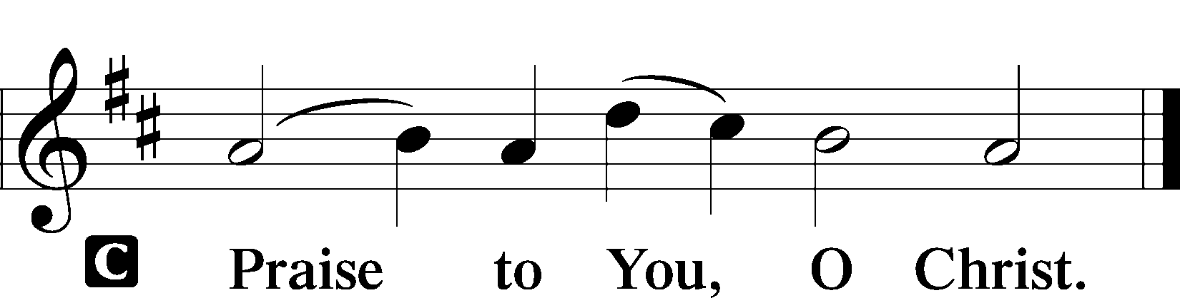

Please be seated

Office Hymn Savior, When in Dust to Thee #419

Sermon The True Confession

Please stand

Nicene Creed

C I believe in one God, (Rom 10:10; Deut 6:4)
the Father Almighty, (Mt 6:9; Ex 6:3)
maker of heaven and earth (Gen 1:1; Jn 1:1)
and of all things visible and invisible. (Col 1:16)
And in one Lord Jesus Christ, (Rom 10:9)
the only-begotten Son of God, (Jn 3:16; Mt 16:16)
begotten of His Father before all worlds, (Jn 1:2)
God of God, Light of Light, (Jn 17:22; Jn 8:12; Jn 1:1)
very God of very God, (Col 2:9) begotten, not made, (Jn 1:2)
being of one substance with the Father, (Jn 10:30)
by whom all things were made; (Heb 1:2; Jn 1:3)
who for us men and for our salvation (1 Tim 2:4; Rom 3:23)
came down from heaven (Jn 6:41; Lk 15:20)
and was incarnate by the Holy Spirit of the virgin Mary (Lk 1:34-35)
and was made man; (Jn 1:14)
and was crucified also for us under Pontius Pilate. (Mk 15:25; Jn 19:16-18)
He suffered and was buried. (Jn 19:1-3; Lk 23:53)
And the third day He rose again according to the Scriptures (1 Cor 15:4; Lk 24:6)
and ascended into heaven (Acts 1:9)
and sits at the right hand of the Father. (Acts 7:55)
And He will come again with glory (Mt 26:64)
to judge both the living and the dead, (Acts 10:42; Mt 3:12)
whose kingdom will have no end. (2 Pt 1:11)
And I believe in the Holy Spirit, (Jn 14:26; Gen 1:2; Acts 2:38)
the Lord and giver of life, (Gen 1:2; Jn 3:6)
who proceeds from the Father and the Son, (Jn 15:26)
who with the Father and the Son together is worshiped and glorified, (Mt 3:16-17)
who spoke by the prophets. (Eze 11:5)
And I believe in one holy Christian and apostolic Church, (1 Pt 2:5; Eph 2:19-22)
I acknowledge one Baptism for the remission of sins, (Eph 4:5)
and I look for the resurrection of the dead (1 Cor 15:35-49; 1 Thess 4:13-18)
and the life T of the world to come. (Mk 10:29-30; Mt 10:40-42)
Amen. (Ps 106:48)
Us men means all people.
Christian: the ancient text reads “catholic,” meaning the whole Church as it confesses the wholeness of Christian doctrine

Prayer of the Church
After each petition of the prayer:
Pastor: Lord, in Your mercy,
People: Hear our prayer.
For comfort, health and recovery: Krista Hansford, Joshua Hathcock, Keely Ramshur, Larry Taylor;
For those who are ill or distressed: Stan Acey, Jenalee Adams, Layne Bagley, Rose Bagley, Shirley Bagley, W.L. Bagley, Sarah Bowman, Mimi Bradley, Richard Bradley, Deloris Brent, Martha Brown, Nathan Brown, Tina Burke, Wayne Burke, Paula Burkhalter, Bobby Carroll, Arthur Collins, James E. Cookston, Joan Cowards, Belinda Cowards-Gonzales, Robert (Andy) Evers, Michele Rae Fowler, Randy Fowler, Parker Haines, Dan Hansen, Paul Hansen, Tim Hansen, Valerie Henderson, Sharon Holleman, Beth Jarratt, Elaine Johnson, Joslyn Jones, Steve Kennedy, Arlene Kleinschmidt, John Koster, Sandra Landers, Katelyn Lawing, Peggy Lucky, Paul McCullough, Jerry McIntyre, Jerry McMahan, Edlia Miller, Elaine Monaghan, Lindberg Moore, Don Ochs, Mildred Odom, Deborah-Annette Ried, Elmira Roever, Jon Sandberg, Noah Schultz, Johnnie Pearl Smiley, Bob Smith, Sam Schneider, Sherri Smith, Deborah Springer, Betty Venator, Leonard Watson, Dana Weaver, Cynthia Widlitze, Carol Wright, Jimmy Wright, Marshall Wright, Barbara Zeigler;
For college and graduate students: Sara Fields, Jonathan Kettler, Roselynn Nelson, Will Nelson;
For military servants and their families: Gabriel Escude, James (Glen) Hansford, Holden Hathcock, Christopher Martin, William Nelson, Steven Tatum, John Weidner Jr.;
For foreign missionaries: especially those serving in Spain;
This week’s prayer family: Gary & Mary Atchley and their loved ones.

Please be seated

Offering

Please stand
Offertory
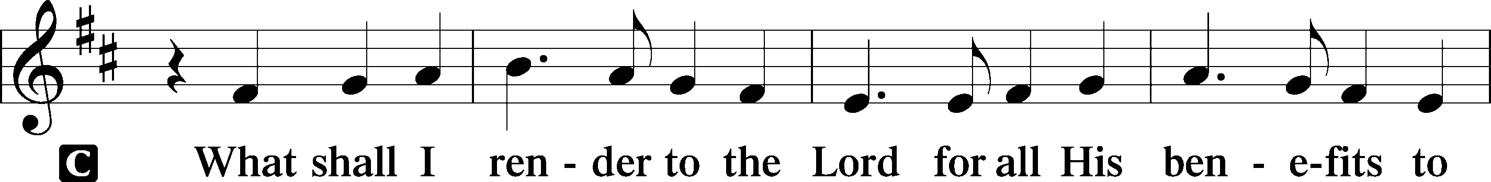
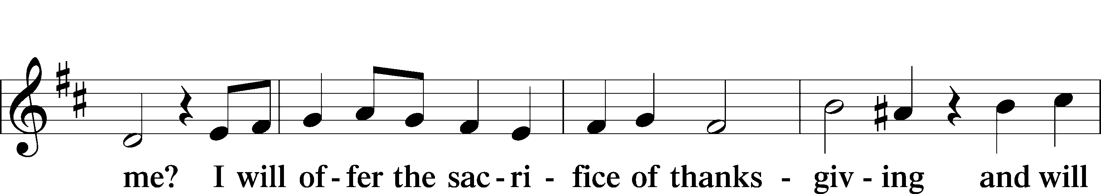
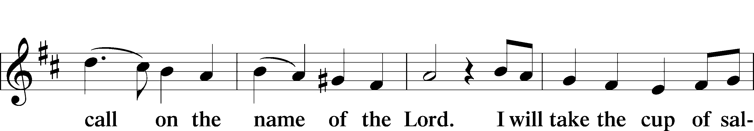
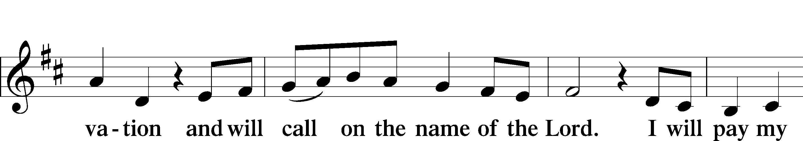
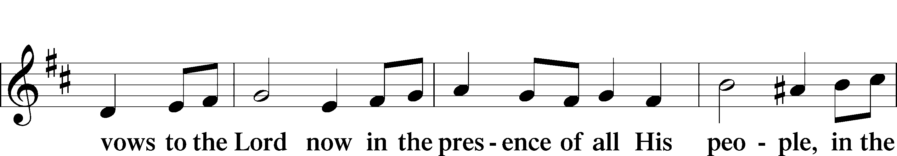
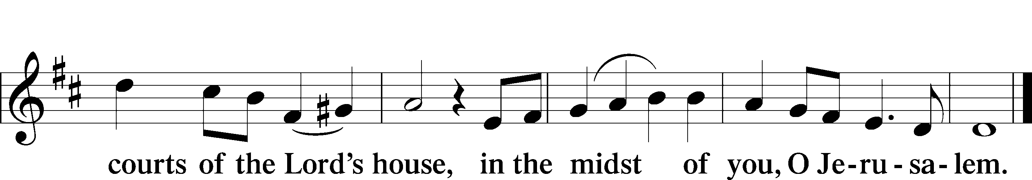
Service of the Sacrament

Preface 2 Timothy 4:22; [Colossians 3:1]; [Psalm 136]

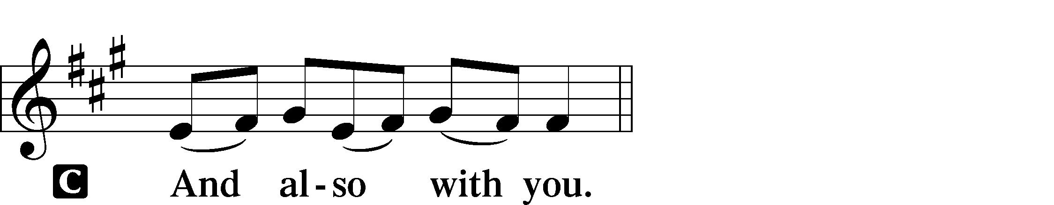

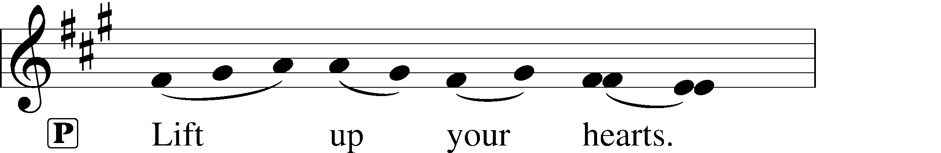


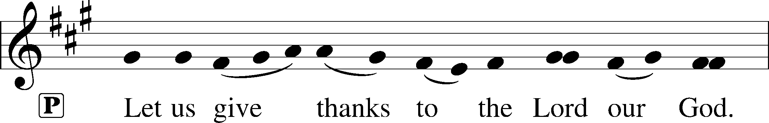
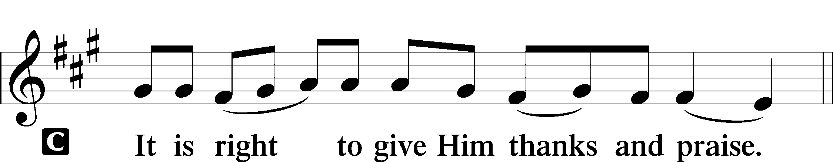

P It is truly good, right, and salutary that we should at all times and in all places give thanks to You, holy Lord, almighty Father, everlasting God, through Jesus Christ, our Lord, who overcame the assaults of the devil and gave His life as a ransom for many that with cleansed hearts we might be prepared joyfully to celebrate the paschal feast in sincerity and truth. Therefore with angels and archangels and with all the company of heaven we laud and magnify Your glorious name, evermore praising You and saying:
Sanctus Isaiah 6:3; Matthew 21:9
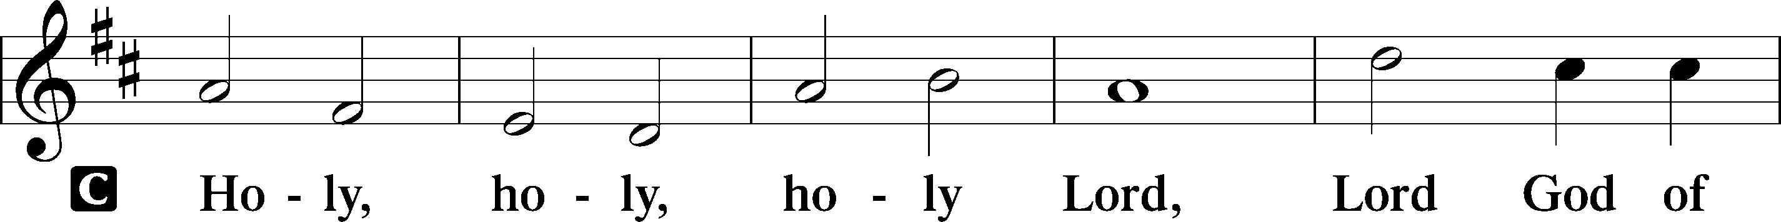
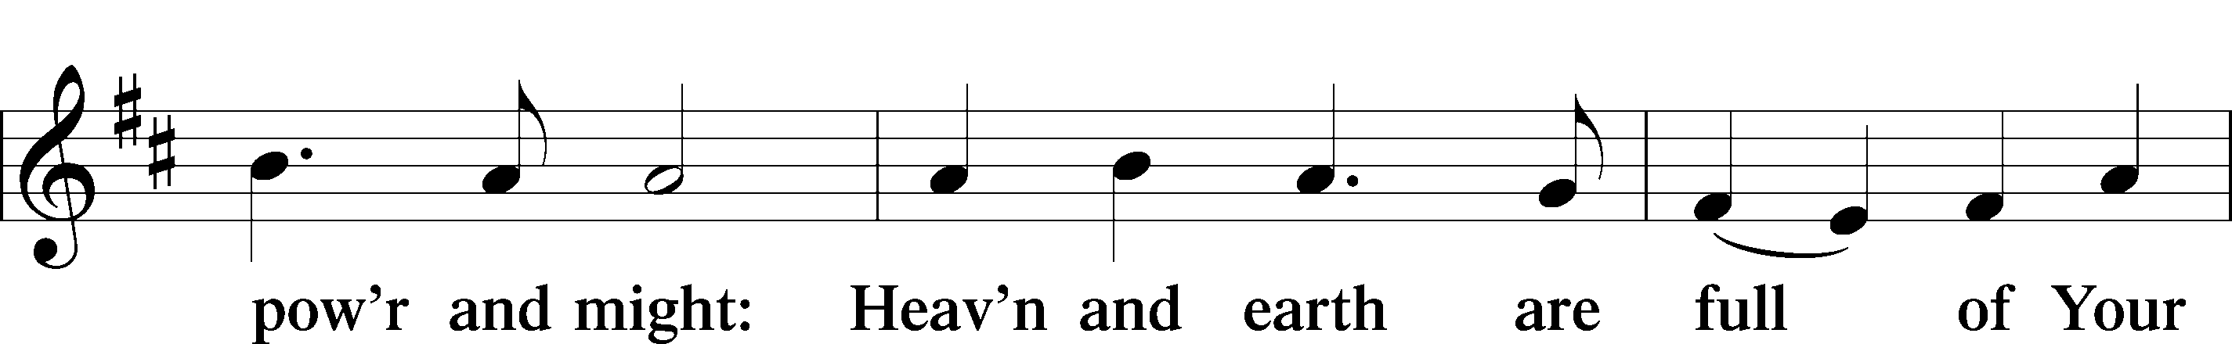
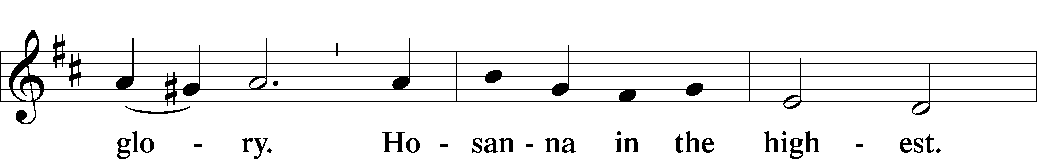
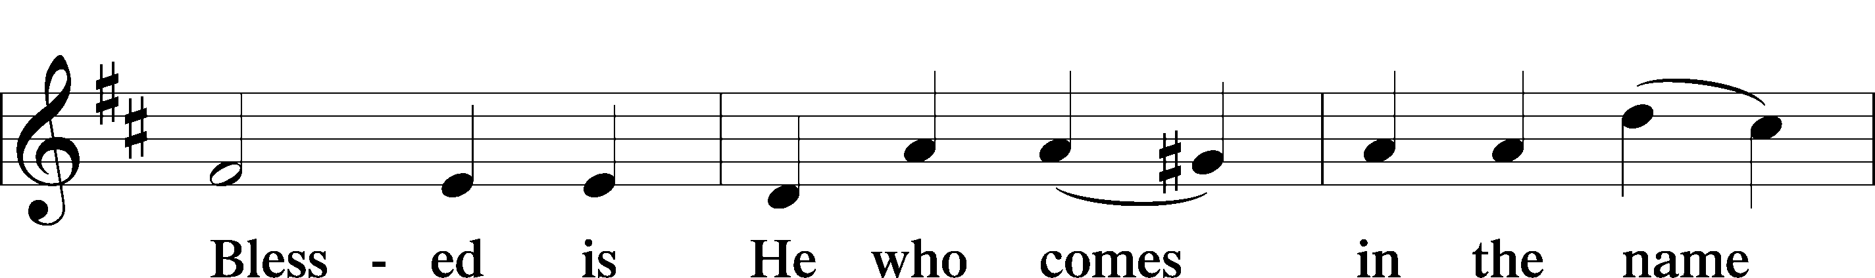
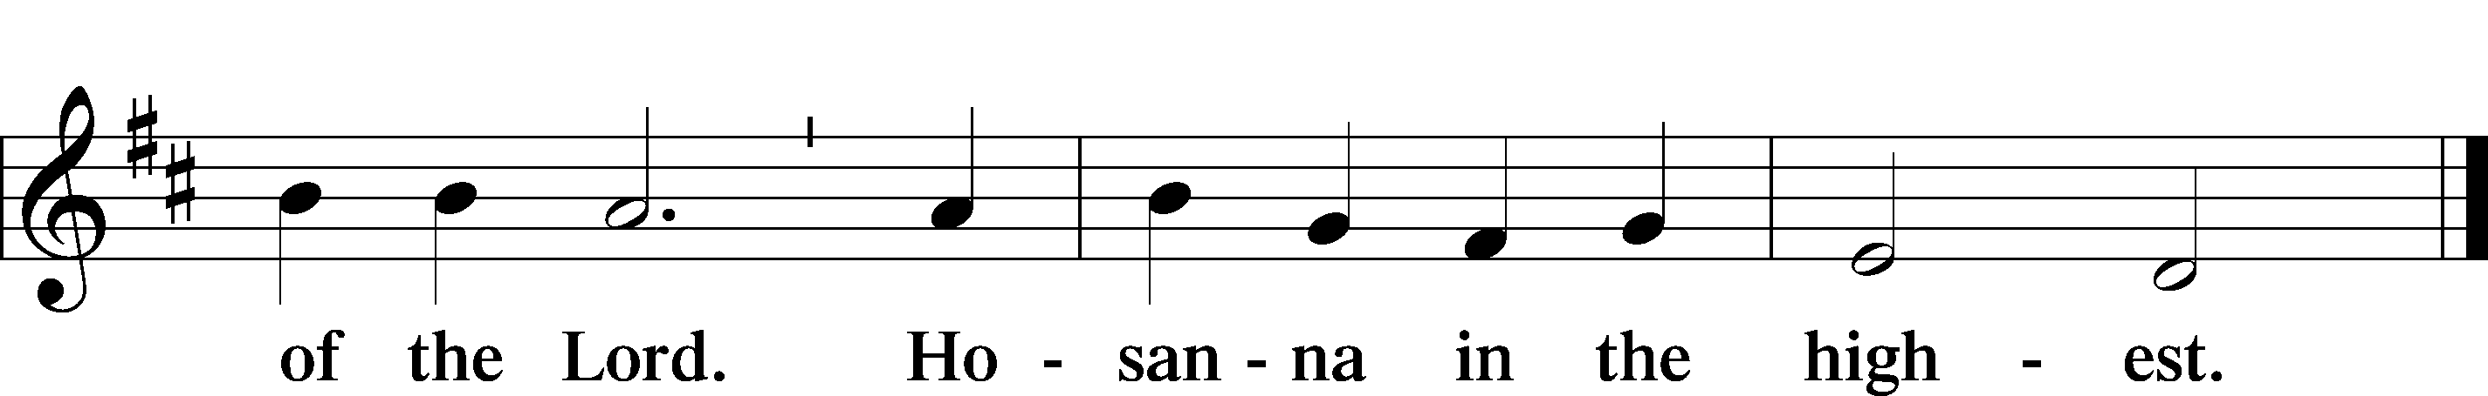

P Blessed are You, Lord of heaven and earth, for You have had mercy on those whom You created and sent Your only-begotten Son into our flesh to bear our sin and be our Savior. With repentant joy we receive the salvation accomplished for us by the all-availing sacrifice of His body and His blood on the cross.
Gathered in the name and the remembrance of Jesus, we beg You, O Lord, to forgive, renew, and strengthen us with Your Word and Spirit. Grant us faithfully to eat His body and drink His blood as He bids us do in His own testament. Gather us together, we pray, from the ends of the earth to celebrate with all the faithful the marriage feast of the Lamb in His kingdom, which has no end. Graciously receive our prayers; deliver and preserve us. To You alone, O Father, be all glory, honor, and worship, with the Son and the Holy Spirit, one God, now and forever.
C Amen.

Lord’s Prayer Matthew 6:9-13
P Lord, remember us in Your kingdom and teach us to pray:
C Our Father who art in heaven,
hallowed be Thy name,
Thy kingdom come,
Thy will be done on earth as it is in heaven;
give us this day our daily bread;
and forgive us our trespasses as we forgive those who trespass against us;
and lead us not into temptation,
but deliver T us from evil.
For Thine is the kingdom and the power and the glory forever and ever. Amen.

The Words of Our Lord Matthew 26:26–28;
Mark 14:22–24; Luke 22:19–20; 1 Corinthians 11:23–25
P Our Lord Jesus Christ, on the night when He was betrayed, took bread, and when He had given thanks, He broke it and gave it to the disciples and said: “Take, eat; this is My T body, which is given for you. This do in remembrance of Me.”
In the same way also He took the cup after supper, and when He had given thanks, He gave it to them, saying: “Drink of it, all of you; this cup is the new testament in My T blood, which is shed for you for the forgiveness of sins. This do, as often as you drink it, in remembrance of Me.”

Pax Domini John 20:19
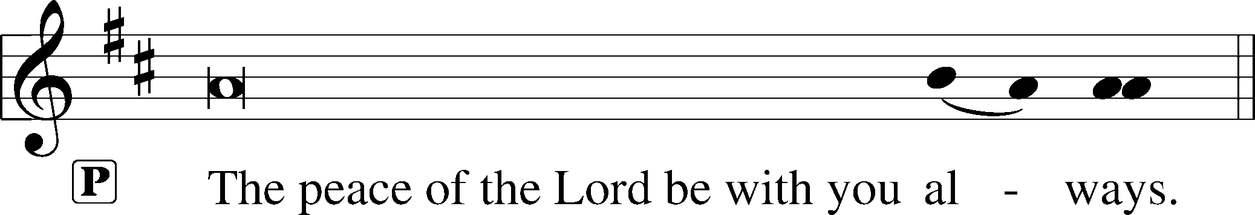


Agnus Dei John 1:29
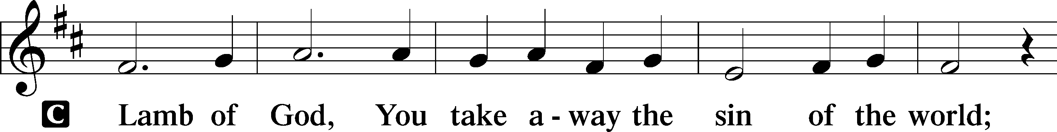
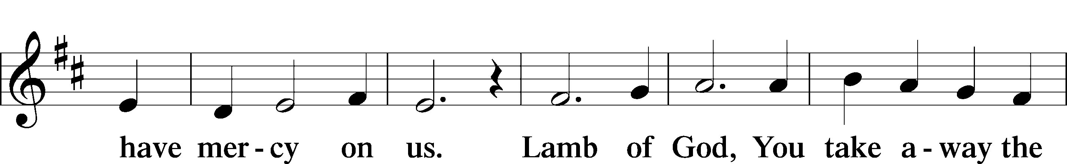
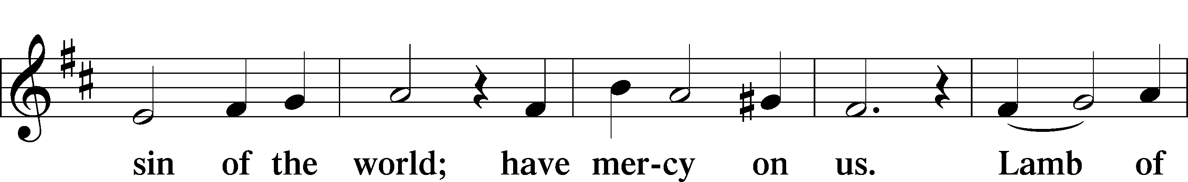
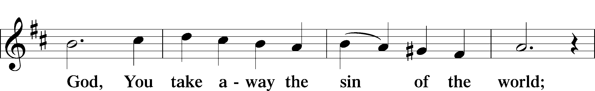
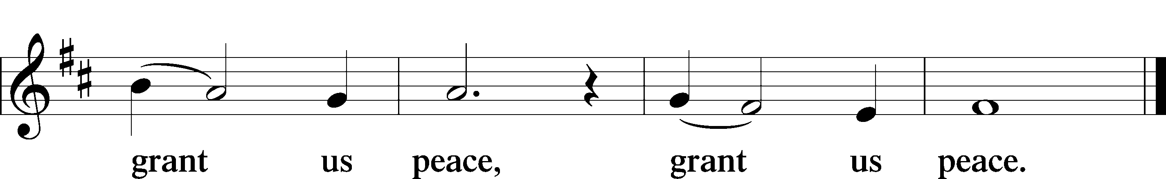

Please be seated

Distribution of the Sacrament
All who are members in good standing of the Lutheran Church - Missouri Synod and have introduced themselves to the pastor are welcome to partake of the Holy Communion at Christ Lutheran. If you have not spoken to the pastor, but would like to receive the Lord's blessing, you may still come to the rail and kneel, crossing one arm over the other in the shape of an 'X'. This symbolizes that one is marked by the cross and Triune name of Almighty God.

Distribution Hymns
We Sing the Praise of Him Who Died #429

Please stand following distribution of communion

Nunc Dimittis Luke 2:29-32
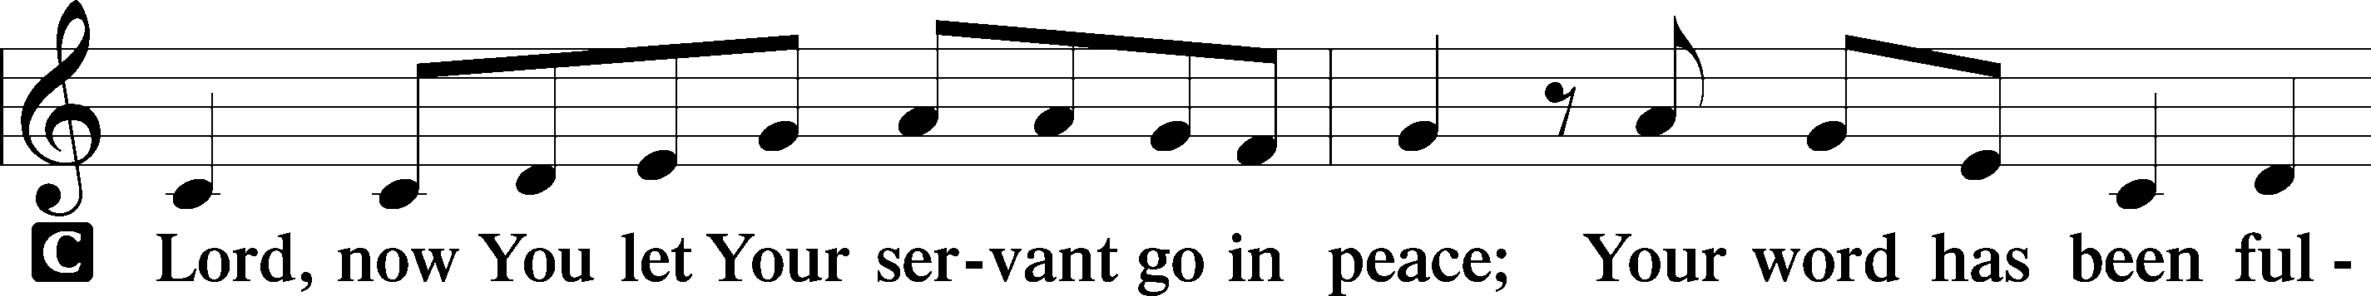
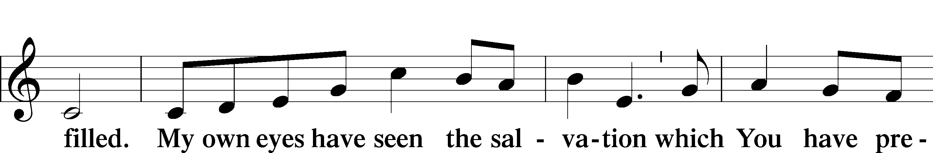
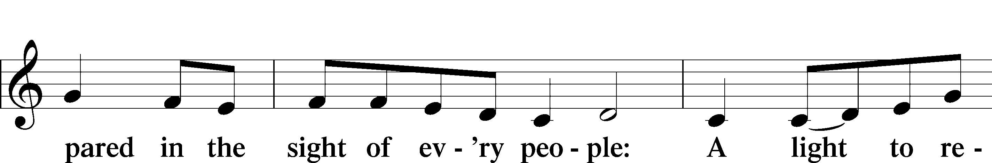
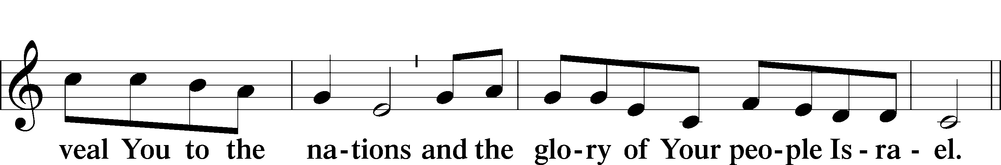
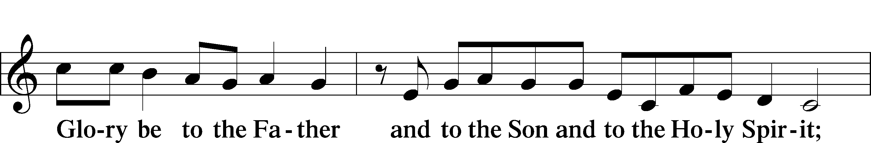
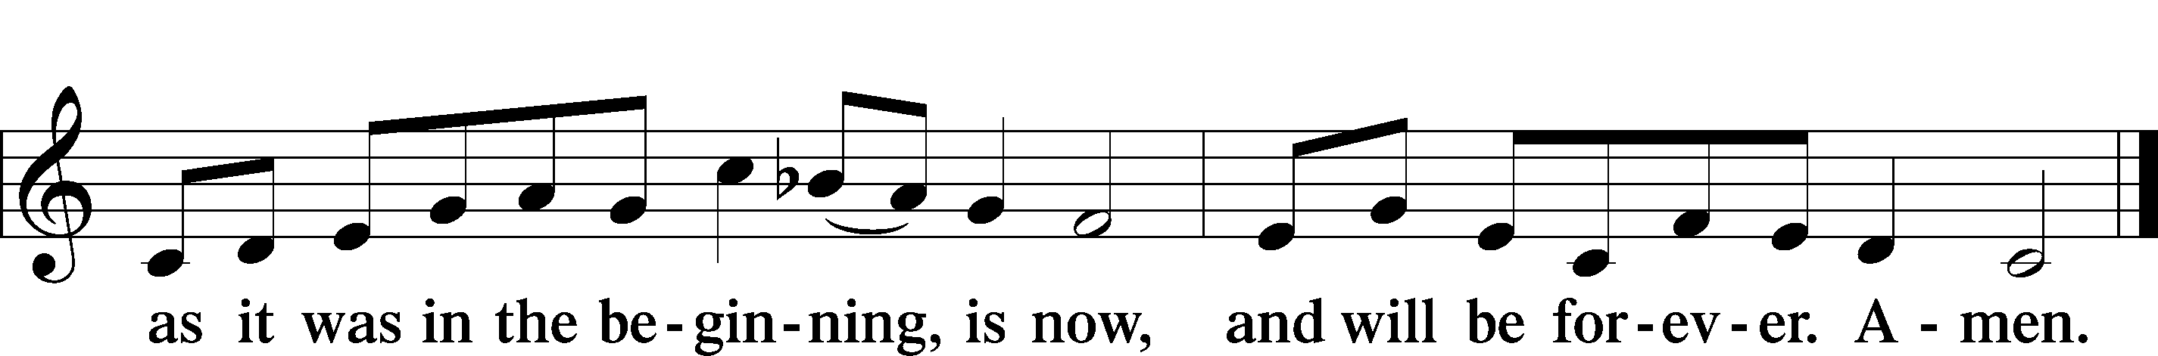

Post-Communion Collect
P We give thanks to You, almighty God, that You have refreshed us through this salutary gift, and we implore You that of Your mercy You would strengthen us through the same in faith toward You and fervent love toward one another; through Jesus Christ, Your Son, our Lord, who lives and reigns with You and the Holy Spirit, one God, now and forever.
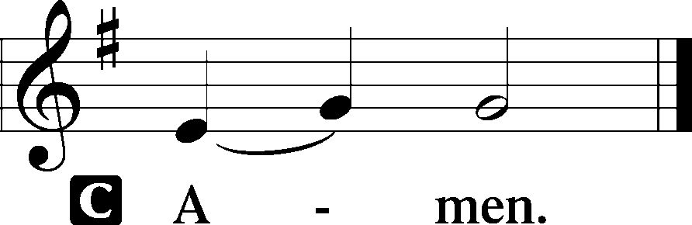
Benediction Numbers 6:24–26
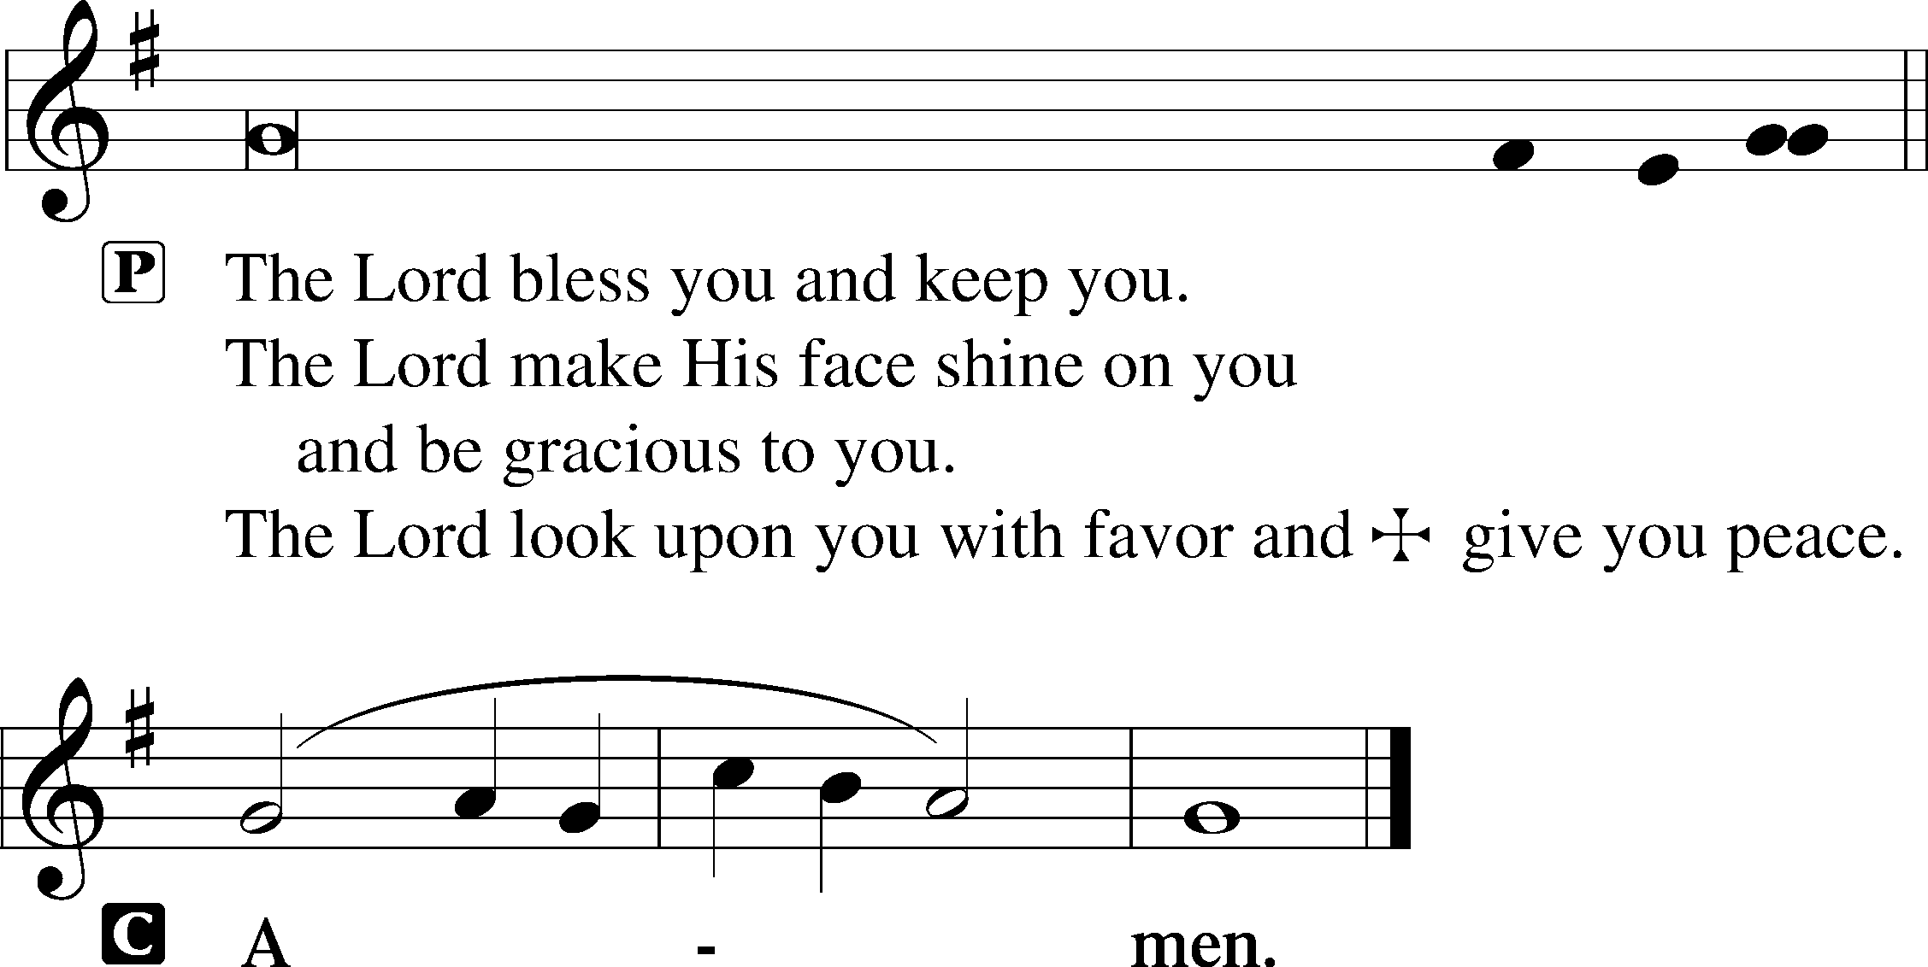

Closing Hymn At the Name of Jesus #512

Acknowledgments
Divine Service, Setting Two from Lutheran Service Book © 2006 Concordia Publishing House. Reprinted with permission. Unless otherwise indicated, all scripture quotations are from The Holy Bible, English Standard Version, copyright © 2001 by Crossway Bibles, a division of Good News Publishers. Used by permission. All rights reserved. Created by Lutheran Service Builder © 2006 Concordia Publishing House.

Serving Today:
Celebrant: Rev. George Fields Lector: Gary Atchley
Acolyte: William Held Organist: Sr. Sara Fields
Interpreter: Denee Smith Cantor: Rush Agent
Ushers: Bruce Bodkin, Roger Fuhrer

Koinonia Tonight: Learn how to thwart Satan and his minions as we read C.S. Lewis’s The Screwtape Letters (chapters 11-15)! Join us tonight at the Burkhalter home (5:00 p.m.) for dinner and discussion. See you there!

No Friday Morning Bible Study This Week: As Pastor will be in Arkansas for a funeral on Friday morning, we will not be meeting for Bible study this week.

Lenten Dinners: Praise God from Whom all blessings flow – especially the blessing of water! Our water is back on at church, and so are our Lenten dinners! Join us at 6:00 p.m. on Wednesdays for food and fellowship before weekly Vespers. If you are interested in helping with food and/or cleanup, see the sign-up sheet emailed by Sister Sara, or contact her at sistersara@christlutheranjacksonms.org. Thank you!

Lenten Vespers: Join us throughout this penitential season as we gather weekly to meditate upon the Passion of Our Lord. Vespers will be held on Wednesday nights at 7:00.

Bible Study Returns! Finally, after almost a year of hiatus, Adult Sunday School is back! To accommodate social distancing, we will meet in the sanctuary—and truly, what sanctuary it will be to dwell in the study of the Scriptures once more! Join us today at 9:15 a.m.!

Readings for next Sunday, March 7th, the Third Sunday in Lent:
Introit Ps. 69:14-16; Psalm 19; Exodus 20:1-17; 1 Corinthians 1:18-31; John 2:13-22.

This week at Christ Lutheran Church: March 1 – March 7

Tuesday 6:15 p.m. Elders Meeting
Wednesday 6:00 p.m. Lenten Dinner
7:00 p.m. Lenten Vespers
Thursday 9:30 p.m. LifeLight: Ezekiel (Session 4)
Friday 10:00 a.m. Christian Burial of Jerome Mutter @ West Memphis, AR
Sunday 8:00 a.m. Divine Service (Mask-Only) – The Third Sunday in Lent
9:15 a.m. Sunday School for All Ages
10:30 a.m. Divine Service – The Third Sunday in Lent



YOUR LIFELINE TO THE LUTHERAN WORLDVIEW…You can listen to in-depth teachings on interesting subjects like:

SACRED MUSIC FOR THE SEASON OF LENT…“When I Survey the Wondrous Cross,” “In the Cross of Christ I Glory,” “My Song Is Love Unknown,” “A Lamb Goes Uncomplaining Forth,” and more…

Issues, Etc. is a radio talk show produced by Lutheran Public Radio and hosted by LCMS Pastor Todd Wilken. You can listen to what you want when you want at www.issuesetc.org. Simply click on “Listen”, choose “On Demand”, then select from the vast array of speakers and topics available in the archives.

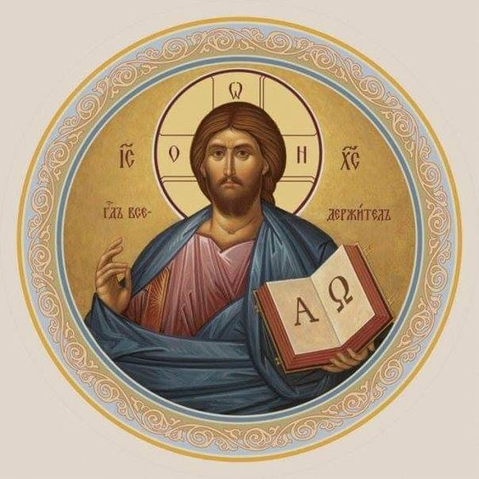

Christ Lutheran Church
The Lutheran Church—Missouri Synod
4423 I-55 North, Jackson, MS 39206-6102
Church phone: (601) 366-2055
www.ChristLutheranJacksonMS.org

Matthew 26:26-29; Mark 14:22-25; Luke 22:14-20, 1 Corinthians 11:23
Matthew 26:28; 1 John 1:7; 1 Peter 1:18-19
1 Corinthians 11:28-32
1 Corinthians 10:17; 1 Corinthians 11:26

