Christ Lutheran Church

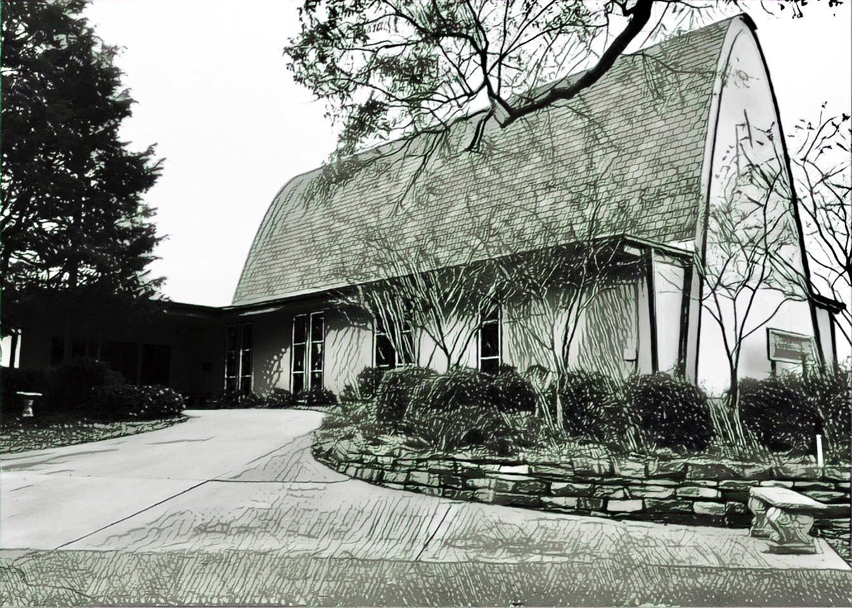

Rev. George Fields, Pastor
Sr. Sara Fields, Deaconess
Divine Service Each Week with Holy Communion: 10:30 a.m.
Sunday School for all ages: 9:15 a.m.
4423 I-55 North, Jackson, MS 39206-6102 – (601) 366-2055
www.christlutheranjacksonms.org

The First Sunday in Lent
+ February 21, 2021 +

The Beloved Son



We welcome our members and guests to Christ Lutheran today,
and pray God’s richest blessings upon you during this time of worship!

All members and our guests are asked to complete the
worship attendance pads which can be found on each pew.
Guests are also asked to sign the guest register found in the Narthex.
We are so glad to have you worshiping with us today!

LARGE PRINT worship folders are available
at the usher stand at the back of the nave.

WELCOME:
‘In the words of the midrash [an ancient Jewish commentary on the Torah]: “the one to bind, the other to be bound; the one to slaughter, the other to be slaughtered.” Yet the two went as one, the father and the son undivided in their obedience to God. If, indeed, the point of Gen. 22 is to expose Isaac’s resolute acceptance of his fate, then these verses begin the long trajectory that culminates in the notion […] that the Aqedah [the story of Abraham’s testing] is as much a test of Isaac as of Abraham—Isaac the archetypical martyr in a race exemplary of martyrs. One influential point of that trajectory is in the [belief] that the death of Jesus of Nazareth was voluntary.’
– Jon Levenson, The Death and Resurrection of the Beloved Son
The Lord’s Supper

In preparation for reception of the Lord’s Supper (Holy Communion), it is important that we review and understand what the Bible teaches regarding this sacrament:
The Bible teaches that Jesus gives us His very body and blood along with bread and wine in Holy Communion, and that these are means by which He forgives our sins, and strengthens us for daily living, and draws us into closer fellowship with Him and other believers. The Bible also teaches us to examine ourselves prior to receiving the meal. For those receiving Holy Communion, examine yourself with these questions:
Do I believe that I am a sinner and I am sorry for my sins?
Do I believe that Jesus Christ is God’s Son and my personal Savior?
Do I believe that Christ’s true body and blood are present in this holy meal for my forgiveness?
Do I truly intend with the help of God to correct my sinful life?
According to Christ’s Word in the Holy Scriptures, and in confession with the true Christian faith, at Christ Lutheran we observe the practice of closed communion. We believe that all who commune must confess the same holy faith, as Holy Scripture teaches. Since one’s church affiliation indicates an individual’s confession of faith, we ask that only those who have been instructed in the above teaching and are confirmed members of The Lutheran Church – Missouri Synod commune. If you have not been instructed in this teaching on Holy Communion, are in doubt, or hold a different confession of faith, you are still welcome to come forward and cross your arms to indicate that you would like a blessing.

Divine Service II

Preservice Music

The congregation may use this time for prayer and meditation.

Opening Hymn Lord Jesus, Think on Me #610

Confession & Absolution
The sign of the cross may be made by all in remembrance of your Baptism.

P In the name of the Father and of the T Son and of the Holy Spirit.
C Amen.

P If we say we have no sin, we deceive ourselves, and the truth is not in us.
C But if we confess our sins, God, who is faithful and just, will forgive our sins and cleanse us from all unrighteousness.

Silence for reflection on God's Word and for self-examination.

P Let us then confess our sins to God our Father.
C Most merciful God, we confess that we are by nature sinful and unclean. We have sinned against You in thought, word, and deed, by what we have done and by what we have left undone. We have not loved You with our whole heart; we have not loved our neighbors as ourselves. We justly deserve Your present and eternal punishment. For the sake of Your Son, Jesus Christ, have mercy on us. Forgive us, renew us, and lead us, so that we may delight in Your will and walk in Your ways to the glory of Your holy name. Amen.

P Almighty God in His mercy has given His Son to die for you and for His sake forgives you all your sins. As a called and ordained servant of Christ, and by His authority, I therefore forgive you all your sins in the name of the Father and of the T Son and of the Holy Spirit.
C Amen.

Service of the Word

Introit: Qui habitat Psalm 91:9-13; Ant. Psalm 91:15-16
When he calls to me, I will answer him; I will be with him in | trouble;*
I will rescue him and | honor him.
With long life I will sat- | isfy him*
and show him my sal- | vation.
Because you have made the Lord your | dwelling place—*
the Most High, who is my | refuge—
no evil shall be allowed to be- | fall you,*
no plague come | near your tent.
For he will command his angels con- | cerning you*
to guard you in | all your ways.
On their hands they will | bear you up,*
lest you strike your foot a- | gainst a stone.
You will tread on the lion and the | adder;*
the young lion and the serpent you will trample | underfoot.
Glory be to the Father and | to the Son*
and to the Holy | Spirit;
as it was in the be- | ginning,*
is now, and will be forever. | Amen.
When he calls to me, I will answer him; I will be with him in | trouble;*
I will rescue him and | honor him.
With long life I will sat- | isfy him*
and show him my sal- | vation.

Kyrie Mark 10:47



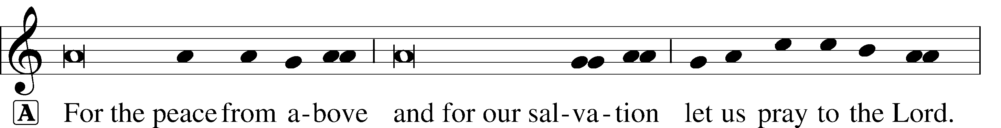
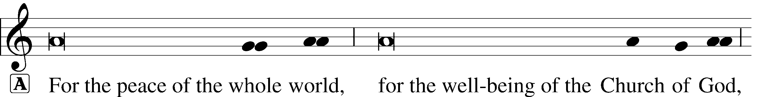
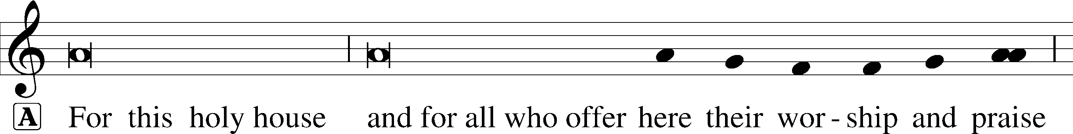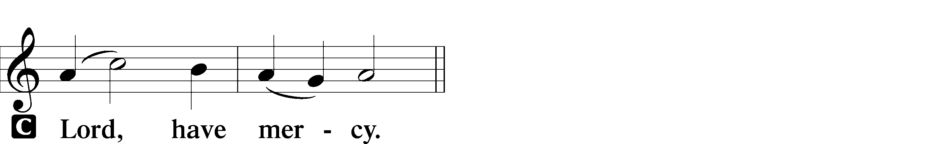


Salutation and Collect of the Day

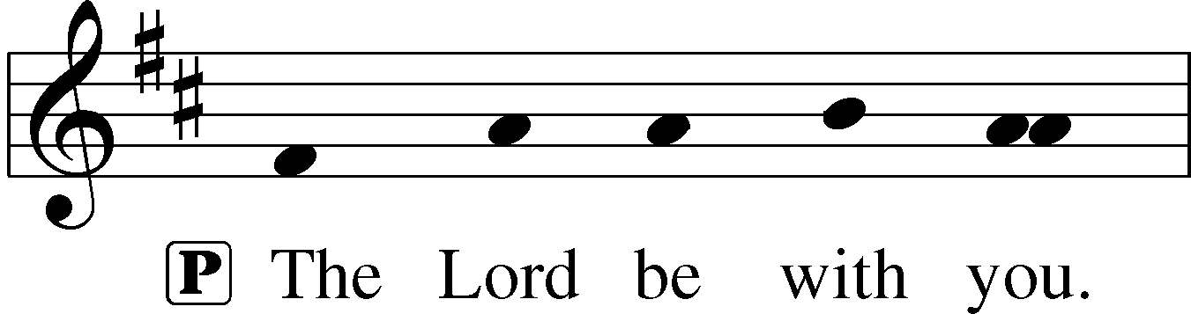
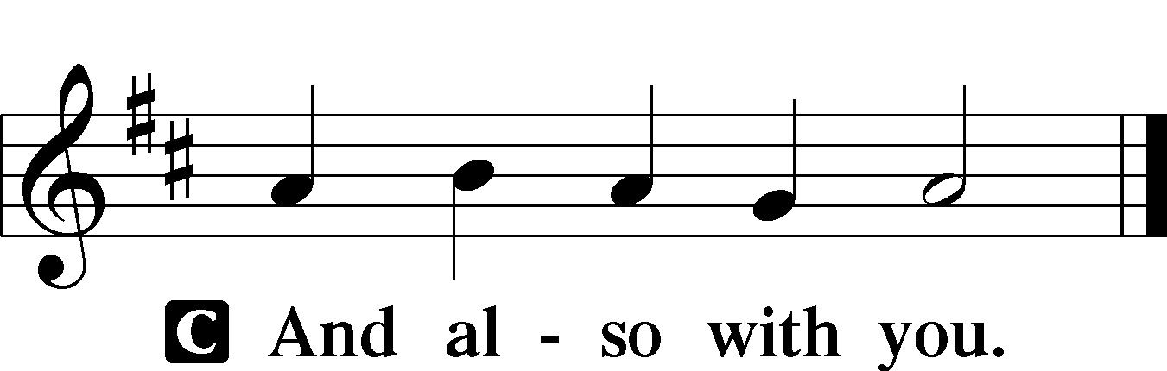
P Let us pray.
O Lord God, You led Your ancient people through the wilderness and brought them to the promised land. Guide the people of Your Church that following our Savior we may walk through the wilderness of this world toward the glory of the world to come; through Jesus Christ, Your Son, our Lord, who lives and reigns with You and the Holy Spirit, one God, now and forever.

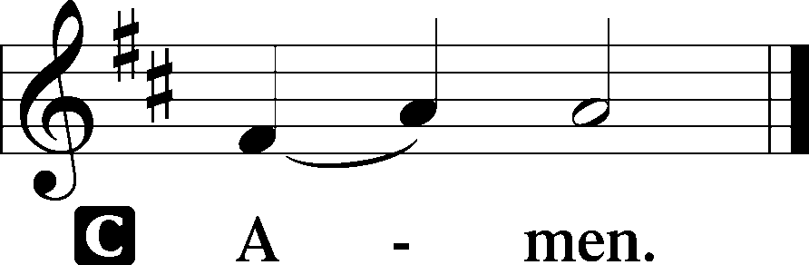

Please be seated
Old Testament Reading Genesis 22:1-18
After these things God tested Abraham and said to him, “Abraham!” And he said, “Here am I.” He said, “Take your son, your only son Isaac, whom you love, and go to the land of Moriah, and offer him there as a burnt offering on one of the mountains of which I shall tell you.” So Abraham rose early in the morning, saddled his donkey, and took two of his young men with him, and his son Isaac. And he cut the wood for the burnt offering and arose and went to the place of which God had told him. On the third day Abraham lifted up his eyes and saw the place from afar. Then Abraham said to his young men, “Stay here with the donkey; I and the boy will go over there and worship and come again to you.” And Abraham took the wood of the burnt offering and laid it on Isaac his son. And he took in his hand the fire and the knife. So they went both of them together. And Isaac said to his father Abraham, “My father!” And he said, “Here am I, my son.” He said, “Behold, the fire and the wood, but where is the lamb for a burnt offering?” Abraham said, “God will provide for himself the lamb for a burnt offering, my son.” So they went both of them together.
When they came to the place of which God had told him, Abraham built the altar there and laid the wood in order and bound Isaac his son and laid him on the altar, on top of the wood. Then Abraham reached out his hand and took the knife to slaughter his son. But the angel of the Lord called to him from heaven and said, “Abraham, Abraham!” And he said, “Here am I.” He said, “Do not lay your hand on the boy or do anything to him, for now I know that you fear God, seeing you have not withheld your son, your only son, from me.” And Abraham lifted up his eyes and looked, and behold, behind him was a ram, caught in a thicket by his horns. And Abraham went and took the ram and offered it up as a burnt offering instead of his son. So Abraham called the name of that place, “The Lord will provide”; as it is said to this day, “On the mount of the Lord it shall be provided.”
And the angel of the Lord called to Abraham a second time from heaven and said, “By myself I have sworn, declares the Lord, because you have done this and have not withheld your son, your only son, I will surely bless you, and I will surely multiply your offspring as the stars of heaven and as the sand that is on the seashore. And your offspring shall possess the gate of his enemies, and in your offspring shall all the nations of the earth be blessed, because you have obeyed my voice.”
A This is the Word of the Lord.
C Thanks be to God.
Gradual Hebrews 12:2
[O come, let us fix our eyes on] | Jesus,*
the founder and perfecter | of our faith,
who for the joy that was set before him endured the cross, despis- | ing the shame,*
and is seated at the right hand of the | throne of God.

Epistle James 1:12-18
Blessed is the man who remains steadfast under trial, for when he has stood the test he will receive the crown of life, which God has promised to those who love him. Let no one say when he is tempted, “I am being tempted by God,” for God cannot be tempted with evil, and he himself tempts no one. But each person is tempted when he is lured and enticed by his own desire. Then desire when it has conceived gives birth to sin, and sin when it is fully grown brings forth death.
Do not be deceived, my beloved brothers. Every good gift and every perfect gift is from above, coming down from the Father of lights with whom there is no variation or shadow due to change. Of his own will he brought us forth by the word of truth, that we should be a kind of firstfruits of his creatures.
A This is the Word of the Lord.
C Thanks be to God.

Tract Psalm 90:1, 4, 15, 16
He who dwells in the shelter of the | Most High*
Will abide in the shadow of the Al- | mighty.
He will cover you with his | pinions,*
And under his wings you will find | refuge.
When he calls to me, I will | answer him;*
I will be with him in | trouble.
With long life I will satis- | fy him*
And show him my sal- | vation.

Please stand

Holy Gospel Mark 1:9-15
P The Holy T Gospel according to St. Mark, the first chapter.

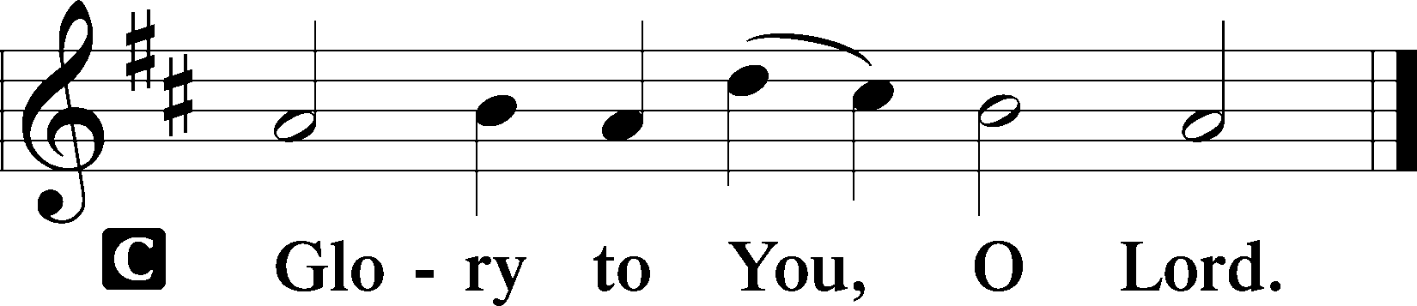
In those days Jesus came from Nazareth of Galilee and was baptized by John in the Jordan. And when he came up out of the water, immediately he saw the heavens opening and the Spirit descending on him like a dove. And a voice came from heaven, “You are my beloved Son; with you I am well pleased.”
The Spirit immediately drove him out into the wilderness. And he was in the wilderness forty days, being tempted by Satan. And he was with the wild animals, and the angels were ministering to him.
Now after John was arrested, Jesus came into Galilee, proclaiming the gospel of God, and saying, “The time is fulfilled, and the kingdom of God is at hand; repent and believe in the gospel.”
P This is the Gospel of the Lord.
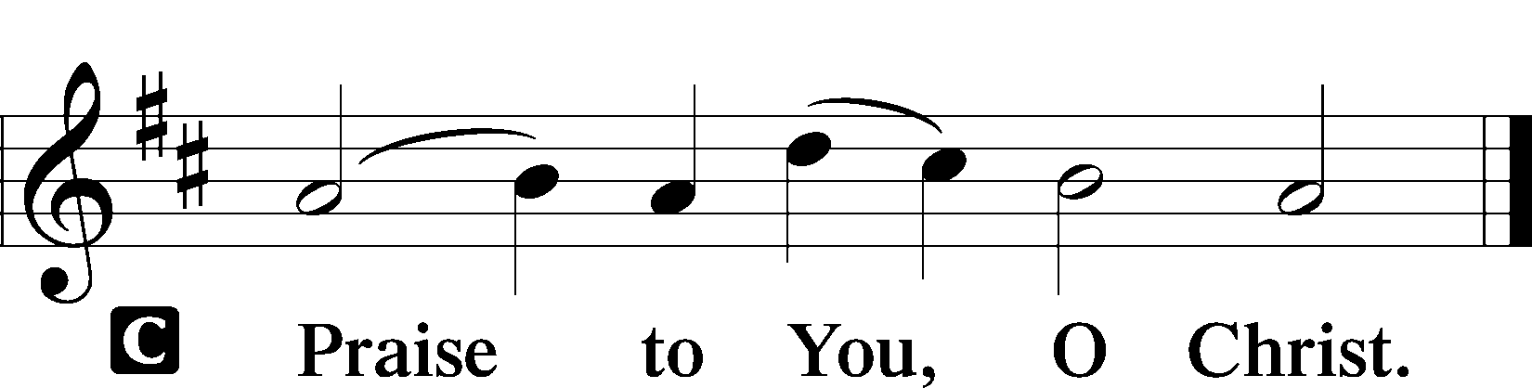

Please be seated

Office Hymn A Lamb Goes Uncomplaining Forth #438

Sermon The Father of the Son

Please stand

Nicene Creed

C I believe in one God, (Rom 10:10; Deut 6:4)
the Father Almighty, (Mt 6:9; Ex 6:3)
maker of heaven and earth (Gen 1:1; Jn 1:1)
and of all things visible and invisible. (Col 1:16)
And in one Lord Jesus Christ, (Rom 10:9)
the only-begotten Son of God, (Jn 3:16; Mt 16:16)
begotten of His Father before all worlds, (Jn 1:2)
God of God, Light of Light, (Jn 17:22; Jn 8:12; Jn 1:1)
very God of very God, (Col 2:9) begotten, not made, (Jn 1:2)
being of one substance with the Father, (Jn 10:30)
by whom all things were made; (Heb 1:2; Jn 1:3)
who for us men and for our salvation (1 Tim 2:4; Rom 3:23)
came down from heaven (Jn 6:41; Lk 15:20)
and was incarnate by the Holy Spirit of the virgin Mary (Lk 1:34-35)
and was made man; (Jn 1:14)
and was crucified also for us under Pontius Pilate. (Mk 15:25; Jn 19:16-18)
He suffered and was buried. (Jn 19:1-3; Lk 23:53)
And the third day He rose again according to the Scriptures (1 Cor 15:4; Lk 24:6)
and ascended into heaven (Acts 1:9)
and sits at the right hand of the Father. (Acts 7:55)
And He will come again with glory (Mt 26:64)
to judge both the living and the dead, (Acts 10:42; Mt 3:12)
whose kingdom will have no end. (2 Pt 1:11)
And I believe in the Holy Spirit, (Jn 14:26; Gen 1:2; Acts 2:38)
the Lord and giver of life, (Gen 1:2; Jn 3:6)
who proceeds from the Father and the Son, (Jn 15:26)
who with the Father and the Son together is worshiped and glorified, (Mt 3:16-17)
who spoke by the prophets. (Eze 11:5)
And I believe in one holy Christian and apostolic Church, (1 Pt 2:5; Eph 2:19-22)
I acknowledge one Baptism for the remission of sins, (Eph 4:5)
and I look for the resurrection of the dead (1 Cor 15:35-49; 1 Thess 4:13-18)
and the life T of the world to come. (Mk 10:29-30; Mt 10:40-42)
Amen. (Ps 106:48)
Us men means all people.
Christian: the ancient text reads “catholic,” meaning the whole Church as it confesses the wholeness of Christian doctrine

Prayer of the Church
After each petition of the prayer:
Pastor: Lord, in Your mercy,
People: Hear our prayer.
For comfort, health and recovery: Krista Hansford, Joshua Hathcock, Ruth Osburn, John Sandberg, Larry Taylor;
For those who mourn: The family and friends of Jerry Mutter, Sam Schneider;
For those who are ill or distressed: Stan Acey, Jenalee Adams, Layne Bagley, Rose Bagley, Shirley Bagley, W.L. Bagley, Sarah Bowman, Mimi Bradley, Richard Bradley, Deloris Brent, Martha Brown, Nathan Brown, Tina Burke, Wayne Burke, Paula Burkhalter, Bobby Carroll, Arthur Collins, James E. Cookston, Joan Cowards, Belinda Cowards-Gonzales, Robert (Andy) Evers, Michele Rae Fowler, Randy Fowler, Parker Haines, Dan Hansen, Paul Hansen, Tim Hansen, Valerie Henderson, Sharon Holleman, Beth Jarratt, Elaine Johnson, Joslyn Jones, Steve Kennedy, Arlene Kleinschmidt, John Koster, Sandra Landers, Katelyn Lawing, Peggy Lucky, Paul McCullough, Jerry McIntyre, Jerry McMahan, Edlia Miller, Elaine Monaghan, Lindberg Moore, Don Ochs, Mildred Odom, Deborah-Annette Ried, Elmira Roever, Jon Sandberg, Noah Schultz, Johnnie Pearl Smiley, Bob Smith, Sam Schneider, Sherri Smith, Deborah Springer, Betty Venator, Leonard Watson, Dana Weaver, Cynthia Widlitze, Carol Wright, Jimmy Wright, Marshall Wright, Barbara Zeigler;
For college and graduate students: Sara Fields, Jonathan Kettler, Roselynn Nelson, Will Nelson;
For military servants and their families: Gabriel Escude, James (Glen) Hansford, Holden Hathcock, Christopher Martin, William Nelson, Steven Tatum, John Weidner Jr.;
For foreign missionaries: especially those serving in Spain;
This week’s prayer family: Justin Alderson and his loved ones.

Please be seated

Offering

Please stand
Offertory
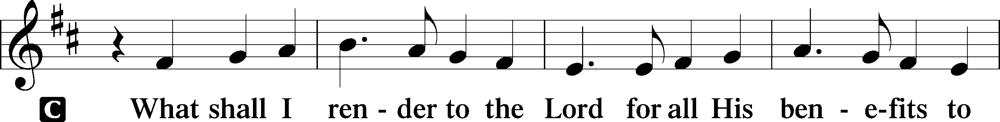
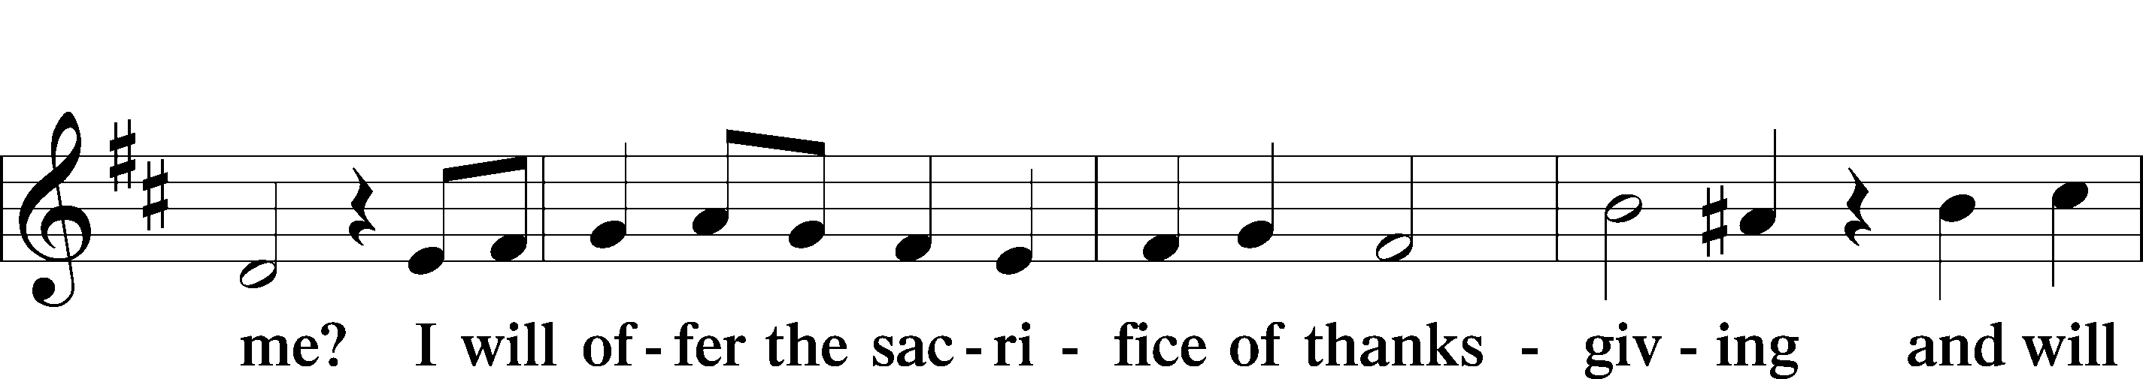
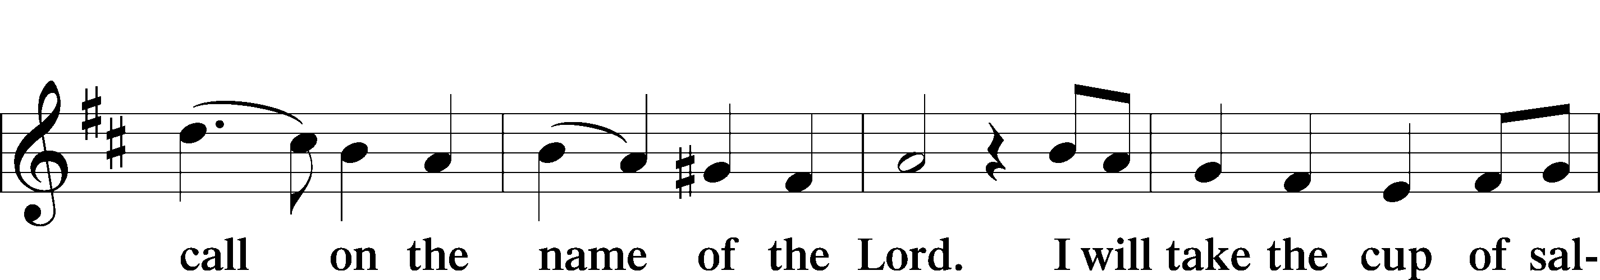
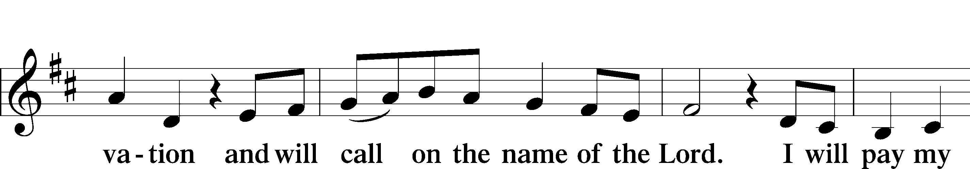
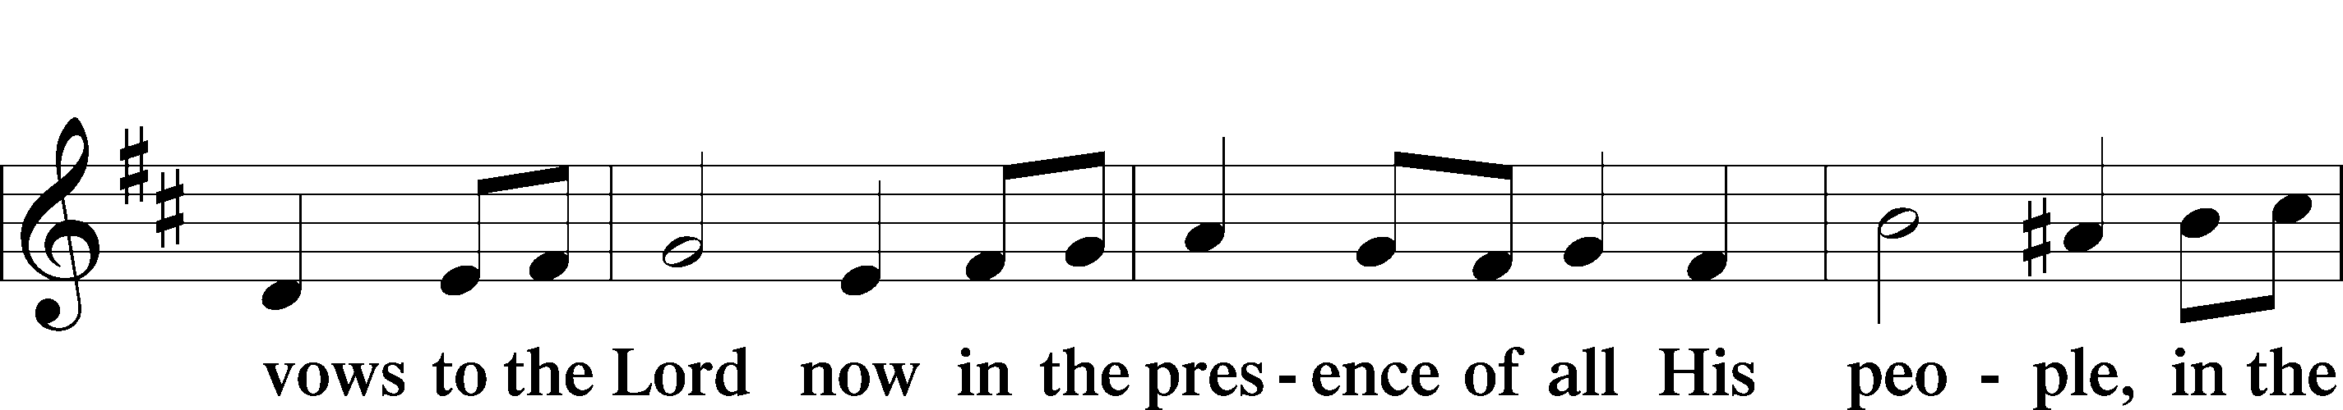
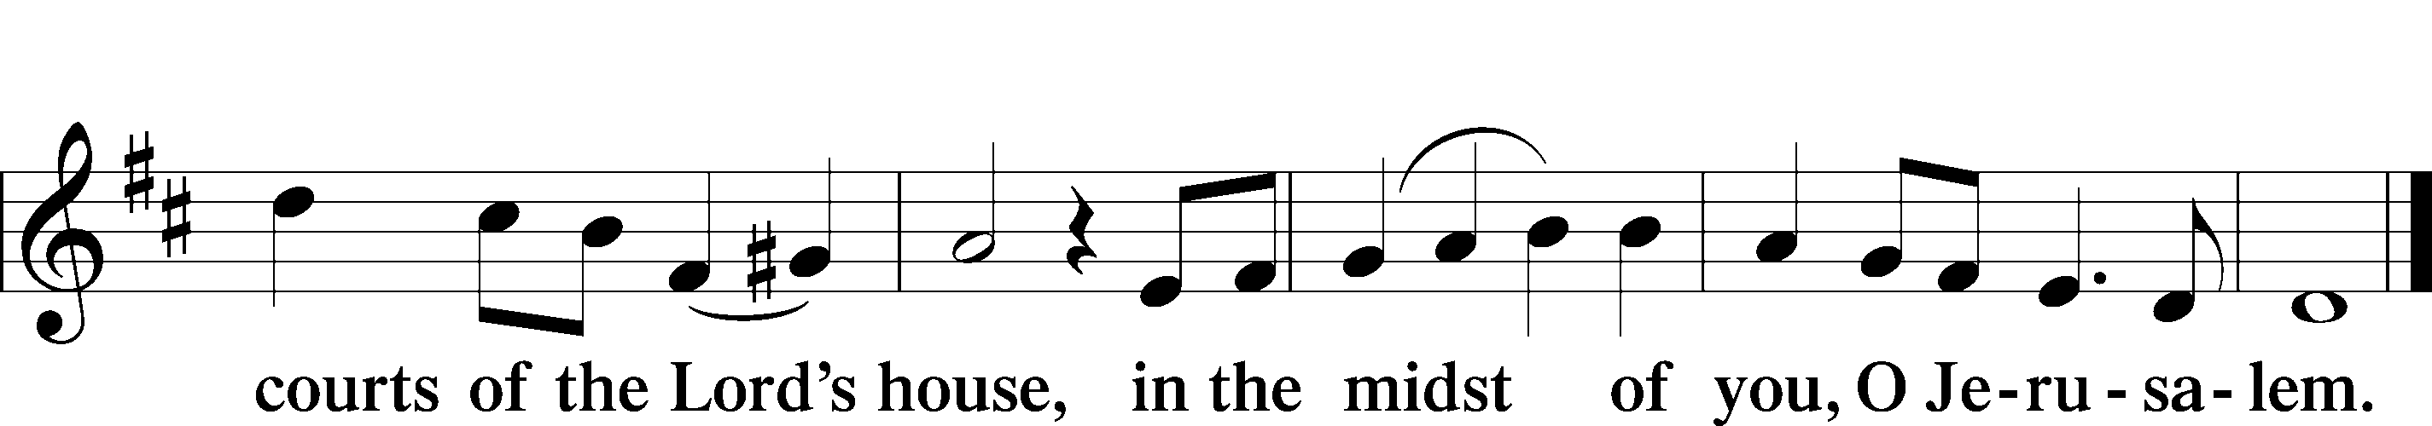
Service of the Sacrament

Preface 2 Timothy 4:22; [Colossians 3:1]; [Psalm 136]






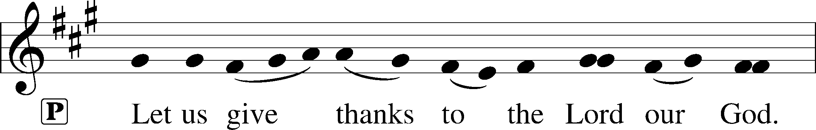
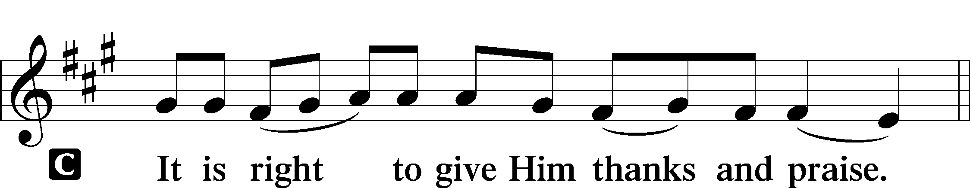

P It is truly good, right, and salutary that we should at all times and in all places give thanks to You, holy Lord, almighty Father, everlasting God, through Jesus Christ, our Lord, who overcame the assaults of the devil and gave His life as a ransom for many that with cleansed hearts we might be prepared joyfully to celebrate the paschal feast in sincerity and truth. Therefore with angels and archangels and with all the company of heaven we laud and magnify Your glorious name, evermore praising You and saying:
Sanctus Isaiah 6:3; Matthew 21:9
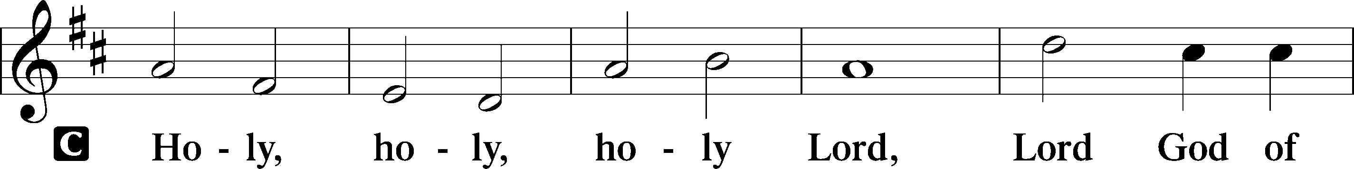
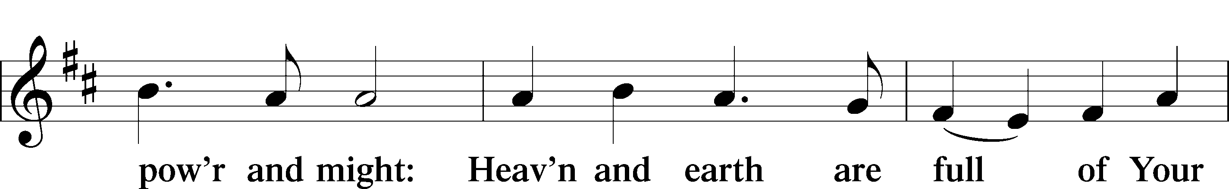
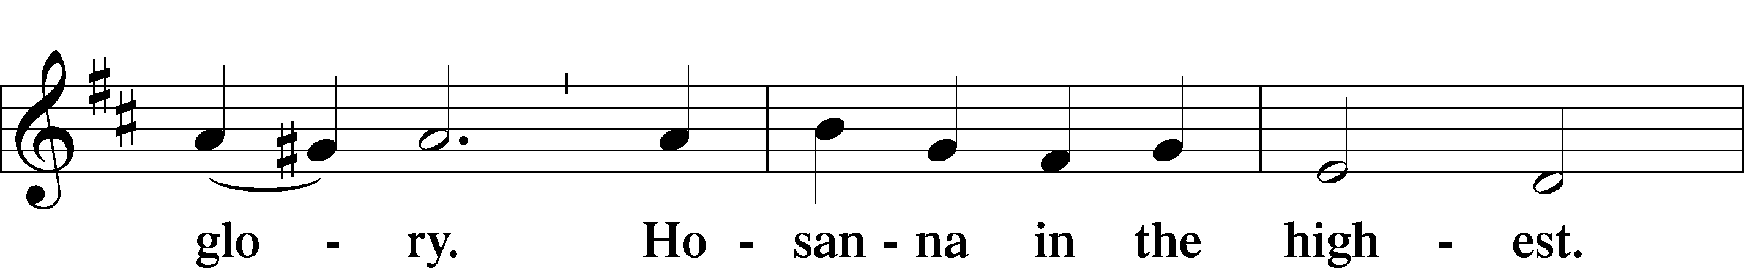
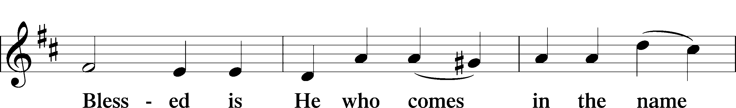
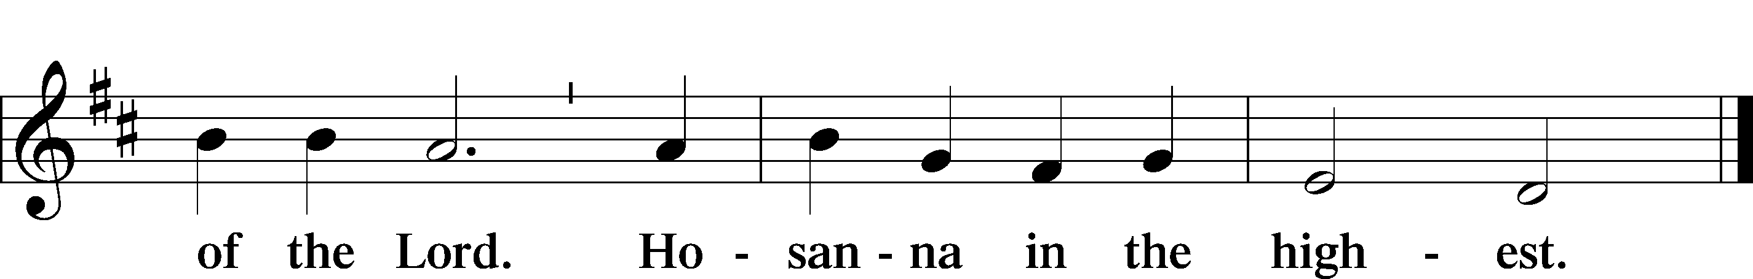

P Blessed are You, Lord of heaven and earth, for You have had mercy on those whom You created and sent Your only-begotten Son into our flesh to bear our sin and be our Savior. With repentant joy we receive the salvation accomplished for us by the all-availing sacrifice of His body and His blood on the cross.
Gathered in the name and the remembrance of Jesus, we beg You, O Lord, to forgive, renew, and strengthen us with Your Word and Spirit. Grant us faithfully to eat His body and drink His blood as He bids us do in His own testament. Gather us together, we pray, from the ends of the earth to celebrate with all the faithful the marriage feast of the Lamb in His kingdom, which has no end. Graciously receive our prayers; deliver and preserve us. To You alone, O Father, be all glory, honor, and worship, with the Son and the Holy Spirit, one God, now and forever.
C Amen.

Lord’s Prayer Matthew 6:9-13
P Lord, remember us in Your kingdom and teach us to pray:
C Our Father who art in heaven,
hallowed be Thy name,
Thy kingdom come,
Thy will be done on earth as it is in heaven;
give us this day our daily bread;
and forgive us our trespasses as we forgive those who trespass against us;
and lead us not into temptation,
but deliver T us from evil.
For Thine is the kingdom and the power and the glory forever and ever. Amen.

The Words of Our Lord Matthew 26:26–28;
Mark 14:22–24; Luke 22:19–20; 1 Corinthians 11:23–25
P Our Lord Jesus Christ, on the night when He was betrayed, took bread, and when He had given thanks, He broke it and gave it to the disciples and said: “Take, eat; this is My T body, which is given for you. This do in remembrance of Me.”
In the same way also He took the cup after supper, and when He had given thanks, He gave it to them, saying: “Drink of it, all of you; this cup is the new testament in My T blood, which is shed for you for the forgiveness of sins. This do, as often as you drink it, in remembrance of Me.”

Pax Domini John 20:19
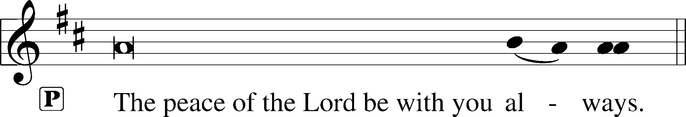


Agnus Dei John 1:29
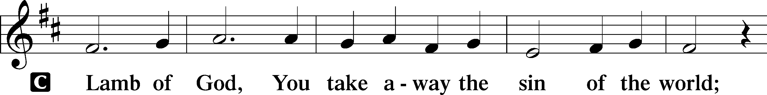
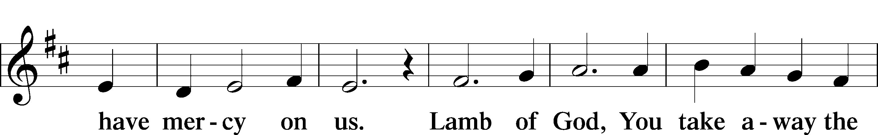
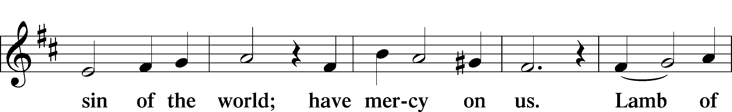
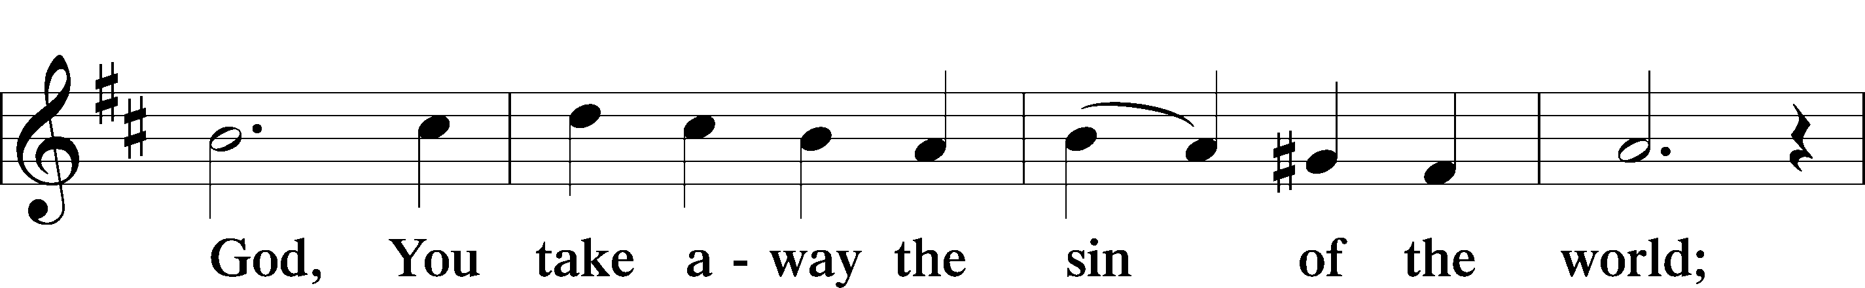
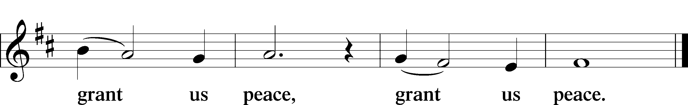

Please be seated

Distribution of the Sacrament
All who are members in good standing of the Lutheran Church - Missouri Synod and have introduced themselves to the pastor are welcome to partake of the Holy Communion at Christ Lutheran. If you have not spoken to the pastor, but would like to receive the Lord's blessing, you may still come to the rail and kneel, crossing one arm over the other in the shape of an 'X'. This symbolizes that one is marked by the cross and Triune name of Almighty God.

Distribution Hymns
Glory Be to Jesus #433

Please stand following distribution of communion

Nunc Dimittis Luke 2:29-32
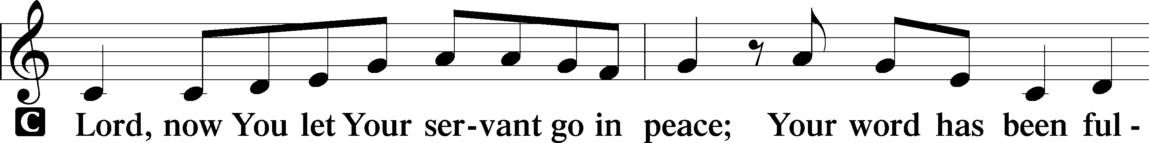
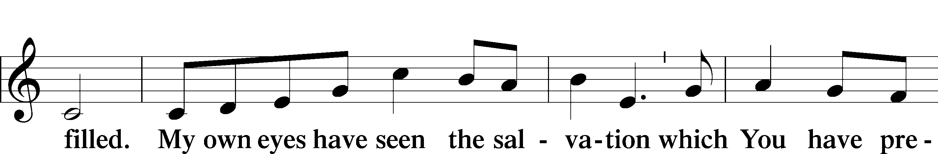
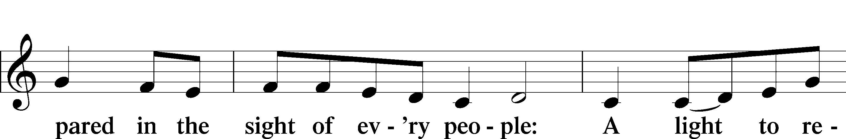
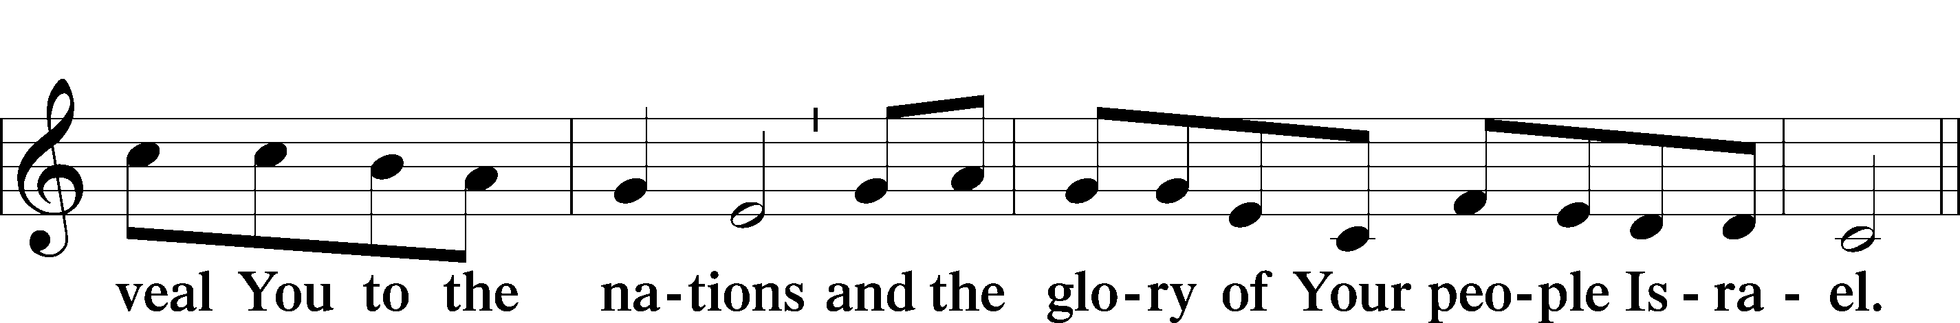
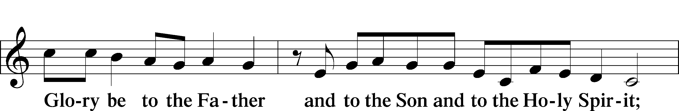
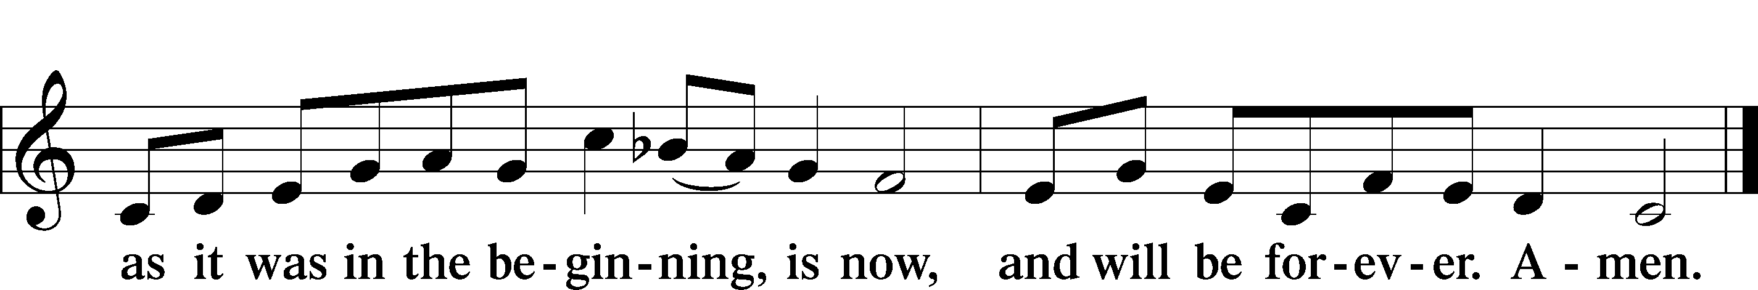

Post-Communion Collect
P We give thanks to You, almighty God, that You have refreshed us through this salutary gift, and we implore You that of Your mercy You would strengthen us through the same in faith toward You and fervent love toward one another; through Jesus Christ, Your Son, our Lord, who lives and reigns with You and the Holy Spirit, one God, now and forever.
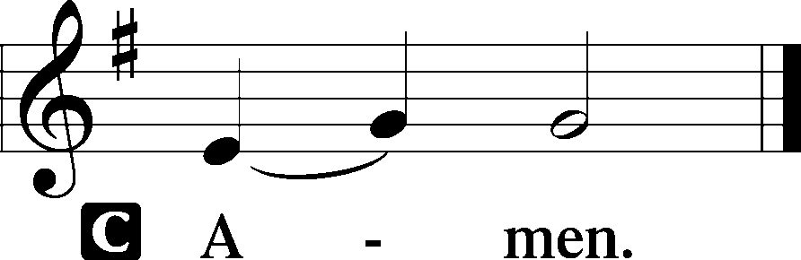
Benediction Numbers 6:24–26
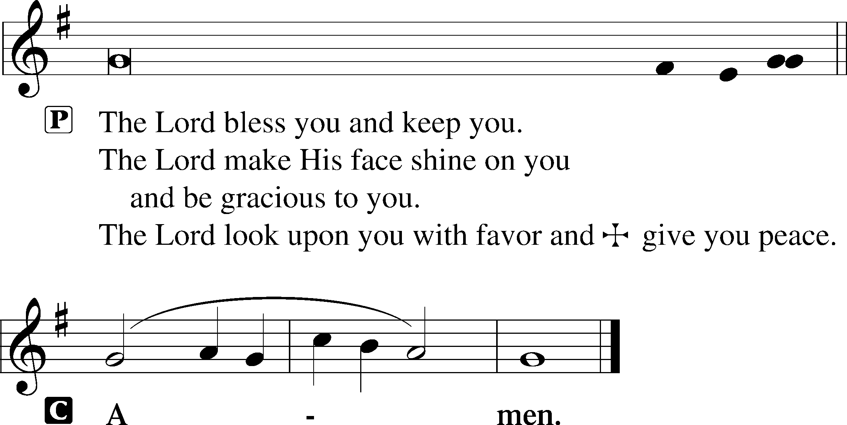

Closing Hymn O Lord, throughout These Forty Days #418

Acknowledgments
Divine Service, Setting Two from Lutheran Service Book © 2006 Concordia Publishing House. Reprinted with permission. Unless otherwise indicated, all scripture quotations are from The Holy Bible, English Standard Version, copyright © 2001 by Crossway Bibles, a division of Good News Publishers. Used by permission. All rights reserved. Created by Lutheran Service Builder © 2006 Concordia Publishing House.

Serving Today:
Celebrant: Rev. George Fields Lector: Gary Atchley
Acolyte: Emma Agent Organist: Sr. Sara Fields
Interpreter: Cathy Brown Cantor: Christopher Burkhalter
Ushers: Bruce Bodkin, Roger Fuhrer

Lenten Vespers: Join us throughout this penitential season as we gather weekly to meditate upon the Passion of Our Lord. Vespers will be held on Wednesday nights at 7:00 beginning February 24.

Lenten Dinners: Throughout our sojourn in Lent, we will gather at 6:00 p.m. on Wednesdays (beginning this week, February 24) for food and fellowship before weekly Vespers. Look for an email sign-up sheet from Sister Sara if you are interested in contributing food or helping with set-up/clean-up. Thank you!

Bible Study Returns! Finally, after almost a year of hiatus, Adult Sunday School will resume next week! To accommodate social distancing, we will meet in the sanctuary—and truly, what sanctuary it will be to dwell in the study of the Scriptures once more! Join us next Sunday at 9:15 a.m.!

Readings for next Sunday, February 28th, the Second Sunday in Lent:
Introit Ps. 115:11-13; Psalm 22:23-31; Genesis 17:1-16; Romans 5:1-11; Mark 8:27-38.

This week at Christ Lutheran Church: February 15 – February 21

Wednesday 6:00 p.m. Lenten Dinner
7:00 p.m. Lenten Vespers
Thursday 9:30 p.m. LifeLight: Ezekiel (Session 4)
Friday 6:30 a.m. Bible Study @ Christ Lutheran, Breakfast @ Broadstreet
Sunday 8:00 a.m. Divine Service (Mask-Only) – The Second Sunday in Lent
9:15 a.m. Sunday School for All Ages
10:30 a.m. Divine Service – The Second Sunday in Lent



YOUR LIFELINE TO THE LUTHERAN WORLDVIEW…You can listen to in-depth teachings on interesting subjects like:

SACRED MUSIC FOR THE SEASON OF LENT…“When I Survey the Wondrous Cross,” “In the Cross of Christ I Glory,” “My Song Is Love Unknown,” “A Lamb Goes Uncomplaining Forth,” and more…

Issues, Etc. is a radio talk show produced by Lutheran Public Radio and hosted by LCMS Pastor Todd Wilken. You can listen to what you want when you want at www.issuesetc.org. Simply click on “Listen”, choose “On Demand”, then select from the vast array of speakers and topics available in the archives.

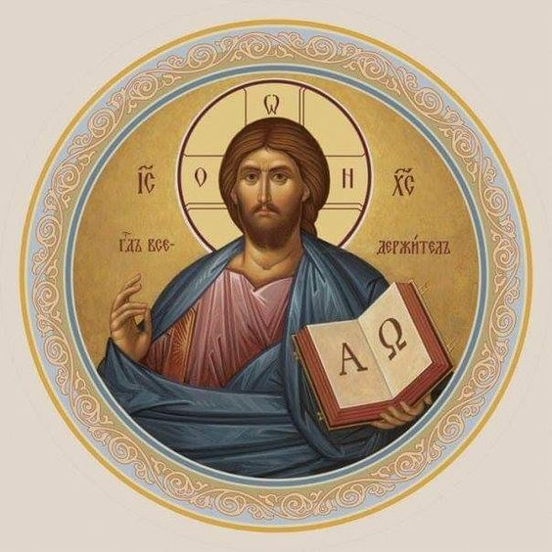

Matthew 26:26-29; Mark 14:22-25; Luke 22:14-20, 1 Corinthians 11:23
Matthew 26:28; 1 John 1:7; 1 Peter 1:18-19
1 Corinthians 11:28-32
1 Corinthians 10:17; 1 Corinthians 11:26

