Christ Lutheran Church




Rev. George Fields, Pastor
Sr. Sara Fields, Deaconess
Divine Service Each Week with Holy Communion: 10:30 a.m.
Sunday School for all ages: 9:15 a.m.
4423 I-55 North, Jackson, MS 39206-6102 – (601) 366-2055
www.christlutheranjacksonms.org

The Third Sunday after the Epiphany
+ January 24, 2021 +

Follow Me



We welcome our members and guests to Christ Lutheran today,
and pray God’s richest blessings upon you during this time of worship!

All members and our guests are asked to complete the
worship attendance pads which can be found on each pew.
Guests are also asked to sign the guest register found in the Narthex.
We are so glad to have you worshiping with us today!

LARGE PRINT worship folders are available
at the usher stand at the back of the nave.

WELCOME:
“Do you hesitate about your business and professions for the sake of your children and parents? It has been demonstrated to us in Scripture that any too dear relations, crafts and trades are to be quite left behind for the Lord’s sake. None of those whom the Lord chose to him said ‘I have no means to live.’”
– Tertullian, On Idolatry
The Lord’s Supper

In preparation for reception of the Lord’s Supper (Holy Communion), it is important that we review and understand what the Bible teaches regarding this sacrament:
The Bible teaches that Jesus gives us His very body and blood along with bread and wine in Holy Communion, and that these are means by which He forgives our sins, and strengthens us for daily living, and draws us into closer fellowship with Him and other believers. The Bible also teaches us to examine ourselves prior to receiving the meal. For those receiving Holy Communion, examine yourself with these questions:
Do I believe that I am a sinner and I am sorry for my sins?
Do I believe that Jesus Christ is God’s Son and my personal Savior?
Do I believe that Christ’s true body and blood are present in this holy meal for my forgiveness?
Do I truly intend with the help of God to correct my sinful life?
According to Christ’s Word in the Holy Scriptures, and in confession with the true Christian faith, at Christ Lutheran we observe the practice of closed communion. We believe that all who commune must confess the same holy faith, as Holy Scripture teaches. Since one’s church affiliation indicates an individual’s confession of faith, we ask that only those who have been instructed in the above teaching and are confirmed members of The Lutheran Church – Missouri Synod commune. If you have not been instructed in this teaching on Holy Communion, are in doubt, or hold a different confession of faith, you are still welcome to come forward and cross your arms to indicate that you would like a blessing.

Divine Service I

Preservice Music
The congregation may use this time for prayer and meditation.

Opening Hymn All Mankind Fell in Adam’s Fall #562

Confession & Absolution

The sign of the cross may be made by all in remembrance of their Baptism.

P In the name of the Father and of the T Son and of the Holy Spirit.
C Amen.

P If we say we have no sin, we deceive ourselves, and the truth is not in us.
C But if we confess our sins, God, who is faithful and just, will forgive our sins and cleanse us from all unrighteousness.
Silence for reflection on God's Word and for self-examination.
P Let us then confess our sins to God our Father.
C Most merciful God, we confess that we are by nature sinful and unclean. We have sinned against You in thought, word, and deed, by what we have done, and by what we have left undone. We have not loved You with our whole heart; we have not loved our neighbors as ourselves. We justly deserve Your present and eternal punishment. For the sake of Your Son, Jesus Christ, have mercy on us. Forgive us, renew us, and lead us, so that we may delight in Your will and walk in Your ways to the glory of Your holy name. Amen.
P Almighty God in His mercy has given His Son to die for you and forgives you all your sins. As a called and ordained servant of Christ, and by His authority, I therefore forgive you all your sins in the name of the Father and of the T the Son, and of the Holy Spirit.
C Amen.

Service of the Word

Introit: Laudate, pueri Psalm 113:1-2, 4, 7-8; Ant. Psalm 113:3
From the rising of the sun to its | setting,*
the name of the Lord is | to be praised!
Praise the Lord! Praise, O servants | of the Lord,*
praise the name | of the Lord!
Blessèd be the name | of the Lord*
from this time forth and for- | evermore!
The Lord is high above all | nations,*
and his glory above the | heavens!
He raises the poor | from the dust*
and lifts the needy from the | ash heap,
to make them sit with | princes,*
with the princes of his | people.
Glory be to the Father and | to the Son*
and to the Holy | Spirit;
as it was in the be- | ginning,*
is now, and will be forever. | Amen.
From the rising of the sun to its | setting,*
the name of the Lord is | to be praised!

Kyrie Mark 10:47

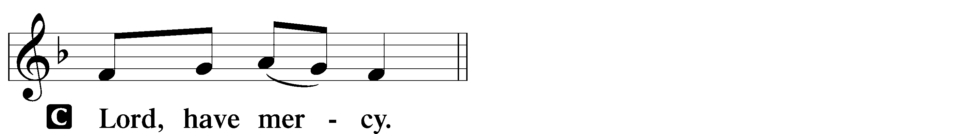
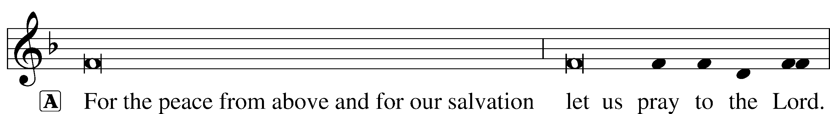


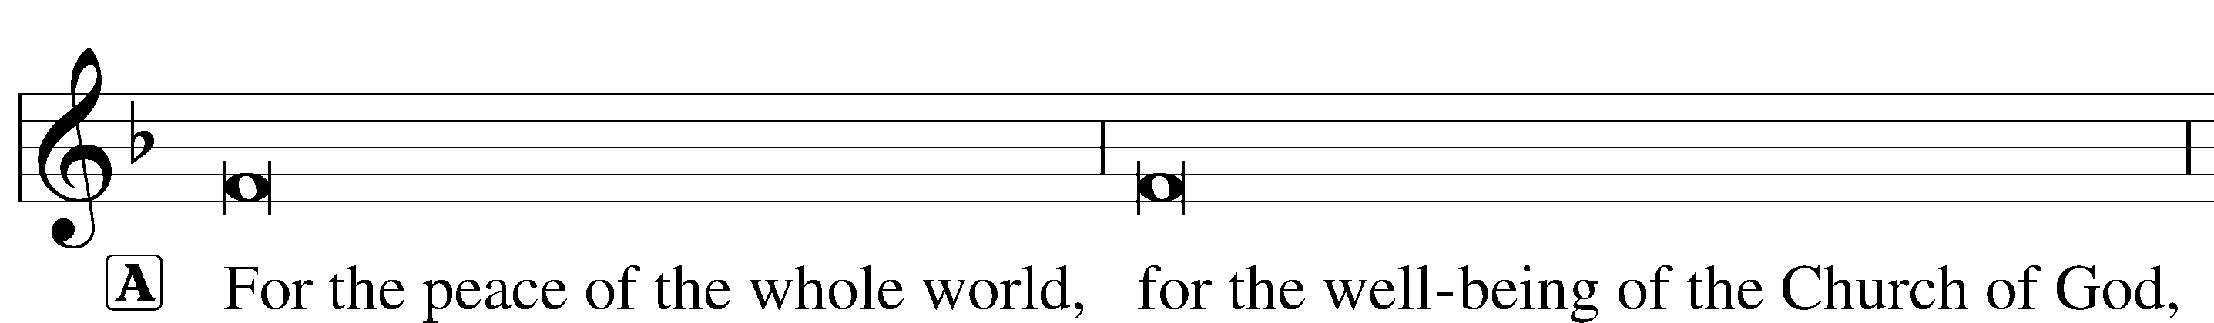


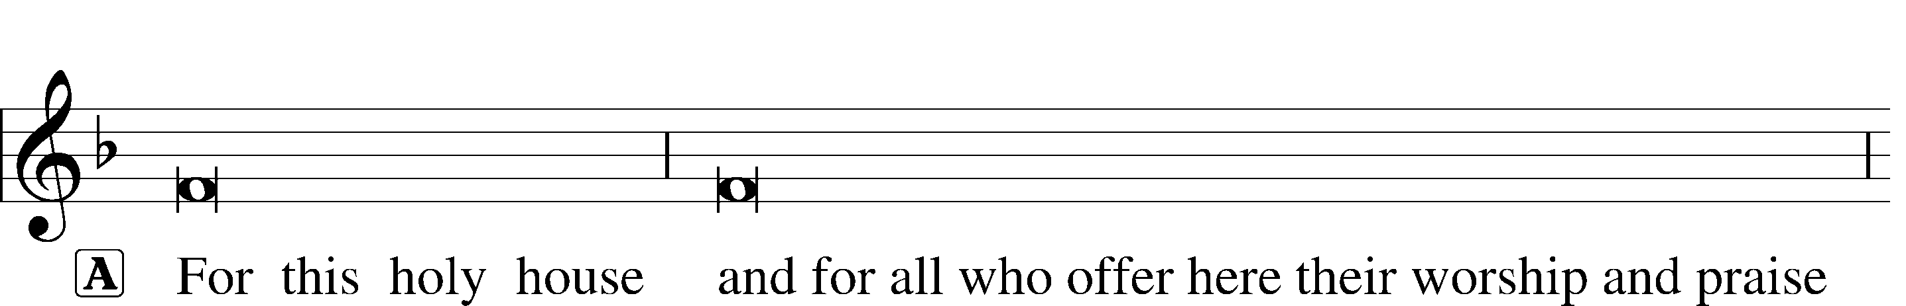

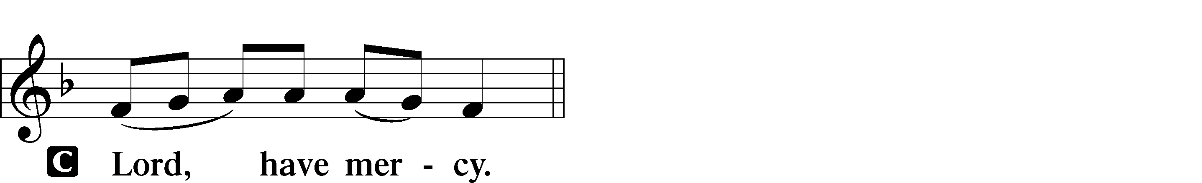
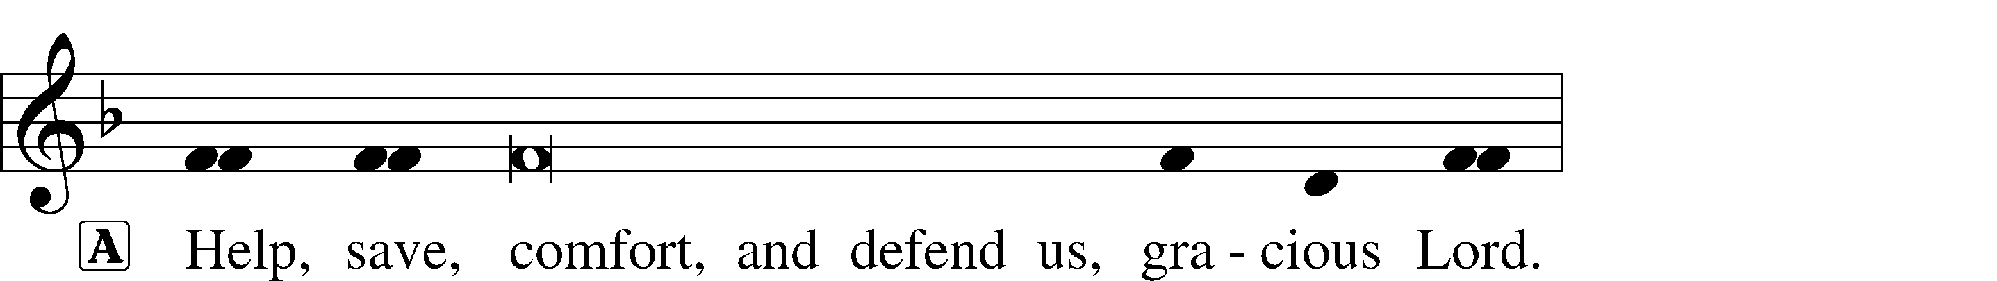

Gloria in Excelsis Luke 2:14; John 1:29
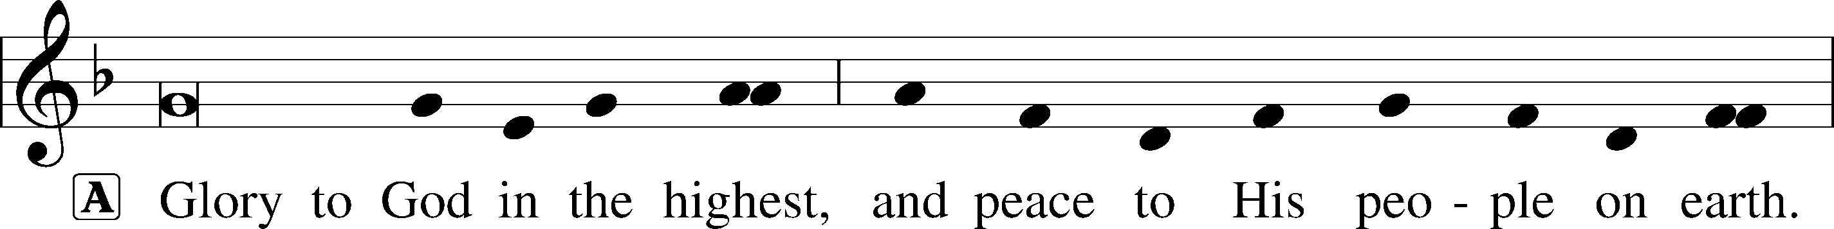
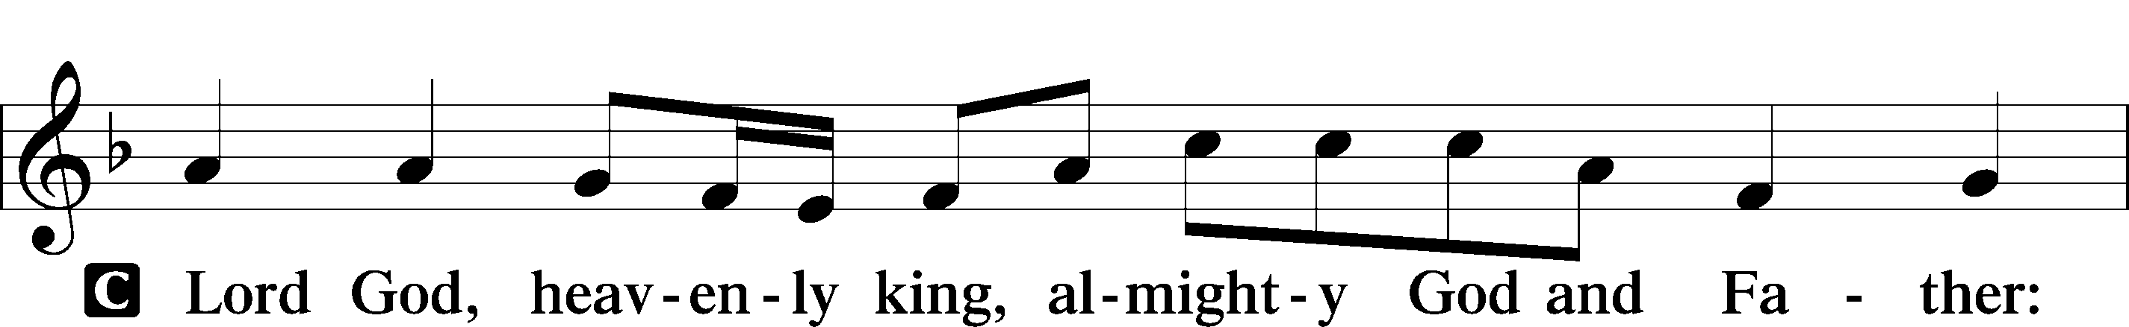
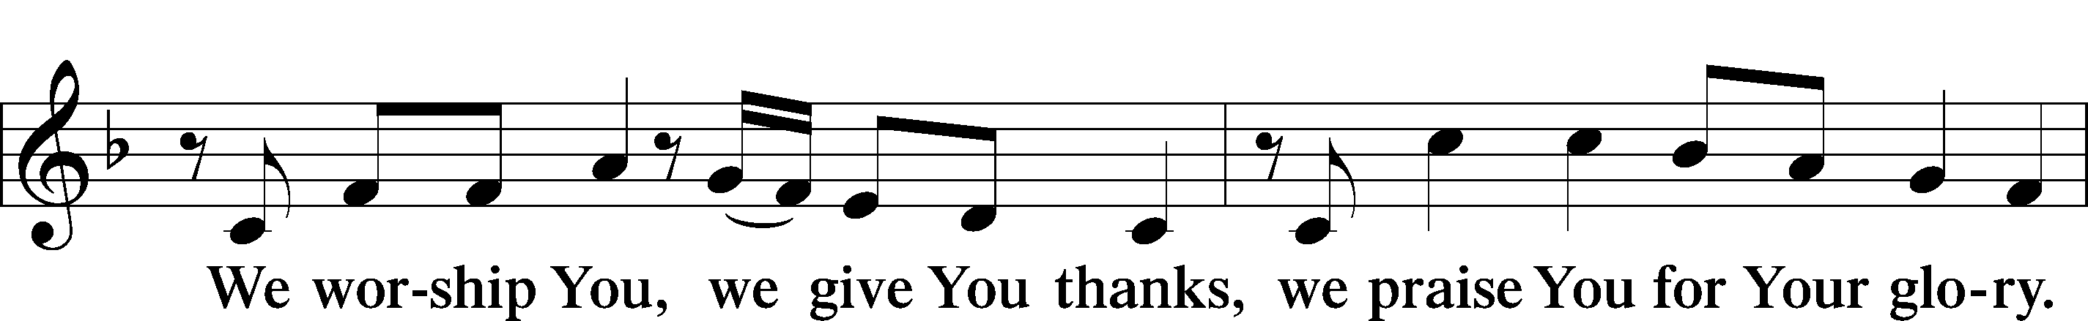
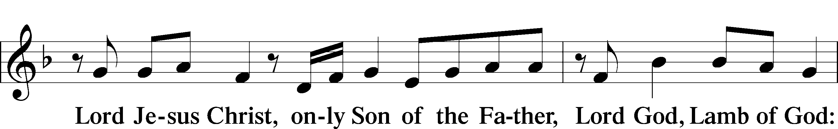
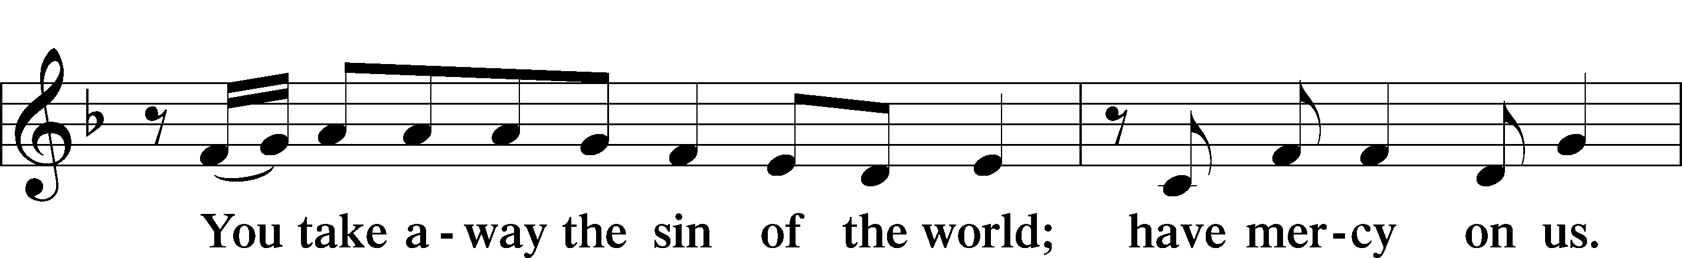
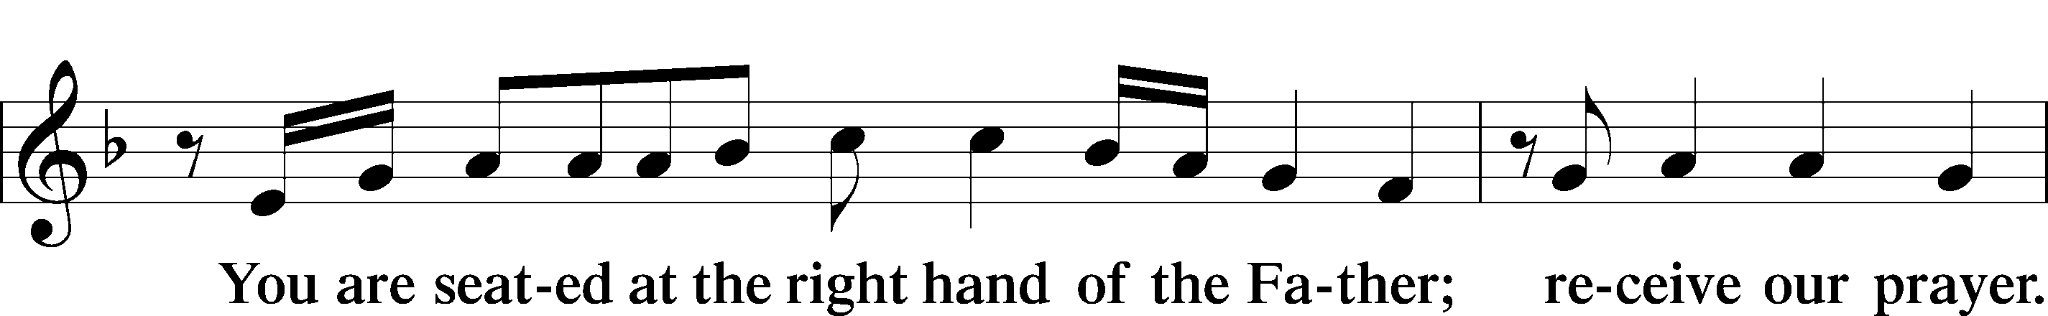
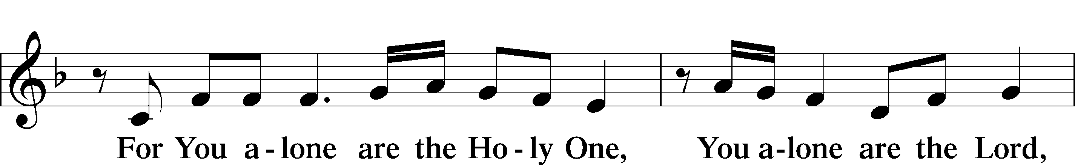
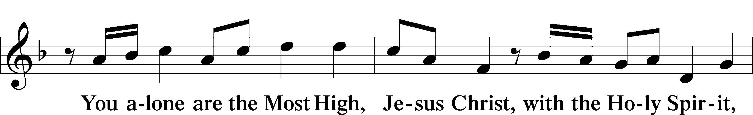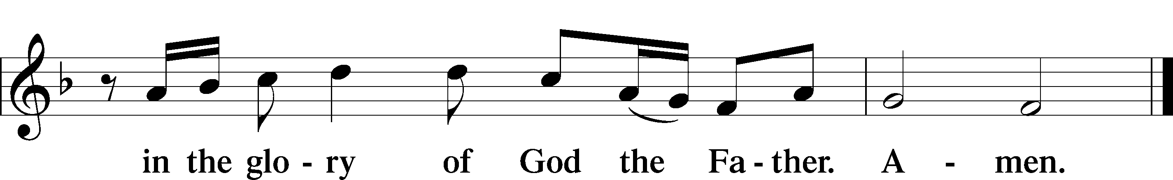

Salutation and Collect of the Day

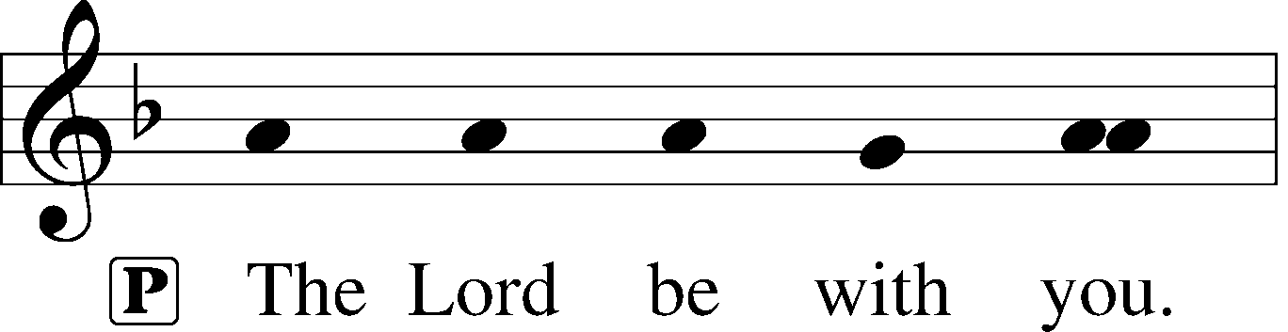
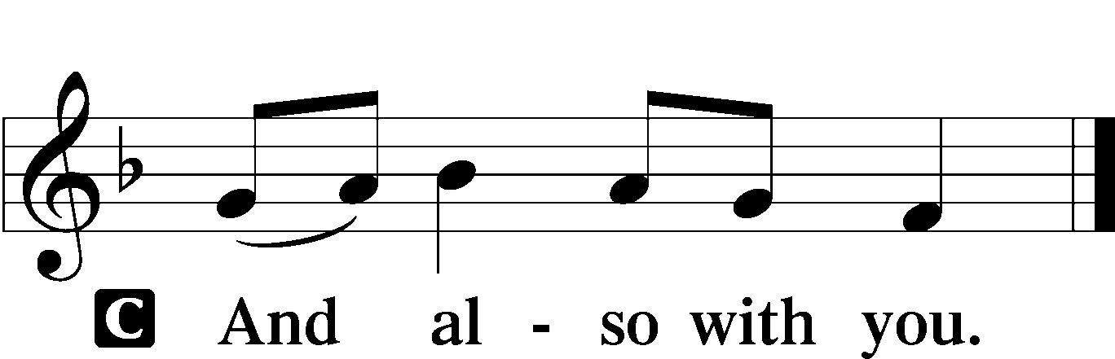

P Let us pray.
Almighty and everlasting God, mercifully look upon our infirmities and stretch forth the hand of Your majesty to heal and defend us; through Jesus Christ, Your Son, our Lord, who lives and reigns with You and the Holy Spirit, one God, now and forever.
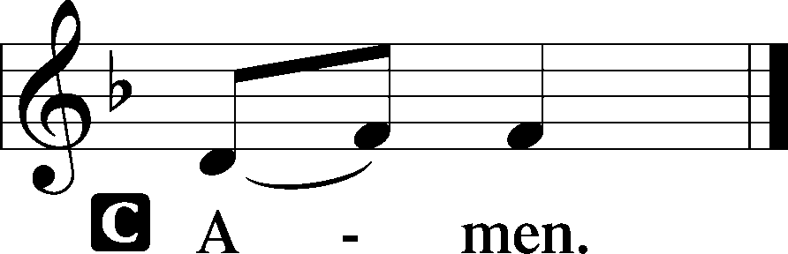

Please be seated

Old Testament Jonah 3:1-5, 10
Then the word of the Lord came to Jonah the second time, saying, “Arise, go to Nineveh, that great city, and call out against it the message that I tell you.” So Jonah arose and went to Nineveh, according to the word of the Lord. Now Nineveh was an exceedingly great city, three days’ journey in breadth. Jonah began to go into the city, going a day’s journey. And he called out, “Yet forty days, and Nineveh shall be overthrown!” And the people of Nineveh believed God. They called for a fast and put on sackcloth, from the greatest of them to the least of them.
When God saw what they did, how they turned from their evil way, God relented of the disaster that he had said he would do to them, and he did not do it.
A This is the Word of the Lord.
C Thanks be to God.

Gradual Psalm 117:1-2; 96:8
Praise the Lord, all | nations!*
Extol him, all | peoples!
For great is his steadfast | love toward us,*
and the faithfulness of the Lord endures for- | ever.
Ascribe to the Lord the glory | due his name;*
bring an offering, and come in- | to his courts!

Epistle 1 Corinthians 7:29-31
This is what I mean, brothers: the appointed time has grown very short. From now on, let those who have wives live as though they had none, and those who mourn as though they were not mourning, and those who rejoice as though they were not rejoicing, and those who buy as though they had no goods, and those who deal with the world as though they had no dealings with it. For the present form of this world is passing away.
A This is the Word of the Lord.
C Thanks be to God.

Please stand

Alleluia
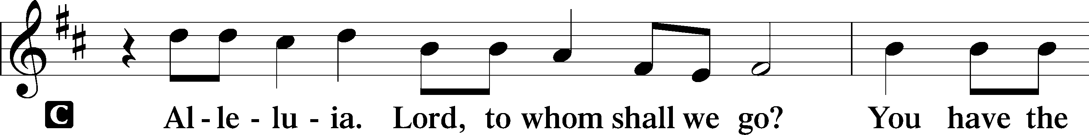
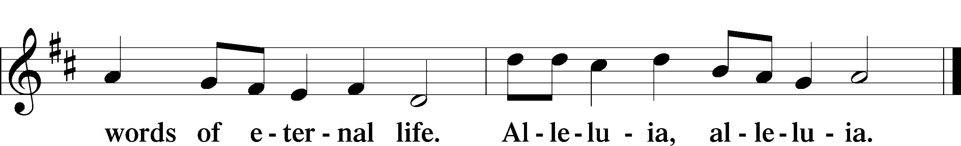

Holy Gospel Mark 1:14-20

P The Holy T Gospel according to St. Mark, the first chapter.

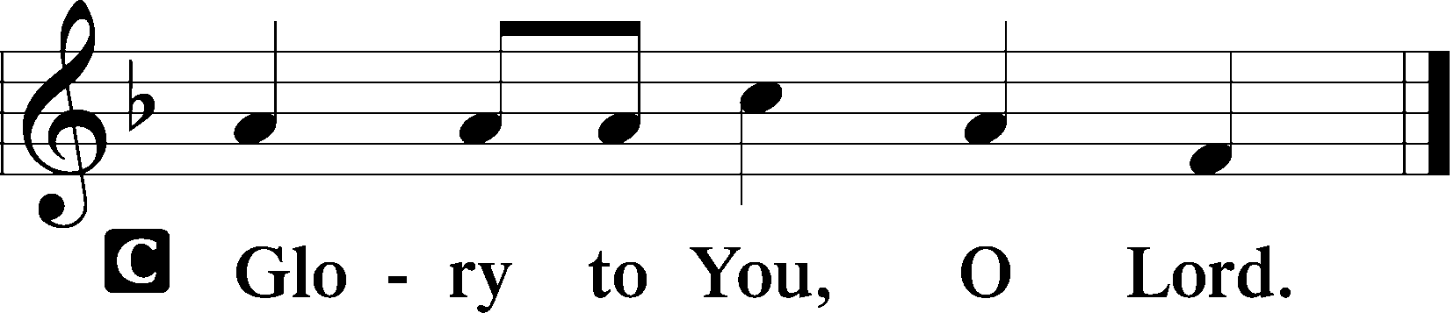
Now after John was arrested, Jesus came into Galilee, proclaiming the gospel of God, and saying, “The time is fulfilled, and the kingdom of God is at hand; repent and believe in the gospel.”
Passing alongside the Sea of Galilee, he saw Simon and Andrew the brother of Simon casting a net into the sea, for they were fishermen. And Jesus said to them, “Follow me, and I will make you become fishers of men.” And immediately they left their nets and followed him. And going on a little farther, he saw James the son of Zebedee and John his brother, who were in their boat mending the nets. And immediately he called them, and they left their father Zebedee in the boat with the hired servants and followed him.
P This is the Gospel of the Lord.
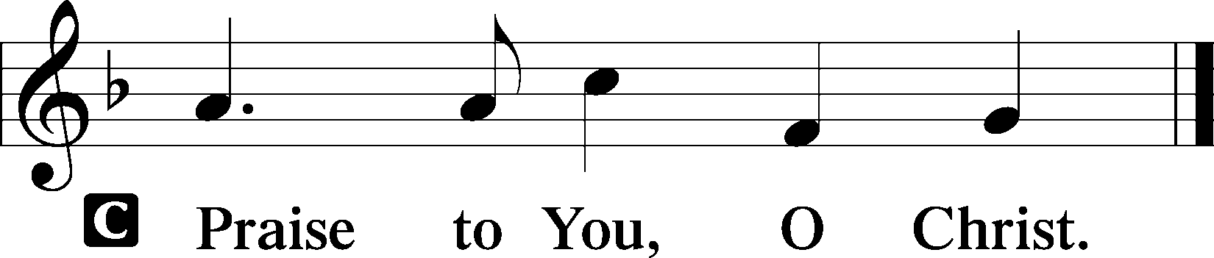

Please be seated

Office Hymn Lord ’Tis Not That I Did Choose Thee #573

Sermon The Father of Us All

Please stand

Nicene Creed

C I believe in one God, (Rom 10:10; Deut 6:4)
the Father Almighty, (Mt 6:9; Ex 6:3)
maker of heaven and earth (Gen 1:1; Jn 1:1)
and of all things visible and invisible. (Col 1:16)
And in one Lord Jesus Christ, (Rom 10:9)
the only-begotten Son of God, (Jn 3:16; Mt 16:16)
begotten of His Father before all worlds, (Jn 1:2)
God of God, Light of Light, (Jn 17:22; Jn 8:12; Jn 1:1)
very God of very God, (Col 2:9) begotten, not made, (Jn 1:2)
being of one substance with the Father, (Jn 10:30)
by whom all things were made; (Heb 1:2; Jn 1:3)
who for us men and for our salvation (1 Tim 2:4; Rom 3:23)
came down from heaven (Jn 6:41; Lk 15:20)
and was incarnate by the Holy Spirit of the virgin Mary (Lk 1:34-35)
and was made man; (Jn 1:14)
and was crucified also for us under Pontius Pilate. (Mk 15:25; Jn 19:16-18)
He suffered and was buried. (Jn 19:1-3; Lk 23:53)
And the third day He rose again according to the Scriptures (1 Cor 15:4; Lk 24:6)
and ascended into heaven (Acts 1:9)
and sits at the right hand of the Father. (Acts 7:55)
And He will come again with glory (Mt 26:64)
to judge both the living and the dead, (Acts 10:42; Mt 3:12)
whose kingdom will have no end. (2 Pt 1:11)
And I believe in the Holy Spirit, (Jn 14:26; Gen 1:2; Acts 2:38)
the Lord and giver of life, (Gen 1:2; Jn 3:6)
who proceeds from the Father and the Son, (Jn 15:26)
who with the Father and the Son together is worshiped and glorified, (Mt 3:16-17)
who spoke by the prophets. (Eze 11:5)
And I believe in one holy Christian and apostolic Church, (1 Pt 2:5; Eph 2:19-22)
I acknowledge one Baptism for the remission of sins, (Eph 4:5)
and I look for the resurrection of the dead (1 Cor 15:35-49; 1 Thess 4:13-18)
and the life T of the world to come. (Mk 10:29-30; Mt 10:40-42)
Amen. (Ps 106:48)
Us men means all people.
Christian: the ancient text reads “catholic,” meaning the whole Church as it confesses the wholeness of Christian doctrine
Prayer of the Church
After each petition of the prayer:
Pastor: Let us pray to the Lord.
People: Lord, have mercy.
For comfort, health and recovery: Brian Atchley, Julia Brackett, Bert Caraway, Debbie Caraway, Cindy Kates, Peggy Lucky, Katie and Baby Rudsenske, Jean Sprecher, Paul Sprecher, Rod Sprecher;
For those who mourn: The Family and Friends of Doug Manton;
For those who are ill or distressed: Stan Acey, Jenalee Adams, Layne Bagley, Rose Bagley, Shirley Bagley, W.L. Bagley, Sarah Bowman, Mimi Bradley, Richard Bradley, Deloris Brent, Martha Brown, Nathan Brown, Tina Burke, Wayne Burke, Paula Burkhalter, Bobby Carroll, Arthur Collins, James E. Cookston, Joan Cowards, Belinda Cowards-Gonzales, Robert (Andy) Evers, Michele Rae Fowler, Randy Fowler, Parker Haines, Dan Hansen, Paul Hansen, Tim Hansen, Valerie Henderson, Sharon Holleman, Beth Jarratt, Elaine Johnson, Joslyn Jones, Steve Kennedy, Arlene Kleinschmidt, John Koster, Sandra Landers, Katelyn Lawing, Peggy Lucky, Paul McCullough, Jerry McIntyre, Jerry McMahan, Edlia Miller, Elaine Monaghan, Lindberg Moore, Jerry Mutter, Don Ochs, Mildred Odom, Deborah-Annette Ried, Elmira Roever, Jon Sandberg, Noah Schultz, Johnnie Pearl Smiley, Bob Smith, Sam Schneider, Sherri Smith, Deborah Springer, MariLyn Unger, Betty Venator, Leonard Watson, Dana Weaver, Cynthia Widlitze, Carol Wright, Jimmy Wright, Marshall Wright, Barbara Zeigler;
For college and graduate students: Sara Fields, Jonathan Kettler, Roselynn Nelson, Will Nelson;
For military servants and their families: Gabriel Escude, James (Glen) Hansford, Holden Hathcock, Christopher Martin, William Nelson, Steven Tatum, John Weidner Jr.;
For foreign missionaries: especially those serving in Spain;
This week’s prayer family: Leonard Watson and his loved ones.

Please be seated

Offering

Please stand

Offertory Psalm 116:12-13, 17-19
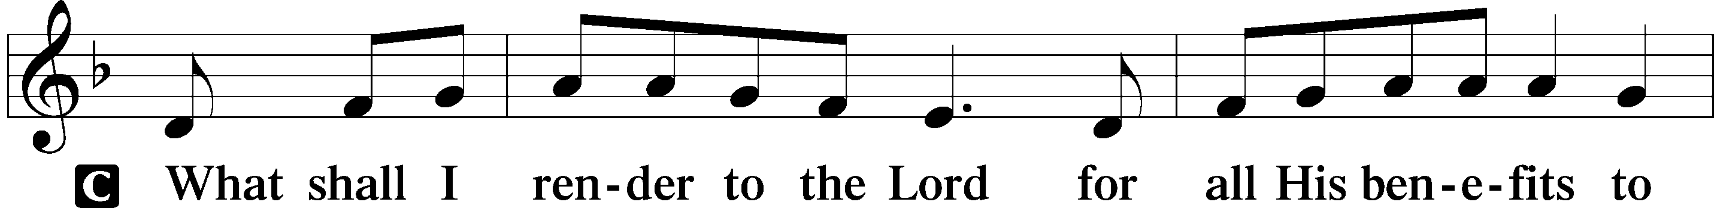
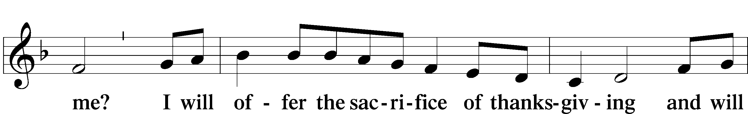
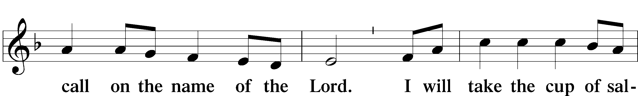
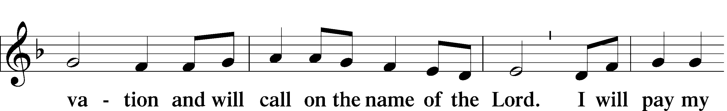

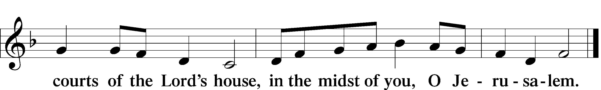
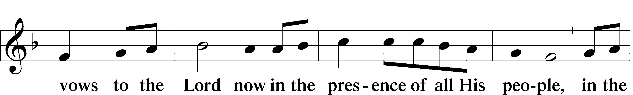

Service of the Sacrament

Preface 2 Timothy 4:22; [Colossians 3:1]; [Psalm 136]





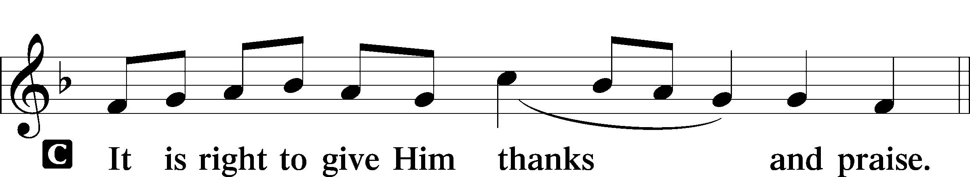

P It is truly good, right, and salutary that we should at all times and in all places give thanks to You, holy Lord, almighty Father, everlasting God, through Jesus Christ, our Lord; for what had been hidden from before the foundation of the world You have made known to the nations in Your Son. In Him, being found in the substance of our mortal nature, You have manifested the fullness of Your glory. Therefore with angels and archangels and with all the company of heaven we laud and magnify Your glorious name, evermore praising You and saying:

Sanctus Isaiah 6:3; Matthew 21:9
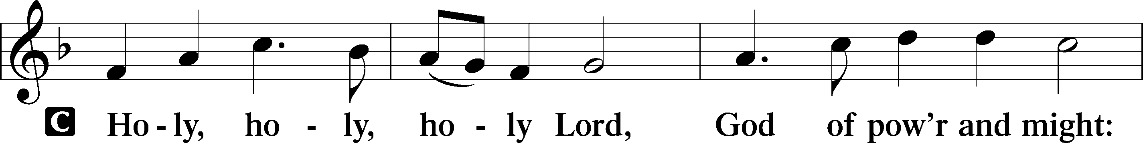
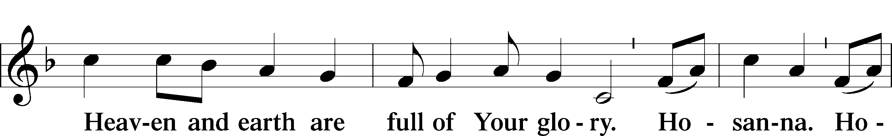
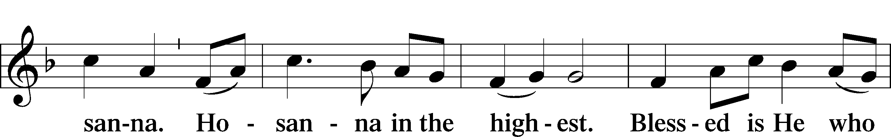
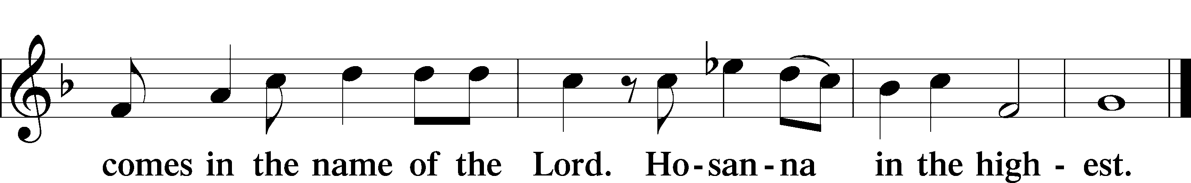

P Blessed are You, Lord of heaven and earth, for You have had mercy on those whom You created and sent Your only-begotten Son into our flesh to bear our sin and be our Savior. With repentant joy we receive the salvation accomplished for us by the all-availing sacrifice of His body and His blood on the cross.
Gathered in the name and the remembrance of Jesus, we beg You, O Lord, to forgive, renew, and strengthen us with Your Word and Spirit. Grant us faithfully to eat His body and drink His blood as He bids us do in His own testament. Gather us together, we pray, from the ends of the earth to celebrate with all the faithful the marriage feast of the Lamb in His kingdom, which has no end. Graciously receive our prayers; deliver and preserve us. To You alone, O Father, be all glory, honor, and worship, with the Son and the Holy Spirit, one God, now and forever.

Lord’s Prayer Matthew 6:9-13
P Lord, remember us in Your kingdom and teach us to pray:
C Our Father who art in heaven,
Hallowed be Thy name,
Thy kingdom come,
Thy will be done on earth as it is in heaven;
Give us this day our daily bread;
And forgive us our trespasses as we forgive those who trespass against us;
And lead us not into temptation,
But deliver T us from evil.
For Thine is the kingdom and the power and the glory forever and ever. Amen.

The Words of Our Lord Matthew 26:26–28
P Our Lord Jesus Christ, on the night when He was betrayed, took bread, and when He had given thanks, He broke it and gave it to the disciples and said: “Take, eat; this is My T body, which is given for you. This do in remembrance of Me.”
In the same way also He took the cup after supper, and when He had given thanks, He gave it to them, saying: “Drink of it, all of you; this cup is the new testament in My T blood, which is shed for you for the forgiveness of sins. This do, as often as you drink it, in remembrance of Me.”

Pax Domini John 20:19
P The peace T of the Lord be with you always.


Agnus Dei John 1:29
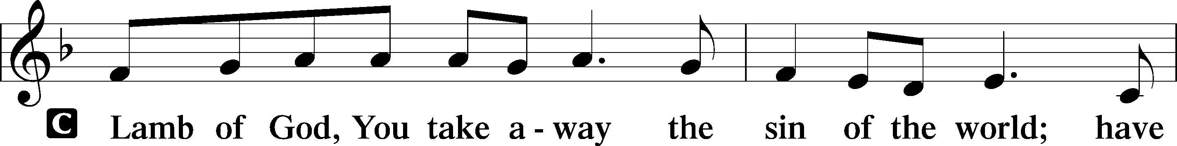
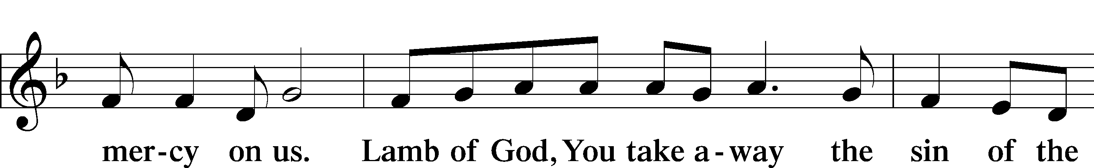
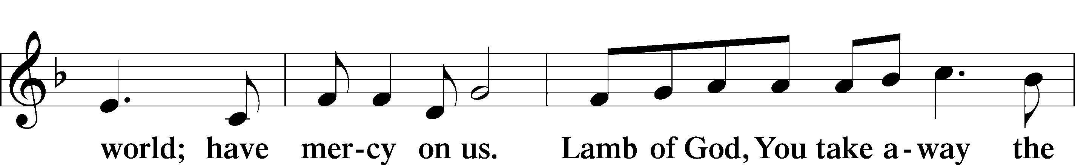
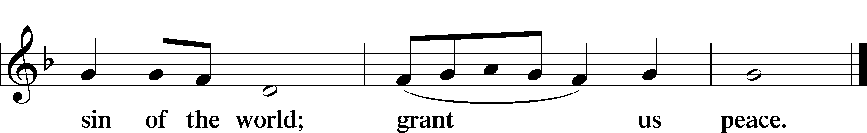
Please be seated

Distribution of the Sacrament
All who are members in good standing of the Lutheran Church - Missouri Synod and have introduced themselves to the pastor are welcome to partake of the Holy Communion at Christ Lutheran. If you have not spoken to the pastor, but would like to receive the Lord's blessing, you may still come to the rail and kneel, crossing one arm over the other in the shape of an 'X'. This symbolizes that one is marked by the cross and Triune name of Almighty God.

Distribution Hymns
Water, Blood, and Spirit Crying #597

Please stand following distribution of communion

Nunc Dimittis Luke 2:29-32
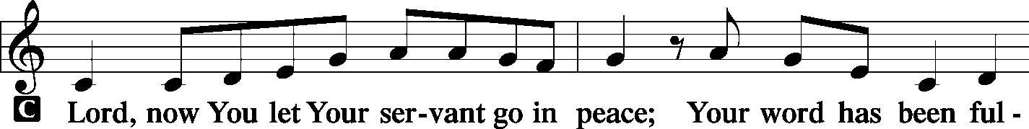
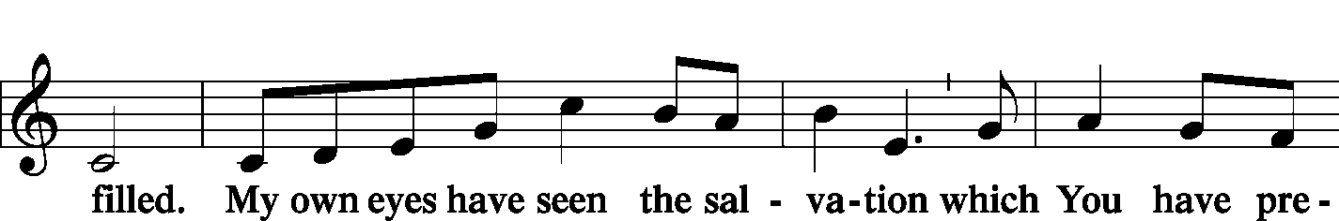
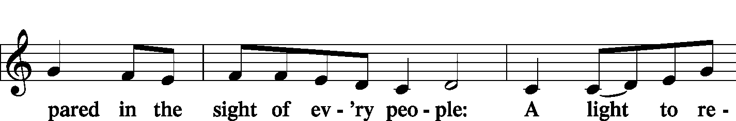
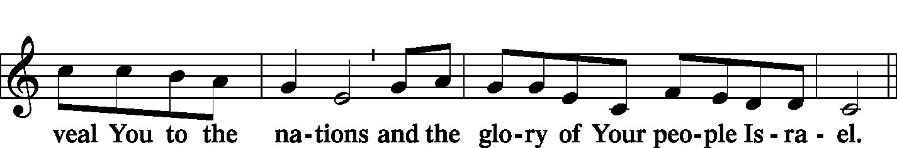
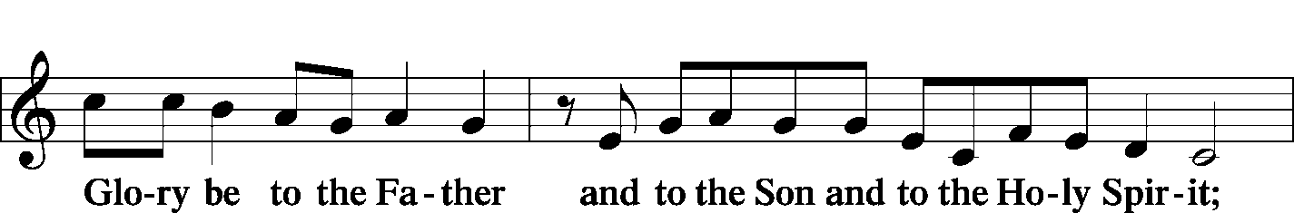
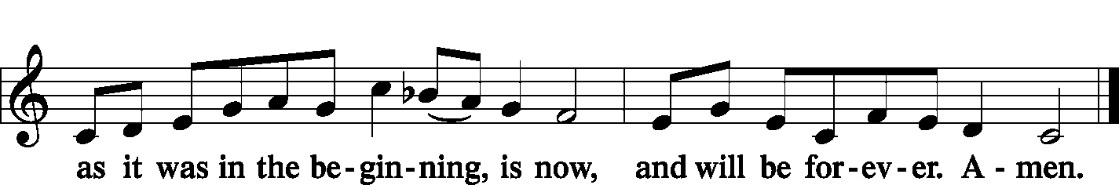

Post-Communion Collect
A Let us pray.
O God the Father, the fountain and source of all goodness, who in loving-kindness sent Your only-begotten Son into the flesh, we thank You that for His sake You have given us pardon and peace in this Sacrament, and we ask You not to forsake Your children but always to rule our hearts and minds by Your Holy Spirit that we may be enabled constantly to serve You; through Jesus Christ, Your Son, our Lord, who lives and reigns with You and the Holy Spirit, one God, now and forever.


Benediction Numbers 6:24–26
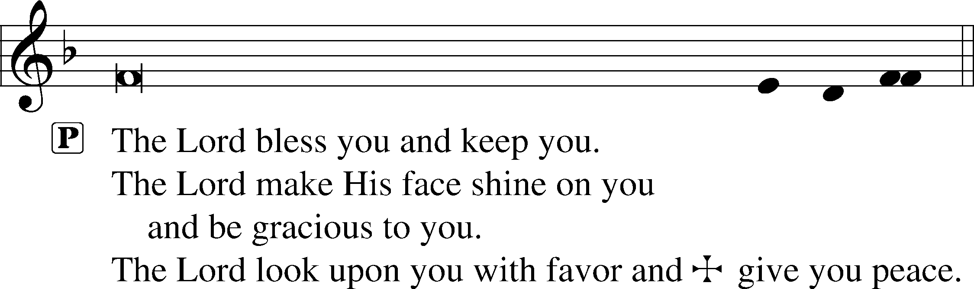

Closing Hymn Christ is the World’s Redeemer #539

Acknowledgments
Divine Service, Setting One from Lutheran Service Book © 2006 Concordia Publishing House. Reprinted with permission. Unless otherwise indicated, all scripture quotations are from The Holy Bible, English Standard Version, copyright © 2001 by Crossway Bibles, a division of Good News Publishers. Used by permission. All rights reserved. Created by Lutheran Service Builder © 2006 Concordia Publishing House. Psalm Antiphon setting by Jeffrey Blersch, used by permission of Liturgy Solutions.

Serving Today:
Celebrant: Rev. George Fields Lector: Eric Held, Keith Martin
Cantor: Chris Burkhalter Organist: Sr. Sara Fields
Interpreter: Denee Smith Ushers: Allen Goodlett, Mark Ochs; Gary Atchley

Altar Flowers: This morning’s altar flowers are given for the glory of God by the Burkhalter Family in celebration of MariLynn Fuhrer’s birthday.

Special Voters Meeting: A special Voters Assembly will convene in two identical sessions next Sunday, January 31st (each session after 8:00 and 10:30 Divine Service, respectively; votes from both meetings will be tallied together as one). We will be voting to adjust Pastor Fields’ call to this congregation from “associate” pastor to “sole” pastor, as well as approving the delay of the Synod and districts’ conventions until 2022 due to the lingering conditions of the pandemic this year. Thank you for your faithful attendance to this task!

Koinonia Next Sunday: It has been many a month, but we are finally back to studying together! Next Sunday at 5:00 p.m., we will jog our memories and dive back into The Screwtape Letters, by C.S. Lewis. Join us at the Fields home for delightful dinner and discussion!

LifeLight This Week: Divine visions, multi-headed creatures, the throne room of God… yes, we are about to start studying the book of Ezekiel! This Thursday, January 28 (at 9:30 a.m.), we reconvene our LifeLight study to begin this new and admittedly strange book. Join us for the adventure – and don’t worry, we’ll have coffee!

Readings for next Sunday, January 31st, the Fourth Sunday after Epiphany:
Introit Ps. 32:1-7; Psalm 111; Deuteronomy 18:15-20; 1 Corinthians 8:1-13; Mark 1:21-28.

This week at Christ Lutheran Church: January 25 – January 31

Thursday 9:30 p.m. LifeLight: Ezekiel (Session 1)
Friday 6:30 a.m. Bible Study @ Christ Lutheran, Breakfast @ Broadstreet
Sunday 8:00 a.m. Divine Service (Mask-Only) – The Fourth Sunday after Epiphany
9:00 a.m. Voters Meeting (Mask-Only)
9:15 a.m. Children’s Sunday School
10:30 a.m. Divine Service – The Fourth Sunday after Epiphany
9:00 a.m. Voters Meeting
5:00 p.m. Koinonia


YOUR LIFELINE TO THE LUTHERAN WORLDVIEW…You can listen to in-depth teachings on interesting subjects like:

The Conversion of Paul, The Book of Revelation, The New Testament Manuscripts, The Need for a Global Children’s’ Rights Movement, Discussing Social Issues with Progressives, and more…

Issues, Etc. is a radio talk show produced by Lutheran Public Radio and hosted by LCMS Pastor Todd Wilken. You can listen to what you want when you want at www.issuesetc.org. Simply click on “Listen”, choose “On Demand”, then select from the vast array of speakers and topics available in the archives.

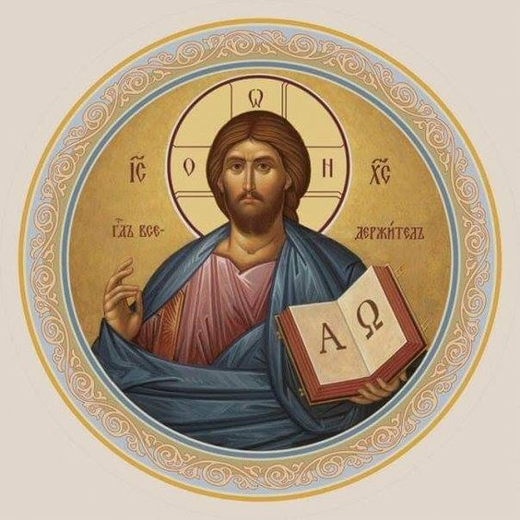

Christ Lutheran Church
The Lutheran Church—Missouri Synod
4423 I-55 North, Jackson, MS 39206-6102
Church phone: (601) 366-2055
www.ChristLutheranJacksonMS.org

Matthew 26:26-29; Mark 14:22-25; Luke 22:14-20, 1 Corinthians 11:23
Matthew 26:28; 1 John 1:7; 1 Peter 1:18-19
1 Corinthians 11:28-32
1 Corinthians 10:17; 1 Corinthians 11:26

