Christ Lutheran Church




Rev. George Fields, Pastor
Sr. Sara Fields, Deaconess
Divine Service Each Week with Holy Communion: 10:30 a.m.
Sunday School for all ages: 9:15 a.m.
4423 I-55 North, Jackson, MS 39206-6102 – (601) 366-2055
www.christlutheranjacksonms.org

The Second Sunday of Christmas
+ January 3, 2021 +

“I Must Be in My Father’s House”



We welcome our members and guests to Christ Lutheran today,
and pray God’s richest blessings upon you during this time of worship!

All members and our guests are asked to complete the
worship attendance pads which can be found on each pew.
Guests are also asked to sign the guest register found in the Narthex.
We are so glad to have you worshiping with us today!

LARGE PRINT worship folders are available
at the usher stand at the back of the nave.

WELCOME:
“The beginning of the Lord’s disputation is taken from His twelfth year. This number of the evangelists was intended for the preaching of the faith. Nor is it idly that, forgetful of His parents according to the flesh, He who according to the flesh assuredly was filled with the wisdom and grace of God is found after three days in the temple. It is a sign that He who was believed dead for our faith would rise again after three days from His triumphal passion and appear on His heavenly throne with divine honor.”
– St. Ambrose of Milan, Exposition of the Gospel of Luke
The Lord’s Supper

In preparation for reception of the Lord’s Supper (Holy Communion), it is important that we review and understand what the Bible teaches regarding this sacrament:
The Bible teaches that Jesus gives us His very body and blood along with bread and wine in Holy Communion, and that these are means by which He forgives our sins, and strengthens us for daily living, and draws us into closer fellowship with Him and other believers. The Bible also teaches us to examine ourselves prior to receiving the meal. For those receiving Holy Communion, examine yourself with these questions:
Do I believe that I am a sinner and I am sorry for my sins?
Do I believe that Jesus Christ is God’s Son and my personal Savior?
Do I believe that Christ’s true body and blood are present in this holy meal for my forgiveness?
Do I truly intend with the help of God to correct my sinful life?
According to Christ’s Word in the Holy Scriptures, and in confession with the true Christian faith, at Christ Lutheran we observe the practice of closed communion. We believe that all who commune must confess the same holy faith, as Holy Scripture teaches. Since one’s church affiliation indicates an individual’s confession of faith, we ask that only those who have been instructed in the above teaching and are confirmed members of The Lutheran Church – Missouri Synod commune. If you have not been instructed in this teaching on Holy Communion, are in doubt, or hold a different confession of faith, you are still welcome to come forward and cross your arms to indicate that you would like a blessing.

Divine Service I

Preservice Music
The congregation may use this time for prayer and meditation.

Opening Hymn Not All the Blood of Beasts #431

Confession & Absolution

The sign of the cross may be made by all in remembrance of their Baptism.

P In the name of the Father and of the T Son and of the Holy Spirit.
C Amen.

P If we say we have no sin, we deceive ourselves, and the truth is not in us.
C But if we confess our sins, God, who is faithful and just, will forgive our sins and cleanse us from all unrighteousness.
Silence for reflection on God's Word and for self-examination.
P Let us then confess our sins to God our Father.
C Most merciful God, we confess that we are by nature sinful and unclean. We have sinned against You in thought, word, and deed, by what we have done, and by what we have left undone. We have not loved You with our whole heart; we have not loved our neighbors as ourselves. We justly deserve Your present and eternal punishment. For the sake of Your Son, Jesus Christ, have mercy on us. Forgive us, renew us, and lead us, so that we may delight in Your will and walk in Your ways to the glory of Your holy name. Amen.
P Almighty God in His mercy has given His Son to die for you and forgives you all your sins. As a called and ordained servant of Christ, and by His authority, I therefore forgive you all your sins in the name of the Father and of the T the Son, and of the Holy Spirit.
C Amen.

Service of the Word

Introit: Laudate Dominum Psalm 147:1, 5, 11-12; Ant. John 1:14
The Word became flesh and dwelt among us, and we have seen his | glory,*
glory as of the only Son from the Father, full of | grace and truth.
Praise the Lord! For it is good to sing praises | to our God;*
for it is pleasant, and a song of praise is | fitting.
Great is our Lord, and abun- | dant in power;*
his understanding is beyond | measure.
But the Lord takes pleasure in those who | fear him,*
in those who hope in his | steadfast love.
Praise the Lord, O Je- | rusalem!*
Praise your God, O | Zion!
Glory be to the Father and | to the Son*
and to the Holy | Spirit;
as it was in the be- | ginning,*
is now, and will be forever. | Amen.
The Word became flesh and dwelt among us, and we have seen his | glory,*
glory as of the only Son from the Father, full of | grace and truth.

Kyrie Mark 10:47


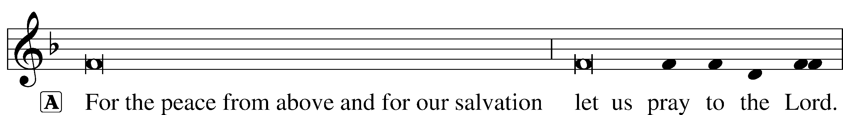


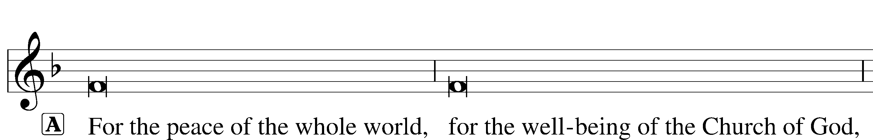


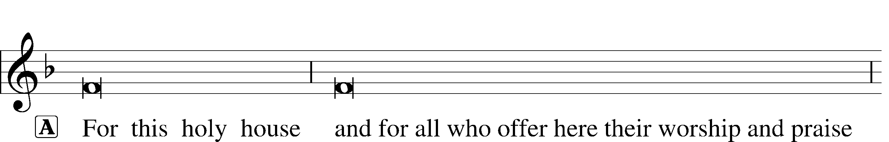


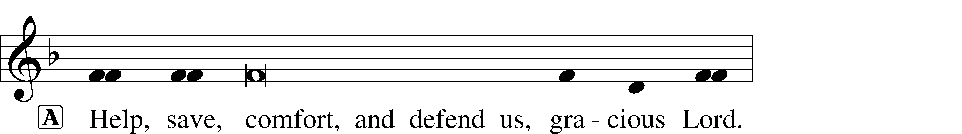

Gloria in Excelsis Luke 2:14; John 1:29
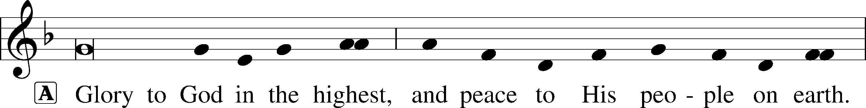
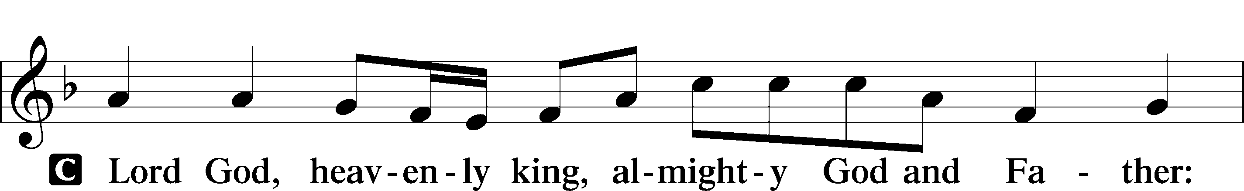
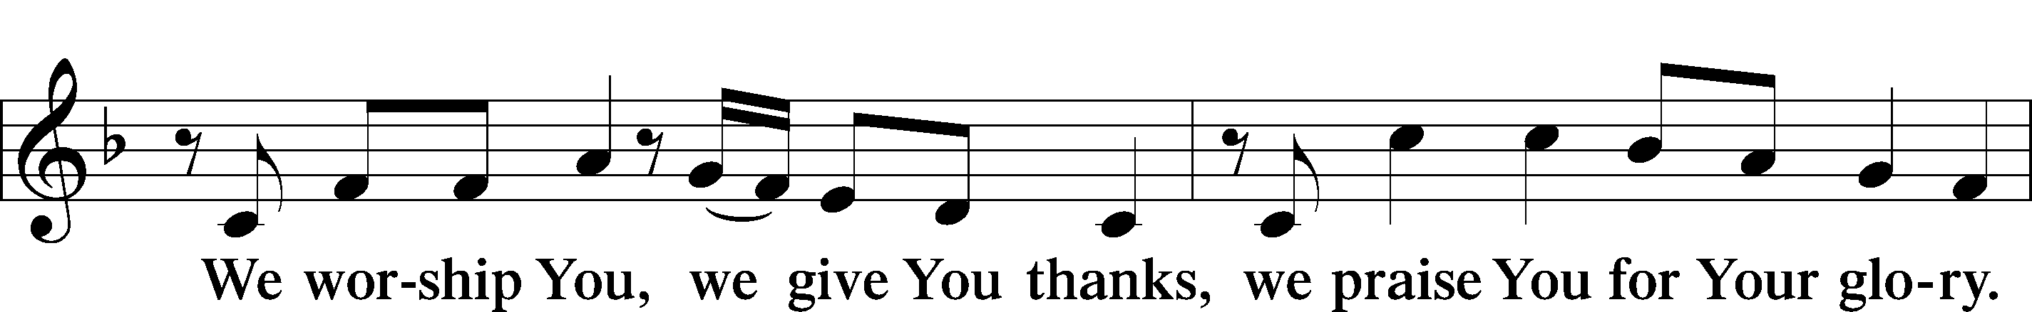
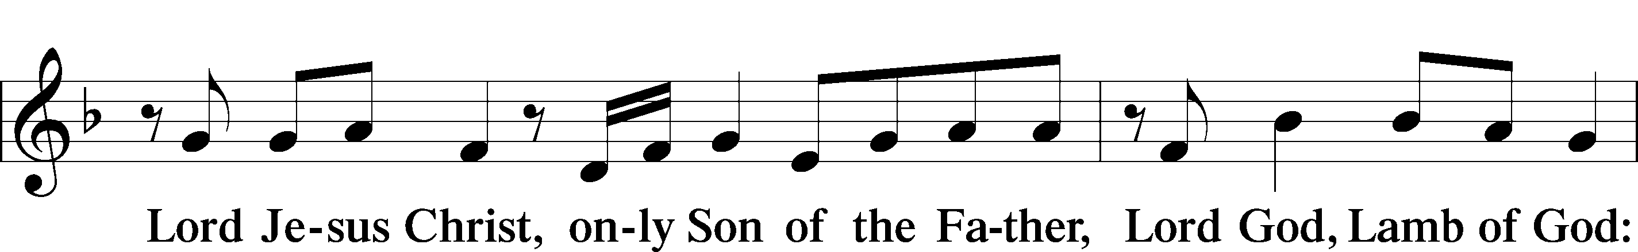
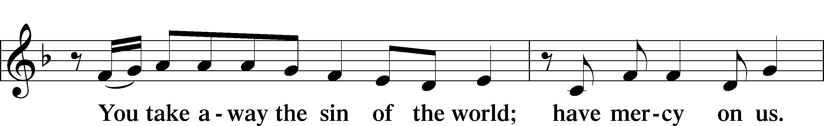
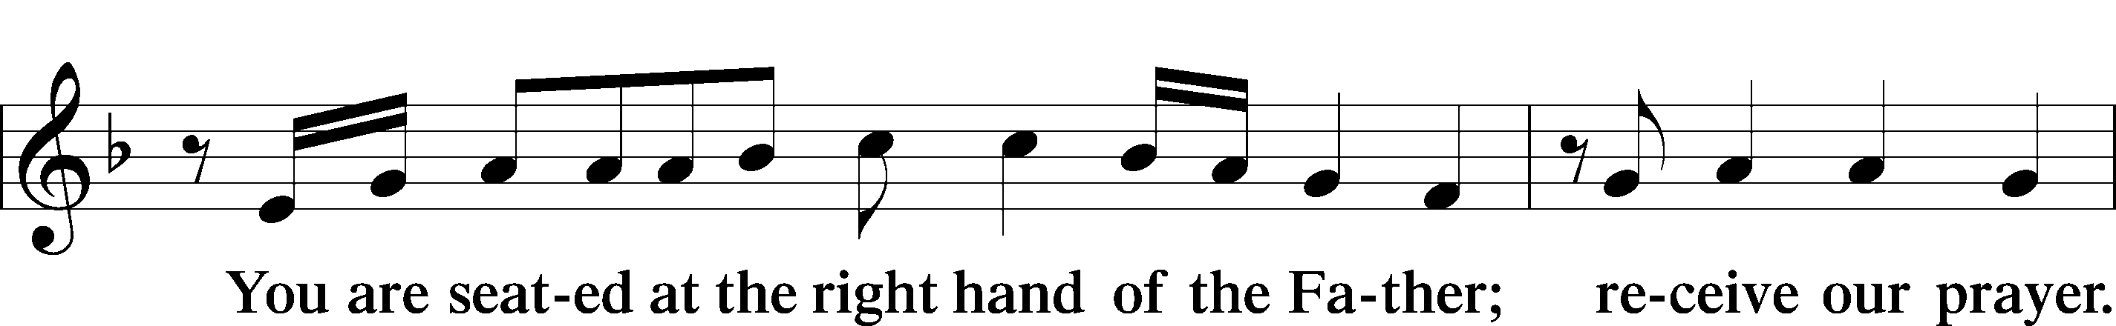
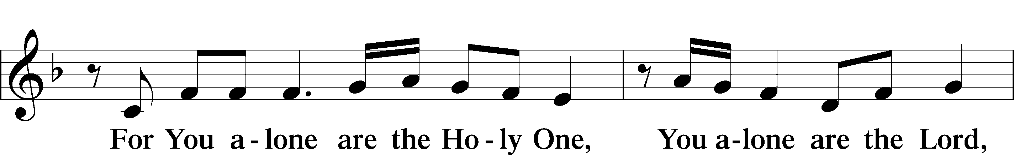
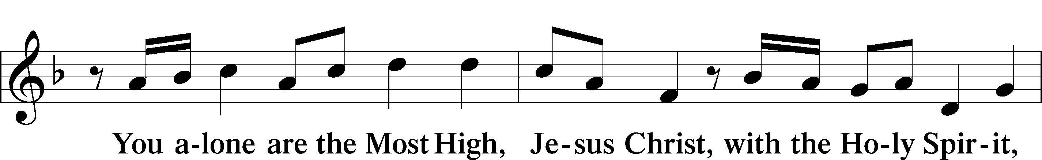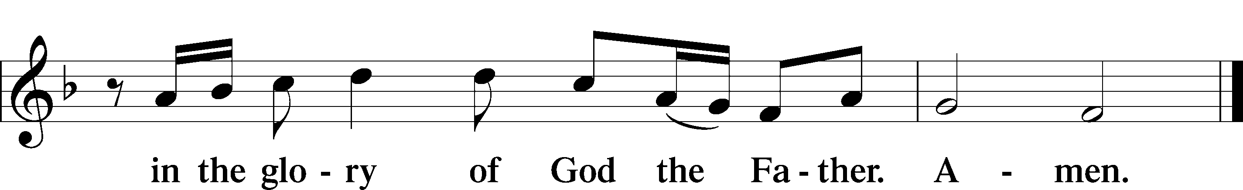
Salutation and Collect of the Day

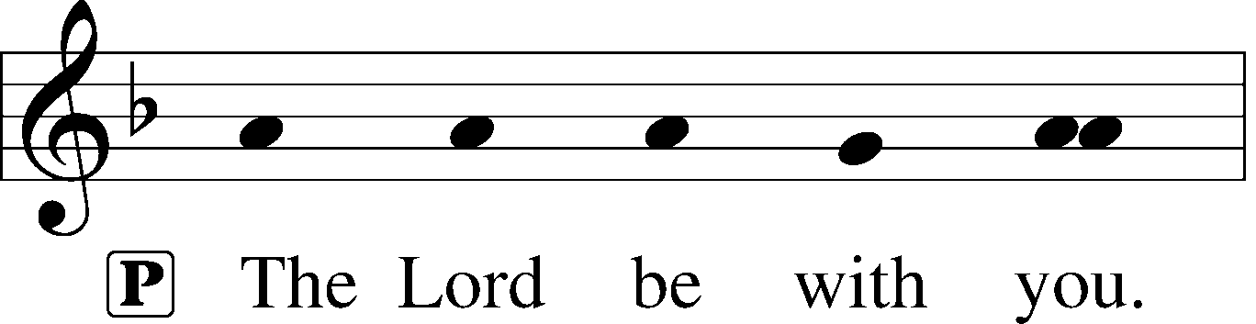
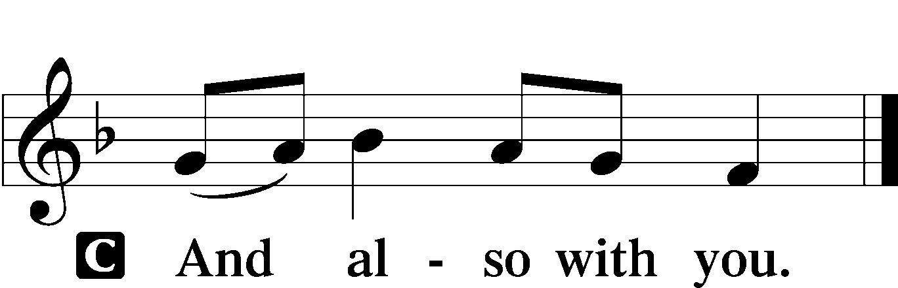

P Let us pray.
Almighty God, You have poured into our hearts the true Light of Your incarnate Word. Grant that this Light may shine forth in our lives; through the same Jesus Christ, Your Son, our Lord, who lives and reigns with You and the Holy Spirit, one God, now and forever.

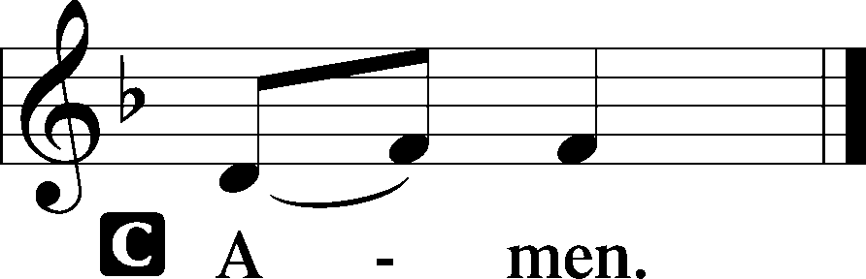

Please be seated

Old Testament 1 Kings 3:4-15
The king went to Gibeon to sacrifice there, for that was the great high place. Solomon used to offer a thousand burnt offerings on that altar.
At Gibeon the Lord appeared to Solomon in a dream by night, and God said, “Ask what I shall give you.” And Solomon said, “You have shown great and steadfast love to your servant David my father, because he walked before you in faithfulness, in righteousness, and in uprightness of heart toward you. And you have kept for him this great and steadfast love and have given him a son to sit on his throne this day. And now, O Lord my God, you have made your servant king in place of David my father, although I am but a little child. I do not know how to go out or come in. And your servant is in the midst of your people whom you have chosen, a great people, too many to be numbered or counted for multitude. Give your servant therefore an understanding mind to govern your people, that I may discern between good and evil, for who is able to govern this your great people?”
It pleased the Lord that Solomon had asked this. And God said to him, “Because you have asked this, and have not asked for yourself long life or riches or the life of your enemies, but have asked for yourself understanding to discern what is right, behold, I now do according to your word. Behold, I give you a wise and discerning mind, so that none like you has been before you and none like you shall arise after you. I give you also what you have not asked, both riches and honor, so that no other king shall compare with you, all your days. And if you will walk in my ways, keeping my statutes and my commandments, as your father David walked, then I will lengthen your days.”
And Solomon awoke, and behold, it was a dream. Then he came to Jerusalem and stood before the ark of the covenant of the Lord, and offered up burnt offerings and peace offerings, and made a feast for all his servants.
A This is the Word of the Lord.
C Thanks be to God.

Gradual Zech. 9:9; Ps. 118:26
To us a child is born, to us a son is | given;*
and the government shall be upon his | shoulder.
And his name shall be called Wonderful Counselor, | Mighty God,*
Everlasting Father, | Prince of Peace.
Sing to the Lord a | new song,*
for he has done | marvelous things!

Epistle Ephesians 1:3-14
Blessed be the God and Father of our Lord Jesus Christ, who has blessed us in Christ with every spiritual blessing in the heavenly places, even as he chose us in him before the foundation of the world, that we should be holy and blameless before him. In love he predestined us for adoption through Jesus Christ, according to the purpose of his will, to the praise of his glorious grace, with which he has blessed us in the Beloved. In him we have redemption through his blood, the forgiveness of our trespasses, according to the riches of his grace, which he lavished upon us, in all wisdom and insight making known to us the mystery of his will, according to his purpose, which he set forth in Christ as a plan for the fullness of time, to unite all things in him, things in heaven and things on earth.
In him we have obtained an inheritance, having been predestined according to the purpose of him who works all things according to the counsel of his will, so that we who were the first to hope in Christ might be to the praise of his glory. In him you also, when you heard the word of truth, the gospel of your salvation, and believed in him, were sealed with the promised Holy Spirit, who is the guarantee of our inheritance until we acquire possession of it, to the praise of his glory.
A This is the Word of the Lord.
C Thanks be to God.

Please stand

Alleluia
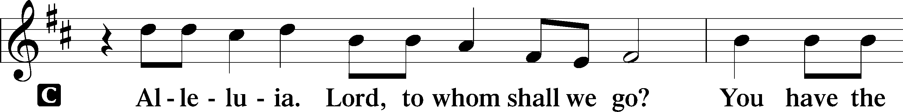
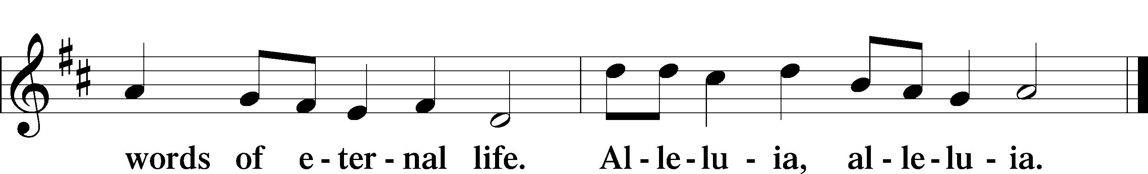

Holy Gospel Luke 2:40-52

P The Holy T Gospel according to St. Luke, the second chapter.

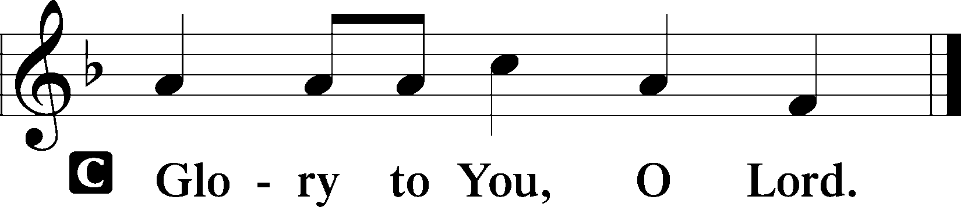
And the child grew and became strong, filled with wisdom. And the favor of God was upon him.
Now his parents went to Jerusalem every year at the Feast of the Passover. And when he was twelve years old, they went up according to custom. And when the feast was ended, as they were returning, the boy Jesus stayed behind in Jerusalem. His parents did not know it, but supposing him to be in the group they went a day’s journey, but then they began to search for him among their relatives and acquaintances, and when they did not find him, they returned to Jerusalem, searching for him. After three days they found him in the temple, sitting among the teachers, listening to them and asking them questions. And all who heard him were amazed at his understanding and his answers. And when his parents saw him, they were astonished. And his mother said to him, “Son, why have you treated us so? Behold, your father and I have been searching for you in great distress.” And he said to them, “Why were you looking for me? Did you not know that I must be in my Father’s house?” And they did not understand the saying that he spoke to them. And he went down with them and came to Nazareth and was submissive to them. And his mother treasured up all these things in her heart.
And Jesus increased in wisdom and in stature and in favor with God and man.
P This is the Gospel of the Lord.
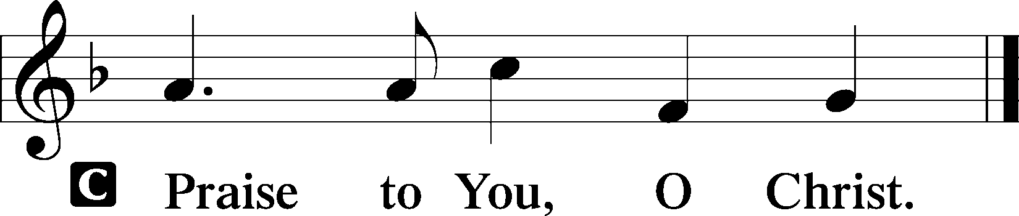

Please be seated

Office Hymn What Child Is This #370

Sermon The Only Sacrifice

Please stand

Nicene Creed

C I believe in one God, (Rom 10:10; Deut 6:4)
the Father Almighty, (Mt 6:9; Ex 6:3)
maker of heaven and earth (Gen 1:1; Jn 1:1)
and of all things visible and invisible. (Col 1:16)
And in one Lord Jesus Christ, (Rom 10:9)
the only-begotten Son of God, (Jn 3:16; Mt 16:16)
begotten of His Father before all worlds, (Jn 1:2)
God of God, Light of Light, (Jn 17:22; Jn 8:12; Jn 1:1)
very God of very God, (Col 2:9) begotten, not made, (Jn 1:2)
being of one substance with the Father, (Jn 10:30)
by whom all things were made; (Heb 1:2; Jn 1:3)
who for us men and for our salvation (1 Tim 2:4; Rom 3:23)
came down from heaven (Jn 6:41; Lk 15:20)
and was incarnate by the Holy Spirit of the virgin Mary (Lk 1:34-35)
and was made man; (Jn 1:14)
and was crucified also for us under Pontius Pilate. (Mk 15:25; Jn 19:16-18)
He suffered and was buried. (Jn 19:1-3; Lk 23:53)
And the third day He rose again according to the Scriptures (1 Cor 15:4; Lk 24:6)
and ascended into heaven (Acts 1:9)
and sits at the right hand of the Father. (Acts 7:55)
And He will come again with glory (Mt 26:64)
to judge both the living and the dead, (Acts 10:42; Mt 3:12)
whose kingdom will have no end. (2 Pt 1:11)
And I believe in the Holy Spirit, (Jn 14:26; Gen 1:2; Acts 2:38)
the Lord and giver of life, (Gen 1:2; Jn 3:6)
who proceeds from the Father and the Son, (Jn 15:26)
who with the Father and the Son together is worshiped and glorified, (Mt 3:16-17)
who spoke by the prophets. (Eze 11:5)
And I believe in one holy Christian and apostolic Church, (1 Pt 2:5; Eph 2:19-22)
I acknowledge one Baptism for the remission of sins, (Eph 4:5)
and I look for the resurrection of the dead (1 Cor 15:35-49; 1 Thess 4:13-18)
and the life T of the world to come. (Mk 10:29-30; Mt 10:40-42)
Amen. (Ps 106:48)
Us men means all people.
Christian: the ancient text reads “catholic,” meaning the whole Church as it confesses the wholeness of Christian doctrine

Prayer of the Church
After each petition of the prayer:
Pastor: Lord, in Your mercy,
People: Hear our prayer.
For comfort, health and recovery: Greg Collins, Joan Cowards, Slade Exley, Glen Hansford, Eleanor Koster, Bob Pedersen, Elmira Roever, Jane Rudsenske, Dana Weaver;
For those who mourn: The family and friends of Michael Avenmarg, Steve Michalovic;
For those who are ill or distressed: Stan Acey, Jenalee Adams, Layne Bagley, Rose Bagley, Shirley Bagley, W.L. Bagley, Sarah Bowman, Mimi Bradley, Richard Bradley, Deloris Brent, Martha Brown, Nathan Brown, Tina Burke, Wayne Burke, Paula Burkhalter, Bobby Carroll, Arthur Collins, James E. Cookston, Joan Cowards, Belinda Cowards-Gonzales, Robert (Andy) Evers, Michele Rae Fowler, Randy Fowler, Parker Haines, Dan Hansen, Paul Hansen, Tim Hansen, Valerie Henderson, Sharon Holleman, Beth Jarratt, Elaine Johnson, Joslyn Jones, Steve Kennedy, Arlene Kleinschmidt, Eleanor Koster, John Koster, Sandra Landers, Katelyn Lawing, Peggy Lucky, Paul McCullough, Jerry McIntyre, Jerry McMahan, Edlia Miller, Elaine Monaghan, Lindberg Moore, Jerry Mutter, Don Ochs, Mildred Odom, Deborah-Annette Ried, Elmira Roever, Jon Sandberg, Noah Schultz, Johnnie Pearl Smiley, Bob Smith, Sam Schneider, Sherri Smith, Deborah Springer, MariLyn Unger, Betty Venator, Leonard Watson, Cynthia Widlitze, Carol Wright, Jimmy Wright, Marshall Wright, Barbara Zeigler;
For college and graduate students: Jake Everly, Sara Fields, Jonathan Kettler, Roselynn Nelson, Will Nelson;
For military servants and their families: Gabriel Escude, James (Glen) Hansford, Holden Hathcock, Christopher Martin, William Nelson, Steven Tatum, John Weidner Jr.;
For foreign missionaries: especially those serving in Spain;
This week’s prayer family: Sheryl Taylor and her loved ones.

Please be seated

Offering

Please stand

Offertory Psalm 116:12-13, 17-19
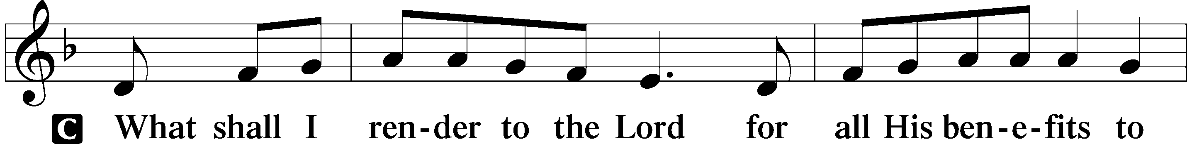
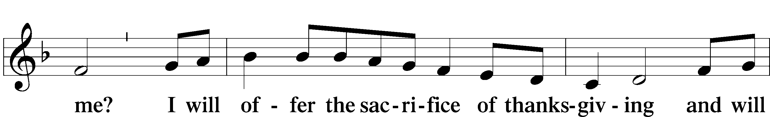
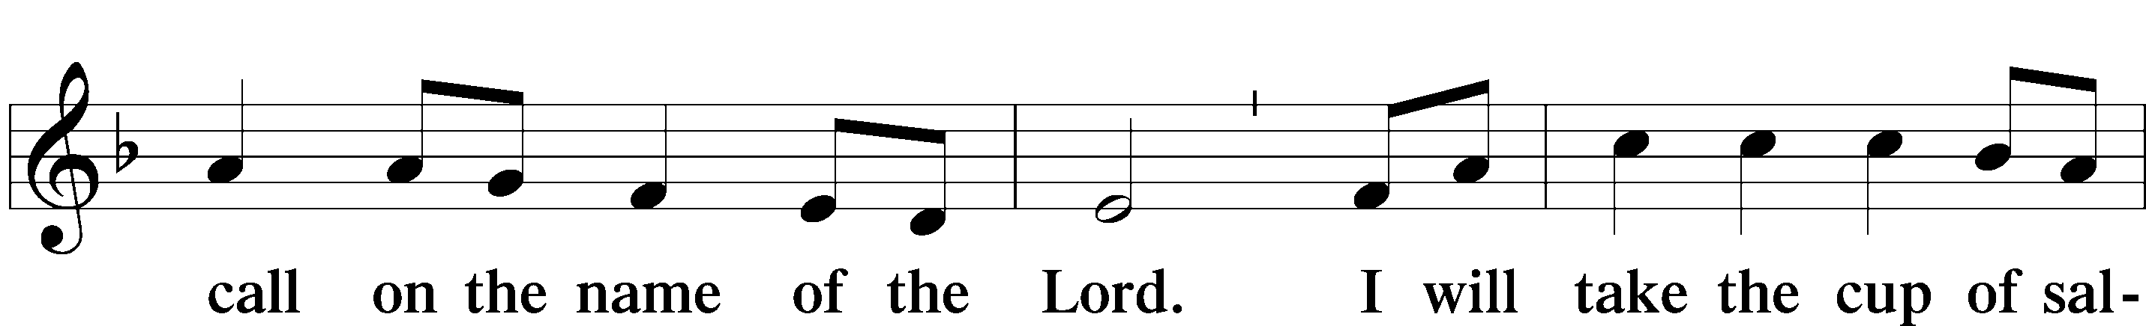
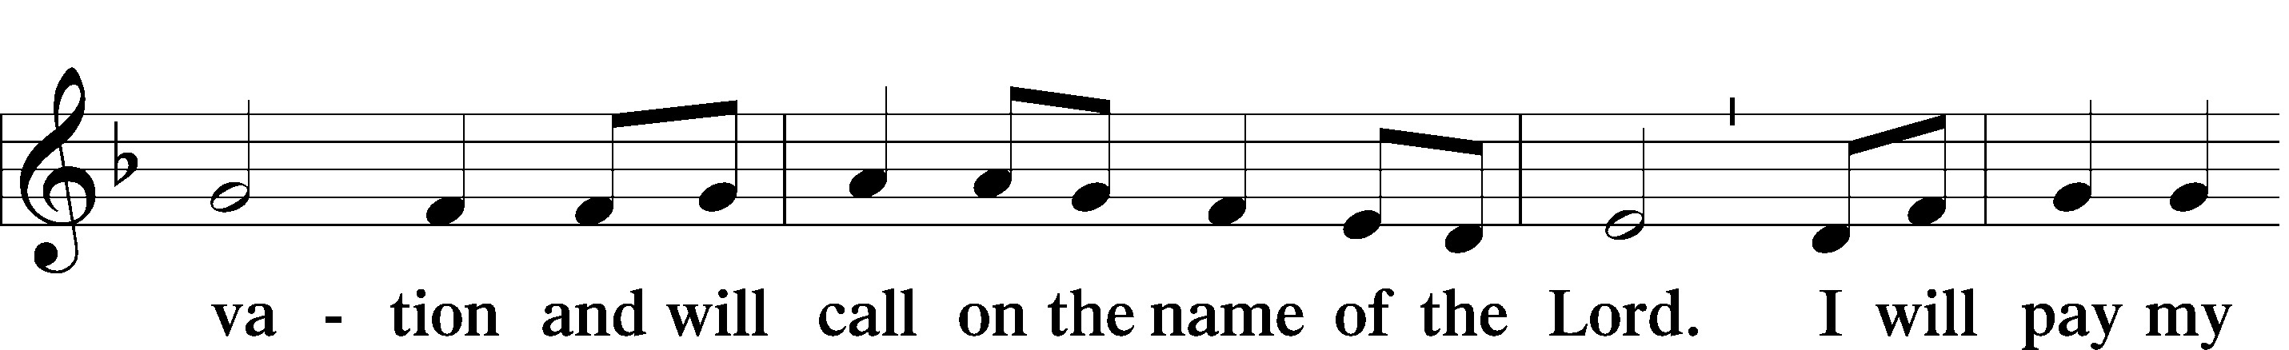
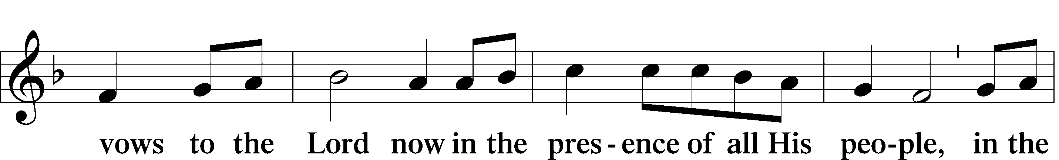
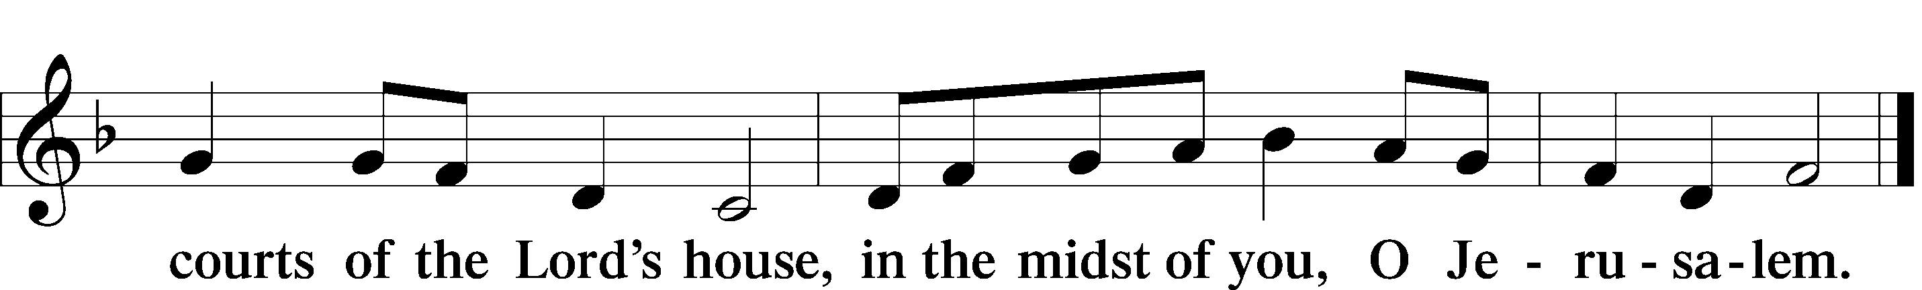

Service of the Sacrament

Preface 2 Timothy 4:22; [Colossians 3:1]; [Psalm 136]





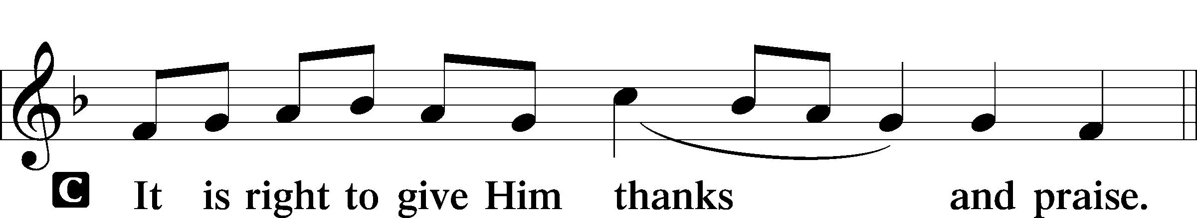

P It is truly good, right, and salutary that we should at all times and in all places give thanks to You, holy Lord, almighty Father, everlasting God, through Jesus Christ, our Lord, whose way John the Baptist prepared, proclaiming Him the promised Messiah, the very Lamb of God who takes away the sin of the world, and calling sinners to repentance that they might escape from the wrath to be revealed when He comes again in glory. Therefore with angels and archangels and with all the company of heaven we laud and magnify Your glorious name, evermore praising You and saying:

Sanctus Isaiah 6:3; Matthew 21:9
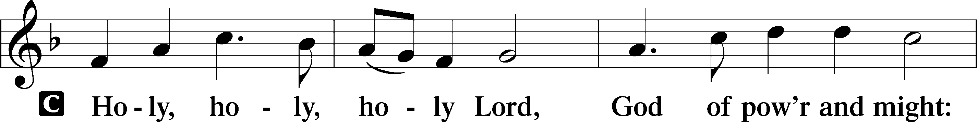
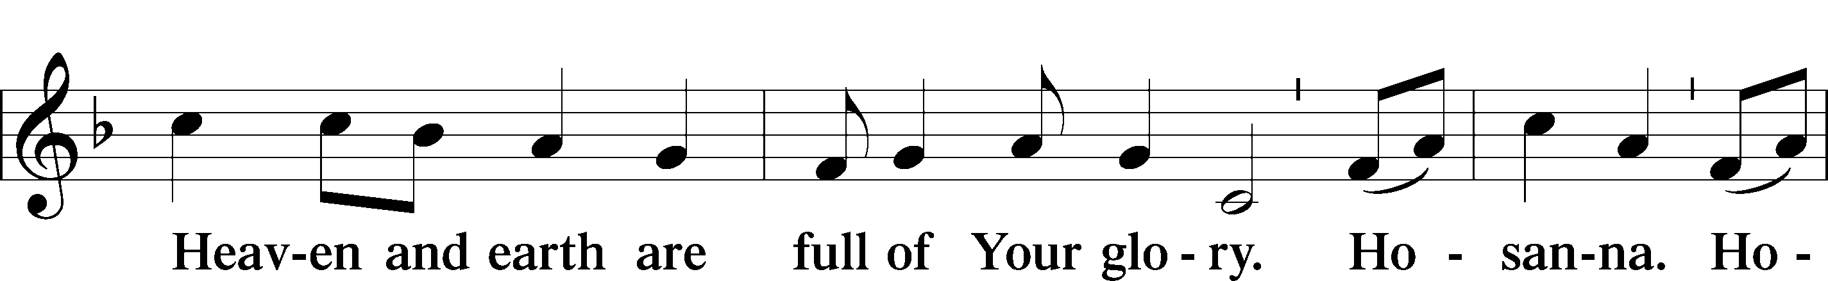
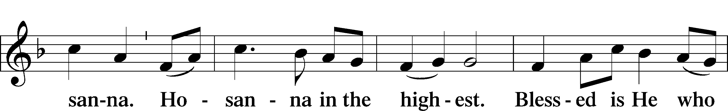
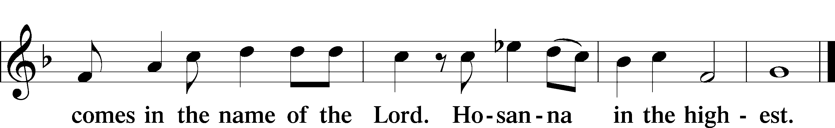

P Blessed are You, Lord of heaven and earth, for You have had mercy on those whom You created and sent Your only-begotten Son into our flesh to bear our sin and be our Savior. With repentant joy we receive the salvation accomplished for us by the all-availing sacrifice of His body and His blood on the cross.
Gathered in the name and the remembrance of Jesus, we beg You, O Lord, to forgive, renew, and strengthen us with Your Word and Spirit. Grant us faithfully to eat His body and drink His blood as He bids us do in His own testament. Gather us together, we pray, from the ends of the earth to celebrate with all the faithful the marriage feast of the Lamb in His kingdom, which has no end. Graciously receive our prayers; deliver and preserve us. To You alone, O Father, be all glory, honor, and worship, with the Son and the Holy Spirit, one God, now and forever.
Lord’s Prayer Matthew 6:9-13
P Lord, remember us in Your kingdom and teach us to pray:
C Our Father who art in heaven,
Hallowed be Thy name,
Thy kingdom come,
Thy will be done on earth as it is in heaven;
Give us this day our daily bread;
And forgive us our trespasses as we forgive those who trespass against us;
And lead us not into temptation,
But deliver T us from evil.
For Thine is the kingdom and the power and the glory forever and ever. Amen.

The Words of Our Lord Matthew 26:26–28
P Our Lord Jesus Christ, on the night when He was betrayed, took bread, and when He had given thanks, He broke it and gave it to the disciples and said: “Take, eat; this is My T body, which is given for you. This do in remembrance of Me.”
In the same way also He took the cup after supper, and when He had given thanks, He gave it to them, saying: “Drink of it, all of you; this cup is the new testament in My T blood, which is shed for you for the forgiveness of sins. This do, as often as you drink it, in remembrance of Me.”

Pax Domini John 20:19
P The peace T of the Lord be with you always.


Agnus Dei John 1:29
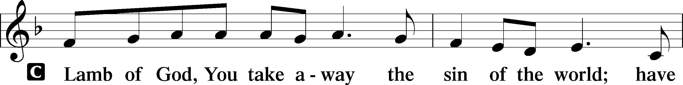
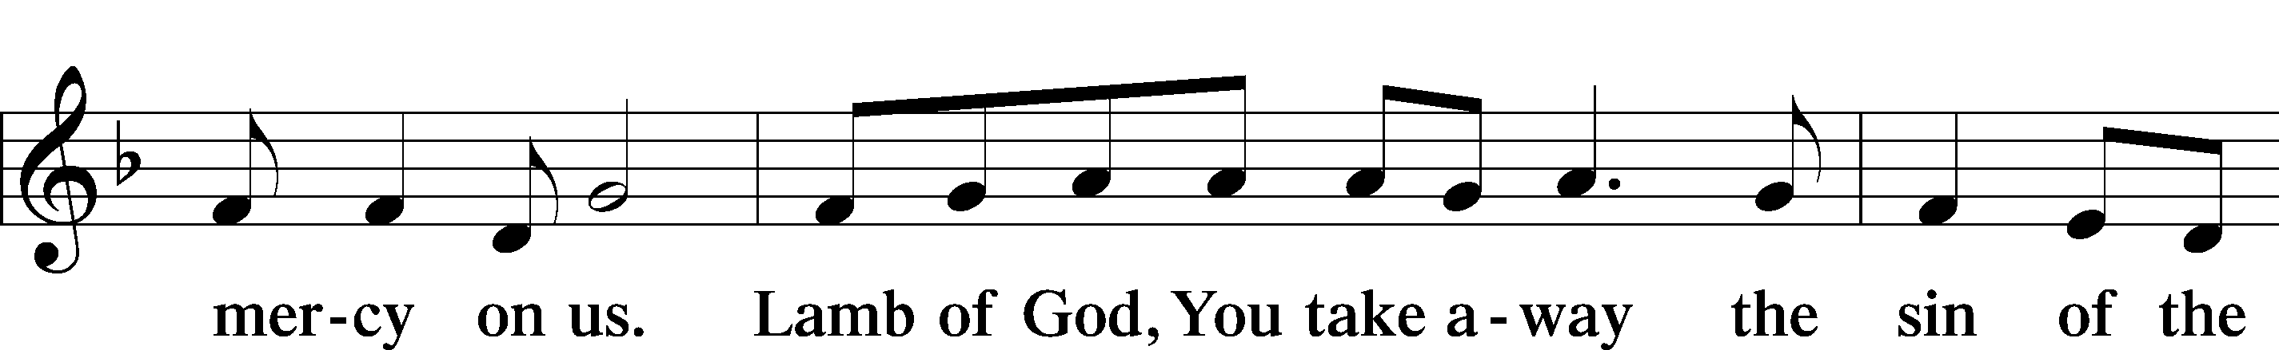
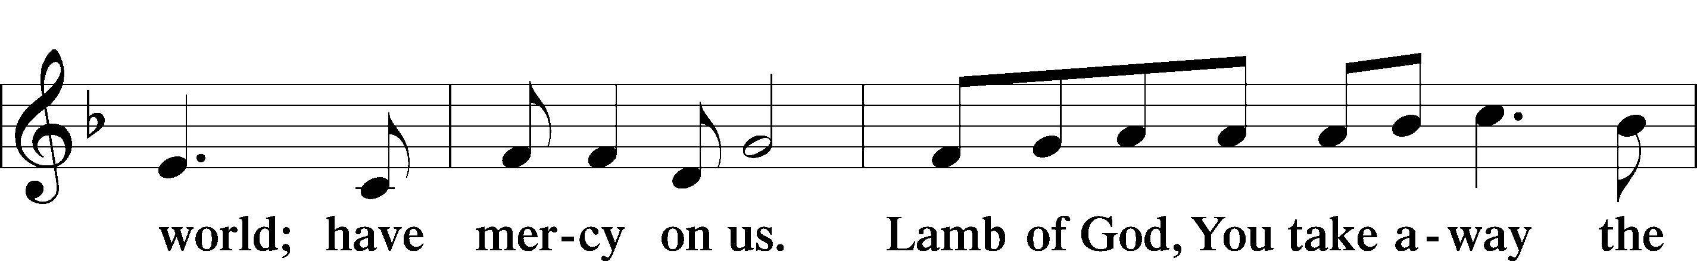
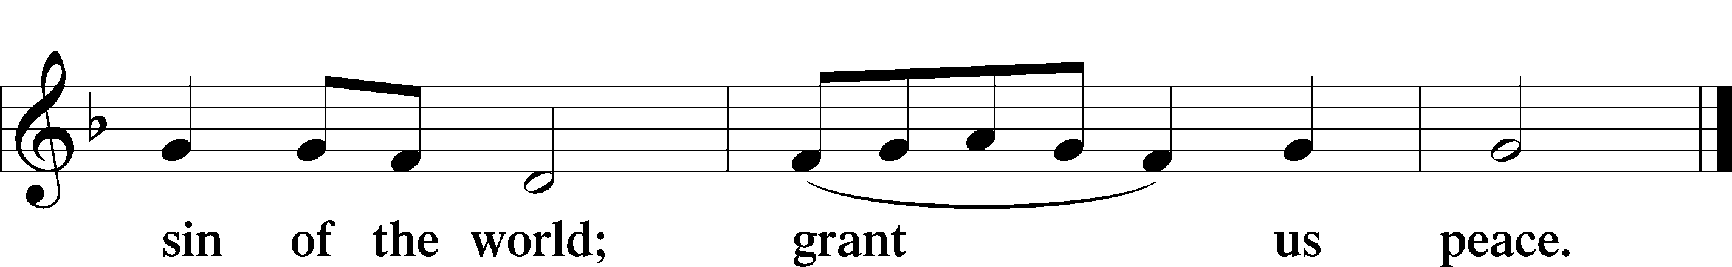

Please be seated

Distribution of the Sacrament
All who are members in good standing of the Lutheran Church - Missouri Synod and have introduced themselves to one of the pastors are welcome to partake of the Holy Communion at Christ Lutheran. If you have not spoken to a pastor, but would like to receive the Lord's blessing, you may still come to the rail and kneel, crossing one arm over the other in the shape of an 'X'. This symbolizes that one is marked by the cross and Triune name of Almighty God.

Distribution Hymns
The Infant Priest Was Holy Born #624

Please stand following distribution of communion

Nunc Dimittis Luke 2:29-32
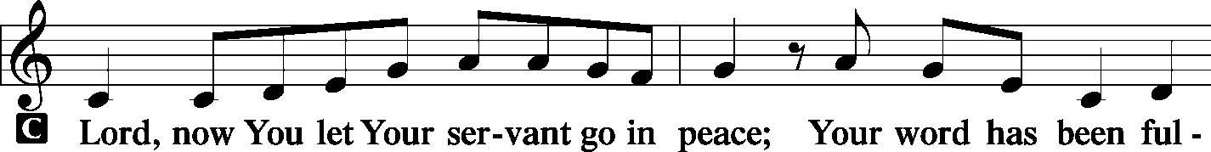
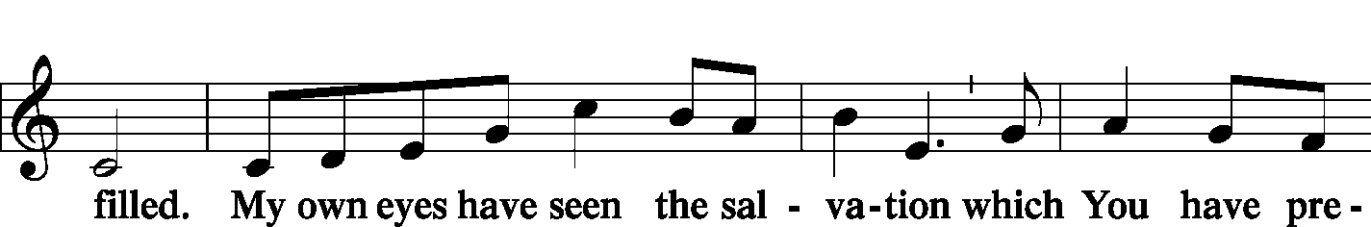
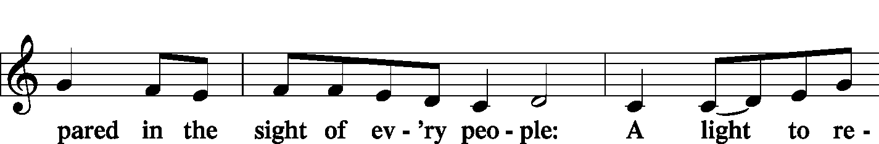
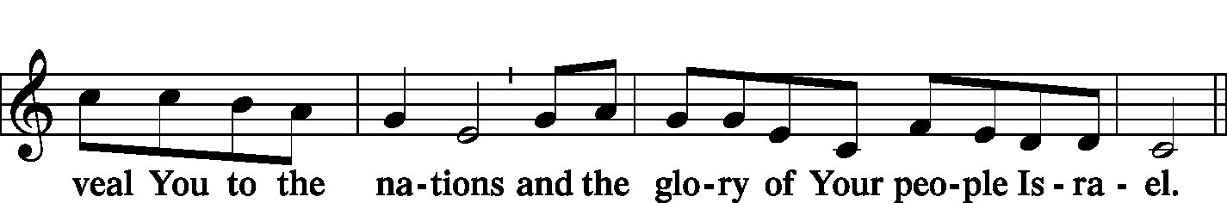
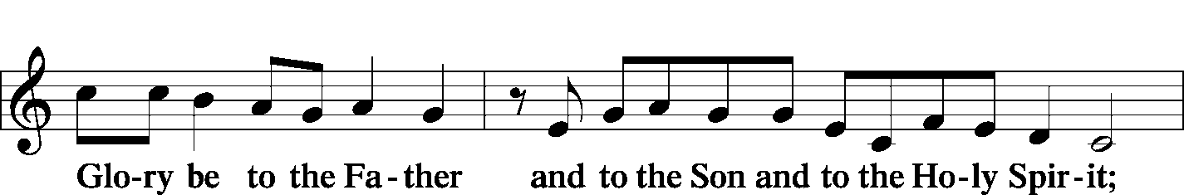
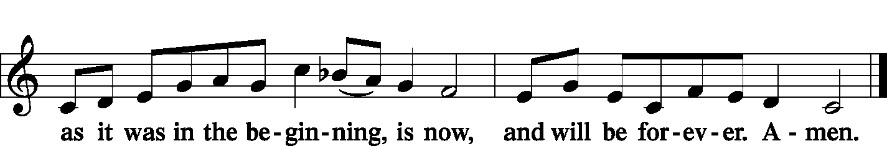

Post-Communion Collect
A Let us pray.
O God the Father, the fountain and source of all goodness, who in loving-kindness sent Your only-begotten Son into the flesh, we thank You that for His sake You have given us pardon and peace in this Sacrament, and we ask You not to forsake Your children but always to rule our hearts and minds by Your Holy Spirit that we may be enabled constantly to serve You; through Jesus Christ, Your Son, our Lord, who lives and reigns with You and the Holy Spirit, one God, now and forever.


Benediction Numbers 6:24–26
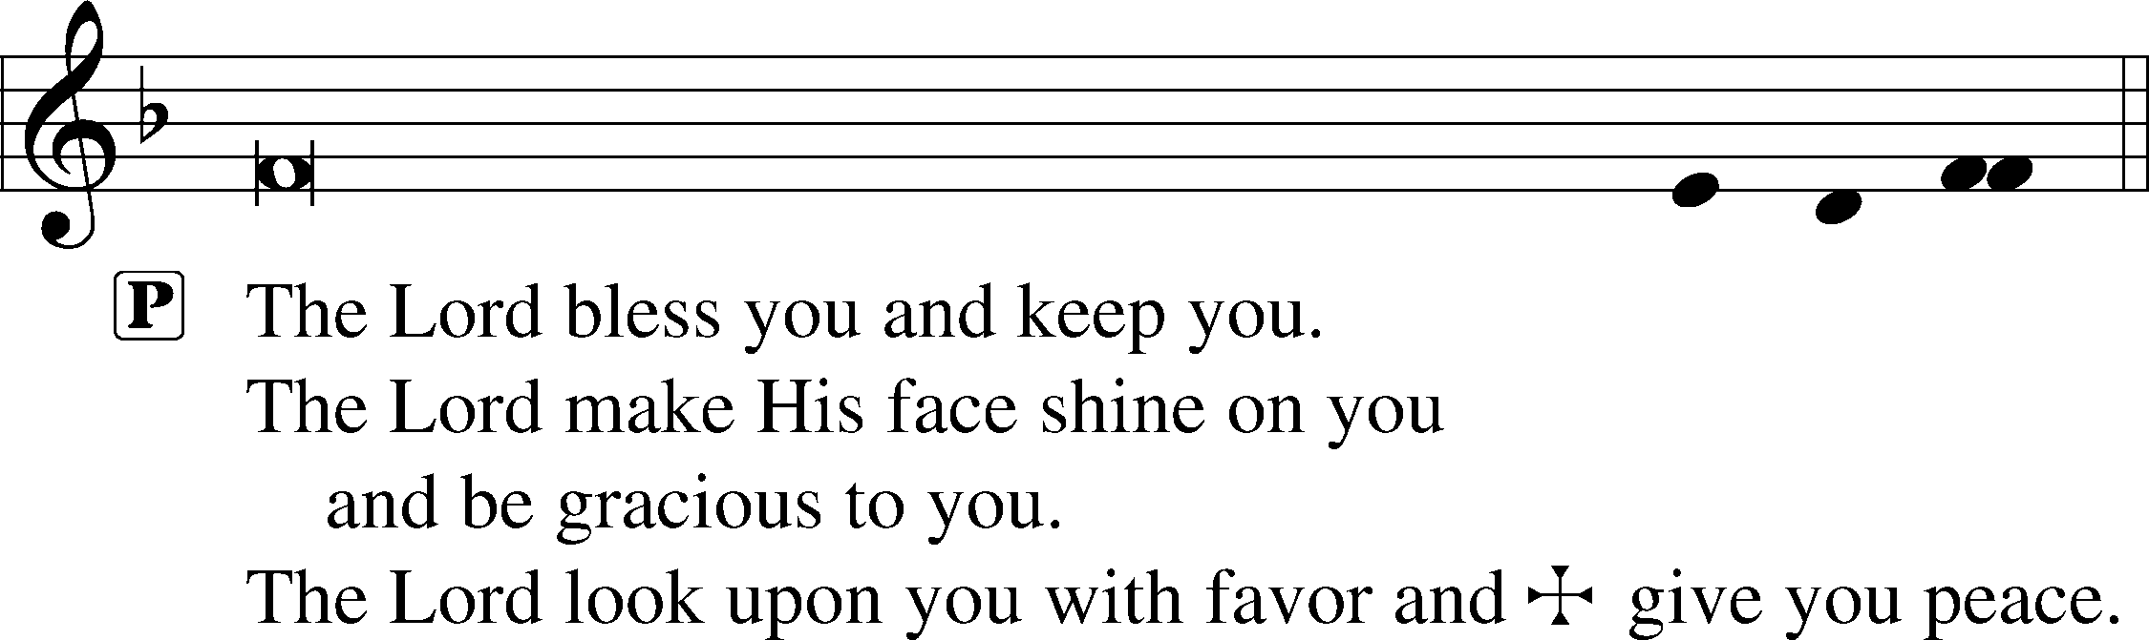

Closing Hymn Angels from the Realms of Glory #367

Acknowledgments
Divine Service, Setting One from Lutheran Service Book © 2006 Concordia Publishing House. Reprinted with permission. Unless otherwise indicated, all scripture quotations are from The Holy Bible, English Standard Version, copyright © 2001 by Crossway Bibles, a division of Good News Publishers. Used by permission. All rights reserved. Created by Lutheran Service Builder © 2006 Concordia Publishing House. Psalm Antiphon setting by Jeffrey Blersch, used by permission of Liturgy Solutions.

Serving Today:
Celebrant: Rev. George Fields Lector: Keith Martin
Cantor: Chris Burkhalter Organist: Sr. Sara Fields
Interpreter: Denee Smith Ushers: Allen Goodlett, Mark Ochs; Gary Atchley

Altar Flower Sign-Up: Sign up for the new year! Flowers have a long history of adorning the Lord’s altar, and you can help to continue this beautiful tradition. The sign-up sheet is on the bulletin board in the Fellowship Hall. Thank you!

Epiphany Work Day: Behold, a new season! Help us un-deck the halls and clean up the church for the season of Epiphany. Join us Saturday, January 9, at 8:00 a.m. Thank you!

Readings for next Sunday, January 10th, the observance of the Feast of the Epiphany of Our Lord: Introit Ps. 45:6-8; Psalm 72:1-11; Isaiah 60:1-6; Ephesians 3:1-12; Matthew 2:1-12.

This week at Christ Lutheran Church: January 4 – January 11

Tuesday 6:15 a.m. Elders Meeting
Friday 6:30 a.m. Bible Study @ Christ Lutheran, Breakfast @ Broadstreet
Saturday 8:00 a.m. Epiphany Work Day
Sunday 8:00 a.m. Divine Service (Mask-Only) – The Feast of the Epiphany of our Lord
9:15 a.m. Children’s Sunday School
10:30 a.m. Divine Service – The Feast of the Epiphany of our Lord


YOUR LIFELINE TO THE LUTHERAN WORLDVIEW…You can listen to in-depth teachings on interesting subjects like:

Christ’s Birth Foretold in Micah, Early Church Fathers on the Birth of Christ, The Christmas Hymn “From Heaven Above to Earth I Come,” Holiday Depression, The New Year Hymn “Now Greet the Swiftly Changing Year,” The Top Religion Stories of 2020, and more…

Issues, Etc. is a radio talk show produced by Lutheran Public Radio and hosted by LCMS Pastor Todd Wilken. You can listen to what you want when you want at www.issuesetc.org. Simply click on “Listen”, choose “On Demand”, then select from the vast array of speakers and topics available in the archives.

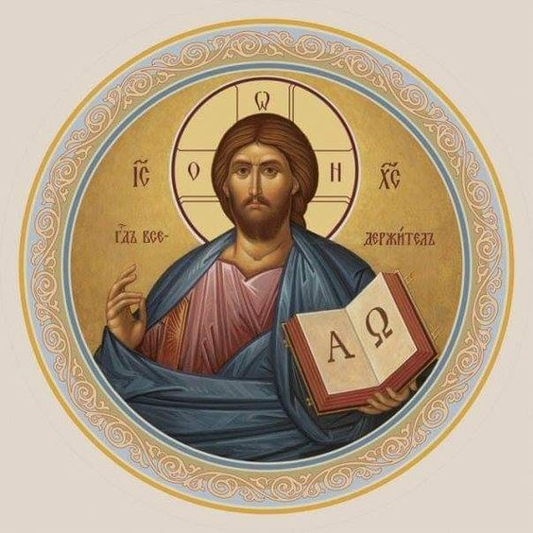

Christ Lutheran Church
The Lutheran Church—Missouri Synod
4423 I-55 North, Jackson, MS 39206-6102
Church phone: (601) 366-2055
www.ChristLutheranJacksonMS.org

Matthew 26:26-29; Mark 14:22-25; Luke 22:14-20, 1 Corinthians 11:23
Matthew 26:28; 1 John 1:7; 1 Peter 1:18-19
1 Corinthians 11:28-32
1 Corinthians 10:17; 1 Corinthians 11:26

