Christ Lutheran Church

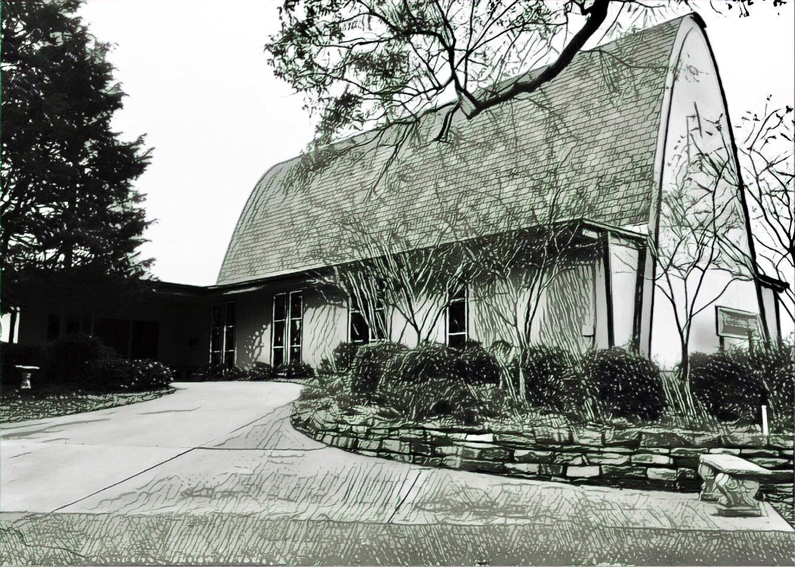

Rev. Dr. James R. Holowach, Pastor
Rev. George N. Fields, Pastor
Sr. Sara E. Fields, Deaconess
Divine Service Each Week with Holy Communion: 10:30 a.m.
Sunday School for all ages: 9:00 a.m.
4423 I-55 North, Jackson, MS 39206-6102 – (601) 366-2055
www.christlutheranjacksonms.org

The Twenty-Fourth Sunday
after Pentecost
+ November 15, 2020 +

“The Great Day of the Lord Is Near”



We welcome our members and guests to Christ Lutheran today,
and pray God’s richest blessings upon you during this time of worship!

All members and our guests are asked to complete the
worship attendance pads which can be found on each pew.
Guests are also asked to sign the guest register found in the Narthex.
We are so glad to have you worshiping with us today!

LARGE PRINT worship folders are available
at the usher stand at the back of the nave.

WELCOME:
“The master had three servants. After they believed and became his servants, they were given a task to do. They received money from their master. One of them traded with it and gained. The second one gained, but not as much. And the third, out of fear and being insufficiently faithful went away and hid his master’s money. From his defensiveness it appears that he feared the master. He was in awe of the master even as the other had ‘zeal for God but not according to knowledge.’ Diffidently, he ‘hid’ his talent in the ground. Such are those who neither exert themselves nor question what has been said nor extend themselves to benefit souls.”
−Origen, Commentary on Matthew (Discourse 66)
The Lord’s Supper

In preparation for reception of the Lord’s Supper (Holy Communion), it is important that we review and understand what the Bible teaches regarding this sacrament:
The Bible teaches that Jesus gives us His very body and blood along with bread and wine in Holy Communion, and that these are means by which He forgives our sins, and strengthens us for daily living, and draws us into closer fellowship with Him and other believers. The Bible also teaches us to examine ourselves prior to receiving the meal. For those receiving Holy Communion, examine yourself with these questions:
Do I believe that I am a sinner and I am sorry for my sins?
Do I believe that Jesus Christ is God’s Son and my personal Savior?
Do I believe that Christ’s true body and blood are present in this holy meal for my forgiveness?
Do I truly intend with the help of God to correct my sinful life?
According to Christ’s Word in the Holy Scriptures, and in confession with the true Christian faith, at Christ Lutheran we observe the practice of closed communion. We believe that all who commune must confess the same holy faith, as Holy Scripture teaches. Since one’s church affiliation indicates an individual’s confession of faith, we ask that only those who have been instructed in the above teaching and are confirmed members of The Lutheran Church – Missouri Synod commune. If you have not been instructed in this teaching on Holy Communion, are in doubt, or hold a different confession of faith, you are still welcome to come forward and cross your arms to indicate that you would like a blessing.

Divine Service III

Preservice Music
The congregation may use this time to pray and meditate.

Opening Hymn The King Shall Come When Morning Dawns #348

Confession & Absolution
The sign of the cross may be made by all in remembrance of their Baptism.

P In the name of the Father and of the T Son and of the Holy Spirit.
C Amen.

P Beloved in the Lord! Let us draw near with a true heart and confess our sins unto God our Father, beseeching Him in the name of our Lord Jesus Christ to grant us forgiveness.

P Our help is in the name of the Lord,
C who made heaven and earth.
P I said, I will confess my transgressions unto the Lord,
C and You forgave the iniquity of my sin.

Silence for reflection on God's Word and for self-examination.

P O almighty God, merciful Father,
C I, a poor, miserable sinner, confess unto You all my sins and iniquities with which I have ever offended You and justly deserved Your temporal and eternal punishment. But I am heartily sorry for them and sincerely repent of them, and I pray You of Your boundless mercy and for the sake of the holy, innocent, bitter sufferings and death of Your beloved Son, Jesus Christ, to be gracious and merciful to me, a poor, sinful being.

P Upon this your confession, I, by virtue of my office, as a called and ordained servant of the Word, announce the grace of God unto all of you, and in the stead and by the command of my Lord Jesus Christ I forgive you all your sins in the name of the Father and of the T Son and of the Holy Spirit.
C Amen.

Service of the Word
Psalm: Domine, refugium Psalm 90:1-12; Ant. Psalm 90:17
Let the favor of the Lord our God be upon us, and establish the work of our hands | upon us;
yes, establish the work | of our hands!
Lord, you have been our | dwelling place*
in all gener- | ations.
Before the mountains were brought forth, or ever you had formed the earth | and the world,*
from everlasting to everlasting | you are God.
You return | man to dust*
and say, “Return, O chil- | dren of man!”
For a thousand years in your sight are but as yesterday when | it is past,*
or as a watch | in the night.
You sweep them away as | with a flood;*
they are like a dream,like grass that is renewed in the | morning:
in the morning it flourishes and | is renewed;*
in the evening it fades and | withers.
For we are brought to an end by your | anger;*
by your wrath we | are dismayed.
You have set our iniquities be- | fore you,*
our secret sins in the light of your | presence.
For all our days pass away un- | der your wrath;*
we bring our years to an end | like a sigh.
The years of our life are seventy, or even by reason of strength | eighty;*
yet their span is but toil and trouble; they are soon gone, and we | fly away.
Who considers the power of your | anger,*
and your wrath according to the | fear of you?
So teach us to number | our days*
that we may get a heart of | wisdom.
Glory be to the Father and | to the Son*
and to the Holy | Spirit;
as it was in the be- | ginning,*
is now, and will be forever. | Amen.
Let the favor of the Lord our God be upon us, and establish the work of our hands | upon us;
yes, establish the work | of our hands!

Kyrie Mark 10:47
The congregation is invited to sing in parts:

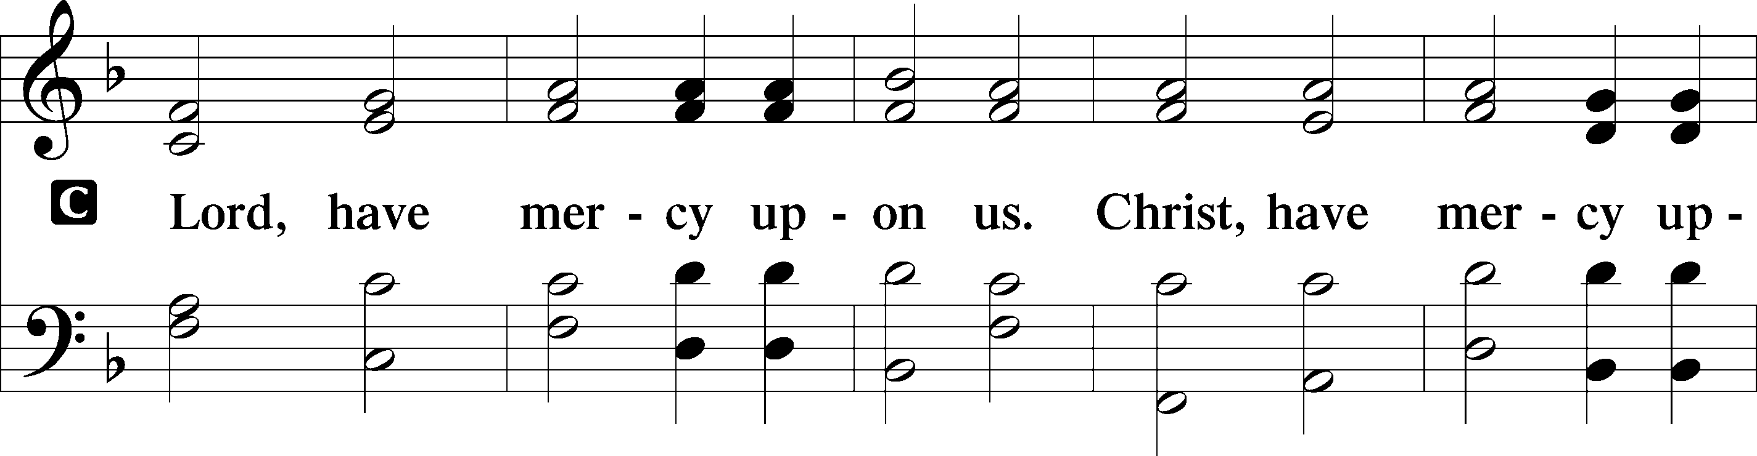
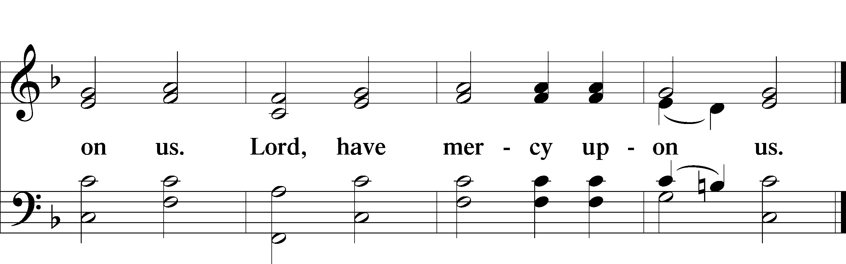

Gloria in Excelsis Luke 2:14; John 1:29
The congregation is invited to sing in parts, which can be found on LSB page 187.
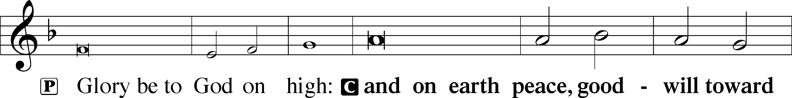
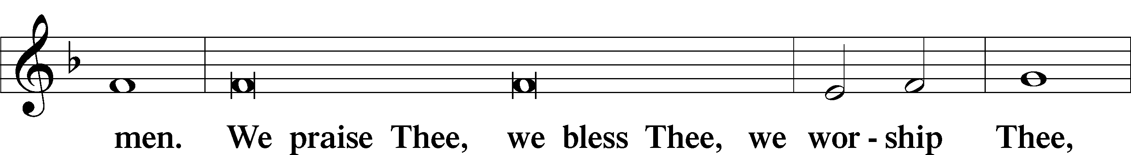
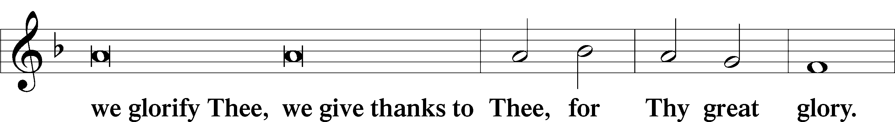
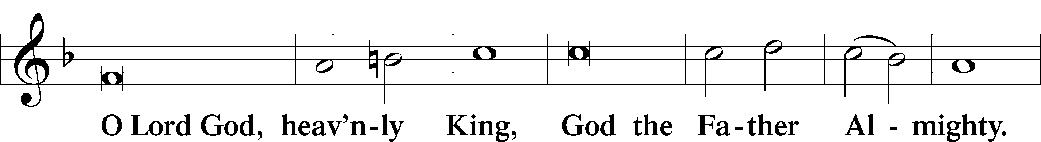
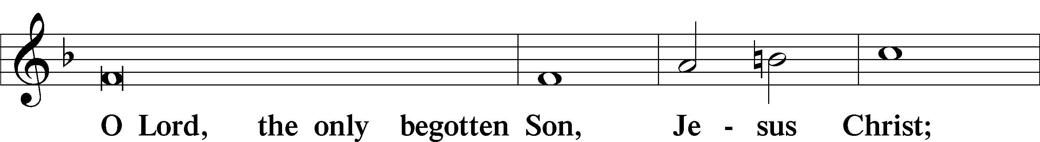
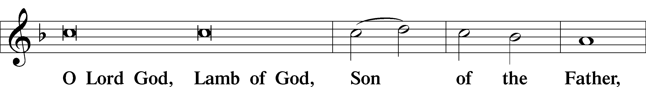
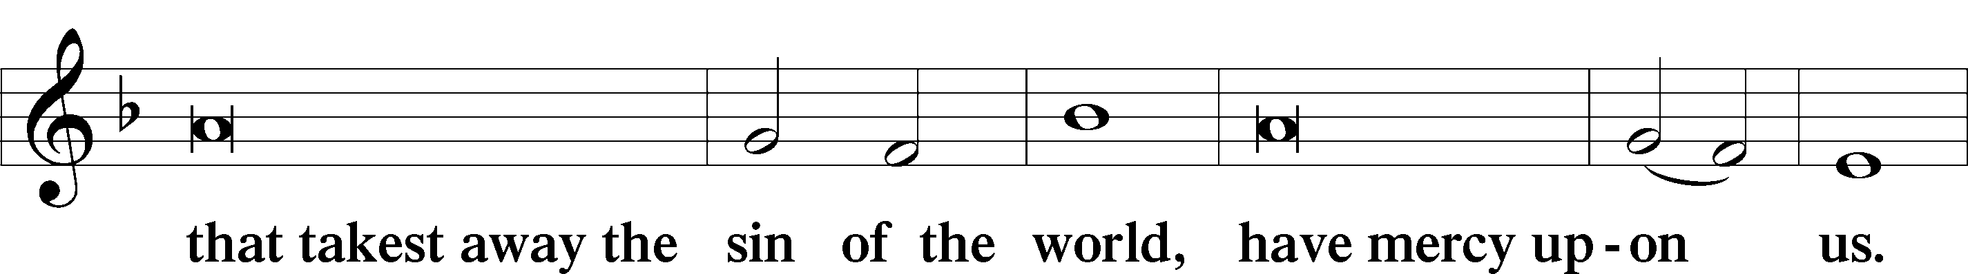
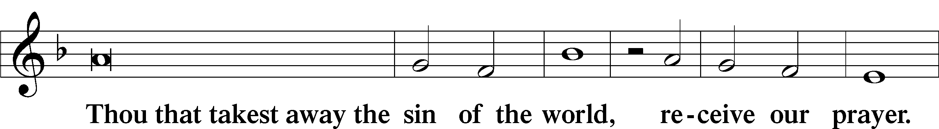
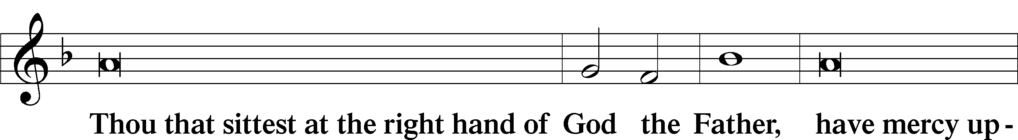
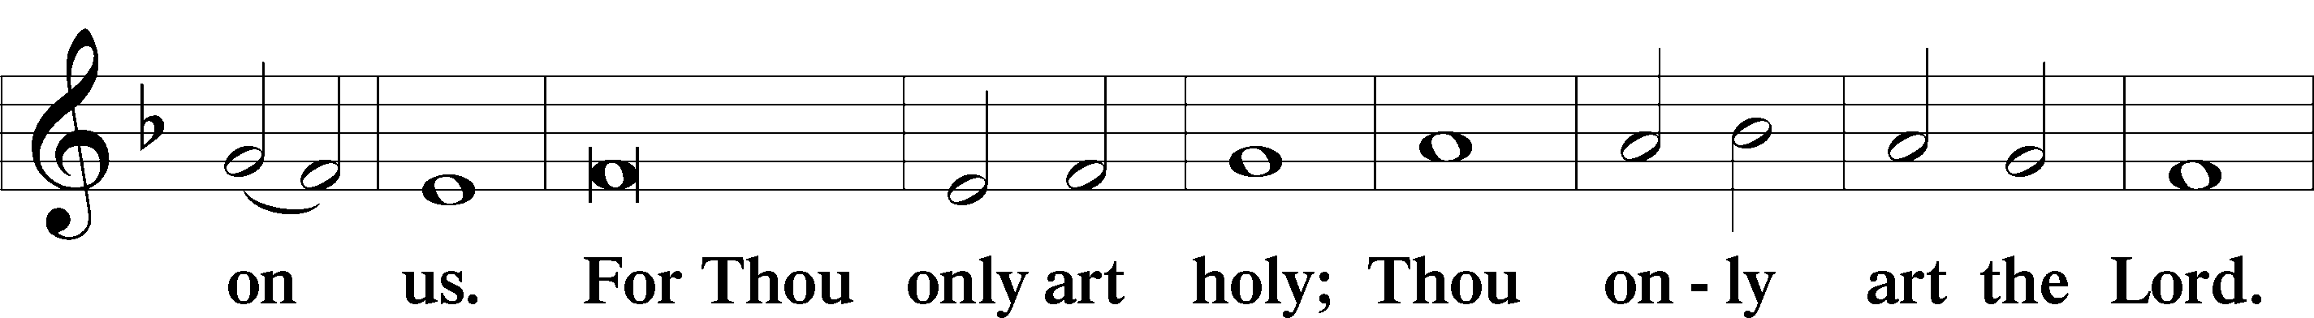
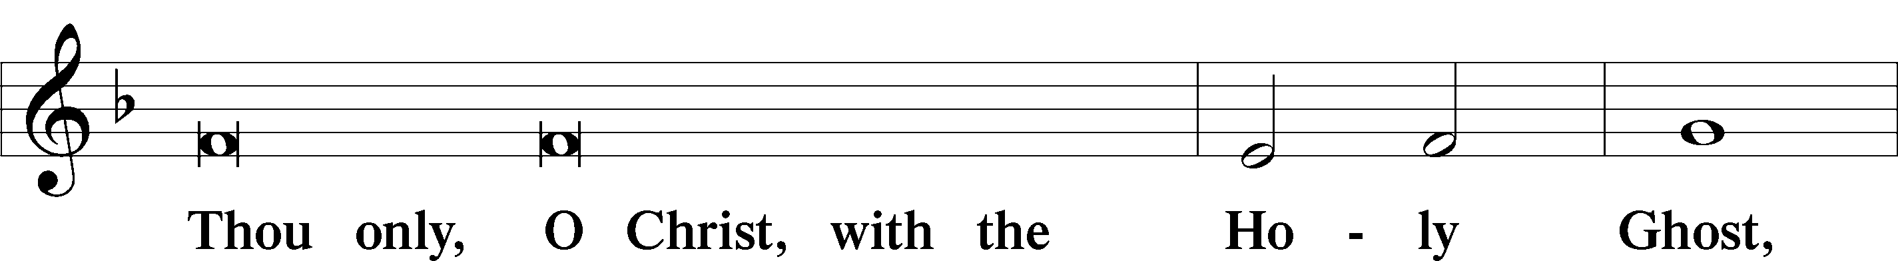
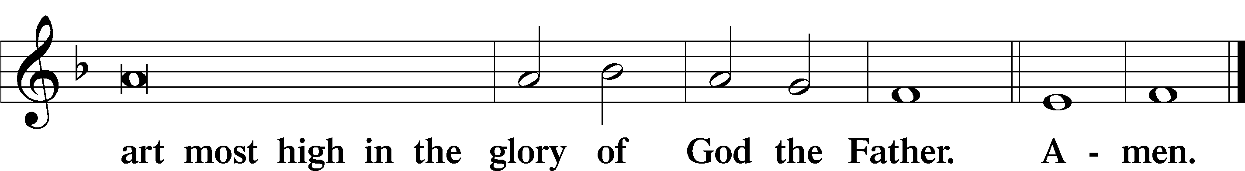

Salutation and Collect of the Day

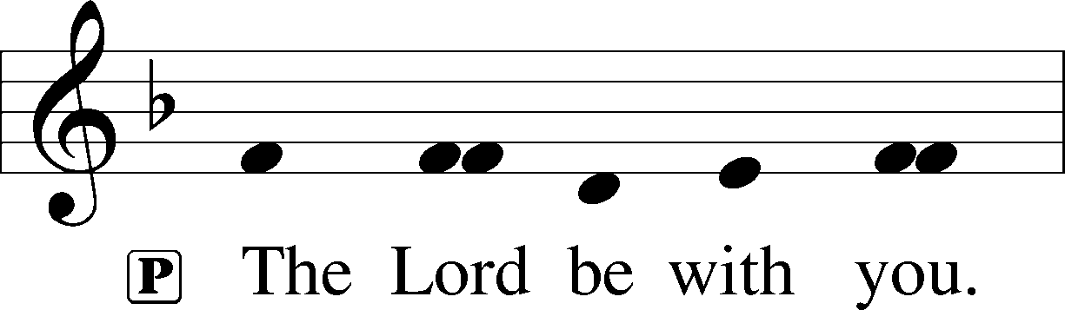
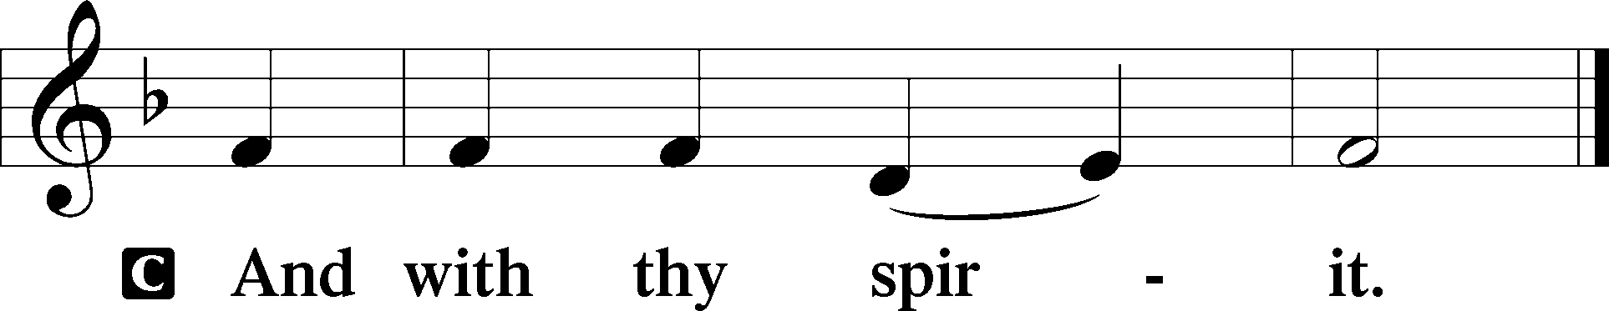

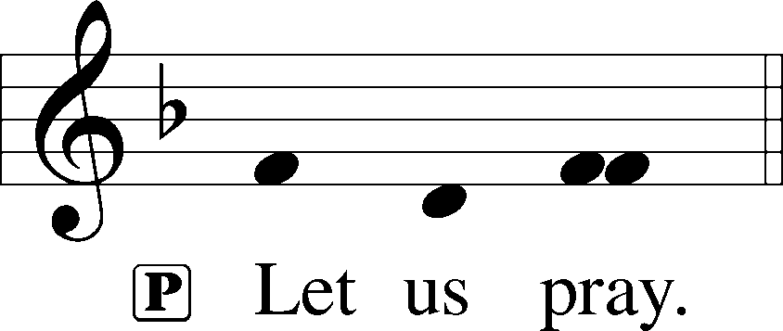

P Almighty and ever-living God, You have given exceedingly great and precious promises to those who trust in You. Dispel from us the works of darkness and grant us to live in the light of Your Son, Jesus Christ, that our faith may never be found wanting; through the same Jesus Christ, our Lord, who lives and reigns with You and the Holy Spirit, one God, now and forever.

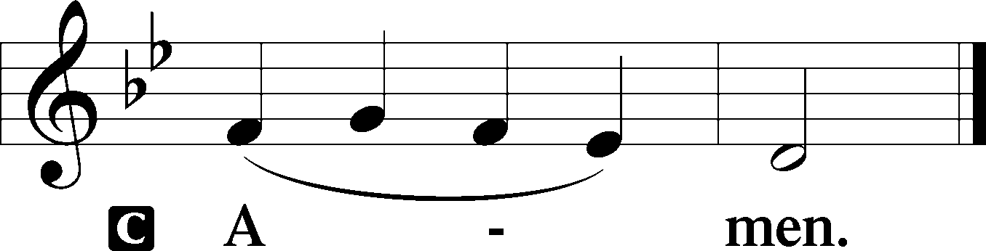

Please be seated

Old Testament Reading Zephaniah 1:7-16

Be silent before the Lord God!
For the day of the Lord is near;
the Lord has prepared a sacrifice
and consecrated his guests.
And on the day of the Lord’s sacrifice—
“I will punish the officials and the king’s sons
and all who array themselves in foreign attire.
On that day I will punish
everyone who leaps over the threshold,
and those who fill their master’s house
with violence and fraud.
“On that day,” declares the Lord,
“a cry will be heard from the Fish Gate,
a wail from the Second Quarter,
a loud crash from the hills.
Wail, O inhabitants of the Mortar!
For all the traders are no more;
all who weigh out silver are cut off.
At that time I will search Jerusalem with lamps,
and I will punish the men
who are complacent,
those who say in their hearts,
‘The Lord will not do good,
nor will he do ill.’
Their goods shall be plundered,
and their houses laid waste.
Though they build houses,
they shall not inhabit them;
though they plant vineyards,
they shall not drink wine from them.”
The great day of the Lord is near,
near and hastening fast;
the sound of the day of the Lord is bitter;
the mighty man cries aloud there.
A day of wrath is that day,
a day of distress and anguish,
a day of ruin and devastation,
a day of darkness and gloom,
a day of clouds and thick darkness,
a day of trumpet blast and battle cry
against the fortified cities
and against the lofty battlements.

A This is the Word of the Lord.
C Thanks be to God.

Gradual Revelation 7:14b, Psalm 84:5
These are the ones coming out of the great tribu- | lation.*
They have washed their robes and made them white in the blood | of the Lamb.
Blessèd are those whose strength is | in you,*
in whose heart are the highways to | Zion.

Epistle Reading 1 Thessalonians 5:1-11
Now concerning the times and the seasons, brothers, you have no need to have anything written to you. For you yourselves are fully aware that the day of the Lord will come like a thief in the night. While people are saying, “There is peace and security,” then sudden destruction will come upon them as labor pains come upon a pregnant woman, and they will not escape. But you are not in darkness, brothers, for that day to surprise you like a thief. For you are all children of light, children of the day. We are not of the night or of the darkness. So then let us not sleep, as others do, but let us keep awake and be sober. For those who sleep, sleep at night, and those who get drunk, are drunk at night. But since we belong to the day, let us be sober, having put on the breastplate of faith and love, and for a helmet the hope of salvation. For God has not destined us for wrath, but to obtain salvation through our Lord Jesus Christ, who died for us so that whether we are awake or asleep we might live with him. Therefore encourage one another and build one another up, just as you are doing.
A This is the Word of the Lord.
C Thanks be to God.

Please stand

Alleluia
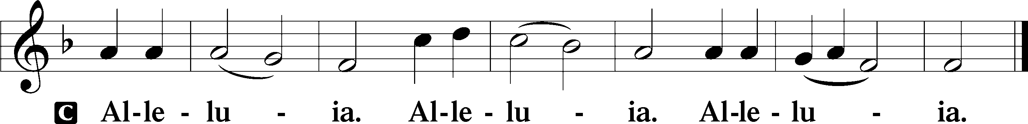

Holy Gospel Matthew 25:14-30

P The Holy Gospel according to St. Matthew, the twenty-fifth chapter.

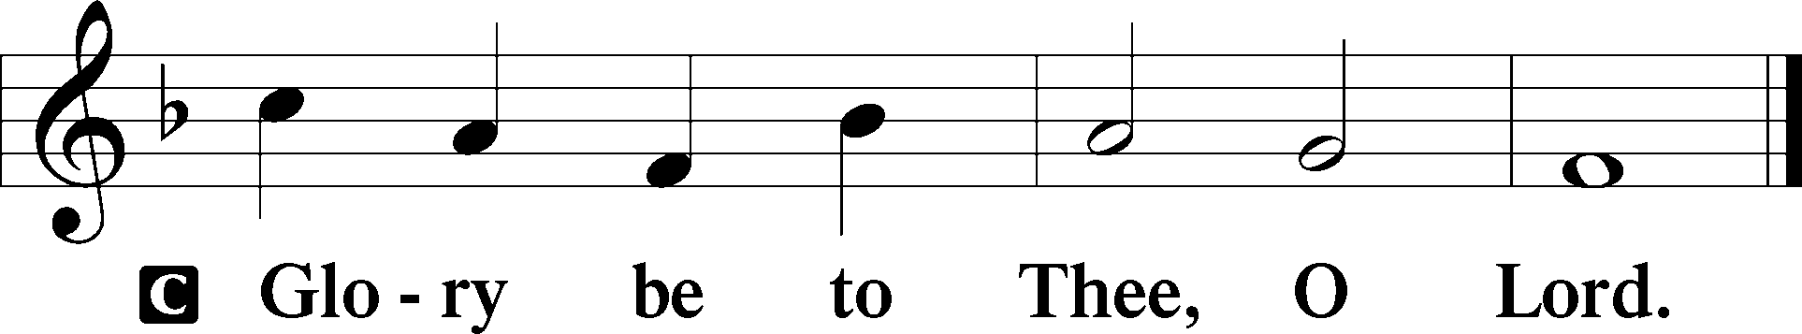
“For it will be like a man going on a journey, who called his servants and entrusted to them his property. To one he gave five talents, to another two, to another one, to each according to his ability. Then he went away. He who had received the five talents went at once and traded with them, and he made five talents more. So also he who had the two talents made two talents more. But he who had received the one talent went and dug in the ground and hid his master’s money. Now after a long time the master of those servants came and settled accounts with them. And he who had received the five talents came forward, bringing five talents more, saying, ‘Master, you delivered to me five talents; here I have made five talents more.’ His master said to him, ‘Well done, good and faithful servant. You have been faithful over a little; I will set you over much. Enter into the joy of your master.’ And he also who had the two talents came forward, saying, ‘Master, you delivered to me two talents; here I have made two talents more.’ His master said to him, ‘Well done, good and faithful servant. You have been faithful over a little; I will set you over much. Enter into the joy of your master.’ He also who had received the one talent came forward, saying, ‘Master, I knew you to be a hard man, reaping where you did not sow, and gathering where you scattered no seed, so I was afraid, and I went and hid your talent in the ground. Here you have what is yours.’ But his master answered him, ‘You wicked and slothful servant! You knew that I reap where I have not sowed and gather where I scattered no seed? Then you ought to have invested my money with the bankers, and at my coming I should have received what was my own with interest. So take the talent from him and give it to him who has the ten talents. For to everyone who has will more be given, and he will have an abundance. But from the one who has not, even what he has will be taken away. And cast the worthless servant into the outer darkness. In that place there will be weeping and gnashing of teeth.’
P This is the Gospel of the Lord.
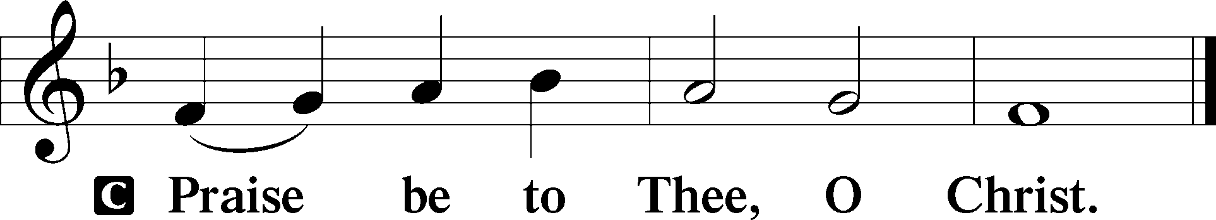

Please be seated

Office Hymn Jesus, Priceless Treasure #743

Sermon Should He Not Come in Wrath?

Please stand

Nicene Creed

C I believe in one God, (Rom 10:10; Deut 6:4)
the Father Almighty, (Mt 6:9; Ex 6:3)
maker of heaven and earth (Gen 1:1; Jn 1:1)
and of all things visible and invisible. (Col 1:16)
And in one Lord Jesus Christ, (Rom 10:9)
the only-begotten Son of God, (Jn 3:16; Mt 16:16)
begotten of His Father before all worlds, (Jn 1:2)
God of God, Light of Light, (Jn 17:22; Jn 8:12; Jn 1:1)
very God of very God, (Col 2:9) begotten, not made, (Jn 1:2)
being of one substance with the Father, (Jn 10:30)
by whom all things were made; (Heb 1:2; Jn 1:3)
who for us men and for our salvation (1 Tim 2:4; Rom 3:23)
came down from heaven (Jn 6:41; Lk 15:20)
and was incarnate by the Holy Spirit of the virgin Mary (Lk 1:34-35)
and was made man; (Jn 1:14)
and was crucified also for us under Pontius Pilate. (Mk 15:25; Jn 19:16-18)
He suffered and was buried. (Jn 19:1-3; Lk 23:53)
And the third day He rose again according to the Scriptures (1 Cor 15:4; Lk 24:6)
and ascended into heaven (Acts 1:9)
and sits at the right hand of the Father. (Acts 7:55)
And He will come again with glory (Mt 26:64)
to judge both the living and the dead, (Acts 10:42; Mt 3:12)
whose kingdom will have no end. (2 Pt 1:11)
And I believe in the Holy Spirit, (Jn 14:26; Gen 1:2; Acts 2:38)
the Lord and giver of life, (Gen 1:2; Jn 3:6)
who proceeds from the Father and the Son, (Jn 15:26)
who with the Father and the Son together is worshiped and glorified, (Mt 3:16-17)
who spoke by the prophets. (Eze 11:5)
And I believe in one holy Christian and apostolic Church, (1 Pt 2:5; Eph 2:19-22)
I acknowledge one Baptism for the remission of sins, (Eph 4:5)
and I look for the resurrection of the dead (1 Cor 15:35-49; 1 Thess 4:13-18)
and the life T of the world to come. (Mk 10:29-30; Mt 10:40-42)
Amen. (Ps 106:48)
Us men means all people.
Christian: the ancient text reads “catholic,” meaning the whole Church as it confesses the wholeness of Christian doctrine

Prayer of the Church
After each petition of the prayer:
Pastor: Let us pray to the Lord.
People: Lord, have mercy.
For comfort, health and recovery: Alyson Behel Moody, David Entrekin, Else Keil, Linda Martin, Corey Ray, Bob Slay;
For those who mourn: The family of Bryce Moody and Ryker Moody;
For those who are ill or distressed: Stan Acey, Jenalee Adams, Layne Bagley, Rose Bagley, Shirley Bagley, W.L. Bagley, Sarah Bowman, Mimi Bradley, Richard Bradley, Deloris Brent, Martha Brown, Nathan Brown, Tina Burke, Wayne Burke, Paula Burkhalter, Bobby Carroll, Arthur Collins, James E. Cookston, Joan Cowards, Belinda Cowards-Gonzales, Robert (Andy) Evers, Michele Rae Fowler, Randy Fowler, Parker Haines, Dan Hansen, Paul Hansen, Tim Hansen, Valerie Henderson, Sharon Holleman, Beth Jarratt, Elaine Johnson, Joslyn Jones, Steve Kennedy, Arlene Kleinschmidt, Eleanor Koster, John Koster, Sandra Landers, Katelyn Lawing, Peggy Lucky, Paul McCullough, Jerry McIntyre, Jerry McMahan, Edlia Miller, Elaine Monaghan, Lindberg Moore, Jerry Mutter, Don Ochs, Mildred Odom, Deborah-Annette Ried, Elmira Roever, Jon Sandberg, Noah Schultz, Johnnie Pearl Smiley, Bob Smith, Sam Schneider, Sherri Smith, Deborah Springer, MariLyn Unger, Betty Venator, Leonard Watson, Cynthia Widlitze, Carol Wright, Jimmy Wright, Marshall Wright, Barbara Zeigler;
For college and graduate students: Jake Everly, Sara Fields, Jonathan Kettler, Roselynn Nelson, Will Nelson;
For military servants and their families: Gabriel Escude, James (Glen) Hansford, Holden Hathcock, Christopher Martin, William Nelson, Steven Tatum, John Weidner Jr.;
For foreign missionaries: David and Shelee Warner;
This week’s prayer family: Ben & Natalie Rudsenske and their loved ones.

Please be seated

Offering

Please stand

Offertory Psalm 51:10-12
The congregation is invited to sing in parts:
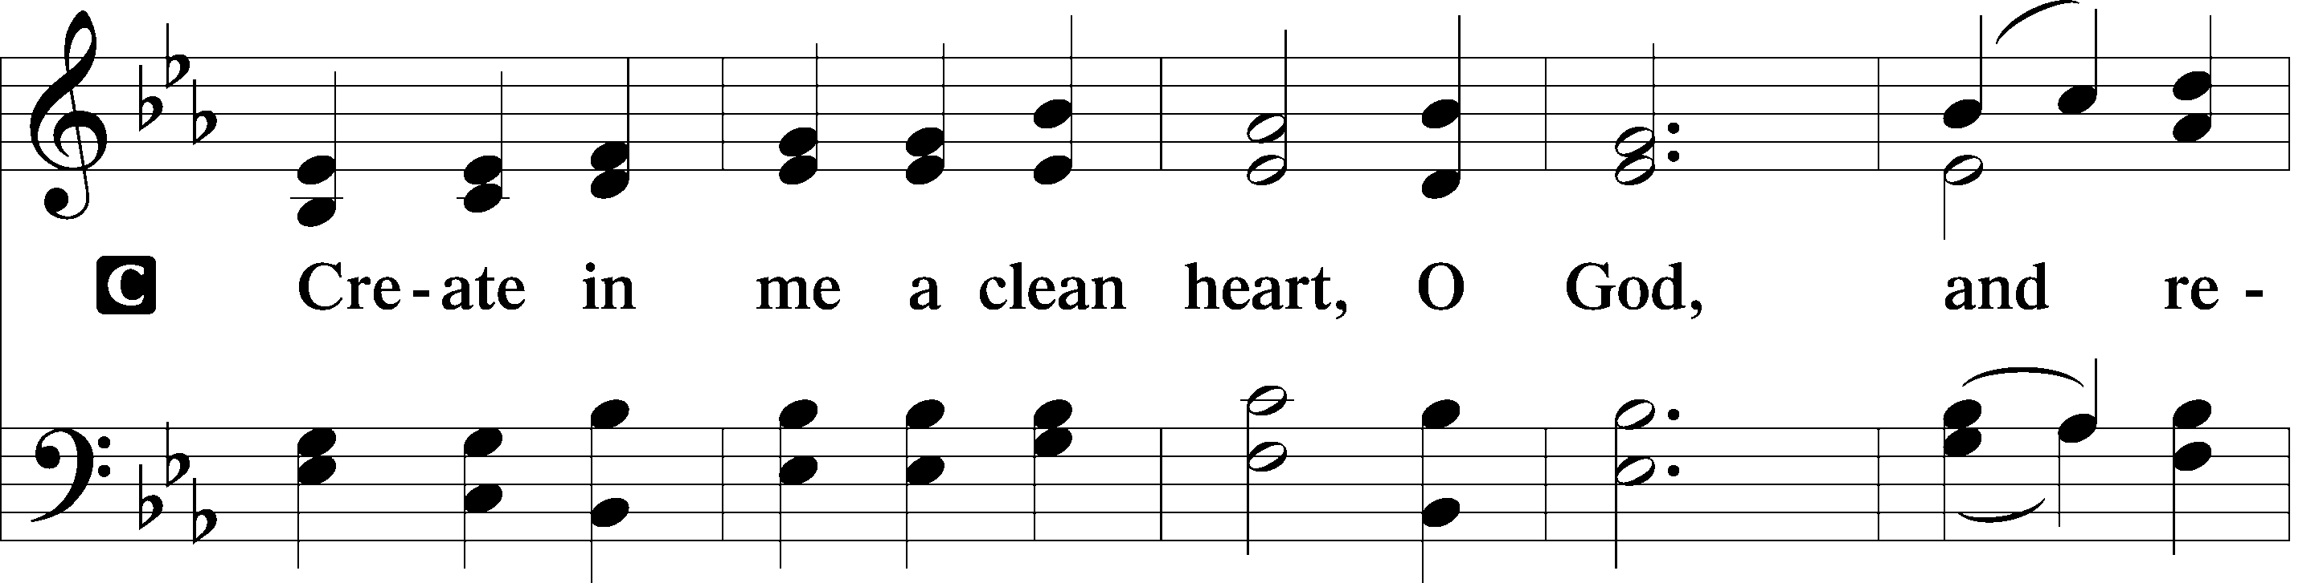
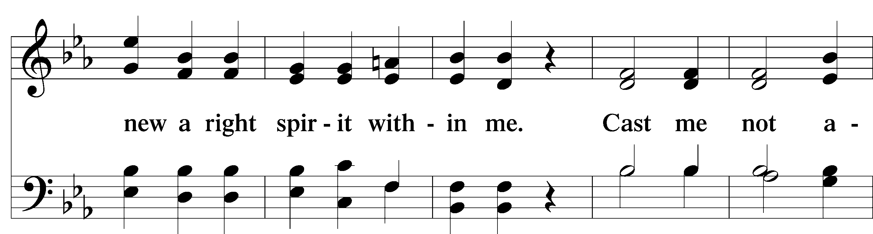
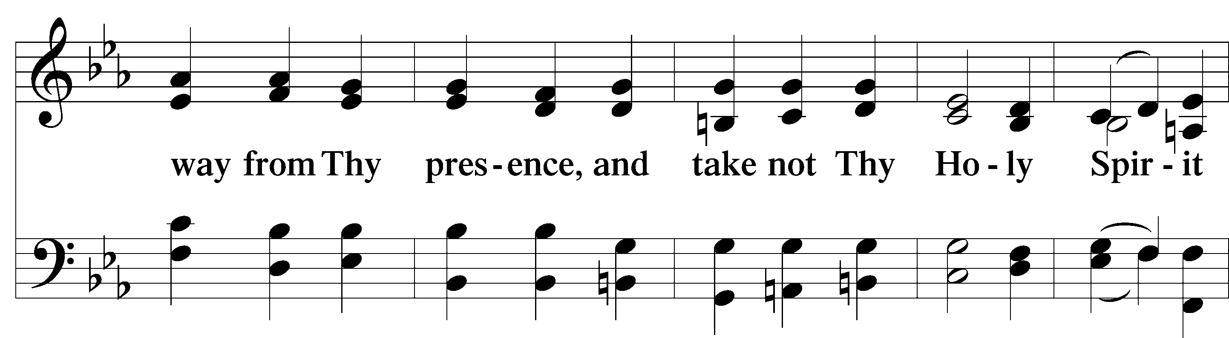
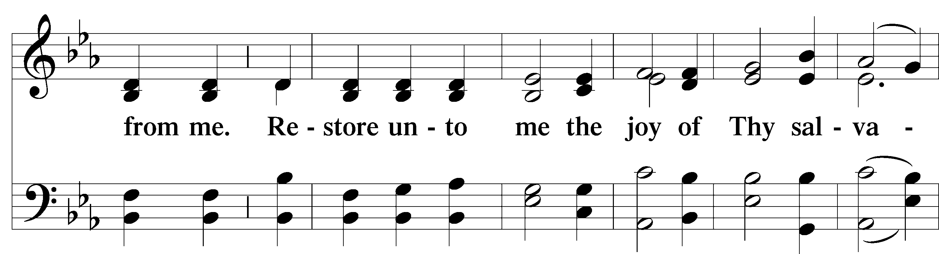
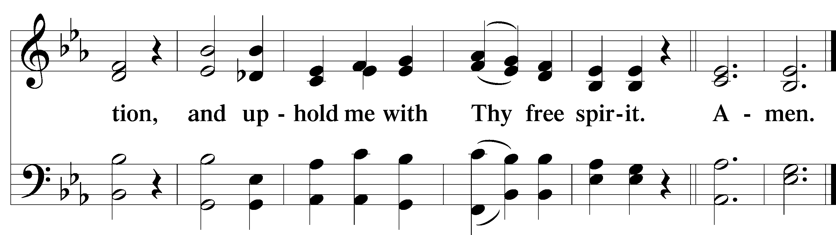

Service of the Sacrament

Preface 2 Timothy 4:22; [Colossians 3:1]; [Psalm 136]

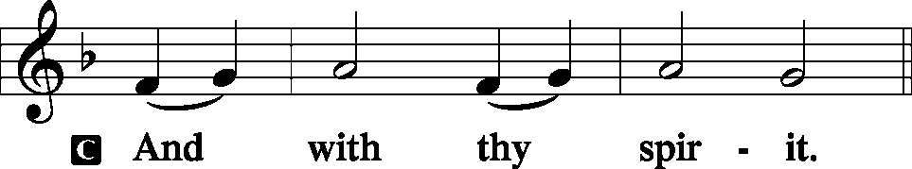
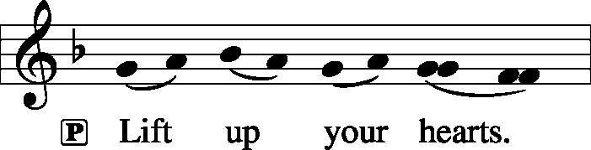

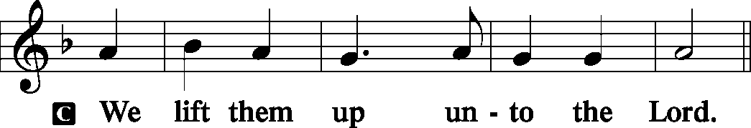
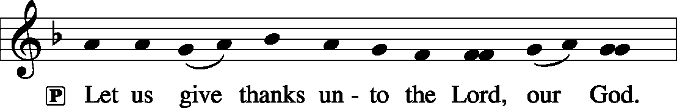
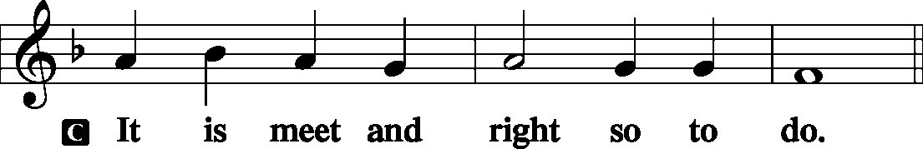

P It is truly meet, right, and salutary that we should at all times and in all places give thanks to You, holy Lord, almighty Father, everlasting God, through Jesus Christ, our Lord, who on this day overcame death and the grave and by His glorious resurrection opened to us the way of everlasting life. Therefore with angels and archangels and with all the company of heaven we laud and magnify Your glorious name, evermore praising You and saying:

Sanctus Isaiah 6:3; Matthew 21:9
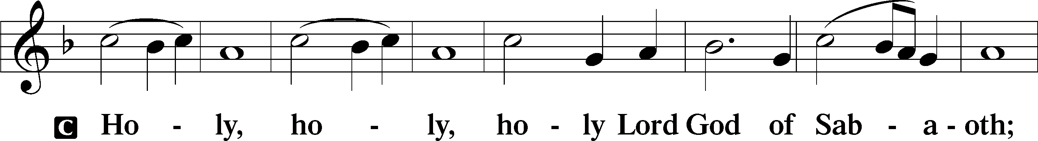
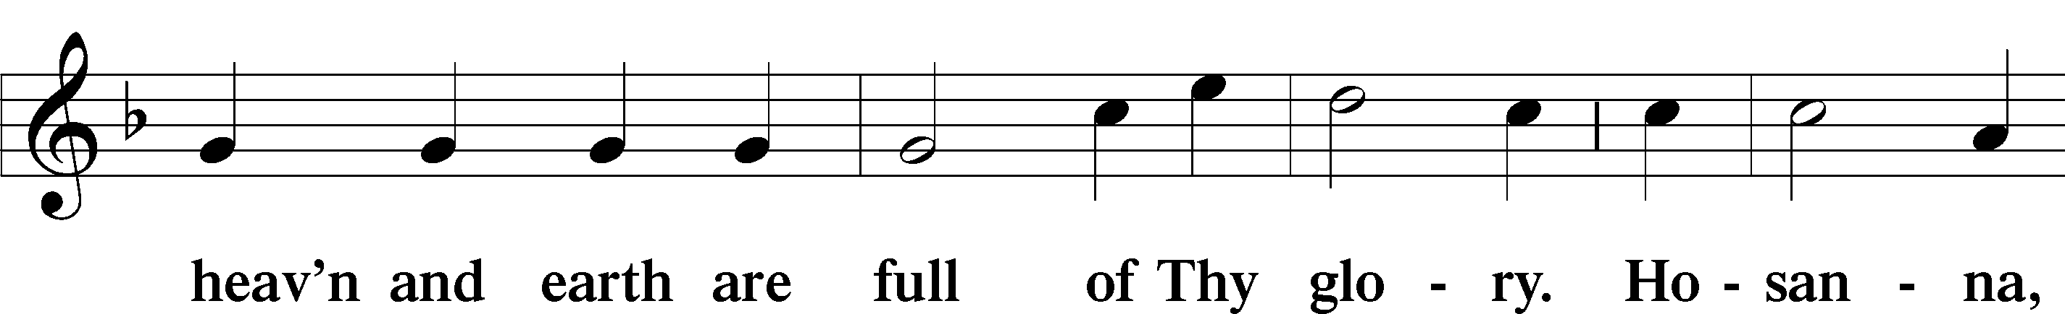
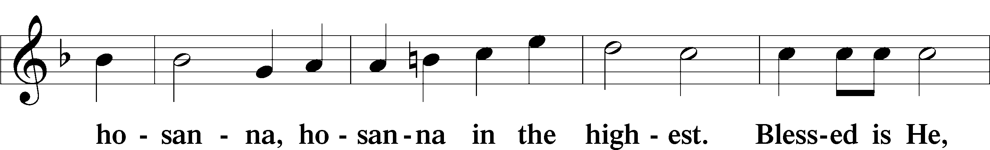
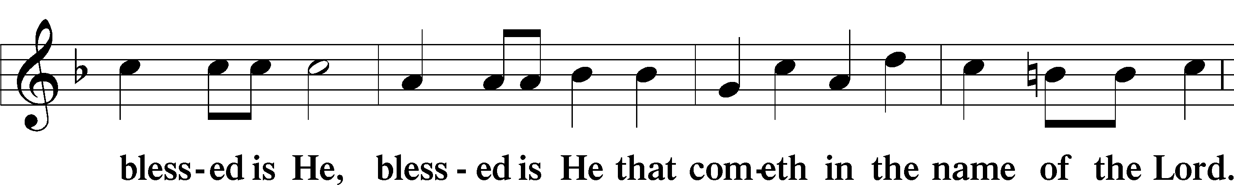
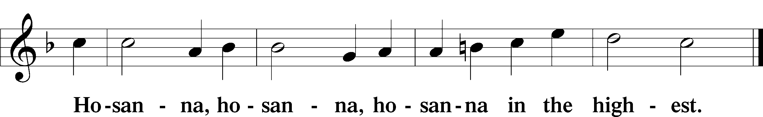

Lord’s Prayer Matthew 6:9-13
P Our Father who art in heaven,
Hallowed be Thy name,
Thy kingdom come,
Thy will be done on earth as it is in heaven;
Give us this day our daily bread;
And forgive us our trespasses as we forgive those who trespass against us;
And lead us not into temptation,
But deliver T us from evil.

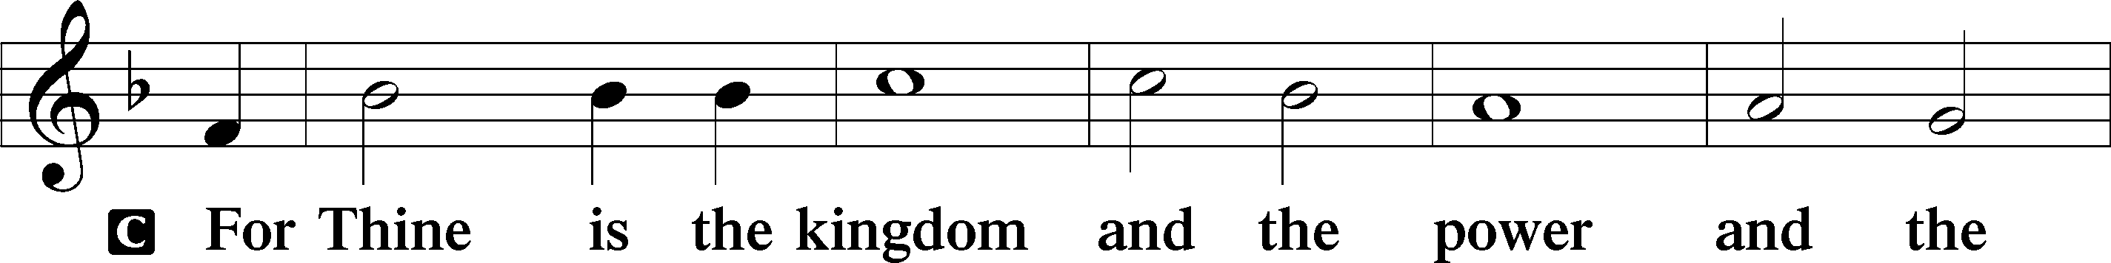
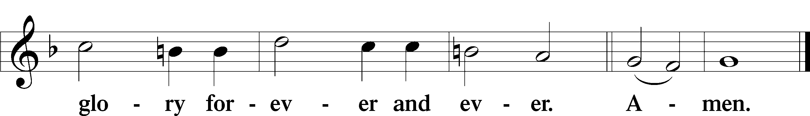

The Words of Our Lord Matthew 26:26–28
P Our Lord Jesus Christ, on the night when He was betrayed, took bread, and when He had given thanks, He broke it and gave it to the disciples and said: “Take, eat; this is My T body, which is given for you. This do in remembrance of Me.”
In the same way also He took the cup after supper, and when He had given thanks, He gave it to them, saying: “Drink of it, all of you; this cup is the new testament in My T blood, which is shed for you for the forgiveness of sins. This do, as often as you drink it, in remembrance of Me.”

Pax Domini John 20:19
P The peace T of the Lord be with you always.
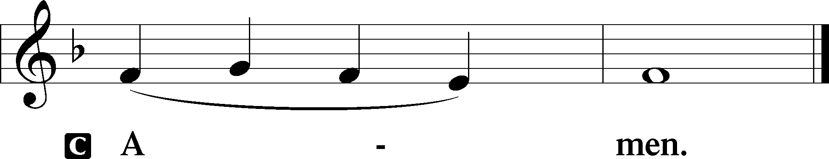

Agnus Dei John 1:29
The congregation is invited to sing in parts.
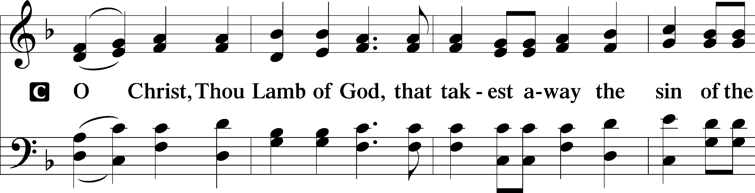
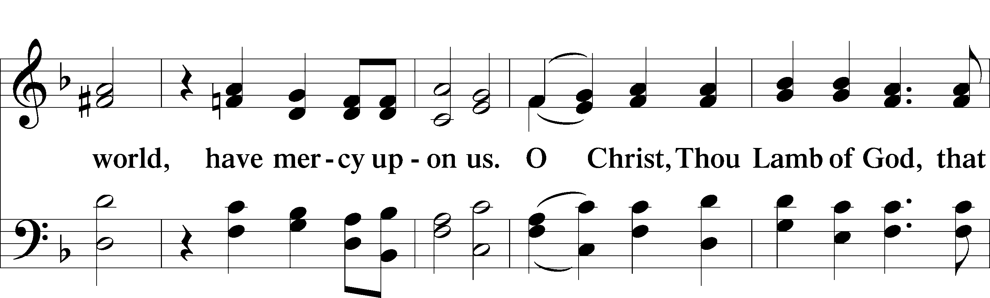
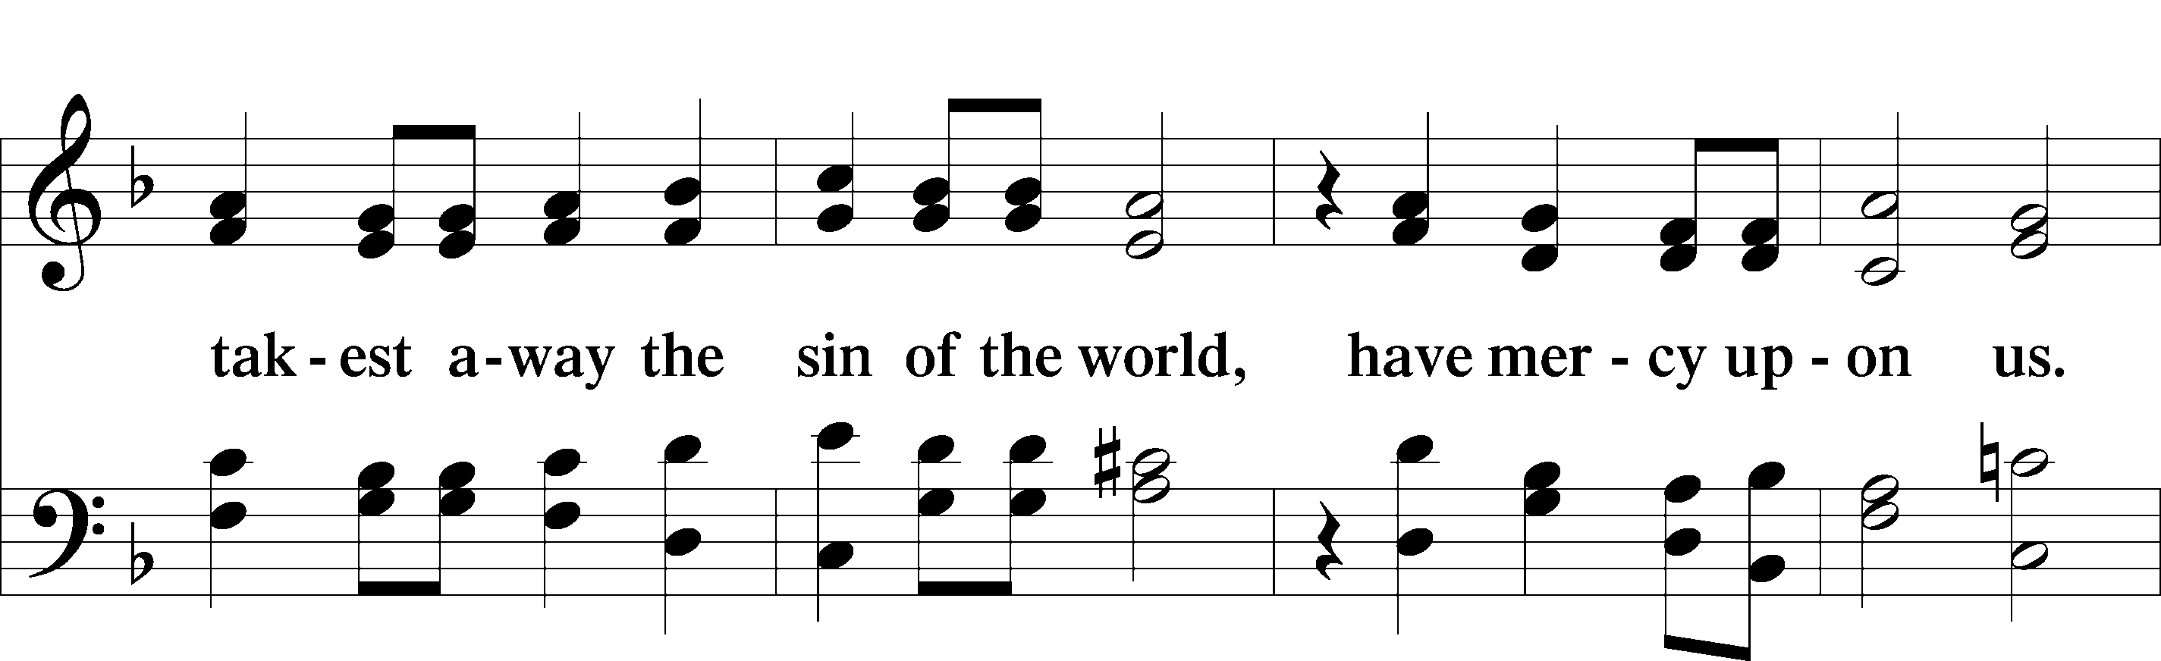
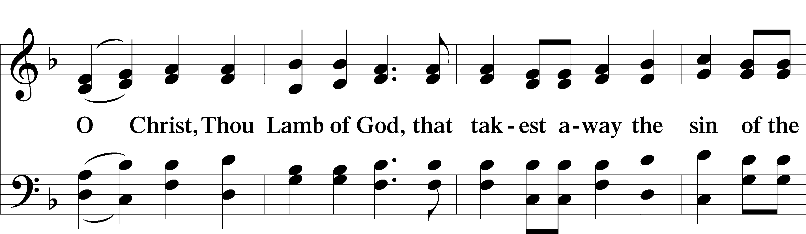
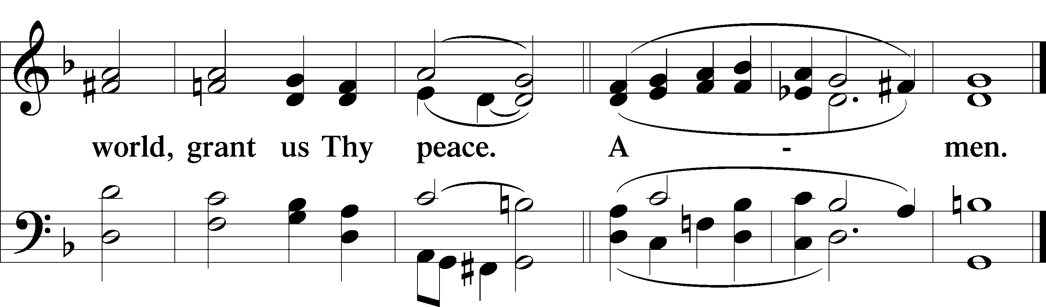
Please be seated

Distribution of the Sacrament
All who are members in good standing of the Lutheran Church - Missouri Synod and have introduced themselves to one of the pastors are welcome to partake of the Holy Communion at Christ Lutheran. If you have not spoken to a pastor, but would like to receive the Lord's blessing, you may still come to the rail and kneel, crossing one arm over the other in the shape of an 'X'. This symbolizes that one is marked by the cross and Triune name of Almighty God.

Distribution Hymns
Soul, Adorn Yourself with Gladness #636, St. 1-5

Please stand following distribution of communion

Nunc Dimittis Luke 2:29-32
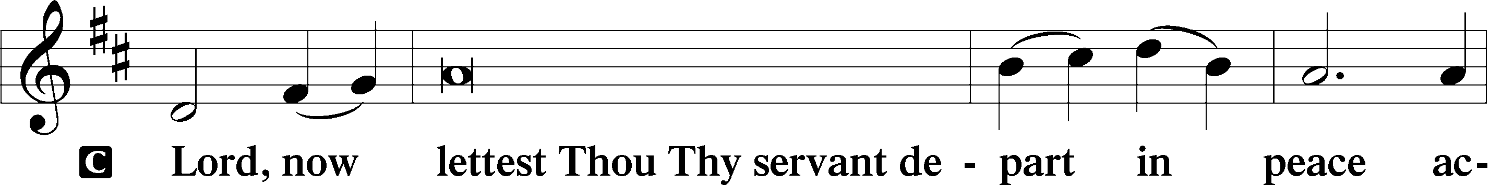
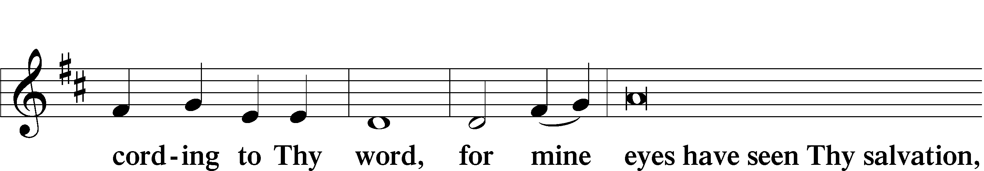
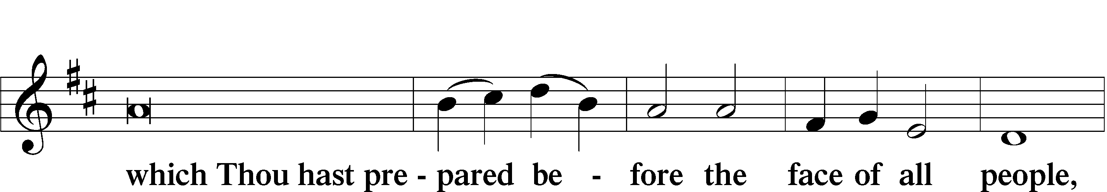
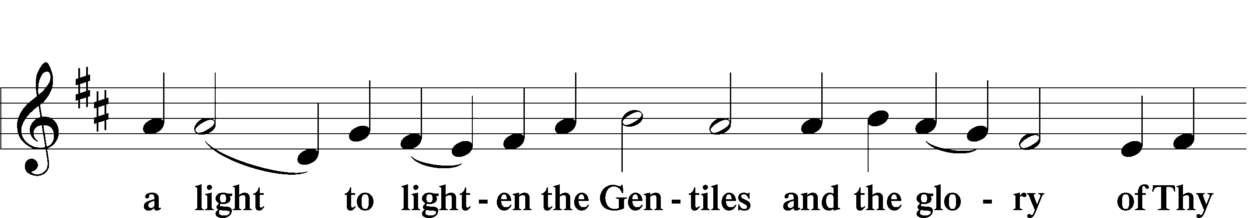
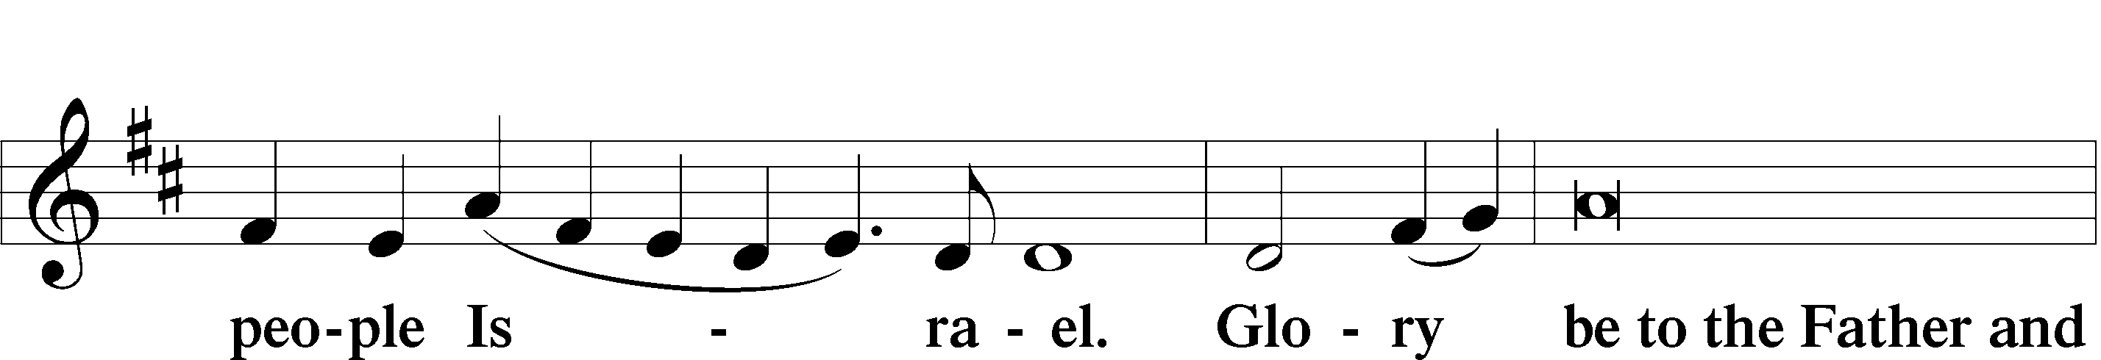
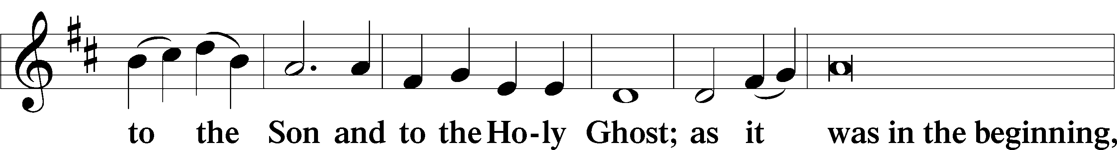
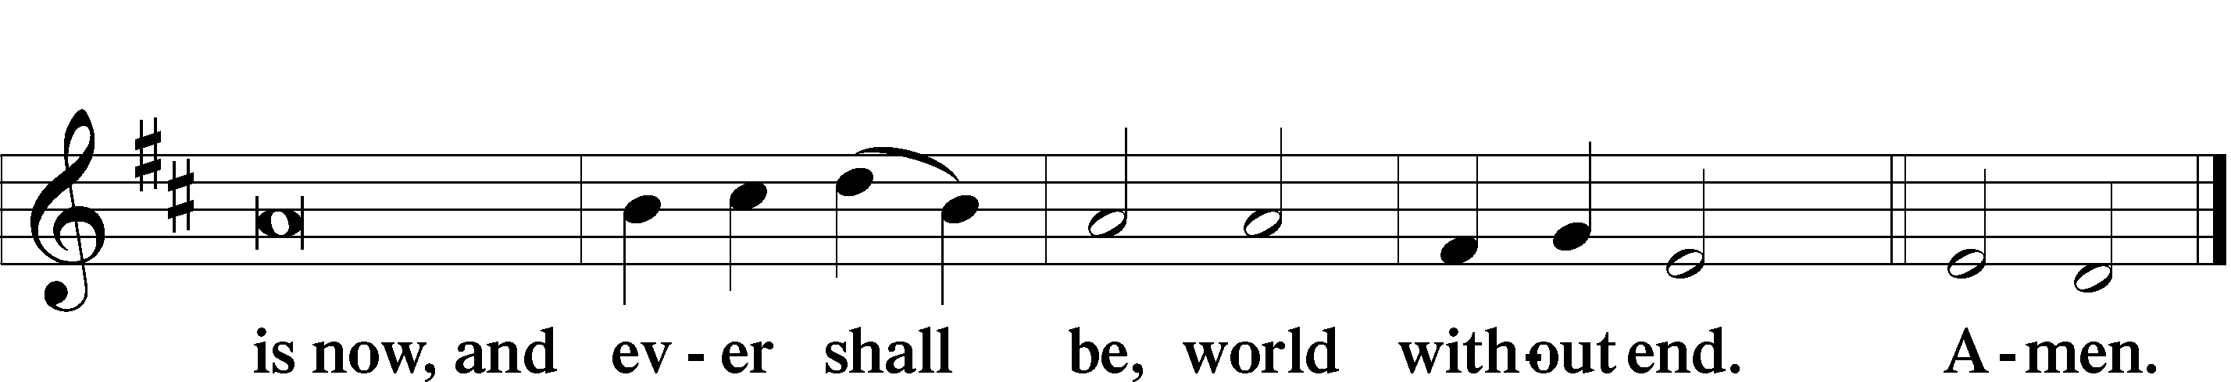

Thanksgiving
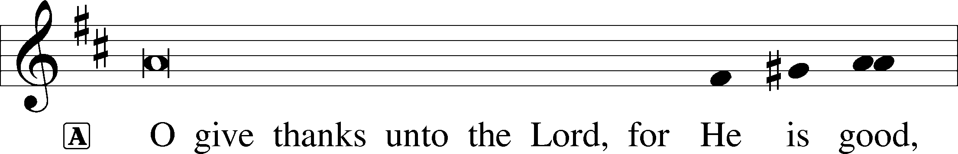
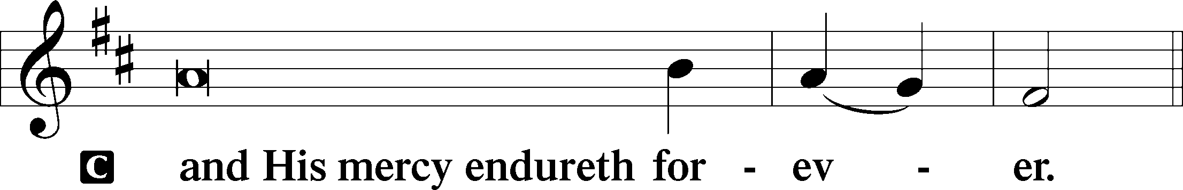

Post-Communion Collect
A We give thanks to You, almighty God, that You have refreshed us through this salutary gift, and we implore You that of Your mercy You would strengthen us through the same in faith toward You and fervent love toward one another; through Jesus Christ, Your Son, our Lord, who lives and reigns with You and the Holy Spirit, one God, now and forever.


Salutation and Benedicamus
P The Lord be with you.
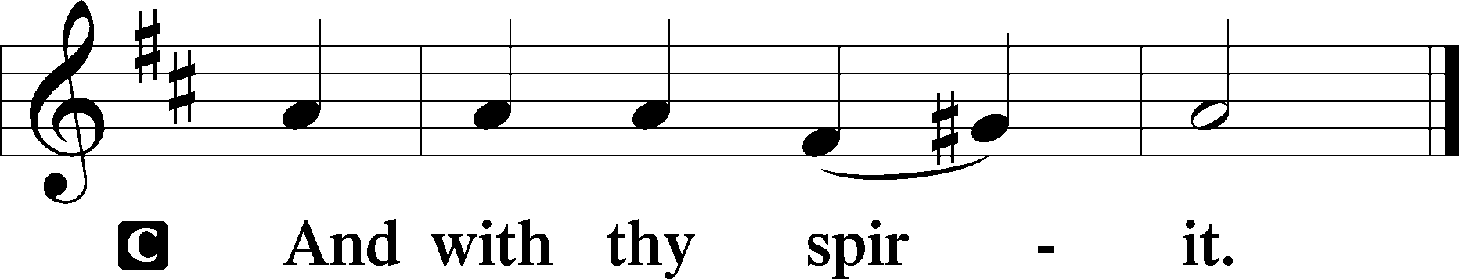
P Bless we the Lord.
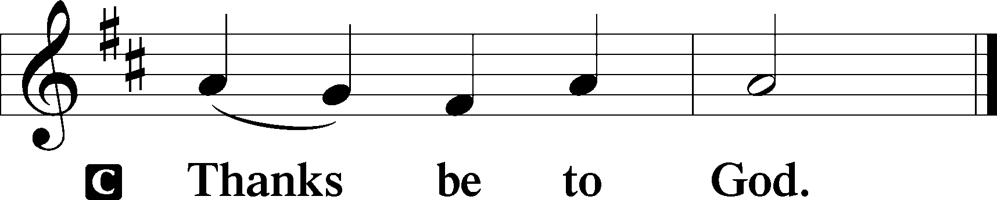
Benediction Numbers 6:24–26
P The Lord bless you and keep you.
The Lord make His face shine upon you and be gracious unto you.
The Lord lift up His countenance upon you and T give you peace.
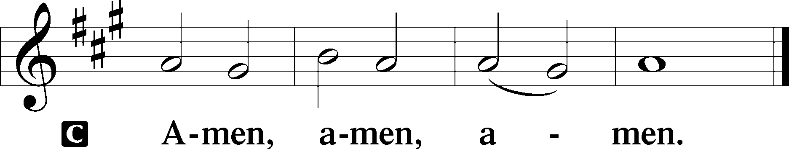

Closing Hymn Be Still, My Soul #752

Acknowledgments
Divine Service, Setting Three from Lutheran Service Book © 2006 Concordia Publishing House. Reprinted with permission. Unless otherwise indicated, all scripture quotations are from The Holy Bible, English Standard Version, copyright © 2001 by Crossway Bibles, a division of Good News Publishers. Used by permission. All rights reserved. Created by Lutheran Service Builder © 2006 Concordia Publishing House.

Serving Today:
Celebrant: Rev. George Fields Lector: Chris Burkhalter
Acolyte: Emily Held Organist: Sr. Sara Fields
Interpreter: Cathy Brown Cantor: Rush Agent, Keith Martin
Ushers: Allen Goodlett, Eric Held; Jonathan Kettler, Mark Ochs

Altar Flowers: This morning’s altar flowers are given for the glory of God by Bob and Gloria Pedersen in celebration of the birthdays of Erica Adams and Pippa Marie Lorence.

CLC Christmas Recital: Calling all musicians! It is time to start practicing up, because the Christ Lutheran Christmas Recital is coming on Saturday, January 3! If you are interested in participating, email Sister Sara at sistersara@christlutheranjacksonms.org. All ages and levels are welcome!

Readings for next Sunday, November 22nd, the Twenty-Fifth Sunday after Pentecost:
Introit Ps. 39:4-8, 12; Psalm 95:1-7; Ezekiel 34:11-16, 20-24; 1 Corinthians 15:20-28; Matthew 25:31-46.

This week at Christ Lutheran Church: November 16 – November 22

Thursday 9:30 a.m. LifeLight: Revelation (Session 7)
Friday 6:30 a.m. Bible Study @ Christ Lutheran, Breakfast @ Broadstreet
6:30 p.m. Divine Service – The Twenty-Fifth Sunday after Pentecost
Sunday 10:30 a.m. Divine Service – The Twenty-Fifth Sunday after Pentecost

Matthew 26:26-29; Mark 14:22-25; Luke 22:14-20, 1 Corinthians 11:23
Matthew 26:28; 1 John 1:7; 1 Peter 1:18-19
1 Corinthians 11:28-32
1 Corinthians 10:17; 1 Corinthians 11:26

