Christ Lutheran Church

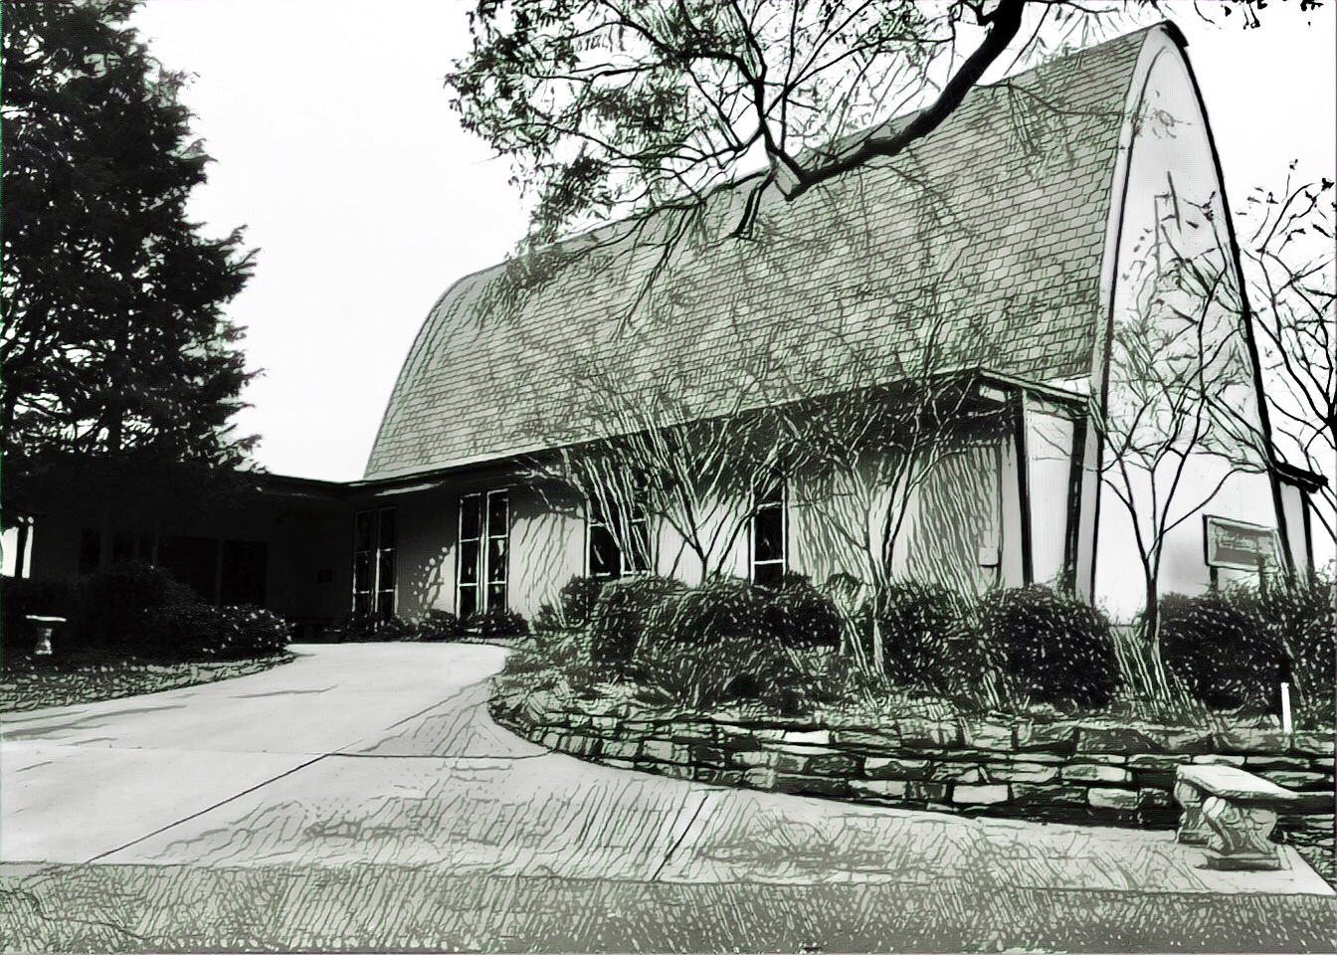

Rev. Dr. James R. Holowach, Pastor
Rev. George N. Fields, Pastor
Sr. Sara E. Fields, Deaconess
Divine Service Each Week with Holy Communion: 10:30 a.m.
Sunday School for all ages: 9:00 a.m.
4423 I-55 North, Jackson, MS 39206-6102 – (601) 366-2055
www.christlutheranjacksonms.org
The Eighteenth Sunday after Pentecost
+ October 4, 2020 +

“Let Me Sing for My Beloved”



We welcome our members and guests to Christ Lutheran today,
and pray God’s richest blessings upon you during this time of worship!

All members and our guests are asked to complete the
worship attendance pads which can be found on each pew.
Guests are also asked to sign the guest register found in the Narthex.
We are so glad to have you worshiping with us today!

LARGE PRINT worship folders are available
at the usher stand at the back of the nave.

WELCOME:
“The Lord planted the Israelites in the promised land, flowing with milk and honey, so that they would bear the fruit of the commandments of God. ‘He surrounded it with a hedge’ means that God fortified it with the protection of angels. The wine press he dug signifies the holy church, where the fruit of righteousness and holiness is gathered; just as the grapes are pressed only with great toil and effort, so also the holy martyrs are crushed like grapes and shed their blood only through great persecutions and tortures. The tower constructed in the middle of the vineyard is the Lord Himself, who appeared like a strong tower in the midst of the holy church through the Virgin. Because of His presence, all the saints and martyrs are protected with spiritual weapons from the most wicked enemy, who is the devil.”
–Epiphanius the Latin, Interpretation of the Gospels
The Lord’s Supper

In preparation for reception of the Lord’s Supper (Holy Communion), it is important that we review and understand what the Bible teaches regarding this sacrament:
The Bible teaches that Jesus gives us His very body and blood along with bread and wine in Holy Communion, and that these are means by which He forgives our sins, and strengthens us for daily living, and draws us into closer fellowship with Him and other believers. The Bible also teaches us to examine ourselves prior to receiving the meal. For those receiving Holy Communion, examine yourself with these questions:
Do I believe that I am a sinner and I am sorry for my sins?
Do I believe that Jesus Christ is God’s Son and my personal Savior?
Do I believe that Christ’s true body and blood are present in this holy meal for my forgiveness?
Do I truly intend with the help of God to correct my sinful life?
According to Christ’s Word in the Holy Scriptures, and in confession with the true Christian faith, at Christ Lutheran we observe the practice of closed communion. We believe that all who commune must confess the same holy faith, as Holy Scripture teaches. Since one’s church affiliation indicates an individual’s confession of faith, we ask that only those who have been instructed in the above teaching and are confirmed members of The Lutheran Church – Missouri Synod commune. If you have not been instructed in this teaching on Holy Communion, are in doubt, or hold a different confession of faith, you are still welcome to come forward and cross your arms to indicate that you would like a blessing.

Divine Service III

Preservice Music
The congregation may use this time to pray and meditate.

Opening Hymn Oh, How Great Is Your Compassion #559

Confession & Absolution
The sign of the cross may be made by all in remembrance of their Baptism.

P In the name of the Father and of the T Son and of the Holy Spirit.
C Amen.

P Beloved in the Lord! Let us draw near with a true heart and confess our sins unto God our Father, beseeching Him in the name of our Lord Jesus Christ to grant us forgiveness.

P Our help is in the name of the Lord,
C who made heaven and earth.
P I said, I will confess my transgressions unto the Lord,
C and You forgave the iniquity of my sin.

Silence for reflection on God's Word and for self-examination.

P O almighty God, merciful Father,
C I, a poor, miserable sinner, confess unto You all my sins and iniquities with which I have ever offended You and justly deserved Your temporal and eternal punishment. But I am heartily sorry for them and sincerely repent of them, and I pray You of Your boundless mercy and for the sake of the holy, innocent, bitter sufferings and death of Your beloved Son, Jesus Christ, to be gracious and merciful to me, a poor, sinful being.

P Upon this your confession, I, by virtue of my office, as a called and ordained servant of the Word, announce the grace of God unto all of you, and in the stead and by the command of my Lord Jesus Christ I forgive you all your sins in the name of the Father and of the T Son and of the Holy Spirit.
C Amen.

Service of the Word

Introit: Alleluia, Confitemini Domino Psalm 118:22-24; Ant. Psalm 118:1

Oh give thanks to the Lord, for | he is good;*
for his steadfast love endures for- | ever!
The stone that the builders re- | jected*
has become the | cornerstone.
This is the Lord’s | doing;*
it is marvelous | in our eyes.
This is the day that the | Lord has made;*
let us rejoice and be | glad in it.
Glory be to the Father and | to the Son*
and to the Holy | Spirit;
as it was in the be- | ginning,*
is now, and will be forever. | Amen.
Oh give thanks to the Lord, for | he is good;*
for his steadfast love endures for- | ever!

Kyrie Mark 10:47
The congregation is invited to sing in parts:

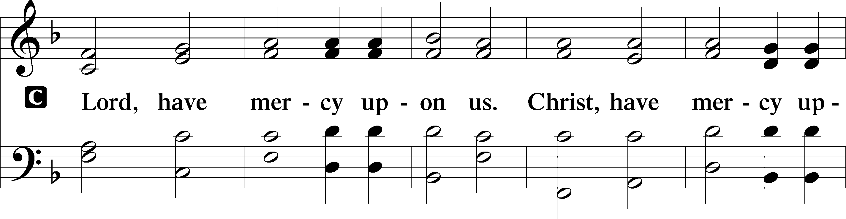
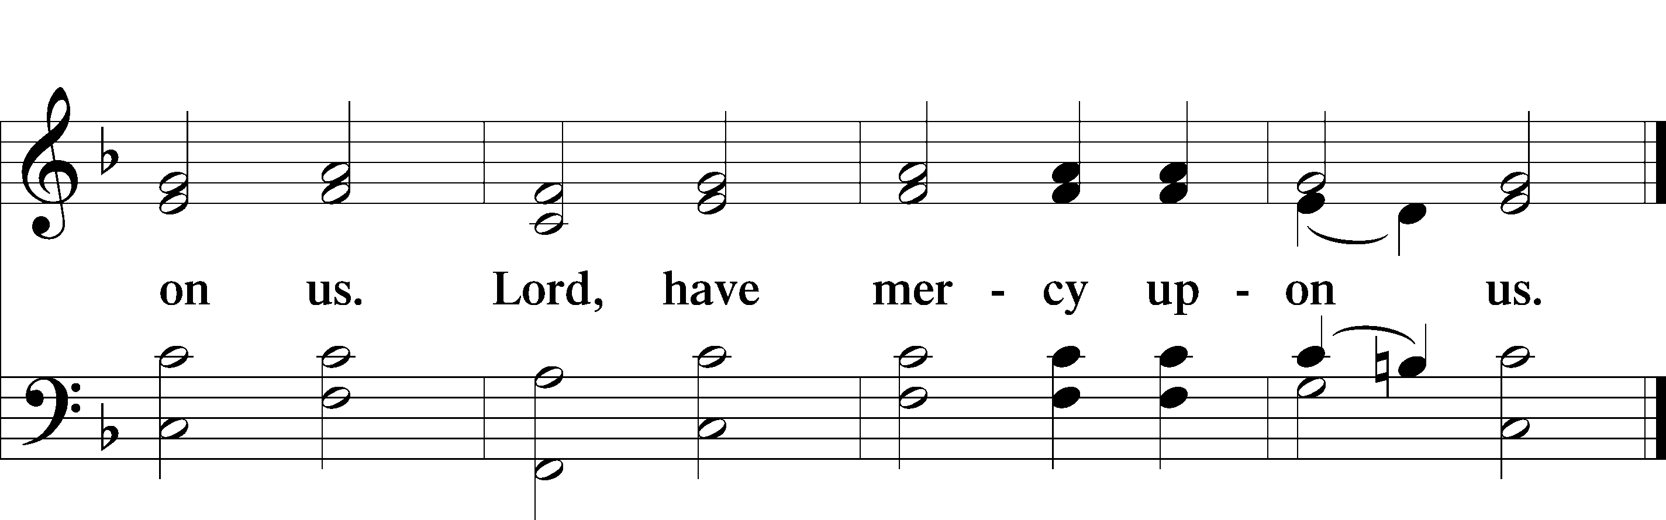

Gloria in Excelsis Luke 2:14; John 1:29
The congregation is invited to sing in parts, which can be found on LSB page 187.
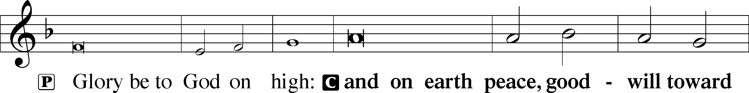
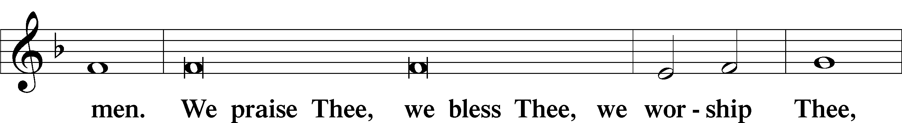
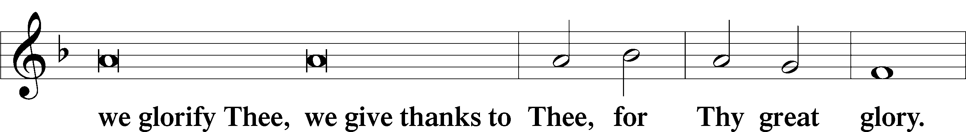
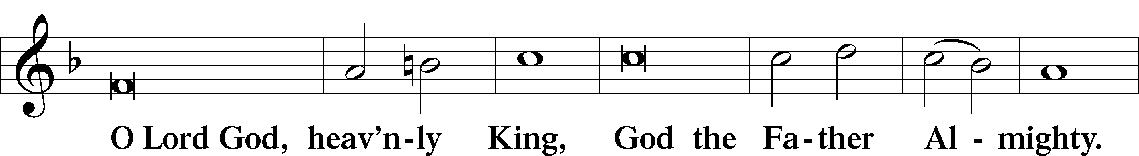
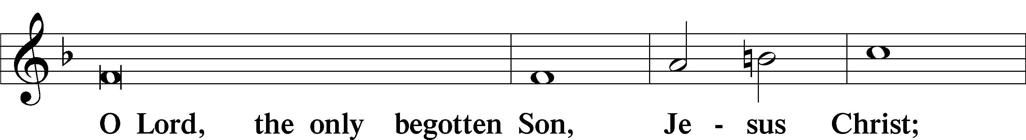
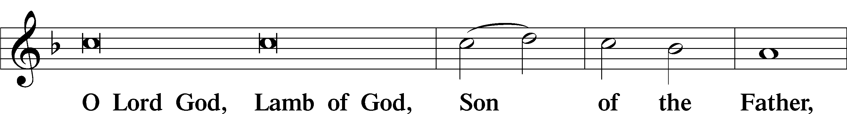
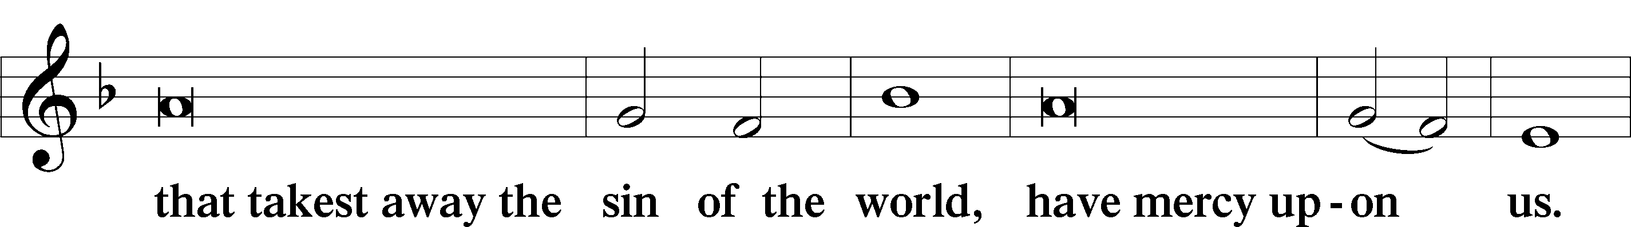
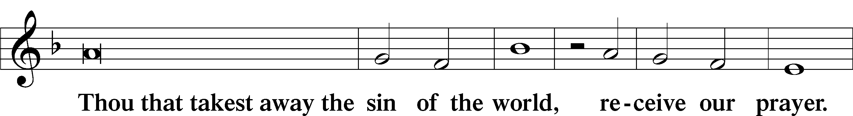
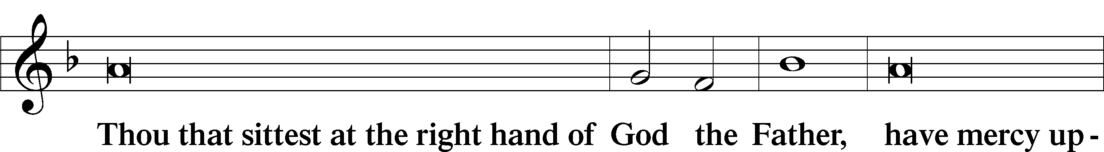
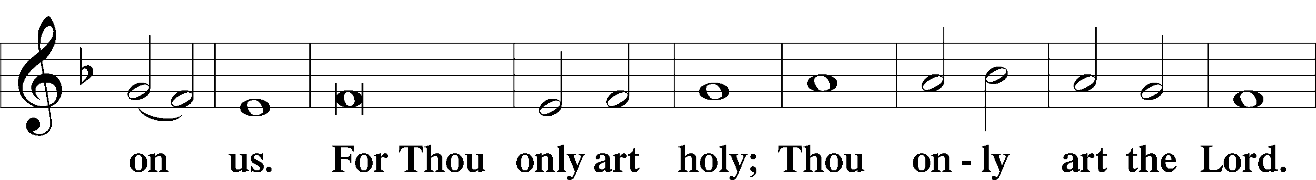
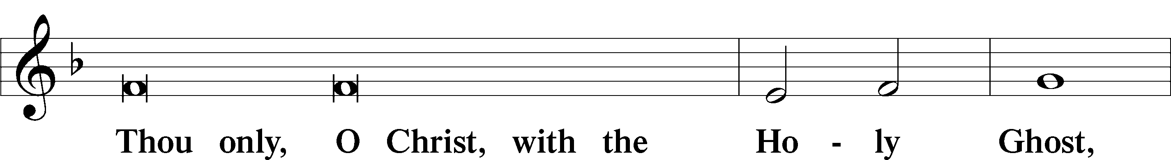
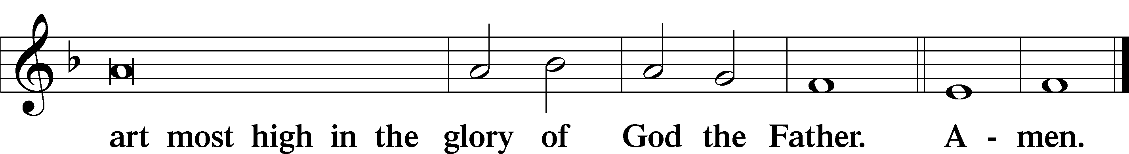

Salutation and Collect of the Day

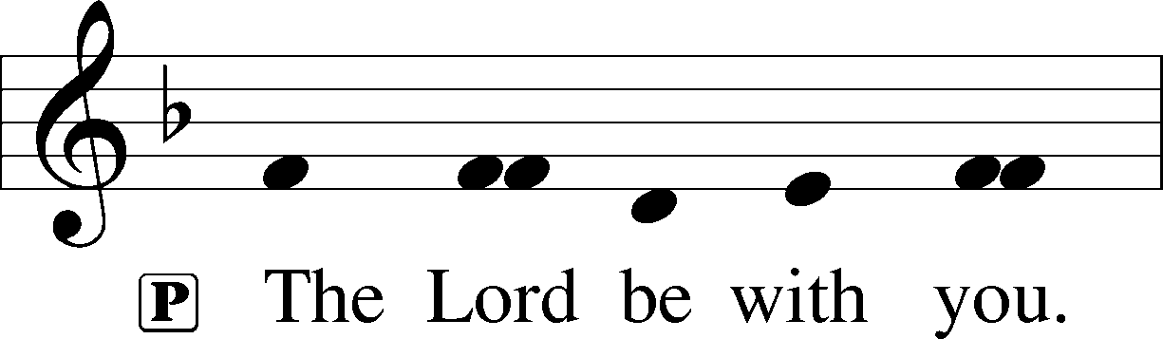
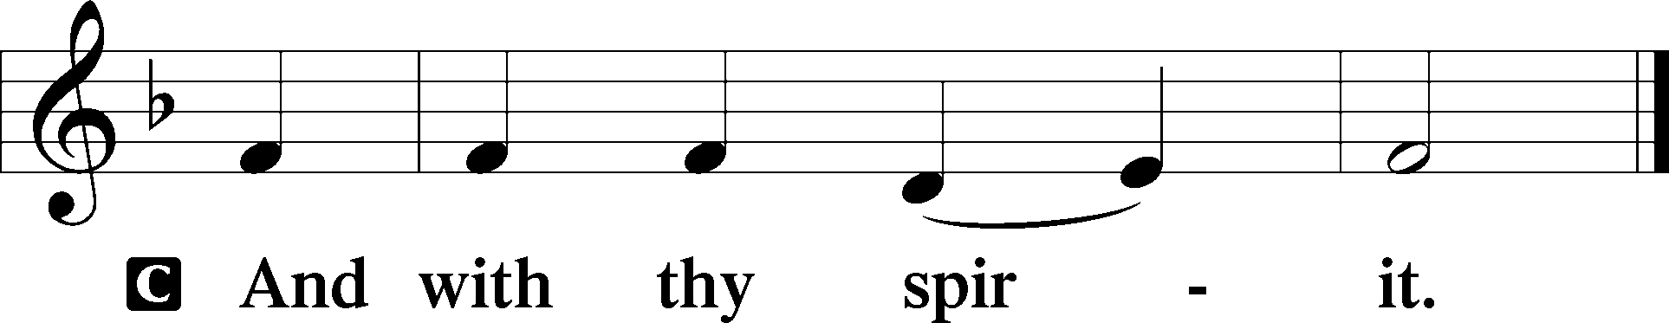

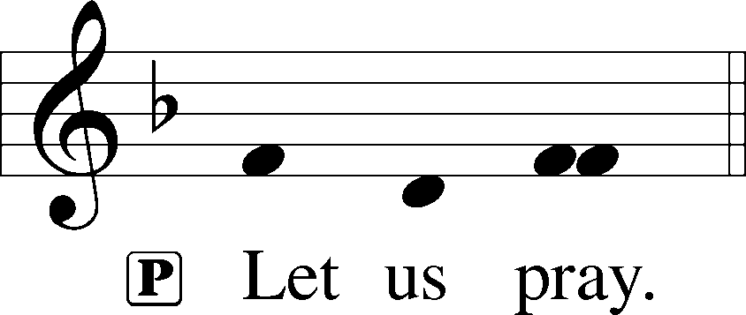

P Gracious God, You gave Your Son into the hands of sinful men who killed Him. Forgive us when we reject Your unfailing love, and grant us the fullness of Your salvation; through Jesus Christ, Your Son, our Lord, who lives and reigns with You and the Holy Spirit, one God, now and forever.

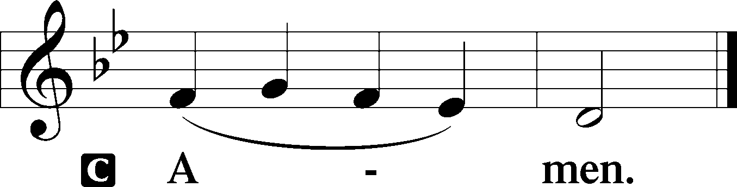

Please be seated

Old Testament Reading Isaiah 5:1-7

Let me sing for my beloved
my love song concerning his vineyard:
My beloved had a vineyard
on a very fertile hill.
He dug it and cleared it of stones,
and planted it with choice vines;
he built a watchtower in the midst of it,
and hewed out a wine vat in it;
and he looked for it to yield grapes,
but it yielded wild grapes.
And now, O inhabitants of Jerusalem
and men of Judah,
judge between me and my vineyard.
What more was there to do for my vineyard,
that I have not done in it?
When I looked for it to yield grapes,
why did it yield wild grapes?

And now I will tell you
what I will do to my vineyard.
I will remove its hedge,
and it shall be devoured;
I will break down its wall,
and it shall be trampled down.
I will make it a waste;
it shall not be pruned or hoed,
and briers and thorns shall grow up;
I will also command the clouds
that they rain no rain upon it.
For the vineyard of the Lord of hosts
is the house of Israel,
and the men of Judah
are his pleasant planting;
and he looked for justice,
but behold, bloodshed;
for righteousness,
but behold, an outcry!

A This is the Word of the Lord.
C Thanks be to God.

Gradual Psalm 91:11; 103:1
He will command his angels con- | cerning you*
to guard you in | all your ways.
Bless the Lord, | O my soul,*
and all that is within me, bless his | holy name!

Epistle Reading Philippians 3:4b-14
[T]hough I myself have reason for confidence in the flesh also. If anyone else thinks he has reason for confidence in the flesh, I have more: circumcised on the eighth day, of the people of Israel, of the tribe of Benjamin, a Hebrew of Hebrews; as to the law, a Pharisee; as to zeal, a persecutor of the church; as to righteousness, under the law blameless. But whatever gain I had, I counted as loss for the sake of Christ. Indeed, I count everything as loss because of the surpassing worth of knowing Christ Jesus my Lord. For his sake I have suffered the loss of all things and count them as rubbish, in order that I may gain Christ and be found in him, not having a righteousness of my own that comes from the law, but that which comes through faith in Christ, the righteousness from God that depends on faith— that I may know him and the power of his resurrection, and may share his sufferings, becoming like him in his death, that by any means possible I may attain the resurrection from the dead.
Not that I have already obtained this or am already perfect, but I press on to make it my own, because Christ Jesus has made me his own. Brothers, I do not consider that I have made it my own. But one thing I do: forgetting what lies behind and straining forward to what lies ahead, I press on toward the goal for the prize of the upward call of God in Christ Jesus.
A This is the Word of the Lord.
C Thanks be to God.

Please stand

Alleluia
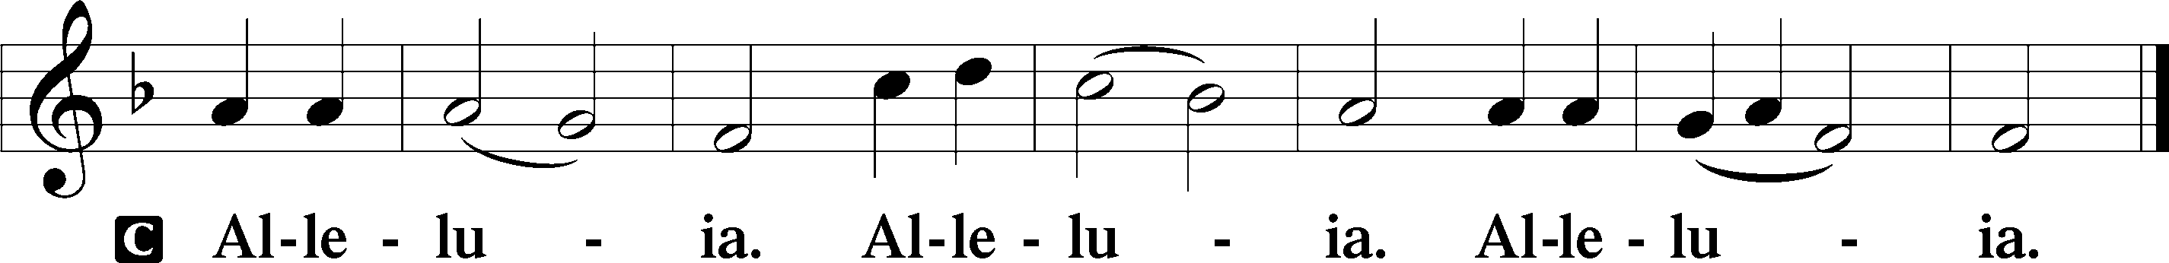

Holy Gospel Matthew 21:33-46

P The Holy Gospel according to St. Matthew, the twenty-first chapter.

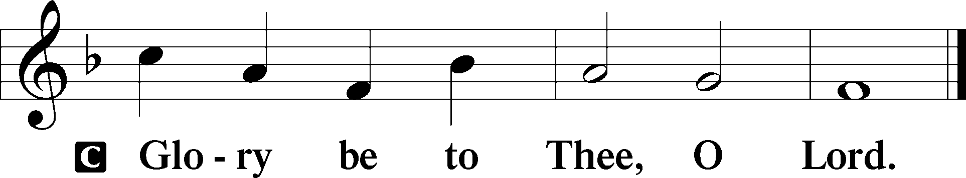
[Jesus said:] “Hear another parable. There was a master of a house who planted a vineyard and put a fence around it and dug a winepress in it and built a tower and leased it to tenants, and went into another country.
When the season for fruit drew near, he sent his servants to the tenants to get his fruit.
And the tenants took his servants and beat one, killed another, and stoned another. Again he sent other servants, more than the first. And they did the same to them. Finally he sent his son to them, saying, ‘They will respect my son.’ But when the tenants saw the son, they said to themselves, ‘This is the heir. Come, let us kill him and have his inheritance.’ And they took him and threw him out of the vineyard and killed him. When therefore the owner of the vineyard comes, what will he do to those tenants?” They said to him, “He will put those wretches to a miserable death and let out the vineyard to other tenants who will give him the fruits in their seasons.”
Jesus said to them, “Have you never read in the Scriptures:
“‘The stone that the builders rejected
has become the cornerstone;
this was the Lord’s doing,
and it is marvelous in our eyes’?
“Therefore I tell you, the kingdom of God will be taken away from you and given to a people producing its fruits. And the one who falls on this stone will be broken to pieces; and when it falls on anyone, it will crush him.”
When the chief priests and the Pharisees heard his parables, they perceived that he was speaking about them. And although they were seeking to arrest him, they feared the crowds, because they held him to be a prophet.
P This is the Gospel of the Lord.
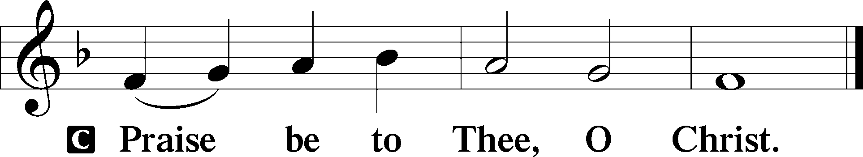

Please be seated

Office Hymn To Thee, Omniscient Lord of All #613

Sermon Come, Let Us Kill Him

Please stand

Nicene Creed

C I believe in one God, (Rom 10:10; Deut 6:4)
the Father Almighty, (Mt 6:9; Ex 6:3)
maker of heaven and earth (Gen 1:1; Jn 1:1)
and of all things visible and invisible. (Col 1:16)
And in one Lord Jesus Christ, (Rom 10:9)
the only-begotten Son of God, (Jn 3:16; Mt 16:16)
begotten of His Father before all worlds, (Jn 1:2)
God of God, Light of Light, (Jn 17:22; Jn 8:12; Jn 1:1)
very God of very God, (Col 2:9) begotten, not made, (Jn 1:2)
being of one substance with the Father, (Jn 10:30)
by whom all things were made; (Heb 1:2; Jn 1:3)
who for us men and for our salvation (1 Tim 2:4; Rom 3:23)
came down from heaven (Jn 6:41; Lk 15:20)
and was incarnate by the Holy Spirit of the virgin Mary (Lk 1:34-35)
and was made man; (Jn 1:14)
and was crucified also for us under Pontius Pilate. (Mk 15:25; Jn 19:16-18)
He suffered and was buried. (Jn 19:1-3; Lk 23:53)
And the third day He rose again according to the Scriptures (1 Cor 15:4; Lk 24:6)
and ascended into heaven (Acts 1:9)
and sits at the right hand of the Father. (Acts 7:55)
And He will come again with glory (Mt 26:64)
to judge both the living and the dead, (Acts 10:42; Mt 3:12)
whose kingdom will have no end. (2 Pt 1:11)
And I believe in the Holy Spirit, (Jn 14:26; Gen 1:2; Acts 2:38)
the Lord and giver of life, (Gen 1:2; Jn 3:6)
who proceeds from the Father and the Son, (Jn 15:26)
who with the Father and the Son together is worshiped and glorified, (Mt 3:16-17)
who spoke by the prophets. (Eze 11:5)
And I believe in one holy Christian and apostolic Church, (1 Pt 2:5; Eph 2:19-22)
I acknowledge one Baptism for the remission of sins, (Eph 4:5)
and I look for the resurrection of the dead (1 Cor 15:35-49; 1 Thess 4:13-18)
and the life T of the world to come. (Mk 10:29-30; Mt 10:40-42)
Amen. (Ps 106:48)
Us men means all people.
Christian: the ancient text reads “catholic,” meaning the whole Church as it confesses the wholeness of Christian doctrine

Prayer of the Church

After each petition of the prayer:
Pastor: Lord, in Your mercy,
People: Hear our prayer.

For comfort, health and recovery: Thomas John Crane, Doug Gilmore, Donna Goldsmith, Paul Hansen, Kenny Solheim, John Unger;
For those who mourn: The family and friends of Donald Lofton;
For those who are ill or distressed: Stan Acey, Jenalee Adams, Kimberly Airhart, Layne Bagley, Rose Bagley, Shirley Bagley, W.L. Bagley, Sarah Bowman, Mimi Bradley, Richard Bradley, Deloris Brent, Martha Brown, Nathan Brown, Tina Burke, Wayne Burke, Paula Burkhalter, Bobby Carroll, Arthur Collins, James E. Cookston, Joan Cowards, Belinda Cowards-Gonzales, Robert (Andy) Evers, Michele Rae Fowler, Randy Fowler, Parker Haines, Dan Hansen, Paul Hansen, Tim Hansen, Valerie Henderson, Sharon Holleman, Beth Jarratt, Elaine Johnson, Joslyn Jones, Steve Kennedy, Arlene Kleinschmidt, Eleanor Koster, John Koster, Sandra Landers, Katelyn Lawing, Peggy Lucky, Paul McCullough, Jerry McIntyre, Jerry McMahan, Mark Millard, Edlia Miller, Mark Miller, Elaine Monaghan, Lindberg Moore, Jerry Mutter, Don Ochs, Mildred Odom, Deborah-Annette Ried, Elmira Roever, Jon Sandberg, Noah Schultz, Johnnie Pearl Smiley, Bob Smith, Sally Smith, Sam Schneider, Sherri Smith, Deborah Springer, MariLyn Unger, Betty Venator, Leonard Watson, Cynthia Widlitze, Carol Wright, Jimmy Wright, Marshall Wright, Barbara Zeigler;
For college and graduate students: Jake Everly, Sara Fields, Jonathan Kettler, Roselynn Nelson, Will Nelson;
For military servants and their families: Gabriel Escude, James (Glen) Hansford, Holden Hathcock, Christopher Martin, William Nelson, Steven Tatum, John Weidner Jr.;
For foreign missionaries: David and Shelee Warner;
This week’s prayer family: Bob & Gloria Pedersen and their loved ones.

Please be seated

Offering

Offertory Psalm 51:10-12
The congregation is invited to sing in parts:
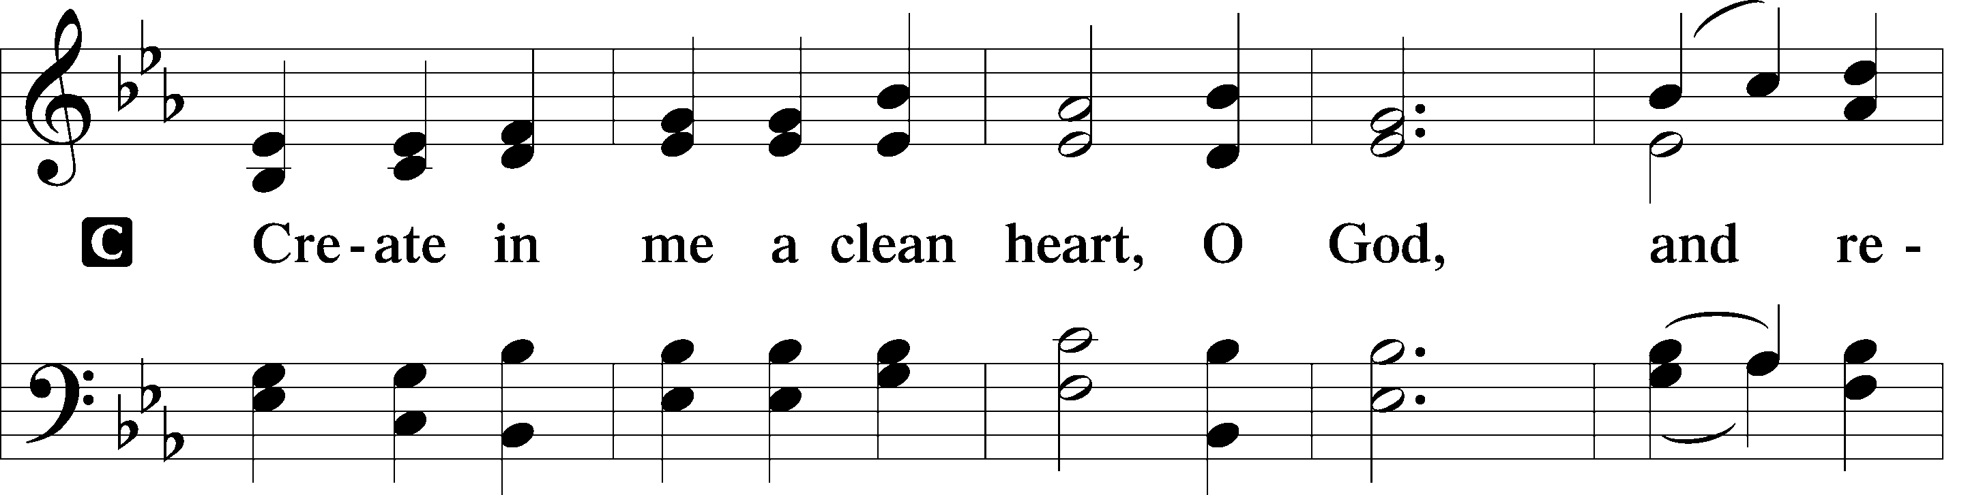
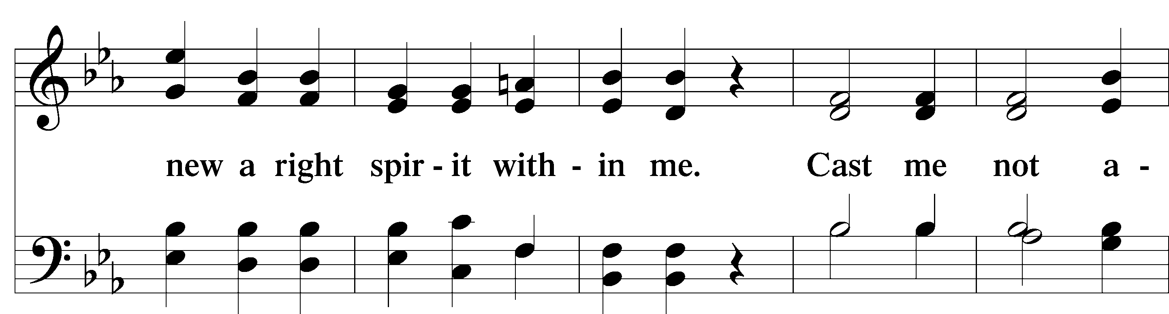
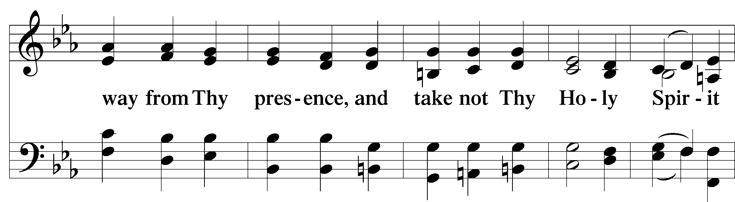
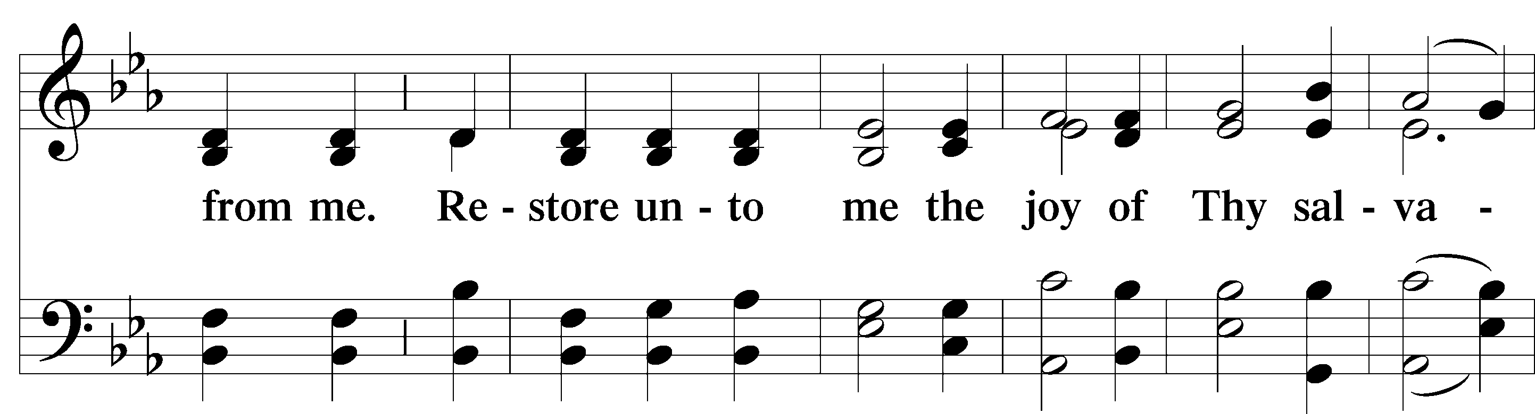
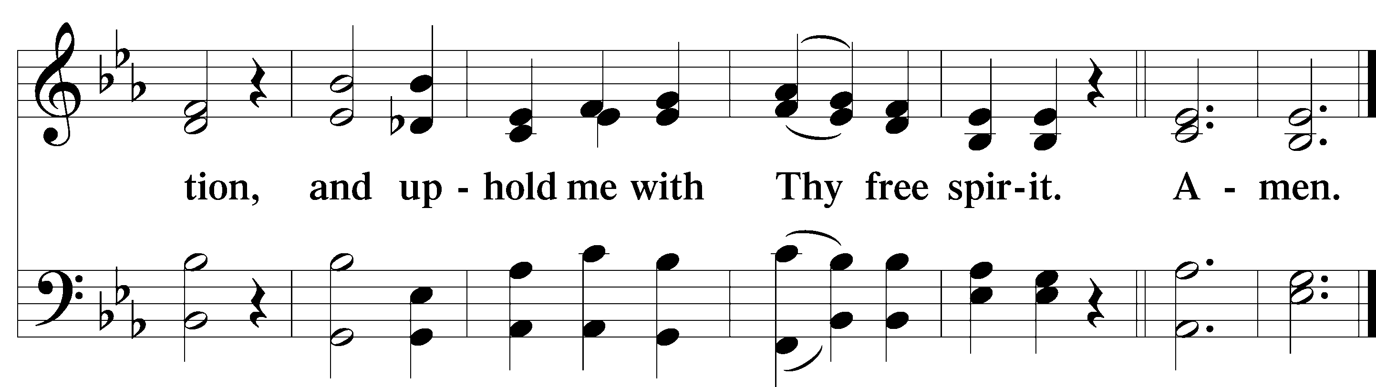
Service of the Sacrament

Preface 2 Timothy 4:22; [Colossians 3:1]; [Psalm 136]

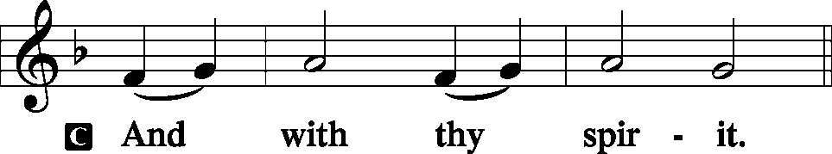
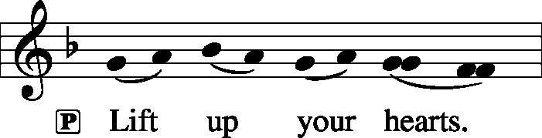

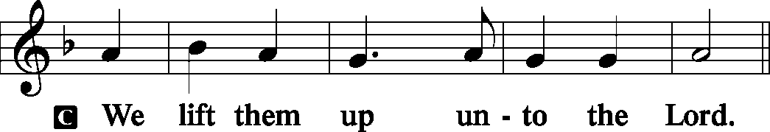
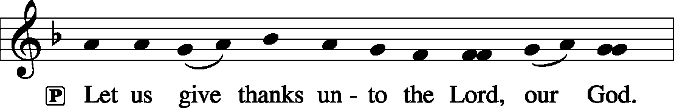
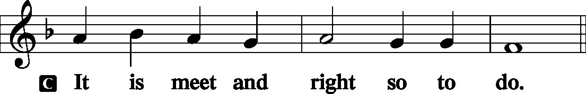

P It is truly meet, right, and salutary that we should at all times and in all places give thanks to You, holy Lord, almighty Father, everlasting God, through Jesus Christ, our Lord, who on this day overcame death and the grave and by His glorious resurrection opened to us the way of everlasting life. Therefore with angels and archangels and with all the company of heaven we laud and magnify Your glorious name, evermore praising You and saying:

Sanctus Isaiah 6:3; Matthew 21:9
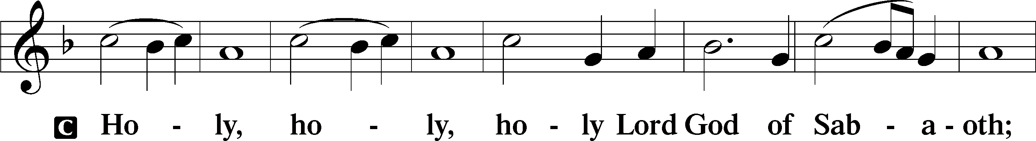
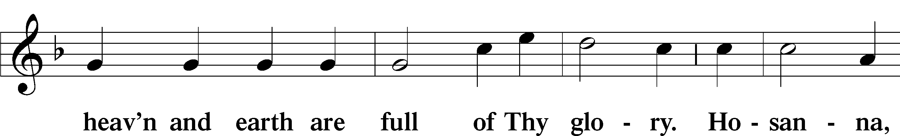
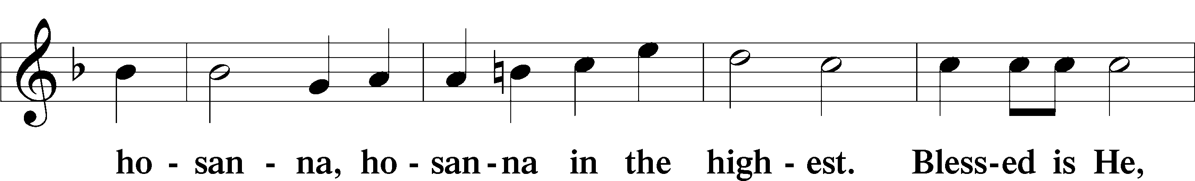
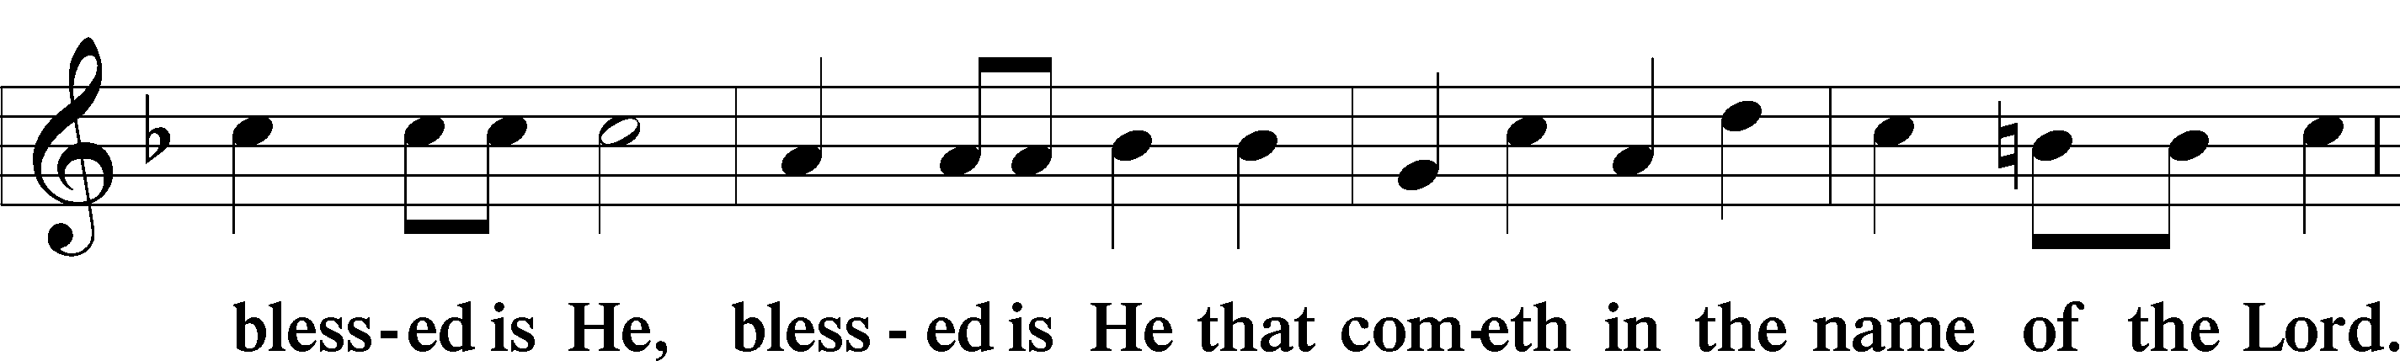
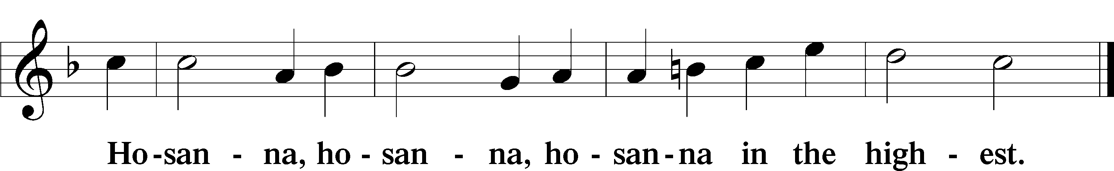

Lord’s Prayer Matthew 6:9-13
P Our Father who art in heaven,
Hallowed be Thy name,
Thy kingdom come,
Thy will be done on earth as it is in heaven;
Give us this day our daily bread;
And forgive us our trespasses as we forgive those who trespass against us;
And lead us not into temptation,
But deliver T us from evil.

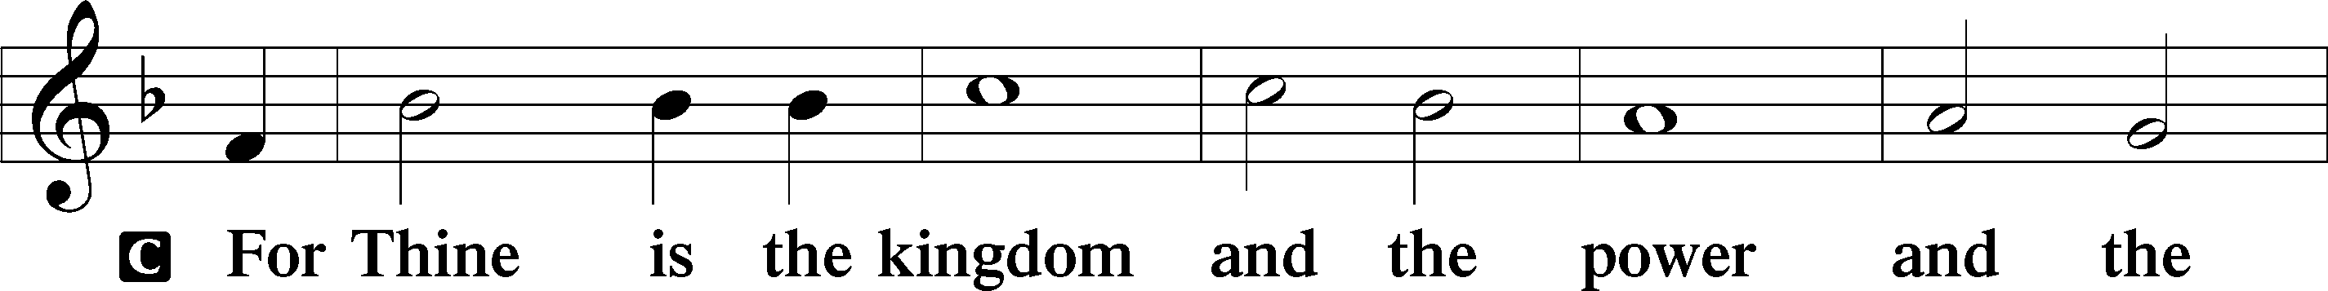
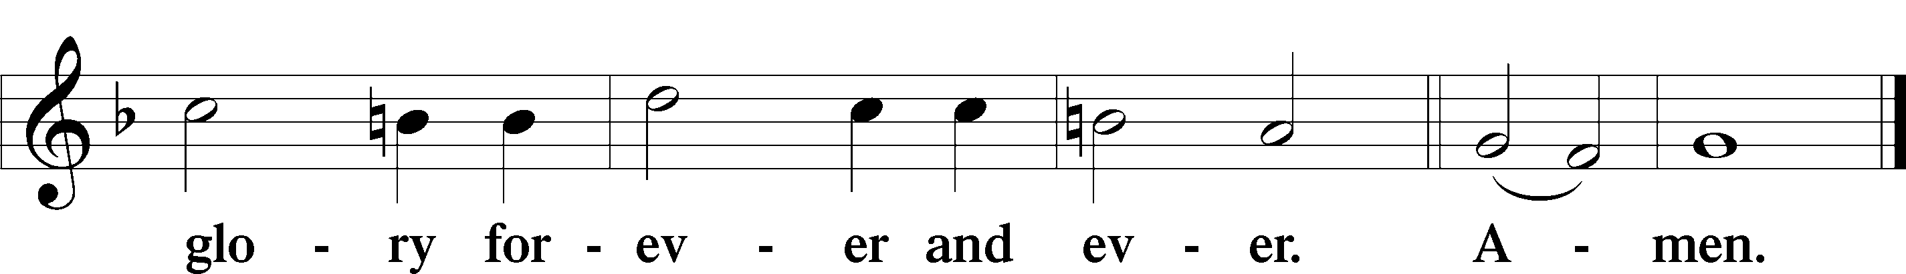
The Words of Our Lord Matthew 26:26–28
P Our Lord Jesus Christ, on the night when He was betrayed, took bread, and when He had given thanks, He broke it and gave it to the disciples and said: “Take, eat; this is My T body, which is given for you. This do in remembrance of Me.”
In the same way also He took the cup after supper, and when He had given thanks, He gave it to them, saying: “Drink of it, all of you; this cup is the new testament in My T blood, which is shed for you for the forgiveness of sins. This do, as often as you drink it, in remembrance of Me.”

Pax Domini John 20:19
P The peace T of the Lord be with you always.
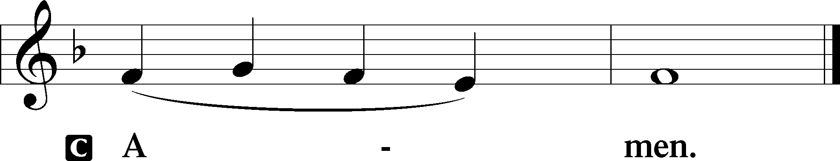

Agnus Dei John 1:29
The congregation is invited to sing in parts.
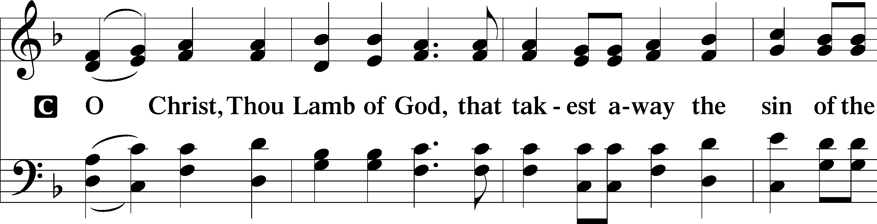
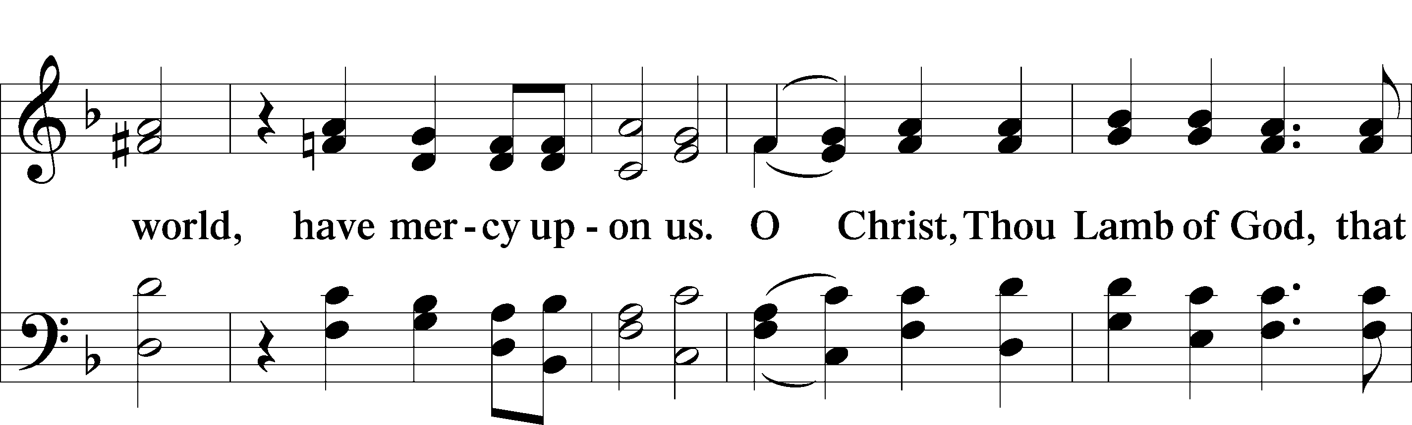
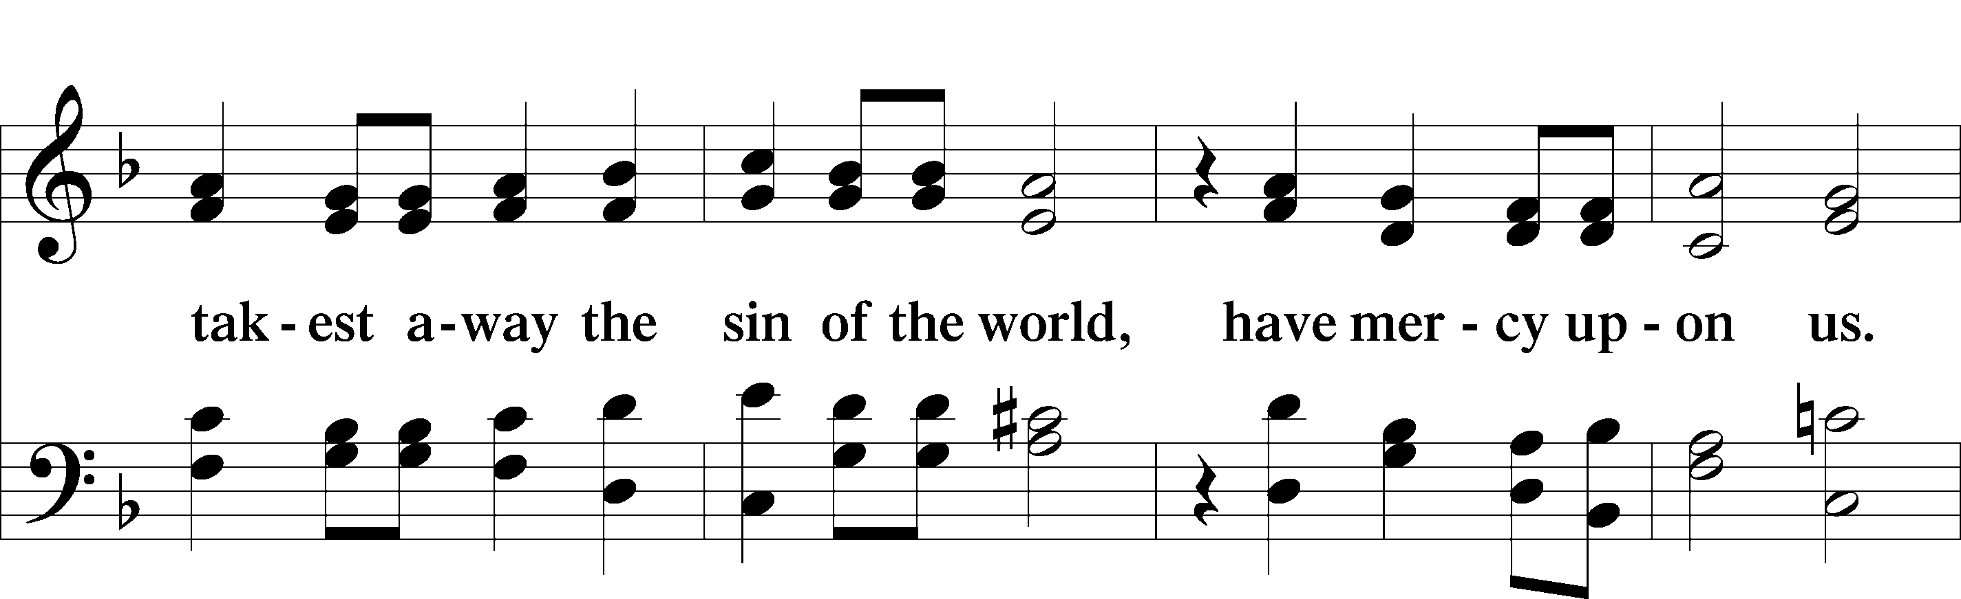
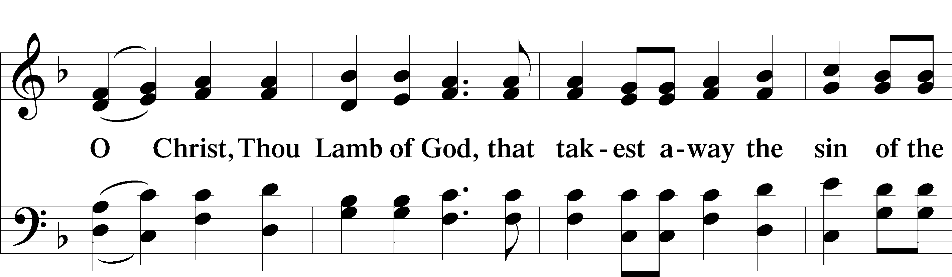
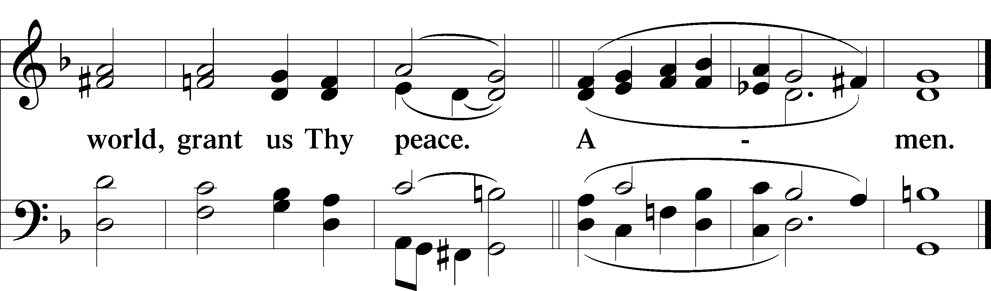
Please be seated

Distribution of the Sacrament
All who are members in good standing of the Lutheran Church - Missouri Synod and have introduced themselves to one of the pastors are welcome to partake of the Holy Communion at Christ Lutheran. If you have not spoken to a pastor, but would like to receive the Lord's blessing, you may still come to the rail and kneel, crossing one arm over the other in the shape of an 'X'. This symbolizes that one is marked by the cross and Triune name of Almighty God.

Distribution Hymns
As Rebels, Lord, Who Foolishly Have Wandered #612

Please stand following distribution of communion
Nunc Dimittis Luke 2:29-32
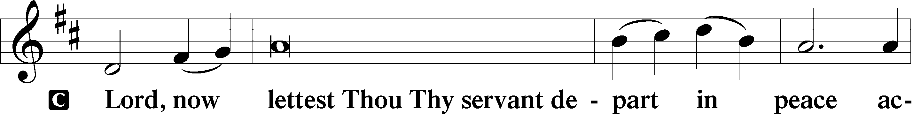
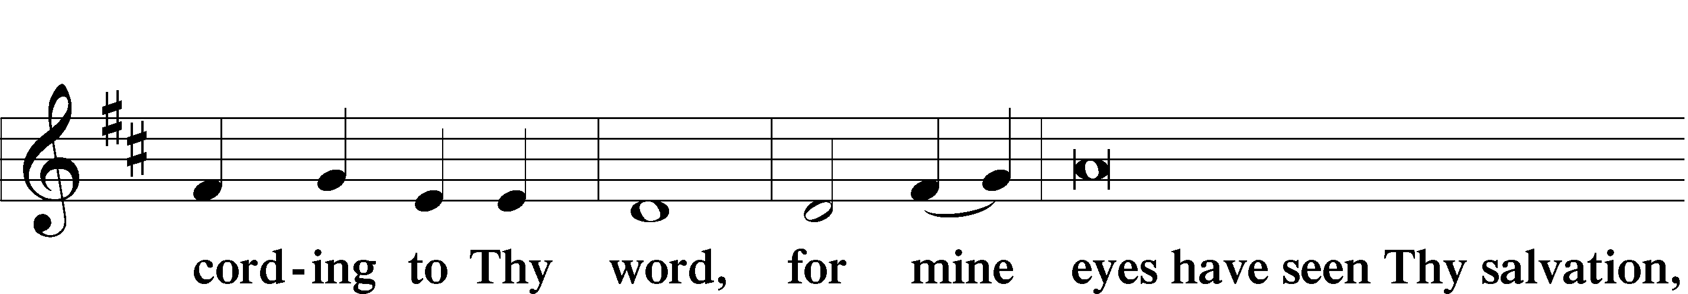
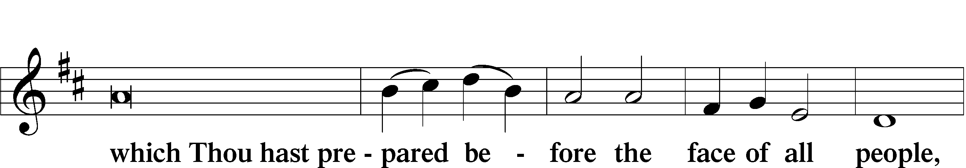
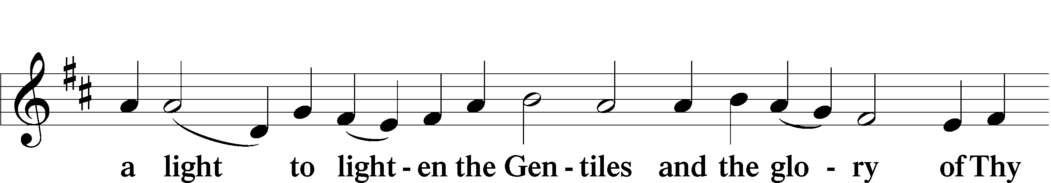
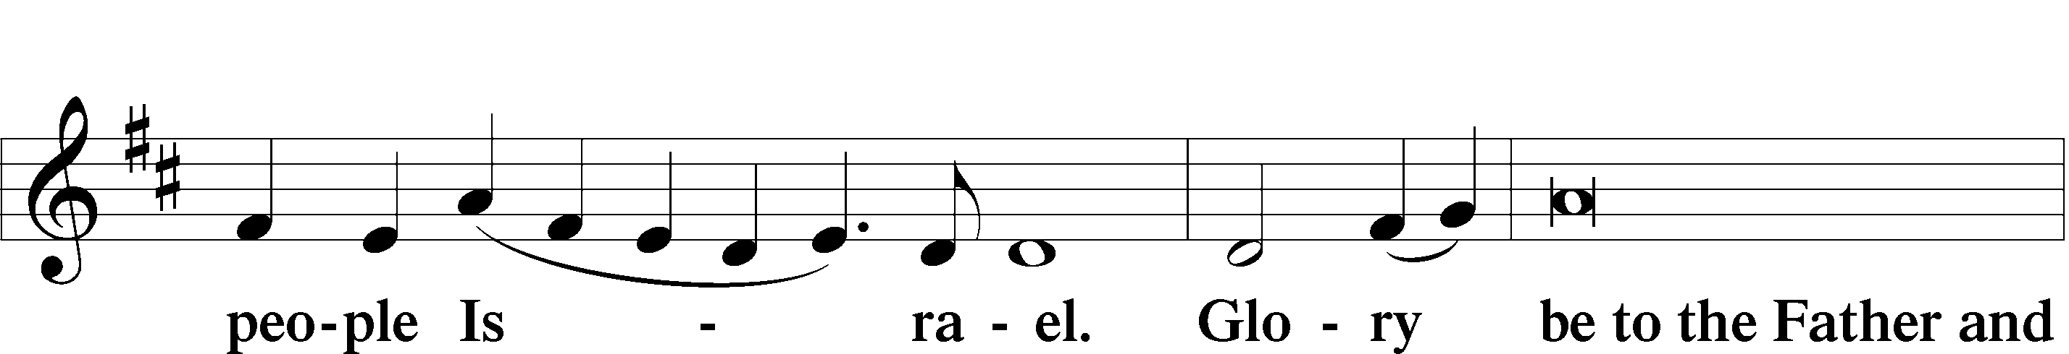
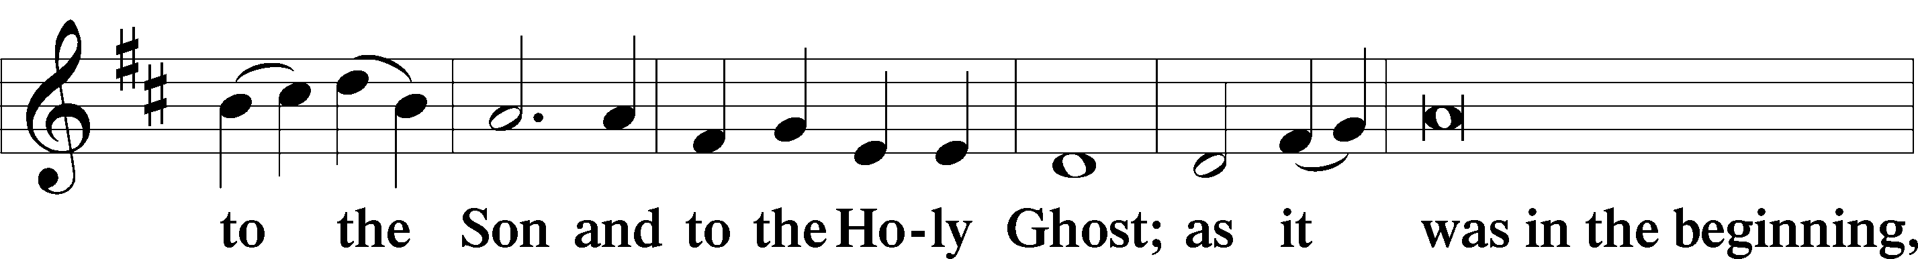
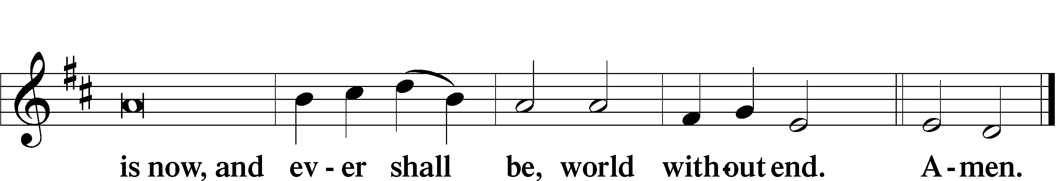

Thanksgiving
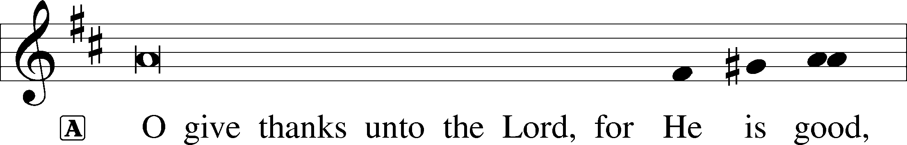
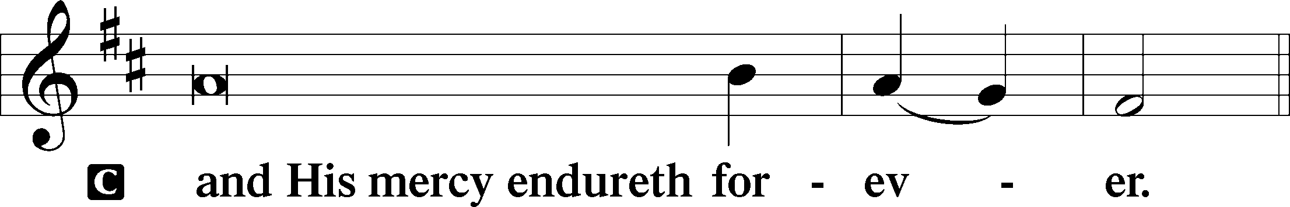
Post-Communion Collect
A We give thanks to You, almighty God, that You have refreshed us through this salutary gift, and we implore You that of Your mercy You would strengthen us through the same in faith toward You and fervent love toward one another; through Jesus Christ, Your Son, our Lord, who lives and reigns with You and the Holy Spirit, one God, now and forever.
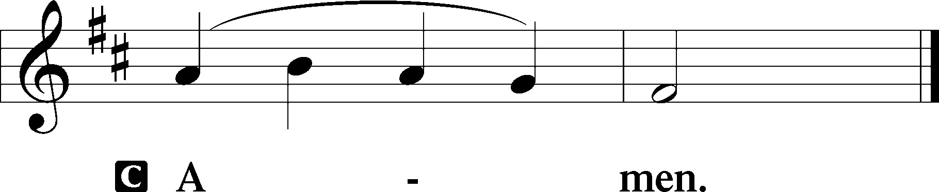

Salutation and Benedicamus
P The Lord be with you.
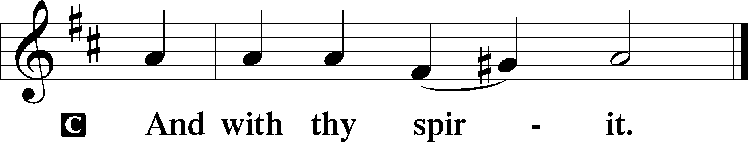
P Bless we the Lord.
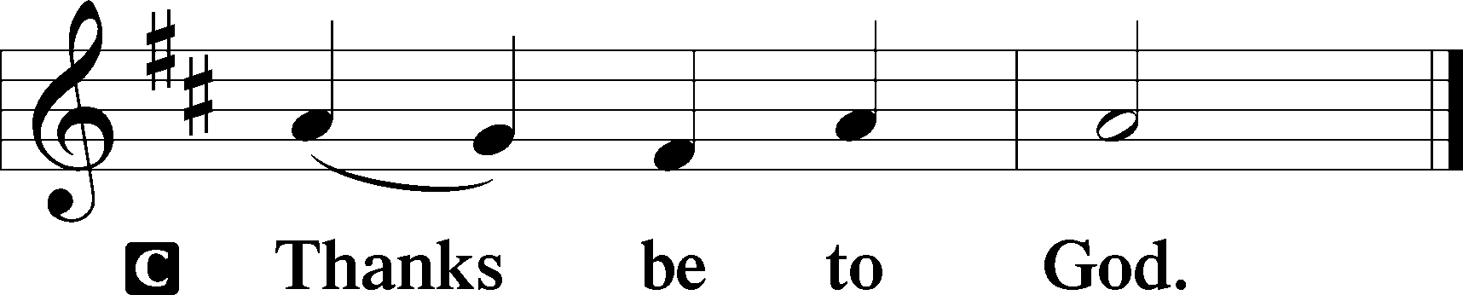

Benediction Numbers 6:24–26
P The Lord bless you and keep you.
The Lord make His face shine upon you and be gracious unto you.
The Lord lift up His countenance upon you and T give you peace.
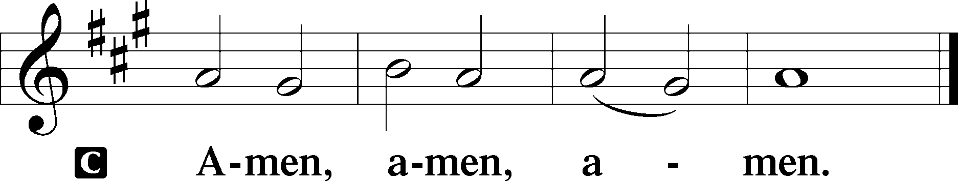

Closing Hymn In God, My Faithful God #745

Acknowledgments
Divine Service, Setting Three from Lutheran Service Book © 2006 Concordia Publishing House. Reprinted with permission. Unless otherwise indicated, all scripture quotations are from The Holy Bible, English Standard Version, copyright © 2001 by Crossway Bibles, a division of Good News Publishers. Used by permission. All rights reserved. Created by Lutheran Service Builder © 2006 Concordia Publishing House.

Serving Today:
Celebrant: Rev. George Fields Liturgist: Rev. James R. Holowach
Interpreter: Cathy Brown Organist: Sr. Sara Fields
Ushers: Allen Goodlett, Eric Held; Bruce Bodkin, Mark Ochs

Altar Flowers: This morning’s altar flowers were given for the glory of God by Bob and Gloria Pedersen in celebration of Dane Pedersen’s birthday.

Funeral for Marion Wassum: On September 20th, our sister Marion was called from this life into Life Everlasting. Together with her family, we will gather on Tuesday, October 6, at 11:00 a.m., to hold a Christian funeral and commend her to the arms of her Savior. Interment will take place in Pittsburgh, Pennsylvania. The family has asked that donations in her memory be made to Christ Lutheran, and they would welcome flowers as well. Thank you for your prayers for Marion's family. Though we mourn, yet we have a hope which not even death can destroy.

New LifeLight Beginning This Week: Dive into the mysteries of Scripture with us as we begin our new LifeLight study of the book of Revelation! We will gather on Thursday mornings at 9:30 a.m., starting this week. Sign up and get your book on the table in the narthex. See you there!

GSLS Oktoberfest: Celebrate Oktoberfest with Good Shepherd Lutheran School! See this month’s newsletter (or ask Sister Sara) for an order form, and send it to PO Box 5013, Brandon, MS 39047.

Readings for next Sunday, October 11th, the Nineteenth Sunday after Pentecost:
Introit Is. 61:10; Psalm 23; Isaiah 25:6-9; Philippians 4:4-13; Matthew 22:1-14.

This week at Christ Lutheran Church: October 5 – October 11

Tuesday 11:00 a.m. Funeral for Marion Wassum
Thursday 9:30 a.m. LifeLight: Revelation
Friday 6:30 a.m. Bible Study @ Christ Lutheran, Breakfast @ Broadstreet
6:30 p.m. Divine Service – Nineteenth Sunday after Pentecost
Sunday 10:30 a.m. Divine Service – Nineteenth Sunday after Pentecost
6:30 p.m. Journey through the Scriptures

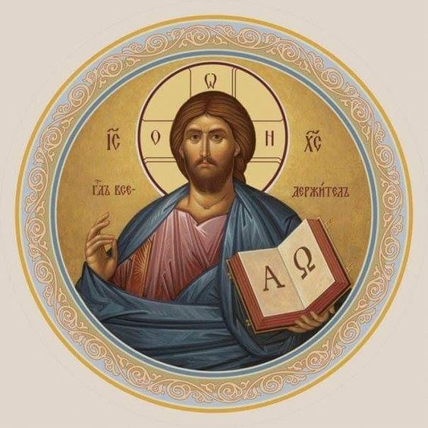

Matthew 26:26-29; Mark 14:22-25; Luke 22:14-20, 1 Corinthians 11:23
Matthew 26:28; 1 John 1:7; 1 Peter 1:18-19
1 Corinthians 11:28-32
1 Corinthians 10:17; 1 Corinthians 11:26

