Christ Lutheran Church



Rev. Dr. James R. Holowach, Pastor
Rev. George N. Fields, Pastor
Sr. Sara E. Fields, Deaconess
Divine Service Each Week with Holy Communion: 10:30 a.m.
Sunday School for all ages: 9:00 a.m.
4423 I-55 North, Jackson, MS 39206-6102 – (601) 366-2055
www.christlutheranjacksonms.org
The Fourteenth Sunday after Pentecost
+ September 6, 2020 +

“I Have Made You a Watchman”
Ezekiel 33:7



We welcome our members and guests to Christ Lutheran today,
and pray God’s richest blessings upon you during this time of worship!

All members and our guests are asked to complete the
worship attendance pads which can be found on each pew.
Guests are also asked to sign the guest register found in the Narthex.
We are so glad to have you worshiping with us today!

LARGE PRINT worship folders are available
at the usher stand at the back of the nave.

WELCOME:
“A true friend is someone who cares enough for you to confront you with unpleasant or embarrassing news and is confident that it is indeed for your own good! You know the phrase: ‘Friends don’t let friends drive drunk!’ We care too much about our friends to let them put themselves in that kind of danger. Even more so, we care enough for our friends that we do not allow them to continue in self-destructive behaviors that invite harm and ‘incur God’s wrath.’ If our neighbor’s house is on fire, we immediately call the fire department and run to the rescue. How odd, then, that we hesitate to intervene when a brother is straying, even though we know the ultimate outcome is severe!”
–Ernest Bernet, Concordia Journal, July, 1999

The Lord’s Supper

In preparation for reception of the Lord’s Supper (Holy Communion), it is important that we review and understand what the Bible teaches regarding this sacrament:
The Bible teaches that Jesus gives us His very body and blood along with bread and wine in Holy Communion, and that these are means by which He forgives our sins, and strengthens us for daily living, and draws us into closer fellowship with Him and other believers. The Bible also teaches us to examine ourselves prior to receiving the meal. For those receiving Holy Communion, examine yourself with these questions:
Do I believe that I am a sinner and I am sorry for my sins?
Do I believe that Jesus Christ is God’s Son and my personal Savior?
Do I believe that Christ’s true body and blood are present in this holy meal for my forgiveness?
Do I truly intend with the help of God to correct my sinful life?
According to Christ’s Word in the Holy Scriptures, and in confession with the true Christian faith, at Christ Lutheran we observe the practice of closed communion. We believe that all who commune must confess the same holy faith, as Holy Scripture teaches. Since one’s church affiliation indicates an individual’s confession of faith, we ask that only those who have been instructed in the above teaching and are confirmed members of The Lutheran Church – Missouri Synod commune. If you have not been instructed in this teaching on Holy Communion, are in doubt, or hold a different confession of faith, you are still welcome to come forward and cross your arms to indicate that you would like a blessing.

Divine Service III

Preservice Music
The congregation may use this time to pray and meditate.

Opening Hymn Where Charity and Love Prevail #845

Confession & Absolution
The sign of the cross may be made by all in remembrance of their Baptism.

P In the name of the Father and of the T Son and of the Holy Spirit.
C Amen.

P Beloved in the Lord! Let us draw near with a true heart and confess our sins unto God our Father, beseeching Him in the name of our Lord Jesus Christ to grant us forgiveness.

P Our help is in the name of the Lord,
C who made heaven and earth.
P I said, I will confess my transgressions unto the Lord,
C and You forgave the iniquity of my sin.

Silence for reflection on God's Word and for self-examination.

P O almighty God, merciful Father,
C I, a poor, miserable sinner, confess unto You all my sins and iniquities with which I have ever offended You and justly deserved Your temporal and eternal punishment. But I am heartily sorry for them and sincerely repent of them, and I pray You of Your boundless mercy and for the sake of the holy, innocent, bitter sufferings and death of Your beloved Son, Jesus Christ, to be gracious and merciful to me, a poor, sinful being.

P Upon this your confession, I, by virtue of my office, as a called and ordained servant of the Word, announce the grace of God unto all of you, and in the stead and by the command of my Lord Jesus Christ I forgive you all your sins in the name of the Father and of the T Son and of the Holy Spirit.
C Amen.

Service of the Word

Psalm: Beati, quorum Psalm 32:1-7; Ant. Psalm 32:1
Cantor: Remember your mercy, O Lord; remember your mercy and love.
All:
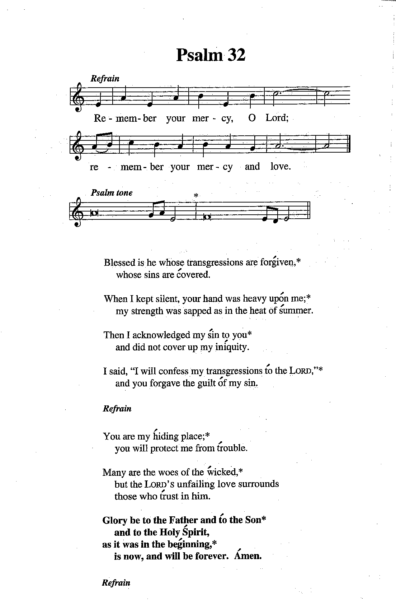
Blessed is he whose transgressions are for- | given,*
whose sins are | covered.
When I kept silent, your hand was heavy up- | on me;*
my strength was sapped as in the heat of | summer.
Then I acknowledged my | sin to you*
and did not cover up my in- | iquity.
I said, “I will confess my transgressions | to the Lord,”*
and you forgave the guilt | of my sin.
Refrain
You are my | hiding place;*
you will protect me from | trouble.
many are the woes of the | wicked,*
but the Lord’s unfailing love surrounds those who | trust in him.
Glory be to the Father and | to the Son*
and to the Holy | Spirit;
as it was in the be- | ginning,*
is now, and will be forever. | Amen.
Refrain
Tune and setting: Michael Joncas, © 1986 GIA Publications, Inc., Chicago, IL. All rights reserved.
Used by permission. OneLicense.net License #A-709296.

Kyrie Mark 10:47
The congregation is invited to sing in parts:

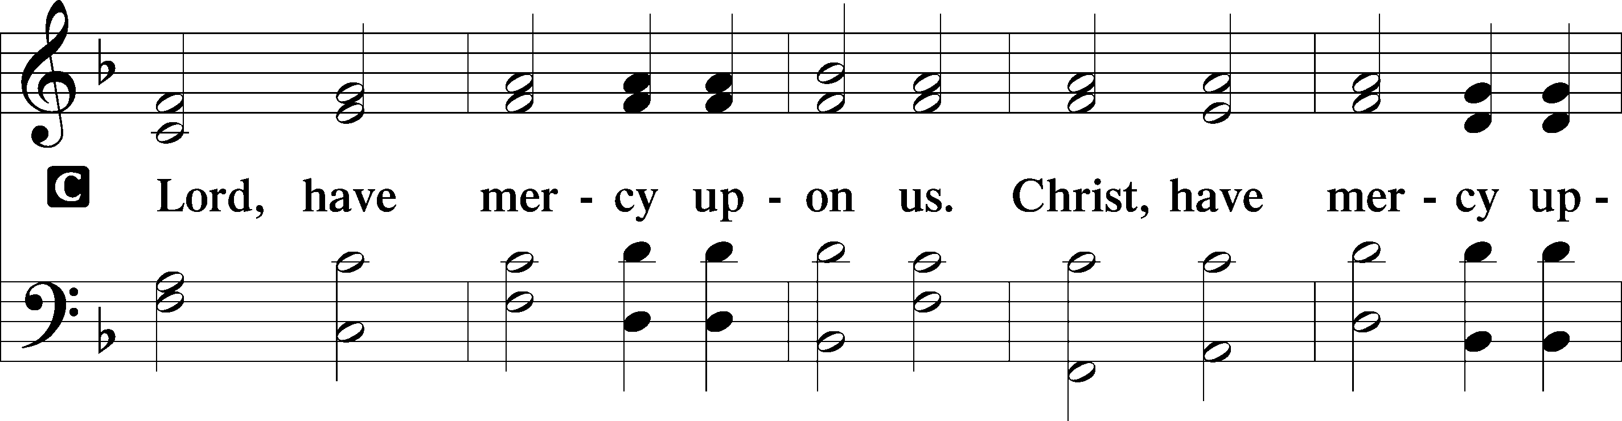
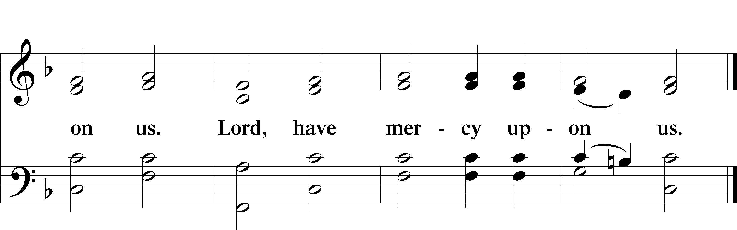

Gloria in Excelsis Luke 2:14; John 1:29
The congregation is invited to sing in parts, which can be found on LSB page 187.
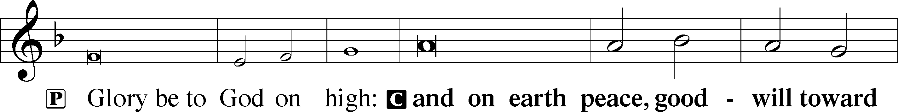
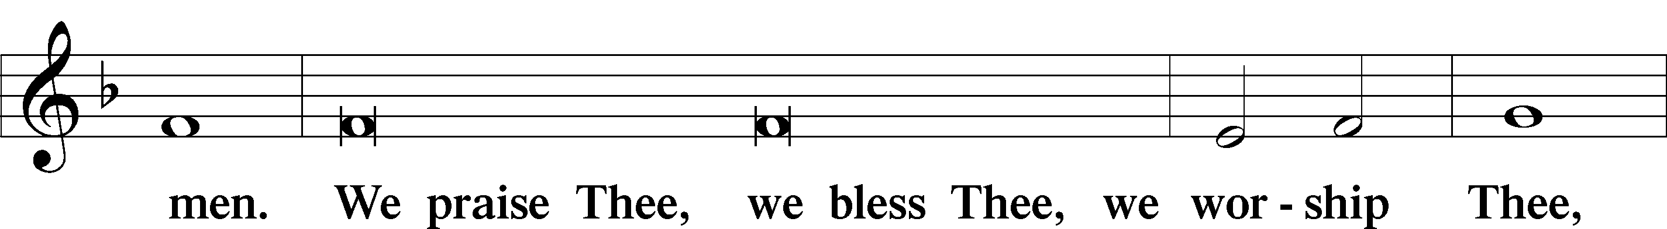
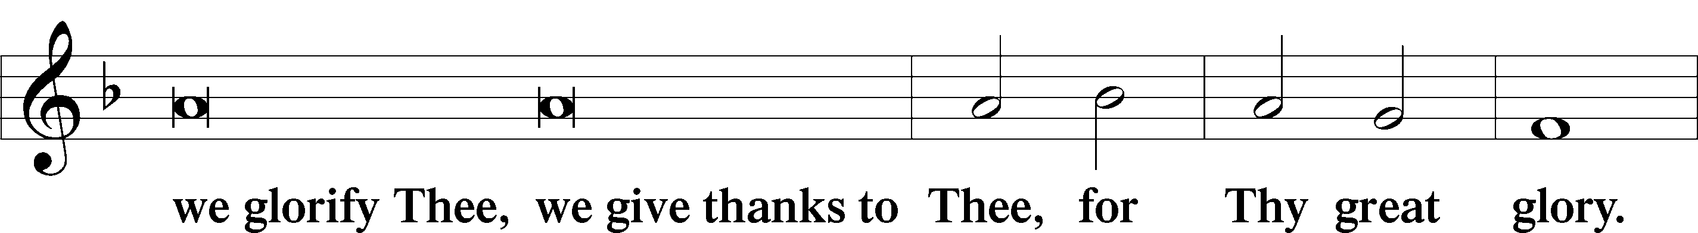
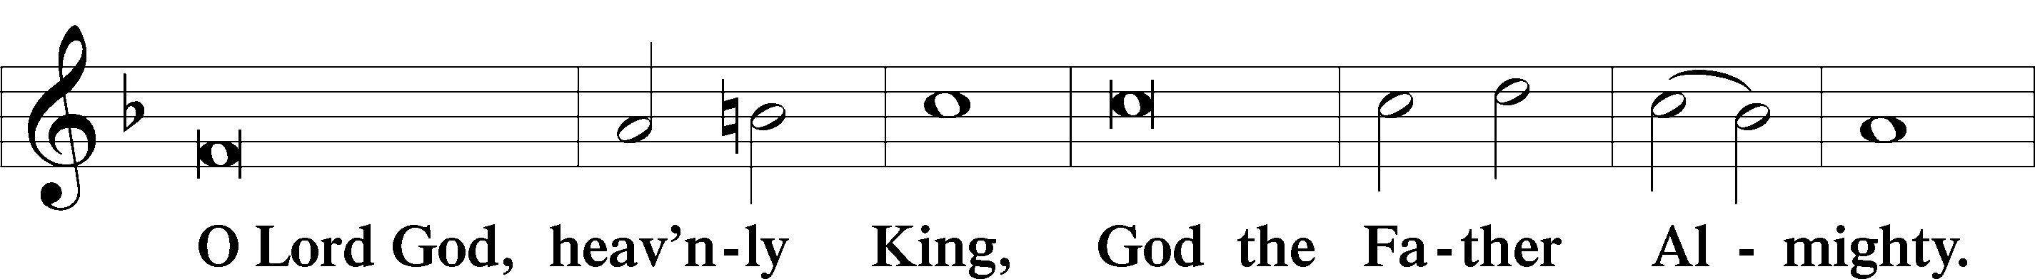
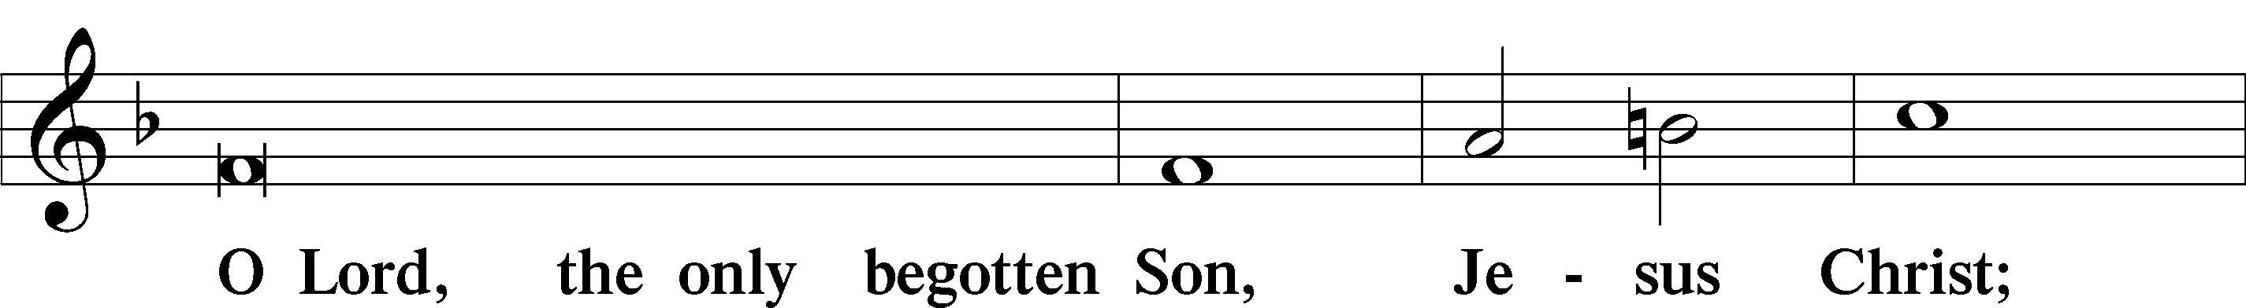
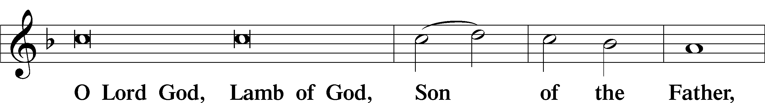
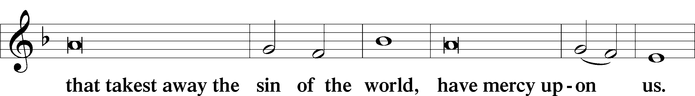
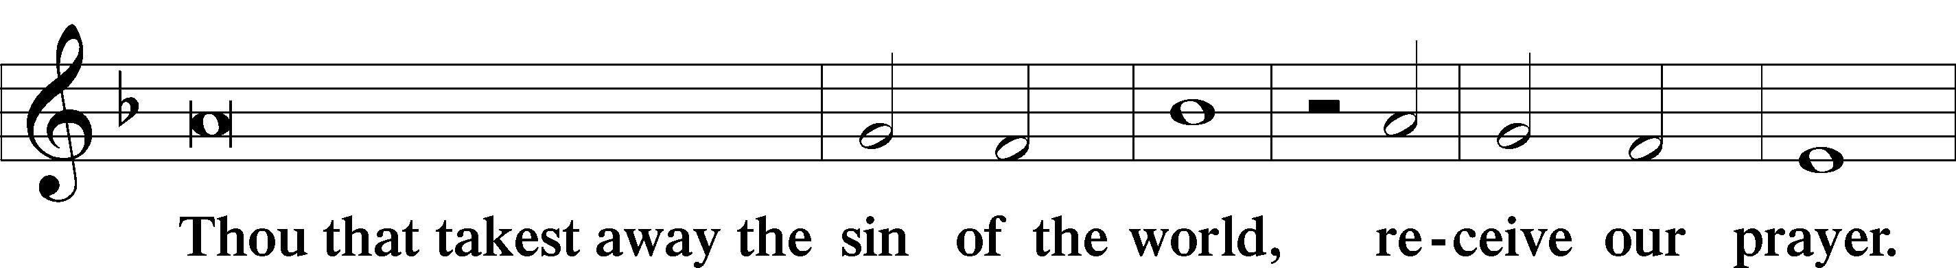
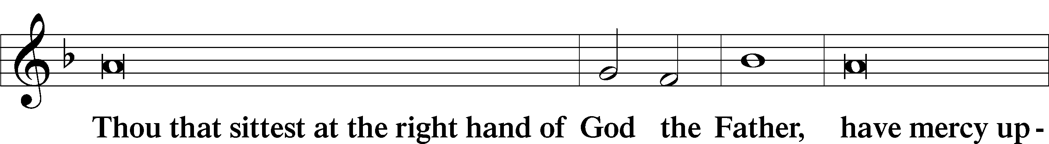
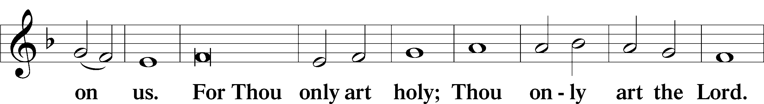
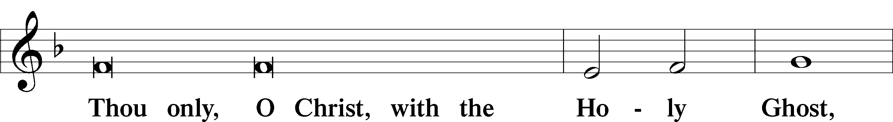
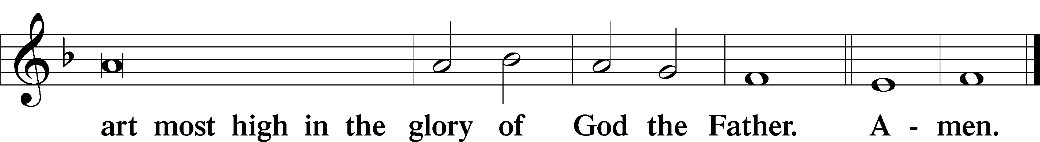

Salutation and Collect of the Day

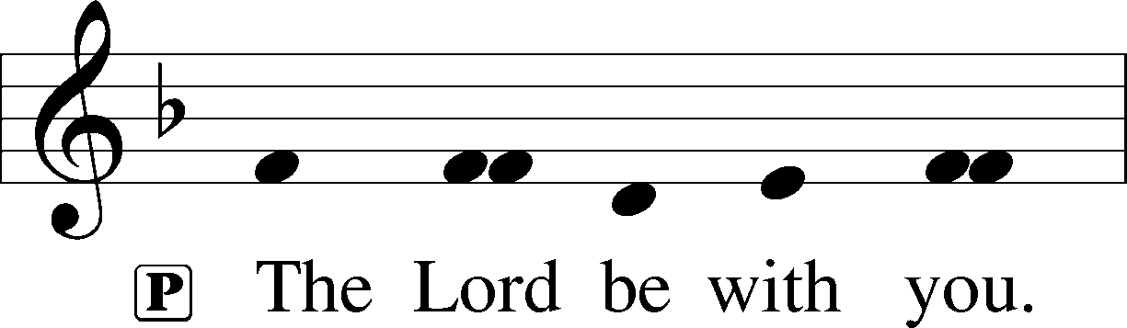
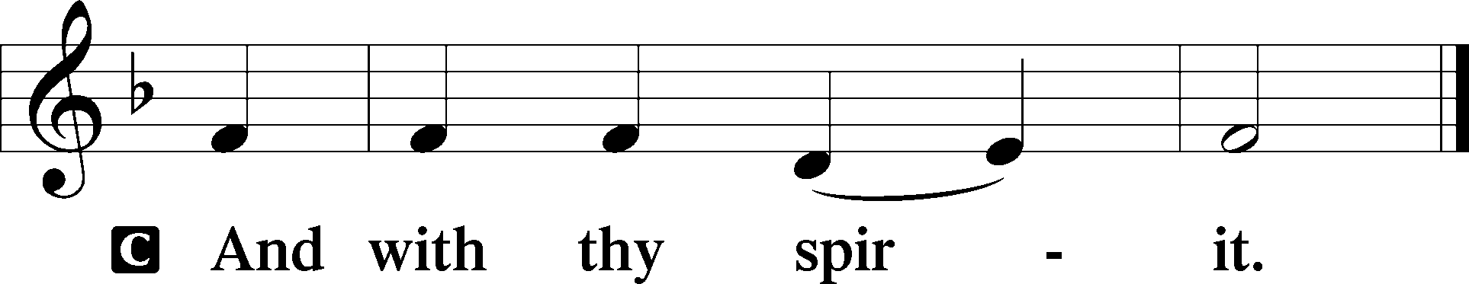

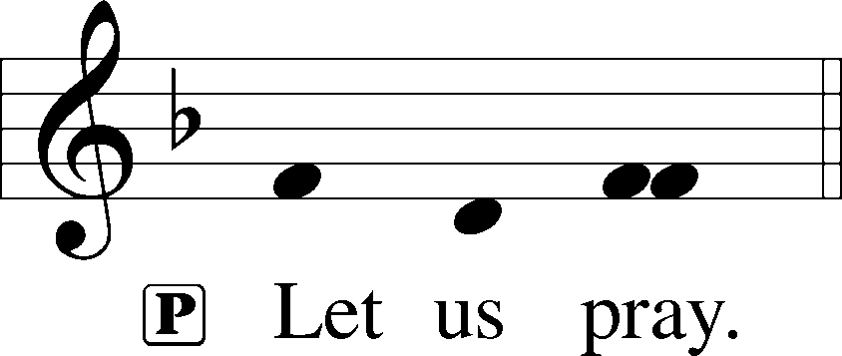

P O God, from whom all good proceeds, grant to us, Your humble servants, Your holy inspiration, that we may set our minds on the things that are right and, by Your merciful guiding, accomplish them; through Jesus Christ, Your Son, our Lord, who lives and reigns with You and the Holy Spirit, one God, now and forever.

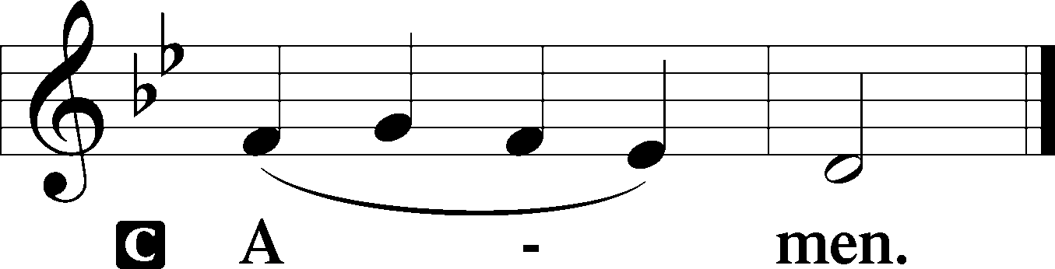

Please be seated

Old Testament Reading Ezekiel 33:7-9
“So you, son of man, I have made a watchman for the house of Israel. Whenever you hear a word from my mouth, you shall give them warning from me. If I say to the wicked, O wicked one, you shall surely die, and you do not speak to warn the wicked to turn from his way, that wicked person shall die in his iniquity, but his blood I will require at your hand. But if you warn the wicked to turn from his way, and he does not turn from his way, that person shall die in his iniquity, but you will have delivered your soul.
A This is the Word of the Lord.
C Thanks be to God.

Gradual Psalm 34:9, 19
Fear the Lord, | you his saints,*
for those who fear him lack | nothing!
Many are the afflictions of the | righteous,*
but the Lord delivers him out | of them all.

Epistle Reading Romans 13:1-10
Let every person be subject to the governing authorities. For there is no authority except from God, and those that exist have been instituted by God. Therefore whoever resists the authorities resists what God has appointed, and those who resist will incur judgment. For rulers are not a terror to good conduct, but to bad. Would you have no fear of the one who is in authority? Then do what is good, and you will receive his approval, for he is God’s servant for your good. But if you do wrong, be afraid, for he does not bear the sword in vain. For he is the servant of God, an avenger who carries out God’s wrath on the wrongdoer. Therefore one must be in subjection, not only to avoid God’s wrath but also for the sake of conscience. For the same reason you also pay taxes, for the authorities are ministers of God, attending to this very thing. Pay to all what is owed to them: taxes to whom taxes are owed, revenue to whom revenue is owed, respect to whom respect is owed, honor to whom honor is owed.
Owe no one anything, except to love each other, for the one who loves another has fulfilled the law. The commandments, “You shall not commit adultery, You shall not murder, You shall not steal, You shall not covet,” and any other commandment, are summed up in this word: “You shall love your neighbor as yourself.” Love does no wrong to a neighbor; therefore love is the fulfilling of the law.
A This is the Word of the Lord.
C Thanks be to God.

Please stand

Alleluia
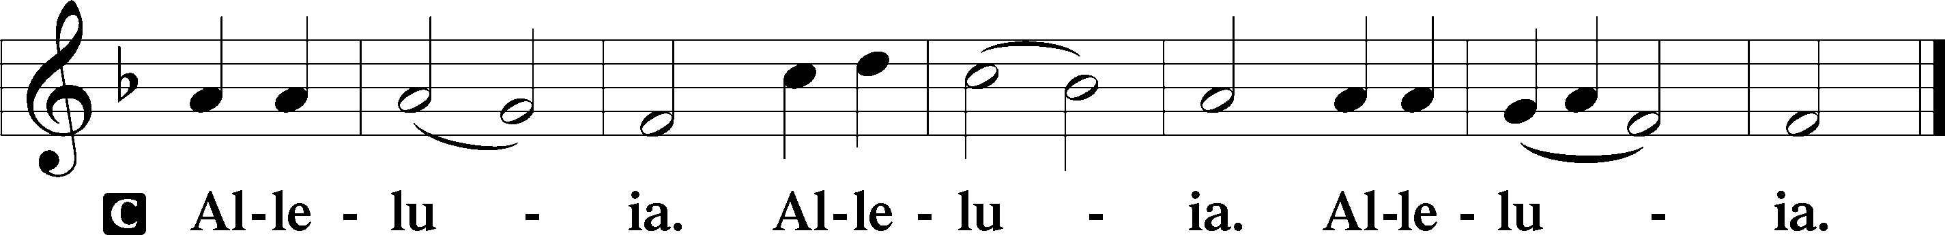

Holy Gospel Matthew 18:1-20

P The Holy Gospel according to St. Matthew, the eighteenth chapter.

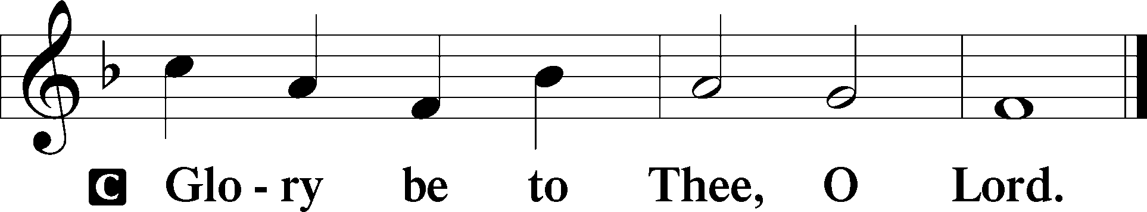
At that time the disciples came to Jesus, saying, “Who is the greatest in the kingdom of heaven?” And calling to him a child, he put him in the midst of them and said, “Truly, I say to you, unless you turn and become like children, you will never enter the kingdom of heaven. Whoever humbles himself like this child is the greatest in the kingdom of heaven.
“Whoever receives one such child in my name receives me, but whoever causes one of these little ones who believe in me to sin, it would be better for him to have a great millstone fastened around his neck and to be drowned in the depth of the sea.
“Woe to the world for temptations to sin! For it is necessary that temptations come, but woe to the one by whom the temptation comes! And if your hand or your foot causes you to sin, cut it off and throw it away. It is better for you to enter life crippled or lame than with two hands or two feet to be thrown into the eternal fire. And if your eye causes you to sin, tear it out and throw it away. It is better for you to enter life with one eye than with two eyes to be thrown into the hell of fire.
“See that you do not despise one of these little ones. For I tell you that in heaven their angels always see the face of my Father who is in heaven. What do you think? If a man has a hundred sheep and one of them has gone astray, does he not leave the ninety-nine on the mountains and go in search of the one that went astray? And if he finds it, truly, I say to you, he rejoices over it more than over the ninety-nine that never went astray. So it is not the will of my Father who is in heaven that one of these little ones should perish.
“If your brother sins against you, go and tell him his fault, between you and him alone. If he listens to you, you have gained your brother. But if he does not listen, take one or two others along with you, that every charge may be established by the evidence of two or three witnesses. If he refuses to listen to them, tell it to the church. And if he refuses to listen even to the church, let him be to you as a Gentile and a tax collector. Truly, I say to you, whatever you bind on earth shall be bound in heaven, and whatever you loose on earth shall be loosed in heaven. Again I say to you, if two of you agree on earth about anything they ask, it will be done for them by my Father in heaven. For where two or three are gathered in my name, there am I among them.”
P This is the Gospel of the Lord.
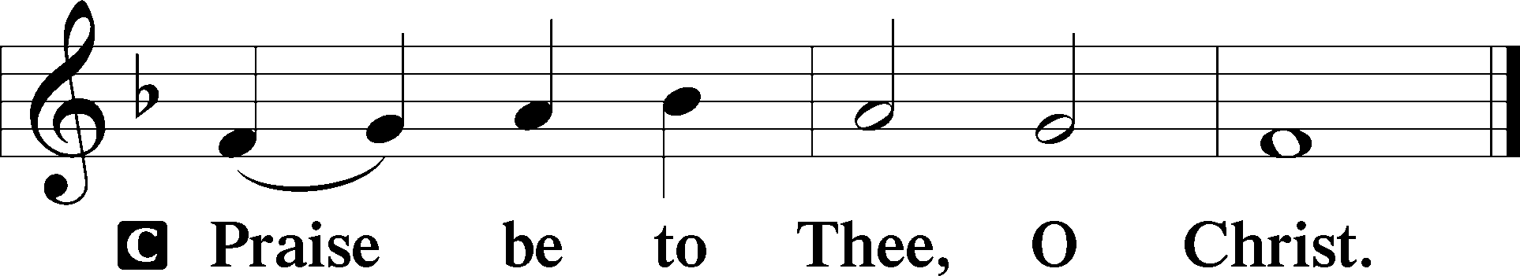

Please be seated

Office Hymn “As Surely as I Live,” God Said (Tune #655)

1 “As surely as I live,” God said,
“I would not see the sinner dead.
I want him turned from error’s ways,
Repentant, living endless days.”

2 And so our Lord gave this command:
“Go forth and preach in ev’ry land;
Bestow on all My pard’ning grace
Who will repent and mend their ways.

3 “All those whose sins you thus remit
I truly pardon and acquit,
And those whose sins you will retain
Condemned and guilty shall remain.

4 “What you will bind, that bound shall be;
What you will loose, that shall be free;
To My dear Church the keys are giv’n
To open, close the gates of heav’n.”

5 All praise to You, O Christ, shall be
For absolution full and free,
In which You show Your richest grace;
From false indulgence guard our race.

6 Praise God the Father and the Son
And Holy Spirit, Three in One,
As was, is now, and so shall be
World without end, eternally!

Sermon Faithful Watchmen
Please stand

Nicene Creed

C I believe in one God, (Rom 10:10; Deut 6:4)
the Father Almighty, (Mt 6:9; Ex 6:3)
maker of heaven and earth (Gen 1:1; Jn 1:1)
and of all things visible and invisible. (Col 1:16)
And in one Lord Jesus Christ, (Rom 10:9)
the only-begotten Son of God, (Jn 3:16; Mt 16:16)
begotten of His Father before all worlds, (Jn 1:2)
God of God, Light of Light, (Jn 17:22; Jn 8:12; Jn 1:1)
very God of very God, (Col 2:9) begotten, not made, (Jn 1:2)
being of one substance with the Father, (Jn 10:30)
by whom all things were made; (Heb 1:2; Jn 1:3)
who for us men and for our salvation (1 Tim 2:4; Rom 3:23)
came down from heaven (Jn 6:41; Lk 15:20)
and was incarnate by the Holy Spirit of the virgin Mary (Lk 1:34-35)
and was made man; (Jn 1:14)
and was crucified also for us under Pontius Pilate. (Mk 15:25; Jn 19:16-18)
He suffered and was buried. (Jn 19:1-3; Lk 23:53)
And the third day He rose again according to the Scriptures (1 Cor 15:4; Lk 24:6)
and ascended into heaven (Acts 1:9)
and sits at the right hand of the Father. (Acts 7:55)
And He will come again with glory (Mt 26:64)
to judge both the living and the dead, (Acts 10:42; Mt 3:12)
whose kingdom will have no end. (2 Pt 1:11)
And I believe in the Holy Spirit, (Jn 14:26; Gen 1:2; Acts 2:38)
the Lord and giver of life, (Gen 1:2; Jn 3:6)
who proceeds from the Father and the Son, (Jn 15:26)
who with the Father and the Son together is worshiped and glorified, (Mt 3:16-17)
who spoke by the prophets. (Eze 11:5)
And I believe in one holy Christian and apostolic Church, (1 Pt 2:5; Eph 2:19-22)
I acknowledge one Baptism for the remission of sins, (Eph 4:5)
and I look for the resurrection of the dead (1 Cor 15:35-49; 1 Thess 4:13-18)
and the life T of the world to come. (Mk 10:29-30; Mt 10:40-42)
Amen. (Ps 106:48)
Us men means all people.
Christian: the ancient text reads “catholic,” meaning the whole Church as it confesses the wholeness of Christian doctrine

Reception of New Members
Prayer of the Church

After each petition of the prayer:
Pastor: Lord, in Your mercy,
People: Hear our prayer.

For comfort, health and recovery: Doug Gilmore, Dan Hansen, Thomas Nielsen, Judy Quarles, Robert Quarles, James Richard Thornell, Ronnie Willis;
For those who are ill or distressed: Stan Acey, Jenalee Adams, Kimberly Airhart, Layne Bagley, Rose Bagley, Shirley Bagley, W.L. Bagley, Sarah Bowman, Mimi Bradley, Richard Bradley, Deloris Brent, Martha Brown, Nathan Brown, Tina Burke, Wayne Burke, Paula Burkhalter, Bobby Carroll, Arthur Collins, James E. Cookston, Joan Cowards, Belinda Cowards-Gonzales, Robert (Andy) Evers, Michele Rae Fowler, Randy Fowler, Parker Haines, Dan Hansen, Paul Hansen, Tim Hansen, Valerie Henderson, Sharon Holleman, Hugh Hunt, Beth Jarratt, Jimmy Jarratt, Elaine Johnson, Joslyn Jones, Steve Kennedy, Arlene Kleinschmidt, Eleanor Koster, John Koster, Sandra Landers, Katelyn Lawing, Peggy Lucky, Paul McCullough, Jerry McIntyre, Jerry McMahan, Mark Millard, Edlia Miller, Mark Miller, Elaine Monaghan, Lindberg Moore, Jerry Mutter, Don Ochs, Mildred Odom, Janea Parker, Deborah-Annette Ried, Elmira Roever, Jon Sandberg, Noah Schultz, Johnnie Pearl Smiley, Bob Smith, Sally Smith, Sam Schneider, Sherri Smith, Deborah Springer, MariLyn Unger, Betty Venator, Leonard Watson, Dana Weaver, Cynthia Widlitze, Carol Wright, Jimmy Wright, Marshall Wright, Barbara Zeigler;
For college and graduate students: Jake Everly, Sara Fields, Jonathan Kettler, Roselynn Nelson, Will Nelson;
For military servants and their families: Gabriel Escude, James (Glen) Hansford, Holden Hathcock, Christopher Martin, William Nelson, Steven Tatum, John Weidner Jr.;
For foreign missionaries: David and Shelee Warner;
This week’s prayer family: Jerry & Bobbie Mutter and their loved ones.

Please be seated

Offering

Offertory Psalm 51:10-12
The congregation is invited to sing in parts:
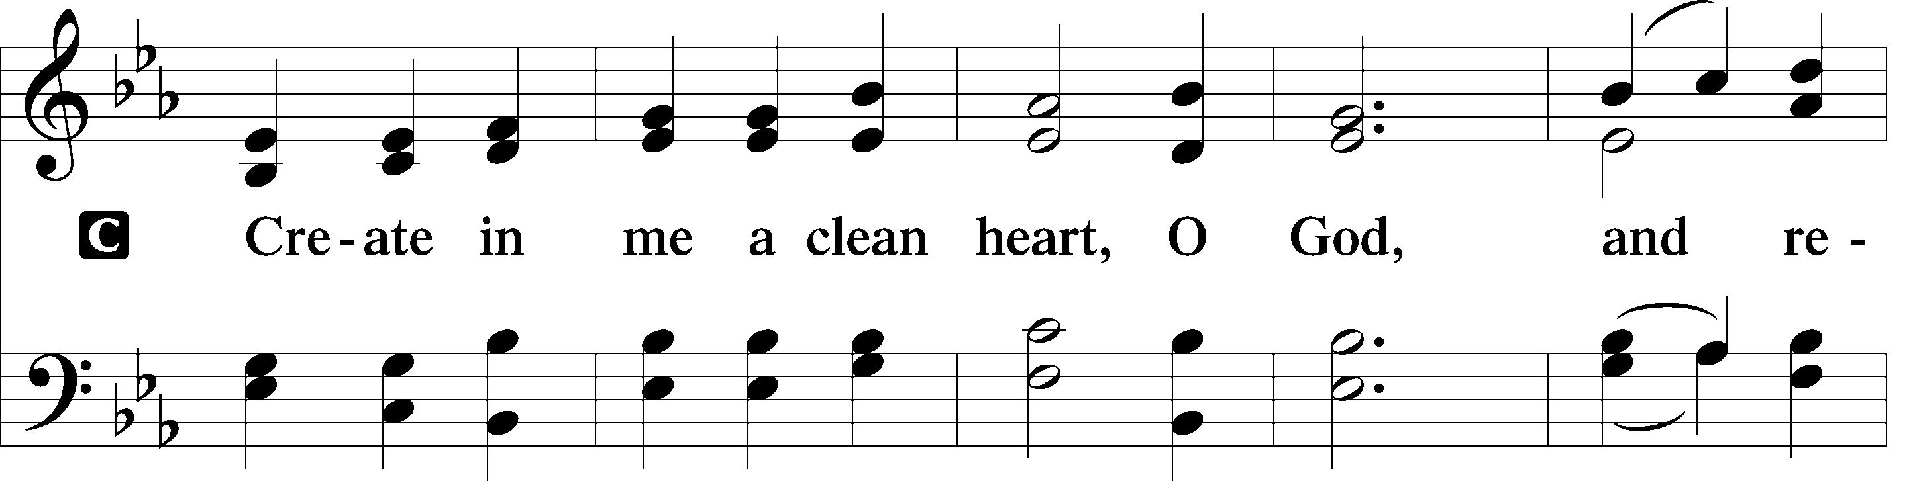
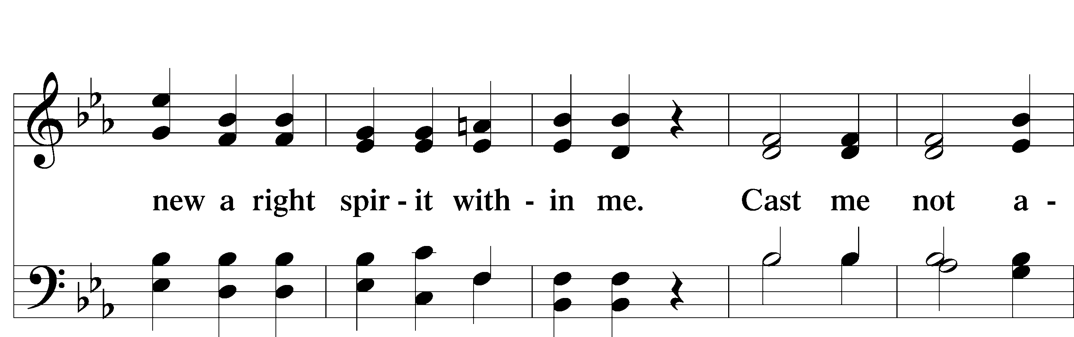
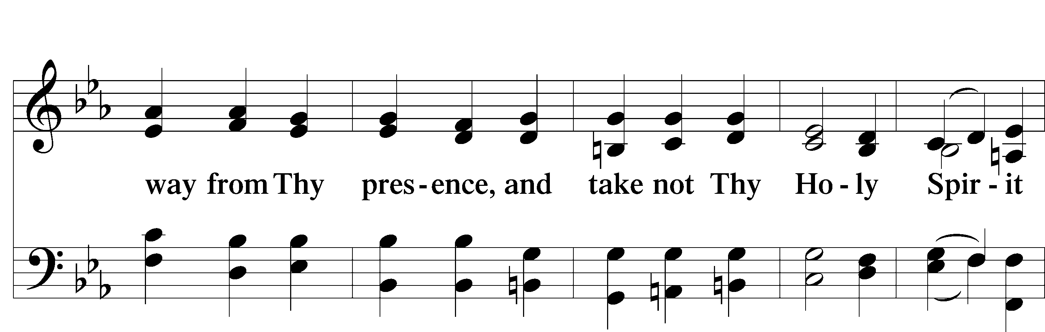
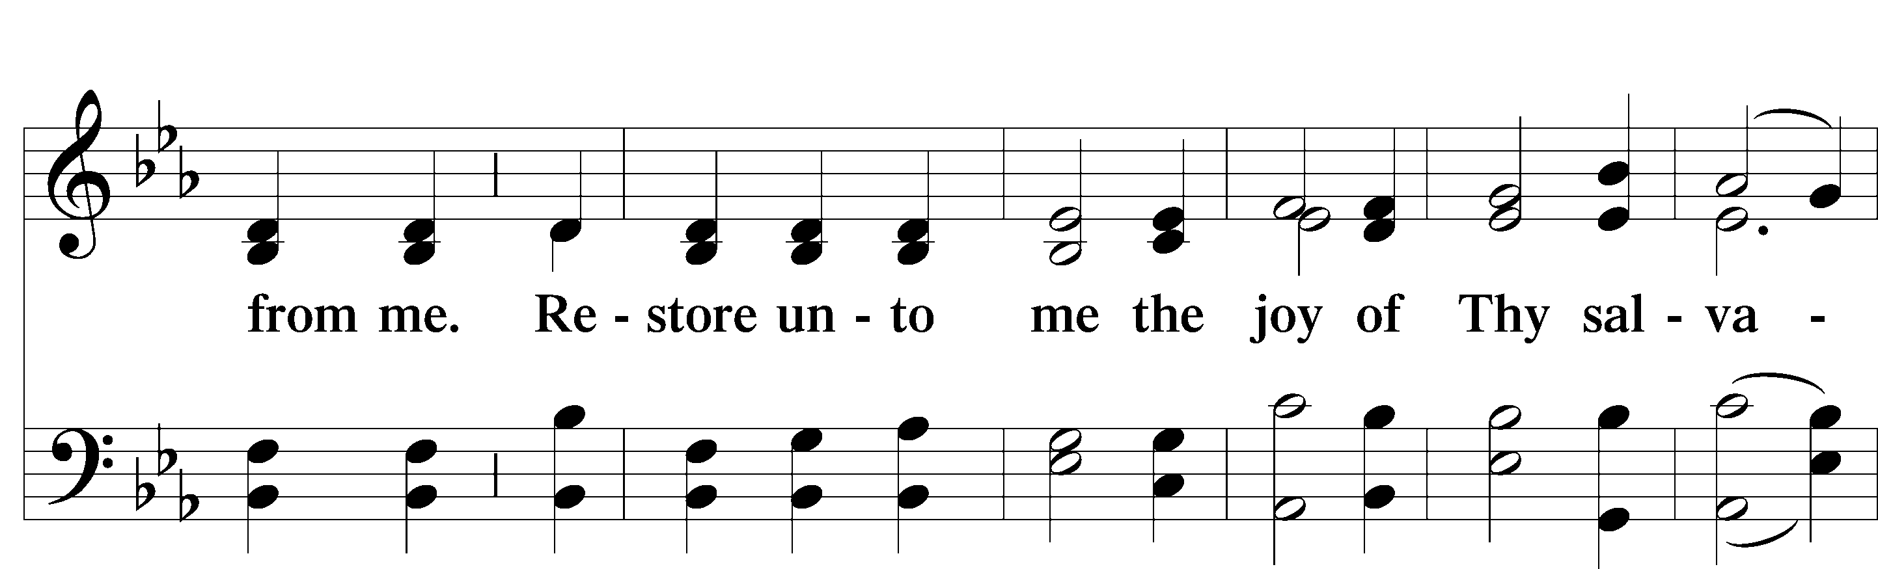
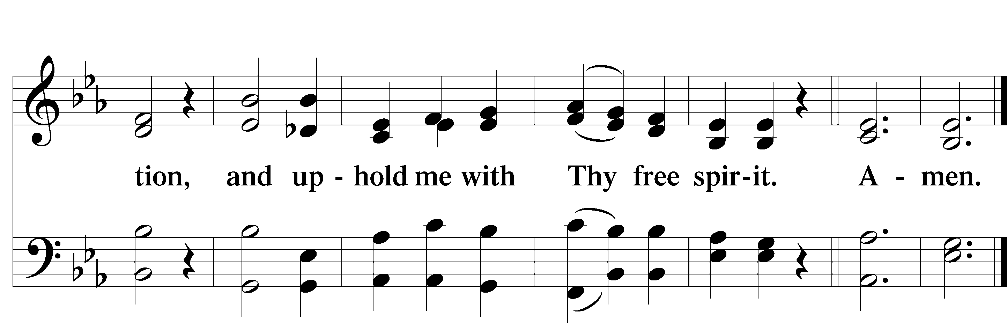
Service of the Sacrament

Preface 2 Timothy 4:22; [Colossians 3:1]; [Psalm 136]

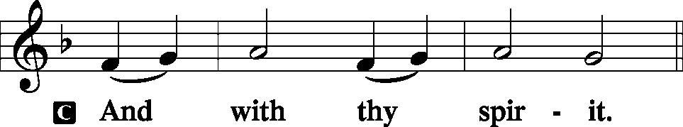
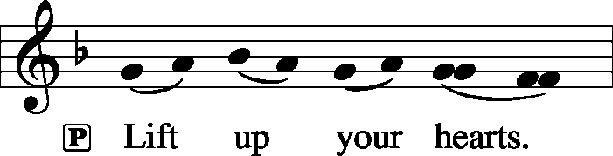

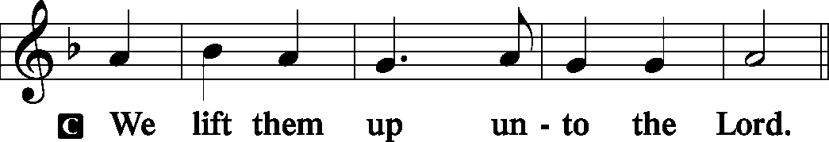
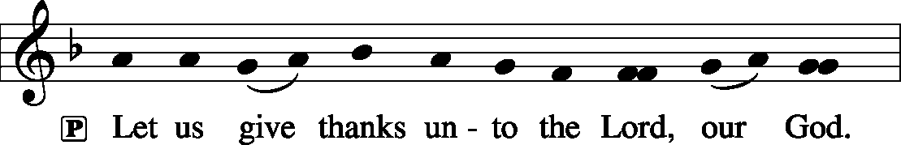
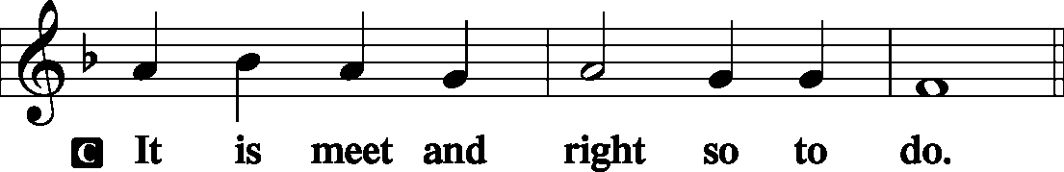

P It is truly meet, right, and salutary that we should at all times and in all places give thanks to You, holy Lord, almighty Father, everlasting God, through Jesus Christ, our Lord, who on this day overcame death and the grave and by His glorious resurrection opened to us the way of everlasting life. Therefore with angels and archangels and with all the company of heaven we laud and magnify Your glorious name, evermore praising You and saying:

Sanctus Isaiah 6:3; Matthew 21:9
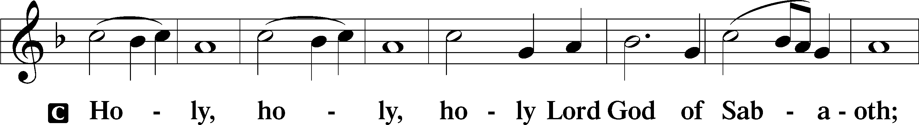
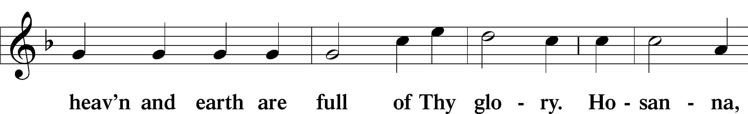
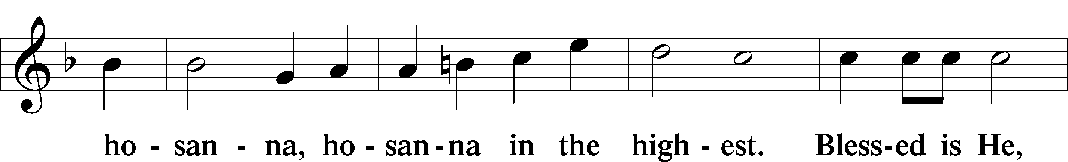
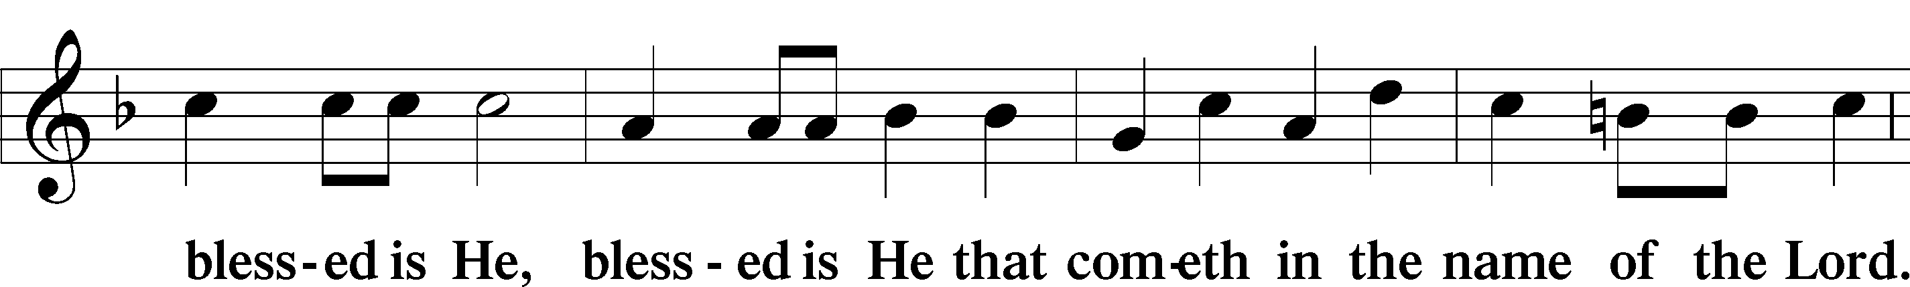
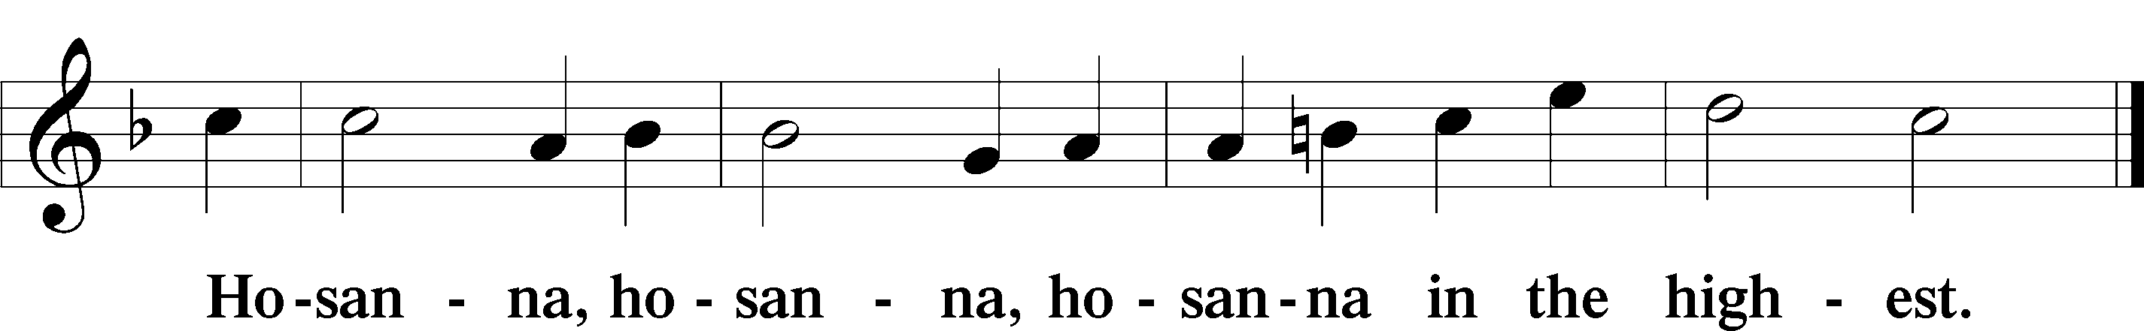

Lord’s Prayer Matthew 6:9-13
P Our Father who art in heaven,
Hallowed be Thy name,
Thy kingdom come,
Thy will be done on earth as it is in heaven;
Give us this day our daily bread;
And forgive us our trespasses as we forgive those who trespass against us;
And lead us not into temptation,
But deliver T us from evil.

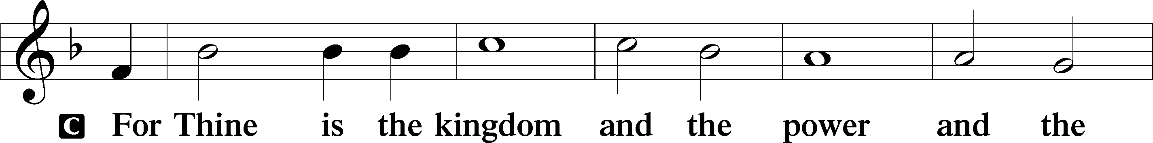
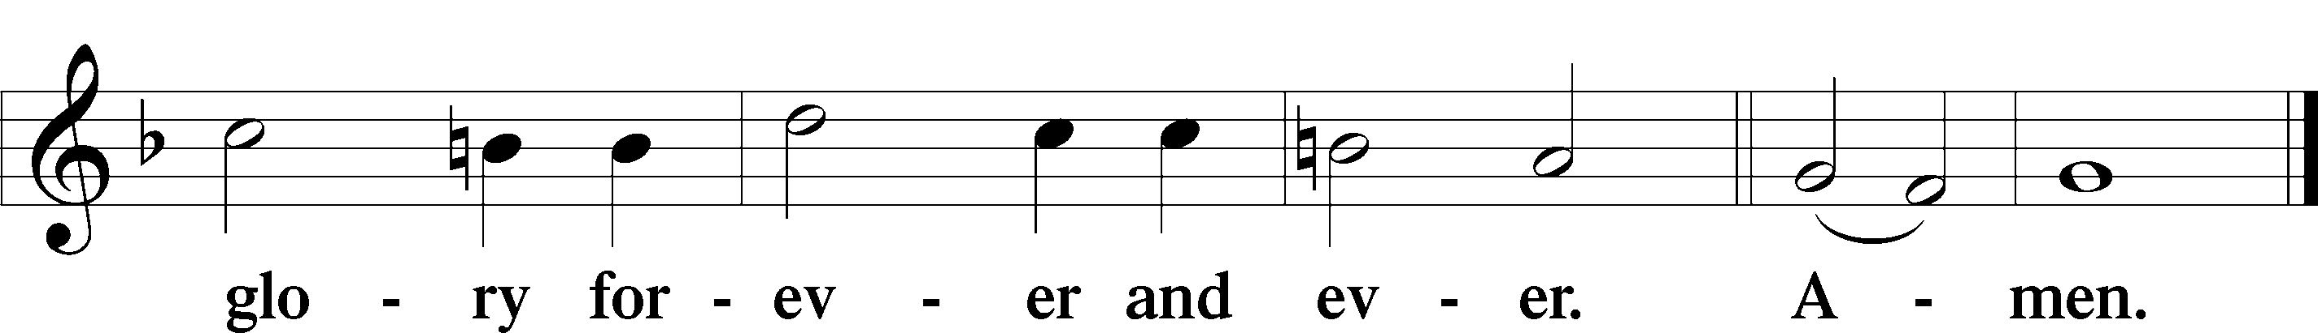
The Words of Our Lord Matthew 26:26–28
P Our Lord Jesus Christ, on the night when He was betrayed, took bread, and when He had given thanks, He broke it and gave it to the disciples and said: “Take, eat; this is My T body, which is given for you. This do in remembrance of Me.”
In the same way also He took the cup after supper, and when He had given thanks, He gave it to them, saying: “Drink of it, all of you; this cup is the new testament in My T blood, which is shed for you for the forgiveness of sins. This do, as often as you drink it, in remembrance of Me.”

Pax Domini John 20:19
P The peace T of the Lord be with you always.
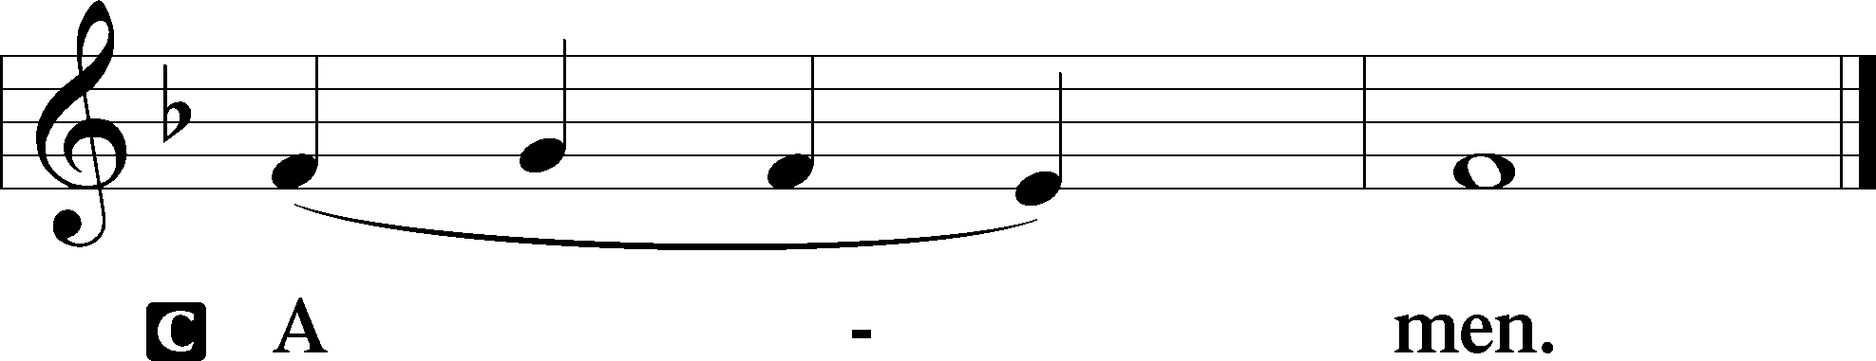

Agnus Dei John 1:29
The congregation is invited to sing in parts.
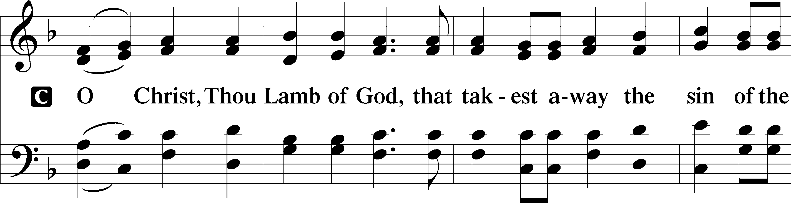
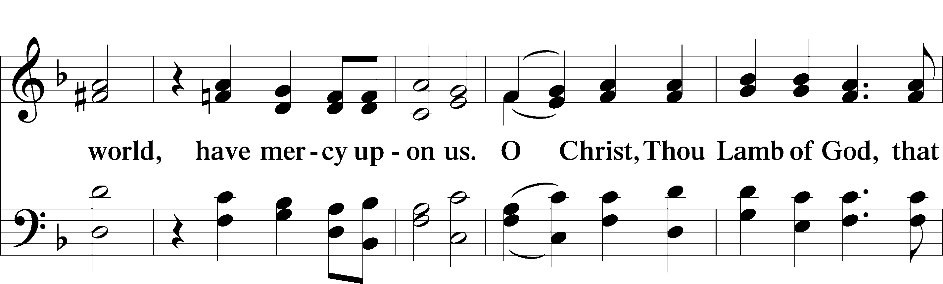
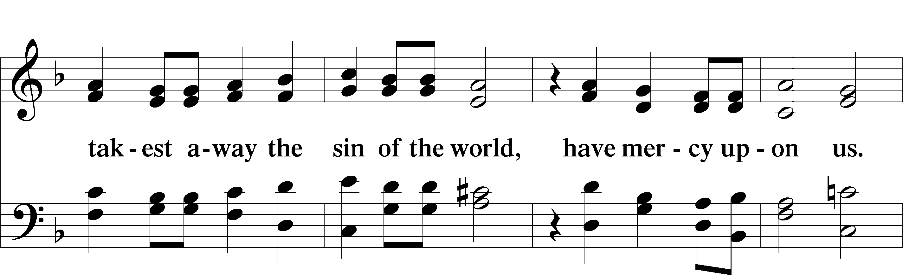
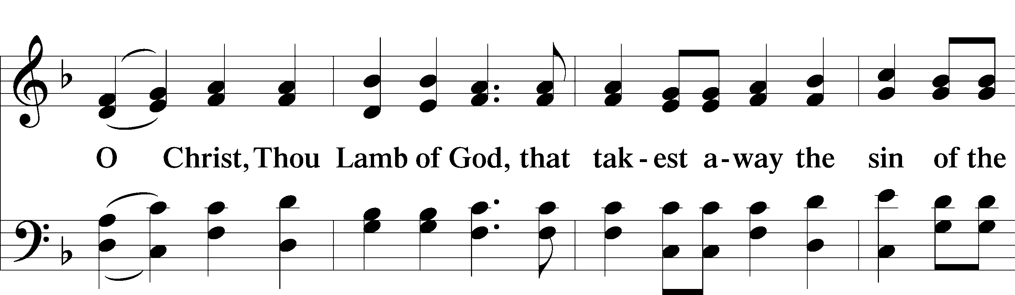
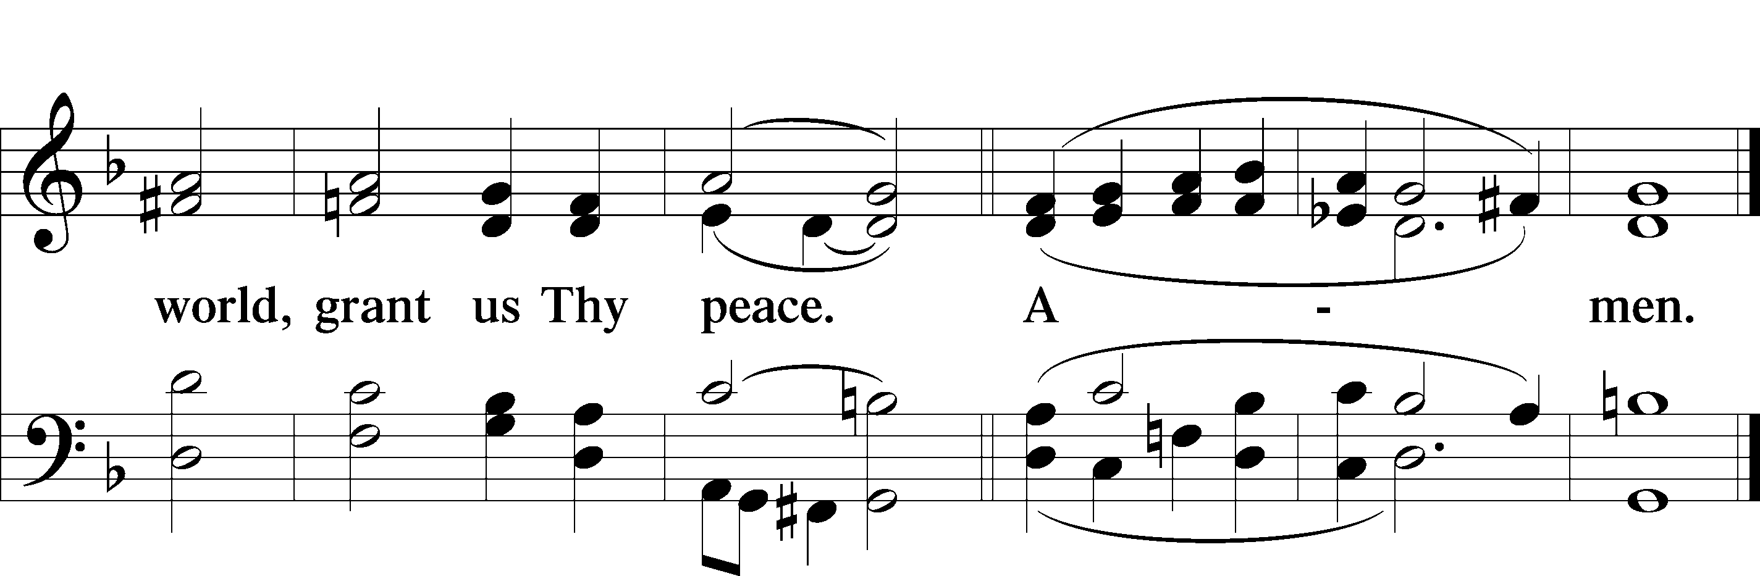
Please be seated

Distribution of the Sacrament
All who are members in good standing of the Lutheran Church - Missouri Synod and have introduced themselves to one of the pastors are welcome to partake of the Holy Communion at Christ Lutheran. If you have not spoken to a pastor, but would like to receive the Lord's blessing, you may still come to the rail and kneel, crossing one arm over the other in the shape of an 'X'. This symbolizes that one is marked by the cross and Triune name of Almighty God.

Distribution Hymns
Today Your Mercy Calls Us #915

Please stand following distribution of communion
Nunc Dimittis Luke 2:29-32
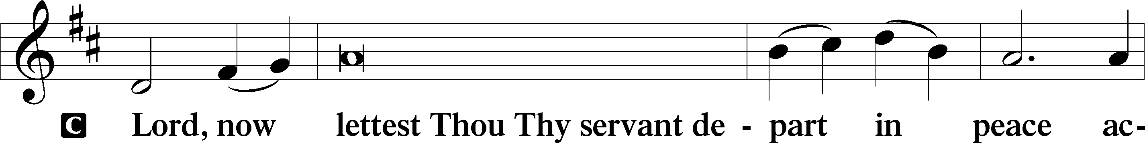
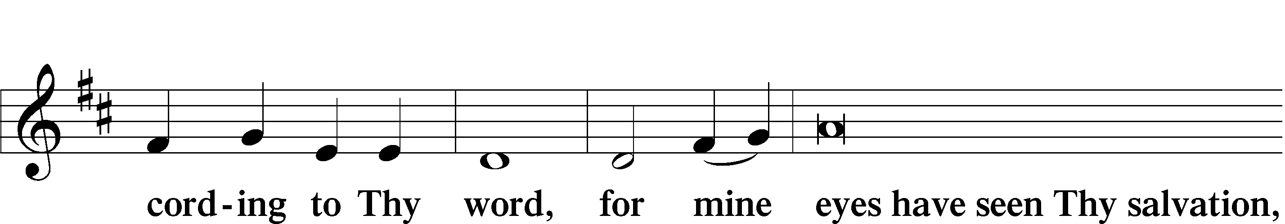
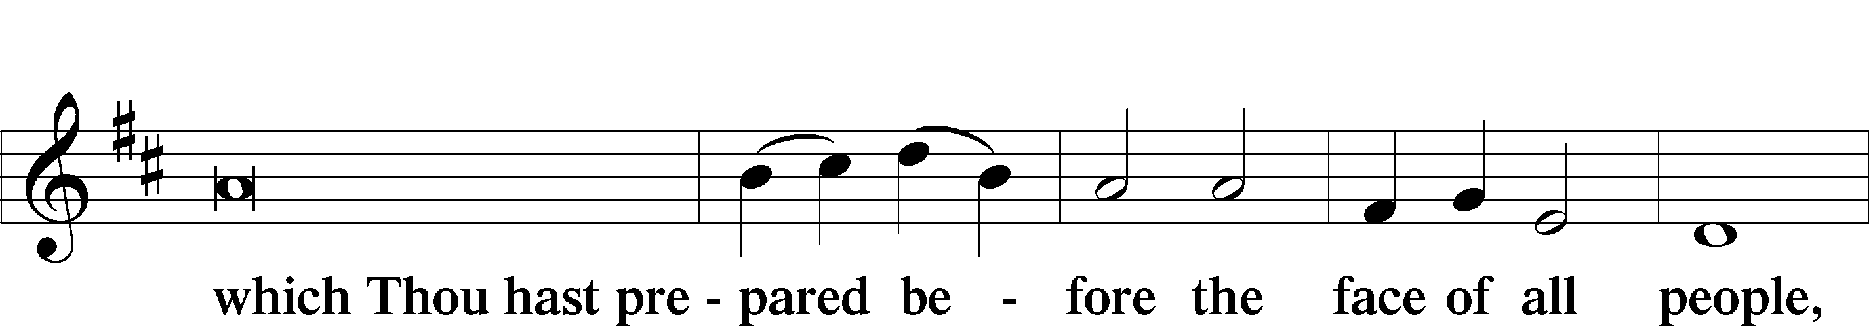
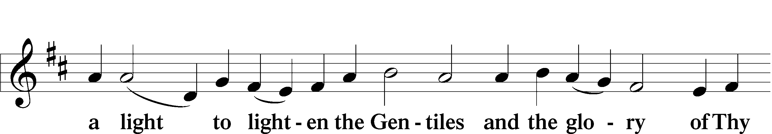
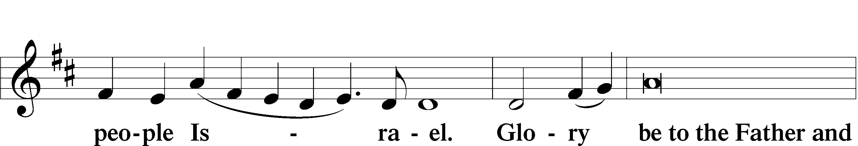
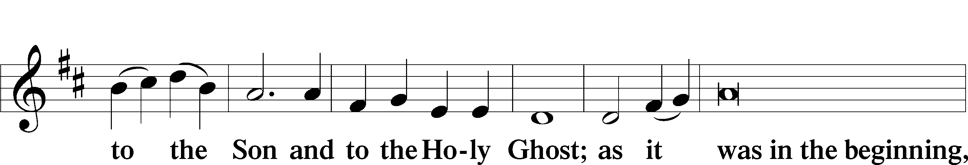
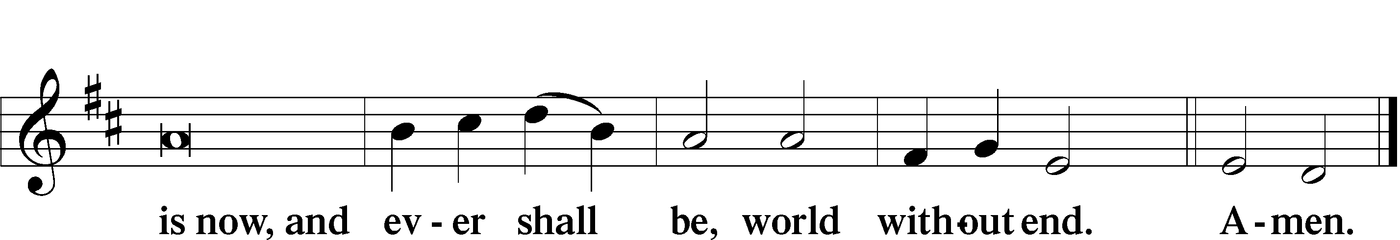

Thanksgiving
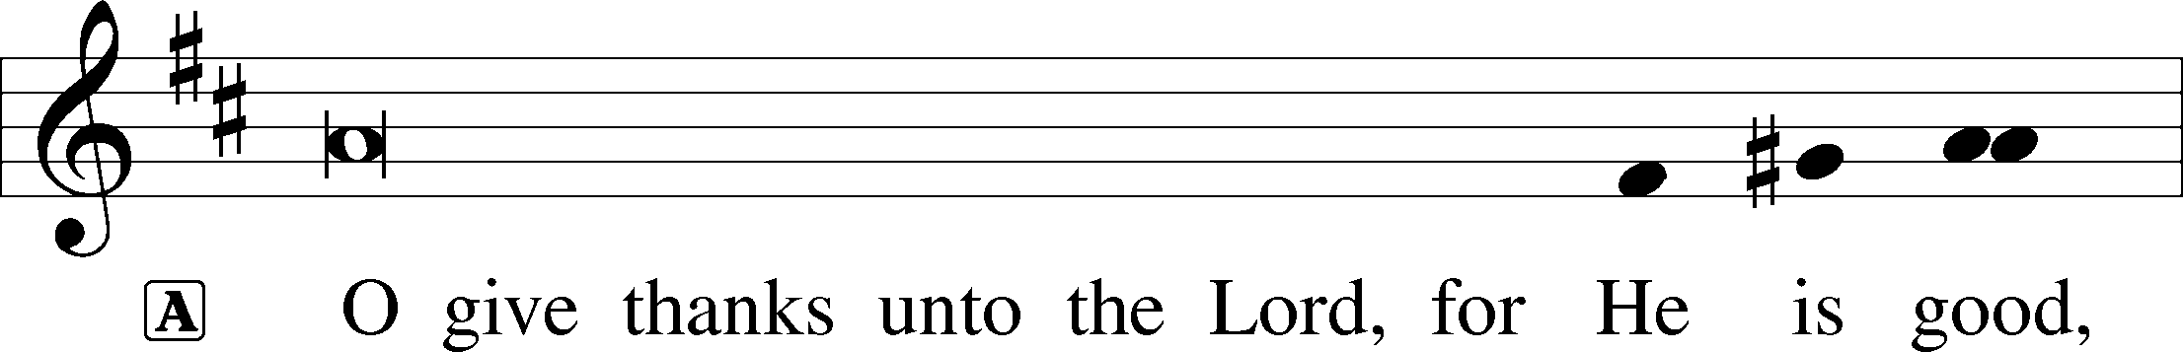
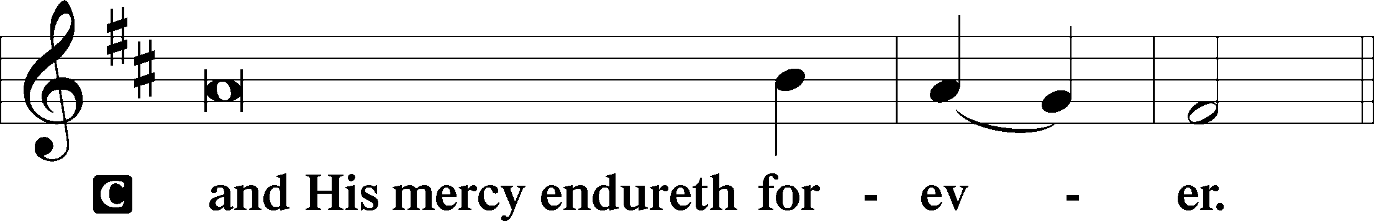
Post-Communion Collect
A We give thanks to You, almighty God, that You have refreshed us through this salutary gift, and we implore You that of Your mercy You would strengthen us through the same in faith toward You and fervent love toward one another; through Jesus Christ, Your Son, our Lord, who lives and reigns with You and the Holy Spirit, one God, now and forever.


Salutation and Benedicamus
P The Lord be with you.
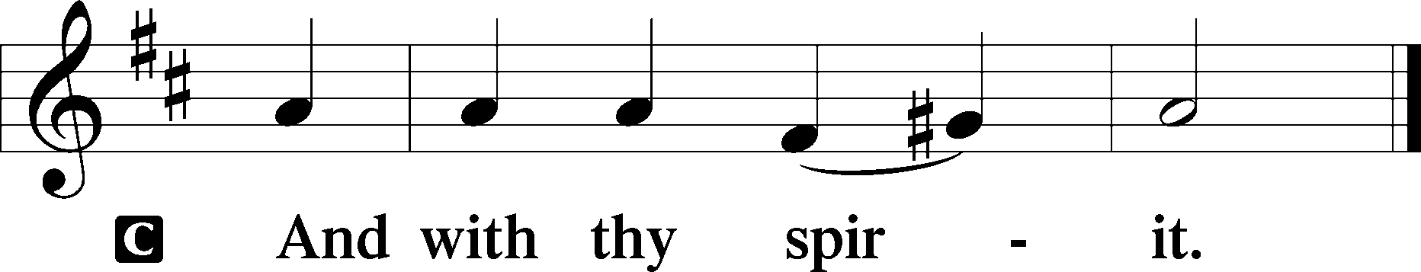
P Bless we the Lord.
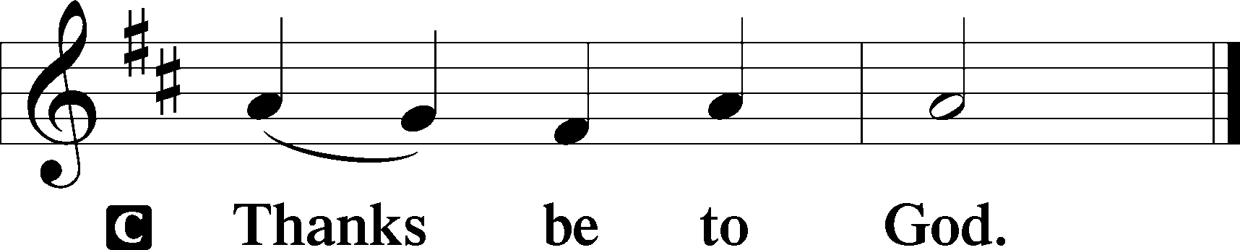

Benediction Numbers 6:24–26
P The Lord bless you and keep you.
The Lord make His face shine upon you and be gracious unto you.
The Lord lift up His countenance upon you and T give you peace.
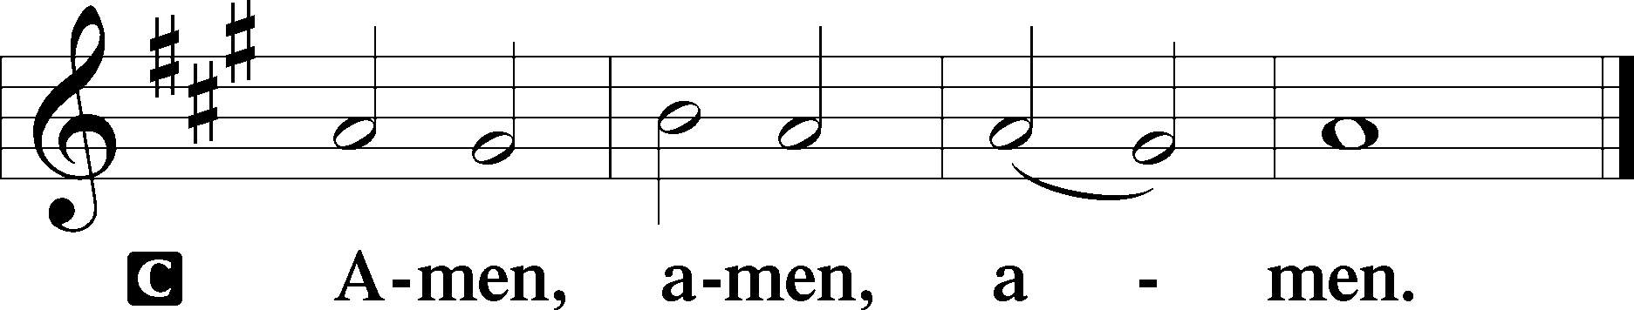

Closing Hymn My Soul, Now Praise Your Maker #820

Acknowledgments
Divine Service, Setting Three from Lutheran Service Book © 2006 Concordia Publishing House. Reprinted with permission. Unless otherwise indicated, all scripture quotations are from The Holy Bible, English Standard Version, copyright © 2001 by Crossway Bibles, a division of Good News Publishers. Used by permission. All rights reserved. Created by Lutheran Service Builder © 2006 Concordia Publishing House.

Serving Today:
Celebrant: Rev. James R. Holowach Liturgist: Rev. George Fields
Acolyte: Emily Held Organist: Sr. Sara Fields
Interpreter: Cathy Brown
Ushers: Allen Goodlett, Eric Held; Bruce Bodkin, Mark Ochs

Altar Flowers: This morning’s altar flowers were given for the glory of God by Bob and Gloria Pedersen and Anna Grace Lorence in celebration of Anna Grace’s birthday.

Let there be… LifeLight! In yet a new phase of our gradual reopening here at CLC, LifeLight will resume its study of the book of Exodus on Wednesday, September 16, at 9:30 a.m. We rejoice to be meeting together once more to study God’s Word!

Attention All Early Birds: Friday Morning Bible Study Resumes This Week
Greet the dawn and step into the light of God’s Word with us every Friday morning as we resume our Friday Morning Bible Study. We will meet at the church at 6:30am, then head over to Broadstreet for breakfast at 7:00am.

Welcome to Our New Members! How pleasant it is when brothers dwell together in unity. And indeed, we have the pleasure of welcoming new brethren into our midst! In our Sunday morning worship service this week, we will receive Reagan Dodge, and Jake and Carol Yenish along with their two children Mark and Caroline into membership. Although we will not have our customary reception following the service, please take a moment to introduce yourselves and welcome them into their new church family!

Good Shepherd Lutheran School Oktoberfest: Be German for a day and celebrate with our sister congregation as Good Shepherd Lutheran School holds its annual Oktoberfest on Saturday, October 24th. Find an order form for to-go dinners at that back of this bulletin – there is no better way to support Lutheran education than through the copious consumption of brats and German chocolate cake!

Readings for next Sunday, September 13th, the Fifteenth Sunday after Pentecost:
Introit Ps. 143:1-2; Psalm 103:1-12; Genesis 50:15-21; Romans 14:1-12; Matthew 18:21-35.

This week at Christ Lutheran Church: September 7 – September 13

Friday 6:30 p.m. Divine Service – Fifteenth Sunday after Pentecost
Sunday 10:30 a.m. Divine Service – Fifteenth Sunday after Pentecost



YOUR LIFELINE TO THE LUTHERAN WORLDVIEW…You can listen to in-depth teachings on interesting subjects like:

The Influence of Christianity on Labor & Economic Freedom, A Christian Response to Soft Totalitarianism, The Demolition of the Western Mind, Constitutional Republic vs. Democracy, and more…

Issues, Etc. is a radio talk show produced by Lutheran Public Radio and hosted by LCMS Pastor Todd Wilken. You can listen to what you want when you want at www.issuesetc.org. Simply click on “Listen”, choose “On Demand”, then select from the vast array of speakers and topics available in the archives.

Matthew 18:4 – “(Jesus said), ‘Whoever humbles himself like this child is the greatest in the kingdom of heaven.’ ”
What does it mean to have childlike faith? Certainly, Jesus does not want us to have a faith that is childish. We are not called to ignorance or silliness. Rather, we are called to trust the way a child trusts – with complete confidence in the Father. We show that confidence in our lives when we follow His directives for our life. Father knows best, so we’ll take His advice!


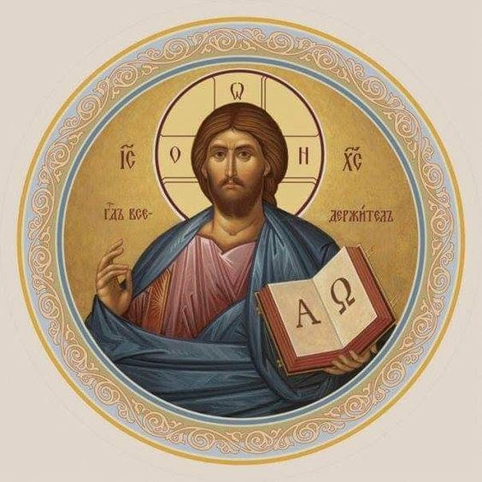

Christ Lutheran Church
Rev. Dr. James R. Holowach, Pastor
Rev. George N. Fields, Pastor
Sr. Sara E. Fields, Deaconess
4423 I-55 North, Jackson, MS 39206-6102
(601) 366-2055
www.christlutheranjacksonms.org

Matthew 26:26-29; Mark 14:22-25; Luke 22:14-20, 1 Corinthians 11:23
Matthew 26:28; 1 John 1:7; 1 Peter 1:18-19
1 Corinthians 11:28-32
1 Corinthians 10:17; 1 Corinthians 11:26

