Christ Lutheran Church



Rev. Dr. James R. Holowach, Pastor
Rev. George N. Fields, Pastor
Sr. Sara E. Fields, Deaconess
Divine Service Each Week with Holy Communion: 10:30 a.m.
Sunday School for all ages: 9:00 a.m.
4423 I-55 North, Jackson, MS 39206-6102 – (601) 366-2055
www.christlutheranjacksonms.org

The Eighth Sunday after Pentecost
+ July 26, 2020 +

“The Kingdom of Heaven Is Like…”



We welcome our members and guests to Christ Lutheran today,
and pray God’s richest blessings upon you during this time of worship!

All members and our guests are asked to complete the
worship attendance pads which can be found on each pew.
Guests are also asked to sign the guest register found in the Narthex.
We are so glad to have you worshiping with us today!

LARGE PRINT worship folders are available
at the usher stand at the back of the nave.

WELCOME:
“Through the comparison of a treasure in the field to our hope, Christ points to wealth that has been covered up, for God is discovered in humanity.”
–St. Hilary of Poitiers, On Matthew

“The old fate was such that by way of punishment mankind could perish in eternal punishment. The new fate was such that, having been converted, mankind could live in the kingdom.”
–St. Gregory the Great, Forty Gospel Homilies

The Lord’s Supper

In preparation for reception of the Lord’s Supper (Holy Communion), it is important that we review and understand what the Bible teaches regarding this sacrament:
The Bible teaches that Jesus gives us His very body and blood along with bread and wine in Holy Communion, and that these are means by which He forgives our sins, and strengthens us for daily living, and draws us into closer fellowship with Him and other believers. The Bible also teaches us to examine ourselves prior to receiving the meal. For those receiving Holy Communion, examine yourself with these questions:
Do I believe that I am a sinner and I am sorry for my sins?
Do I believe that Jesus Christ is God’s Son and my personal Savior?
Do I believe that Christ’s true body and blood are present in this holy meal for my forgiveness?
Do I truly intend with the help of God to correct my sinful life?
According to Christ’s Word in the Holy Scriptures, and in confession with the true Christian faith, at Christ Lutheran we observe the practice of closed communion. We believe that all who commune must confess the same holy faith, as Holy Scripture teaches. Since one’s church affiliation indicates an individual’s confession of faith, we ask that only those who have been instructed in the above teaching and are confirmed members of The Lutheran Church – Missouri Synod commune. If you have not been instructed in this teaching on Holy Communion, are in doubt, or hold a different confession of faith, you are still welcome to come forward and cross your arms to indicate that you would like a blessing.

Divine Service III

Preservice Music
The congregation may use this time to pray and meditate.

Opening Hymn I Leave All Things to God’s Direction #719

Confession & Absolution
The sign of the cross may be made by all in remembrance of their Baptism.

P In the name of the Father and of the T Son and of the Holy Spirit.
C Amen.

P Beloved in the Lord! Let us draw near with a true heart and confess our sins unto God our Father, beseeching Him in the name of our Lord Jesus Christ to grant us forgiveness.

P Our help is in the name of the Lord,
C who made heaven and earth.
P I said, I will confess my transgressions unto the Lord,
C and You forgave the iniquity of my sin.

Silence for reflection on God's Word and for self-examination.

P O almighty God, merciful Father,
C I, a poor, miserable sinner, confess unto You all my sins and iniquities with which I have ever offended You and justly deserved Your temporal and eternal punishment. But I am heartily sorry for them and sincerely repent of them, and I pray You of Your boundless mercy and for the sake of the holy, innocent, bitter sufferings and death of Your beloved Son, Jesus Christ, to be gracious and merciful to me, a poor, sinful being.

P Upon this your confession, I, by virtue of my office, as a called and ordained servant of the Word, announce the grace of God unto all of you, and in the stead and by the command of my Lord Jesus Christ I forgive you all your sins in the name of the Father and of the T Son and of the Holy Spirit.
C Amen.

Service of the Word

Introit: Alleluia confitemini Domino Psalm 105:2-6; Ant. Psalm 105:1
Oh give thanks to the Lord; call up- | on his name;*
make known his deeds among the | peoples!
Sing to him, sing prais- | es to him;*
tell of all his | wondrous works!
Glory in his | holy name;*
let the hearts of those who seek the | Lord rejoice!
Seek the Lord | and his strength;*
seek his presence con- | tinually!
Remember the wondrous works that | he has done,*
his miracles, and the judgments he | uttered,
O offspring of Abraham, his | servant,*
children of Jacob, his | chosen ones!
Glory be to the Father and | to the Son*
and to the Holy | Spirit;
as it was in the be- | ginning,*
is now, and will be forever. | Amen.
Oh give thanks to the Lord; call up- | on his name;*
make known his deeds among the | peoples!

Kyrie Mark 10:47
The congregation is invited to sing in parts:

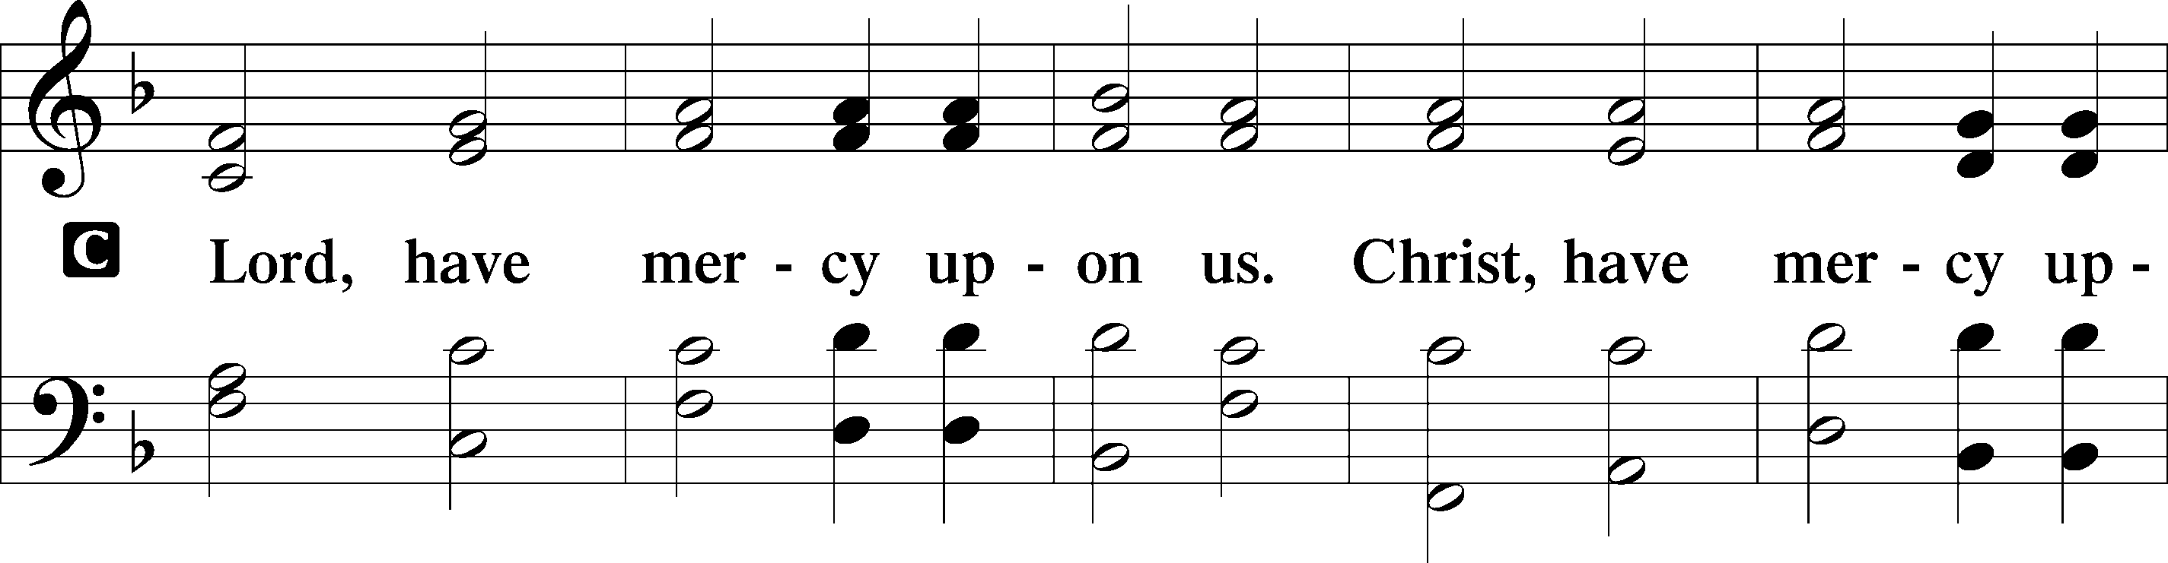
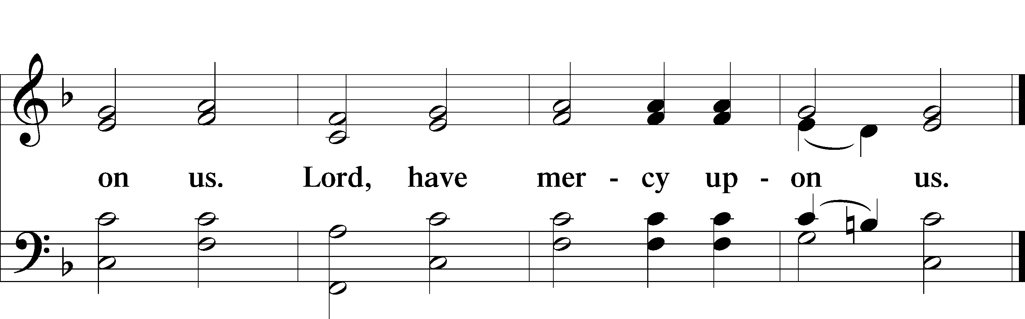

Gloria in Excelsis
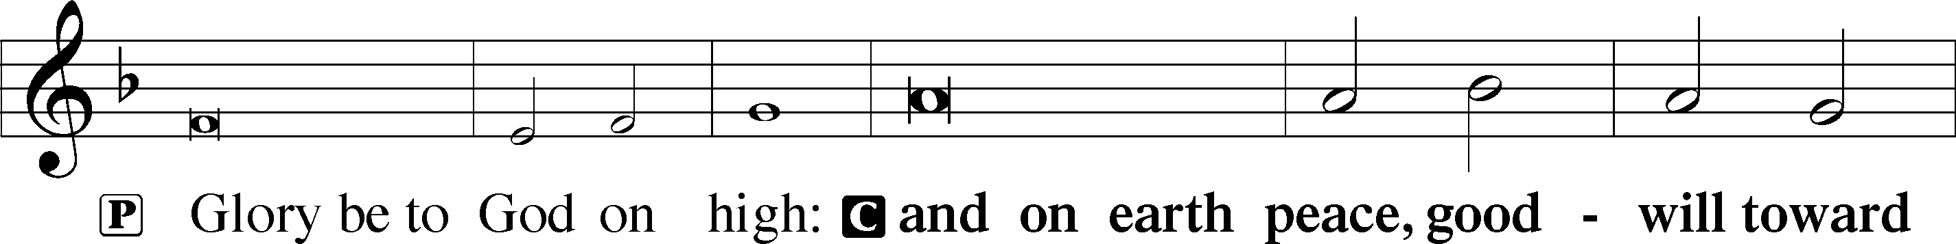
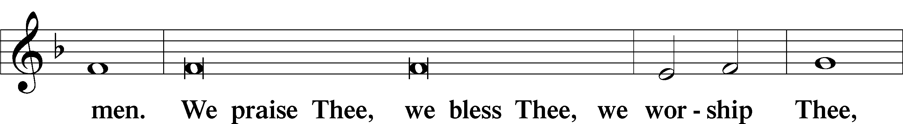
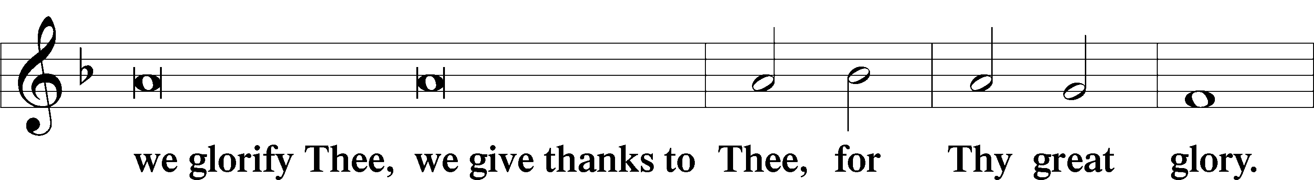
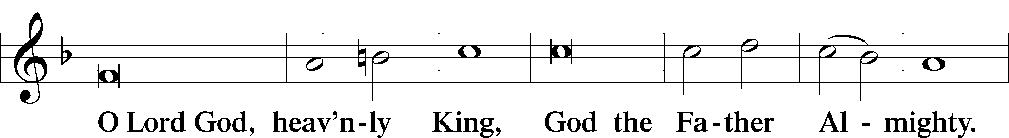
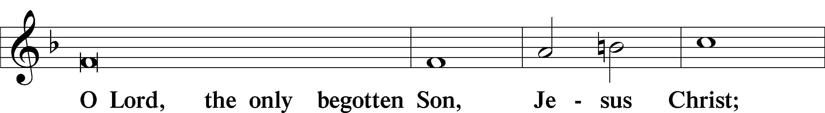
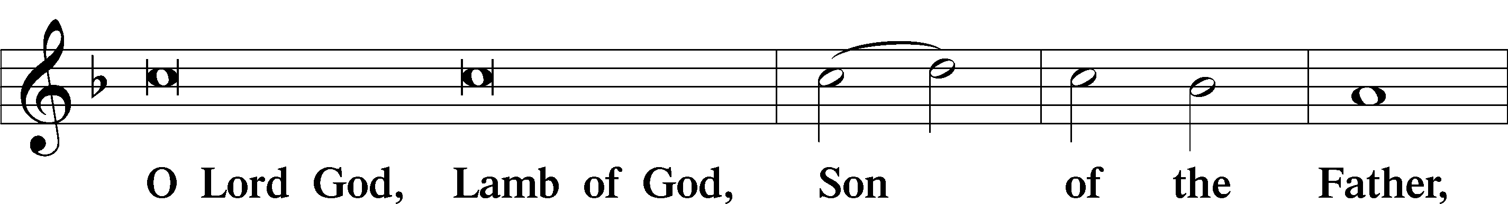
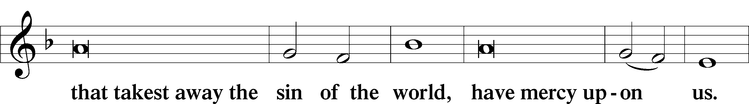
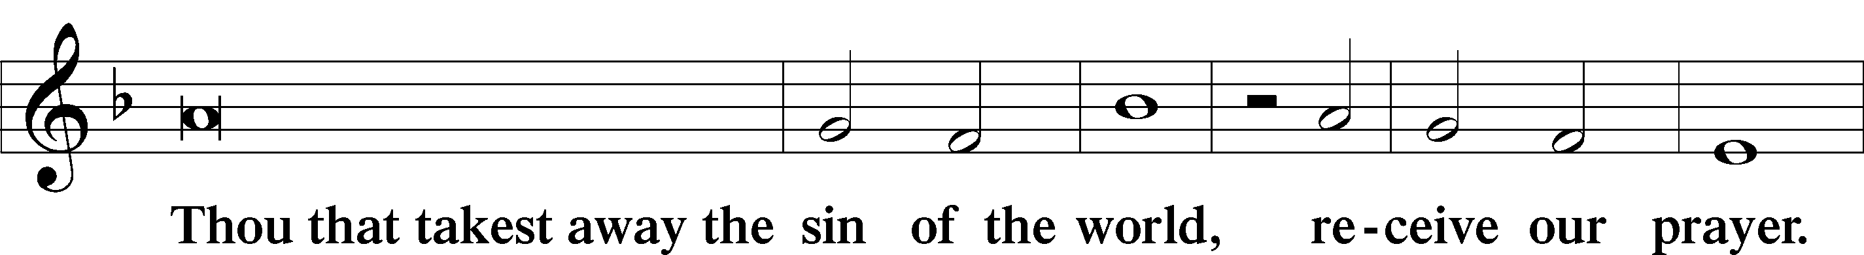
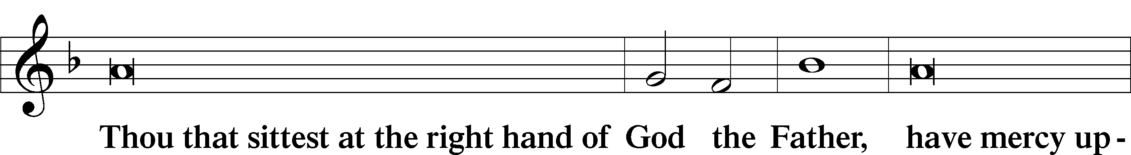
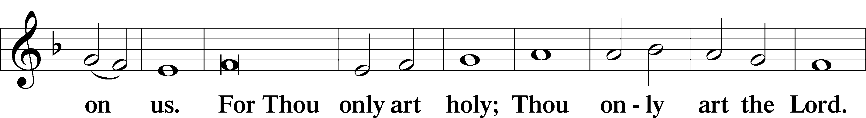
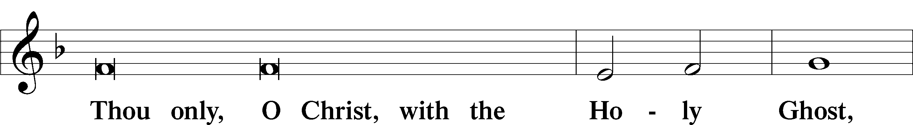
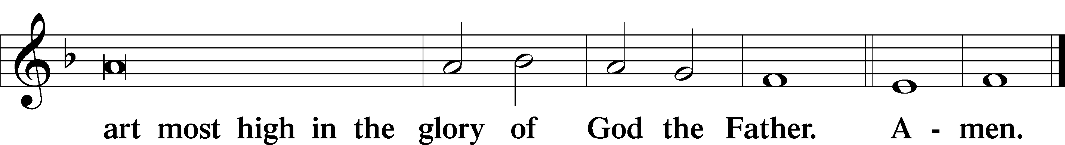

Salutation and Collect of the Day

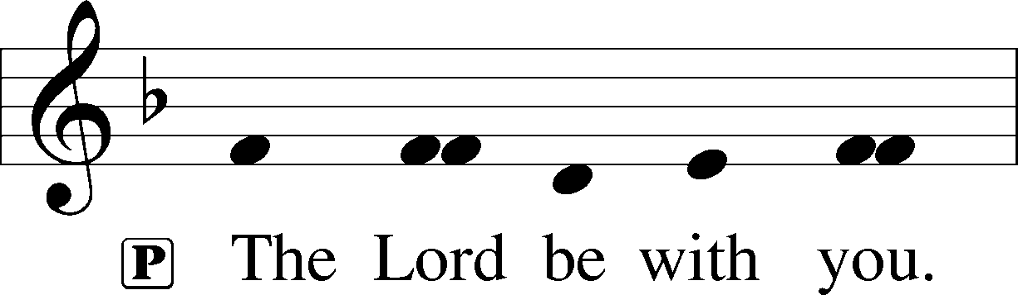
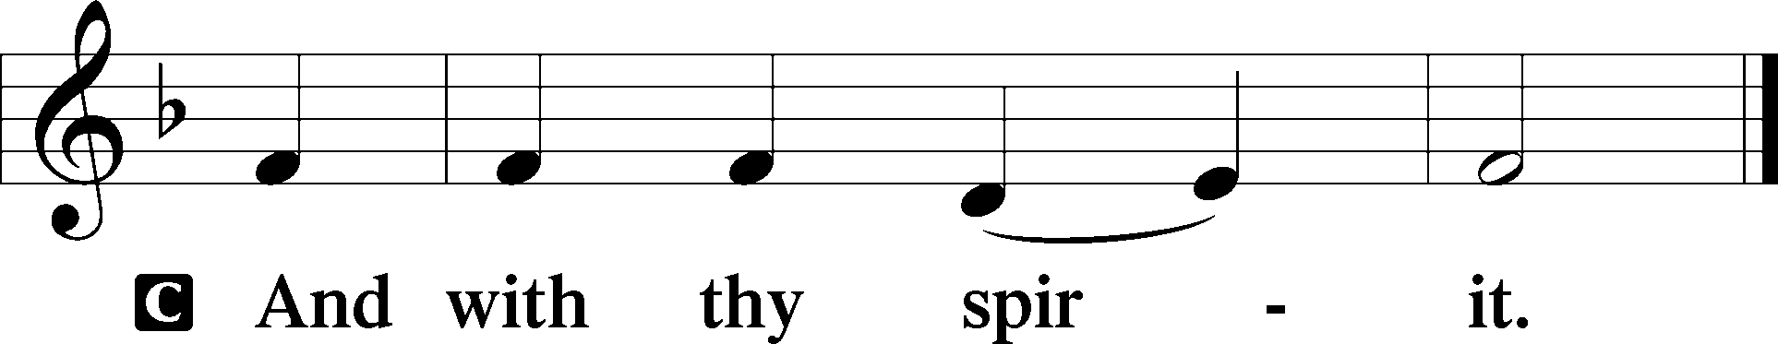

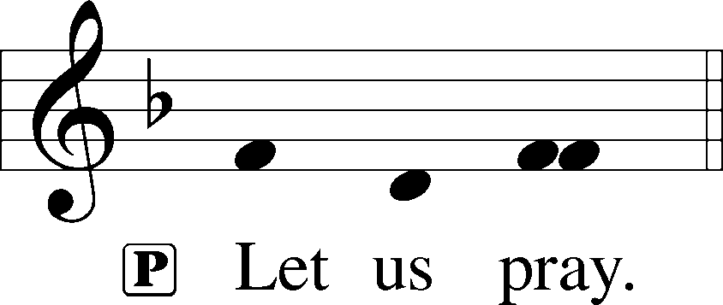

P Almighty and everlasting God, give us an increase of faith, hope, and love, that, receiving what You have promised, we may love what You have commanded; through Jesus Christ, Your Son, our Lord, who lives and reigns with You and the Holy Spirit, one God, now and forever.

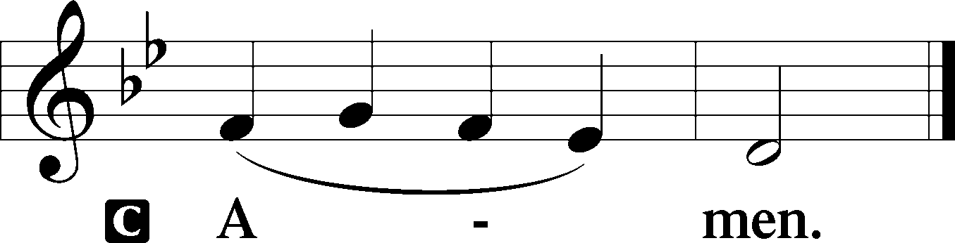
Please be seated

Old Testament Reading Deuteronomy 7:6-9
“For you are a people holy to the Lord your God. The Lord your God has chosen you to be a people for his treasured possession, out of all the peoples who are on the face of the earth. It was not because you were more in number than any other people that the Lord set his love on you and chose you, for you were the fewest of all peoples, but it is because the Lord loves you and is keeping the oath that he swore to your fathers, that the Lord has brought you out with a mighty hand and redeemed you from the house of slavery, from the hand of Pharaoh king of Egypt.
“Know therefore that the Lord your God is God, the faithful God who keeps covenant and steadfast love with those who love him and keep his commandments, to a thousand generations.”
A This is the Word of the Lord.
C Thanks be to God.

Gradual Romans 11:33, 36
Oh, the depth of the riches and wisdom and knowl- | edge of God!*
How unsearchable are his judgments and how inscrutable | his ways!
For from him and through him and to him are | all things.*
To him be glory forever. | Amen.

Epistle Reading Romans 8:28-39
We know that for those who love God all things work together for good, for those who are called according to his purpose.
For those whom he foreknew he also predestined to be conformed to the image of his Son, in order that he might be the firstborn among many brothers. And those whom he predestined he also called, and those whom he called he also justified, and those whom he justified he also glorified.
What then shall we say to these things? If God is for us, who can be against us? He who did not spare his own Son but gave him up for us all, how will he not also with him graciously give us all things? Who shall bring any charge against God’s elect? It is God who justifies. Who is to condemn? Christ Jesus is the one who died—more than that, who was raised—who is at the right hand of God, who indeed is interceding for us. Who shall separate us from the love of Christ? Shall tribulation, or distress, or persecution, or famine, or nakedness, or danger, or sword? As it is written,
“For your sake we are being killed all the day long;
we are regarded as sheep to be slaughtered.”
No, in all these things we are more than conquerors through him who loved us. For I am sure that neither death nor life, nor angels nor rulers, nor things present nor things to come, nor powers, nor height nor depth, nor anything else in all creation, will be able to separate us from the love of God in Christ Jesus our Lord.
A This is the Word of the Lord.
C Thanks be to God.

Please stand

Alleluia
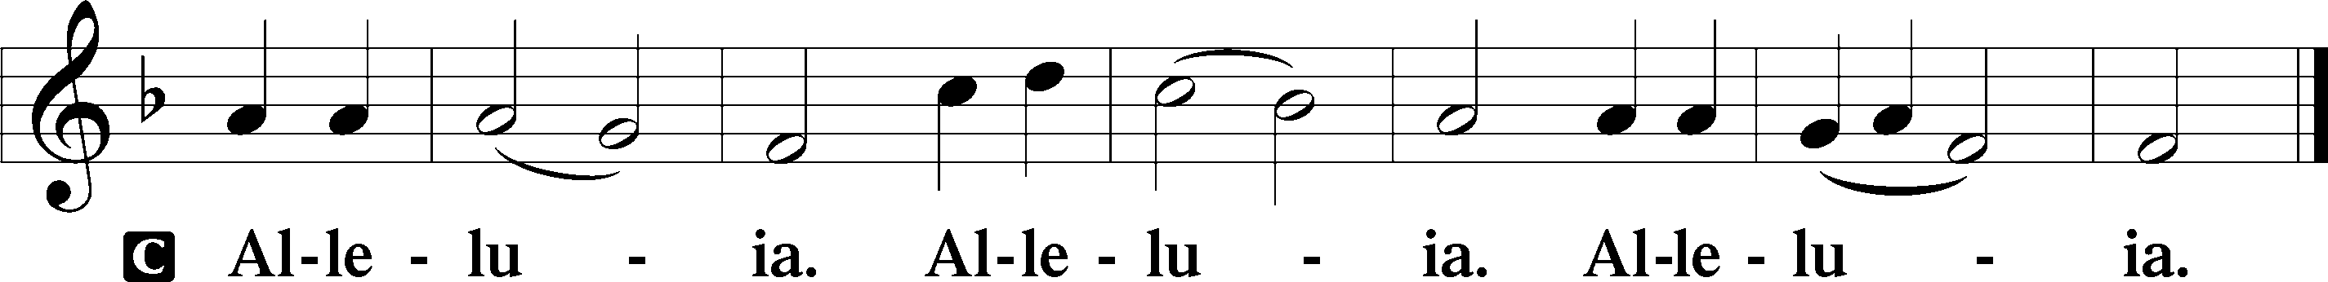

Holy Gospel Matthew 13:44-52

P The Holy Gospel according to St. Matthew, the thirteenth chapter.

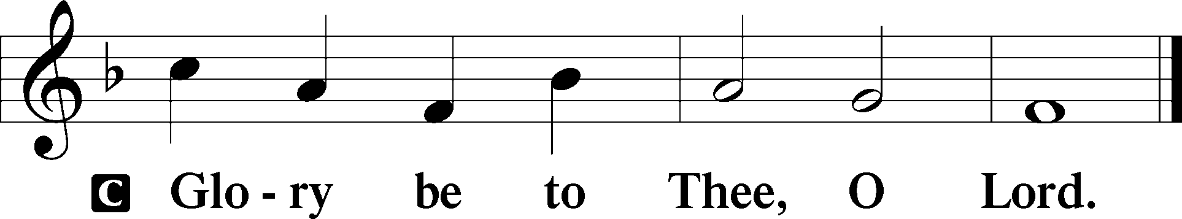
[Jesus said:] “The kingdom of heaven is like treasure hidden in a field, which a man found and covered up. Then in his joy he goes and sells all that he has and buys that field.
“Again, the kingdom of heaven is like a merchant in search of fine pearls, who, on finding one pearl of great value, went and sold all that he had and bought it.
“Again, the kingdom of heaven is like a net that was thrown into the sea and gathered fish of every kind. When it was full, men drew it ashore and sat down and sorted the good into containers but threw away the bad. So it will be at the close of the age. The angels will come out and separate the evil from the righteous and throw them into the fiery furnace. In that place there will be weeping and gnashing of teeth.
“Have you understood all these things?” They said to him, “Yes.” And he said to them, “Therefore every scribe who has been trained for the kingdom of heaven is like a master of a house, who brings out of his treasure what is new and what is old.”
P This is the Gospel of the Lord.
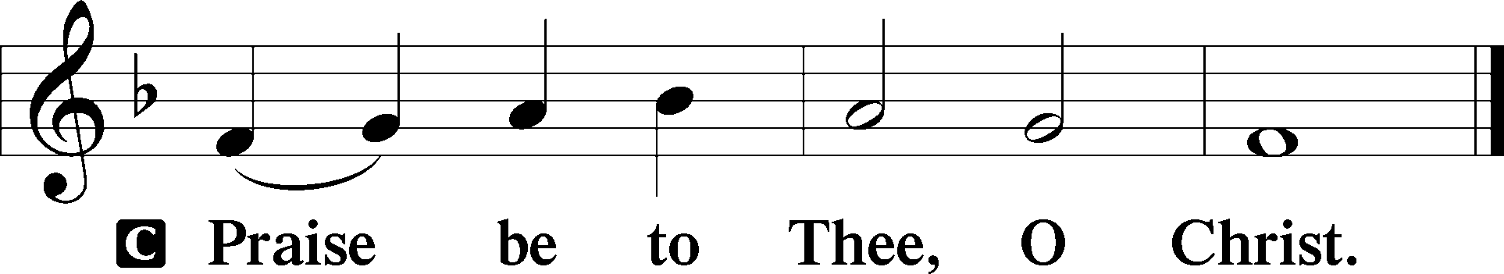

Please be seated

Office Hymn From God Can Nothing Move Me #713

Sermon The Treasured Possession

Please stand

Nicene Creed

C I believe in one God, (Rom 10:10; Deut 6:4)
the Father Almighty, (Mt 6:9; Ex 6:3)
maker of heaven and earth (Gen 1:1; Jn 1:1)
and of all things visible and invisible. (Col 1:16)
And in one Lord Jesus Christ, (Rom 10:9)
the only-begotten Son of God, (Jn 3:16; Mt 16:16)
begotten of His Father before all worlds, (Jn 1:2)
God of God, Light of Light, (Jn 17:22; Jn 8:12; Jn 1:1)
very God of very God, (Col 2:9) begotten, not made, (Jn 1:2)
being of one substance with the Father, (Jn 10:30)
by whom all things were made; (Heb 1:2; Jn 1:3)
who for us men and for our salvation (1 Tim 2:4; Rom 3:23)
came down from heaven (Jn 6:41; Lk 15:20)
and was incarnate by the Holy Spirit of the virgin Mary (Lk 1:34-35)
and was made man; (Jn 1:14)
and was crucified also for us under Pontius Pilate. (Mk 15:25; Jn 19:16-18)
He suffered and was buried. (Jn 19:1-3; Lk 23:53)
And the third day He rose again according to the Scriptures (1 Cor 15:4; Lk 24:6)
and ascended into heaven (Acts 1:9)
and sits at the right hand of the Father. (Acts 7:55)
And He will come again with glory (Mt 26:64)
to judge both the living and the dead, (Acts 10:42; Mt 3:12)
whose kingdom will have no end. (2 Pt 1:11)
And I believe in the Holy Spirit, (Jn 14:26; Gen 1:2; Acts 2:38)
the Lord and giver of life, (Gen 1:2; Jn 3:6)
who proceeds from the Father and the Son, (Jn 15:26)
who with the Father and the Son together is worshiped and glorified, (Mt 3:16-17)
who spoke by the prophets. (Eze 11:5)
And I believe in one holy Christian and apostolic Church, (1 Pt 2:5; Eph 2:19-22)
I acknowledge one Baptism for the remission of sins, (Eph 4:5)
and I look for the resurrection of the dead (1 Cor 15:35-49; 1 Thess 4:13-18)
and the life T of the world to come. (Mk 10:29-30; Mt 10:40-42)
Amen. (Ps 106:48)
Us men means all people.
Christian: the ancient text reads “catholic,” meaning the whole Church as it confesses the wholeness of Christian doctrine

Prayer of the Church

After each petition of the prayer:
Pastor: Let us pray to the Lord.
People: Lord, have mercy.

For comfort, health and recovery: Allison Agent, Blair Alford, Cooper Jamison, Amy Lewis, Tom McKenna, Bob Pedersen, Gail Oakes, Alaena Ramsey, David Riley, John Rudsenske, Greg White;
For those who are ill or distressed: Stan Acey, Jenalee Adams, Kimberly Airhart, Layne Bagley, Rose Bagley, Shirley Bagley, W.L. Bagley, Sarah Bowman, Mimi Bradley, Richard Bradley, Deloris Brent, Martha Brown, Nathan Brown, Tina Burke, Wayne Burke, Paula Burkhalter, Bobby Carroll, Arthur Collins, James E. Cookston, Joan Cowards, Belinda Cowards-Gonzales, Mike Ellis, Robert (Andy) Evers, Michele Rae Fowler, Randy Fowler, Parker Haines, Dan Hansen, Paul Hansen, Tim Hansen, Valerie Henderson, Sharon Holleman, Hugh Hunt, Beth Jarratt, Jimmy Jarratt, Elaine Johnson, Joslyn Jones, Steve Kennedy, Arlene Kleinschmidt, Eleanor Koster, John Koster, Sandra Landers, Katelyn Lawing, Peggy Lucky, Paul McCullough, Jerry McIntyre, Jerry McMahan, Mark Millard, Edlia Miller, Mark Miller, Elaine Monaghan, Lindberg Moore, Jerry Mutter, Don Ochs, Mildred Odom, Janea Parker, Deborah-Annette Ried, Elmira Roever, Jon Sandberg, Noah Schultz, Johnnie Pearl Smiley, Bob Smith, Sally Smith, Sam Schneider, Sherri Smith, Deborah Springer, MariLyn Unger, Betty Venator, Leonard Watson, Dana Weaver, Cynthia Widlitze, Carol Wright, Jimmy Wright, Marshall Wright, Barbara Zeigler;
For college and graduate students: Jake Everly, Sara Fields, Roselynn Nelson;
For military servants and their families: Gabriel Escude, James (Glen) Hansford, Holden Hathcock, Christopher Martin, William Nelson, Steven Tatum, John Weidner Jr.;
For foreign missionaries: David and Shelee Warner;
This week’s prayer family: Miachel Martin and his loved ones.

Please be seated

Offering

Offertory Psalm 51:10-12
The congregation is invited to sing in parts:
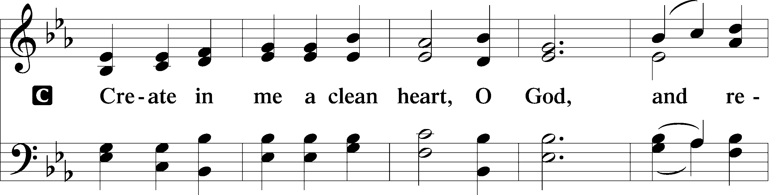
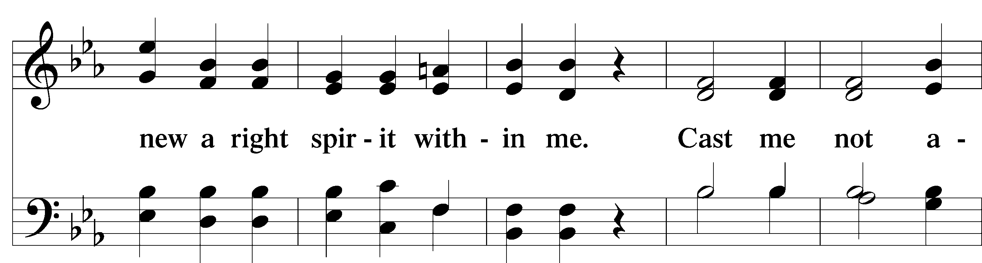
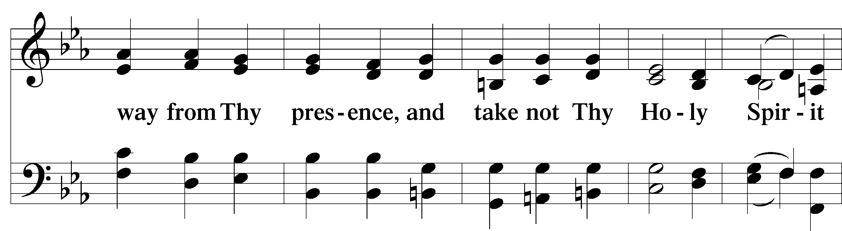
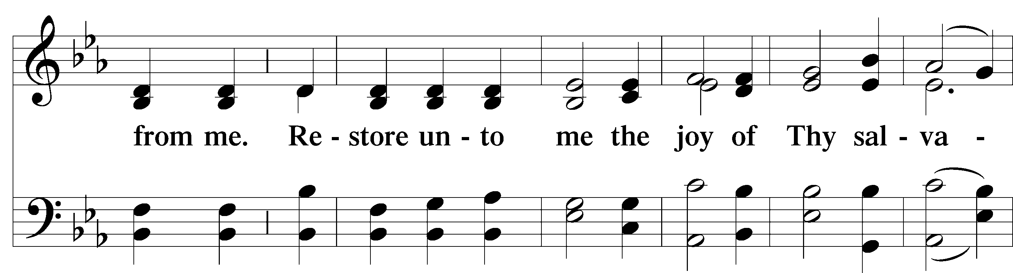
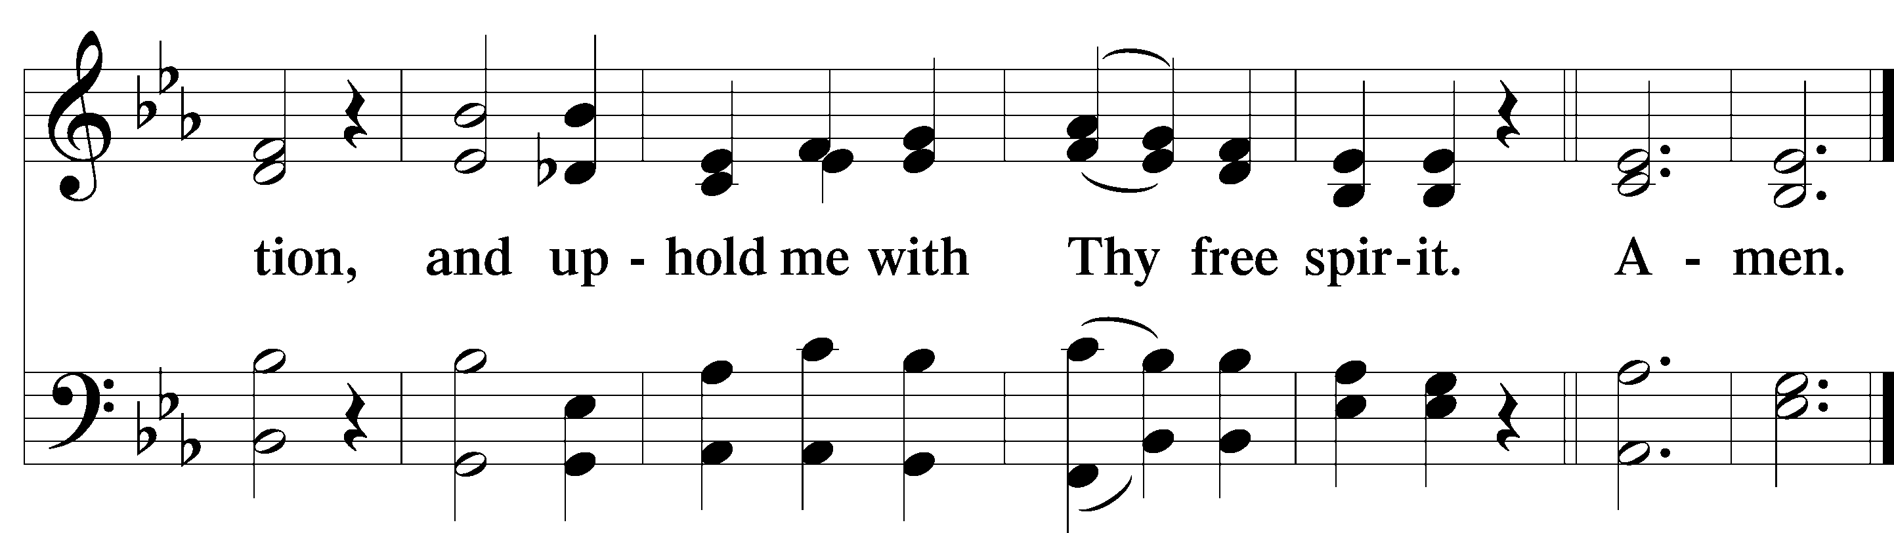

Service of the Sacrament

Preface 2 Timothy 4:22; [Colossians 3:1]; [Psalm 136]

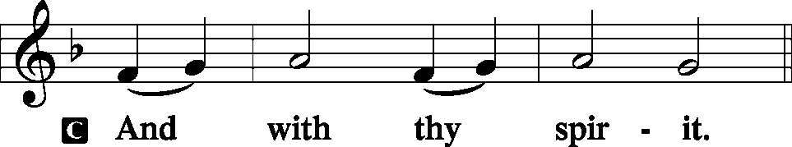
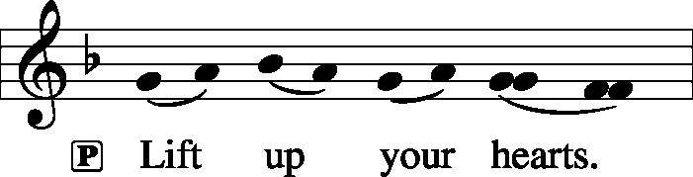

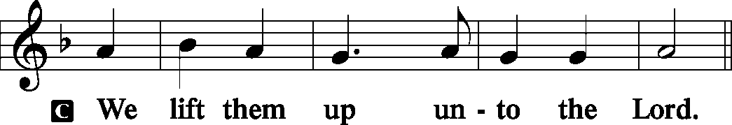
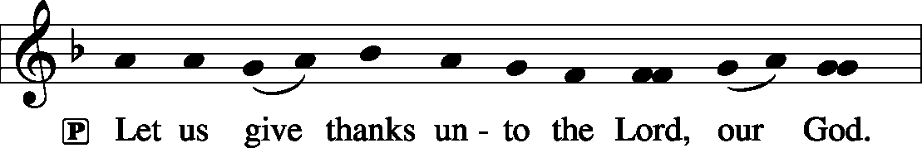
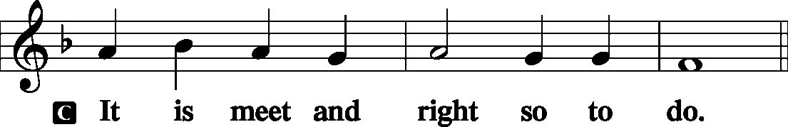

P It is truly meet, right, and salutary that we should at all times and in all places give thanks to You, holy Lord, almighty Father, everlasting God, through Jesus Christ, our Lord, who on this day overcame death and the grave and by His glorious resurrection opened to us the way of everlasting life. Therefore with angels and archangels and with all the company of heaven we laud and magnify Your glorious name, evermore praising You and saying:

Sanctus Isaiah 6:3; Matthew 21:9
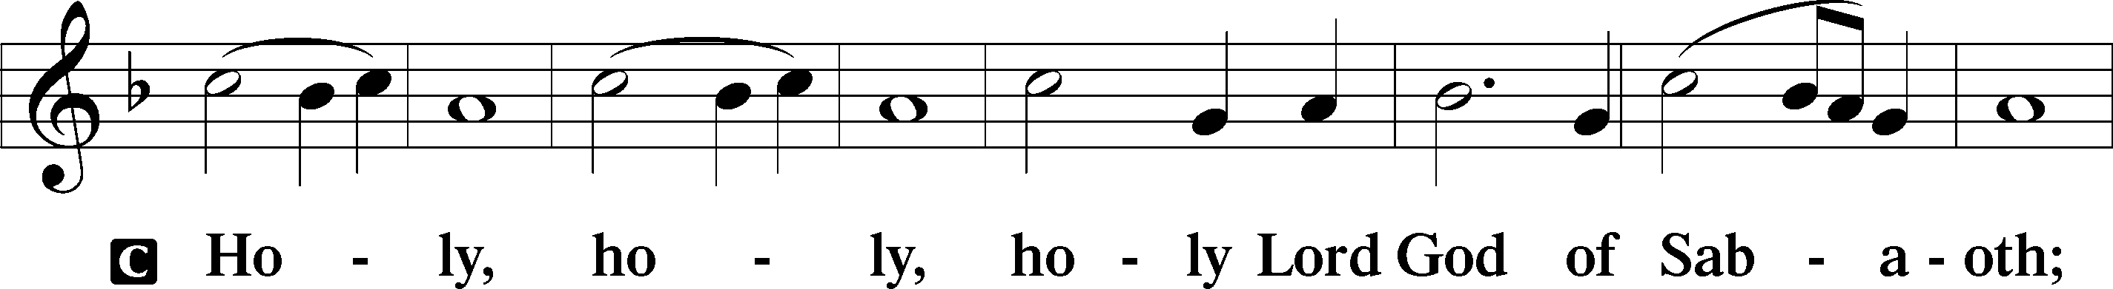
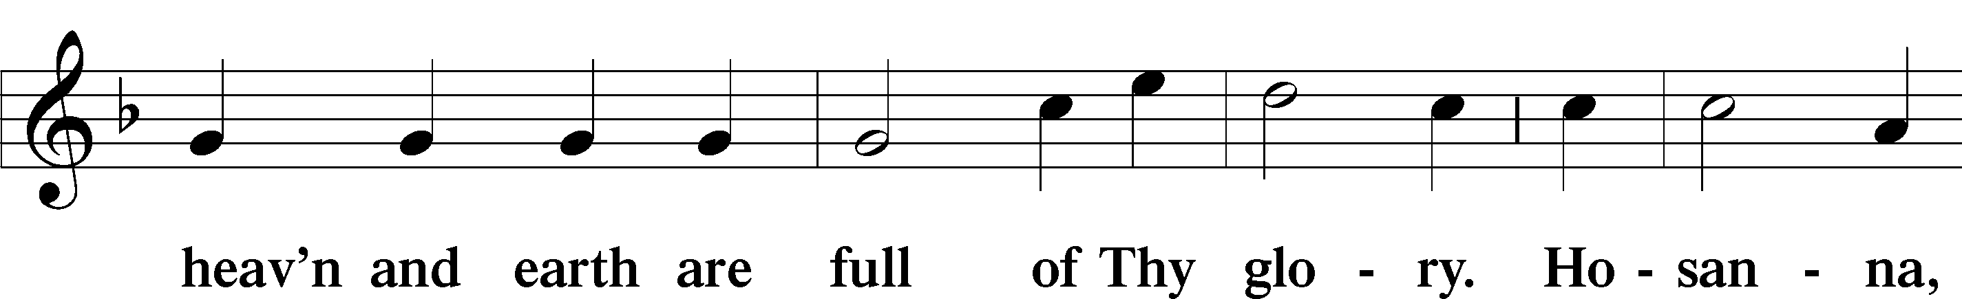
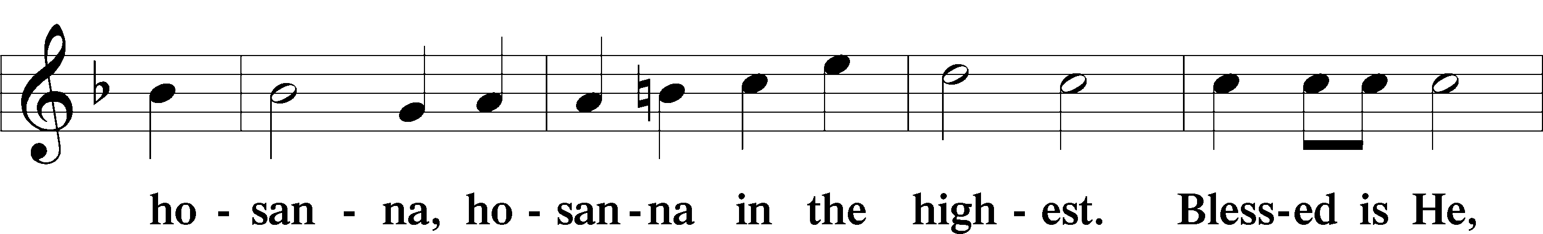
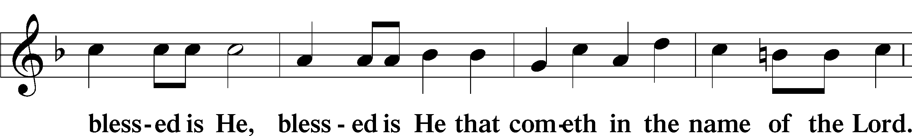
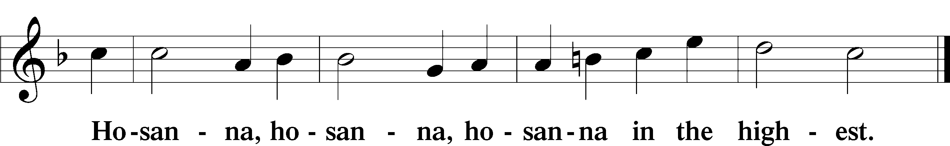

Lord’s Prayer Matthew 6:9-13
P Our Father who art in heaven,
Hallowed be Thy name,
Thy kingdom come,
Thy will be done on earth as it is in heaven;
Give us this day our daily bread;
And forgive us our trespasses as we forgive those who trespass against us;
And lead us not into temptation,
But deliver T us from evil.

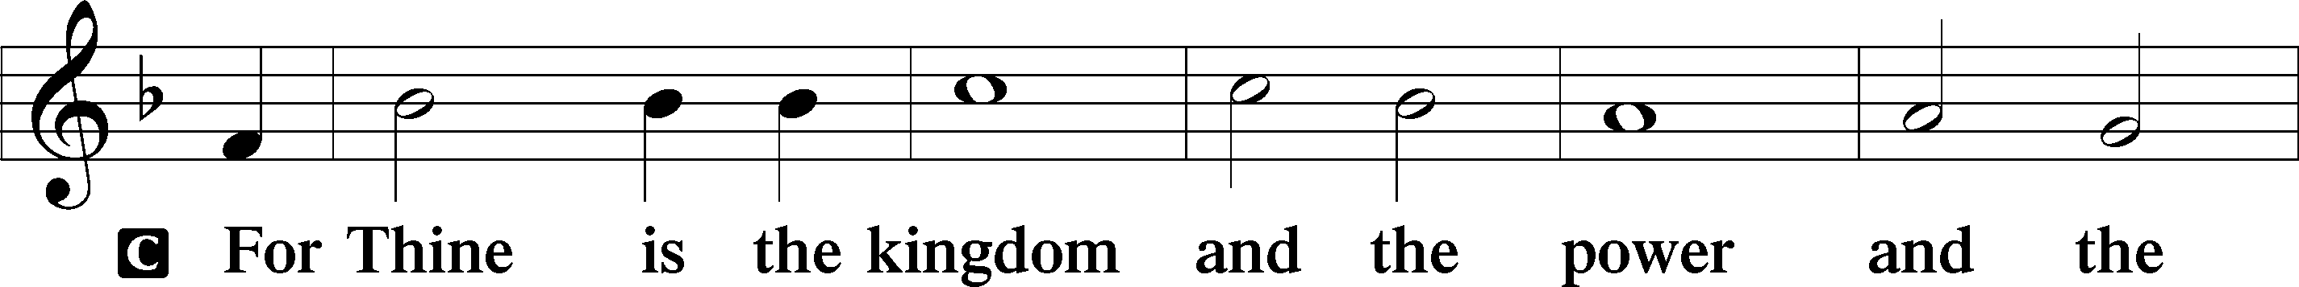
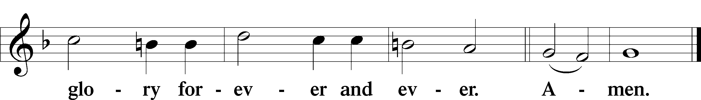

The Words of Our Lord Matthew 26:26–28
P Our Lord Jesus Christ, on the night when He was betrayed, took bread, and when He had given thanks, He broke it and gave it to the disciples and said: “Take, eat; this is My T body, which is given for you. This do in remembrance of Me.”
In the same way also He took the cup after supper, and when He had given thanks, He gave it to them, saying: “Drink of it, all of you; this cup is the new testament in My T blood, which is shed for you for the forgiveness of sins. This do, as often as you drink it, in remembrance of Me.”

Pax Domini John 20:19
P The peace T of the Lord be with you always.
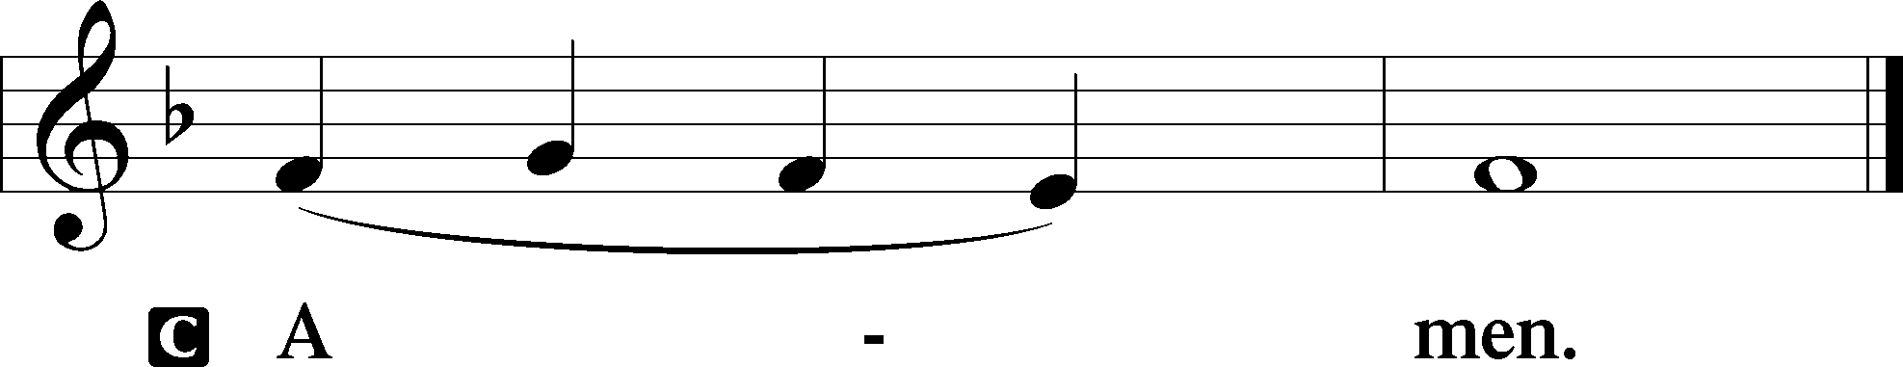

Agnus Dei John 1:29
The congregation is invited to sing in parts.
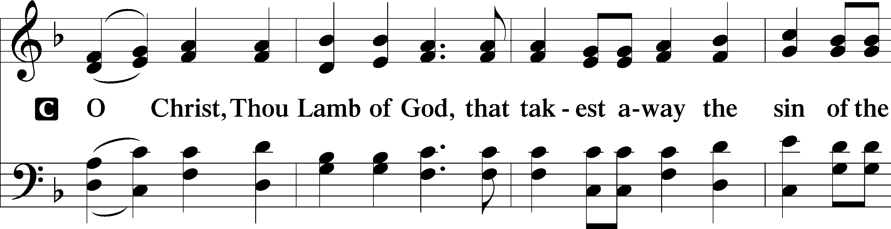
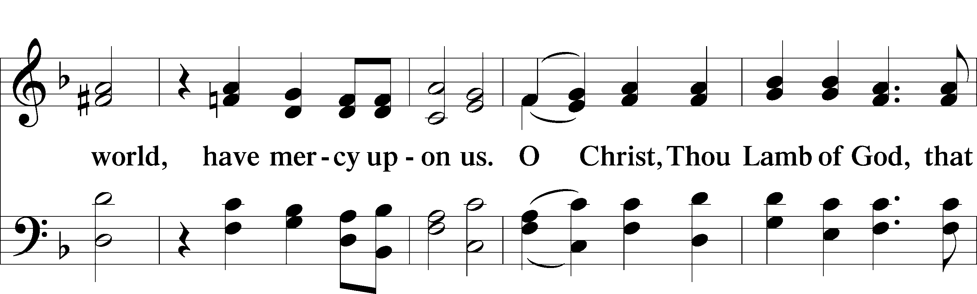
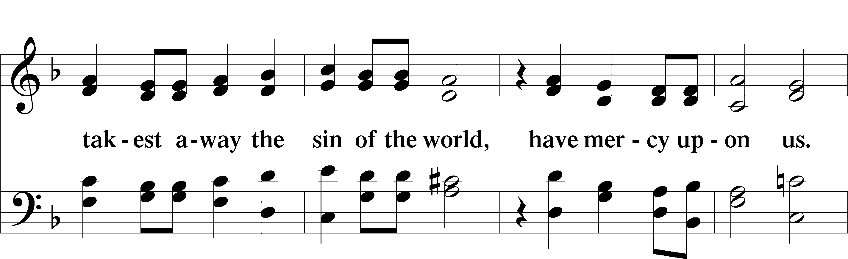
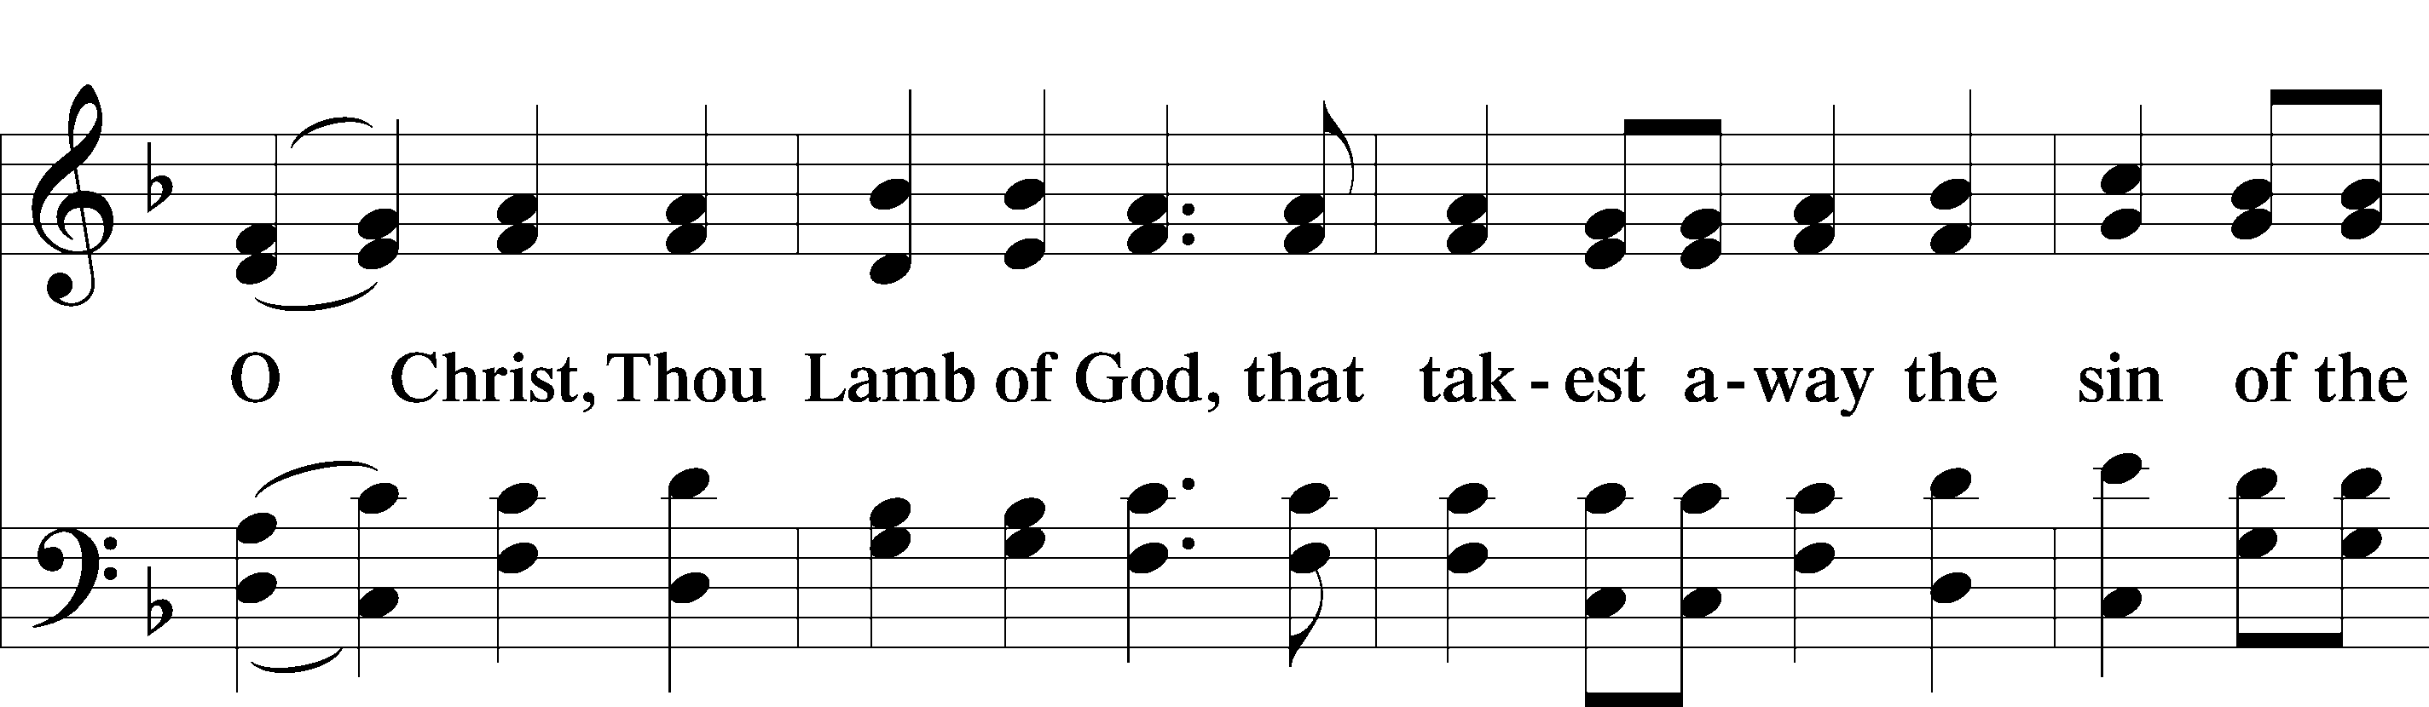
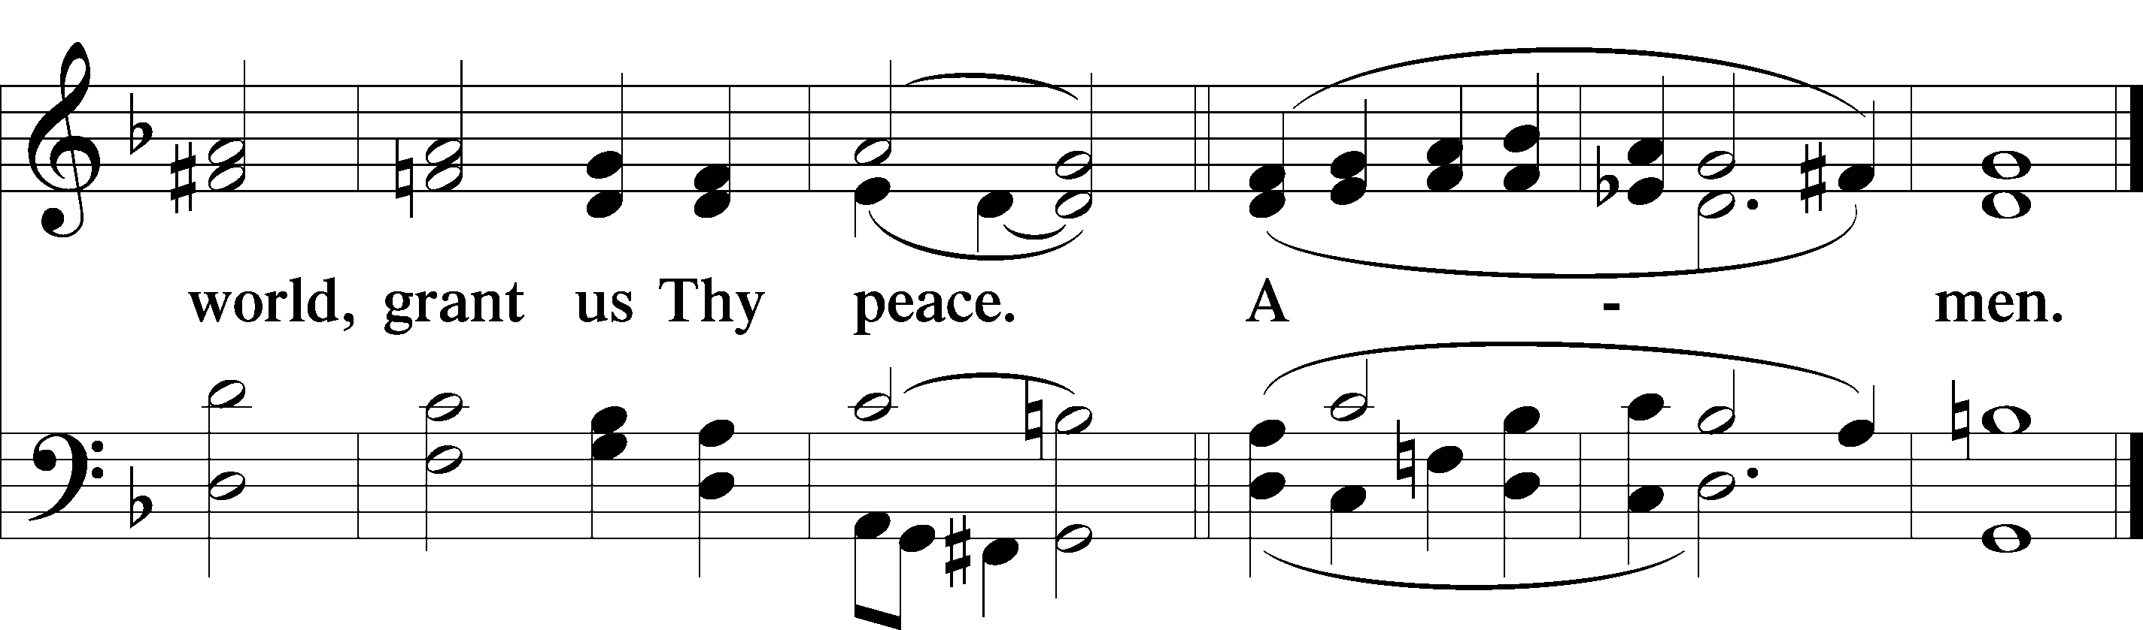
Please be seated

Distribution of the Sacrament
All who are members in good standing of the Lutheran Church - Missouri Synod and have introduced themselves to one of the pastors are welcome to partake of the Holy Communion at Christ Lutheran. If you have not spoken to a pastor, but would like to receive the Lord's blessing, you may still come to the rail and kneel, crossing one arm over the other in the shape of an 'X'. This symbolizes that one is marked by the cross and Triune name of Almighty God.

Distribution Hymns
What Is the World to Me #730

Please stand following distribution of communion

Nunc Dimittis Luke 2:29-32
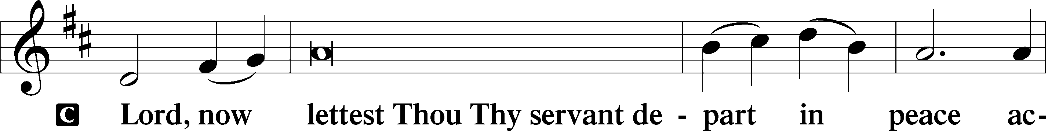
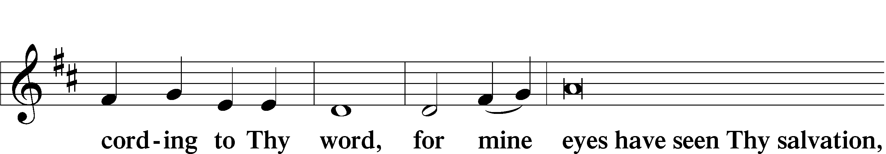
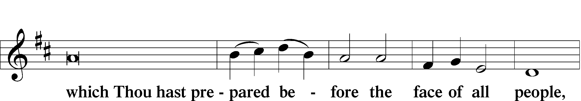
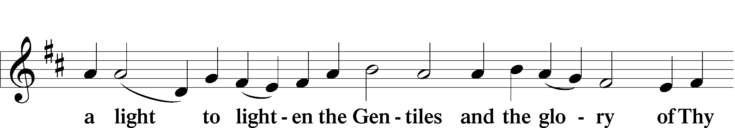
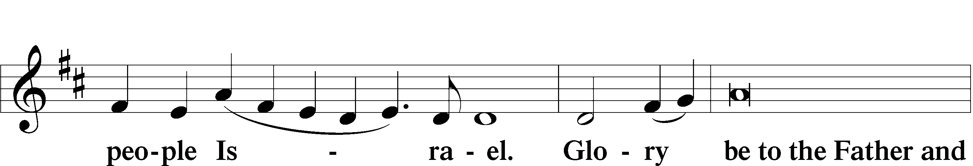
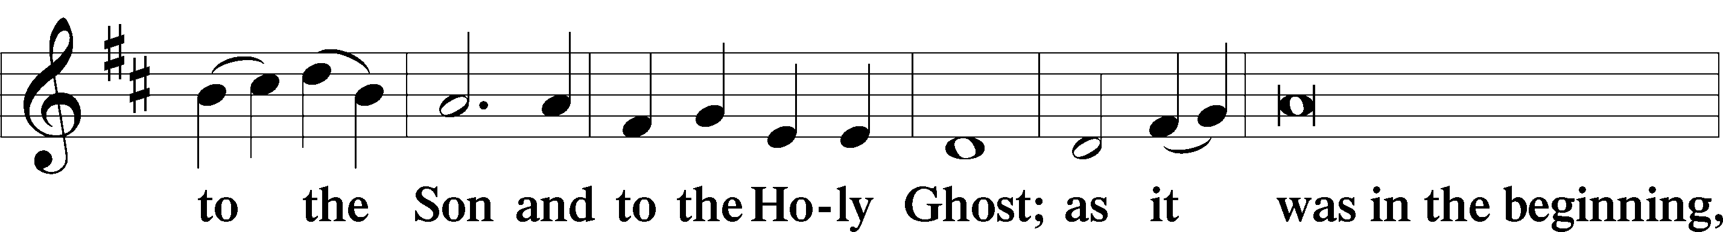
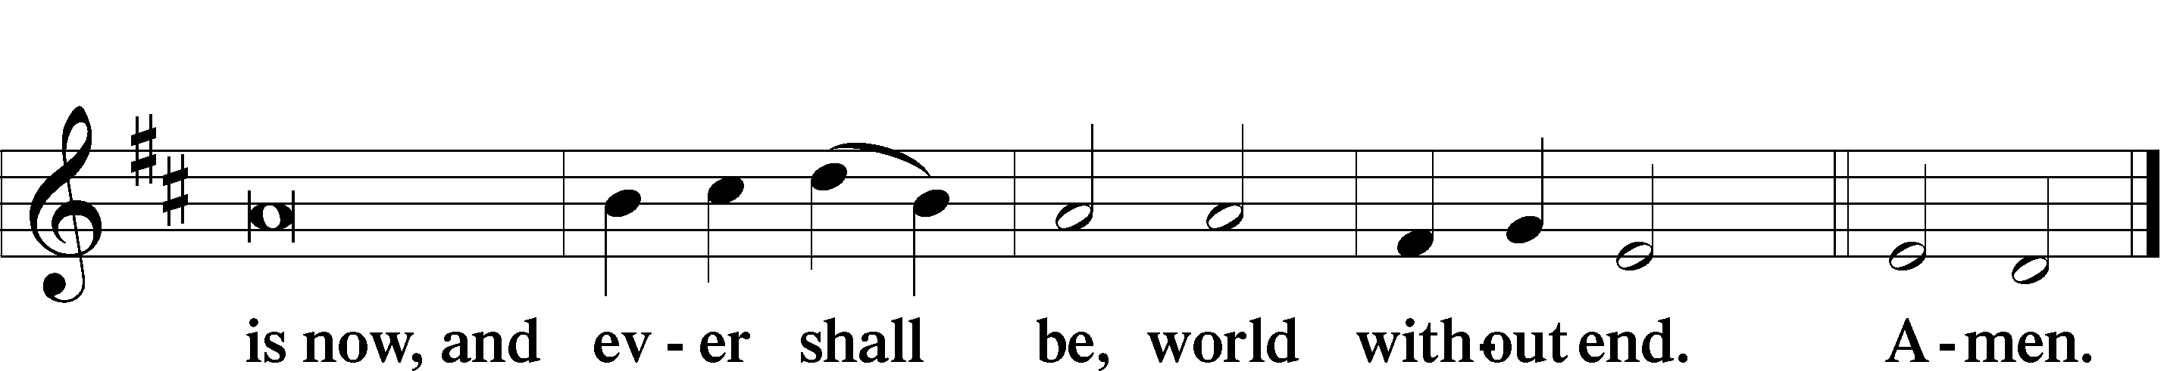

Thanksgiving
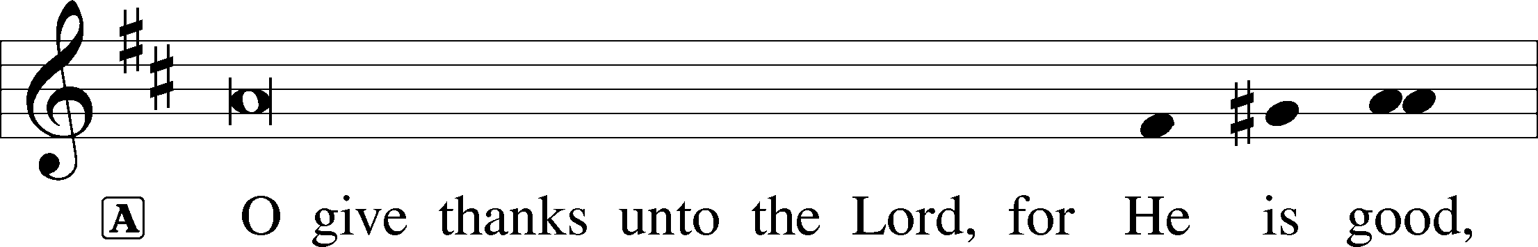
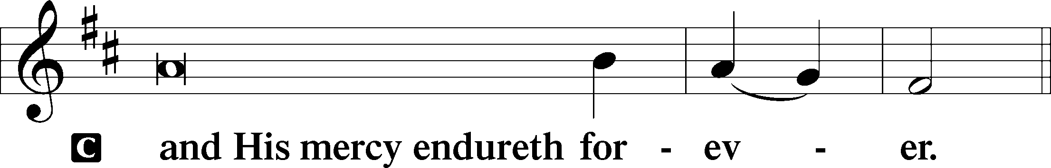

Post-Communion Collect
A We give thanks to You, almighty God, that You have refreshed us through this salutary gift, and we implore You that of Your mercy You would strengthen us through the same in faith toward You and fervent love toward one another; through Jesus Christ, Your Son, our Lord, who lives and reigns with You and the Holy Spirit, one God, now and forever.
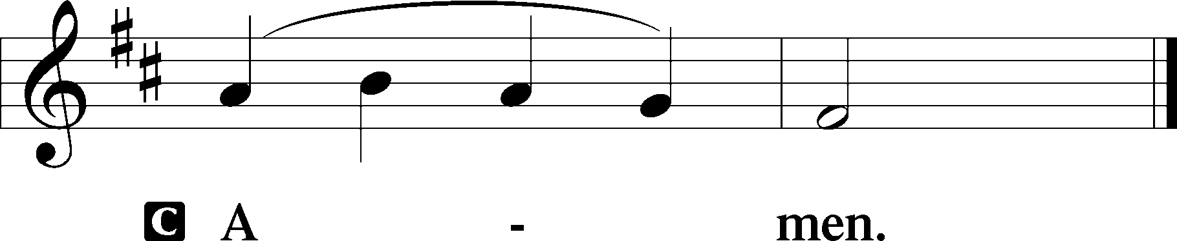

Salutation and Benedicamus
P The Lord be with you.
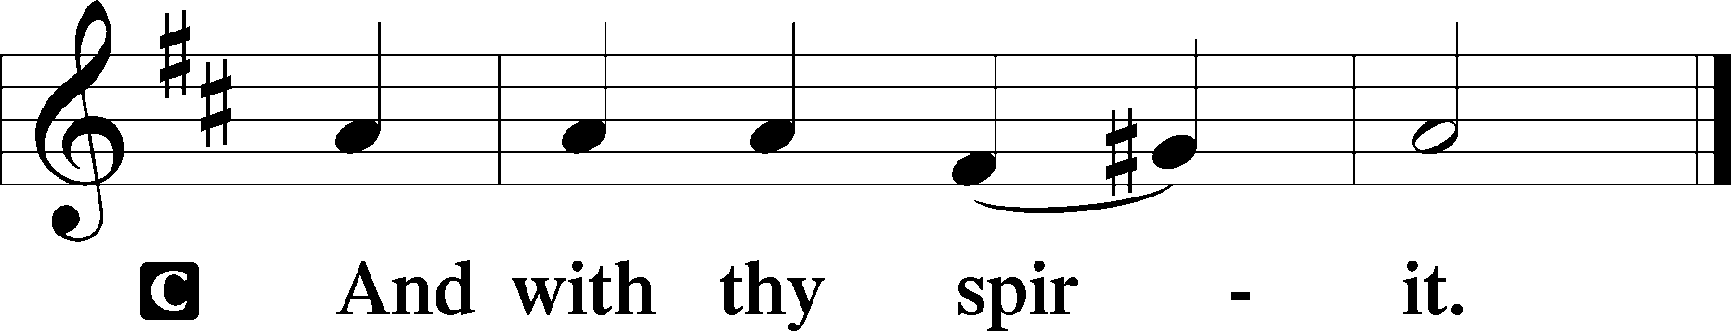
P Bless we the Lord.
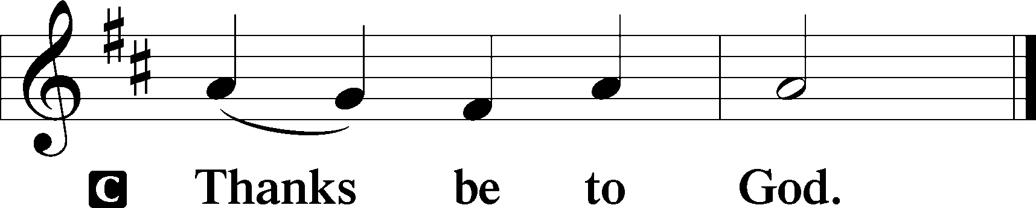
Benediction Numbers 6:24–26
P The Lord bless you and keep you.
The Lord make His face shine upon you and be gracious unto you.
The Lord lift up His countenance upon you and T give you peace.
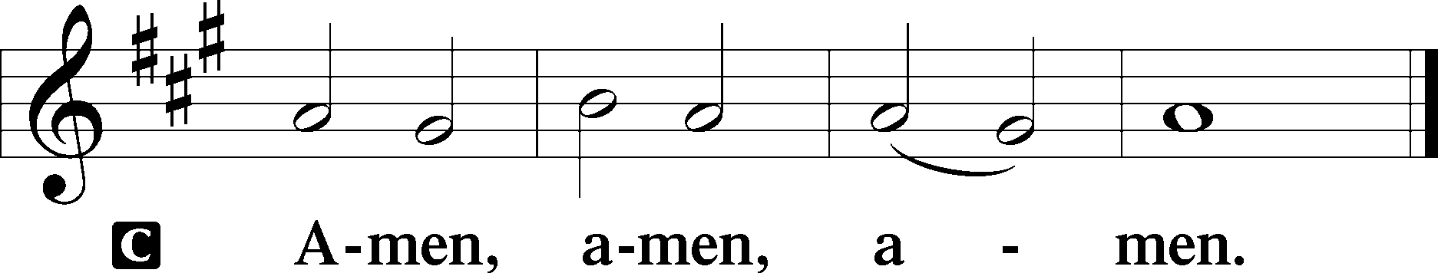

Closing Hymn The Will of God Is Always Best #758

Acknowledgments
Divine Service, Setting Three from Lutheran Service Book © 2006 Concordia Publishing House. Reprinted with permission. Unless otherwise indicated, all scripture quotations are from The Holy Bible, English Standard Version, copyright © 2001 by Crossway Bibles, a division of Good News Publishers. Used by permission. All rights reserved. Created by Lutheran Service Builder © 2006 Concordia Publishing House.

Serving Today:
Celebrant: Rev. George Fields Elder: Eric Held, Keith Martin
Acolyte: James Hansford, Will Nelson Organist: Sr. Sara Fields
Interpreter: Greg Goldman Cantor: Jake Everly
Ushers: Bruce Bodkin, Allen Goodlett, Eric Held

Altar Flowers: This morning’s altar flowers were given for the glory of God by the Held Family in celebration of Emily’s birthday.

Readings for next Sunday, August 2nd, the Ninth Sunday after Pentecost:
Introit Ps. 105:39-43; Psalm 136:1-26; Isaiah 55:1-5; Romans 9:1-13; Matthew 14:13-21.

This week at Christ Lutheran Church: July 27 – August 2

Friday 6:30 p.m. Divine Service – Ninth Sunday after Pentecost
Sunday 10:30 a.m. Divine Service – Ninth Sunday after Pentecost



YOUR LIFELINE TO THE LUTHERAN WORLDVIEW…You can listen to in-depth teachings on interesting subjects like:

Myths about Lutheran Worship, Callings in Life, The Hymn “Thy Strong Word,” Johann Sebastian Bach, and more…

Issues, Etc. is a radio talk show produced by Lutheran Public Radio and hosted by LCMS Pastor Todd Wilken. You can listen to what you want when you want at www.issuesetc.org. Simply click on “Listen”, choose “On Demand”, then select from the vast array of speakers and topics available in the archives.

Matthew 13:45-46 – “Again, the kingdom of heaven is like a merchant in search of fine pearls, who, on finding one pearl of great value, went and sold all that he had and bought it.”
Indeed, Jesus redeemed us and purchased us back from sin and death with all that He had. We belong to Him now. And this is the foundation for our own generosity: imitating the out-sized generosity of Jesus.

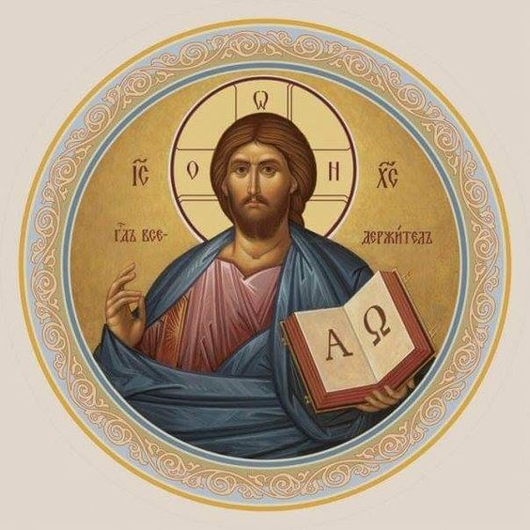

Matthew 26:26-29; Mark 14:22-25; Luke 22:14-20, 1 Corinthians 11:23
Matthew 26:28; 1 John 1:7; 1 Peter 1:18-19
1 Corinthians 11:28-32
1 Corinthians 10:17; 1 Corinthians 11:26

