Christ Lutheran Church

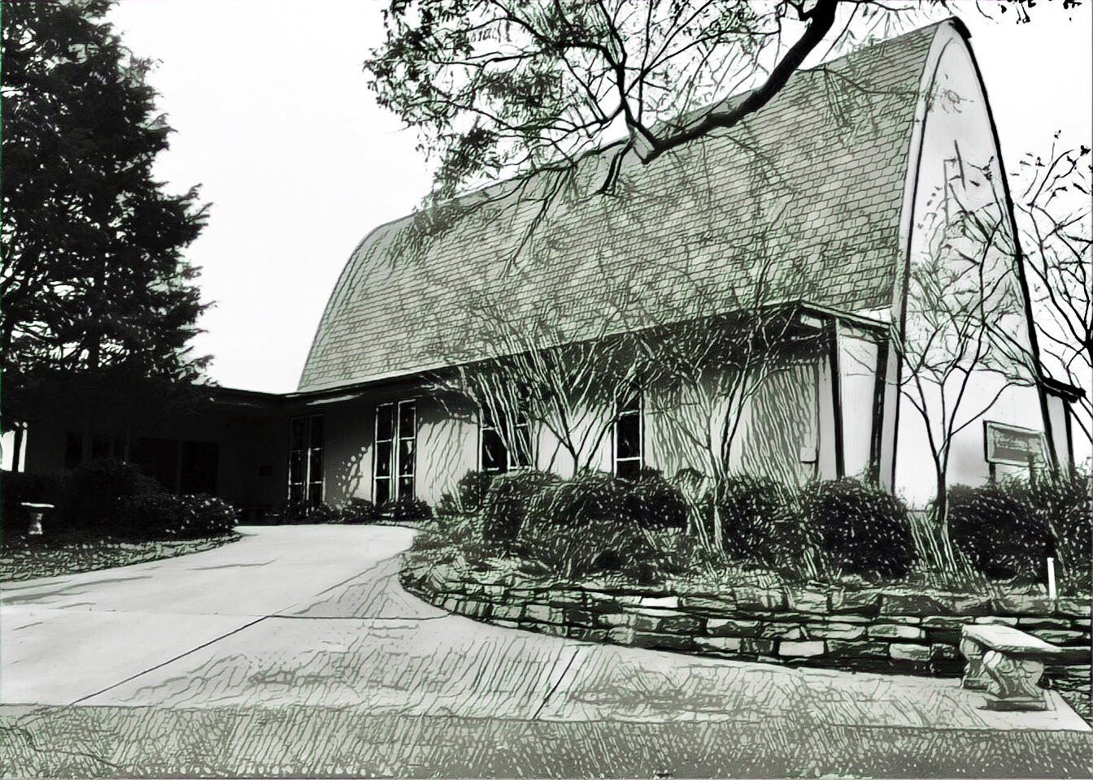

Rev. Dr. James R. Holowach, Pastor
Rev. George N. Fields, Pastor
Sr. Sara E. Fields, Deaconess
Divine Service Each Week with Holy Communion: 10:30 a.m.
Sunday School for all ages: 9:00 a.m.
4423 I-55 North, Jackson, MS 39206-6102 – (601) 366-2055
www.christlutheranjacksonms.org

The Fifth Sunday after Pentecost
+ July 5, 2020 +

“Return to Your Stronghold”



We welcome our members and guests to Christ Lutheran today,
and pray God’s richest blessings upon you during this time of worship!

All members and our guests are asked to complete the
worship attendance pads which can be found on each pew.
Guests are also asked to sign the guest register found in the Narthex.
We are so glad to have you worshiping with us today!

LARGE PRINT worship folders are available
at the usher stand at the back of the nave.

WELCOME:
“Stand apart from the inclinations to love sin and to love the flesh. Turn to deeds worthy of praise. Draw near to me, so that you may become sharers of the divine nature and partakers of the Holy Spirit. Jesus called everyone, not only the people of Israel. As the Maker and Lord of all, He spoke to the weary Jews who did not have the strength to bear the yoke of the law. He spoke to idolaters heavy laden and oppressed by the devil and weighed down by the multitude of their sins.”
–St. Cyril of Alexandria, Fragment 149

The Lord’s Supper

In preparation for reception of the Lord’s Supper (Holy Communion), it is important that we review and understand what the Bible teaches regarding this sacrament:
The Bible teaches that Jesus gives us His very body and blood along with bread and wine in Holy Communion, and that these are means by which He forgives our sins, and strengthens us for daily living, and draws us into closer fellowship with Him and other believers. The Bible also teaches us to examine ourselves prior to receiving the meal. For those receiving Holy Communion, examine yourself with these questions:
Do I believe that I am a sinner and I am sorry for my sins?
Do I believe that Jesus Christ is God’s Son and my personal Savior?
Do I believe that Christ’s true body and blood are present in this holy meal for my forgiveness?
Do I truly intend with the help of God to correct my sinful life?
According to Christ’s Word in the Holy Scriptures, and in confession with the true Christian faith, at Christ Lutheran we observe the practice of closed communion. We believe that all who commune must confess the same holy faith, as Holy Scripture teaches. Since one’s church affiliation indicates an individual’s confession of faith, we ask that only those who have been instructed in the above teaching and are confirmed members of The Lutheran Church – Missouri Synod commune. If you have not been instructed in this teaching on Holy Communion, are in doubt, or hold a different confession of faith, you are still welcome to come forward and cross your arms to indicate that you would like a blessing.

Divine Service III

Preservice Music
The congregation may use this time to pray and meditate.

Opening Hymn Lift Up Your Heads, Ye Mighty Gates #341

Confession & Absolution
The sign of the cross may be made by all in remembrance of their Baptism.

P In the name of the Father and of the T Son and of the Holy Spirit.
C Amen.

P Beloved in the Lord! Let us draw near with a true heart and confess our sins unto God our Father, beseeching Him in the name of our Lord Jesus Christ to grant us forgiveness.

P Our help is in the name of the Lord,
C who made heaven and earth.
P I said, I will confess my transgressions unto the Lord,
C and You forgave the iniquity of my sin.

Silence for reflection on God's Word and for self-examination.

P O almighty God, merciful Father,
C I, a poor, miserable sinner, confess unto You all my sins and iniquities with which I have ever offended You and justly deserved Your temporal and eternal punishment. But I am heartily sorry for them and sincerely repent of them, and I pray You of Your boundless mercy and for the sake of the holy, innocent, bitter sufferings and death of Your beloved Son, Jesus Christ, to be gracious and merciful to me, a poor, sinful being.

P Upon this your confession, I, by virtue of my office, as a called and ordained servant of the Word, announce the grace of God unto all of you, and in the stead and by the command of my Lord Jesus Christ I forgive you all your sins in the name of the Father and of the T Son and of the Holy Spirit.
C Amen.

Service of the Word

Introit: Qui habitat Psalm 91:2, 9-10; Ant. Psalm 91:1

He who dwells in the shelter of the | Most High*
will abide in the shadow of the Al- | mighty.
I will say to the Lord, “My refuge and my | fortress,*
my God, in | whom I trust.”
Because you have made the Lord your | dwelling place—*
the Most High, who is my | refuge—
no evil shall be allowed to be- | fall you,*
no plague come | near your tent.
Glory be to the Father and | to the Son*
and to the Holy | Spirit;
as it was in the be- | ginning,*
is now, and will be forever. | Amen.
He who dwells in the shelter of the | Most High*
will abide in the shadow of the Al- | mighty.

Kyrie Mark 10:47
The congregation is invited to sing in parts:

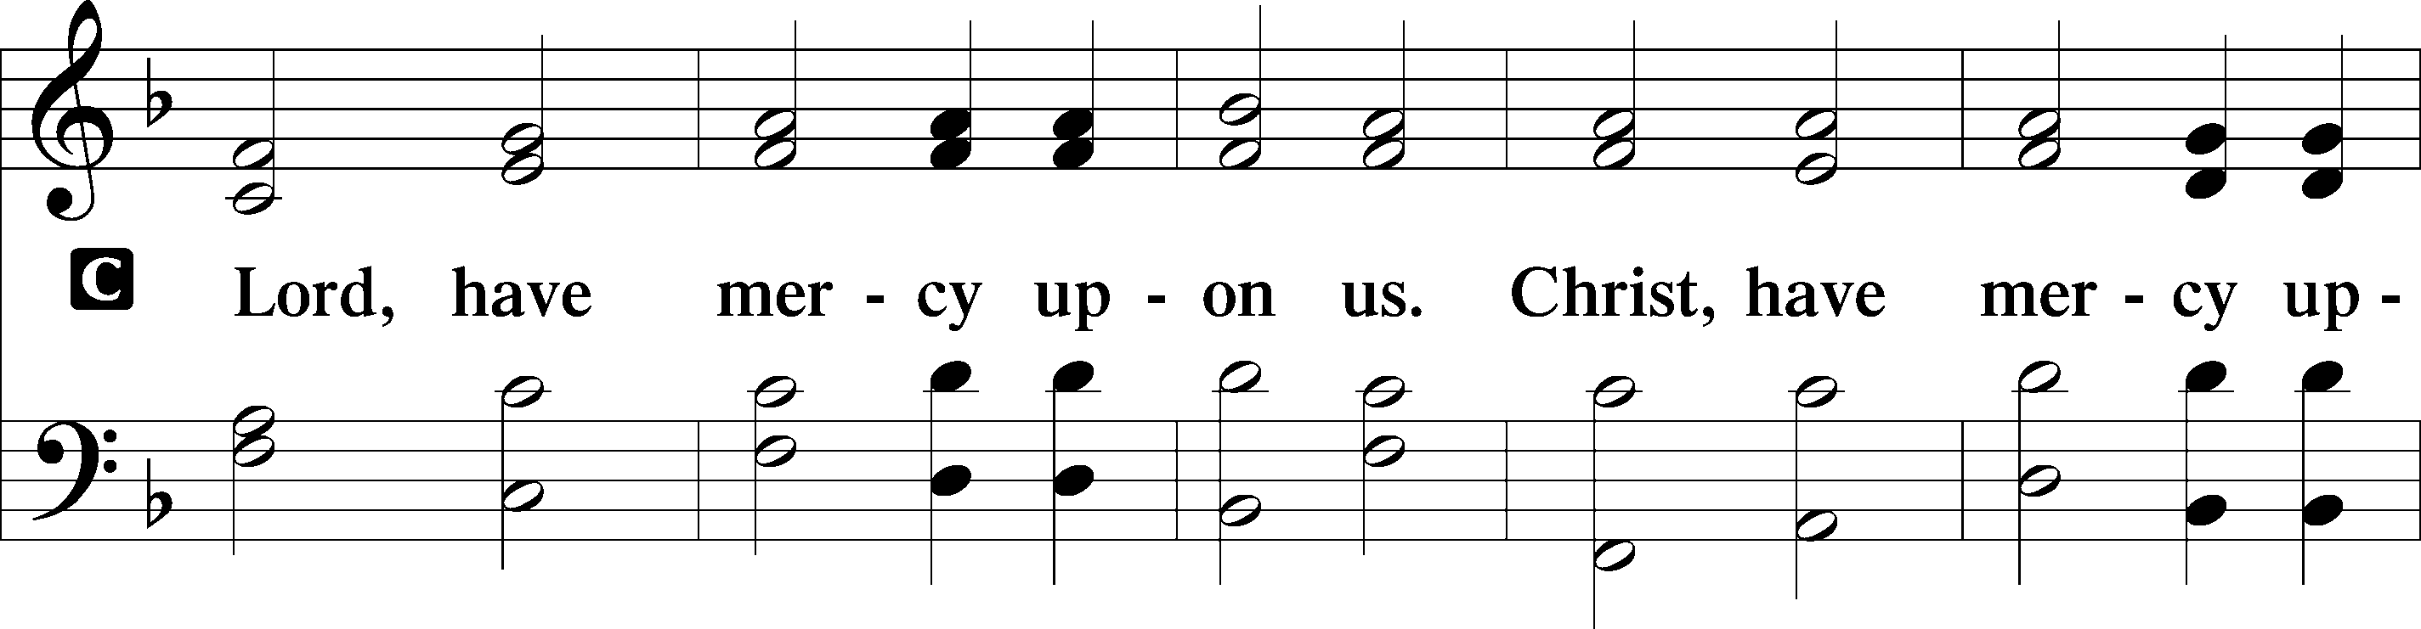
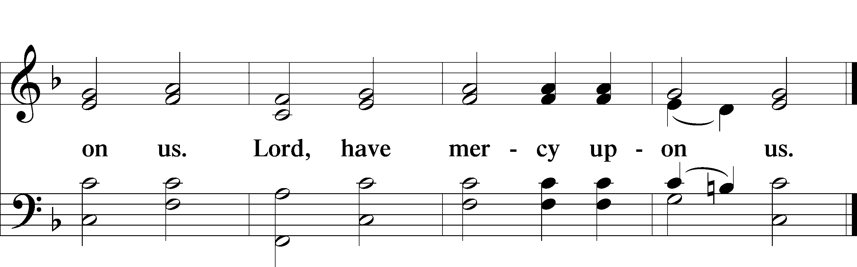

Gloria in Excelsis
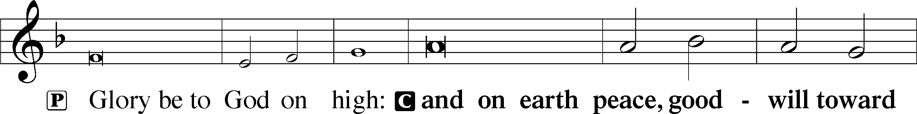
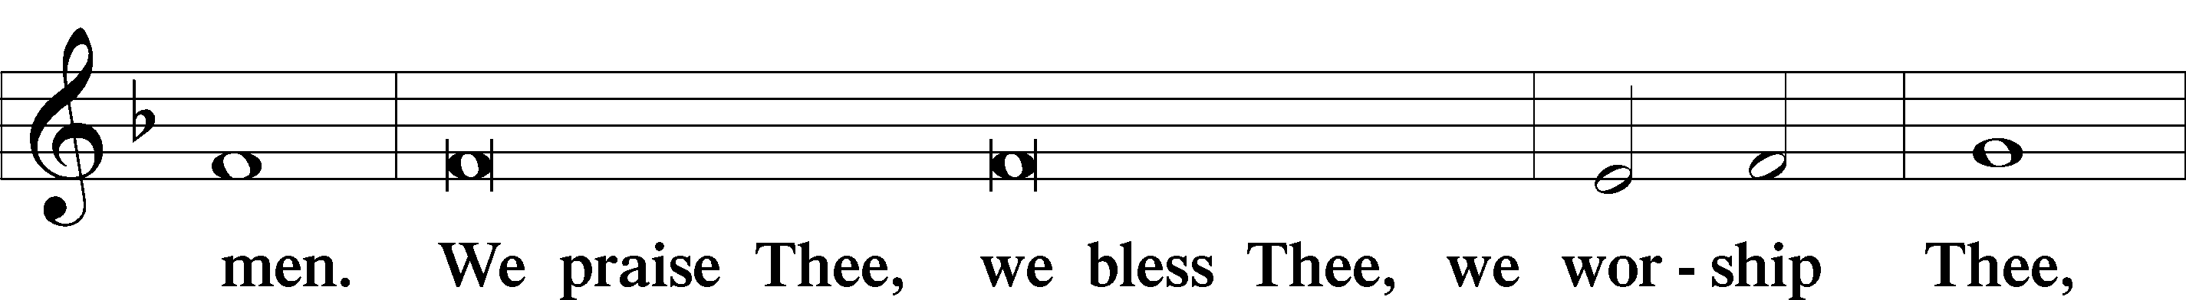
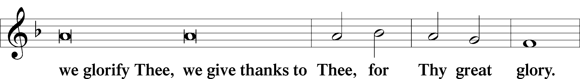
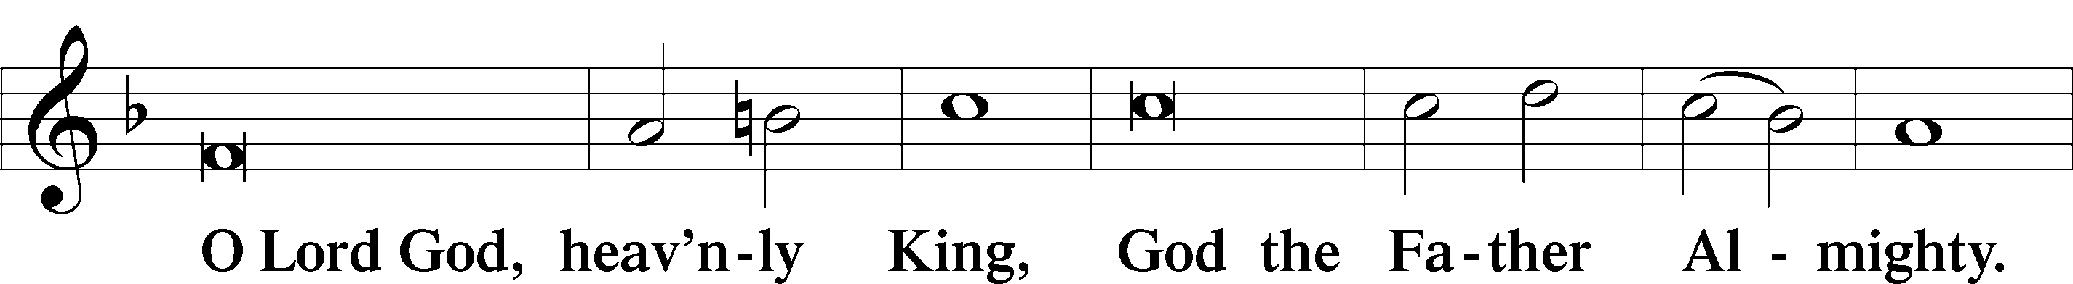
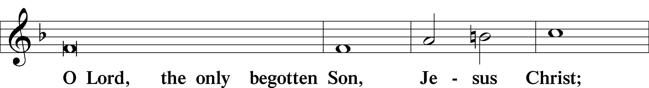
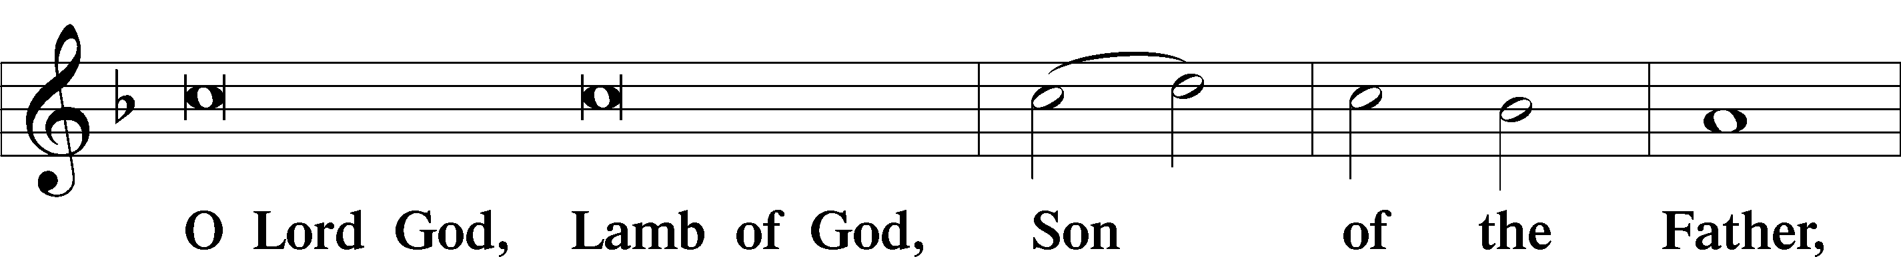
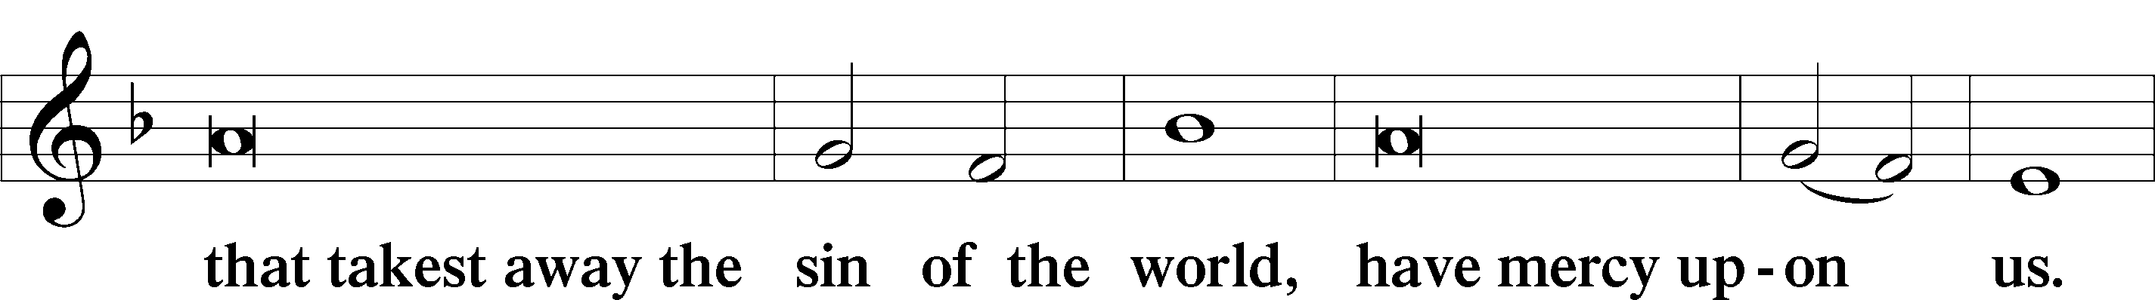
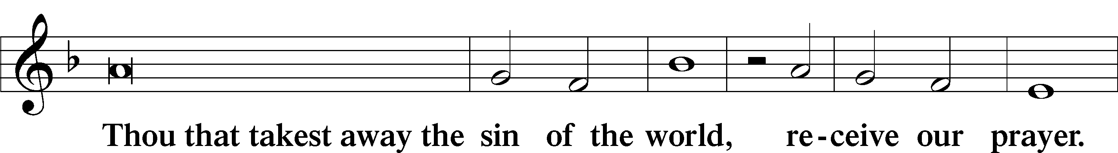
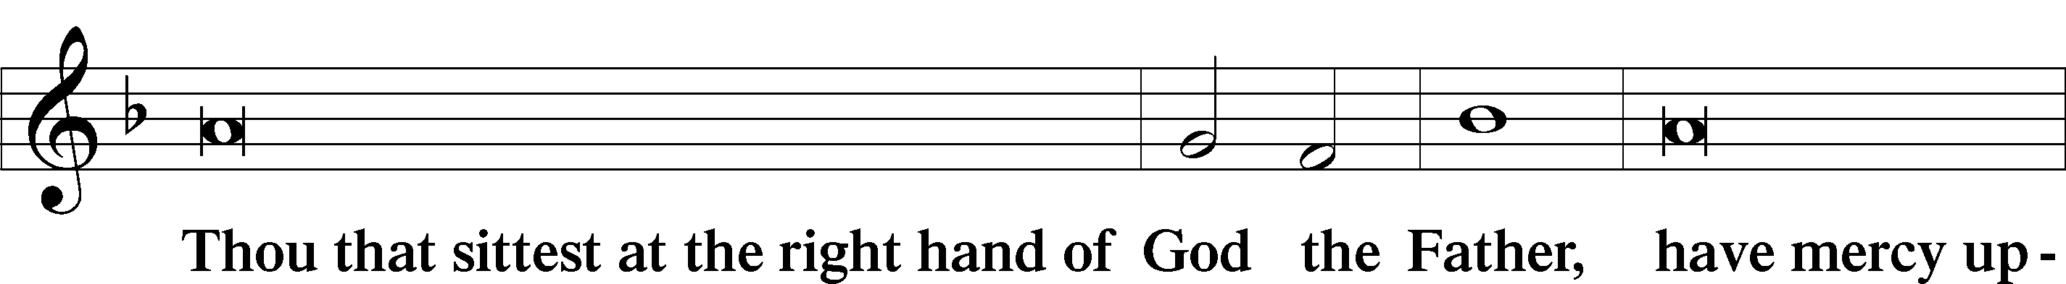
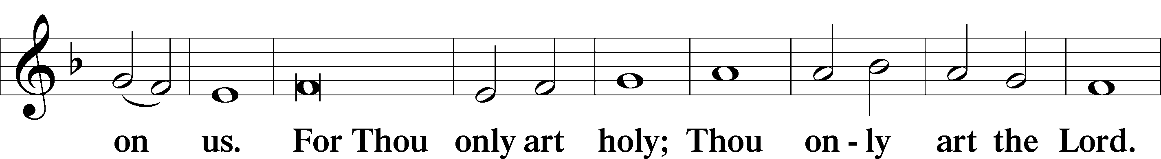
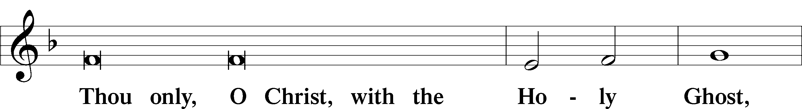
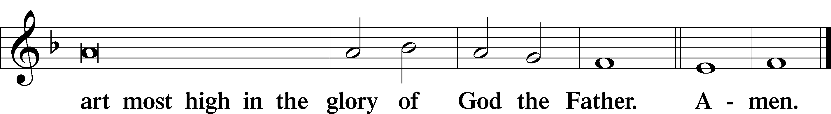

Salutation and Collect of the Day

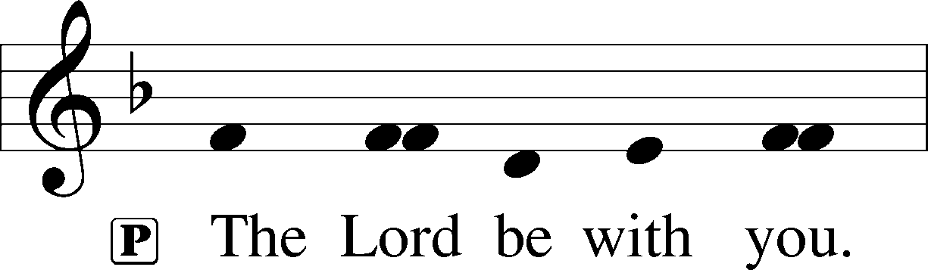
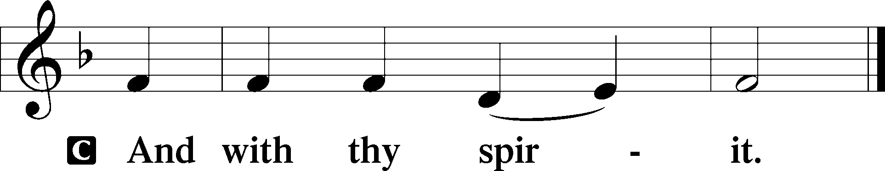

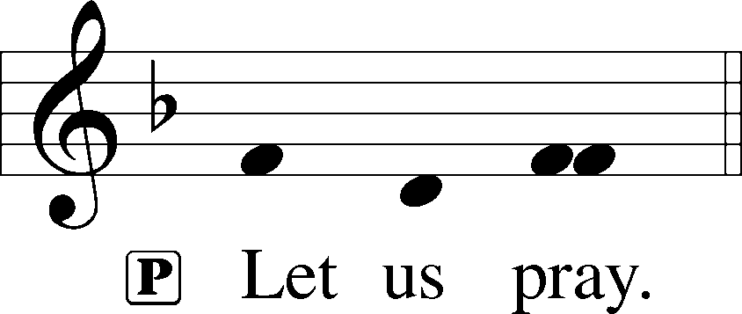

P Gracious God, our heavenly Father, Your mercy attends us all our days. Be our strength and support amid the wearisome changes of this world, and at life’s end grant us Your promised rest and the full joys of Your salvation; through Jesus Christ, Your Son, our Lord, who lives and reigns with You and the Holy Spirit, one God, now and forever.

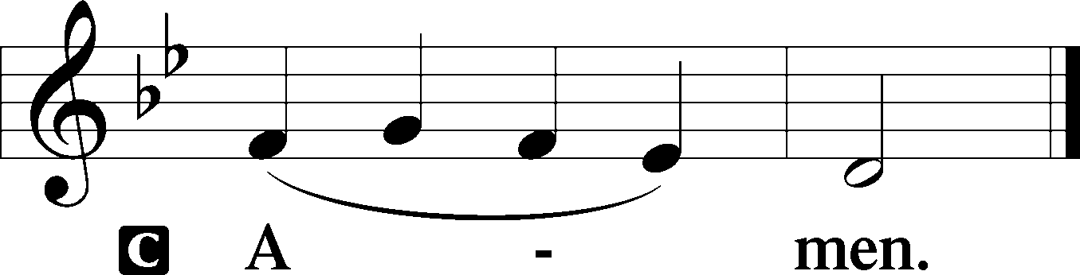
Please be seated

Old Testament Reading Zechariah 9:9-12
Rejoice greatly, O daughter of Zion!
Shout aloud, O daughter of Jerusalem!
behold, your king is coming to you;
righteous and having salvation is he,
humble and mounted on a donkey,
on a colt, the foal of a donkey.
I will cut off the chariot from Ephraim
and the war horse from Jerusalem;
and the battle bow shall be cut off,
and he shall speak peace to the nations;
his rule shall be from sea to sea,
and from the River to the ends of the earth.
As for you also, because of the blood of my covenant with you,
I will set your prisoners free from the waterless pit.
Return to your stronghold, O prisoners of hope;
today I declare that I will restore to you double.
A This is the Word of the Lord.
C Thanks be to God.

Gradual Romans 11:33, 36
Oh, the depth of the riches and wisdom and knowl- | edge of God!*
How unsearchable are his judgments and how inscrutable | his ways!
For from him and through him and to him are | all things.*
To him be glory forever. | Amen.
Epistle Reading Romans 7:14-25a
For we know that the law is spiritual, but I am of the flesh, sold under sin. I do not understand my own actions. For I do not do what I want, but I do the very thing I hate. Now if I do what I do not want, I agree with the law, that it is good. So now it is no longer I who do it, but sin that dwells within me. For I know that nothing good dwells in me, that is, in my flesh. For I have the desire to do what is right, but not the ability to carry it out. For I do not do the good I want, but the evil I do not want is what I keep on doing. Now if I do what I do not want, it is no longer I who do it, but sin that dwells within me.
So I find it to be a law that when I want to do right, evil lies close at hand. For I delight in the law of God, in my inner being, but I see in my members another law waging war against the law of my mind and making me captive to the law of sin that dwells in my members. Wretched man that I am! Who will deliver me from this body of death? Thanks be to God through Jesus Christ our Lord! So then, I myself serve the law of God with my mind, but with my flesh I serve the law of sin.
A This is the Word of the Lord.
C Thanks be to God.

Please stand

Alleluia
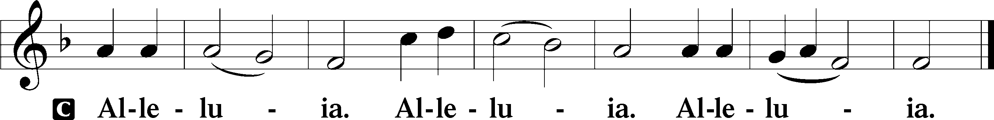

Holy Gospel Matthew 11:25-30

P The Holy Gospel according to St. Matthew, the eleventh chapter.

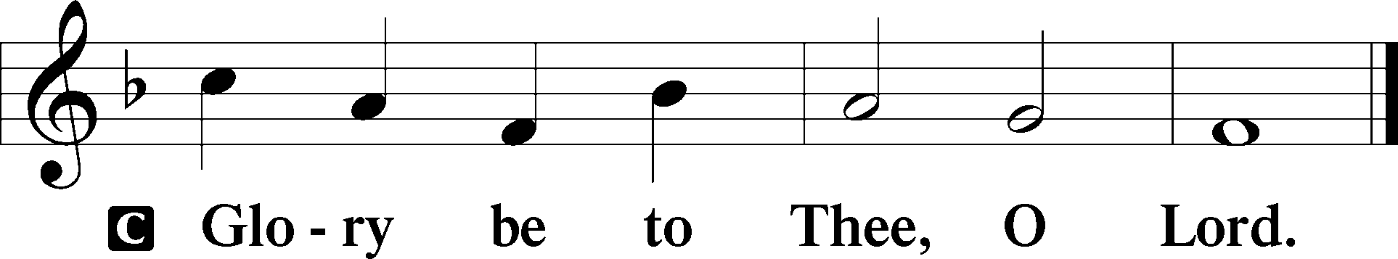
At that time Jesus declared, “I thank you, Father, Lord of heaven and earth, that you have hidden these things from the wise and understanding and revealed them to little children; yes, Father, for such was your gracious will. All things have been handed over to me by my Father, and no one knows the Son except the Father, and no one knows the Father except the Son and anyone to whom the Son chooses to reveal him. Come to me, all who labor and are heavy laden, and I will give you rest. Take my yoke upon you, and learn from me, for I am gentle and lowly in heart, and you will find rest for your souls. For my yoke is easy, and my burden is light.”
P This is the Gospel of the Lord.
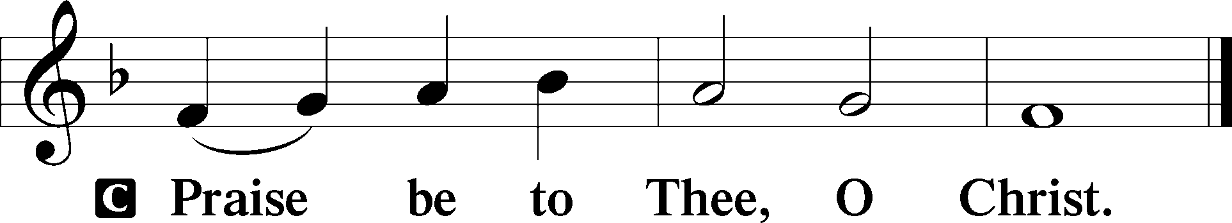

Please be seated

Office Hymn The King Shall Come When Morning Dawns #348

Sermon O Prisoner of Hope

Please stand

Nicene Creed

C I believe in one God, (Rom 10:10; Deut 6:4)
the Father Almighty, (Mt 6:9; Ex 6:3)
maker of heaven and earth (Gen 1:1; Jn 1:1)
and of all things visible and invisible. (Col 1:16)
And in one Lord Jesus Christ, (Rom 10:9)
the only-begotten Son of God, (Jn 3:16; Mt 16:16)
begotten of His Father before all worlds, (Jn 1:2)
God of God, Light of Light, (Jn 17:22; Jn 8:12; Jn 1:1)
very God of very God, (Col 2:9) begotten, not made, (Jn 1:2)
being of one substance with the Father, (Jn 10:30)
by whom all things were made; (Heb 1:2; Jn 1:3)
who for us men and for our salvation (1 Tim 2:4; Rom 3:23)
came down from heaven (Jn 6:41; Lk 15:20)
and was incarnate by the Holy Spirit of the virgin Mary (Lk 1:34-35)
and was made man; (Jn 1:14)
and was crucified also for us under Pontius Pilate. (Mk 15:25; Jn 19:16-18)
He suffered and was buried. (Jn 19:1-3; Lk 23:53)
And the third day He rose again according to the Scriptures (1 Cor 15:4; Lk 24:6)
and ascended into heaven (Acts 1:9)
and sits at the right hand of the Father. (Acts 7:55)
And He will come again with glory (Mt 26:64)
to judge both the living and the dead, (Acts 10:42; Mt 3:12)
whose kingdom will have no end. (2 Pt 1:11)
And I believe in the Holy Spirit, (Jn 14:26; Gen 1:2; Acts 2:38)
the Lord and giver of life, (Gen 1:2; Jn 3:6)
who proceeds from the Father and the Son, (Jn 15:26)
who with the Father and the Son together is worshiped and glorified, (Mt 3:16-17)
who spoke by the prophets. (Eze 11:5)
And I believe in one holy Christian and apostolic Church, (1 Pt 2:5; Eph 2:19-22)
I acknowledge one Baptism for the remission of sins, (Eph 4:5)
and I look for the resurrection of the dead (1 Cor 15:35-49; 1 Thess 4:13-18)
and the life T of the world to come. (Mk 10:29-30; Mt 10:40-42)
Amen. (Ps 106:48)
Us men means all people.
Christian: the ancient text reads “catholic,” meaning the whole Church as it confesses the wholeness of Christian doctrine

Prayer of the Church

After each petition of the prayer:
Pastor: Let us pray to the Lord.
People: Lord, have mercy.

For comfort, health and recovery: Daniel Hudson, Verna Jean Hudson, Edgar Johnson, John Rudsenske, Amy Lewis, Kim Severin, Eloise Springer, Justin Thomas, Thomas Upton;
For those who are ill or distressed: Stan Acey, Jenalee Adams, Kimberly Airhart, Layne Bagley, Rose Bagley, Shirley Bagley, W.L. Bagley, Sarah Bowman, Mimi Bradley, Richard Bradley, Deloris Brent, Martha Brown, Nathan Brown, Tina Burke, Wayne Burke, Paula Burkhalter, Bobby Carroll, Arthur Collins, James E. Cookston, Joan Cowards, Belinda Cowards-Gonzales, Mike Ellis, Robert (Andy) Evers, Michele Rae Fowler, Randy Fowler, Parker Haines, Dan Hansen, Paul Hansen, Tim Hansen, Valerie Henderson, Sharon Holleman, Hugh Hunt, Beth Jarratt, Jimmy Jarratt, Elaine Johnson, Joslyn Jones, Steve Kennedy, Arlene Kleinschmidt, Eleanor Koster, John Koster, Sandra Landers, Katelyn Lawing, Peggy Lucky, Paul McCullough, Jerry McIntyre, Jerry McMahan, Mark Millard, Edlia Miller, Mark Miller, Elaine Monaghan, Lindberg Moore, Jerry Mutter, Don Ochs, Mildred Odom, Janea Parker, Deborah-Annette Ried, Elmira Roever, Jon Sandberg, Noah Schultz, Johnnie Pearl Smiley, Bob Smith, Sally Smith, Sam Schneider, Sherri Smith, Deborah Springer, MariLyn Unger, Betty Venator, Leonard Watson, Dana Weaver, Cynthia Widlitze, Carol Wright, Jimmy Wright, Marshall Wright, Barbara Zeigler;
For college and graduate students: Jake Everly, Sara Fields, Roselynn Nelson;
For military servants and their families: Gabriel Escude, James (Glen) Hansford, Holden Hathcock, Christopher Martin, William Nelson, Steven Tatum, John Weidner Jr.;
For foreign missionaries: David and Shelee Warner;
This week’s prayer family: The Kettler Family and their loved ones.

Please be seated

Offering

Offertory Psalm 51:10-12
The congregation is invited to sing in parts:
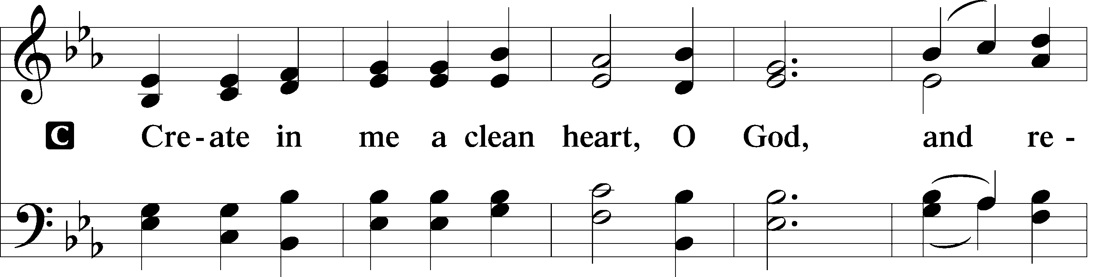
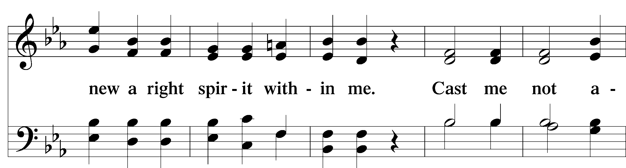
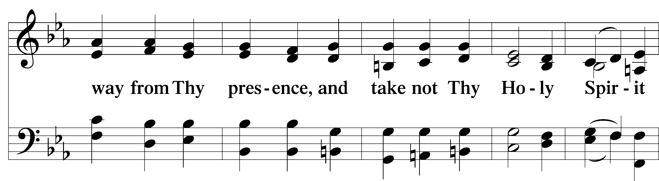
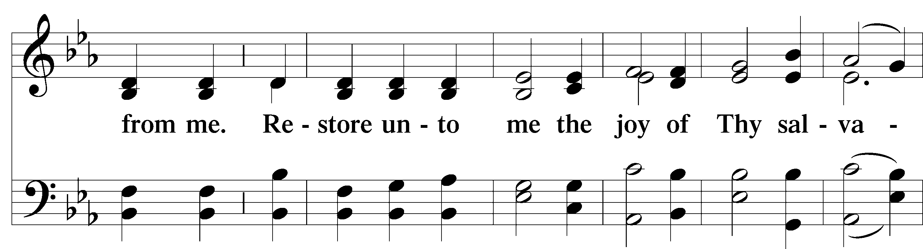
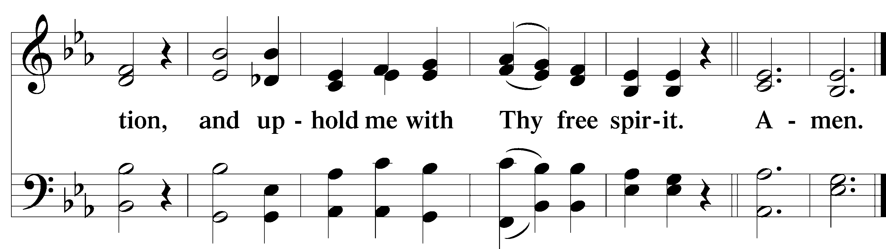

Service of the Sacrament

Preface 2 Timothy 4:22; [Colossians 3:1]; [Psalm 136]

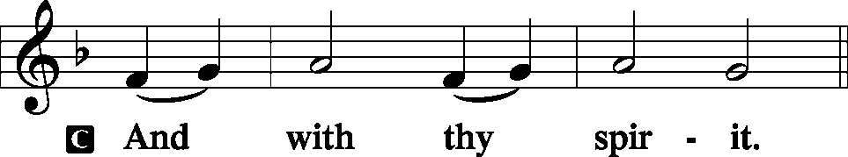
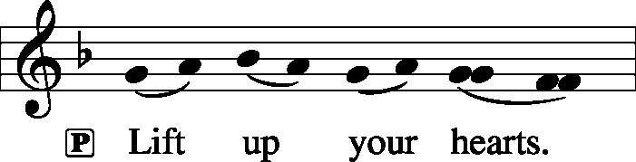

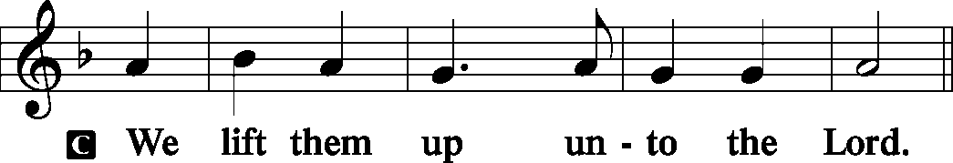
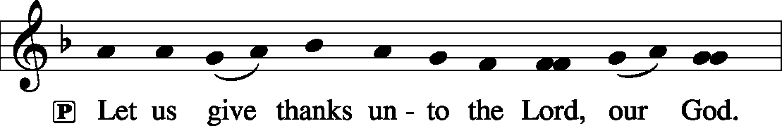
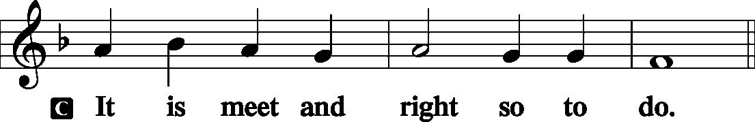

P It is truly meet, right, and salutary that we should at all times and in all places give thanks to You, holy Lord, almighty Father, everlasting God, through Jesus Christ, our Lord, who on this day overcame death and the grave and by His glorious resurrection opened to us the way of everlasting life. Therefore with angels and archangels and with all the company of heaven we laud and magnify Your glorious name, evermore praising You and saying:

Sanctus Isaiah 6:3; Matthew 21:9
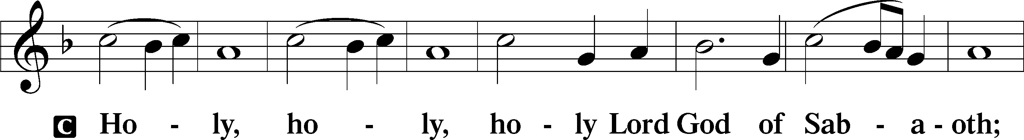
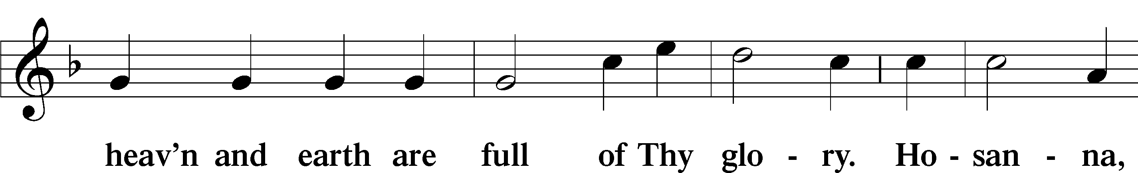
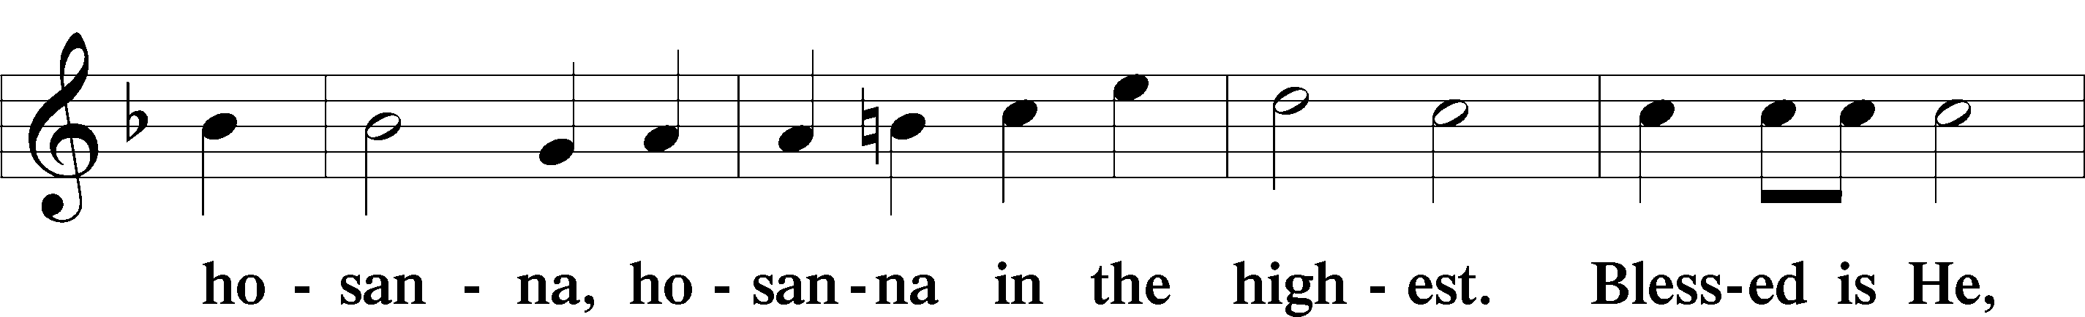
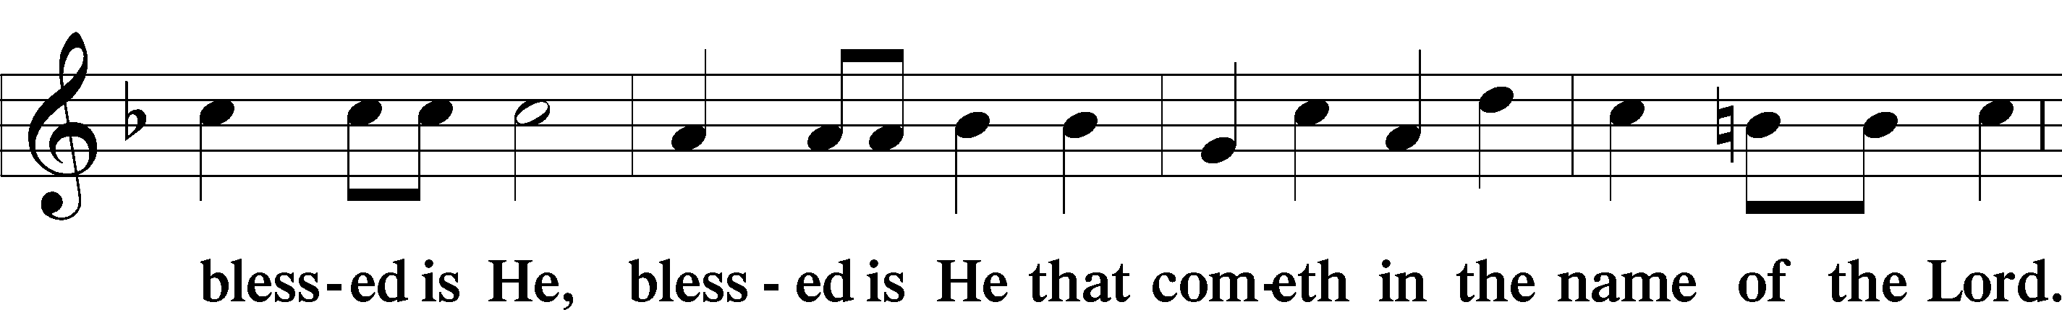
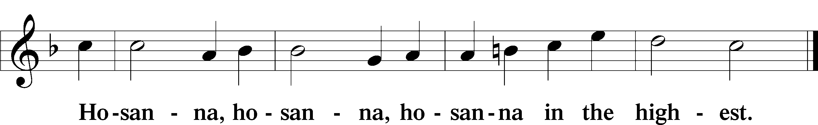

Lord’s Prayer Matthew 6:9-13
P Our Father who art in heaven,
Hallowed be Thy name,
Thy kingdom come,
Thy will be done on earth as it is in heaven;
Give us this day our daily bread;
And forgive us our trespasses as we forgive those who trespass against us;
And lead us not into temptation,
But deliver T us from evil.

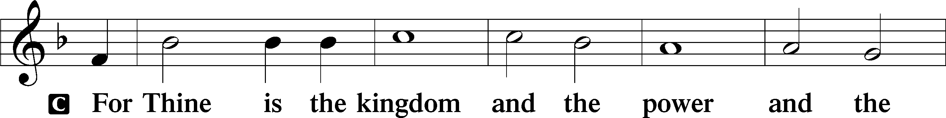
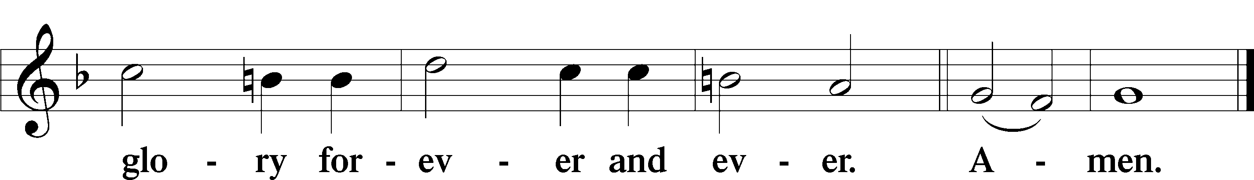
The Words of Our Lord Matthew 26:26–28
P Our Lord Jesus Christ, on the night when He was betrayed, took bread, and when He had given thanks, He broke it and gave it to the disciples and said: “Take, eat; this is My T body, which is given for you. This do in remembrance of Me.”
In the same way also He took the cup after supper, and when He had given thanks, He gave it to them, saying: “Drink of it, all of you; this cup is the new testament in My T blood, which is shed for you for the forgiveness of sins. This do, as often as you drink it, in remembrance of Me.”

Pax Domini John 20:19
P The peace T of the Lord be with you always.
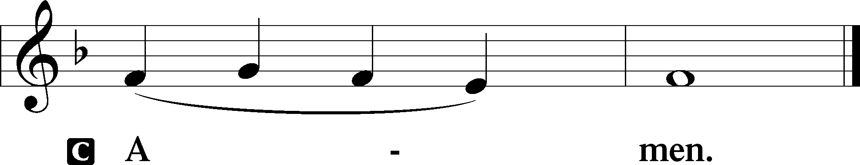

Agnus Dei John 1:29
The congregation is invited to sing in parts.
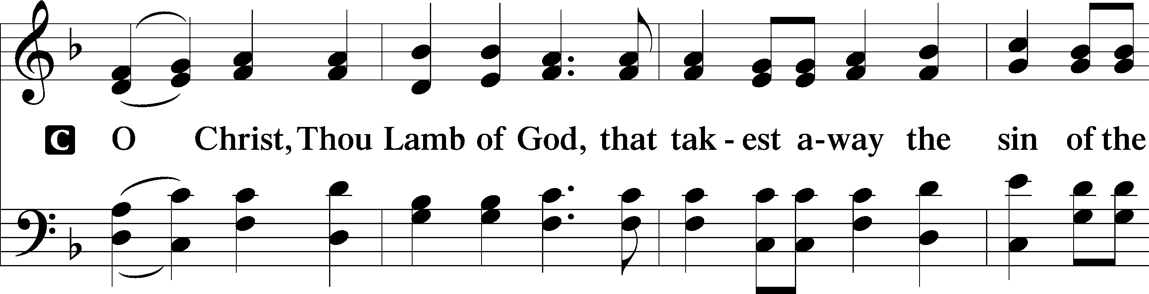
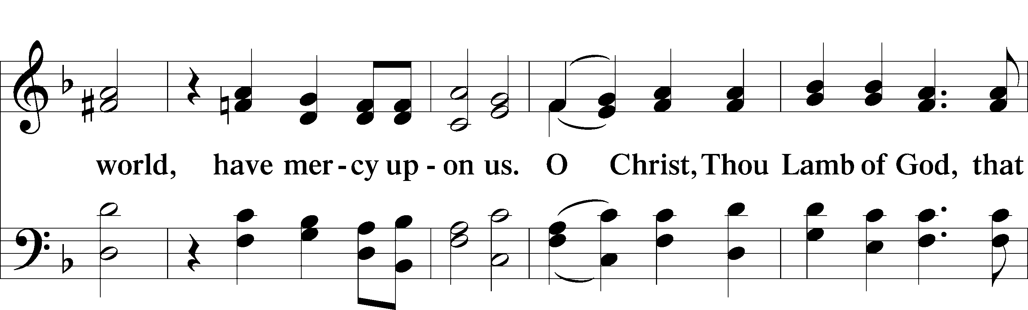
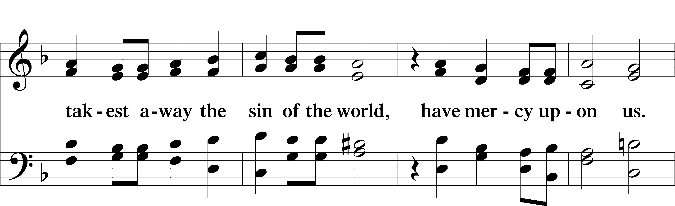
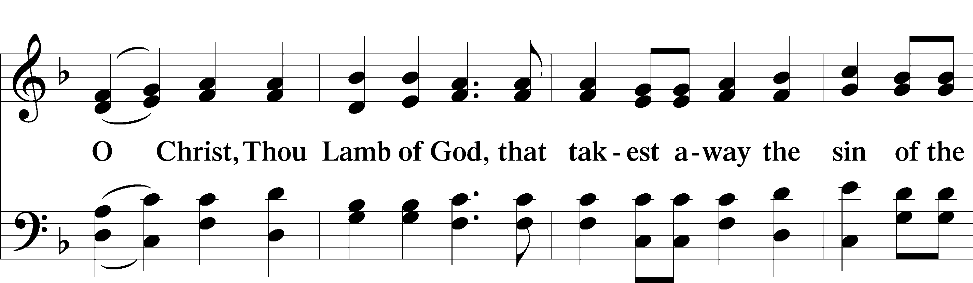
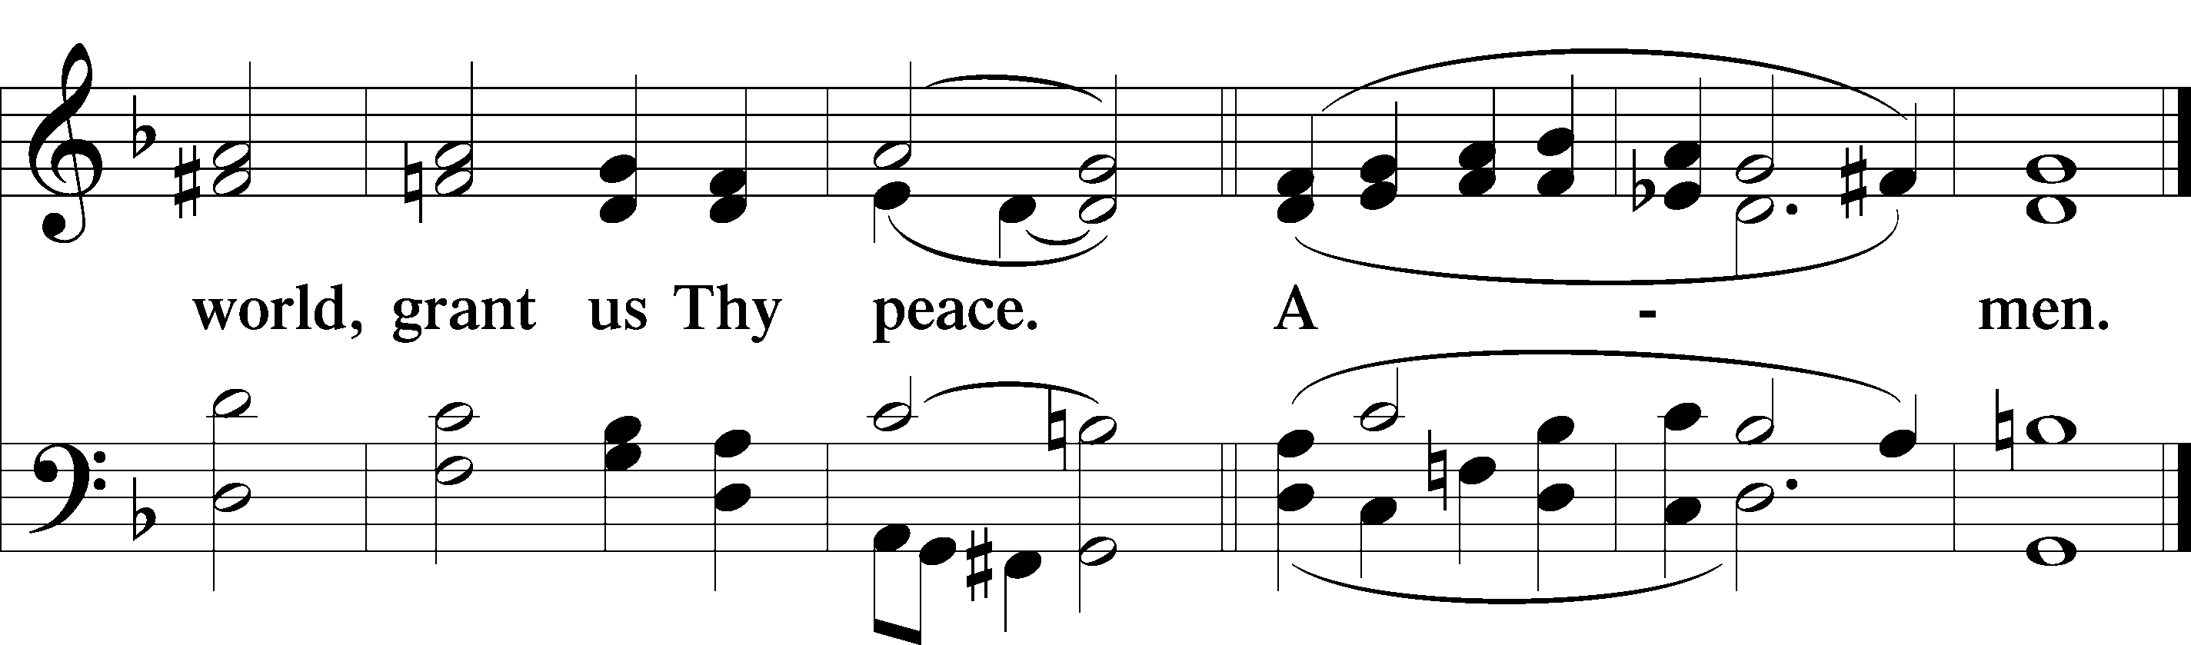
Please be seated

Distribution of the Sacrament
All who are members in good standing of the Lutheran Church - Missouri Synod and have introduced themselves to one of the pastors are welcome to partake of the Holy Communion at Christ Lutheran. If you have not spoken to a pastor, but would like to receive the Lord's blessing, you may still come to the rail and kneel, crossing one arm over the other in the shape of an 'X'. This symbolizes that one is marked by the cross and Triune name of Almighty God.

Distribution Hymns
Draw Near and Take the Body of the Lord #637

Please stand following distribution of communion
Nunc Dimittis Luke 2:29-32
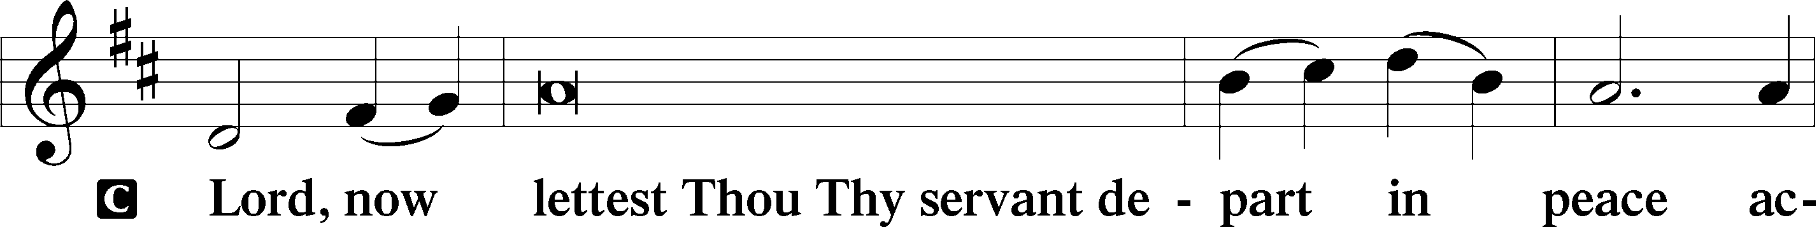
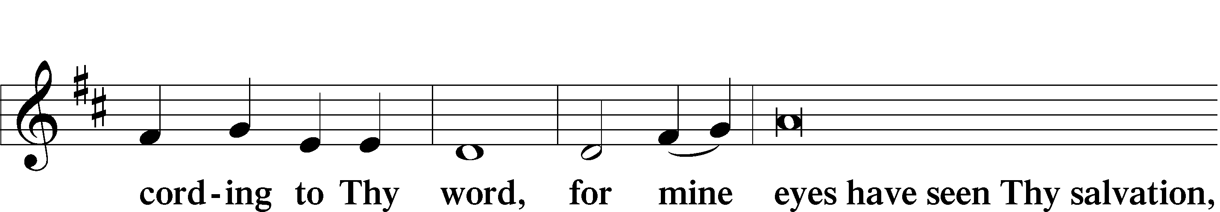
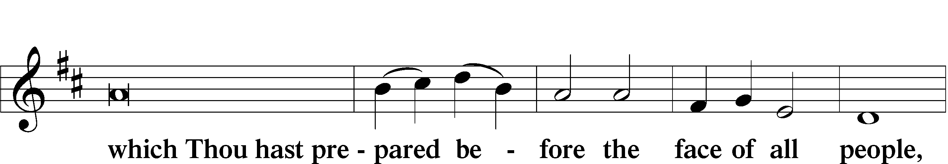
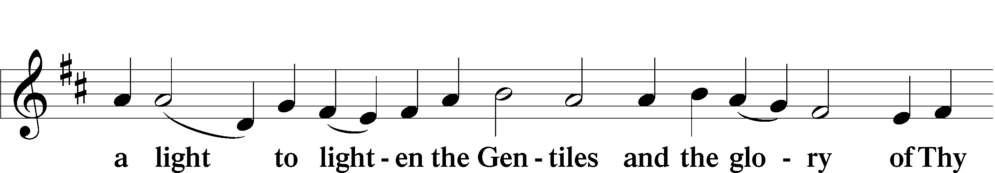
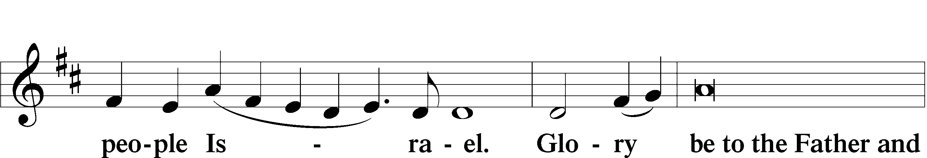
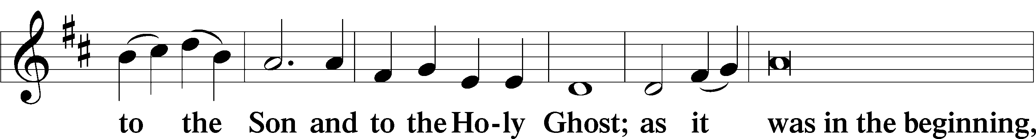
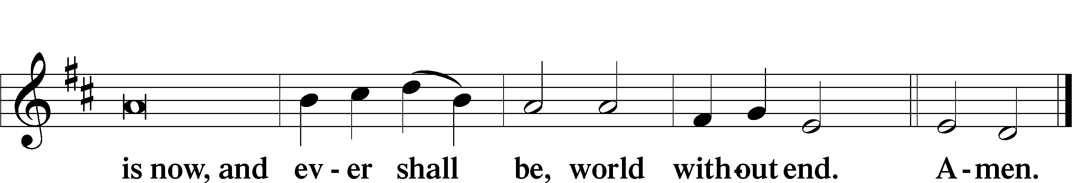

Thanksgiving
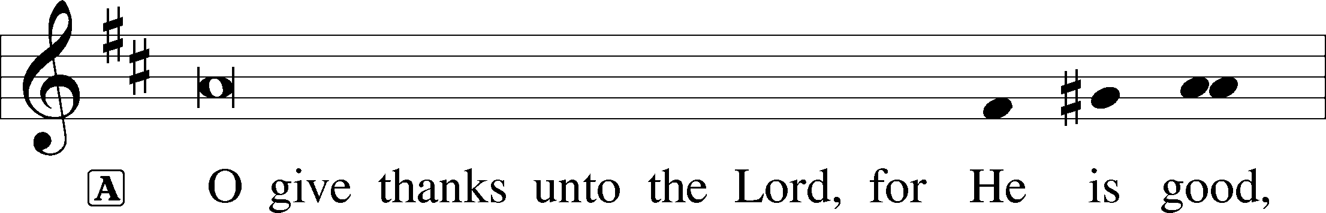
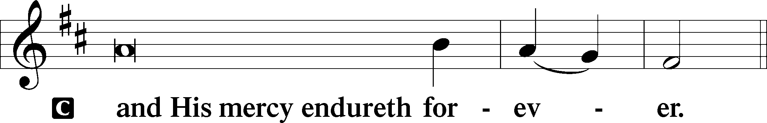

Post-Communion Collect
A We give thanks to You, almighty God, that You have refreshed us through this salutary gift, and we implore You that of Your mercy You would strengthen us through the same in faith toward You and fervent love toward one another; through Jesus Christ, Your Son, our Lord, who lives and reigns with You and the Holy Spirit, one God, now and forever.
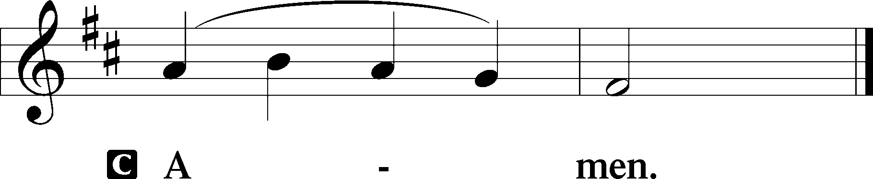

Salutation and Benedicamus
P The Lord be with you.
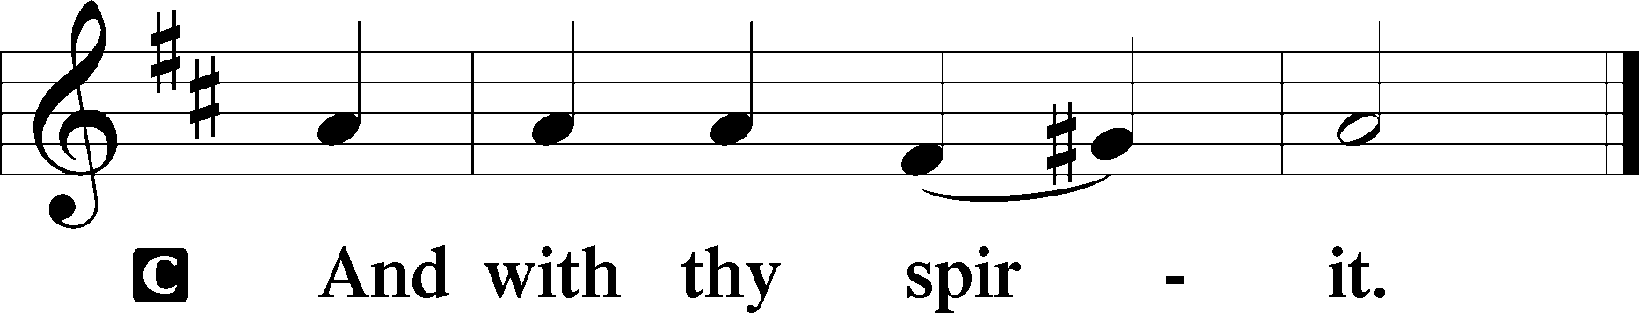
P Bless we the Lord.
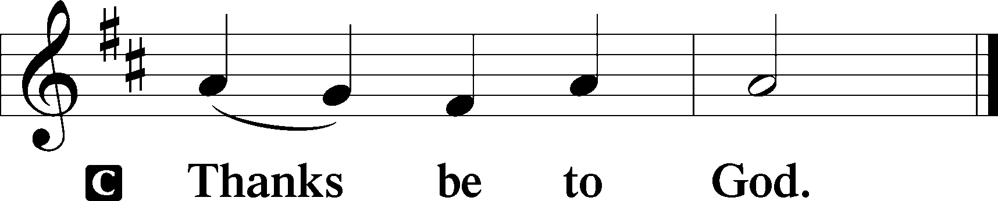

Benediction Numbers 6:24–26
P The Lord bless you and keep you.
The Lord make His face shine upon you and be gracious unto you.
The Lord lift up His countenance upon you and T give you peace.
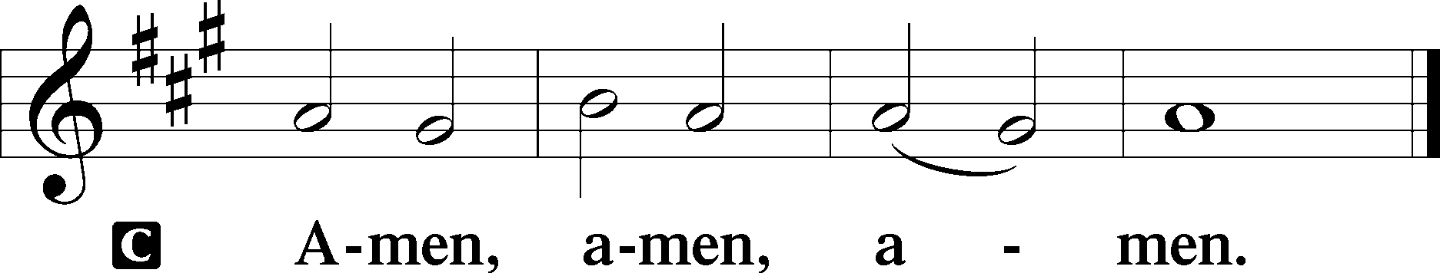

Closing Hymn Jerusalem, the Golden #672

Acknowledgments
Divine Service, Setting Three from Lutheran Service Book © 2006 Concordia Publishing House. Reprinted with permission. Unless otherwise indicated, all scripture quotations are from The Holy Bible, English Standard Version, copyright © 2001 by Crossway Bibles, a division of Good News Publishers. Used by permission. All rights reserved. Created by Lutheran Service Builder © 2006 Concordia Publishing House.

Serving Today:
Celebrant: Rev. George Fields Liturgist: Rev. James R. Holowach
Acolyte: Will Nelson Organist: Sr. Sara Fields
Interpreter: Denee Smith Cantor: Keith Martin
Ushers: Bruce Bodkin, Allen Goodlett, Eric Held

Readings for next Sunday, July 12th, the Sixth Sunday after Pentecost:
Introit Ps. 103:15-19; Psalm 65:1-13; Isaiah 55:10-13; Romans 8:12-17; Matthew 13:1-9, 18-23.

This week at Christ Lutheran Church: July 6 – July 12

Tuesday 6:15 p.m. Elders’ Meeting
7:30 p.m. Evening Prayer Online
Thursday 7:30 p.m. Compline Online
Friday 6:30 p.m. Divine Service – Sixth Sunday after Pentecost
Sunday 10:30 a.m. Divine Service – Sixth Sunday after Pentecost



YOUR LIFELINE TO THE LUTHERAN WORLDVIEW…You can listen to in-depth teachings on interesting subjects like:

Darwinian Evolution, Christ’s Descent into Hell, The Word “Priest” in the Bible, The Prophet Isaiah and more…

Issues, Etc. is a radio talk show produced by Lutheran Public Radio and hosted by LCMS Pastor Todd Wilken. You can listen to what you want when you want at www.issuesetc.org. Simply click on “Listen”, choose “On Demand”, then select from the vast array of speakers and topics available in the archives.

Matt. 11:28 – “Come to me, all who labor and are heavy laden, and I will give you rest.”
Jesus has come to do the work so that we might have rest from burdens and labors we are not capable of bearing. He frees us from sin, death, and the demands of the Law. In that peace and rest of Jesus we find a new purpose. His light yoke, which is no burden to bear, is a joy.

Matthew 26:26-29; Mark 14:22-25; Luke 22:14-20, 1 Corinthians 11:23
Matthew 26:28; 1 John 1:7; 1 Peter 1:18-19
1 Corinthians 11:28-32
1 Corinthians 10:17; 1 Corinthians 11:26

