Christ Lutheran Church

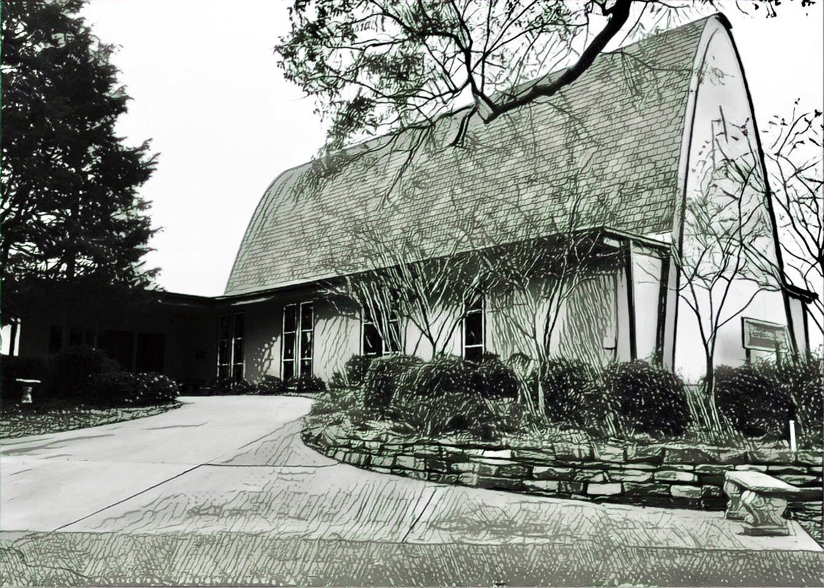

Rev. Dr. James R. Holowach, Pastor
Rev. George N. Fields, Pastor
Sr. Sara E. Fields, Deaconess
Divine Service Each Week with Holy Communion: 10:30 a.m.
Sunday School for all ages: 9:00 a.m.
4423 I-55 North, Jackson, MS 39206-6102 – (601) 366-2055
www.christlutheranjacksonms.org

The Second Sunday after Pentecost
+ June 14, 2020 +

“He Had Compassion for Them”



We welcome our members and guests to Christ Lutheran today,
and pray God’s richest blessings upon you during this time of worship!

All members and our guests are asked to complete the
worship attendance pads which can be found on each pew.
Guests are also asked to sign the guest register found in the Narthex.
We are so glad to have you worshiping with us today!

LARGE PRINT worship folders are available
at the usher stand at the back of the nave.

WELCOME:
“For this reason Christ was sent to teach us that the came simply to do good. He did not wait for the sick to come to him. He himself hurried to them, bearing them a twofold blessing: the gospel of the reign of God and the healing of their diseases. And for this he went everywhere, not overlooking the least.”
–St. John Chrysostom, The Gospel of Matthew, Homily 32
The Lord’s Supper

In preparation for reception of the Lord’s Supper (Holy Communion), it is important that we review and understand what the Bible teaches regarding this sacrament:
The Bible teaches that Jesus gives us His very body and blood along with bread and wine in Holy Communion, and that these are means by which He forgives our sins, and strengthens us for daily living, and draws us into closer fellowship with Him and other believers. The Bible also teaches us to examine ourselves prior to receiving the meal. For those receiving Holy Communion, examine yourself with these questions:
Do I believe that I am a sinner and I am sorry for my sins?
Do I believe that Jesus Christ is God’s Son and my personal Savior?
Do I believe that Christ’s true body and blood are present in this holy meal for my forgiveness?
Do I truly intend with the help of God to correct my sinful life?
According to Christ’s Word in the Holy Scriptures, and in confession with the true Christian faith, at Christ Lutheran we observe the practice of closed communion. We believe that all who commune must confess the same holy faith, as Holy Scripture teaches. Since one’s church affiliation indicates an individual’s confession of faith, we ask that only those who have been instructed in the above teaching and are confirmed members of The Lutheran Church – Missouri Synod commune. If you have not been instructed in this teaching on Holy Communion, are in doubt, or hold a different confession of faith, you are still welcome to come forward and cross your arms to indicate that you would like a blessing.

Divine Service III

Preservice Music
The congregation may use this time to pray and meditate.

Opening Hymn Oh, How Great Is Your Compassion #559

Confession & Absolution
The sign of the cross may be made by all in remembrance of their Baptism.

P In the name of the Father and of the T Son and of the Holy Spirit.
C Amen.

P Beloved in the Lord! Let us draw near with a true heart and confess our sins unto God our Father, beseeching Him in the name of our Lord Jesus Christ to grant us forgiveness.

P Our help is in the name of the Lord,
C who made heaven and earth.
P I said, I will confess my transgressions unto the Lord,
C and You forgave the iniquity of my sin.

Silence for reflection on God's Word and for self-examination.

P O almighty God, merciful Father,
C I, a poor, miserable sinner, confess unto You all my sins and iniquities with which I have ever offended You and justly deserved Your temporal and eternal punishment. But I am heartily sorry for them and sincerely repent of them, and I pray You of Your boundless mercy and for the sake of the holy, innocent, bitter sufferings and death of Your beloved Son, Jesus Christ, to be gracious and merciful to me, a poor, sinful being.

P Upon this your confession, I, by virtue of my office, as a called and ordained servant of the Word, announce the grace of God unto all of you, and in the stead and by the command of my Lord Jesus Christ I forgive you all your sins in the name of the Father and of the T Son and of the Holy Spirit.
C Amen.
Service of the Word

Introit: Deus misereatur nostri Psalm 67:4-7; Ant. Psalm 67:3

Let the peoples praise you, | O God;*
let all the peoples | praise you!
Let the nations be glad and | sing for joy,*
for you judge the peoples with equity and guide the nations up- | on earth.
Let the peoples praise you, | O God;*
let all the peoples | praise you!
The earth has yielded its | increase;*
God, our God, shall | bless us.
God shall | bless us;*
let all the ends of the earth | fear him!
Glory be to the Father and | to the Son*
and to the Holy | Spirit;
as it was in the be- | ginning,*
is now, and will be forever. | Amen.
Let the peoples praise you, | O God;*
let all the peoples | praise you!

Kyrie Mark 10:47
The congregation is invited to sing in parts:

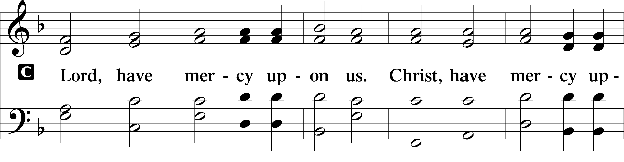
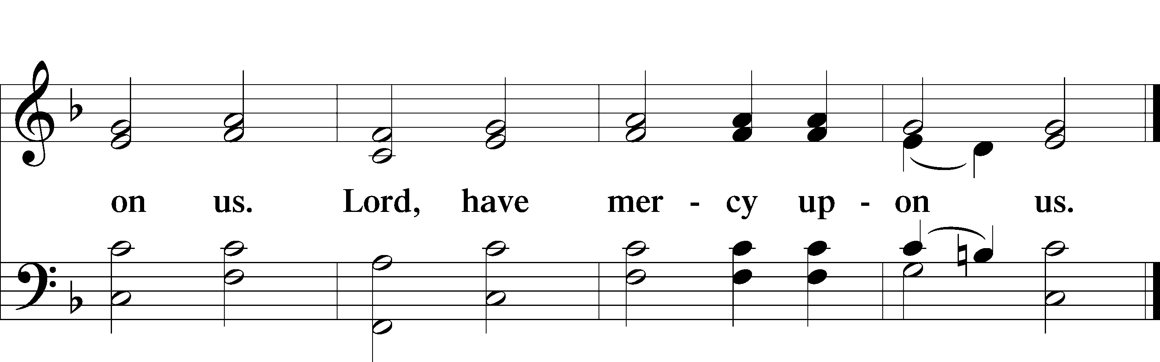

Gloria in Excelsis
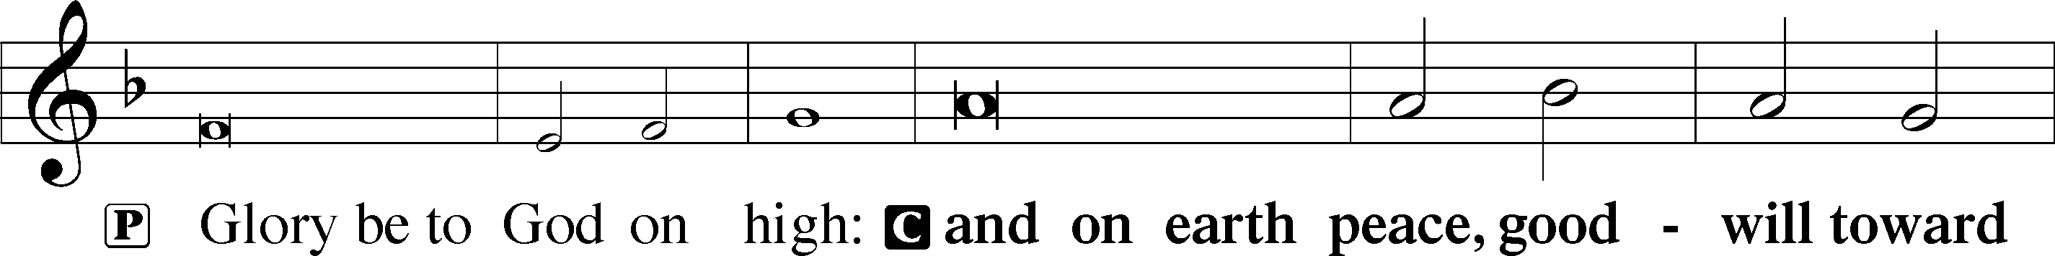
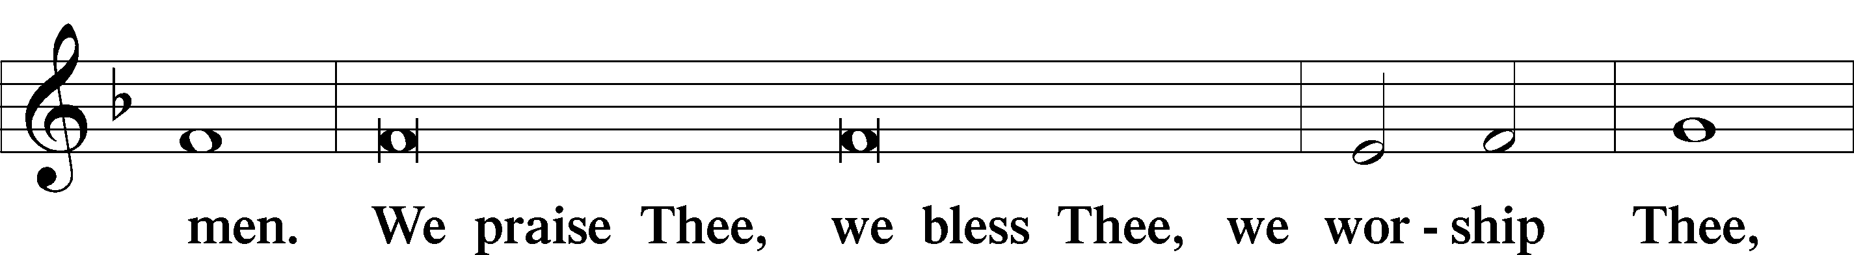
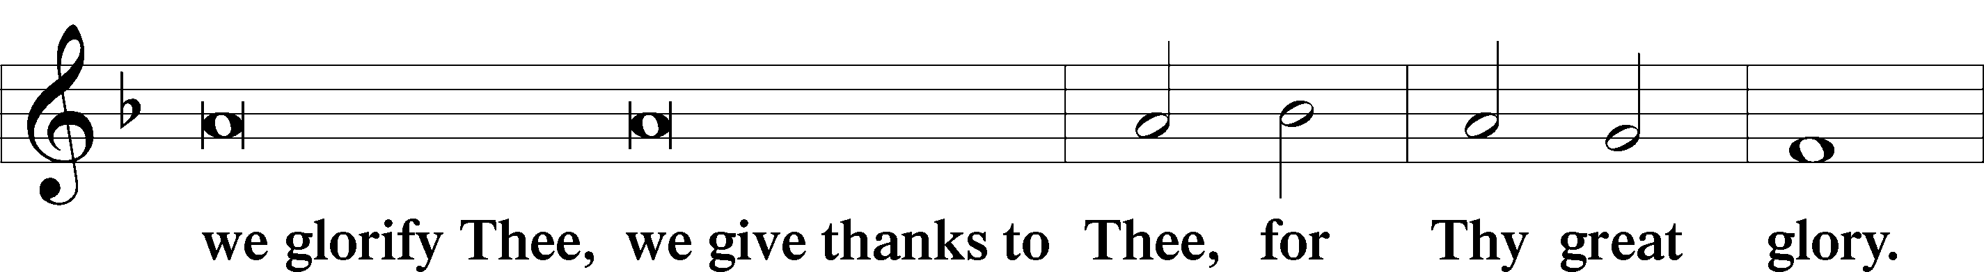
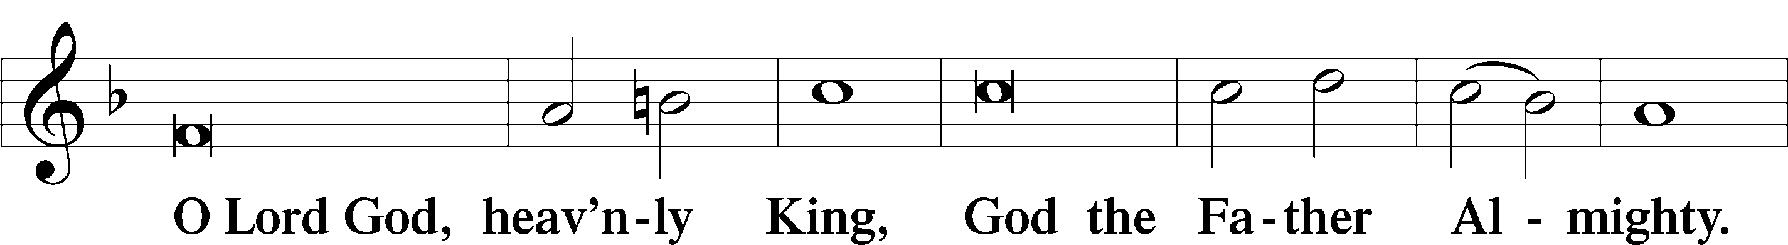
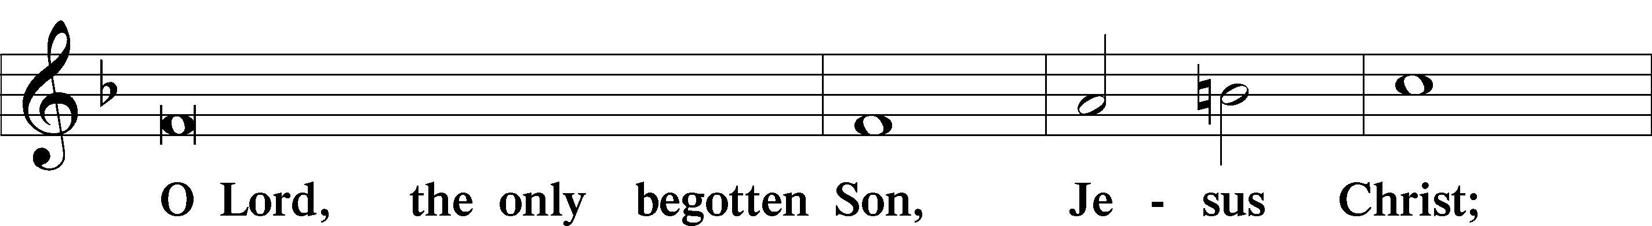
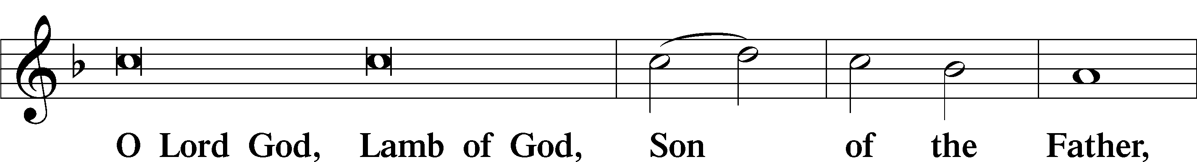
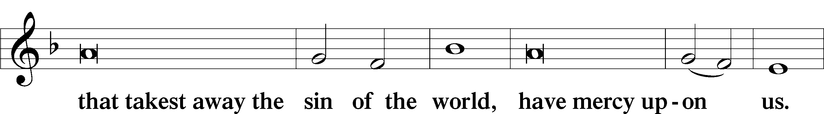
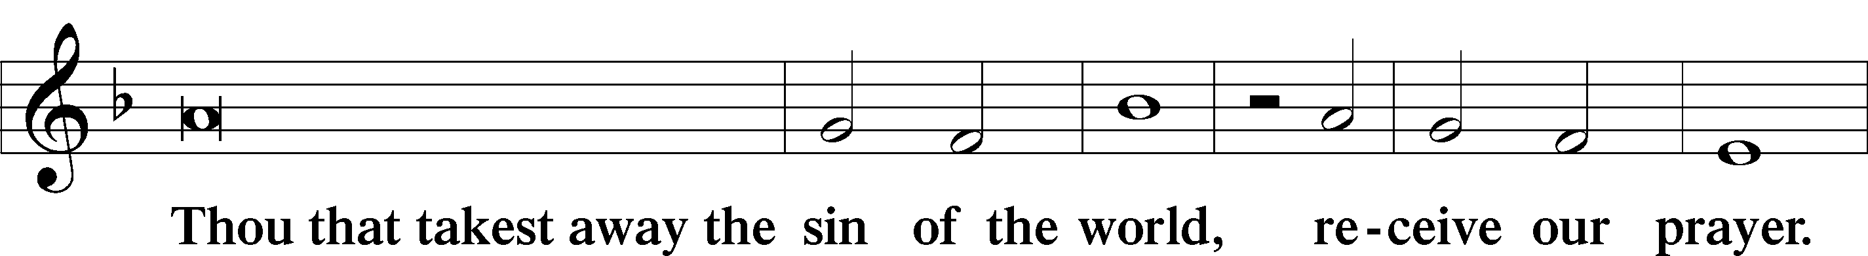
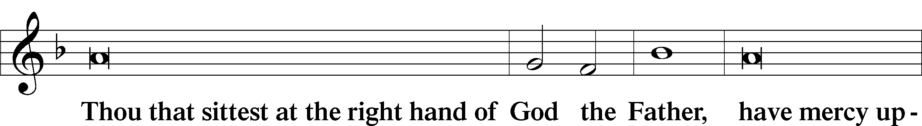
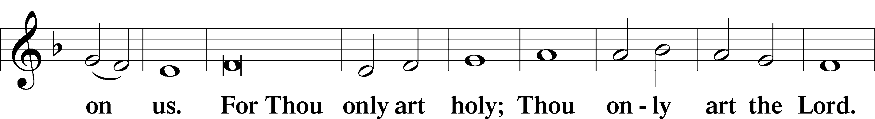
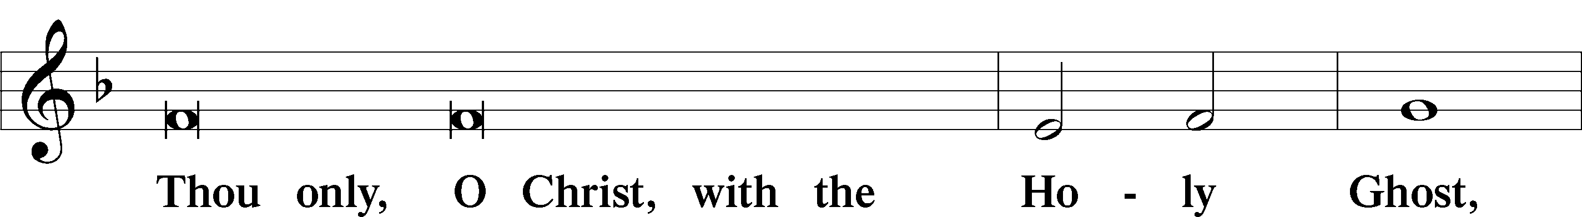
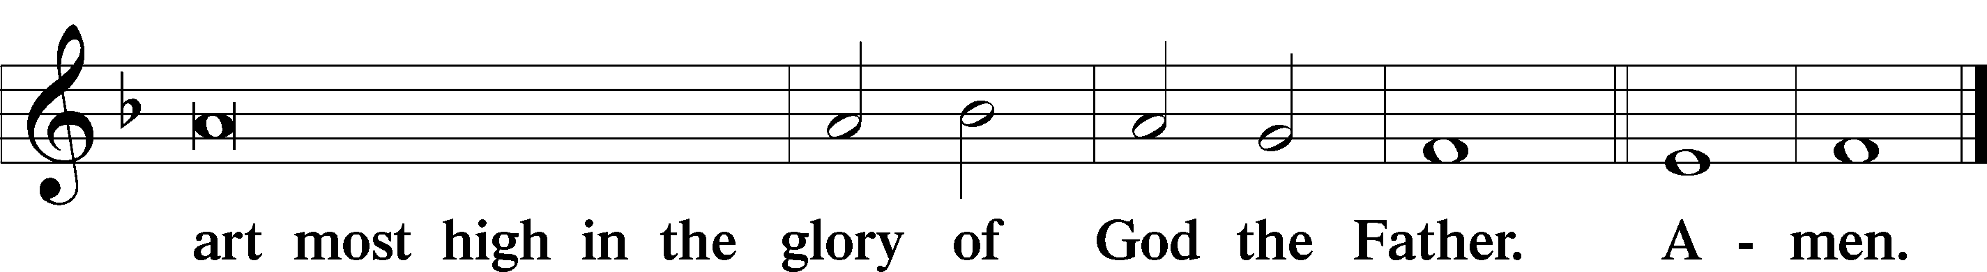

Salutation and Collect of the Day

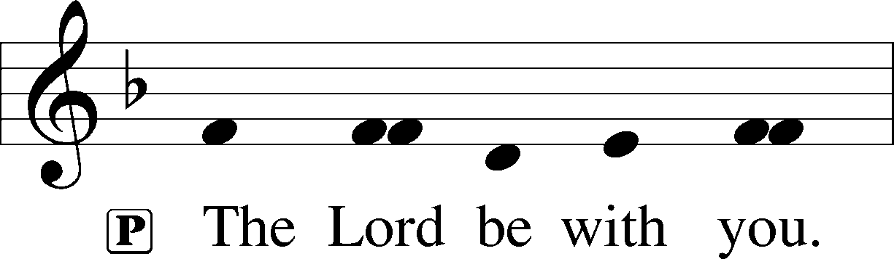
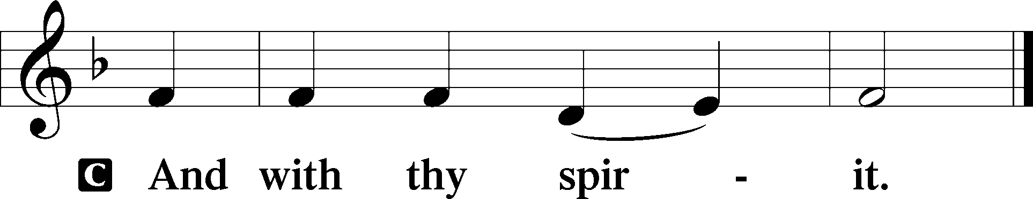

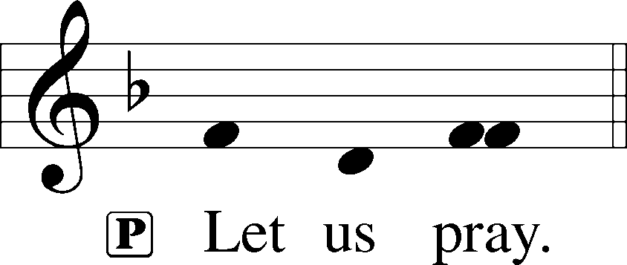

P Almighty, eternal God, in the Word of Your apostles and prophets You have proclaimed to us Your saving will. Grant us faith to believe Your promises that we may receive eternal salvation; through Jesus Christ, our Lord, who lives and reigns with You and the Holy Spirit, one God, now and forever.

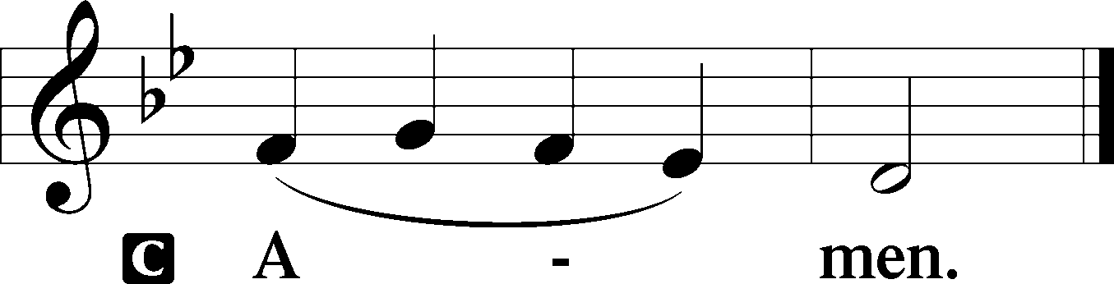
Please be seated

Old Testament Reading Exodus 19:2-8
They set out from Rephidim and came into the wilderness of Sinai, and they encamped in the wilderness. There Israel encamped before the mountain, while Moses went up to God. The Lord called to him out of the mountain, saying, “Thus you shall say to the house of Jacob, and tell the people of Israel: You yourselves have seen what I did to the Egyptians, and how I bore you on eagles’ wings and brought you to myself. Now therefore, if you will indeed obey my voice and keep my covenant, you shall be my treasured possession among all peoples, for all the earth is mine; and you shall be to me a kingdom of priests and a holy nation. These are the words that you shall speak to the people of Israel.”
So Moses came and called the elders of the people and set before them all these words that the Lord had commanded him. All the people answered together and said, “All that the Lord has spoken we will do.” And Moses reported the words of the people to the Lord.
A This is the Word of the Lord.
C Thanks be to God.

Gradual Psalm 145:3, 5, 6
Great is the Lord, and greatly | to be praised,*
and his greatness is un- | searchable.
On your wondrous works, I will | meditate,*
and I will declare your | greatness.

Epistle Reading Romans 5:6-15
For while we were still weak, at the right time Christ died for the ungodly. For one will scarcely die for a righteous person—though perhaps for a good person one would dare even to die— but God shows his love for us in that while we were still sinners, Christ died for us. Since, therefore, we have now been justified by his blood, much more shall we be saved by him from the wrath of God. For if while we were enemies we were reconciled to God by the death of his Son, much more, now that we are reconciled, shall we be saved by his life. More than that, we also rejoice in God through our Lord Jesus Christ, through whom we have now received reconciliation.
Therefore, just as sin came into the world through one man, and death through sin, and so death spread to all men because all sinned— for sin indeed was in the world before the law was given, but sin is not counted where there is no law. Yet death reigned from Adam to Moses, even over those whose sinning was not like the transgression of Adam, who was a type of the one who was to come.
But the free gift is not like the trespass. For if many died through one man’s trespass, much more have the grace of God and the free gift by the grace of that one man Jesus Christ abounded for many.
A This is the Word of the Lord.
C Thanks be to God.

Please stand

Alleluia
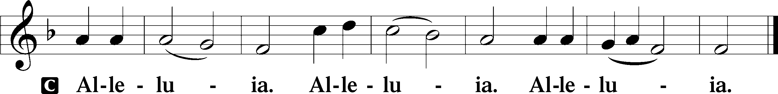

Holy Gospel Matthew 9:35-10:8

P The Holy Gospel according to St. Matthew, the ninth chapter.

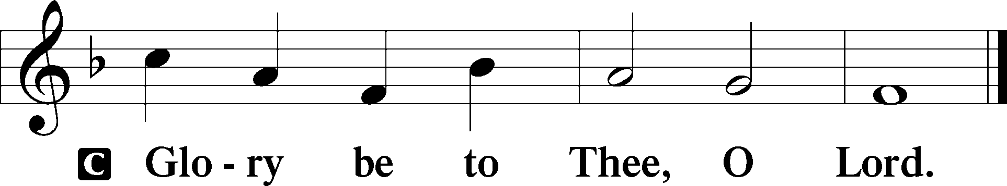
And Jesus went throughout all the cities and villages, teaching in their synagogues and proclaiming the gospel of the kingdom and healing every disease and every affliction. When he saw the crowds, he had compassion for them, because they were harassed and helpless, like sheep without a shepherd. Then he said to his disciples, “The harvest is plentiful, but the laborers are few; therefore pray earnestly to the Lord of the harvest to send out laborers into his harvest.”
And he called to him his twelve disciples and gave them authority over unclean spirits, to cast them out, and to heal every disease and every affliction. The names of the twelve apostles are these: first, Simon, who is called Peter, and Andrew his brother; James the son of Zebedee, and John his brother; Philip and Bartholomew; Thomas and Matthew the tax collector; James the son of Alphaeus, and Thaddaeus; Simon the Cananaean, and Judas Iscariot, who betrayed him.
These twelve Jesus sent out, instructing them, “Go nowhere among the Gentiles and enter no town of the Samaritans, but go rather to the lost sheep of the house of Israel. And proclaim as you go, saying, ‘The kingdom of heaven is at hand.’ Heal the sick, raise the dead, cleanse lepers, cast out demons. You received without paying; give without pay.
P This is the Gospel of the Lord.
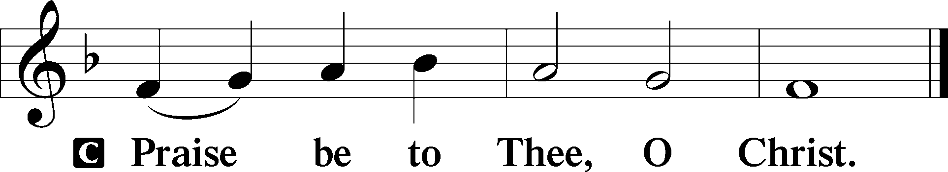

Please be seated

Office Hymn O Love, How Deep #544

Sermon The One Who Is Near

Please stand

Nicene Creed

C I believe in one God, (Rom 10:10; Deut 6:4)
the Father Almighty, (Mt 6:9; Ex 6:3)
maker of heaven and earth (Gen 1:1; Jn 1:1)
and of all things visible and invisible. (Col 1:16)
And in one Lord Jesus Christ, (Rom 10:9)
the only-begotten Son of God, (Jn 3:16; Mt 16:16)
begotten of His Father before all worlds, (Jn 1:2)
God of God, Light of Light, (Jn 17:22; Jn 8:12; Jn 1:1)
very God of very God, (Col 2:9) begotten, not made, (Jn 1:2)
being of one substance with the Father, (Jn 10:30)
by whom all things were made; (Heb 1:2; Jn 1:3)
who for us men and for our salvation (1 Tim 2:4; Rom 3:23)
came down from heaven (Jn 6:41; Lk 15:20)
and was incarnate by the Holy Spirit of the virgin Mary (Lk 1:34-35)
and was made man; (Jn 1:14)
and was crucified also for us under Pontius Pilate. (Mk 15:25; Jn 19:16-18)
He suffered and was buried. (Jn 19:1-3; Lk 23:53)
And the third day He rose again according to the Scriptures (1 Cor 15:4; Lk 24:6)
and ascended into heaven (Acts 1:9)
and sits at the right hand of the Father. (Acts 7:55)
And He will come again with glory (Mt 26:64)
to judge both the living and the dead, (Acts 10:42; Mt 3:12)
whose kingdom will have no end. (2 Pt 1:11)
And I believe in the Holy Spirit, (Jn 14:26; Gen 1:2; Acts 2:38)
the Lord and giver of life, (Gen 1:2; Jn 3:6)
who proceeds from the Father and the Son, (Jn 15:26)
who with the Father and the Son together is worshiped and glorified, (Mt 3:16-17)
who spoke by the prophets. (Eze 11:5)
And I believe in one holy Christian and apostolic Church, (1 Pt 2:5; Eph 2:19-22)
I acknowledge one Baptism for the remission of sins, (Eph 4:5)
and I look for the resurrection of the dead (1 Cor 15:35-49; 1 Thess 4:13-18)
and the life T of the world to come. (Mk 10:29-30; Mt 10:40-42)
Amen. (Ps 106:48)
Us men means all people.
Christian: the ancient text reads “catholic,” meaning the whole Church as it confesses the wholeness of Christian doctrine

Prayer of the Church

After each petition of the prayer:
Pastor: Lord, in Your mercy,
People: Hear our prayer.

For comfort, health and recovery: Dan Hansen, Paul Hansen, Eric Held, Steve Kennedy, Lady Cate Lorence, Mark Millard, Mary Elizabeth Ridlehoover, John Rudsenske, Sam Schneider, Terry Smith, Alli Thomas;
For those who are ill or distressed: Stan Acey, Jenalee Adams, Kimberly Airhart, Layne Bagley, Rose Bagley, Shirley Bagley, W.L. Bagley, Sarah Bowman, Mimi Bradley, Richard Bradley, Deloris Brent, Martha Brown, Nathan Brown, Tina Burke, Wayne Burke, Paula Burkhalter, Bobby Carroll, Arthur Collins, James E. Cookston, Joan Cowards, Belinda Cowards-Gonzales, Mike Ellis, Robert (Andy) Evers, Michele Rae Fowler, Randy Fowler, Parker Haines, Dan Hansen, Paul Hansen, Tim Hansen, Valerie Henderson, Sharon Holleman, Hugh Hunt, Beth Jarratt, Jimmy Jarratt, Elaine Johnson, Joslyn Jones, Arlene Kleinschmidt, Eleanor Koster, John Koster, Sandra Landers, Katelyn Lawing, Peggy Lucky, Paul McCullough, Jerry McIntyre, Jerry McMahan, Edlia Miller, Mark Miller, Elaine Monaghan, Lindberg Moore, Jerry Mutter, Don Ochs, Mildred Odom, Janea Parker, Deborah-Annette Ried, Elmira Roever, Jon Sandberg, Noah Schultz, Johnnie Pearl Smiley, Bob Smith, Sally Smith, Sherri Smith, Deborah Springer, MariLyn Unger, Betty Venator, Leonard Watson, Dana Weaver, Cynthia Widlitze, Carol Wright, Jimmy Wright, Marshall Wright, Barbara Zeigler;
For college and graduate students: Jake Everly, Sara Fields, Claudia Nelson, Roselynn Nelson, Katie Rudsenske;
For military servants and their families: Gabriel Escude, James (Glen) Hansford, Holden Hathcock, Christopher Martin, William Nelson, Steven Tatum, John Weidner Jr.;
For foreign missionaries: David and Shelee Warner;
This week’s prayer family: Hugh & Becky Hunt and their loved ones.

Please be seated

Offering

Offertory Psalm 51:10-12
The congregation is invited to sing in parts:
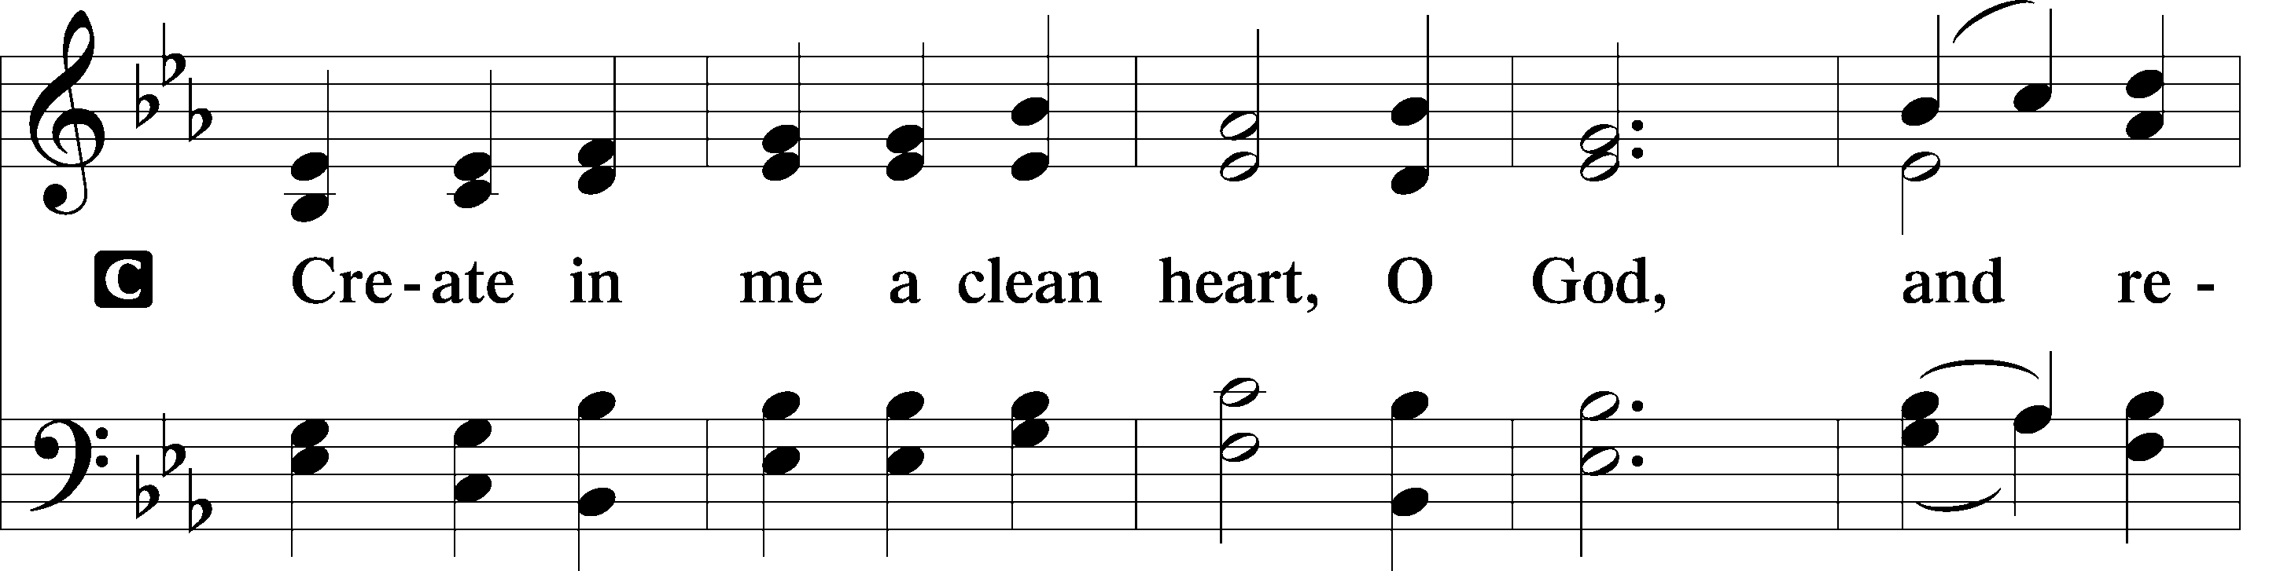
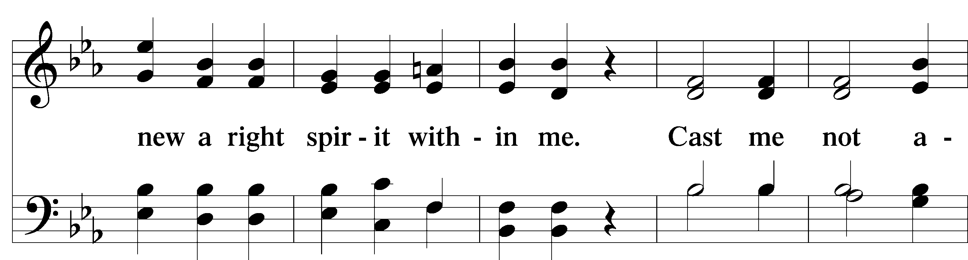
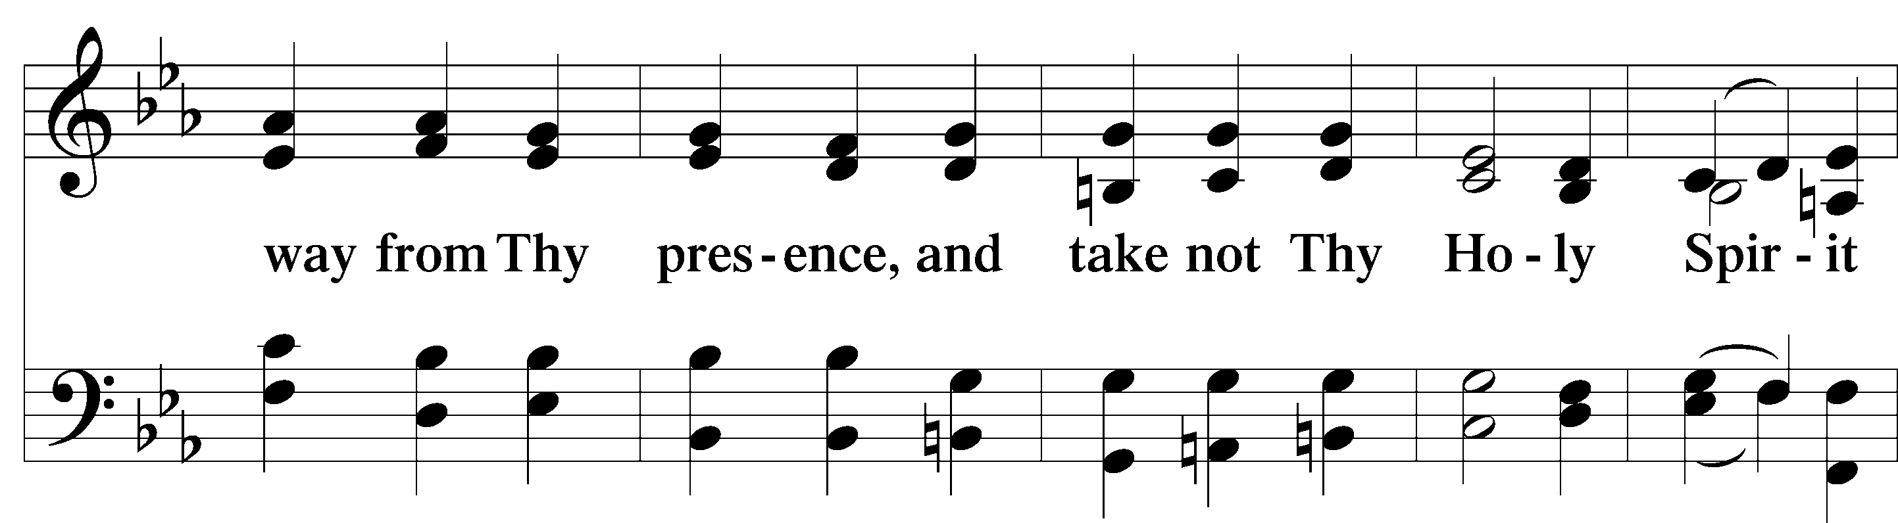
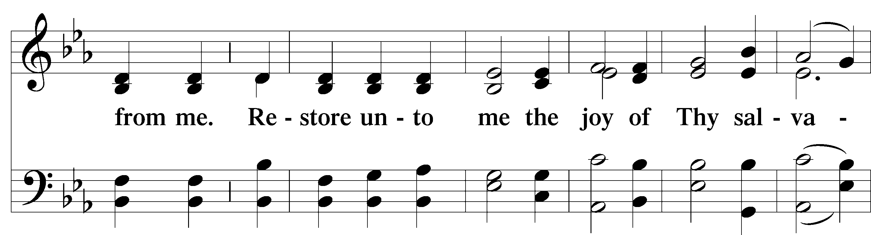
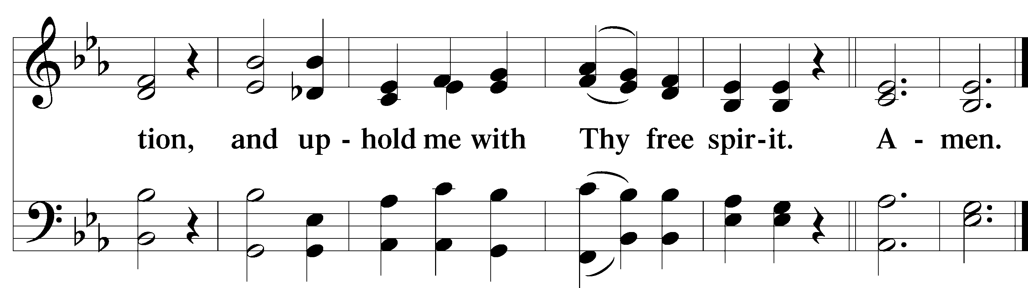

Service of the Sacrament

Preface 2 Timothy 4:22; [Colossians 3:1]; [Psalm 136]

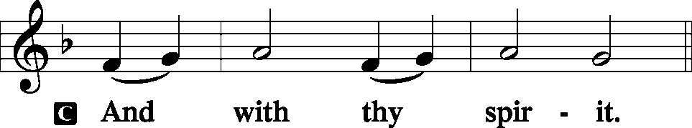
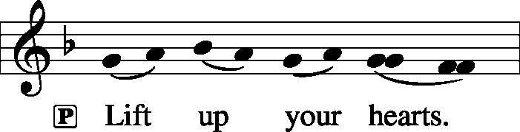

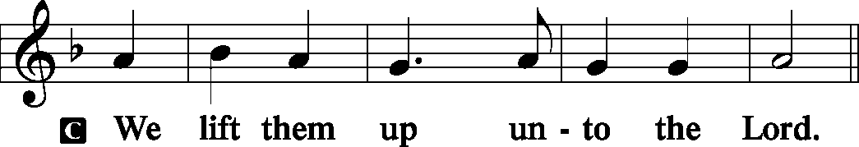
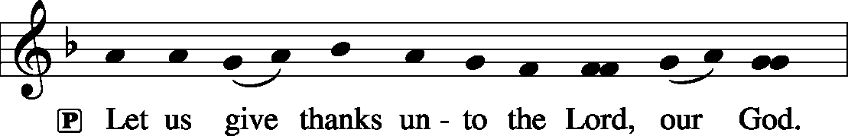
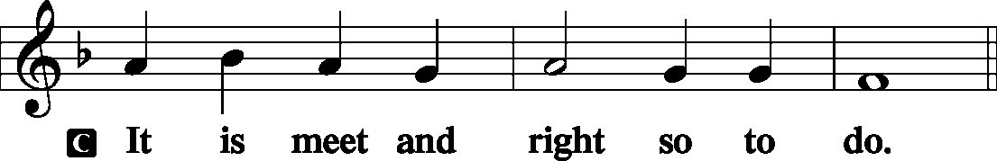

P It is truly meet, right, and salutary that we should at all times and in all places give thanks to You, holy Lord, almighty Father, everlasting God, through Jesus Christ, our Lord, who on this day overcame death and the grave and by His glorious resurrection opened to us the way of everlasting life. Therefore with angels and archangels and with all the company of heaven we laud and magnify Your glorious name, evermore praising You and saying:

Sanctus Isaiah 6:3; Matthew 21:9
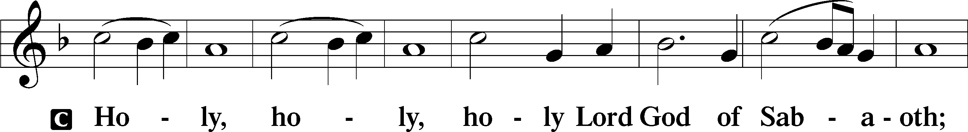
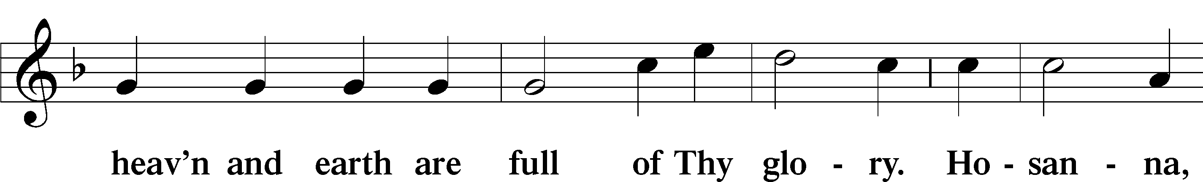
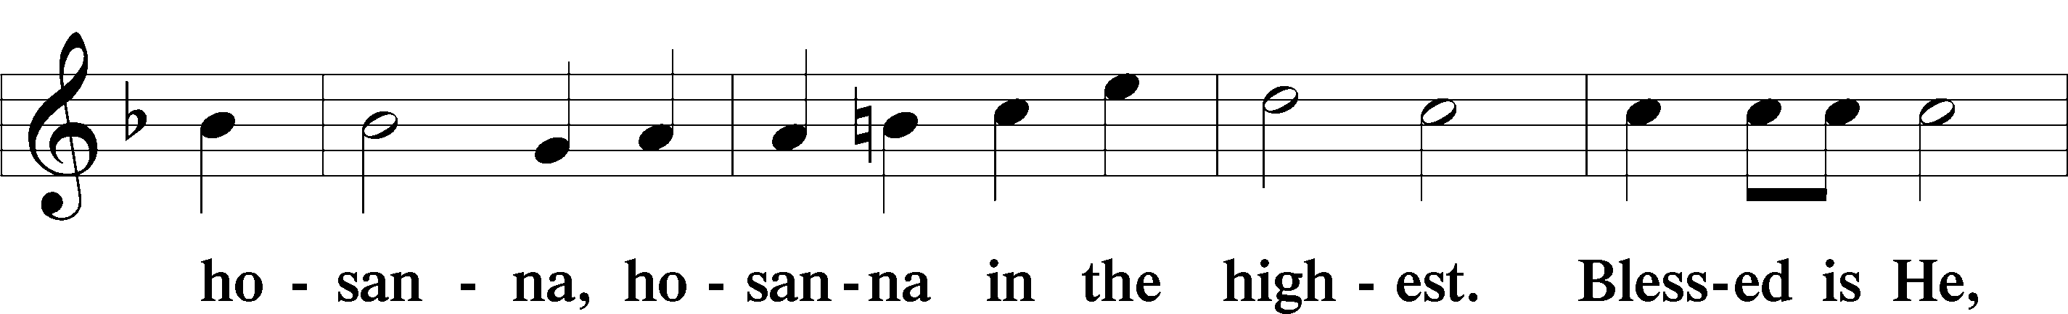
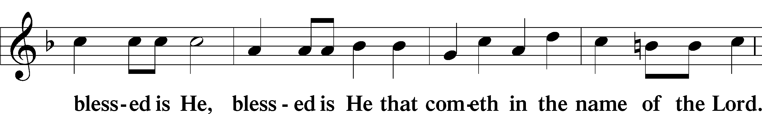
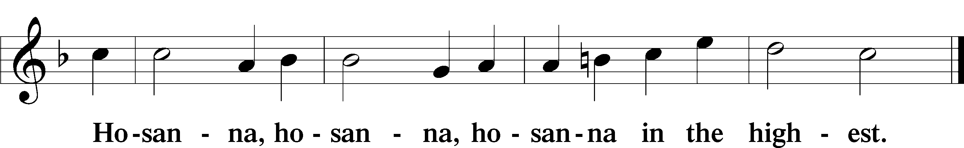

Lord’s Prayer Matthew 6:9-13
P Our Father who art in heaven,
Hallowed be Thy name,
Thy kingdom come,
Thy will be done on earth as it is in heaven;
Give us this day our daily bread;
And forgive us our trespasses as we forgive those who trespass against us;
And lead us not into temptation,
But deliver T us from evil.

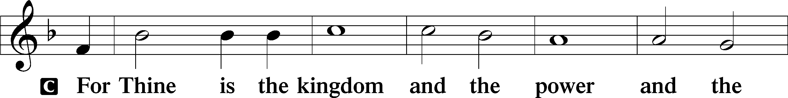
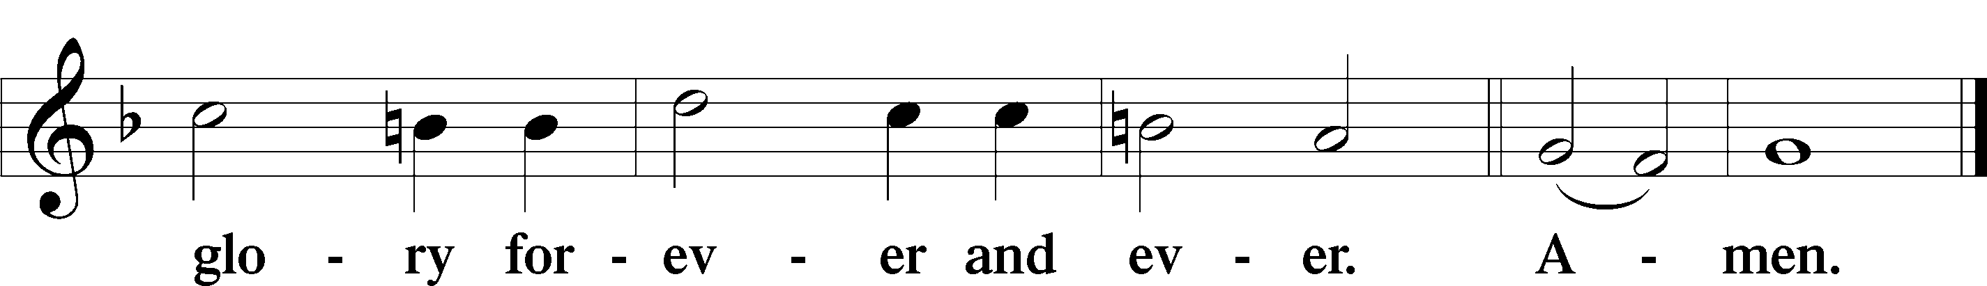
The Words of Our Lord Matthew 26:26–28
P Our Lord Jesus Christ, on the night when He was betrayed, took bread, and when He had given thanks, He broke it and gave it to the disciples and said: “Take, eat; this is My T body, which is given for you. This do in remembrance of Me.”
In the same way also He took the cup after supper, and when He had given thanks, He gave it to them, saying: “Drink of it, all of you; this cup is the new testament in My T blood, which is shed for you for the forgiveness of sins. This do, as often as you drink it, in remembrance of Me.”

Pax Domini John 20:19
P The peace T of the Lord be with you always.
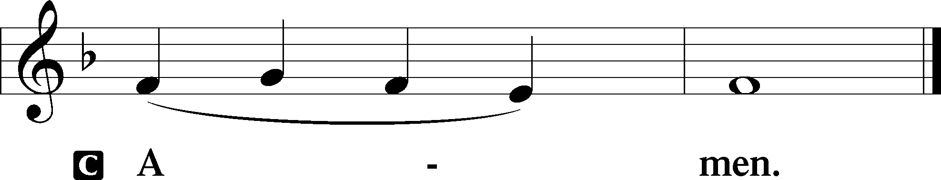

Agnus Dei John 1:29
The congregation is invited to sing in parts.
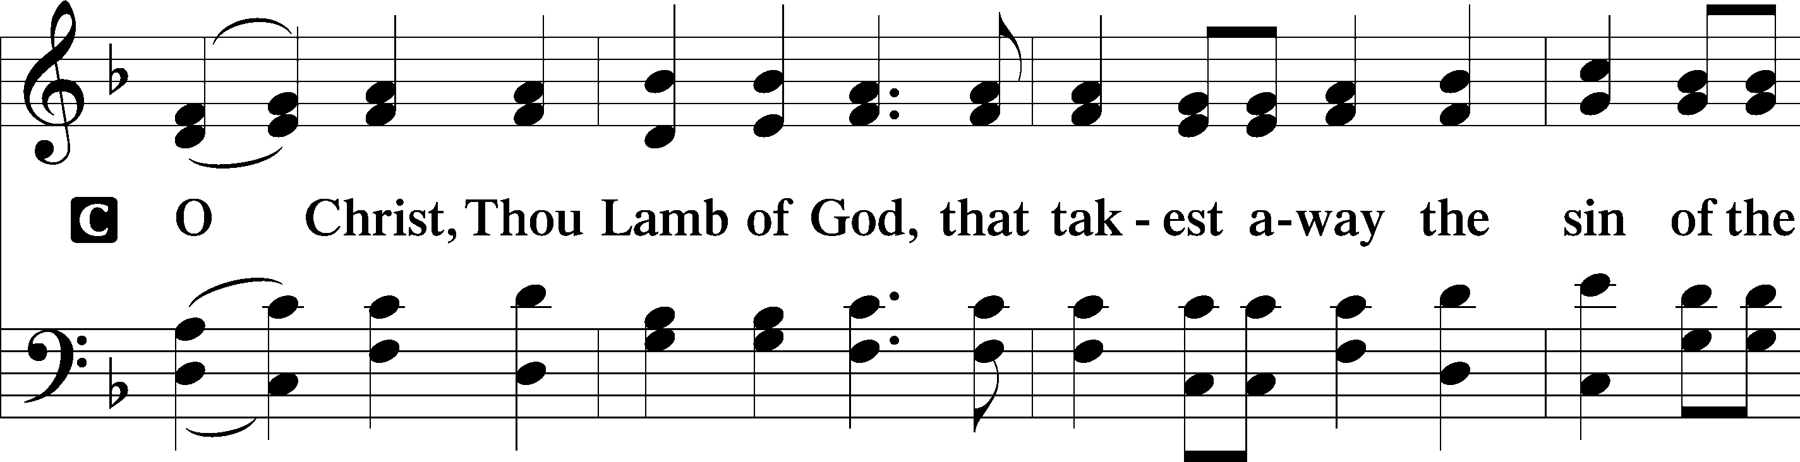
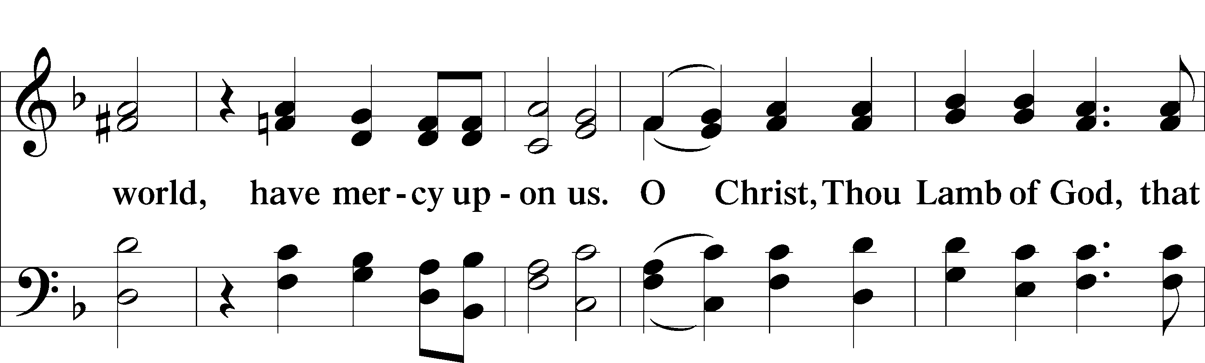
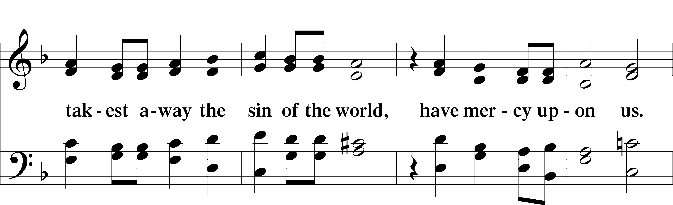
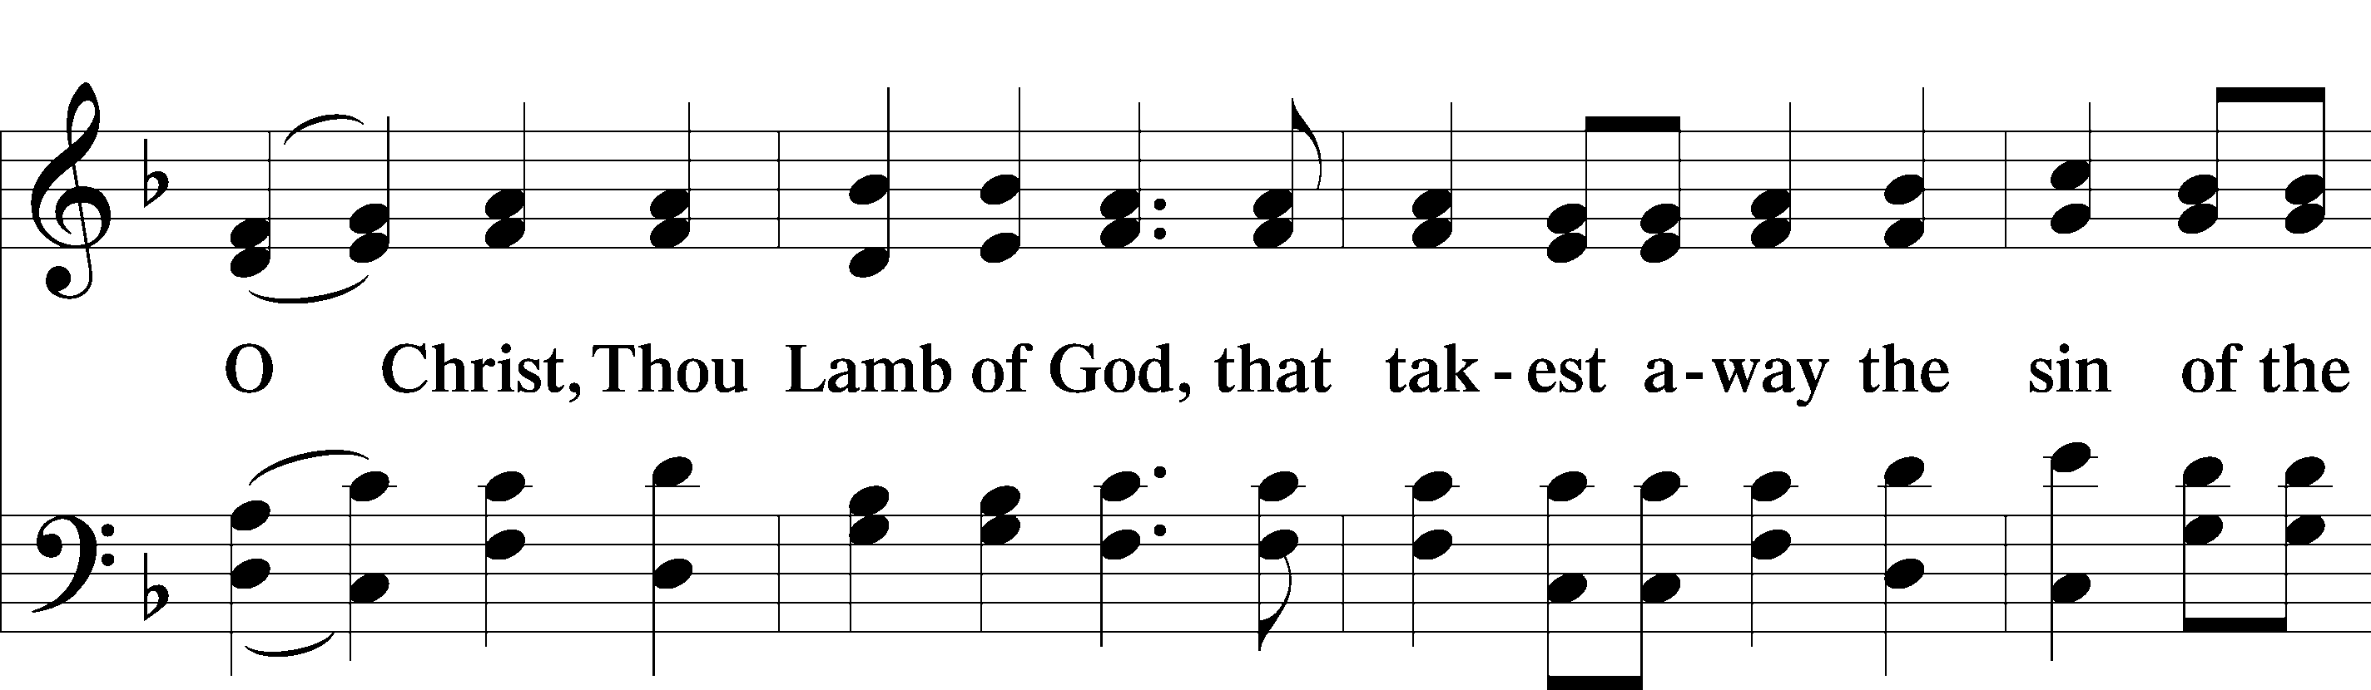
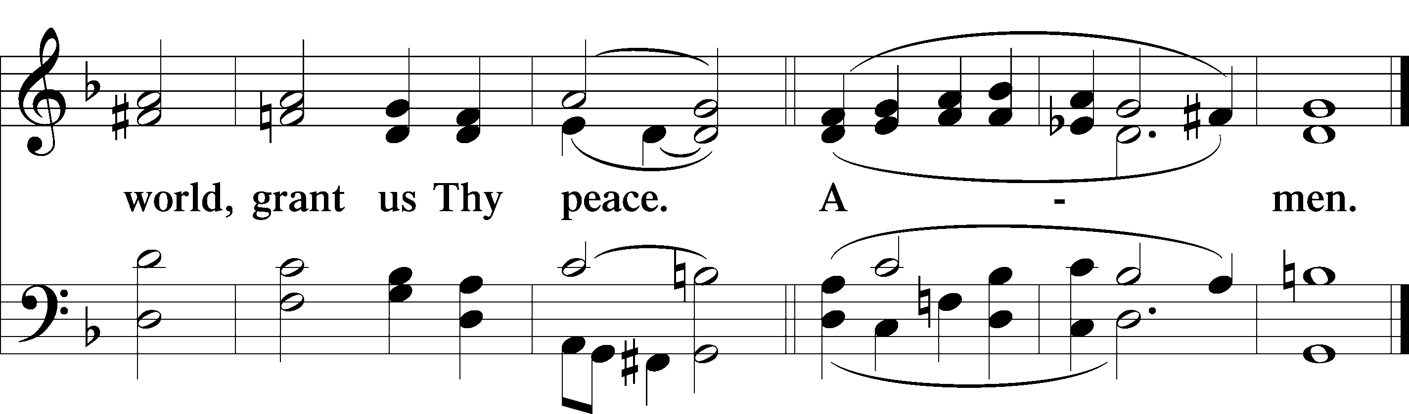
Please be seated

Distribution of the Sacrament
All who are members in good standing of the Lutheran Church - Missouri Synod and have introduced themselves to one of the pastors are welcome to partake of the Holy Communion at Christ Lutheran. If you have not spoken to a pastor, but would like to receive the Lord's blessing, you may still come to the rail and kneel, crossing one arm over the other in the shape of an 'X'. This symbolizes that one is marked by the cross and Triune name of Almighty God.

Distribution Hymns
Where Charity and Love Prevail (Tune #348)

1 Where charity and love prevail
There God is ever found;
Brought here together by Christ’s love
By love are we thus bound.

2 With grateful joy and holy fear
His charity we learn;
Let us with heart and mind and soul
Now love Him in return.

3 Forgive we now each other’s faults
As we our faults confess,
And let us love each other well
In Christian holiness.

4 Let strife among us be unknown;
Let all contention cease;
Be God’s the glory that we seek;
Be ours His holy peace.

5 Let us recall that in our midst
Dwells Christ, His only Son;
As members of His body joined
We are in Him made one.

6 For love excludes no race or clan
That names the Savior’s name;
His family embraces all
Whose Father is the same.

Please stand following distribution of communion

Nunc Dimittis Luke 2:29-32
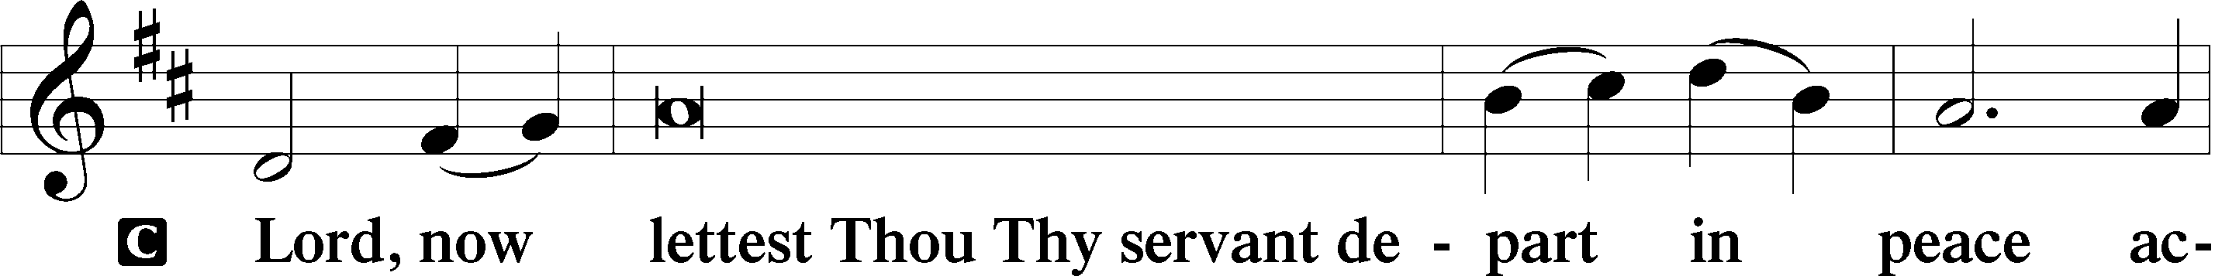
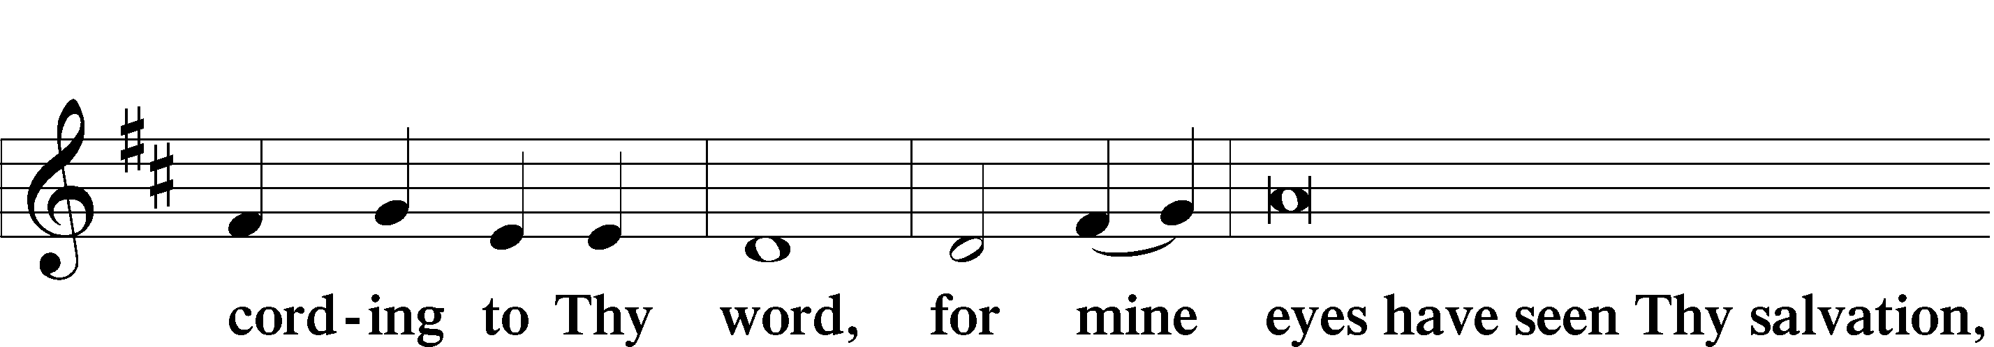
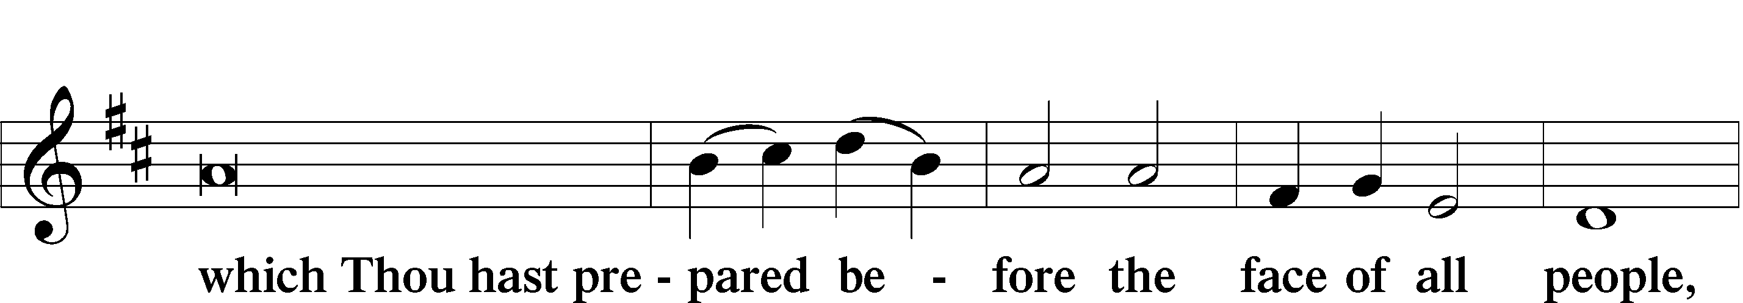
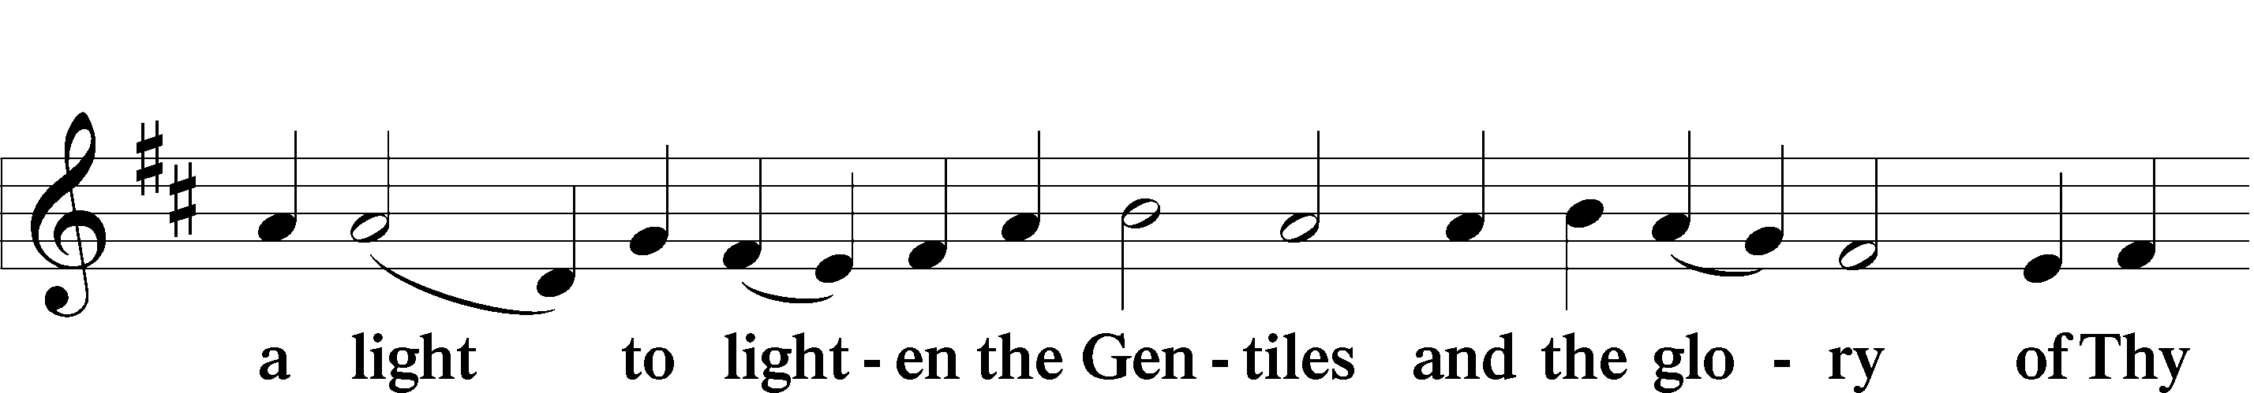
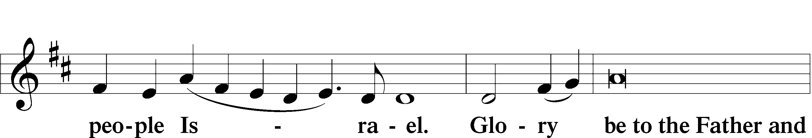
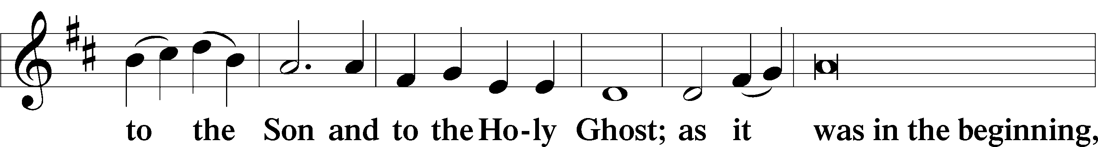
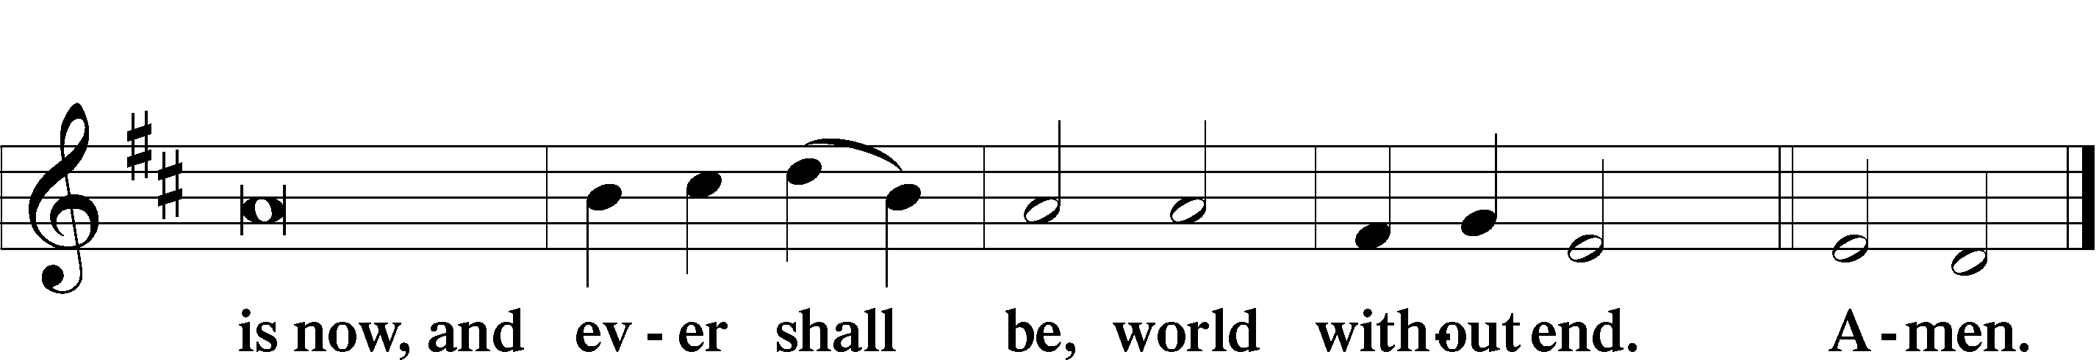

Thanksgiving
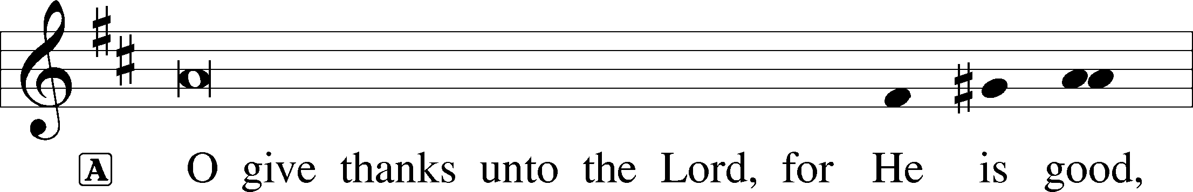

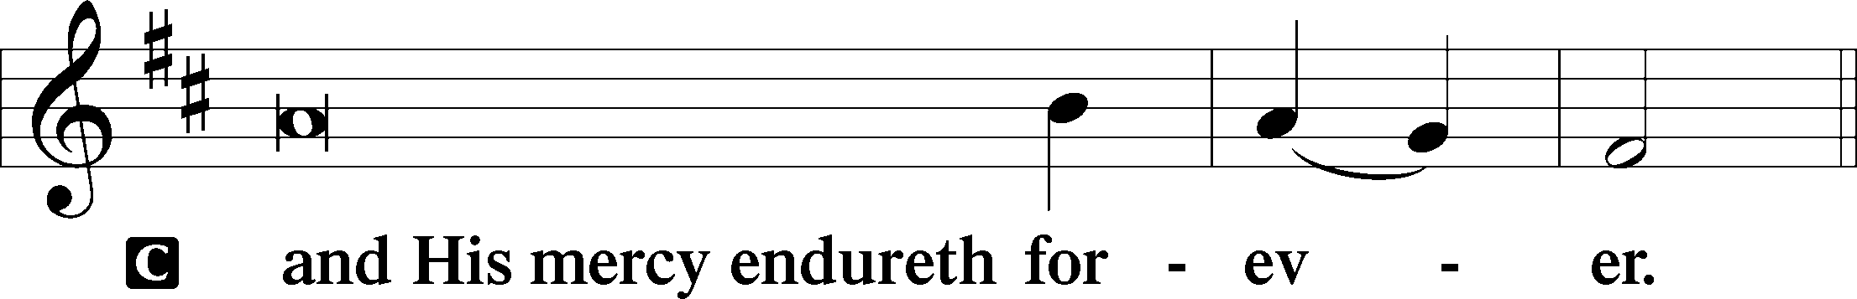

Post-Communion Collect
A We give thanks to You, almighty God, that You have refreshed us through this salutary gift, and we implore You that of Your mercy You would strengthen us through the same in faith toward You and fervent love toward one another; through Jesus Christ, Your Son, our Lord, who lives and reigns with You and the Holy Spirit, one God, now and forever.


Salutation and Benedicamus
P The Lord be with you.
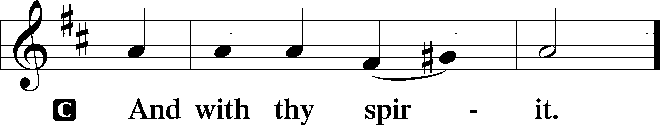
P Bless we the Lord.
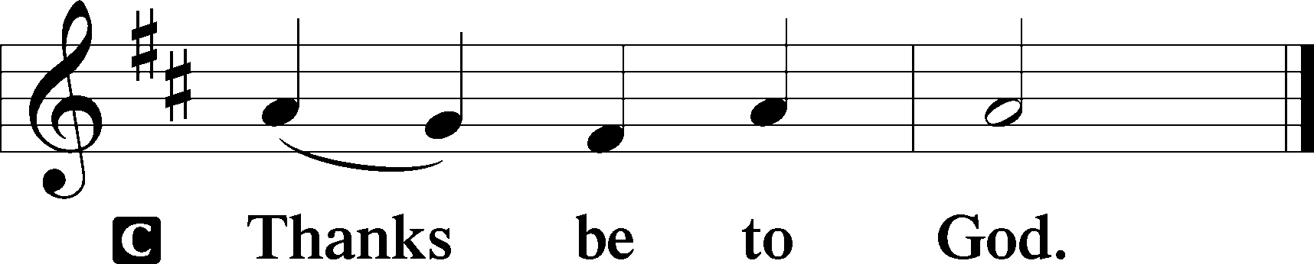
Benediction Numbers 6:24–26
P The Lord bless you and keep you.
The Lord make His face shine upon you and be gracious unto you.
The Lord lift up His countenance upon you and T give you peace.
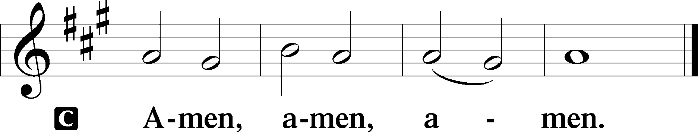

Closing Hymn What Wondrous Love Is This #543

Acknowledgments
Divine Service, Setting Three from Lutheran Service Book © 2006 Concordia Publishing House. Reprinted with permission. Unless otherwise indicated, all scripture quotations are from The Holy Bible, English Standard Version, copyright © 2001 by Crossway Bibles, a division of Good News Publishers. Used by permission. All rights reserved. Created by Lutheran Service Builder © 2006 Concordia Publishing House.

Serving Today:
Celebrant: Rev. George Fields Organist: Sr. Sara Fields
Interpreter: Greg Goldman

Altar Flowers: This morning’s altar flowers are given for the glory of God by the family of Hugh Green in his memory.

Prayer Requests: Remember, just because we don’t have time together before Sunday school doesn’t mean that you can’t ask for prayers! If you or someone you know is in need of intercession, simply contact the church office or Sister Sara, and we will add your request to our weekly prayers.

May Voters Meeting Postponed: A congregational meeting cannot be held in May to elect the persons to serve on the church council during the 2020-2021 year because of the virus restrictions. Normally, the congregation elects the council members at the May congregation meeting. At the May church council meeting, the council postponed the election until the congregation can meet. After virus restrictions are lifted, the council will schedule a congregation meeting. All current council members have agreed to continue to serve until the congregation elects the 2020-2021 council members. If you have questions or comments about the postponement of the congregation meeting and election, contact Bob Pedersen at 601-829-1553 (H), 601-965-1926 (O) or email him at bpedersen@watkinseager.com or pedersengloria.bob@att.net.

Readings for next Sunday, June 21st, the Third Sunday after Pentecost:
Introit Ps. 56:3-4, 10-11; Psalm 91:1-16; Jeremiah 20:7-13; Romans 6:12-23; Matthew 10:5a, 21-33.

This week at Christ Lutheran Church: June 8 – June 14

Tuesday 7:30 p.m. Evening Prayer Online
Thursday 7:30 p.m. Compline Online
Friday 6:30 p.m. Divine Service – Second Sunday after Pentecost
Sunday 10:30 a.m. Divine Service – Second Sunday after Pentecost



YOUR LIFELINE TO THE LUTHERAN WORLDVIEW…You can listen to in-depth teachings on interesting subjects like:

The Vocation of Father, Consolation in Suffering, Christ’s Descent into Hell, The Rite of Anointing the Sick with Oil, and more…

Issues, Etc. is a radio talk show produced by Lutheran Public Radio and hosted by LCMS Pastor Todd Wilken. You can listen to what you want when you want at www.issuesetc.org. Simply click on “Listen”, choose “On Demand”, then select from the vast array of speakers and topics available in the archives.

Rom. 5:8 – “But God shows his love for us in that while we were still sinners, Christ died for us.”
God did not wait for mankind to make the first move. He did not wait for Adam and Eve to come looking for Him, but He went and found them. And while we were still sinners, still enemies of God, and still set against Him, He sent His Son Jesus to suffer, die, and rise for us. God was moved by His own love and generosity and kindness. We now seek to grow up into His image as loving, generous, and kind sons and daughters of the Heavenly Father.
CLC Reopening:
Phase Two!

"I was glad when they said to me, 'Let us go into the house of the Lord.'" (Ps. 122:1)

And indeed, today is a day of great gladness! Christ Lutheran Church is further opening its doors for worship! See details below for our newest phase of reopening, beginning this week:

Based on current data regarding the virus, combined with the recent CLC survey responses (thank you for your feedback!), the pastors and elders are beginning the next phase of our gradual reopening. We will hold two services weekly, one at 6:30 on Friday evenings, and one at our regular 10:30 time on Sunday mornings.

- For those who may be at higher risk or have other health concerns, Friday nights will be limited to twenty people, including staff. Strict social distancing, sanitation, and safe communion procedures will be observed, and any visiting before or after the service will take place outdoors. If you would like to attend on Friday night, please email me (Sister Sara) so we can plan for your attendance.
- For those who are eager to return to the regular Sunday time, this service will be limited to fifty people in accordance with the Governor's current Executive Order, CDC, and State Health Department guidelines. The same safety precautions outlined for the Friday service will be implemented to ensure that we do not inadvertently harm one another in our enthusiasm to reconvene as a church family. Particularly, families will be asked to sit in designated locations, the offering plates will not be passed, and new measures will be taken in the distribution of communion to maintain social distancing and minimize risk of personal contact. Based on our attendance data during the months before the shutdown, current attendance data, and our recent survey results, it is highly unlikely we will attain the fifty person limit in the near future. However, if we do go over that number, plans are in place to accommodate overflow and maintain appropriate social distancing.
This plan will go into effect Friday, June 12, wherein we will be observing the Second Sunday after Pentecost. (To clarify, there will be no Wednesday service, beginning this week).

We are doing what we can to make church a safe environment for our church family to come home to. However, if you are concerned about venturing forth, please do not feel compelled to come before you are ready. As we have said before, the Lord is eternally patient, and His Supper will be ready for you when you are safe to partake of it.

For those who remain at home, we will continue to stream our worship services, that you may join us from afar. Lord willing, we will be all reunited soon!

If you have any questions or concerns, please feel free to call/email Sister Sara or the pastors. See you soon!

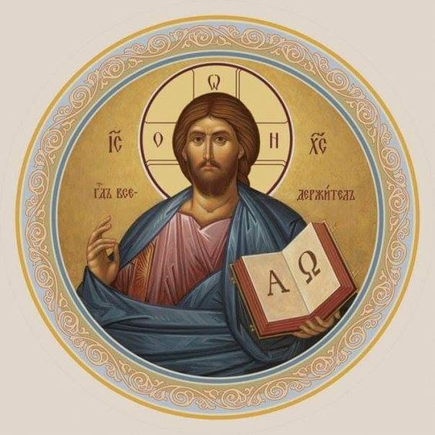

Christ Lutheran Church
Rev. Dr. James R. Holowach, Pastor
Rev. George N. Fields, Pastor
Sr. Sara E. Fields, Deaconess
4423 I-55 North, Jackson, MS 39206-6102
(601) 366-2055
www.christlutheranjacksonms.org

Matthew 26:26-29; Mark 14:22-25; Luke 22:14-20, 1 Corinthians 11:23
Matthew 26:28; 1 John 1:7; 1 Peter 1:18-19
1 Corinthians 11:28-32
1 Corinthians 10:17; 1 Corinthians 11:26

