Christ Lutheran Church
Good Friday
+ April 17, 2020 +

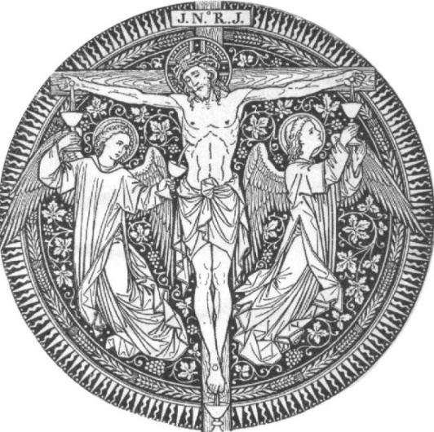

By His Stripes, We Are Healed.

The Chief Service for Good Friday

Service of the Word

The congregation enters in silence.

Please stand

Invocation
P In the name of the Father and of the T Son and of the Holy Spirit.
C Amen.

Collect of the Day
P Let us pray.
Almighty God, graciously behold this Your family for whom our Lord Jesus Christ was willing to be betrayed and delivered into the hands of sinful men to suffer death upon the cross; through the same Jesus Christ, Your Son, our Lord, who lives and reigns with You and the Holy Spirit, one God, now and forever.
C Amen.

Please be seated

Old Testament Reading Isaiah 52:13—53:12
Behold, my servant shall act wisely;
he shall be high and lifted up,
and shall be exalted.
As many were astonished at you—
his appearance was so marred, beyond human semblance,
and his form beyond that of the children of mankind—
so shall he sprinkle many nations;
kings shall shut their mouths because of him;
for that which has not been told them they see,
and that which they have not heard they understand.
Who has believed what they heard from us?
And to whom has the arm of the Lord been revealed?
For he grew up before him like a young plant,
and like a root out of dry ground;
he had no form or majesty that we should look at him,
and no beauty that we should desire him.
He was despised and rejected by men;
a man of sorrows, and acquainted with grief;
and as one from whom men hide their faces
he was despised, and we esteemed him not.
Surely he has borne our griefs
and carried our sorrows;
yet we esteemed him stricken,
smitten by God, and afflicted.
But he was wounded for our transgressions;
he was crushed for our iniquities;
upon him was the chastisement that brought us peace,
and with his stripes we are healed.
All we like sheep have gone astray;
we have turned every one to his own way;
and the Lord has laid on him
the iniquity of us all.
He was oppressed, and he was afflicted,
yet he opened not his mouth;
like a lamb that is led to the slaughter,
and like a sheep that before its shearers is silent,
so he opened not his mouth.
By oppression and judgment he was taken away;
and as for his generation, who considered
that he was cut off out of the land of the living,
stricken for the transgression of my people?
And they made his grave with the wicked
and with a rich man in his death,
although he had done no violence,
and there was no deceit in his mouth.
Yet it was the will of the Lord to crush him;
he has put him to grief;
when his soul makes an offering for sin,
he shall see his offspring; he shall prolong his days;
the will of the Lord shall prosper in his hand.
Out of the anguish of his soul he shall see and be satisfied;
by his knowledge shall the righteous one, my servant,
make many to be accounted righteous,
and he shall bear their iniquities.
Therefore I will divide him a portion with the many,
and he shall divide the spoil with the strong,
because he poured out his soul to death
and was numbered with the transgressors;
yet he bore the sin of many,
and makes intercession for the transgressors.
A This is the Word of the Lord.
C Thanks be to God.

Please stand

Collect
P Let us pray.
Merciful and everlasting God, You did not spare Your only Son but delivered Him up for us all to bear our sins on the cross. Grant that our hearts may be so fixed with steadfast faith in Him that we fear not the power of sin, death, and the devil; through the same Jesus Christ, our Lord.
C Amen.

Please be seated

Epistle Reading Hebrews 4:14-16; 5:7-9
Since then we have a great high priest who has passed through the heavens, Jesus, the Son of God, let us hold fast our confession. For we do not have a high priest who is unable to sympathize with our weaknesses, but one who in every respect has been tempted as we are, yet without sin. Let us then with confidence draw near to the throne of grace, that we may receive mercy and find grace to help in time of need.
In the days of his flesh, Jesus offered up prayers and supplications, with loud cries and tears, to him who was able to save him from death, and he was heard because of his reverence. Although he was a son, he learned obedience through what he suffered. And being made perfect, he became the source of eternal salvation to all who obey him,
A This is the Word of the Lord.
C Thanks be to God.

Please stand

Collect
P Let us pray.
Almighty and everlasting God, You willed that Your Son should bear for us the pains of the cross and so remove from us the power of the adversary. Help us so to remember and give thanks for our Lord's passion that we may receive forgiveness of sin and redemption from everlasting death; through Jesus Christ, our Lord.
C Amen.

Please be seated

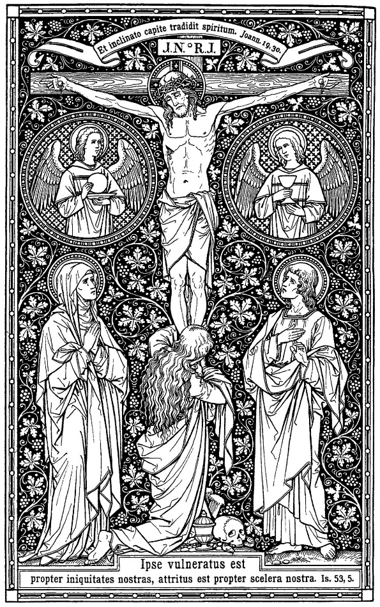
The Passion of Our Lord Jesus Christ

Hymn Jesus, I Will Ponder Now #440, Stanza 1

Reading Betrayal and Arrest of Jesus John 18:1-11

Hymn O Sacred Head, Now Wounded #450, Stanza 1

Reading Jesus before the High Priest and the Denial of Peter John 18:12-27

Hymn O Sacred Head, Now Wounded #450, Stanza 2
Sung by Cantor

Reading Jesus before Pilate John 18:28-40

Hymn O Sacred Head, Now Wounded #449, Stanza 2

Reading Jesus Prepared for Crucifixion John 19:1-16a

Hymn O Sacred Head, Now Wounded #450, Stanza 4

Please stand

Reading The Crucifixion of Jesus John 19:16b-24

Hymn O Sacred Head, Now Wounded #450, Stanza 5

Reading Jesus’ Mother and His Death John 19:25-30

Hymn O Sacred Head, Now Wounded #450, Stanza 6
Sung by Cantor

Reading Jesus’ Side Is Pierced John 19:31-42

Hymn O Sacred Head, Now Wounded #449, Stanza 4

Silence

Please be seated

Sermon The Burial of the Son

Office Hymn A Lamb Goes Uncomplaining Forth #438

Please stand

Bidding Prayer
A Let us pray for the whole Christian Church, that our Lord God would defend her against all the assaults and temptations of the adversary and keep her perpetually on the true foundation, Jesus Christ:
P Almighty and everlasting God, since You have revealed Your glory to all nations in Jesus Christ and in the Word of His truth, keep, we ask You, in safety the works of Your mercy so that Your Church, spread throughout all the nations, may be defended against the adversary and may serve You in true faith and persevere in the confession of Your name; through Jesus Christ, our Lord.
C Amen.

A Let us pray for all the ministers of the Word, for all vocations in the Church, and for all the people of God:
P Almighty and everlasting God, by whose Spirit the whole body of the Church is governed and sanctified, receive the supplications and prayers which we offer before You for all Your servants in Your holy Church that every member of the same may truly serve You according to Your calling; through Jesus Christ, our Lord.
C Amen.

A Let us pray for our catechumens, that our Lord God would open their hearts and the door of His mercy that, having received the remission of all their sins by the washing of regeneration, they may be mindful of their Baptism and evermore be found in Christ Jesus, our Lord:
P Almighty God and Father, because You always grant growth to Your Church, increase the faith and understanding of our catechumens that, rejoicing in their new birth by the water of Holy Baptism, they may forever continue in the family of those whom You adopt as Your sons and daughters; through Jesus Christ, our Lord.
C Amen.

A Let us pray for all in authority that we may lead a quiet and peaceable life in all godliness and honesty:
P O merciful Father in heaven, because You hold in Your hand all the might of man and because You have ordained, for the punishment of evildoers and for the praise of those who do well, all the powers that exist in all the nations of the world, we humbly pray You graciously to regard Your servants, especially Donald, our President; the Congress of the United States; Tate, our Governor; and all those who make, administer, and judge our laws; that all who receive the sword as Your ministers may bear it according to Your Word; through Jesus Christ, our Lord.
C Amen.

A Let us pray our Lord God Almighty that He would deliver the world from all error, take away disease, ward off famine, set free those in bondage, and grant health to the sick and a safe journey to all who travel:
P Almighty and everlasting God, the consolation of the sorrowful and the strength of the weak, may the prayers of those who in any tribulation or distress cry to You graciously come before You, so that in all their necessities they may rejoice in Your manifold help and comfort; through Jesus Christ, our Lord.
C Amen.

A Let us pray for all who are outside the Church, that our Lord God would be pleased to deliver them from their error, call them to faith in the true and living God and His only Son, Jesus Christ, our Lord, and gather them into His family, the Church:
P Almighty and everlasting God, because You seek not the death but the life of all, hear our prayers for all who have no right knowledge of You, free them from their error, and for the glory of Your name bring them into the fellowship of Your holy Church; through Jesus Christ, our Lord.
C Amen.

A Let us pray for peace, that we may come to the knowledge of God's holy Word and walk before Him as is fitting for Christians:
P Almighty and everlasting God, King of Glory, and Lord of heaven and earth, by whose Spirit all things are goverened, by whose providence all things are ordered, the God of peace and the author of all concord, grant us, we implore You, Your heavenly peace and concord that we may serve You in true fear, to the praise and glory of Your name; through Jesus Christ, our Lord.
C Amen.

A Let us pray for our enemies, that God would remember them in mercy and graciously grant them such things as are needful for them and profitable for their salvation:
P O almighty, everlasting God, through Your only Son, our blessed Lord, You have commanded us to love our enemies, to do good to those who hate us, and to pray for those who persecute us. We therefore earnestly implore You that by Your gracious visitation all our enemies may be led to true repentance and may have the same love and be of one accord and one mind and heart with us and with Your whole Christian Church; through Jesus Christ, our Lord.
C Amen.

A Let us pray for the fruits of the earth, that God would send down His blessing upon them and graciously dispose our hearts to enjoy them according to His own good will:
P O Lord, Father Almighty, by Your Word You created and You continue to bless and uphold all things. We pray You so to reveal to us Your Word, our Lord Jesus Christ that, through His dwelling in our hearts, we may by Your grace be made ready to receive Your blessing on all the fruits of the earth and whatsoever pertains to our bodily need; through Jesus Christ, our Lord.
C Amen.

A Finally, let us pray for all things for which our Lord would have us ask, saying:
C Our Father who art in heaven,
hallowed be Thy name,
Thy kingdom come,
Thy will be done on earth as it is in heaven;
give us this day our daily bread;
and forgive us our trespasses as we forgive those who trespass against us;
and lead us not into temptation,
but deliver T us from evil.
For Thine is the kingdom and the power and the glory forever and ever. Amen.

Sentence and Response
The pastor unveils the crucifix as the sentences are sung:
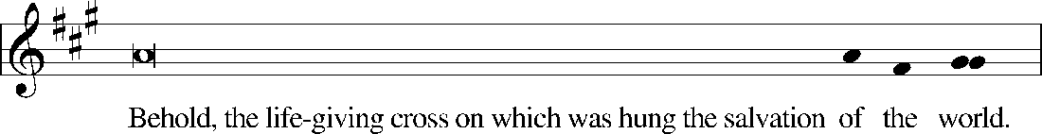
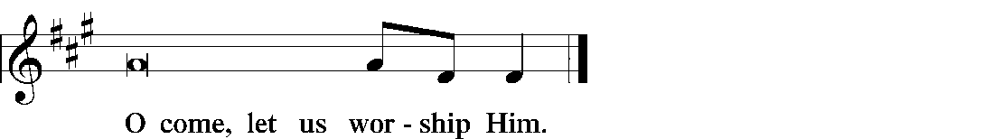

Please be seated

The First Reproach
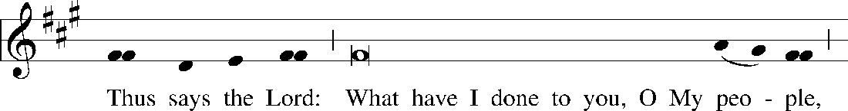
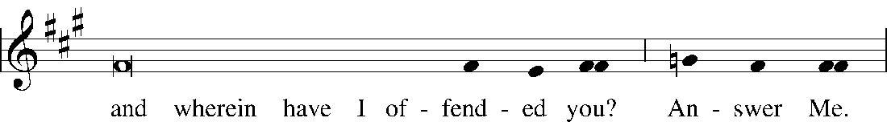
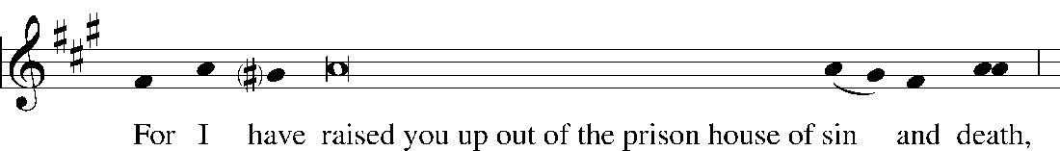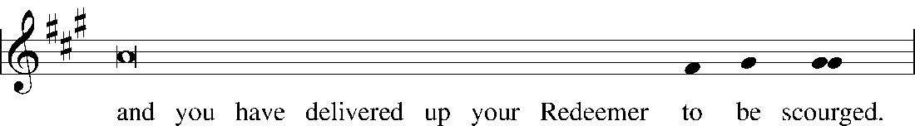
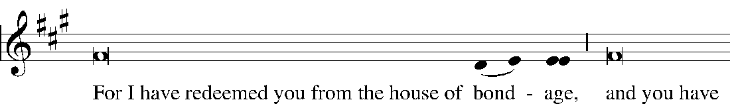
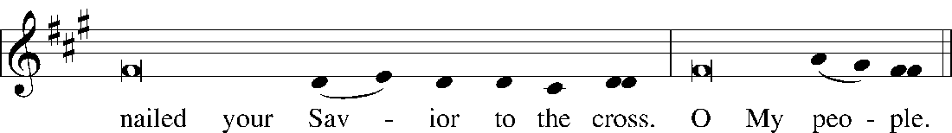

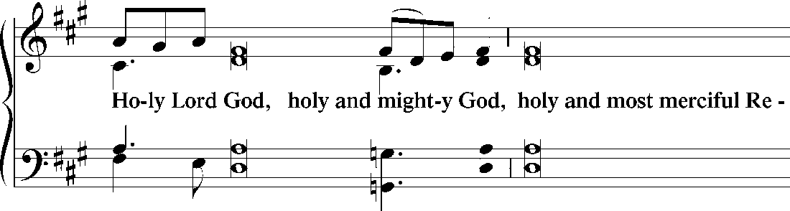
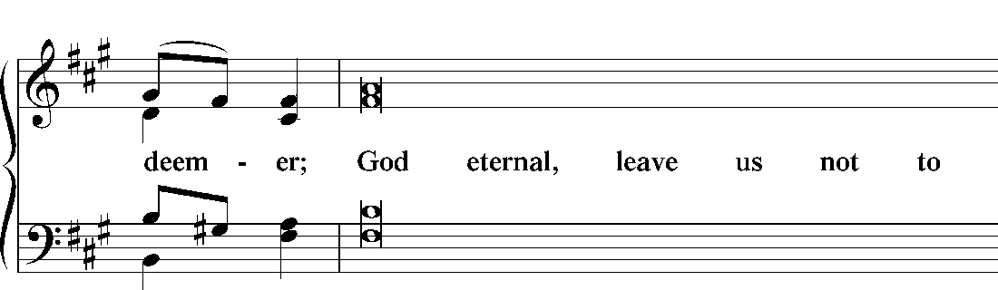
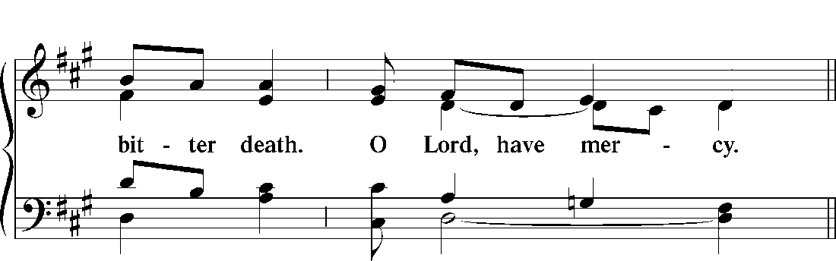

Hymn Lamb of God, Pure and Holy #434, Stanza 1

1 Lamb of God, pure and holy,
Who on the cross didst suffer,
Ever patient and lowly,
Thyself to scorn didst offer.
All sins Thou borest for us,
Else had despair reigned o’er us:
Have mercy on us, O Jesus! O Jesus!

The Second Reproach
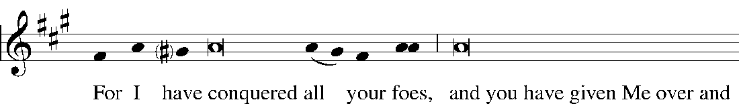
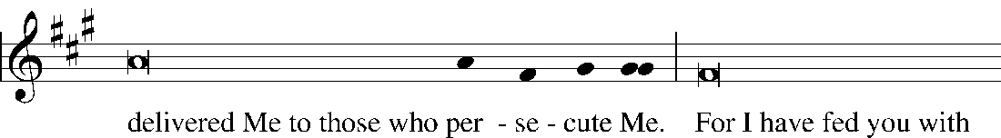
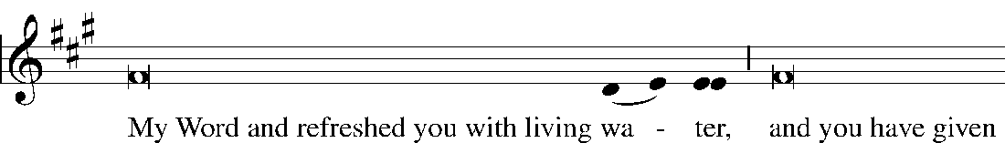
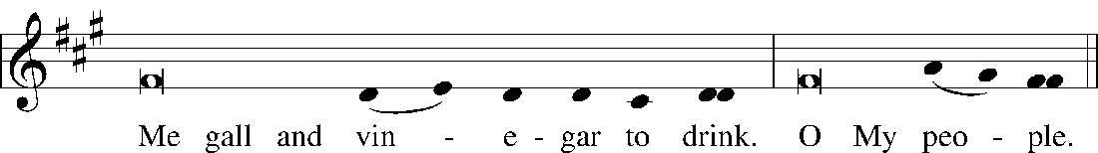

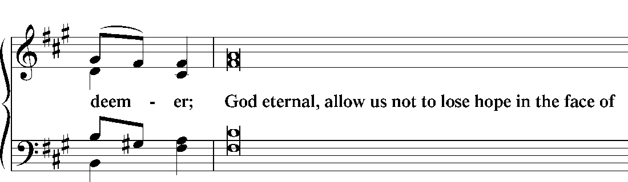
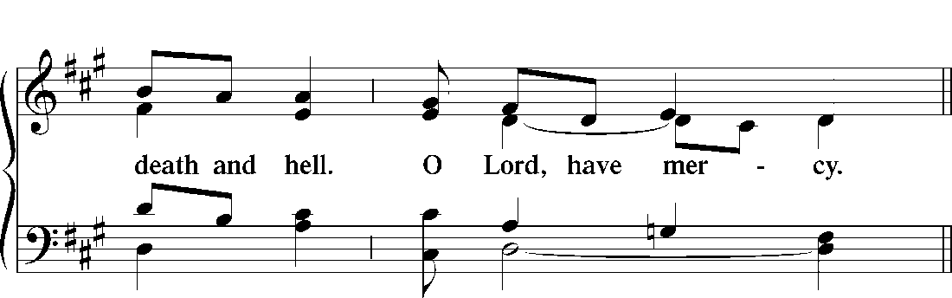

Hymn Lamb of God, Pure and Holy #434, Stanza 2

2 Lamb of God, pure and holy,
Who on the cross didst suffer,
Ever patient and lowly,
Thyself to scorn didst offer.
All sins Thou borest for us,
Else had despair reigned o’er us:
Have mercy on us, O Jesus! O Jesus!

The Third Reproach
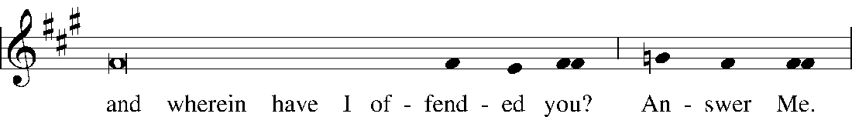
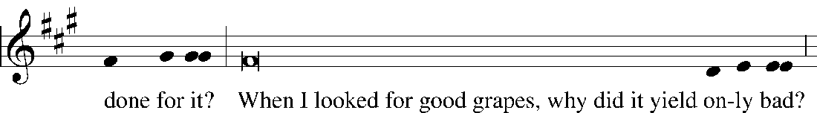
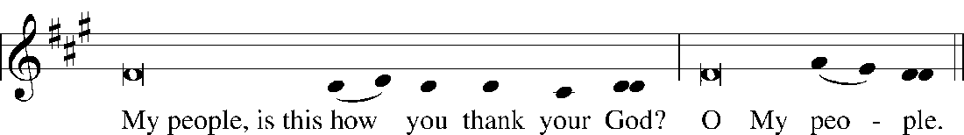

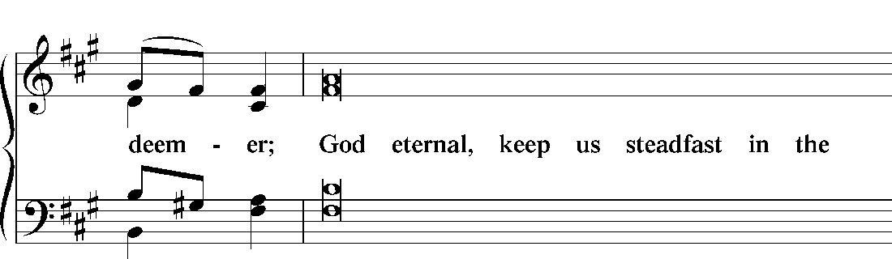
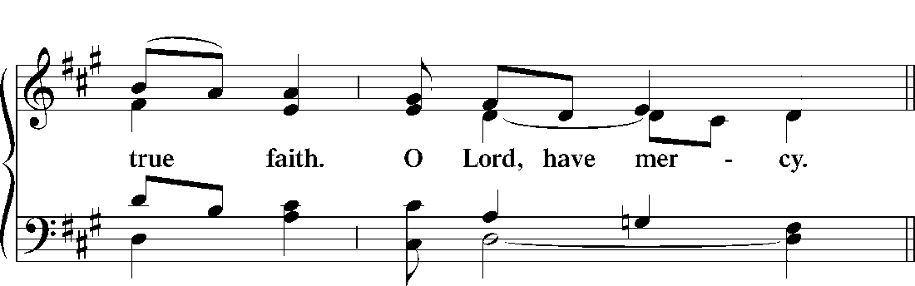

Hymn Lamb of God, Pure and Holy #434, Stanza 3

2 Lamb of God, pure and holy,
Who on the cross didst suffer,
Ever patient and lowly,
Thyself to scorn didst offer.
All sins Thou borest for us,
Else had despair reigned o’er us:
Thy peace be with us, O Jesus! O Jesus!

Please kneel/stand

Adoration of Christ
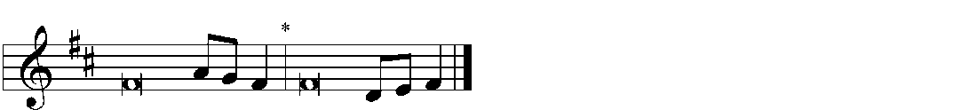
C We adore You, | O Lord,*
and we praise and glorify Your holy resur- | rection.
For behold, by the wood | of Your cross*
joy has come into | all the world.
God be merciful to us and | bless us,*
and cause His face to shine upon us, and have mercy up- | on us.
We adore You, | O Lord,*
and we praise and glorify Your holy resur- | rection.
For behold, by the wood | of Your cross*
joy has come into | all the world.

Please be seated

Hymn Sing, My Tongue, the Glorious Battle (#454)

Cantor:
Faithful cross above all other,
One and only noble tree!
None in foliage, none in blossom,
None in fruit thy peer may be!
Sweetest wood and sweetest iron,
Sweetest weight is hung on thee!

All:
1 Sing, my tongue, the glorious battle;
Sing the ending of the fray.
Now above the cross, the trophy,
Sound the loud triumphant lay;
Tell how Christ, the world’s redeemer,
As a victim won the day.

2 God, his Maker, sorely grieving
That the first-made Adam fell,
When he ate the fruit of sorrow,
Whose reward was death and hell,
Noted then this Wood, the ruin
Of the ancient wood to quell.

3 Tell how, when at length the fullness
Of th’appointed time was come,
He, the Word, was born of woman,
Left for us His Father’s home,
Blazed the path of true obedience,
Shone as light amidst the gloom.

4 Weeps the Infant in the manger
That in Bethl’hem’s stable stands;
And His limbs the Virgin Mother
Doth compose in swaddling bands,
Meetly thus in linen folding
Of her God the feet and hands.

5 Thus, with thirty years accomplished,
He went forth from Nazareth,
Destined, dedicated, willing
Did His work and met His death;
Like a lamb He humbly yielded
On the cross His dying breath.

6 He endured the nails, the spitting,
Vinegar, and spear, and reed;
From that holy Body broken
Blood and water forth proceed:
Earth, and stars, and sky, and ocean,
By that flood from stain are freed.

∆7 Unto God be praised and glory;
To the Father and the Son,
To th’eternal Spirit honor
Now and evermore be done;
Praise and glory in the highest
While the timeless ages run.

Please remain standing

Concluding Collect
P Let us pray.
We implore You, O Lord, that Your abundant blessing may be upon Your people who have held the passion and death of Your Son in devout remembrance, that we may receive Your pardon and the gift of Your comfort, and may increase in faith and take hold of eternal salvation; through the same Jesus Christ, Your Son, our Lord, who lives and reigns with You and the Holy Spirit, one God, now and forever.
C Amen.

Strepitus
A harsh sound, known as the Strepitus,
acknowledges that the tomb is sealed,
the meaning of the cross fulfilled,
the sacrifice completed.

Closing Hymn The Royal Banners Forward Go (#455)

Cantor:
1 The royal banners forward go;
The cross shows forth redemption’s flow,
Where He, by whom our flesh was made,
Our ransom in His flesh has paid:

All:

2 The Victim here, by nails held fast,
Extending hands and feet at last
For our redemption offered, dies,
For us is made a sacrifice.

3 Where deep for us the spear was dyed,
Life’s torrent rushing from His side,
To wash us in the precious flood
Where flowed the water and the blood.

4 Fulfilled is all that David told
In sure prophetic song of old,
That God the nations’ king should be
And reign in triumph from the tree,

5 O tree of beauty, tree most fair,
Ordained those holy limbs to bear:
Gone is thy shame, each crimsoned bough
Proclaims the King of Glory now.

6 On whose hard arms, so widely flung,
The weight of this world’s ransom hung,
The price of humankind to pay
And spoil the spoiler of his prey.

∆7 To Thee, eternal Three in One,
Let homage meet by all be done;
As by the cross Thou dost restore,
So guide and keep us evermore.
Amen.

Depart in peace, joy, and silence, as we now keep the vigil of Easter
and prepare for the joyous celebration of our Lord’s bodily resurrection.

Rev. Dr. James R. Holowach, Pastor
Rev. George N. Fields, Pastor
Sr. Sara E. Fields, Deaconess
Divine Service Each Week with Holy Communion: 10:30 a.m.
Sunday School for all ages: 9:00 a.m.
4423 I-55 North, Jackson, MS 39206-6102
(601) 366-2055
www.christlutheranjacksonms.org

