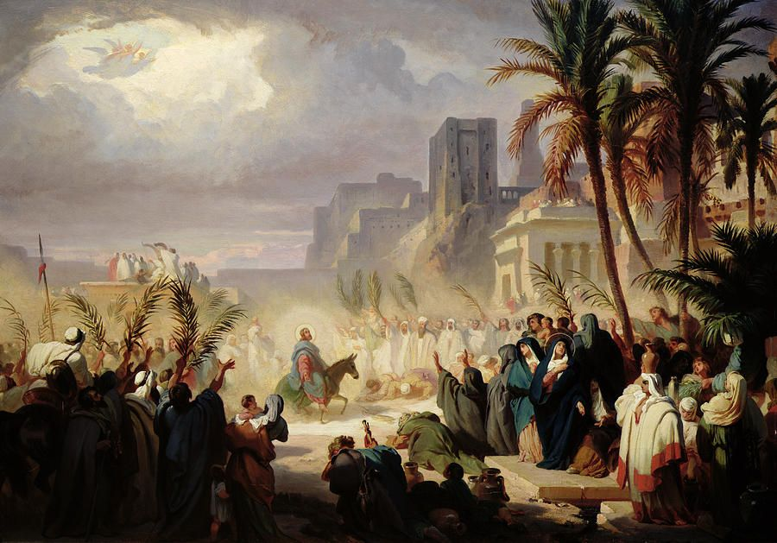

Christ Lutheran Church
The Feast of Palm Sunday
+ April 12, 2020 +

The service of Passion Sunday, beginning with the procession with palms, reflects the contrasting attitudes toward Jesus that were on display during the days leading up to His crucifixion. “Palm Sunday” is named after the palms which were spread before Jesus as He entered Jerusalem. The acclamation of the people, “Hosanna to the Son of David; Blessed is he who comes in the name of the Lord,” clearly reveals that they hailed Jesus as the messianic king. Yet only days later, our Lord would hear the cry “Crucify!” This contrast is reflected on this day as the joy of His triumphal entry into Jerusalem gives way to the somber remembrance of His passion. The extended reading from the Passion narrative sets before the people of God all that our Lord did on our behalf. Thus is the Church prepared to enter Holy Week – the most important week of the church year.

Divine Service III

Announcements

Greeting
P The grace of our Lord T Jesus Christ, the love of God and the communion of the Holy Spirit be with you all.
C Amen.
P Blessed is He who comes in the name of the Lord.
C Hosanna to the Son of David.

Collect
P Let us pray.
Most merciful God, as the people of Jerusalem, with palms in their hands, gathered to greet Your dearly beloved Son when He came into His Holy City, grant that we may ever hail Him as our King and, when He comes again, may go forth to meet Him with trusting and steadfast hearts, and follow Him in the way that leads to eternal life; through the same Jesus Christ, our Lord, who lives and reigns with You and the Holy Spirit, one God, now and forever.
C Amen.
Holy Gospel John 12:12-19
P The Holy Gospel T according to St. John, the twelfth chapter.
C Glory to You, O Lord.
The next day the great crowd that had come for the Feast heard that Jesus was on his way to Jerusalem. They took palm branches and went out to meet him, shouting,
"Hosanna!"
"Blessed is he who comes in the name of the Lord!"
"Blessed is the King of Israel!"
Jesus found a young donkey and sat upon it, as it is written,
"Do not be afraid, O Daughter of Zion;
see, your king is coming,
seated on a donkey's colt."
At first his disciples did not understand all this. Only after Jesus was glorified did they realize that these things had been written about him and that they had done these things to him. Now the crowd that was with him when he called Lazarus from the tomb and raised him from the dead continued to spread the word. Many people, because they had heard that he had given this miraculous sign, went out to meet him. So the Pharisees said to one another, "See, this is getting us nowhere. Look how the whole world has gone after him!"
P This is the Gospel of the Lord.
C Praise to You, O Christ.
P Let us go forth in peace,
C In the name of the Lord.

Processional Anthem All Glory, Laud, and Honor #442
Refrain: All glory, laud, and honor to You, Redeemer, King,
To whom the lips of children made sweet hosannas ring.
1. You are the King of Israel and David’s royal Son,
Now in the Lord’s name coming, our King and Blessèd One. Refrain
2. The company of angels are praising You on high,
Creation and all mortals in chorus make reply. Refrain
3. The multitude of pilgrims with palms before You went;
Our praise and prayer and anthems before You we present. Refrain
4. To You before Your passion they sang their hymns of praise;
To You, now high exalted, our melody we raise. Refrain
5. Their praises you accepted; Accept the prayers we bring,
Great author of all goodness, O good and gracious King. Refrain

P Blessed is He who comes in the name of the Lord.
C Hosanna in the highest.

The crucifix is veiled, highlighting the contrast between Jesus’ triumphal entry and His passion.

Confession & Absolution
A time of silence for reflection on God’s Word and self-examination is observed.

P Beloved in the Lord! Let us draw near with a true heart and confess our sins unto God our Father, beseeching Him in the name of our Lord Jesus Christ to grant us forgiveness.

P Our help is in the name of the Lord,
C who made heaven and earth.
P I said, I will confess my transgressions unto the Lord,
C and You forgave the iniquity of my sin.
Silence for reflection on God's Word and for self-examination.

P O almighty God, merciful Father,
C I, a poor, miserable sinner, confess unto You all my sins and iniquities with which I have ever offended You and justly deserved Your temporal and eternal punishment. But I am heartily sorry for them and sincerely repent of them, and I pray You of Your boundless mercy and for the sake of the holy, innocent, bitter sufferings and death of Your beloved Son, Jesus Christ, to be gracious and merciful to me, a poor, sinful being.

P Upon this your confession, I, by virtue of my office, as a called and ordained servant of the Word, announce the grace of God unto all of you, and in the stead and by the command of my Lord Jesus Christ I forgive you all your sins in the name of the Father and of the T Son and of the Holy Spirit.
C Amen.

Service of the Word
Introit: Domini est terra Psalm 24:7-10; Ant. Psalm 118:26
Blessèd is he who comes in the name | of the Lord!*
We bless you from the house | of the Lord.
Lift up your heads, O gates! And be lifted up, O | ancient doors,*
that the King of glory | may come in.
Who is this King of | glory?*
The Lord, strong and mighty, the Lord, mighty in | battle!
Lift up your heads, O gates! And lift them up, O | ancient doors,*
that the King of glory | may come in.
Who is this King of | glory?*
The Lord of hosts, he is the King of | glory!
Glory be to the Father and | to the Son*
and to the Holy | Spirit;
as it was in the be- | ginning,*
is now, and will be forever. | Amen.
Blessèd is he who comes in the name | of the Lord!*
We bless you from the house | of the Lord.
Kyrie Mark 10:47
The congregation is invited to sing in parts:

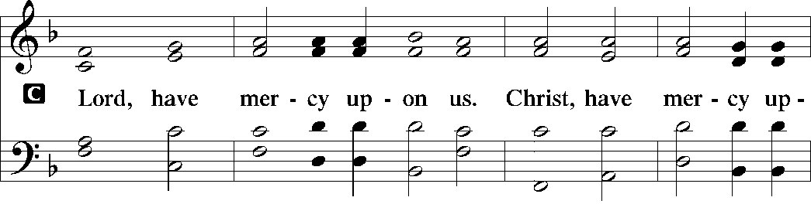
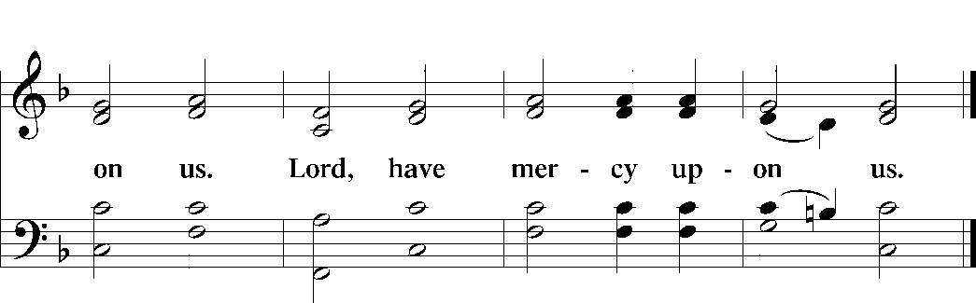

Salutation and Collect of the Day

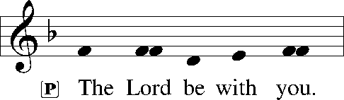
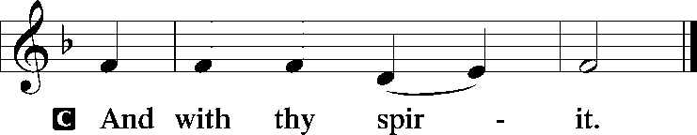

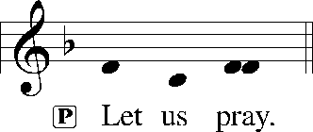

P Almighty and everlasting God, You sent Your Son, our Savior Jesus Christ, to take upon Himself our flesh and to suffer death upon the cross. Mercifully grant that we may follow the example of His great humility and patience and be made partakers of His resurrection; through the same Jesus Christ, our Lord, who lives and reigns with You and the Holy Spirit, one God, now and forever.

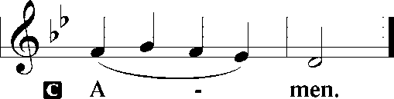

Please be seated

Old Testament Reading Isaiah 50:4-9a
The Lord God has given me
the tongue of those who are taught,
that I may know how to sustain with a word
him who is weary.
Morning by morning he awakens;
he awakens my ear
to hear as those who are taught.
The Lord God has opened my ear,
and I was not rebellious;
I turned not backward.
I gave my back to those who strike,
and my cheeks to those who pull out the beard;
I hid not my face
from disgrace and spitting.
But the Lord God helps me;
therefore I have not been disgraced;
therefore I have set my face like a flint,
and I know that I shall not be put to shame.
He who vindicates me is near.
Who will contend with me?
Let us stand up together.
Who is my adversary?
Let him come near to me.
Behold, the Lord God helps me;
who will declare me guilty?
Behold, all of them will wear out like a garment;
the moth will eat them up.
A This is the Word of the Lord.
C Thanks be to God.

Gradual Hebrews 9:12, 15; Psalm 111:9
[Christ] entered once for all into the holy places, by means of | his own blood,*
thus securing an eternal re- | demption.
Therefore he is the mediator of a new | covenant,*
so that those who are called may receive the promised eternal in- | heritance.
He sent redemption to his | people;*
he has commanded his covenant for- | ever.

Epistle Reading Philippians 2:5-11
Your attitude should be the same as that of Christ Jesus: Who, being in very nature God, did not consider equality with God something to be grasped, but made himself nothing, taking the very nature of a servant, being made in human likeness. And being found in appearance as a man, he humbled himself and became obedient to death—even death on a cross! Therefore God exalted him to the highest place and gave him the name that is above every name, that at the name of Jesus every knee should bow, in heaven and on earth and under the earth, and every tongue confess that Jesus Christ is Lord, to the glory of God the Father.
A This is the Word of the Lord.
C Thanks be to God.

Holy Gospel Matthew 27:11-66

P The Holy Gospel T according to St. Matthew, the twenty-seventh chapter.

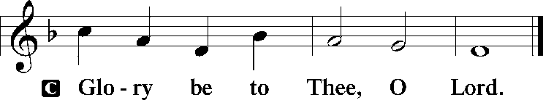
Now Jesus stood before the governor, and the governor asked him, “Are you the King of the Jews?” Jesus said, “You have said so.” But when he was accused by the chief priests and elders, he gave no answer. Then Pilate said to him, “Do you not hear how many things they testify against you?” But he gave him no answer, not even to a single charge, so that the governor was greatly amazed.
Now at the feast the governor was accustomed to release for the crowd any one prisoner whom they wanted. And they had then a notorious prisoner called Barabbas. So when they had gathered, Pilate said to them, “Whom do you want me to release for you: Barabbas, or Jesus who is called Christ?” For he knew that it was out of envy that they had delivered him up. Besides, while he was sitting on the judgment seat, his wife sent word to him, “Have nothing to do with that righteous man, for I have suffered much because of him today in a dream.” Now the chief priests and the elders persuaded the crowd to ask for Barabbas and destroy Jesus. The governor again said to them, “Which of the two do you want me to release for you?” And they said, “Barabbas.” Pilate said to them, “Then what shall I do with Jesus who is called Christ?” They all said, “Let him be crucified!” And he said, “Why, what evil has he done?” But they shouted all the more, “Let him be crucified!”
So when Pilate saw that he was gaining nothing, but rather that a riot was beginning, he took water and washed his hands before the crowd, saying, “I am innocent of this man’s blood; see to it yourselves.” And all the people answered, “His blood be on us and on our children!” Then he released for them Barabbas, and having scourged Jesus, delivered him to be crucified.
Then the soldiers of the governor took Jesus into the governor’s headquarters, and they gathered the whole battalion before him. And they stripped him and put a scarlet robe on him, and twisting together a crown of thorns, they put it on his head and put a reed in his right hand. And kneeling before him, they mocked him, saying, “Hail, King of the Jews!” And they spit on him and took the reed and struck him on the head. And when they had mocked him, they stripped him of the robe and put his own clothes on him and led him away to crucify him.
As they went out, they found a man of Cyrene, Simon by name. They compelled this man to carry his cross. And when they came to a place called Golgotha (which means Place of a Skull), they offered him wine to drink, mixed with gall, but when he tasted it, he would not drink it. And when they had crucified him, they divided his garments among them by casting lots. Then they sat down and kept watch over him there. And over his head they put the charge against him, which read, “This is Jesus, the King of the Jews.” Then two robbers were crucified with him, one on the right and one on the left. And those who passed by derided him, wagging their heads and saying, “You who would destroy the temple and rebuild it in three days, save yourself! If you are the Son of God, come down from the cross.” So also the chief priests, with the scribes and elders, mocked him, saying, “He saved others; he cannot save himself. He is the King of Israel; let him come down now from the cross, and we will believe in him. He trusts in God; let God deliver him now, if he desires him. For he said, ‘I am the Son of God.’” And the robbers who were crucified with him also reviled him in the same way.
Now from the sixth hour there was darkness over all the land until the ninth hour. And about the ninth hour Jesus cried out with a loud voice, saying, “Eli, Eli, lema sabachthani?” that is, “My God, my God, why have you forsaken me?” And some of the bystanders, hearing it, said, “This man is calling Elijah.” And one of them at once ran and took a sponge, filled it with sour wine, and put it on a reed and gave it to him to drink. But the others said, “Wait, let us see whether Elijah will come to save him.” And Jesus cried out again with a loud voice and yielded up his spirit.
And behold, the curtain of the temple was torn in two, from top to bottom. And the earth shook, and the rocks were split. The tombs also were opened. And many bodies of the saints who had fallen asleep were raised, and coming out of the tombs after his resurrection they went into the holy city and appeared to many. When the centurion and those who were with him, keeping watch over Jesus, saw the earthquake and what took place, they were filled with awe and said, “Truly this was the Son of God!”
There were also many women there, looking on from a distance, who had followed Jesus from Galilee, ministering to him, among whom were Mary Magdalene and Mary the mother of James and Joseph and the mother of the sons of Zebedee.
When it was evening, there came a rich man from Arimathea, named Joseph, who also was a disciple of Jesus. He went to Pilate and asked for the body of Jesus. Then Pilate ordered it to be given to him. And Joseph took the body and wrapped it in a clean linen shroud and laid it in his own new tomb, which he had cut in the rock. And he rolled a great stone to the entrance of the tomb and went away. Mary Magdalene and the other Mary were there, sitting opposite the tomb.
Next day, that is, after the day of Preparation, the chief priests and the Pharisees gathered before Pilate and said, “Sir, we remember how that impostor said, while he was still alive, ‘After three days I will rise.’ Therefore order the tomb to be made secure until the third day, lest his disciples go and steal him away and tell the people, ‘He has risen from the dead,’ and the last fraud will be worse than the first.” Pilate said to them, “You have a guard of soldiers. Go, make it as secure as you can.” So they went and made the tomb secure by sealing the stone and setting a guard.
P This is the Gospel of the Lord.
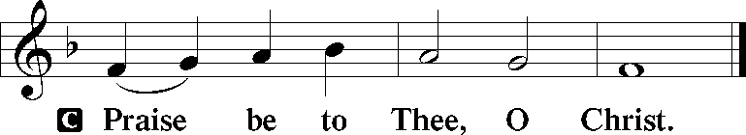

Hymn of the Day Not All the Blood of Beasts #431
Sermon Let His Blood Be on Us

Please stand

Nicene Creed
C | I believe in one God, (Rom 10:10; Deut 6:4)  the Father Almighty, (Mt 6:9; Ex 6:3)  maker of heaven and earth (Gen 1:1; Jn 1:1)  and of all things visible and invisible. (Col 1:16)  And in one Lord Jesus Christ, (Rom 10:9)  the only-begotten Son of God, (Jn 3:16; Mt 16:16)  begotten of His Father before all worlds, (Jn 1:2)  God of God, Light of Light, (Jn 17:22; Jn 8:12; Jn 1:1)  very God of very God, (Col 2:9)  begotten, not made, (Jn 1:2)  being of one substance with the Father, (Jn 10:30)  by whom all things were made; (Heb 1:2; Jn 1:3)  who for us men and for our salvation (1 Tim 2:4; Rom 3:23)  came down from heaven (Jn 6:41; Lk 15:20)  and was incarnate by the Holy Spirit of the virgin Mary (Lk 1:34-35)  and was made man; (Jn 1:14)  and was crucified also for us under Pontius Pilate. (Mk 15:25; Jn 19:16-18)  He suffered and was buried. (Jn 19:1-3; Lk 23:53)  And the third day He rose again according to the Scriptures (1 Cor 15:4; Lk 24:6)  and ascended into heaven (Acts 1:9)  and sits at the right hand of the Father. (Acts 7:55)  And He will come again with glory (Mt 26:64)  to judge both the living and the dead, (Acts 10:42; Mt 3:12)  whose kingdom will have no end. (2 Pt 1:11)  And I believe in the Holy Spirit, (Jn 14:26; Gen 1:2; Acts 2:38)  the Lord and giver of life, (Gen 1:2; Jn 3:6)  who proceeds from the Father and the Son, (Jn 15:26)  who with the Father and the Son together is worshiped and glorified, (Mt 3:16-17)  who spoke by the prophets. (Eze 11:5)  And I believe in one holy Christian and apostolic Church, (1 Pt 2:5; Eph 2:19-22)  I acknowledge one Baptism for the remission of sins, (Eph 4:5)  and I look for the resurrection of the dead (1 Cor 15:35-49; 1 Thess 4:13-18)  and the life T of the world to come. (Mk 10:29-30; Mt 10:40-42)  Amen. (Ps 106:48)
Us men means all people.
Christian: the ancient text reads “catholic,” meaning the whole Church as it confesses the wholeness of Christian doctrine.

Prayer of the Church
After each petition of the prayer:
Pastor: Let us pray to the Lord.
People: Lord, have mercy.
For comfort, health and recovery: Mary Cornelius, Bill Gassett, Terry Gassett, Dan Hansen, Marilyn Unger;
For those who mourn: The family and friends of Alex Kettler;
For those who are ill or distressed: Stan Acey, Jenalee Adams, Kimberly Airhart, Layne Bagley, Rose Bagley, Shirley Bagley, W.L. Bagley, Sarah Bowman, Mimi Bradley, Richard Bradley, Deloris Brent, Martha Brown, Nathan Brown, Tina Burke, Wayne Burke, Paula Burkhalter, Amie Caroll, Bobby Carroll, Arthur Collins, James E. Cookston, Joan Cowards, Belinda Cowards-Gonzales, Mike Ellis, Robert (Andy) Evers, Michele Rae Fowler, Randy Fowler, Parker Haines, Dan Hansen, Paul Hansen, Tim Hansen, Valerie Henderson, Sharon Holleman, Hugh Hunt, Beth Jarratt, Jimmy Jarratt, Elaine Johnson, Joslyn Jones, Arlene Kleinschmidt, Eleanor Koster, John Koster, Sandra Landers, Katelyn Lawing, Peggy Lucky, Paul McCullough, Jerry McIntyre, Jerry McMahan, Edlia Miller, Mark Miller, Elaine Monaghan, Lindberg Moore, Jerry Mutter, Don Ochs, Mildred Odom, Janea Parker, Deborah-Annette Ried, Elmira Roever, Jon Sandberg, Noah Schultz, Johnnie Pearl Smiley, Bob Smith, Sally Smith, Sherri Smith, Deborah Springer, MariLyn Unger, Betty Venator, Leonard Watson, Dana Weaver, Cynthia Widlitze, Carol Wright, Jimmy Wright, Marshall Wright, Barbara Zeigler;
For college and graduate students: Jake Everly, Sara Fields, Keith Martin, Claudia Nelson, Roselynn Nelson, Katie Rudsenske;
For military servants and their families: Gabriel Escude, James (Glen) Hansford, Holden Hathcock, Christopher Martin, William Nelson, Steven Tatum, John Weidner Jr.;
For foreign missionaries: David and Shelee Warner;
This week’s prayer family: Allen & Sabrina Goodlett and their loved ones.
Please be seated

Offering

Offertory Psalm 51:10-12
The congregation is invited to sing in parts:
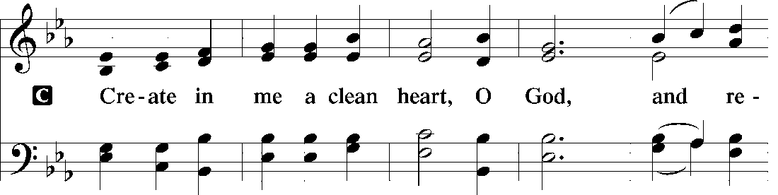
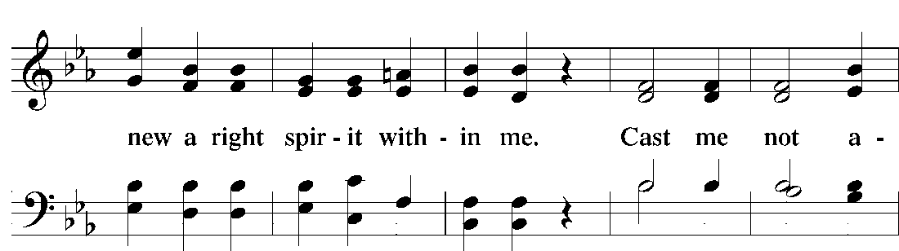
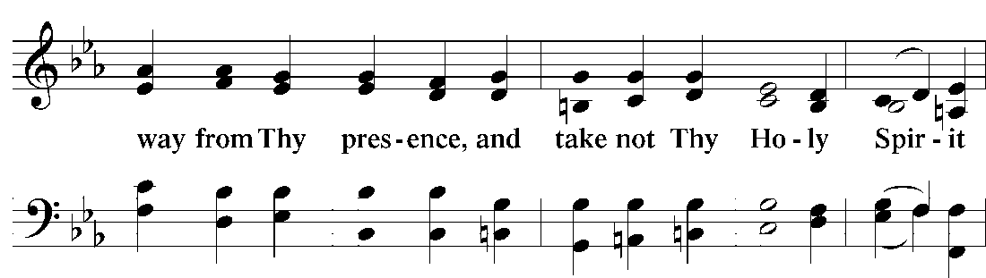
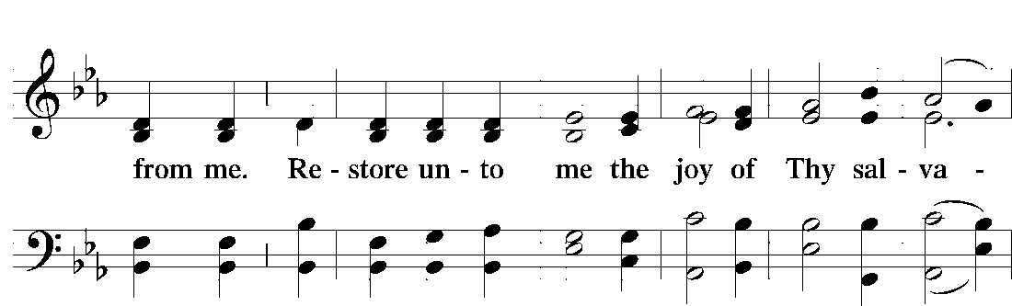
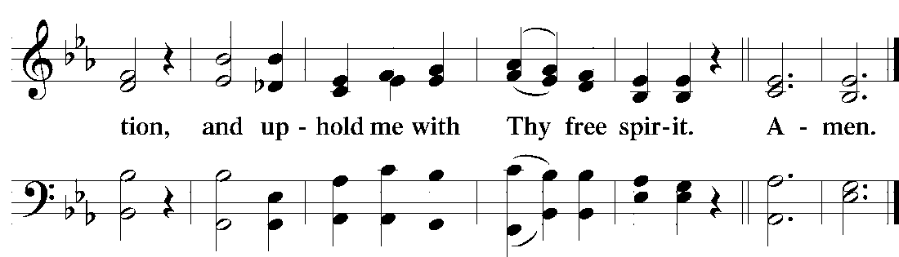

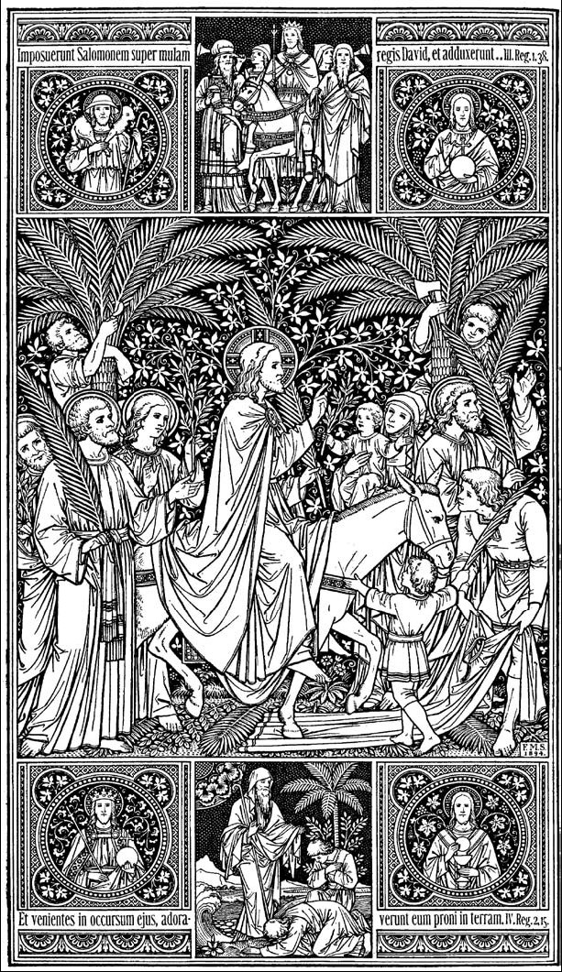

Service of the Sacrament
Preface 2 Timothy 4:22; [Colossians 3:1]; [Psalm 136]
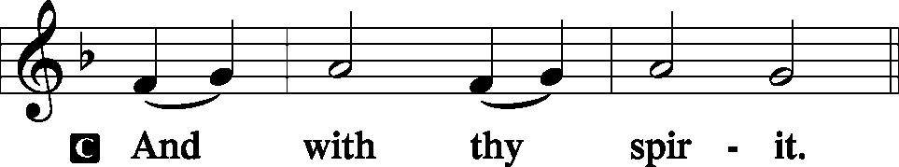
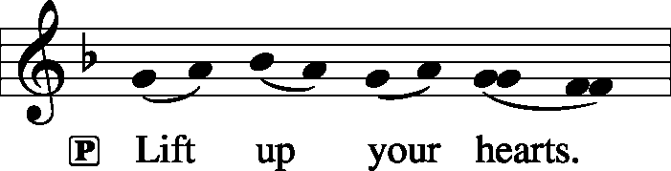

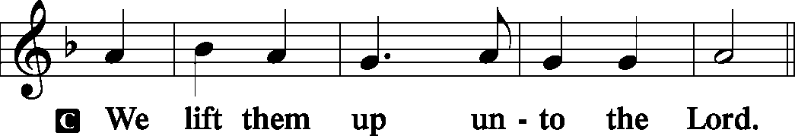
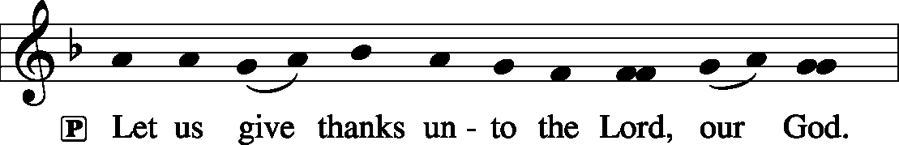
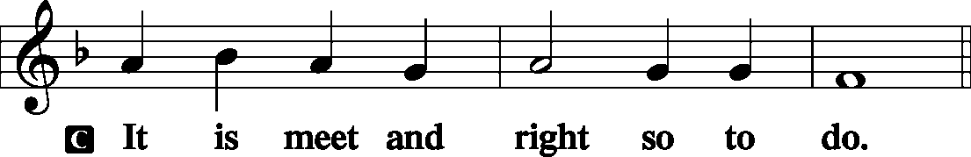

P It is truly meet, right, and salutary that we should at all times and in all places give thanks to You, holy Lord, almighty Father, everlasting God, through Jesus Christ, our Lord, who accomplished the salvation of mankind by the tree of the cross that, where death arose, there life also might rise again and that the serpent who overcame by the tree of the garden might likewise by the tree of the cross be overcome. Therefore with angels and archangels and with all the company of heaven we laud and magnify Your glorious name, evermore praising You and saying:

Sanctus Isaiah 6:3; Matthew 21:9
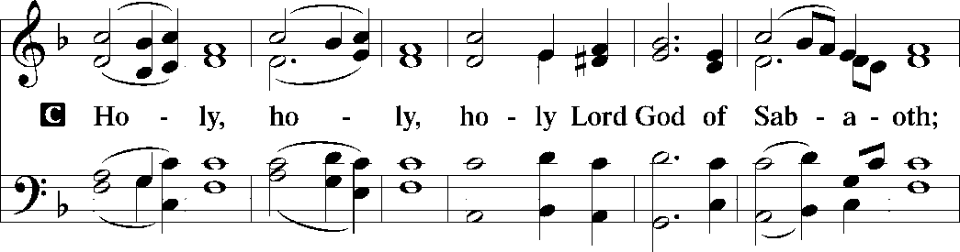
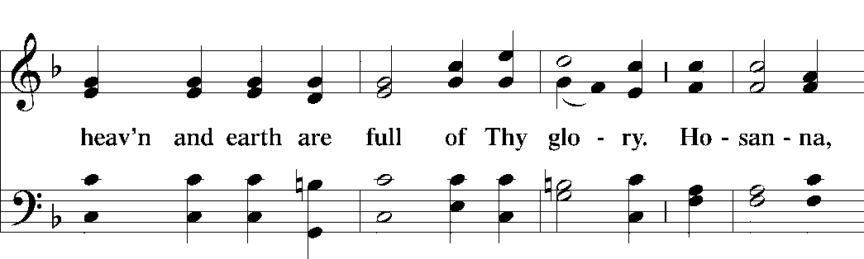
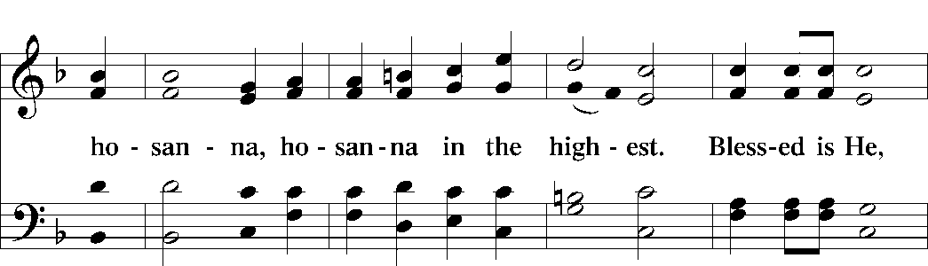
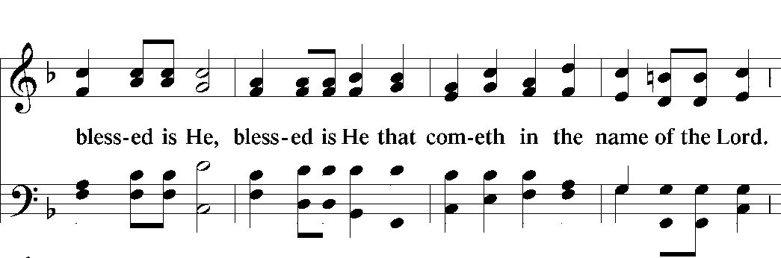
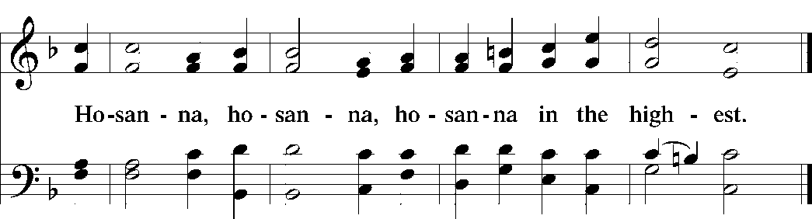

Lord’s Prayer Matthew 6:9-13
P Our Father who art in heaven, hallowed be Thy name,
Thy kingdom come, Thy will be done on earth
as it is in heaven;
give us this day our daily bread;
and forgive us our trespasses as we forgive those
who trespass against us;
and lead us not into temptation, but deliver T us from evil.
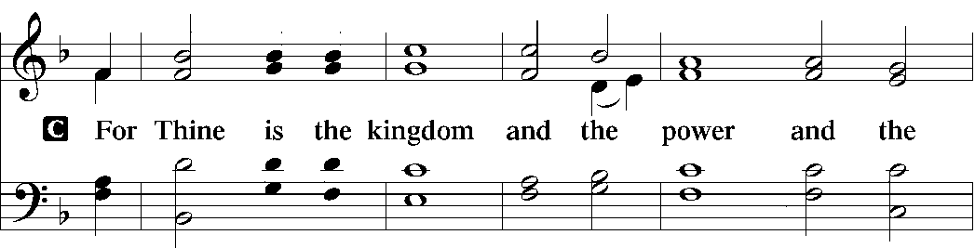
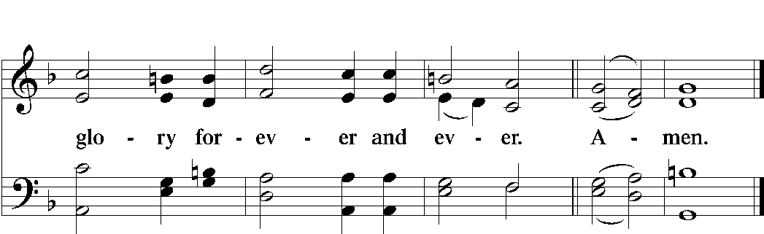

The Words of Our Lord Matt. 26:26-28, Mark 14:22-24; Luke 22:19-20; 1 Cor. 11:23-25
P Our Lord Jesus Christ, on the night when He was betrayed, took bread, and when He had given thanks, He broke it and gave it to the disciples and said: “Take, eat; this is My T body, which is given for you. This do in remembrance of Me.”
In the same way also He took the cup after supper, and when He had given thanks, He gave it to them, saying: “Drink of it, all of you; this cup is the new testament in My T blood, which is shed for you for the forgiveness of sins. This do, as often as you drink it, in remembrance of Me.”

Pax Domini John 20:19
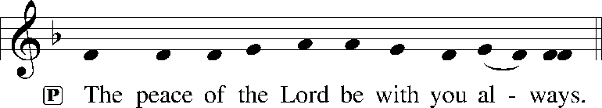

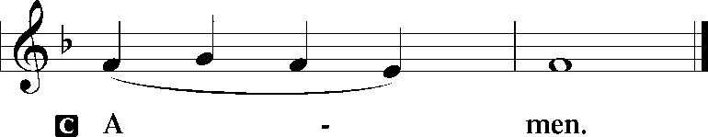

Agnus Dei John 1:29
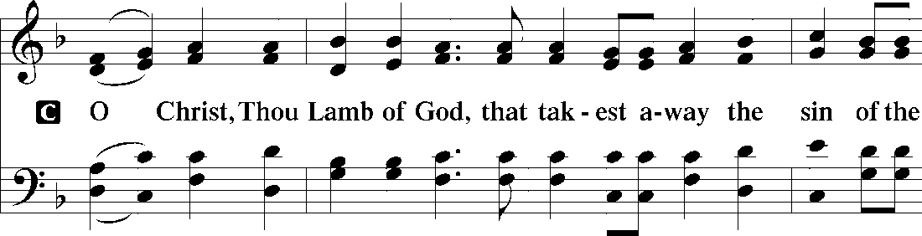
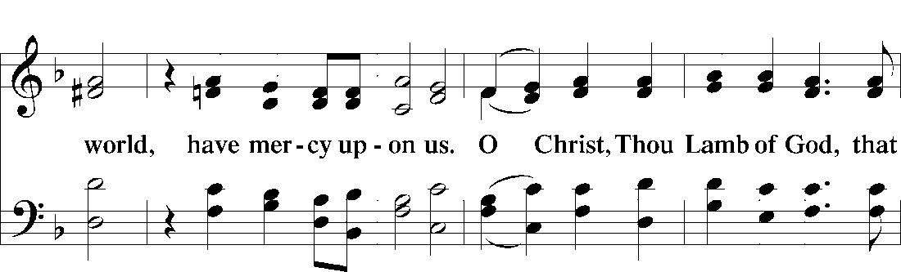
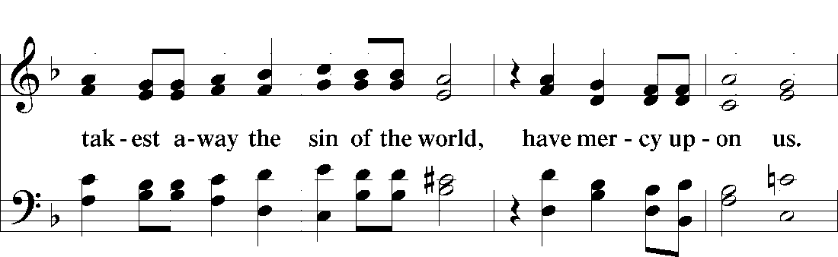
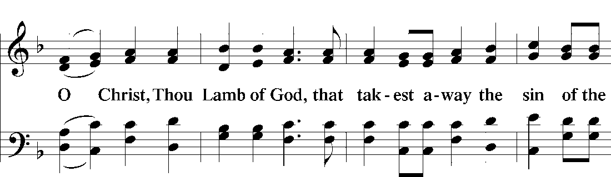
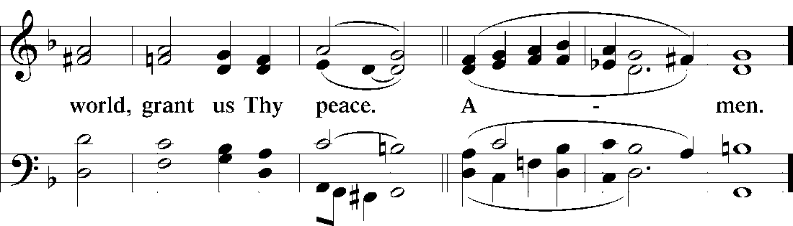

Please be seated

Distribution of the Sacrament
All who are members in good standing of the Lutheran Church - Missouri Synod and have introduced themselves to one of the pastors are welcome to partake of the Holy Communion at Christ Lutheran. If you have not spoken to a pastor, but would like to receive the Lord's blessing, you may still come to the rail and kneel, crossing one arm over the other in the shape of an 'X'. This symbolizes that one is marked by the cross and Triune name of Almighty God.

Distribution Hymns
Jesus, Thy Blood and Righteousness #563

When all have received the Holy Supper, we stand to sing:

Nunc Dimittis Luke 2:29-32
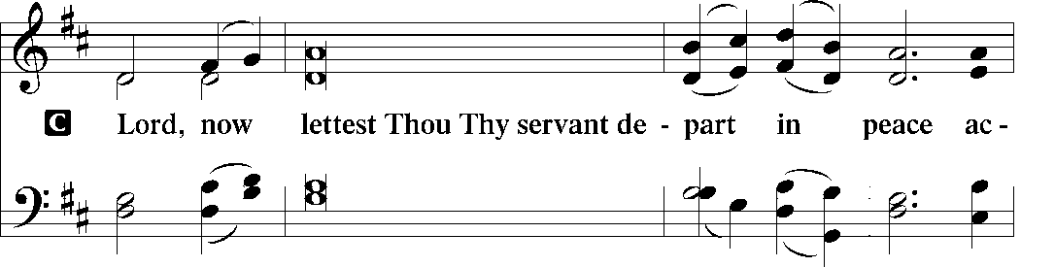
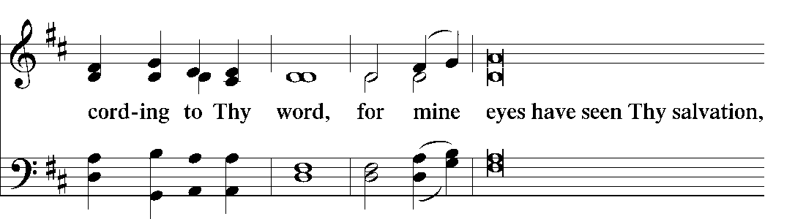
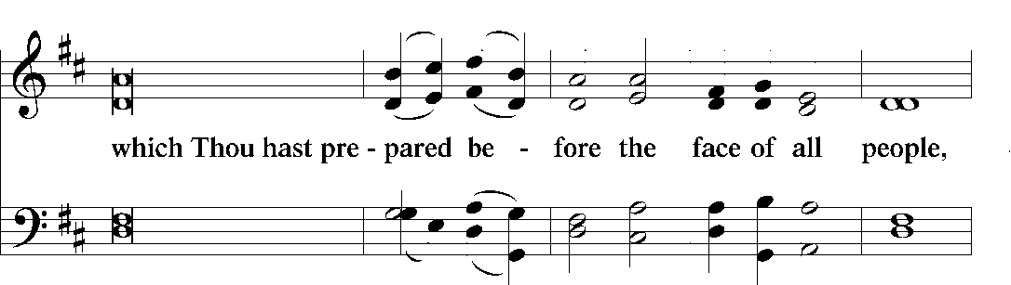
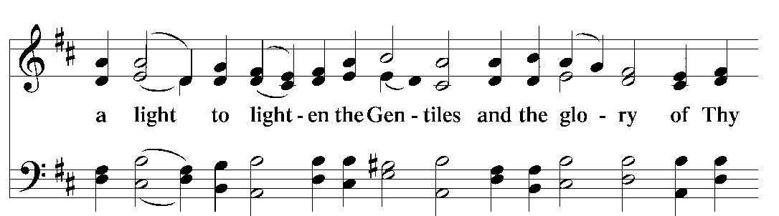
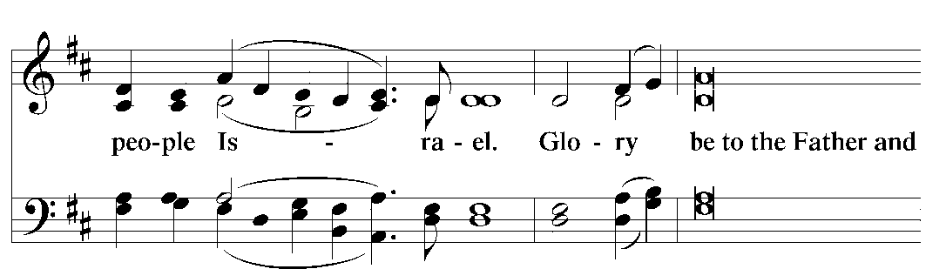
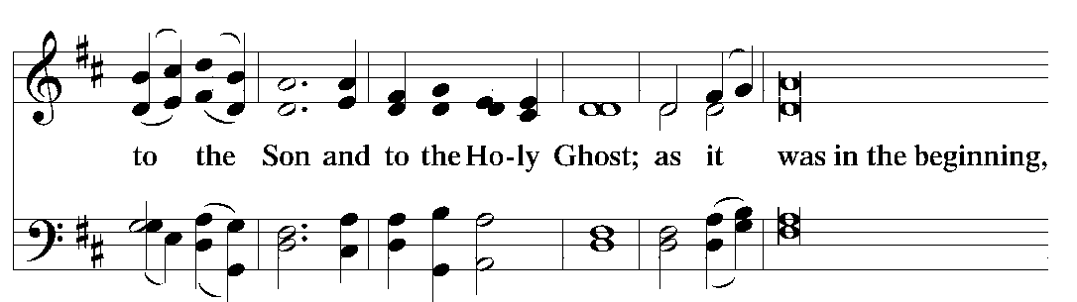
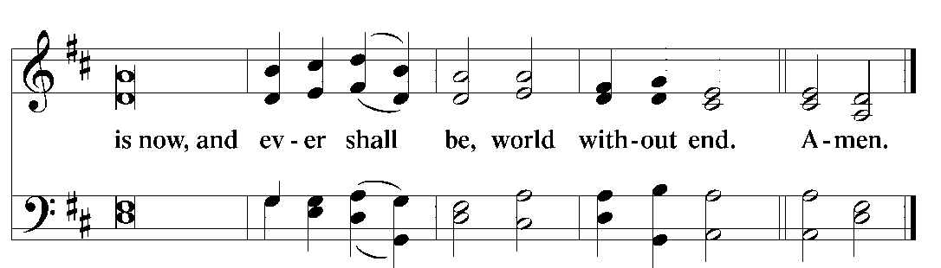

Thanksgiving
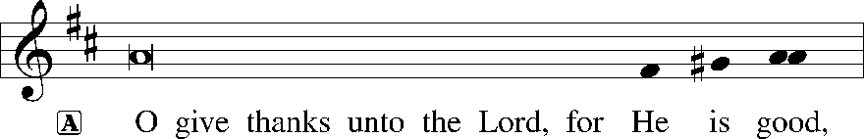

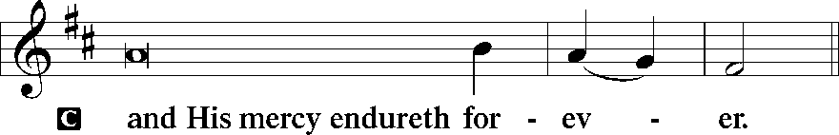

Post-Communion Collect
P Let us pray.
O God the Father, the fountain and source of all goodness, who in loving-kindness sent Your only-begotten Son into the flesh, we thank You that for His sake You have given us pardon and peace in this Sacrament, and we ask You not to forsake Your children but always to rule our hearts and minds by Your Holy Spirit that we may be enabled constantly to serve You; through Jesus Christ, Your Son, our Lord, who lives and reigns with You and the Holy Spirit, one God, now and forever.
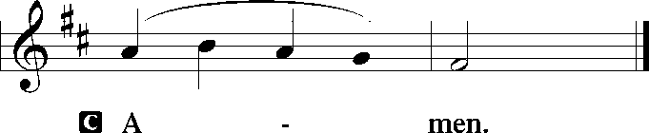

Salutation
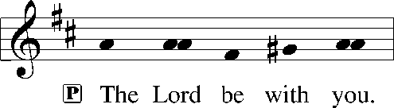

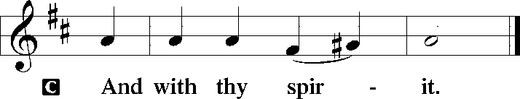

Benedicamus
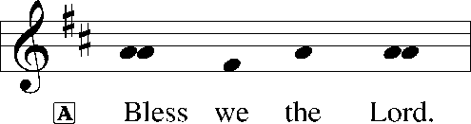

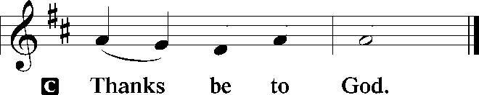

Benediction
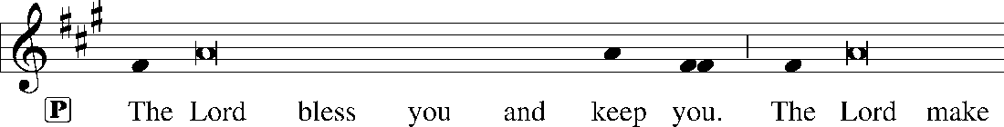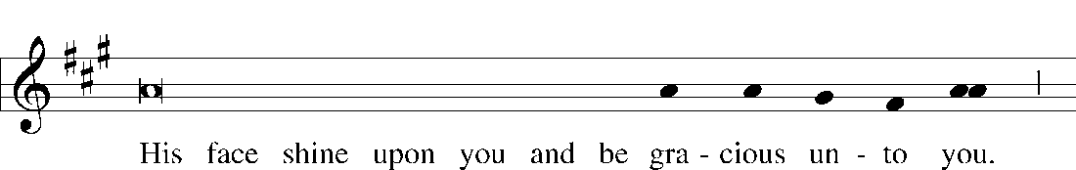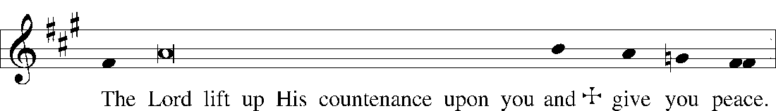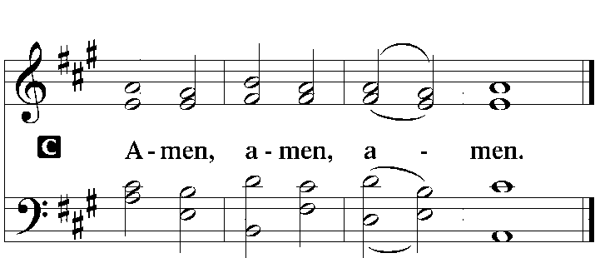

Closing Hymn O Sacred Head, Now Wounded #450

Acknowledgments
Divine Service, Setting Three from Lutheran Service Book © 2006 Concordia Publishing House. Reprinted with permission. Unless otherwise indicated, all scripture quotations are from The Holy Bible, English Standard Version, copyright © 2001 by Crossway Bibles, a division of Good News Publishers. Used by permission. All rights reserved. Created by Lutheran Service Builder © 2006 Concordia Publishing House.

Serving Today:
Celebrant: Rev. George Fields Cantor: Rachel Landrum
Interpreter: Greg Goldman Organist: Sr. Sara Fields

Holy Week Services: Today commences Holy Week, wherein we trace the steps of our Lord during His Passion. See below for service times.
Friday 3:00 p.m. Chief Service of Good Friday
Sunday 10:30 a.m. Easter Sunday Divine Service

Passion Week Pictures: Quarantine might keep us home, but we can still celebrate together! Take photos of how you are celebrating Holy Week and post them to the Christ Lutheran Facebook page (and/or email them to Sister Sara to be included in the May newsletter!). We can’t wait to see you!

No Offering Plate? No problem! You can send your tithe by check directly to church (4423 I-55 North, Jackson, MS 39206), or you can visit the church website at ChristLutheranJacksonMS.org and click the “Give” button at the top of the page. Thank you for your continued faithfulness!

Life at Christ… while You’re at Home: Don’t let quarantine keep you down! The good Lord continues to give you His gracious gifts. Join us, even from afar:
- Find bulletins and audio recordings of CLC’s worship services in your email inbox (contact Sister Sara if you have not received them). They will be sent in time for you to participate at our normal service hours, that we may “not give up meeting together” (Hebrews 10:25).
- Find video of our worship services streamed on the Christ Lutheran Facebook page.
- Follow Christ Lutheran on Facebook for daily encouragement and updates.
- Check the church blog (ChristLutheranJacksonMS.org/LifeAtChrist/) for articles and meditations from your pastors.
- Contact us – by phone, email, Facebook, or carrier pigeon – with concerns, prayer requests, questions, and thoughts. We are here for you!
Even and especially in times of crisis, God is with His people – you don’t have to go it alone. Join together with your family here at Christ Lutheran, wherever you may be, as we await the celebration of our Lord’s victory over the grave!

Readings for next Sunday, April 19th, The Feast of the Resurrection of Our Lord:
Introit Ex. 15:1-2a, 6, 13, 17-18; Psalm 16; Acts 10:34-43; Colossians 3:1-4; Matthew 28:1-10.

This week at Christ Lutheran Church: April 12−April 19

Friday 3:00 p.m. Chief Service of Good Friday
Sunday 10:30 a.m. Easter Sunday — Divine Service

YOUR LIFELINE TO THE LUTHERAN WORLDVIEW…You can listen to in-depth teachings on interesting subjects like:
Apparent Contradictions in the Bible on the Resurrection, The Easter Hymn “O Sons and Daughters of the King,” Bad Easter Sermons, Answering Arguments against Christ’s Bodily Resurrection and more…
Issues, Etc. is a radio talk show produced by Lutheran Public Radio and hosted by LCMS Pastor Todd Wilken. You can listen to what you want when you want at www.issuesetc.org. Simply click on “Listen”, choose “On Demand”, then select from the vast array of speakers and topics available in the archives.

Matt. 21:3 – “If anyone says anything to you, you shall say, ‘The Lord needs them,’ and he will send them at once.”
Did Jesus really need the donkey? If the man had refused to give the donkey, would the work of salvation have been derailed? Of course not. But what an honor for the man who owned this donkey and foal! Likewise, the Lord needs none of us, but what an honor for God to choose to use our generosity in the work of His Church.

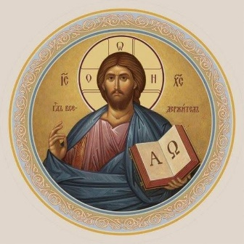

Rev. Dr. James R. Holowach, Pastor
Rev. George N. Fields, Pastor
Sr. Sara E. Fields, Deaconess
Divine Service Each Week with Holy Communion: 10:30 a.m.
Sunday School for all ages: 9:00 a.m.
4423 I-55 North, Jackson, MS 39206-6102
(601) 366-2055
www.christlutheranjacksonms.org

