Christ Lutheran Church

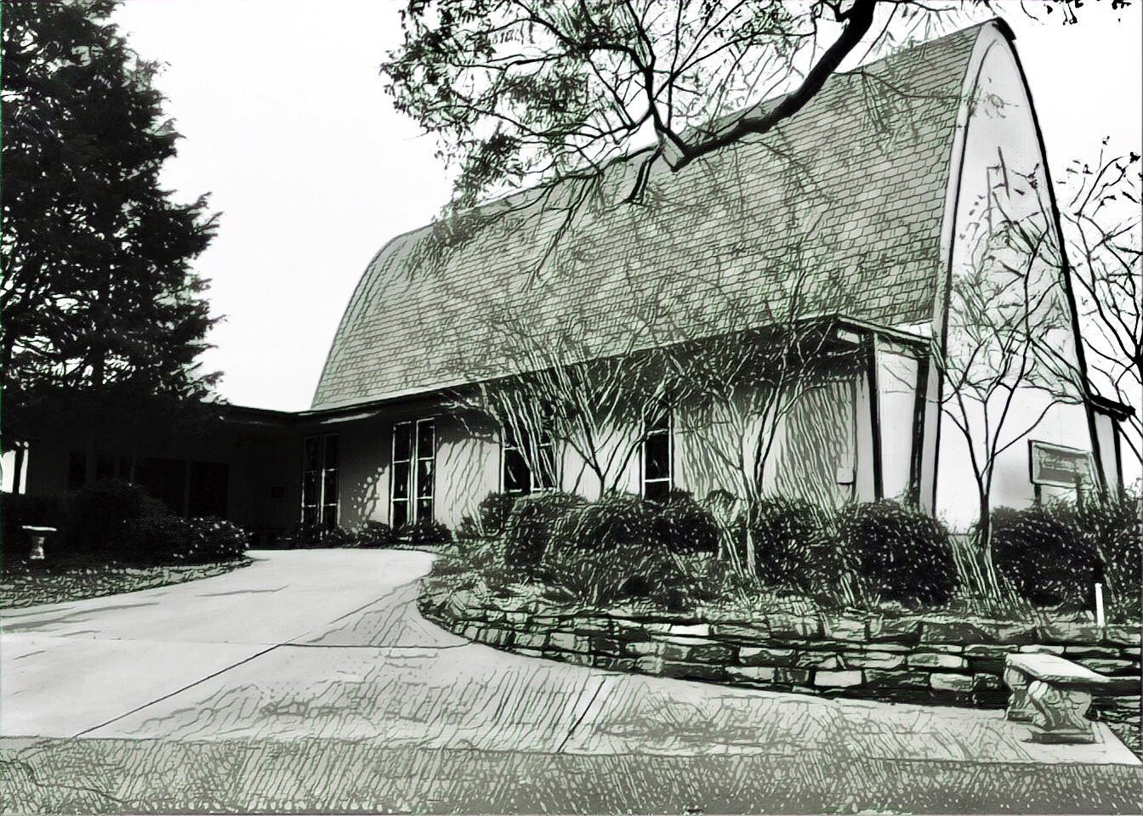

Rev. Dr. James R. Holowach, Pastor
Rev. George N. Fields, Pastor
Sr. Sara E. Fields, Deaconess
Divine Service Each Week with Holy Communion: 10:30 a.m.
Sunday School for all ages: 9:00 a.m.
4423 I-55 North, Jackson, MS 39206-6102 – (601) 366-2055
www.christlutheranjacksonms.org
The Third Sunday of Easter
+ April 26, 2020 +

“O Foolish Ones”



We welcome our members and guests to Christ Lutheran today,
and pray God’s richest blessings upon you during this time of worship!

All members and our guests are asked to complete the
worship attendance pads which can be found on each pew.
Guests are also asked to sign the guest register found in the Narthex.
We are so glad to have you worshiping with us today!

LARGE PRINT worship folders are available
at the usher stand at the back of the nave.

WELCOME:
“At the radiance of his birth therefore a radiant star appeared, and at his dark death there appeared a dark gloom. The Lord of the star appeared in his own person to the two who were traveling with him along the road, but his identity was hidden from them. His star too was like this, for its light appeared to all humanity while its pathway was hidden from humanity.”
–St. Ephrem the Syrian, Commentary on Tatian’s Diatessaron
The Lord’s Supper

In preparation for reception of the Lord’s Supper (Holy Communion), it is important that we review and understand what the Bible teaches regarding this sacrament:
The Bible teaches that Jesus gives us His very body and blood along with bread and wine in Holy Communion, and that these are means by which He forgives our sins, and strengthens us for daily living, and draws us into closer fellowship with Him and other believers. The Bible also teaches us to examine ourselves prior to receiving the meal. For those receiving Holy Communion, examine yourself with these questions:
Do I believe that I am a sinner and I am sorry for my sins?
Do I believe that Jesus Christ is God’s Son and my personal Savior?
Do I believe that Christ’s true body and blood are present in this holy meal for my forgiveness?
Do I truly intend with the help of God to correct my sinful life?
According to Christ’s Word in the Holy Scriptures, and in confession with the true Christian faith, at Christ Lutheran we observe the practice of closed communion. We believe that all who commune must confess the same holy faith, as Holy Scripture teaches. Since one’s church affiliation indicates an individual’s confession of faith, we ask that only those who have been instructed in the above teaching and are confirmed members of The Lutheran Church – Missouri Synod commune. If you have not been instructed in this teaching on Holy Communion, are in doubt, or hold a different confession of faith, you are still welcome to come forward and cross your arms to indicate that you would like a blessing.

Divine Service II

Preservice Music

Opening Hymn This Joyful Eastertide #482

Confession & Absolution
The sign of the cross may be made by all in remembrance of your Baptism.

P In the name of the Father and of the T Son and of the Holy Spirit.
C Amen.

P If we say we have no sin, we deceive ourselves, and the truth is not in us.
C But if we confess our sins, God, who is faithful and just, will forgive our sins and cleanse us from all unrighteousness.

Silence for reflection on God's Word and for self-examination.

P Let us then confess our sins to God our Father.
C Most merciful God, we confess that we are by nature sinful and unclean. We have sinned against You in thought, word, and deed, by what we have done and by what we have left undone. We have not loved You with our whole heart; we have not loved our neighbors as ourselves. We justly deserve Your present and eternal punishment. For the sake of Your Son, Jesus Christ, have mercy on us. Forgive us, renew us, and lead us, so that we may delight in Your will and walk in Your ways to the glory of Your holy name. Amen.

P Almighty God in His mercy has given His Son to die for you and for His sake forgives you all your sins. As a called and ordained servant of Christ, and by His authority, I therefore forgive you all your sins in the name of the Father and of the T Son and of the Holy Spirit.
C Amen.

Service of the Word

Introit: Ecce quam bonum Psalm 133; Ant. Psalm 133:1

Behold, how good and pleas- | ant it is*
when brothers dwell in | unity!
It is like the precious oil on the head, running down on the beard, on the beard of | Aaron,*
running down on the collar | of his robes!
It is like the dew of Hermon, which falls on the mountains of | Zion!*
For there the Lord has commanded the blessing, life for- | evermore.
Glory be to the Father and | to the Son*
and to the Holy | Spirit;
as it was in the be- | ginning,*
is now, and will be forever. | Amen.
Behold, how good and pleas- | ant it is*
when brothers dwell in | unity!

Kyrie Mark 10:47



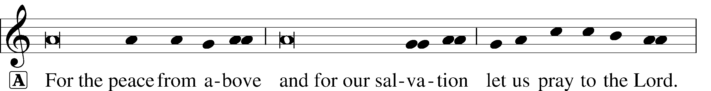
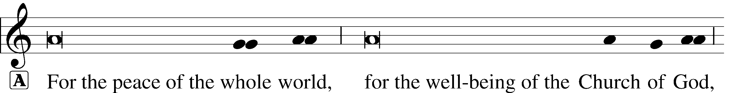
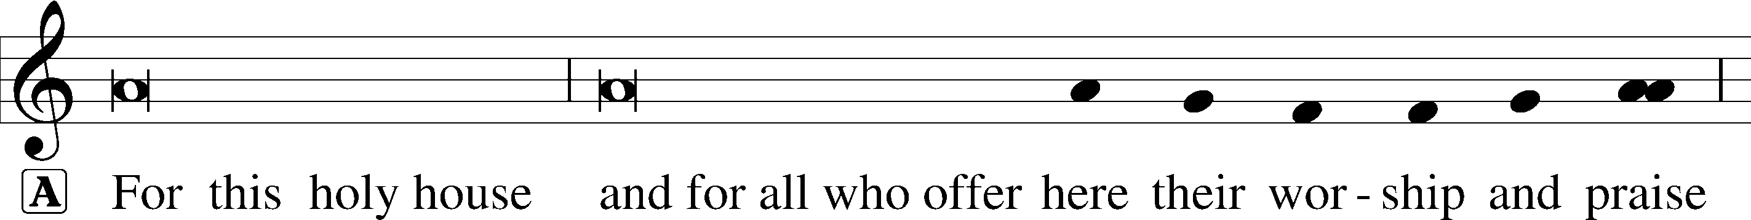


Dignus Est
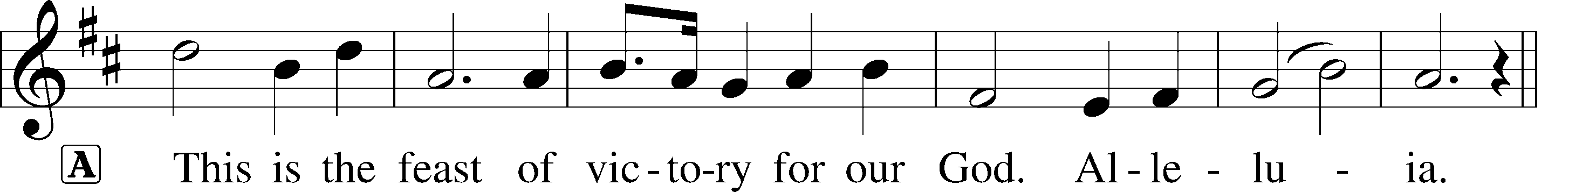
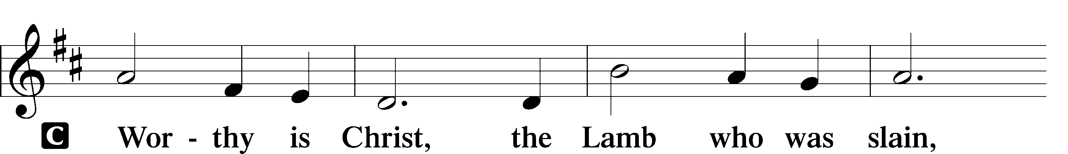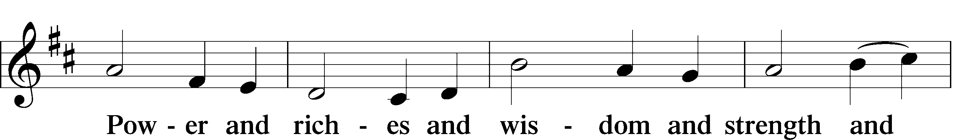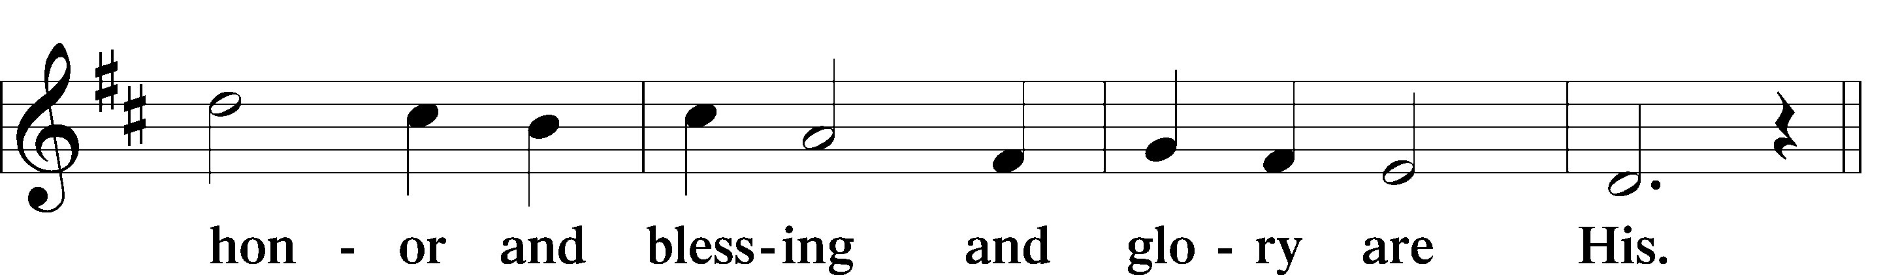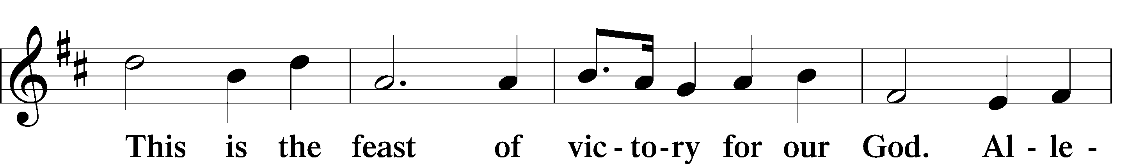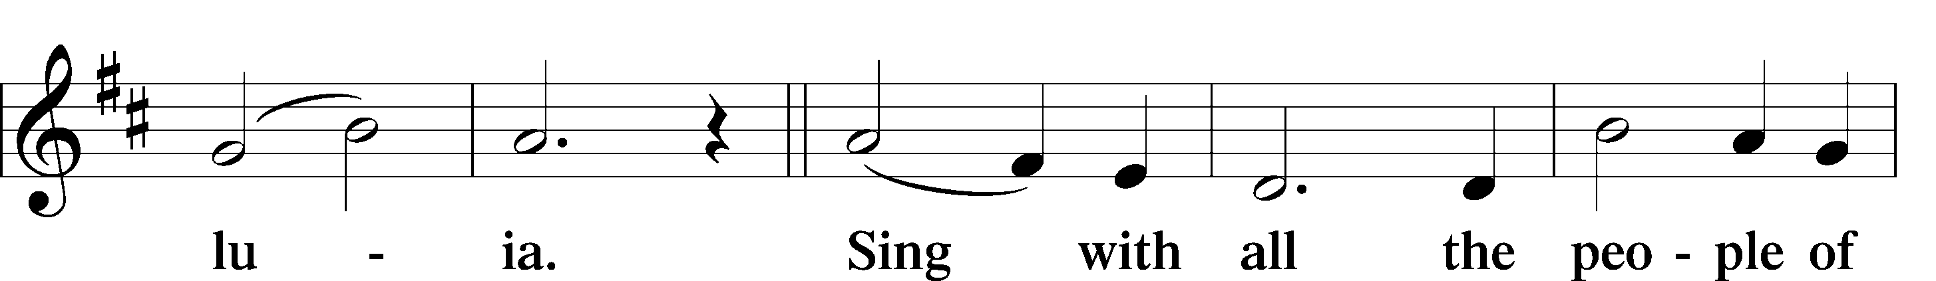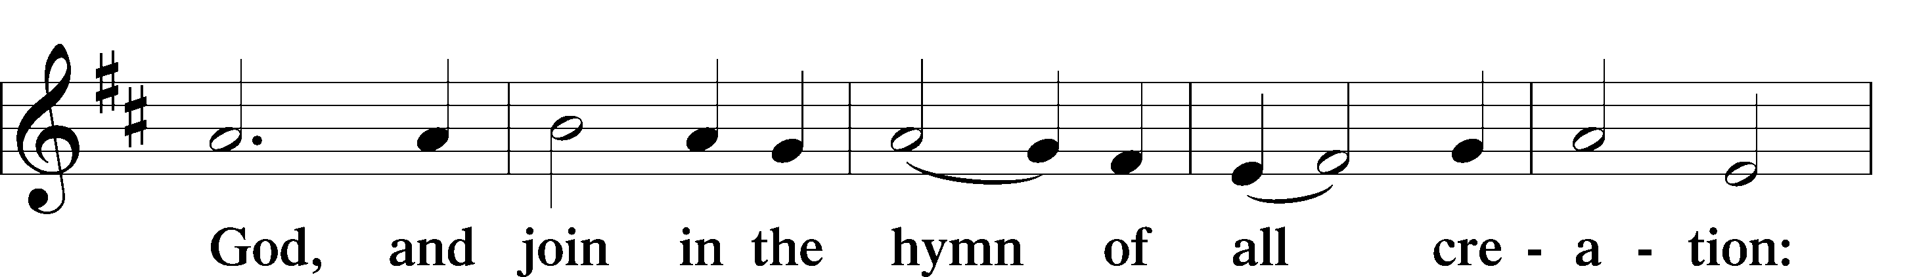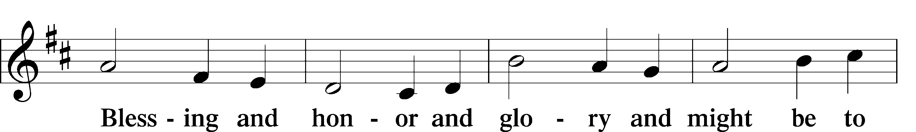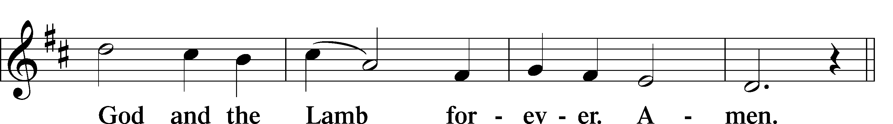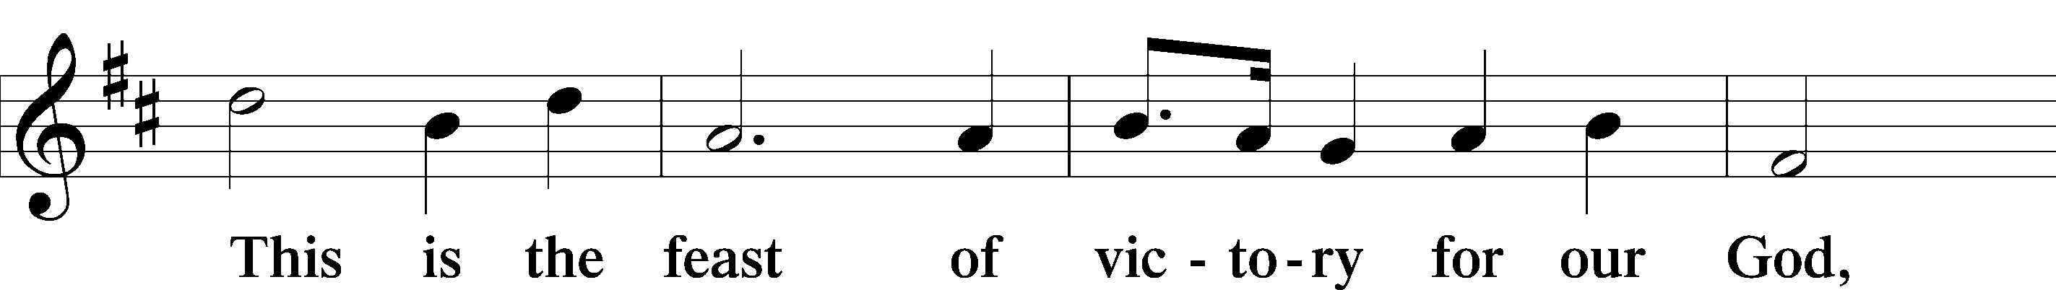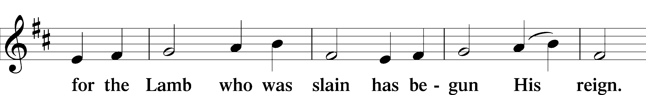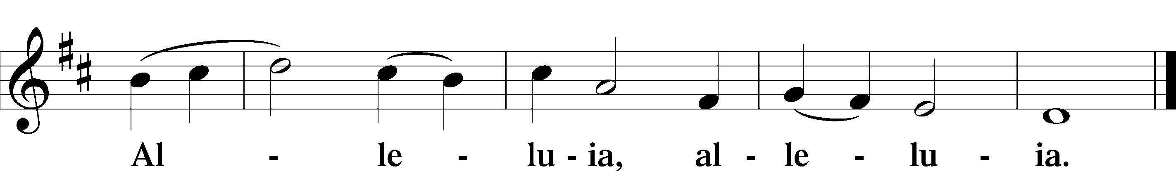

Salutation and Collect of the Day

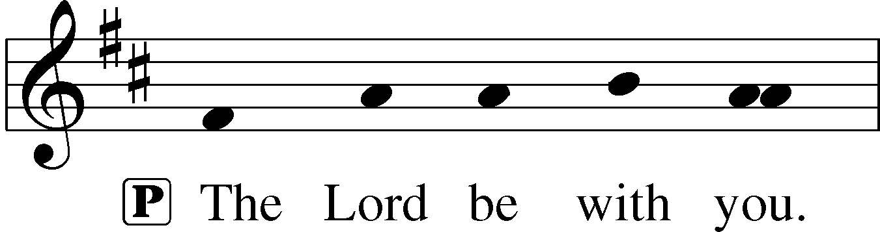
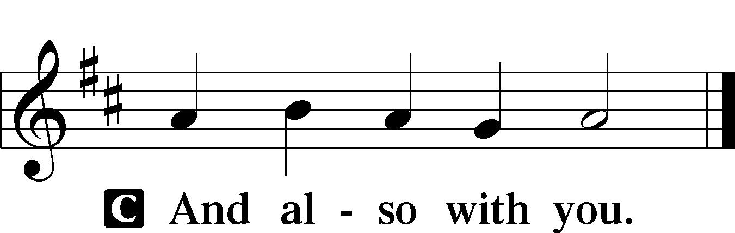
P Let us pray.
O God, through the humiliation of Your Son You raised up the fallen world. Grant to Your faithful people, rescued from the peril of everlasting death, perpetual gladness and eternal joys; through Jesus Christ, our Lord, who lives and reigns with You and the Holy Spirit, one God, now and forever.

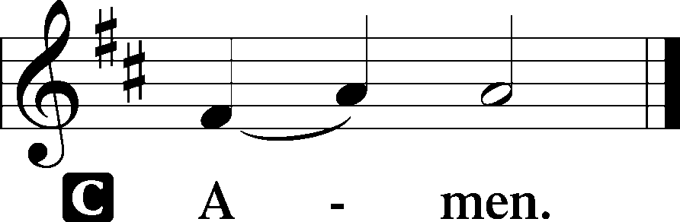

First Reading Acts 2:14a, 36-41
But Peter, standing with the eleven, lifted up his voice and addressed them, “Men of Judea and all who dwell in Jerusalem, let this be known to you, and give ear to my words. Let all the house of Israel therefore know for certain that God has made him both Lord and Christ, this Jesus whom you crucified.”
Now when they heard this they were cut to the heart, and said to Peter and the rest of the apostles, “Brothers, what shall we do?” And Peter said to them, “Repent and be baptized every one of you in the name of Jesus Christ for the forgiveness of your sins, and you will receive the gift of the Holy Spirit. For the promise is for you and for your children and for all who are far off, everyone whom the Lord our God calls to himself.” And with many other words he bore witness and continued to exhort them, saying, “Save yourselves from this crooked generation.” So those who received his word were baptized, and there were added that day about three thousand souls.
A This is the Word of the Lord.
C Thanks be to God.

Gradual Matt. 28:7; Heb. 2:7, Ps. 8:6
Christ has risen | from the dead.*
[God the Father] has crowned him with glory and | honor,
He has given him dominion over the works | of his hands;*
he has put all things un- | der his feet.

Epistle 1 Peter 1:17-25
And if you call on him as Father who judges impartially according to each one’s deeds, conduct yourselves with fear throughout the time of your exile, knowing that you were ransomed from the futile ways inherited from your forefathers, not with perishable things such as silver or gold, but with the precious blood of Christ, like that of a lamb without blemish or spot. He was foreknown before the foundation of the world but was made manifest in the last times for your sake, who through him are believers in God, who raised him from the dead and gave him glory, so that your faith and hope are in God.
Having purified your souls by your obedience to the truth for a sincere brotherly love, love one another earnestly from a pure heart, since you have been born again, not of perishable seed but of imperishable, through the living and abiding word of God; for
“All flesh is like grass
and all its glory like the flower of grass.
The grass withers,
and the flower falls,
but the word of the Lord remains forever.”
And this word is the good news that was preached to you.
A This is the Word of the Lord.
C Thanks be to God.
Please stand

Alleluia
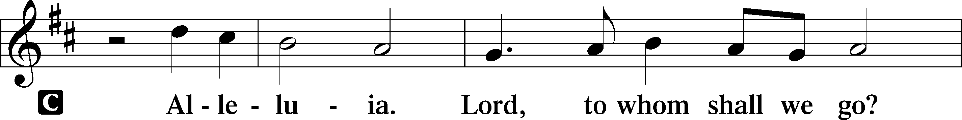
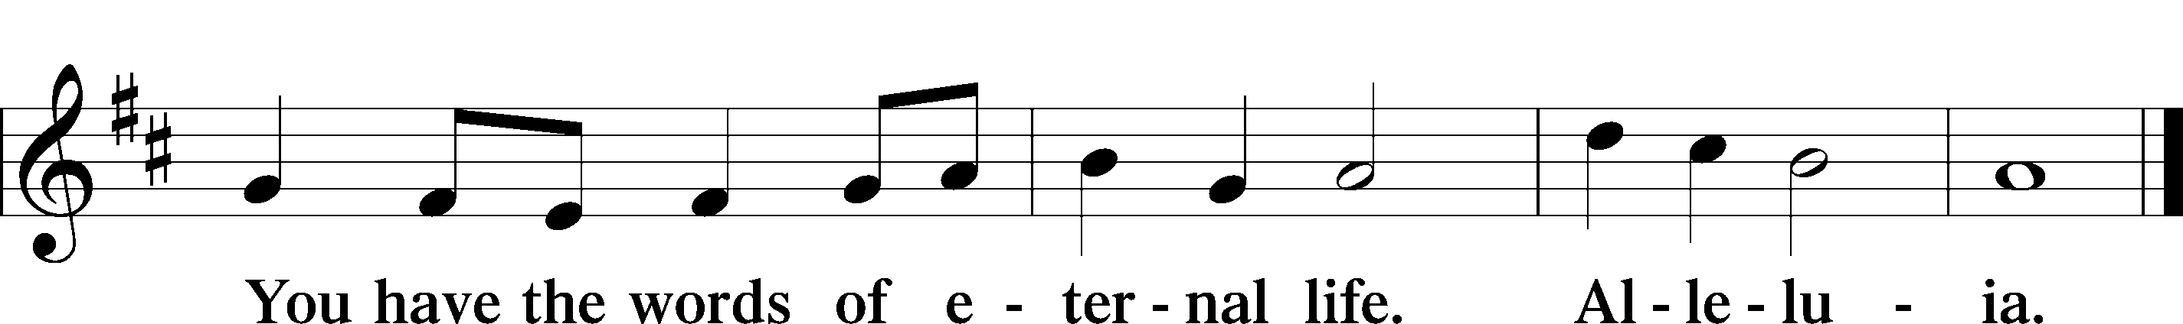

Holy Gospel Luke 24:13-35

P The Holy Gospel according to St. Luke, the twenty-fourth chapter.

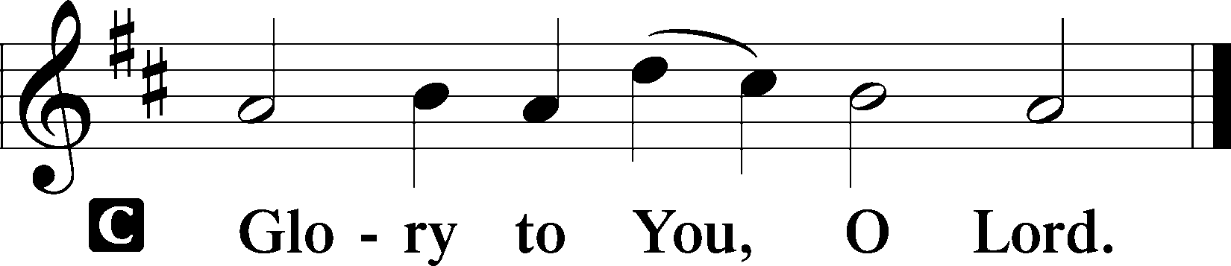
That very day two of them were going to a village named Emmaus, about seven miles from Jerusalem, and they were talking with each other about all these things that had happened. While they were talking and discussing together, Jesus himself drew near and went with them. But their eyes were kept from recognizing him. And he said to them, “What is this conversation that you are holding with each other as you walk?” And they stood still, looking sad. Then one of them, named Cleopas, answered him, “Are you the only visitor to Jerusalem who does not know the things that have happened there in these days?” And he said to them, “What things?” And they said to him, “Concerning Jesus of Nazareth, a man who was a prophet mighty in deed and word before God and all the people, and how our chief priests and rulers delivered him up to be condemned to death, and crucified him. But we had hoped that he was the one to redeem Israel. Yes, and besides all this, it is now the third day since these things happened. Moreover, some women of our company amazed us. They were at the tomb early in the morning, and when they did not find his body, they came back saying that they had even seen a vision of angels, who said that he was alive. Some of those who were with us went to the tomb and found it just as the women had said, but him they did not see.” And he said to them, “O foolish ones, and slow of heart to believe all that the prophets have spoken! Was it not necessary that the Christ should suffer these things and enter into his glory?” And beginning with Moses and all the Prophets, he interpreted to them in all the Scriptures the things concerning himself.
So they drew near to the village to which they were going. He acted as if he were going farther, but they urged him strongly, saying, “Stay with us, for it is toward evening and the day is now far spent.” So he went in to stay with them. When he was at table with them, he took the bread and blessed and broke it and gave it to them. And their eyes were opened, and they recognized him. And he vanished from their sight. They said to each other, “Did not our hearts burn within us while he talked to us on the road, while he opened to us the Scriptures?” And they rose that same hour and returned to Jerusalem. And they found the eleven and those who were with them gathered together, saying, “The Lord has risen indeed, and has appeared to Simon!” Then they told what had happened on the road, and how he was known to them in the breaking of the bread.
P This is the Gospel of the Lord.
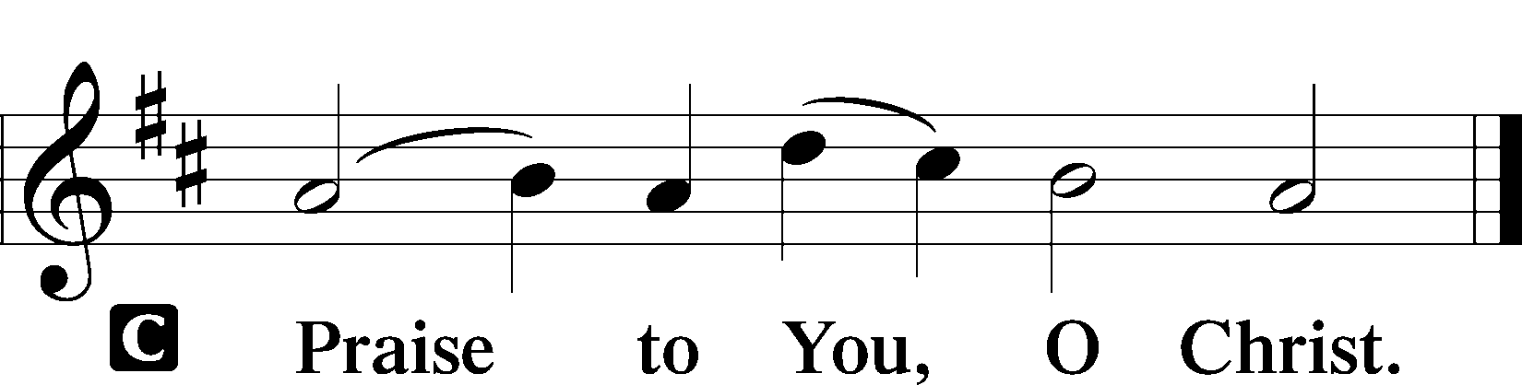

Please be seated

Office Hymn Who Are You Who Walk in Sorrow #476

Sermon The Journey that Must Be Walked

Please stand

Nicene Creed

C I believe in one God, (Rom 10:10; Deut 6:4)
the Father Almighty, (Mt 6:9; Ex 6:3)
maker of heaven and earth (Gen 1:1; Jn 1:1)
and of all things visible and invisible. (Col 1:16)
And in one Lord Jesus Christ, (Rom 10:9)
the only-begotten Son of God, (Jn 3:16; Mt 16:16)
begotten of His Father before all worlds, (Jn 1:2)
God of God, Light of Light, (Jn 17:22; Jn 8:12; Jn 1:1)
very God of very God, (Col 2:9) begotten, not made, (Jn 1:2)
being of one substance with the Father, (Jn 10:30)
by whom all things were made; (Heb 1:2; Jn 1:3)
who for us men and for our salvation (1 Tim 2:4; Rom 3:23)
came down from heaven (Jn 6:41; Lk 15:20)
and was incarnate by the Holy Spirit of the virgin Mary (Lk 1:34-35)
and was made man; (Jn 1:14)
and was crucified also for us under Pontius Pilate. (Mk 15:25; Jn 19:16-18)
He suffered and was buried. (Jn 19:1-3; Lk 23:53)
And the third day He rose again according to the Scriptures (1 Cor 15:4; Lk 24:6)
and ascended into heaven (Acts 1:9)
and sits at the right hand of the Father. (Acts 7:55)
And He will come again with glory (Mt 26:64)
to judge both the living and the dead, (Acts 10:42; Mt 3:12)
whose kingdom will have no end. (2 Pt 1:11)
And I believe in the Holy Spirit, (Jn 14:26; Gen 1:2; Acts 2:38)
the Lord and giver of life, (Gen 1:2; Jn 3:6)
who proceeds from the Father and the Son, (Jn 15:26)
who with the Father and the Son together is worshiped and glorified, (Mt 3:16-17)
who spoke by the prophets. (Eze 11:5)
And I believe in one holy Christian and apostolic Church, (1 Pt 2:5; Eph 2:19-22)
I acknowledge one Baptism for the remission of sins, (Eph 4:5)
and I look for the resurrection of the dead (1 Cor 15:35-49; 1 Thess 4:13-18)
and the life T of the world to come. (Mk 10:29-30; Mt 10:40-42)
Amen. (Ps 106:48)

Us men means all people.
Christian: the ancient text reads “catholic,” meaning the whole Church as it confesses the wholeness of Christian doctrine

Prayer of the Church

After each petition of the prayer:
Pastor: Let us pray to the Lord.
People: Lord, have mercy.

For comfort, health and recovery: Bruce Bodkin, Terry Gassett, Dan Hansen, Lois Niemann, Laura Oaks, Marilyn Unger;
For those who mourn: The family of Warren Towne;
For those who are ill or distressed: Stan Acey, Jenalee Adams, Kimberly Airhart, Layne Bagley, Rose Bagley, Shirley Bagley, W.L. Bagley, Sarah Bowman, Mimi Bradley, Richard Bradley, Deloris Brent, Martha Brown, Nathan Brown, Tina Burke, Wayne Burke, Paula Burkhalter, Amie Caroll, Bobby Carroll, Arthur Collins, James E. Cookston, Joan Cowards, Belinda Cowards-Gonzales, Mike Ellis, Robert (Andy) Evers, Michele Rae Fowler, Randy Fowler, Parker Haines, Dan Hansen, Paul Hansen, Tim Hansen, Valerie Henderson, Sharon Holleman, Hugh Hunt, Beth Jarratt, Jimmy Jarratt, Elaine Johnson, Joslyn Jones, Arlene Kleinschmidt, Eleanor Koster, John Koster, Sandra Landers, Katelyn Lawing, Peggy Lucky, Paul McCullough, Jerry McIntyre, Jerry McMahan, Edlia Miller, Mark Miller, Elaine Monaghan, Lindberg Moore, Jerry Mutter, Don Ochs, Mildred Odom, Janea Parker, Deborah-Annette Ried, Elmira Roever, Jon Sandberg, Noah Schultz, Johnnie Pearl Smiley, Bob Smith, Sally Smith, Sherri Smith, Deborah Springer, MariLyn Unger, Betty Venator, Leonard Watson, Dana Weaver, Cynthia Widlitze, Carol Wright, Jimmy Wright, Marshall Wright, Barbara Zeigler;
For college and graduate students: Jake Everly, Sara Fields, Keith Martin, Claudia Nelson, Roselynn Nelson, Katie Rudsenske;
For military servants and their families: Gabriel Escude, James (Glen) Hansford, Holden Hathcock, Christopher Martin, William Nelson, Steven Tatum, John Weidner Jr.;
For foreign missionaries: David and Shelee Warner;
This week’s prayer family: Merina Hansen and her loved ones.

Please be seated

Offering

Please be seated

Offertory
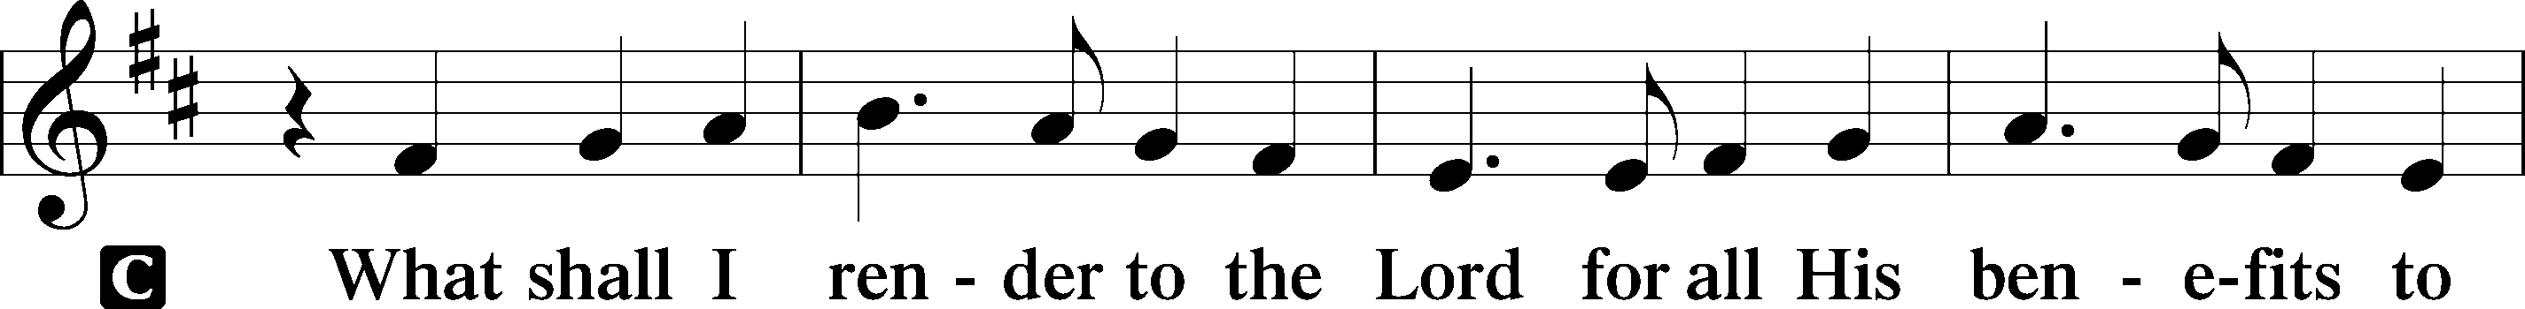
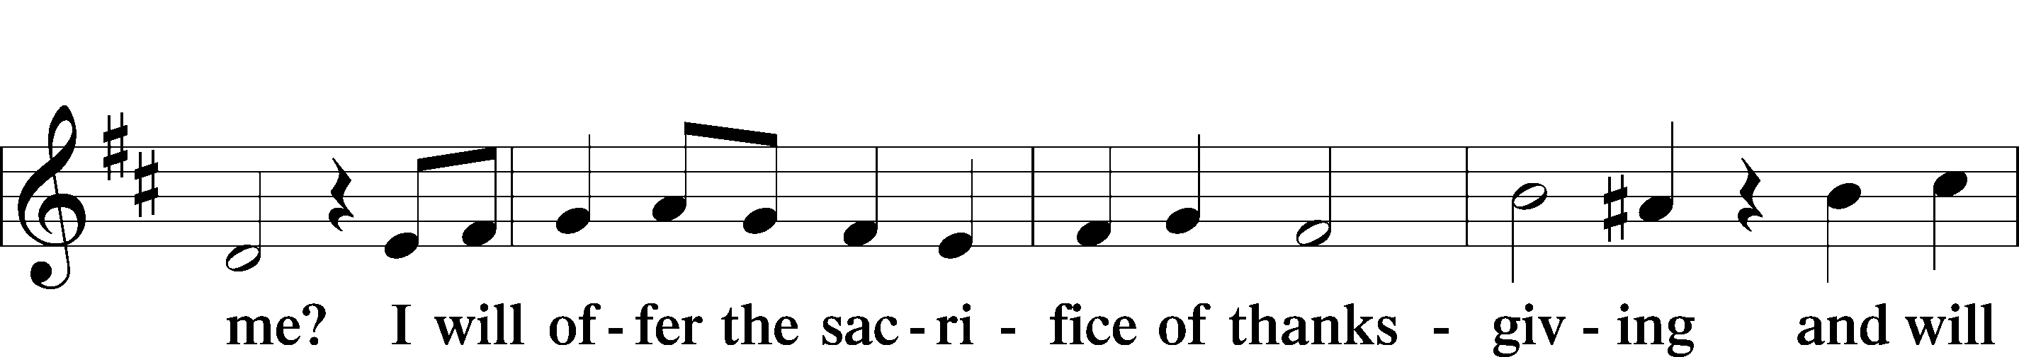
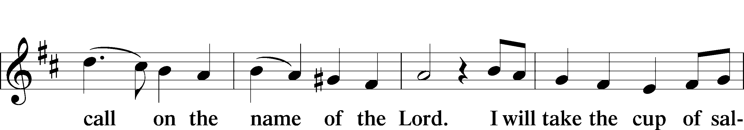
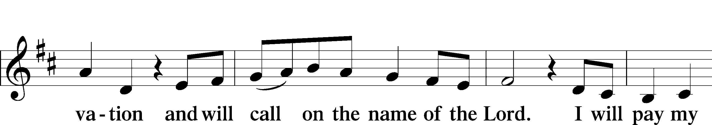
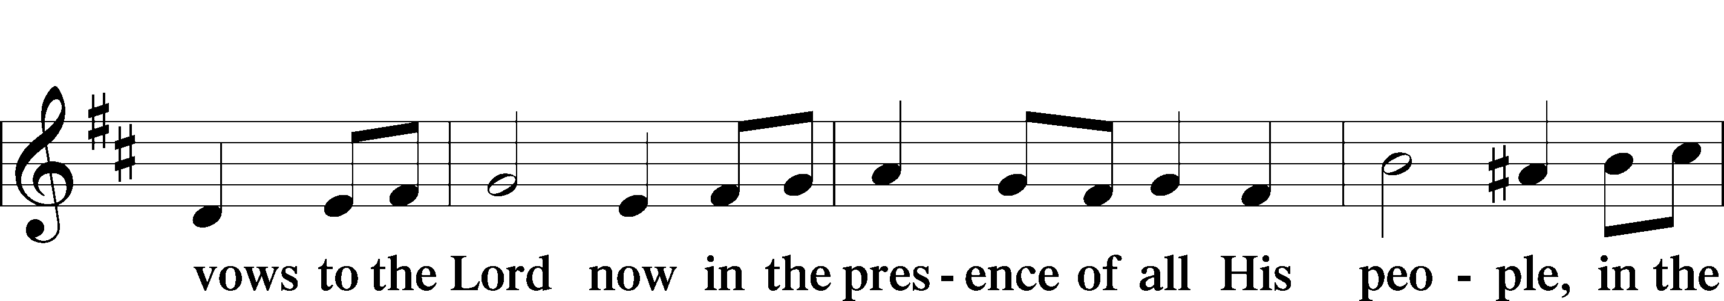
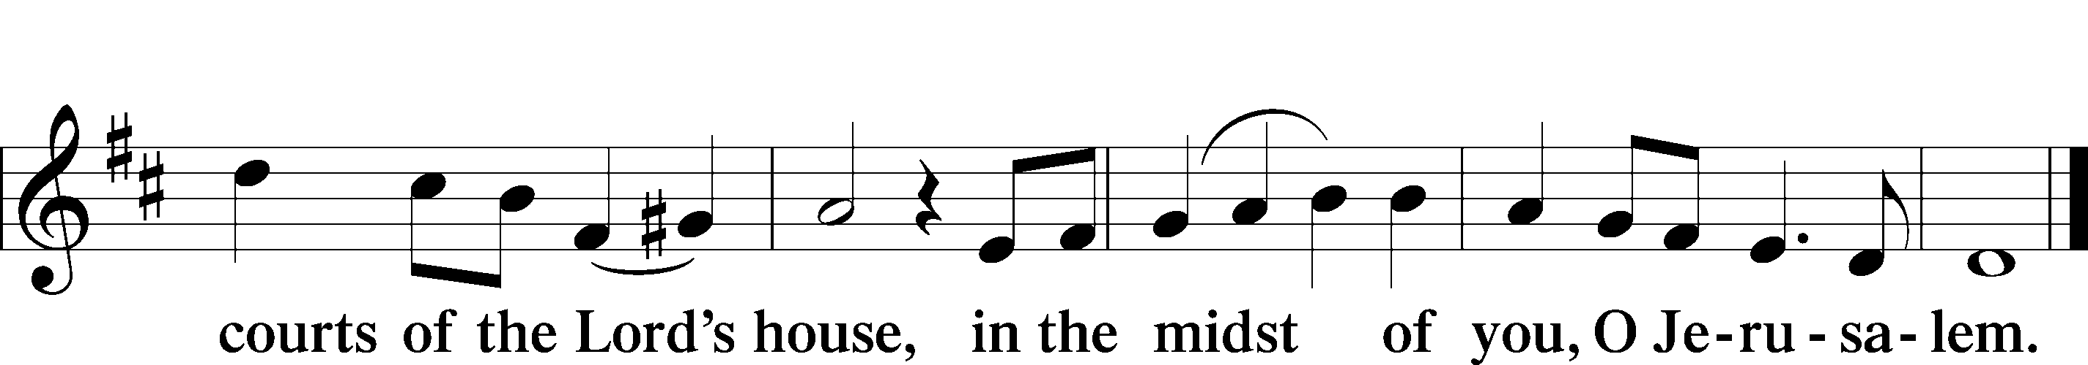

Service of the Sacrament

Preface 2 Timothy 4:22; [Colossians 3:1]; [Psalm 136]






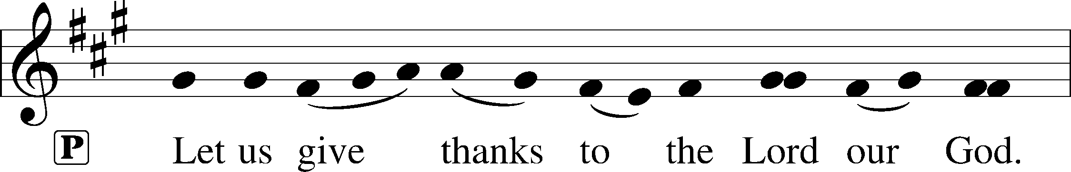
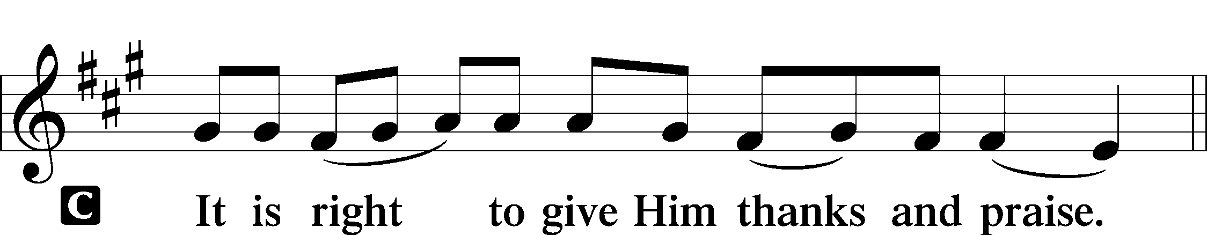

P It is truly good, right, and salutary that we should at all times and in all places give thanks to You, holy Lord, almighty Father, everlasting God. And most especially are we bound to praise You on this day for the glorious resurrection of Your Son, Jesus Christ, the very Paschal Lamb, who was sacrificed for us and bore the sins of the world. By His dying He has destroyed death, and by His rising again He has restored to us everlasting life. Therefore with Mary Magdalene, Peter and John, and with all the witnesses of the resurrection, with angels and archangels, and with all the company of heaven we laud and magnify Your glorious name, evermore praising You and saying:
Sanctus Isaiah 6:3; Matthew 21:9
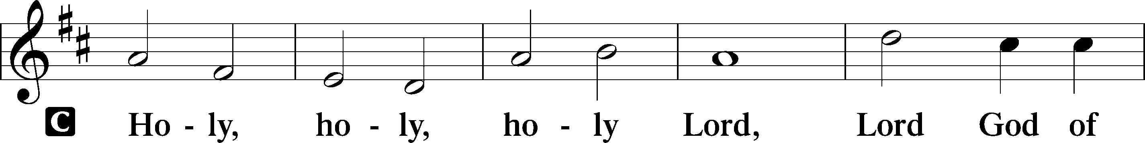
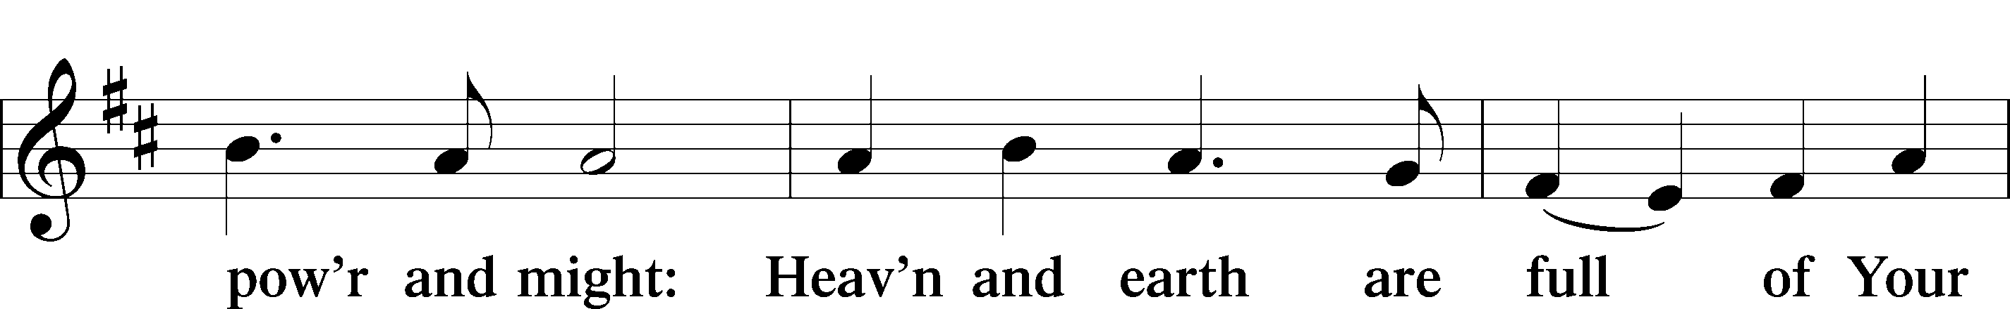
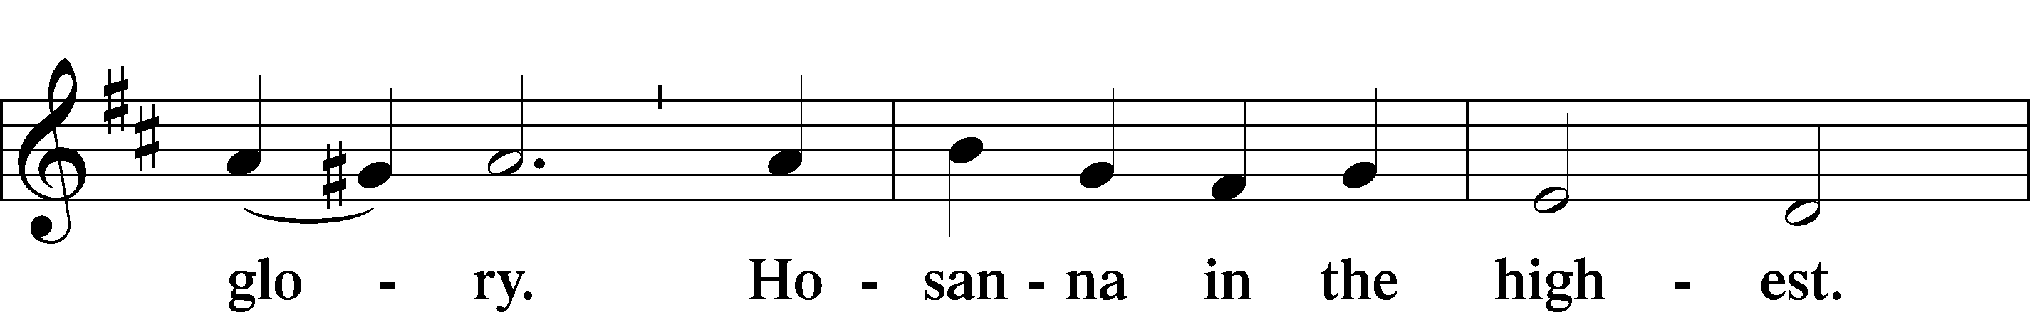
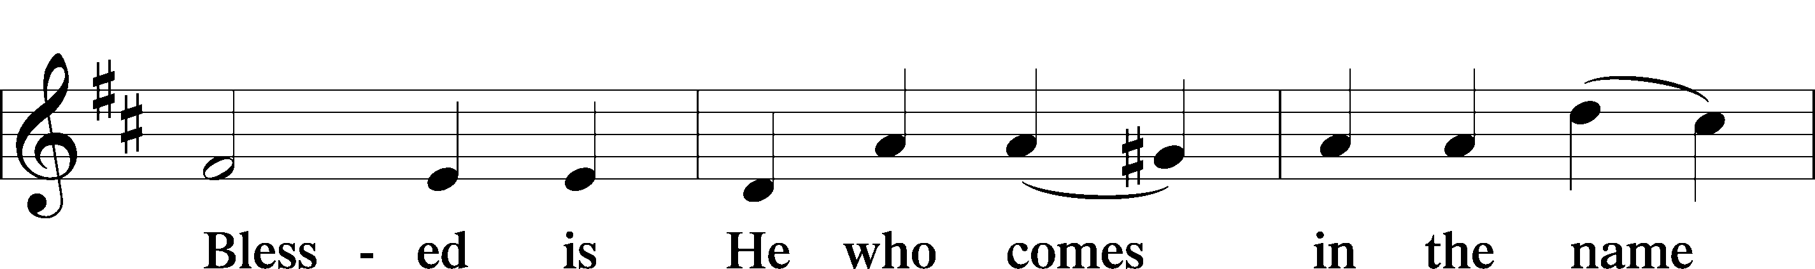
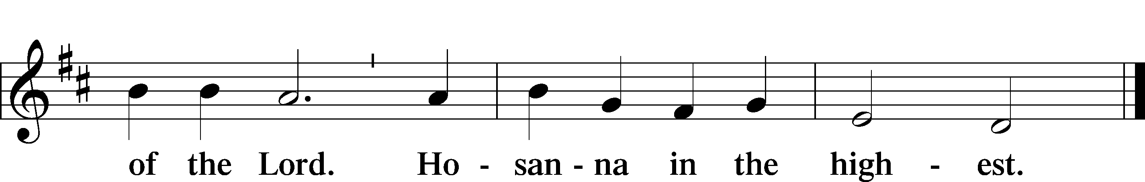

P Blessed are You, Lord of heaven and earth, for You have had mercy on those whom You created and sent Your only-begotten Son into our flesh to bear our sin and be our Savior. With repentant joy we receive the salvation accomplished for us by the all-availing sacrifice of His body and His blood on the cross.
Gathered in the name and the remembrance of Jesus, we beg You, O Lord, to forgive, renew, and strengthen us with Your Word and Spirit. Grant us faithfully to eat His body and drink His blood as He bids us do in His own testament. Gather us together, we pray, from the ends of the earth to celebrate with all the faithful the marriage feast of the Lamb in His kingdom, which has no end. Graciously receive our prayers; deliver and preserve us. To You alone, O Father, be all glory, honor, and worship, with the Son and the Holy Spirit, one God, now and forever.
C Amen.

Lord’s Prayer Matthew 6:9-13
P Lord, remember us in Your kingdom and teach us to pray:
C Our Father who art in heaven,
hallowed be Thy name,
Thy kingdom come,
Thy will be done on earth as it is in heaven;
give us this day our daily bread;
and forgive us our trespasses as we forgive those who trespass against us;
and lead us not into temptation,
but deliver T us from evil.
For Thine is the kingdom and the power and the glory forever and ever. Amen.

The Words of Our Lord Matthew 26:26–28;
Mark 14:22–24; Luke 22:19–20; 1 Corinthians 11:23–25
P Our Lord Jesus Christ, on the night when He was betrayed, took bread, and when He had given thanks, He broke it and gave it to the disciples and said: “Take, eat; this is My T body, which is given for you. This do in remembrance of Me.”
In the same way also He took the cup after supper, and when He had given thanks, He gave it to them, saying: “Drink of it, all of you; this cup is the new testament in My T blood, which is shed for you for the forgiveness of sins. This do, as often as you drink it, in remembrance of Me.”

Pax Domini John 20:19
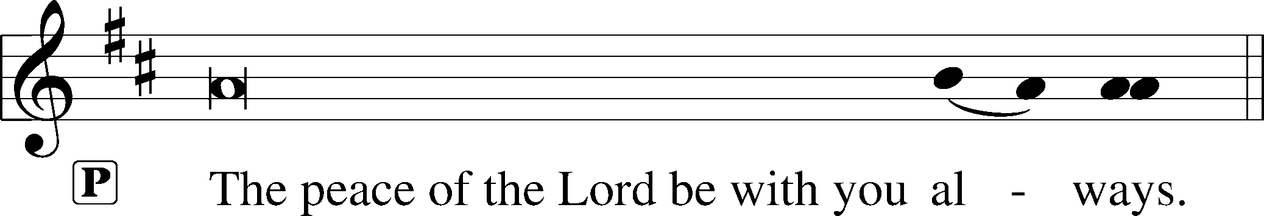


Agnus Dei John 1:29
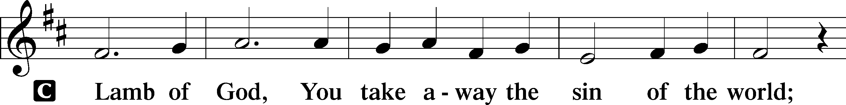
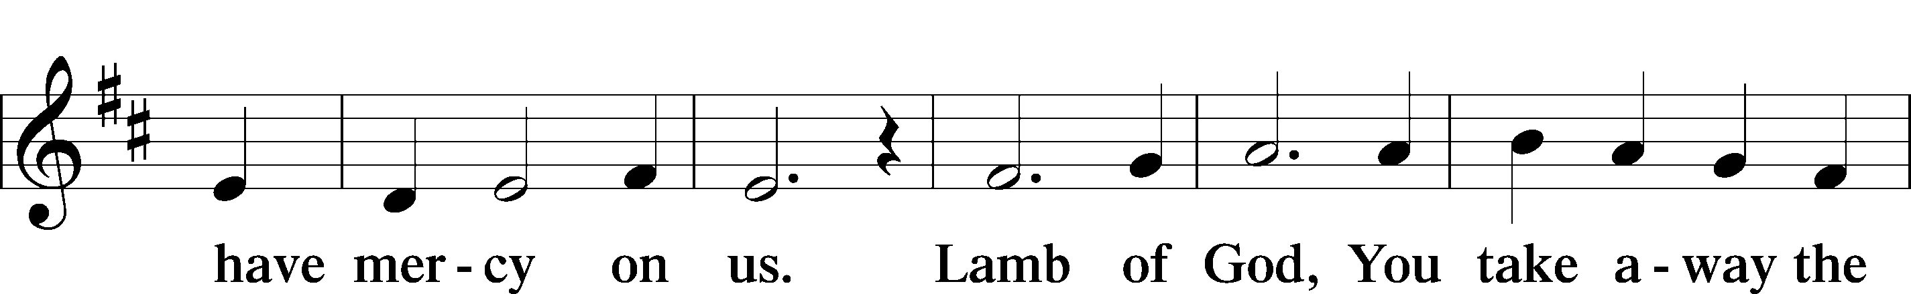
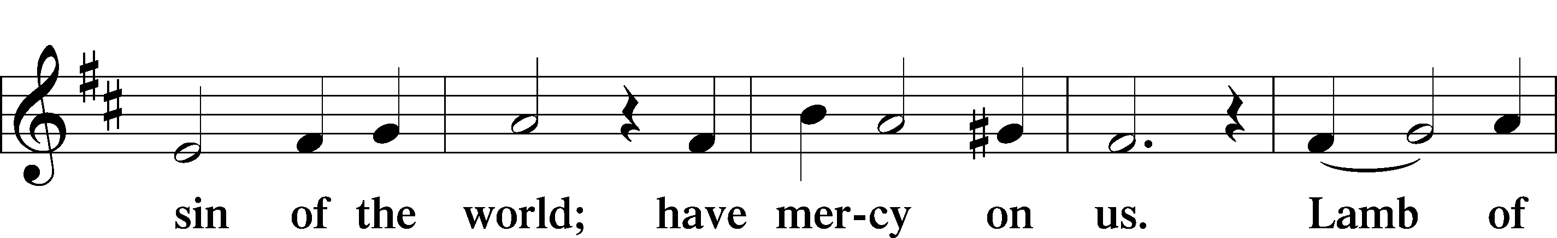
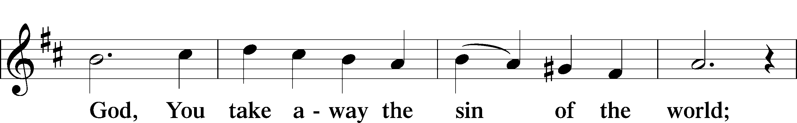
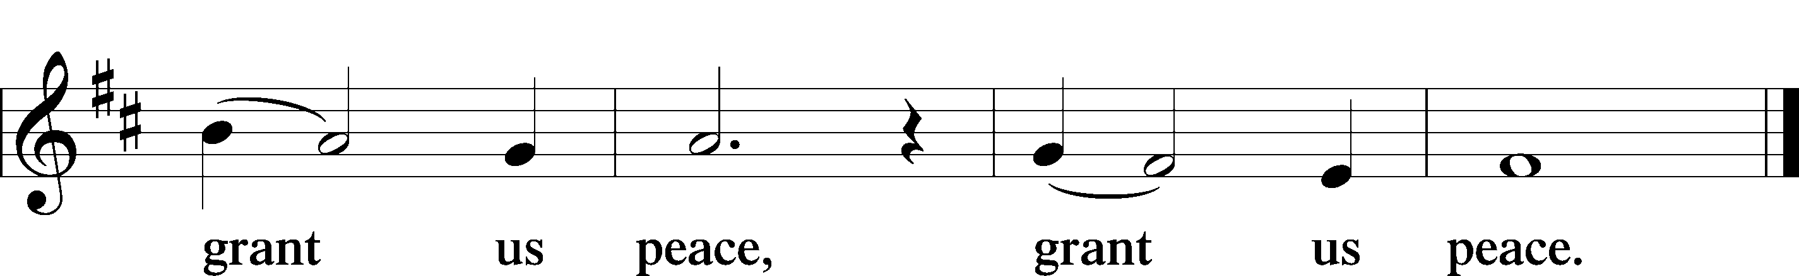

Please be seated

Distribution of the Sacrament
All who are members in good standing of the Lutheran Church - Missouri Synod and have introduced themselves to one of the pastors are welcome to partake of the Holy Communion at Christ Lutheran. If you have not spoken to a pastor, but would like to receive the Lord's blessing, you may still come to the rail and kneel, crossing one arm over the other in the shape of an 'X'. This symbolizes that one is marked by the cross and Triune name of Almighty God.

Distribution Hymns
Jesus, Lead Thou On #718
Please stand following distribution of communion

Nunc Dimittis Luke 2:29-32
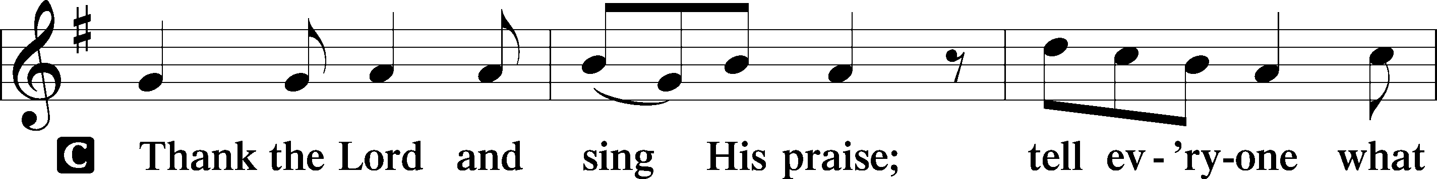
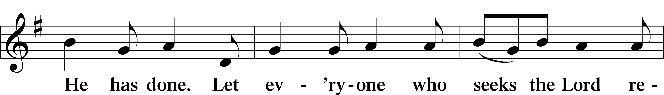
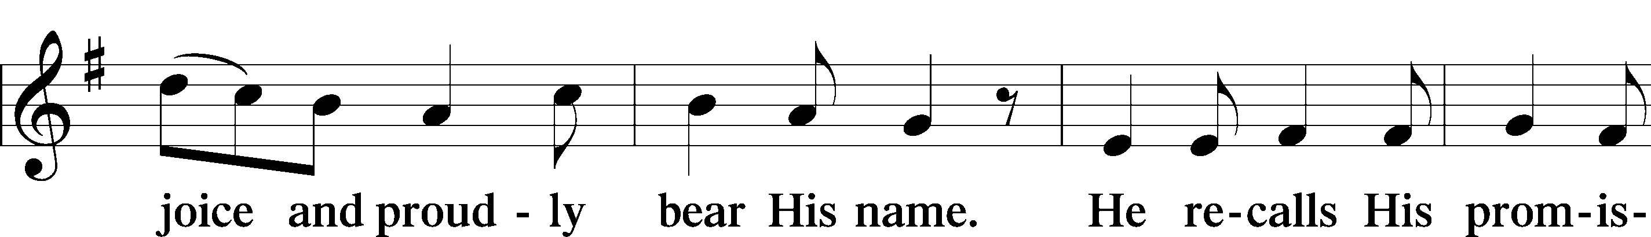
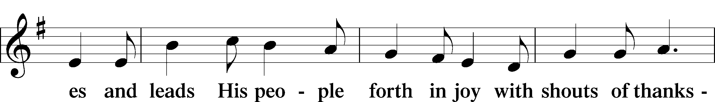
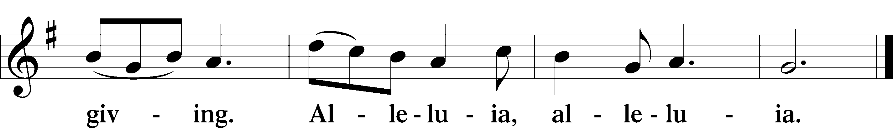

Post-Communion Collect

P We give thanks to You, almighty God, that You have refreshed us through this salutary gift, and we implore You that of Your mercy You would strengthen us through the same in faith toward You and fervent love toward one another; through Jesus Christ, Your Son, our Lord, who lives and reigns with You and the Holy Spirit, one God, now and forever.
Benediction Numbers 6:24–26
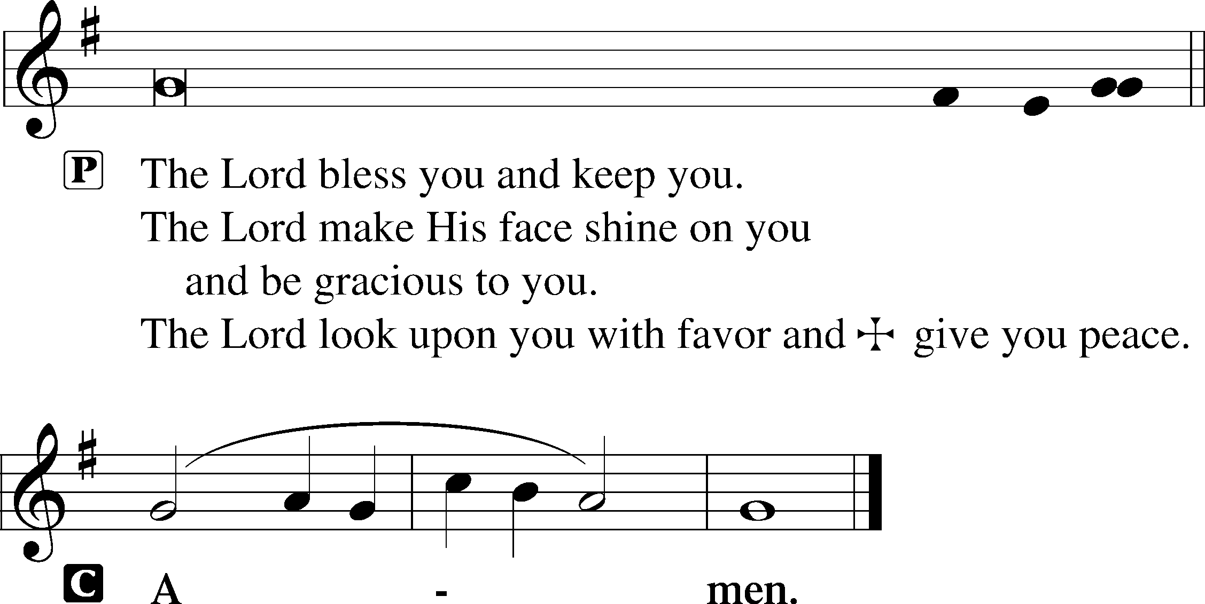

Closing Hymn I Walk in Danger All the Way #716

Postlude

Acknowledgments
Divine Service, Setting Two from Lutheran Service Book © 2006 Concordia Publishing House. Reprinted with permission. Unless otherwise indicated, all scripture quotations are from The Holy Bible, English Standard Version, copyright © 2001 by Crossway Bibles, a division of Good News Publishers. Used by permission. All rights reserved. Created by Lutheran Service Builder © 2006 Concordia Publishing House.

Today’s Worship Servants:
Celebrant: Rev. George Fields Cantors: Rachel Landrum
Interpreter: Greg Goldman Organist: Sr. Sara Fields

Altar Flowers: This morning’s altar flowers are given for the glory of God by Chuck and Margaret Haynes in celebration of their 50th wedding anniversary.
1 Peter 1:18-19 – “Knowing that you were ransomed from the futile ways inherited from your forefathers, not with perishable things such as silver or gold, but with the precious blood of Christ, like that of a lamb without blemish or spot.”
We have been ransomed – bought back from the slavery into which we were born. We do not belong to ourselves, or to the devil, or to the world. We belong to Jesus. Therefore, we live our lives not in accordance with our own wisdom but in line with God’s Word.

This week at Christ Lutheran Church: April 27 – May 3

Sunday 10:30 a.m. Divine Service Online – The Fourth Sunday of Easter



YOUR LIFELINE TO THE LUTHERAN WORLDVIEW…You can listen to in-depth teachings on interesting subjects like:

The Third Use of the Law, “Kindness” in the Bible, 4th Century Bishop Athanasius of Alexandria, Speaking the Truth in Love and more…

Issues, Etc. is a radio talk show produced by Lutheran Public Radio and hosted by LCMS Pastor Todd Wilken. You can listen to what you want when you want at www.issuesetc.org. Simply click on “Listen”, choose “On Demand”, then select from the vast array of speakers and topics available in the archives.

The Easter Season—The Great Fifty Days

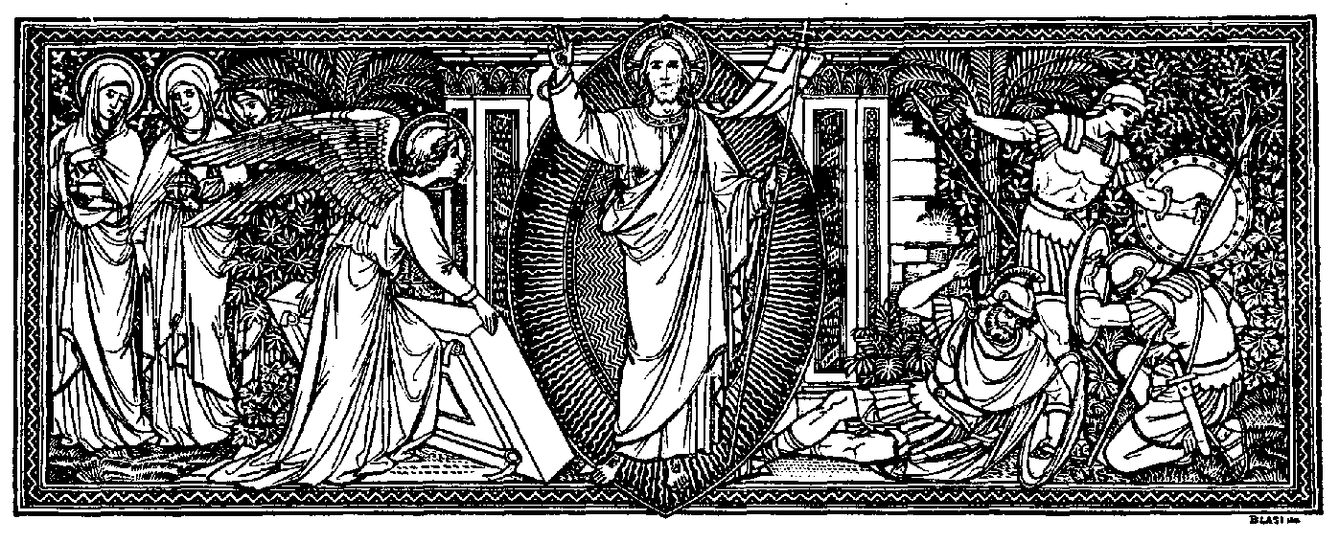

“The Easter season is a fifty-day-long season of joy extending from Easter to Pentecost. During this time, the Church celebrates the end of Christ’s struggles and proclaims His victory over death and the reception of the benefits of His life, death, and resurrection as gracious gifts of love and mercy for all those who believe in Him. This is the Church’s great season of joy! Christ is risen! He is risen indeed. Alleluia!”

—Treasury of Daily Prayer, CPH

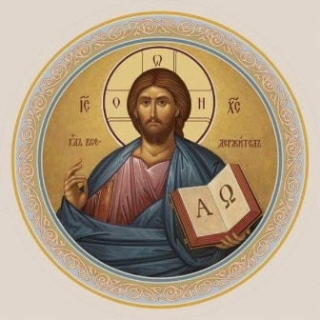

Christ Lutheran Church
Rev. Dr. James R. Holowach, Pastor
Rev. George N. Fields, Pastor
Sr. Sara E. Fields, Deaconess
4423 I-55 North, Jackson, MS 39206-6102
(601) 366-2055
www.christlutheranjacksonms.org

Matthew 26:26-29; Mark 14:22-25; Luke 22:14-20, 1 Corinthians 11:23
Matthew 26:28; 1 John 1:7; 1 Peter 1:18-19
1 Corinthians 11:28-32
1 Corinthians 10:17; 1 Corinthians 11:26

