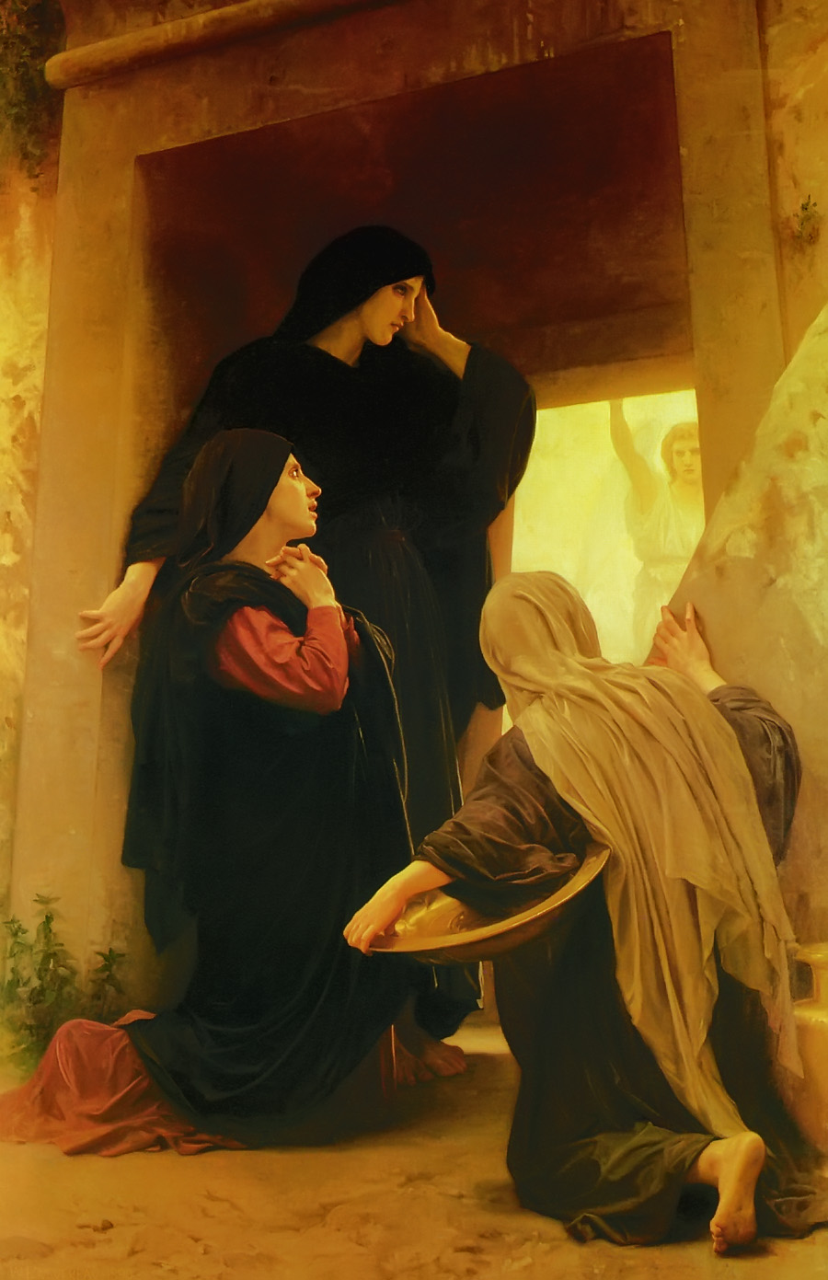

Christ Lutheran Church
The Feast of the Resurrection of Our Lord
+ April 19, 2020 +
The Feast of the
Resurrection of Our Lord
+ April 19, 2020 +

The Passover of Our Lord



We welcome our members and guests to Christ Lutheran today,
and pray God’s richest blessings upon you during this time of worship!

All members and our guests are asked to complete the
worship attendance pads which can be found on each pew.
Guests are also asked to sign the guest register found in the Narthex.
We are so glad to have you worshiping with us today!

LARGE PRINT worship folders are available
at the usher stand at the back of the nave.

WELCOME:
“On the third day the friends of Christ coming at daybreak to the place found the grave empty and the stone rolled away. In varying ways they realized the new wonder; but even they hardly realized that the world had died in the night. What they were looking at was the first day of a new creation, with a new heaven and a new earth; and in a semblance of the gardener God walked again in the garden, in the cool not of the evening but the dawn.”
–G.K. Chesterton, The Everlasting Man
The Lord’s Supper

In preparation for reception of the Lord’s Supper (Holy Communion), it is important that we review and understand what the Bible teaches regarding this sacrament:
The Bible teaches that Jesus gives us His very body and blood along with bread and wine in Holy Communion, and that these are means by which He forgives our sins, and strengthens us for daily living, and draws us into closer fellowship with Him and other believers. The Bible also teaches us to examine ourselves prior to receiving the meal. For those receiving Holy Communion, examine yourself with these questions:
Do I believe that I am a sinner and I am sorry for my sins?
Do I believe that Jesus Christ is God’s Son and my personal Savior?
Do I believe that Christ’s true body and blood are present in this holy meal for my forgiveness?
Do I truly intend with the help of God to correct my sinful life?
According to Christ’s Word in the Holy Scriptures, and in confession with the true Christian faith, at Christ Lutheran we observe the practice of closed communion. We believe that all who commune must confess the same holy faith, as Holy Scripture teaches. Since one’s church affiliation indicates an individual’s confession of faith, we ask that only those who have been instructed in the above teaching and are confirmed members of The Lutheran Church – Missouri Synod commune. If you have not been instructed in this teaching on Holy Communion, are in doubt, or hold a different confession of faith, you are still welcome to come forward and cross your arms to indicate that you would like a blessing.

Divine Service II

Preservice Music

The congregation stands to face the back of the church.
As the processional cross passes, the congregation turns to face the cross.

Processional Hymn Jesus Christ Is Risen Today #457

Confession & Absolution
The sign of the cross may be made by all in remembrance of your Baptism.

P In the name of the Father and of the T Son and of the Holy Spirit.
C Amen.

P If we say we have no sin, we deceive ourselves, and the truth is not in us.
C But if we confess our sins, God, who is faithful and just, will forgive our sins and cleanse us from all unrighteousness.

Silence for reflection on God's Word and for self-examination.

P Let us then confess our sins to God our Father.
C Most merciful God, we confess that we are by nature sinful and unclean. We have sinned against You in thought, word, and deed, by what we have done and by what we have left undone. We have not loved You with our whole heart; we have not loved our neighbors as ourselves. We justly deserve Your present and eternal punishment. For the sake of Your Son, Jesus Christ, have mercy on us. Forgive us, renew us, and lead us, so that we may delight in Your will and walk in Your ways to the glory of Your holy name. Amen.

P Almighty God in His mercy has given His Son to die for you and for His sake forgives you all your sins. As a called and ordained servant of Christ, and by His authority, I therefore forgive you all your sins in the name of the Father and of the T Son and of the Holy Spirit.
C Amen.

Service of the Word

Introit: Cantemus Domino Ex. 15:2, 6, 13, 17-18; antiphon 15:1
Cantor: I will sing to the Lord, for He has triumphed gloriously;
The horse and his rider He has thrown into the sea.

All:
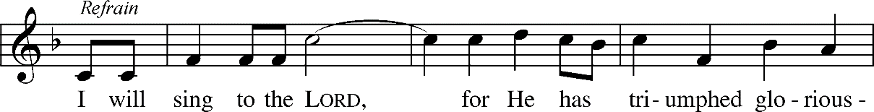

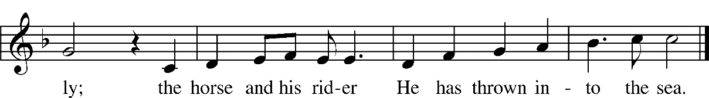



The LORD is my strength | and my song,*
and He has become my sal- | vation;
Your right hand, O Lord, glorious | in power,*
Your right hand, O Lord, shatters the | enemy.
Refrain
You have led in Your steadfast love the people whom You | have redeemed;*
You have guided them by Your strength to Your ho- | ly abode.
You will bring them in and plant them on Your own | mountain,*
the place, O Lord, which You have made for | Your abode,
the sanctuary, O Lord, which Your hands have es- | tablished.*
The Lord will reign forever and | ever.
Glory be to the Father and | to the Son*
and to the Holy | Spirit;
as it was in the be- | ginning,*
is now, and will be forever. | Amen.
Refrain
Kyrie Mark 10:47



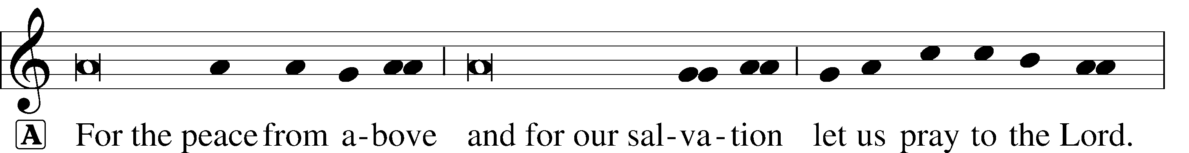
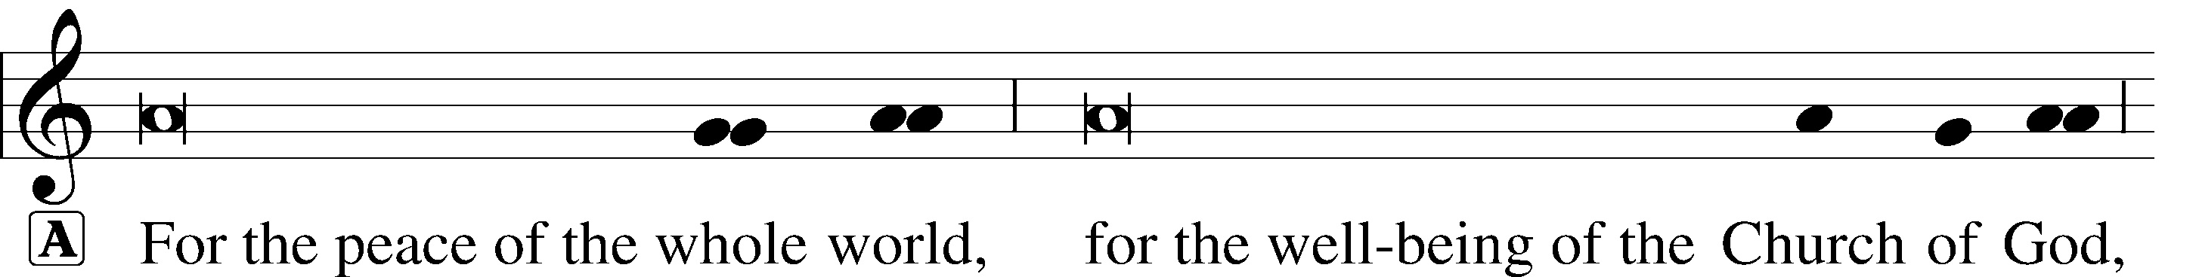
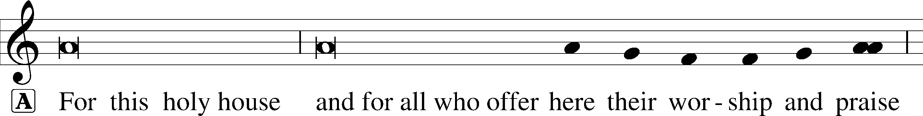


Dignus Est
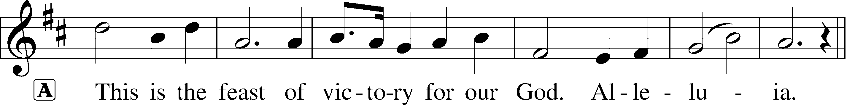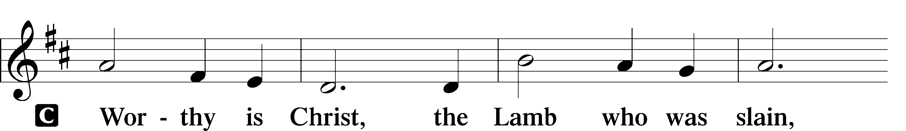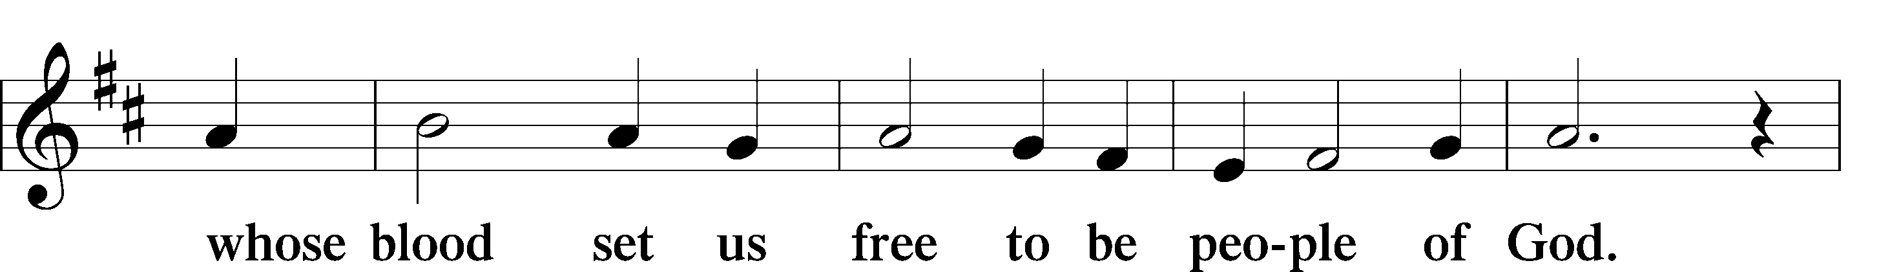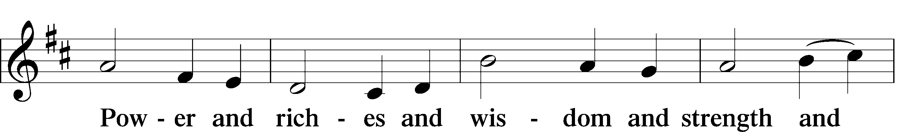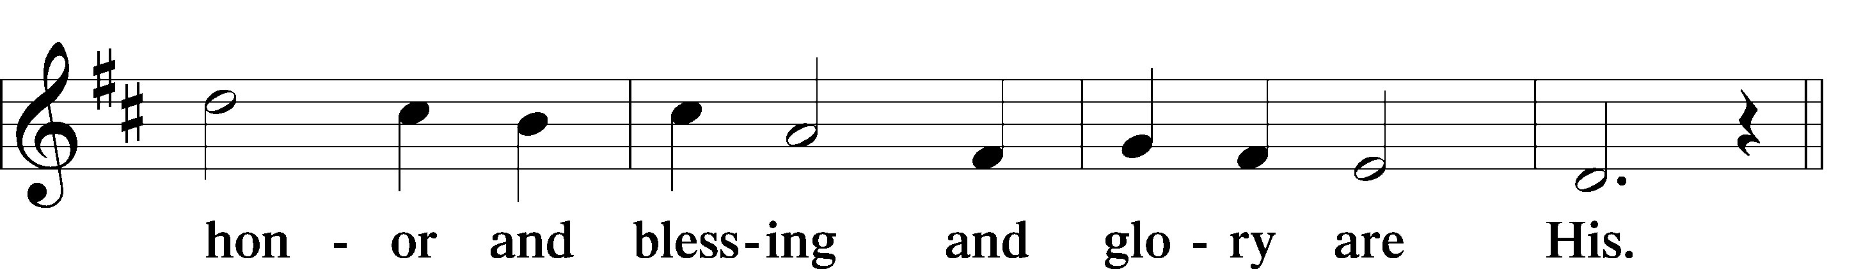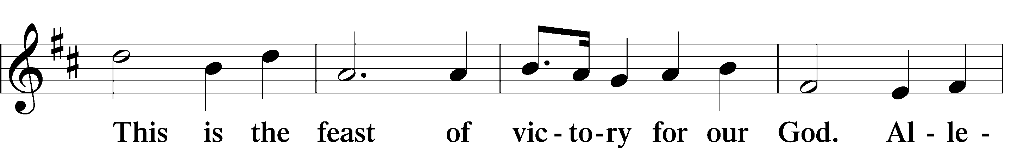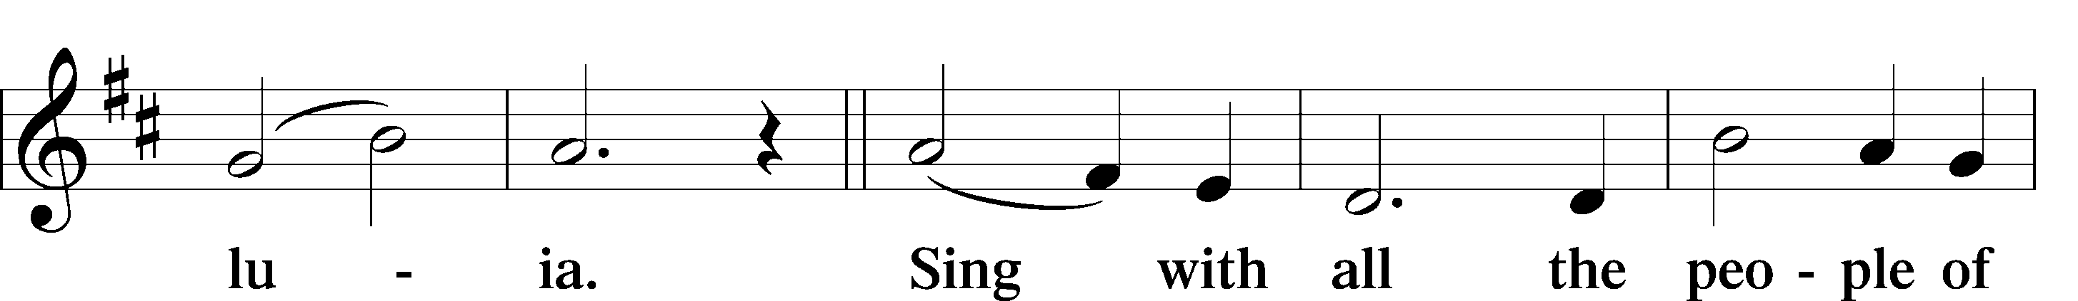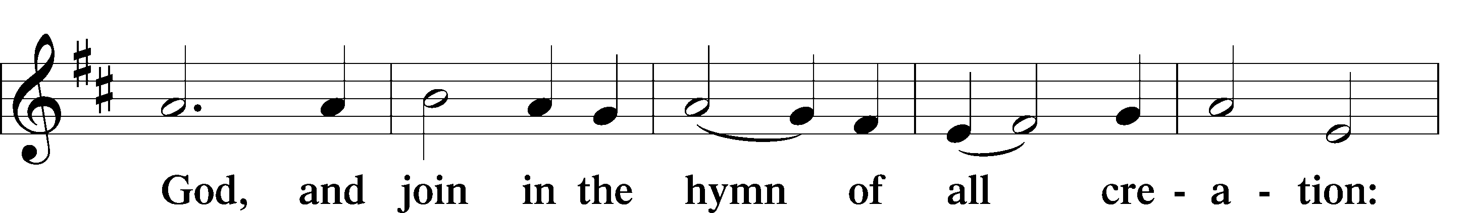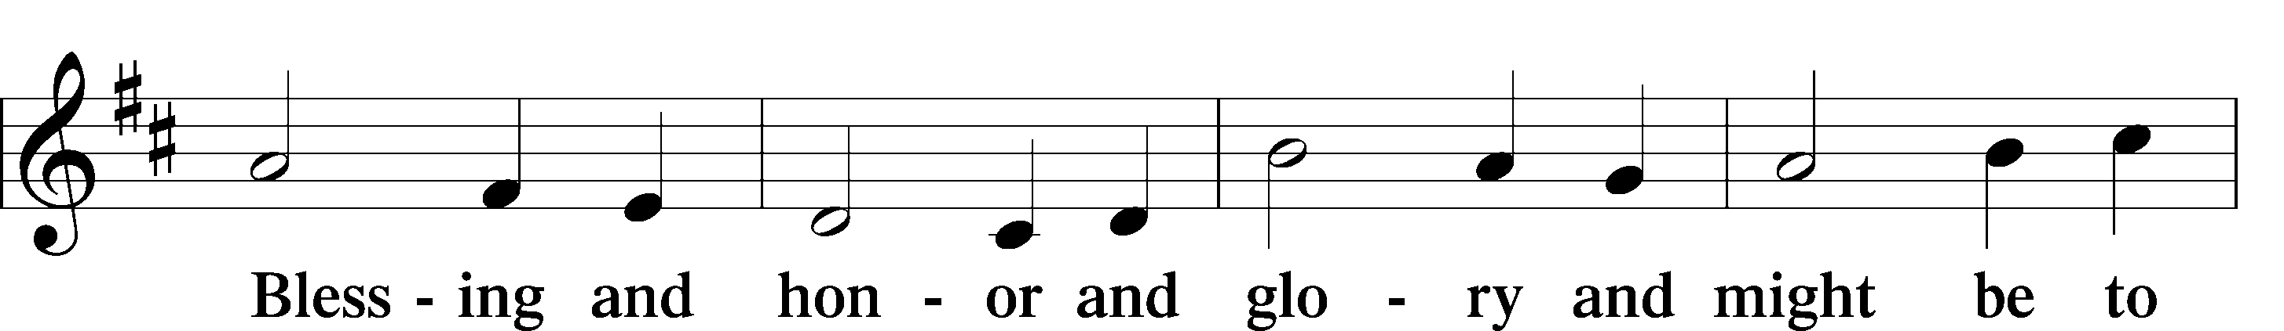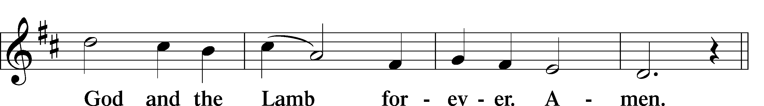

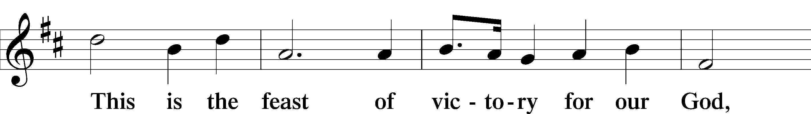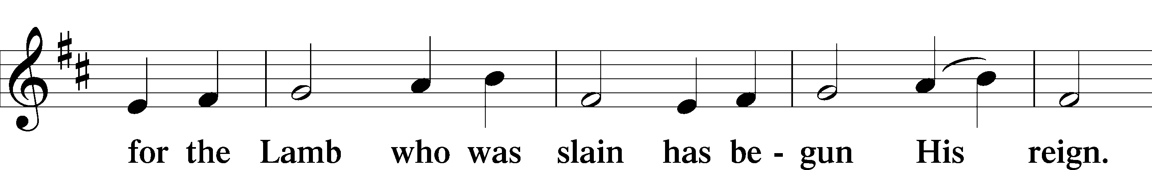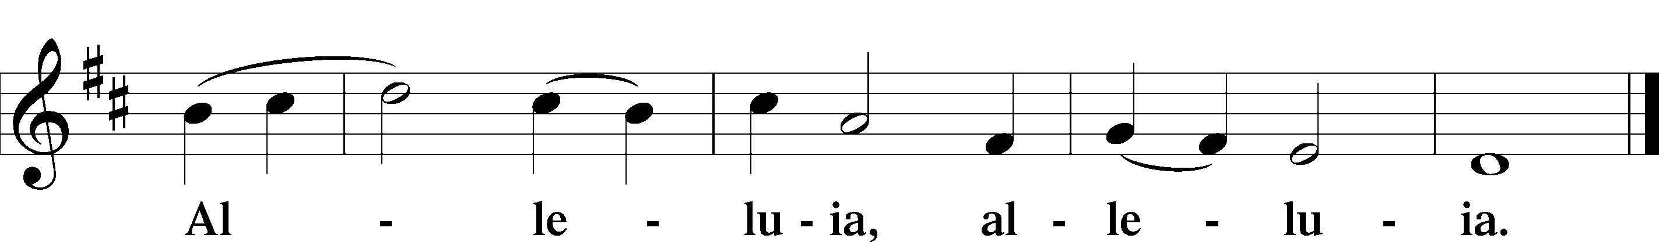

Salutation and Collect of the Day

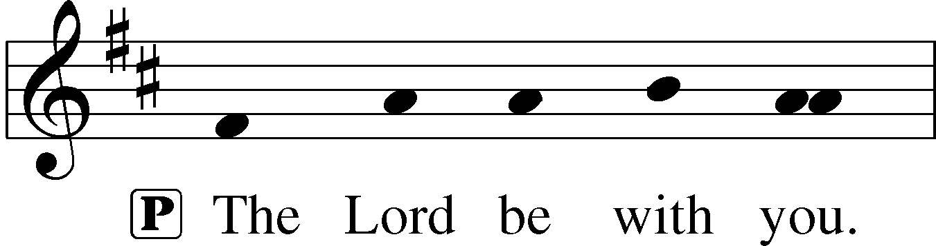
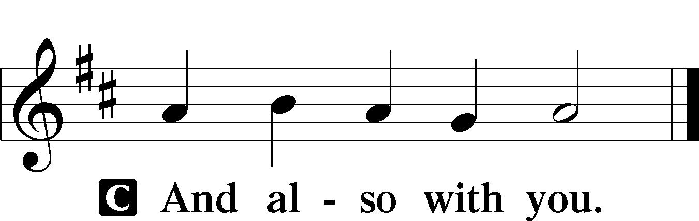
P Let us pray.
Almighty God, through Your only-begotten Son, Jesus Christ, You overcame death and opened to us the gate of everlasting life. We humbly pray that we may live before You in righteousness and purity forever; through the same Jesus Christ, our Lord, who lives and reigns with You and the Holy Spirit, one God, now and forever.

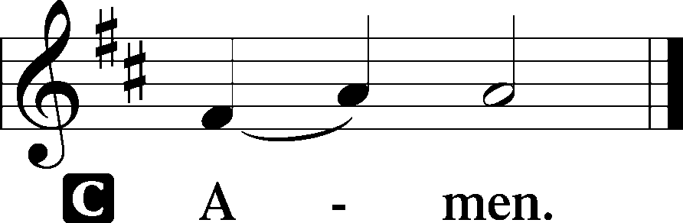

Old Testament Reading Exodus 14:10-15:1
When Pharaoh drew near, the people of Israel lifted up their eyes, and behold, the Egyptians were marching after them, and they feared greatly. And the people of Israel cried out to the Lord. They said to Moses, “Is it because there are no graves in Egypt that you have taken us away to die in the wilderness? What have you done to us in bringing us out of Egypt? Is not this what we said to you in Egypt, ‘Leave us alone that we may serve the Egyptians’? For it would have been better for us to serve the Egyptians than to die in the wilderness.” And Moses said to the people, “Fear not, stand firm, and see the salvation of the Lord, which he will work for you today. For the Egyptians whom you see today, you shall never see again. The Lord will fight for you, and you have only to be silent.”
The Lord said to Moses, “Why do you cry to me? Tell the people of Israel to go forward. Lift up your staff, and stretch out your hand over the sea and divide it, that the people of Israel may go through the sea on dry ground. And I will harden the hearts of the Egyptians so that they shall go in after them, and I will get glory over Pharaoh and all his host, his chariots, and his horsemen. And the Egyptians shall know that I am the Lord, when I have gotten glory over Pharaoh, his chariots, and his horsemen.”
Then the angel of God who was going before the host of Israel moved and went behind them, and the pillar of cloud moved from before them and stood behind them, coming between the host of Egypt and the host of Israel. And there was the cloud and the darkness. And it lit up the night without one coming near the other all night.
Then Moses stretched out his hand over the sea, and the Lord drove the sea back by a strong east wind all night and made the sea dry land, and the waters were divided. And the people of Israel went into the midst of the sea on dry ground, the waters being a wall to them on their right hand and on their left. The Egyptians pursued and went in after them into the midst of the sea, all Pharaoh’s horses, his chariots, and his horsemen. And in the morning watch the Lord in the pillar of fire and of cloud looked down on the Egyptian forces and threw the Egyptian forces into a panic, clogging their chariot wheels so that they drove heavily. And the Egyptians said, “Let us flee from before Israel, for the Lord fights for them against the Egyptians.”
Then the Lord said to Moses, “Stretch out your hand over the sea, that the water may come back upon the Egyptians, upon their chariots, and upon their horsemen.” So Moses stretched out his hand over the sea, and the sea returned to its normal course when the morning appeared. And as the Egyptians fled into it, the Lord threw the Egyptians into the midst of the sea. The waters returned and covered the chariots and the horsemen; of all the host of Pharaoh that had followed them into the sea, not one of them remained. But the people of Israel walked on dry ground through the sea, the waters being a wall to them on their right hand and on their left.
Thus the Lord saved Israel that day from the hand of the Egyptians, and Israel saw the Egyptians dead on the seashore. Israel saw the great power that the Lord used against the Egyptians, so the people feared the Lord, and they believed in the Lord and in his servant Moses.
Then Moses and the people of Israel sang this song to the Lord, saying,
“I will sing to the Lord, for he has triumphed gloriously;
the horse and his rider he has thrown into the sea.
A This is the Word of the Lord.
C Thanks be to God.

Gradual Matt. 28:7; Heb. 2:7, Ps. 8:6

Christ has risen | from the dead.*
[God the Father] has crowned him with glory and | honor,
He has given him dominion over the works | of his hands;*
he has put all things un- | der his feet.

Epistle 1 Corinthians 15:1-11
Now I would remind you, brothers, of the gospel I preached to you, which you received, in which you stand, and by which you are being saved, if you hold fast to the word I preached to you—unless you believed in vain.
For I delivered to you as of first importance what I also received: that Christ died for our sins in accordance with the Scriptures, that he was buried, that he was raised on the third day in accordance with the Scriptures, and that he appeared to Cephas, then to the twelve. Then he appeared to more than five hundred brothers at one time, most of whom are still alive, though some have fallen asleep. Then he appeared to James, then to all the apostles. Last of all, as to one untimely born, he appeared also to me. For I am the least of the apostles, unworthy to be called an apostle, because I persecuted the church of God. But by the grace of God I am what I am, and his grace toward me was not in vain. On the contrary, I worked harder than any of them, though it was not I, but the grace of God that is with me. Whether then it was I or they, so we preach and so you believed.
A This is the Word of the Lord.
C Thanks be to God.
Please stand and face the crucifix

Gospel Procession
Cantor: Christians, to the Paschal Victim
Offer your thankful praises!
The Lamb the sheep has ransomed:
Christ, who only is sinless,
Reconciling sinners to the Father.
Death and life have contended
In that combat stupendous:
The Prince of life, who died,
Reigns immortal.

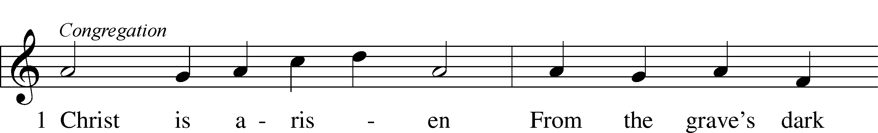
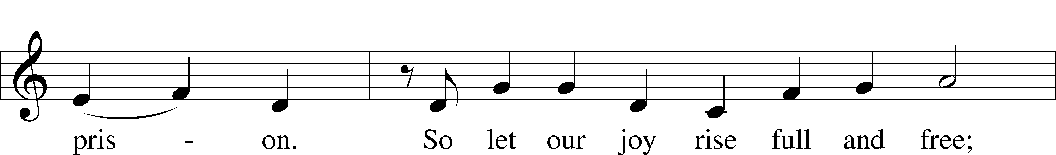
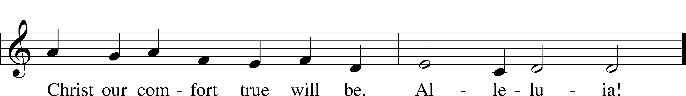

Cantor: “Speak, Mary, declaring
What you saw when wayfaring.”
“The tomb of Christ, who is living,
The glory of Jesus’ resurrection;
Bright angels attesting,
The shroud and napkin resting.
My Lord, my hope, is arisen;
To Galilee He goes before you.”

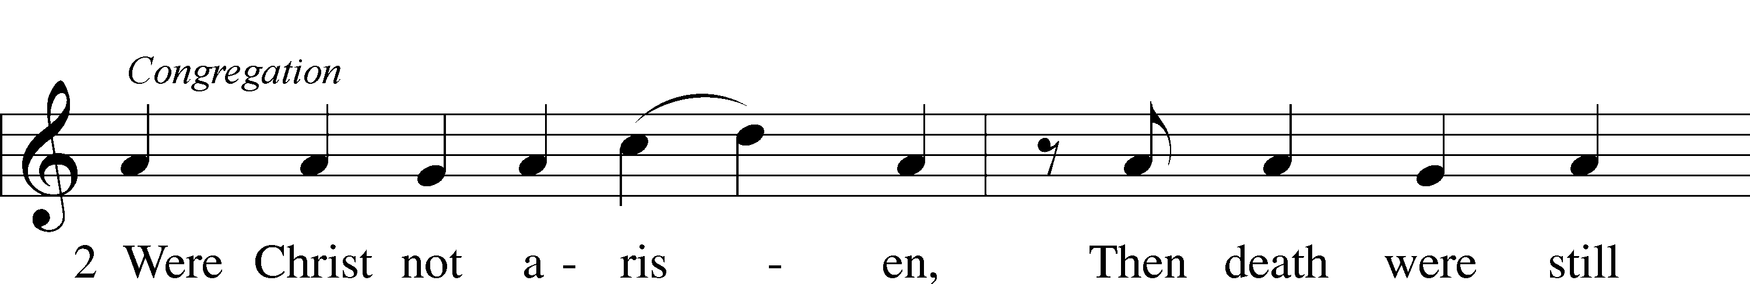
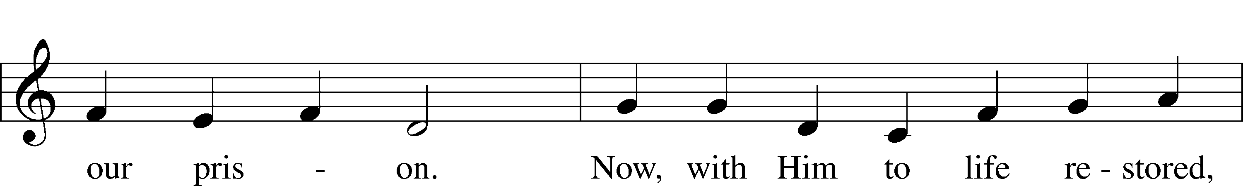
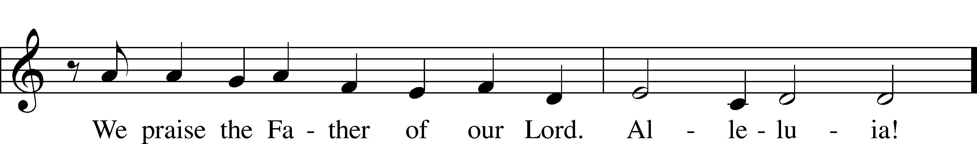

Holy Gospel John 20:1-18

P The Holy Gospel according to St. John, the twentieth chapter.

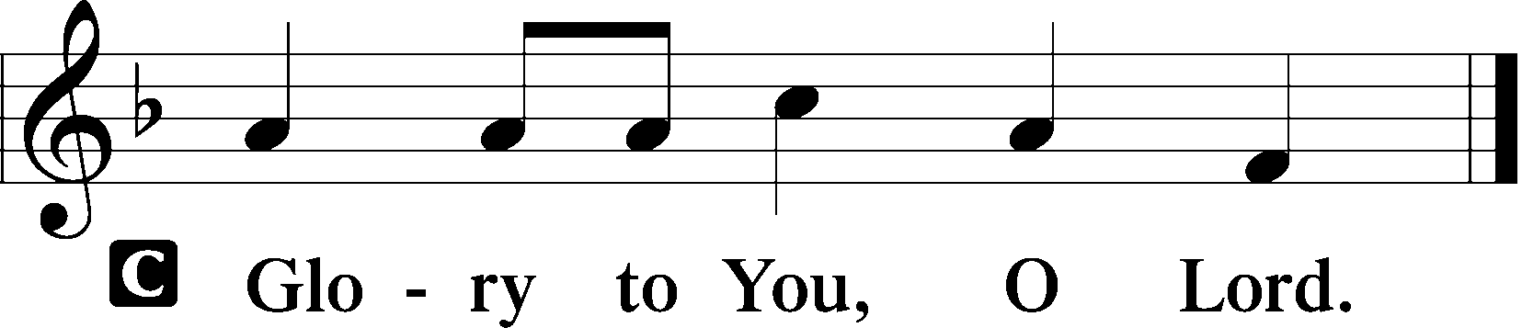
Now on the first day of the week Mary Magdalene came to the tomb early, while it was still dark, and saw that the stone had been taken away from the tomb. So she ran and went to Simon Peter and the other disciple, the one whom Jesus loved, and said to them, “They have taken the Lord out of the tomb, and we do not know where they have laid him.” So Peter went out with the other disciple, and they were going toward the tomb. Both of them were running together, but the other disciple outran Peter and reached the tomb first. And stooping to look in, he saw the linen cloths lying there, but he did not go in. Then Simon Peter came, following him, and went into the tomb. He saw the linen cloths lying there, and the face cloth, which had been on Jesus' head, not lying with the linen cloths but folded up in a place by itself. Then the other disciple, who had reached the tomb first, also went in, and he saw and believed; for as yet they did not understand the Scripture, that he must rise from the dead. Then the disciples went back to their homes.
But Mary stood weeping outside the tomb, and as she wept she stooped to look into the tomb. And she saw two angels in white, sitting where the body of Jesus had lain, one at the head and one at the feet. They said to her, “Woman, why are you weeping?” She said to them, “They have taken away my Lord, and I do not know where they have laid him.” Having said this, she turned around and saw Jesus standing, but she did not know that it was Jesus. Jesus said to her, “Woman, why are you weeping? Whom are you seeking?” Supposing him to be the gardener, she said to him, “Sir, if you have carried him away, tell me where you have laid him, and I will take him away.” Jesus said to her, “Mary.” She turned and said to him in Aramaic, “Rabboni!” (which means Teacher). Jesus said to her, “Do not cling to me, for I have not yet ascended to the Father; but go to my brothers and say to them, ‘I am ascending to my Father and your Father, to my God and your God.’” Mary Magdalene went and announced to the disciples, “I have seen the Lord”—and that he had said these things to her.
P This is the Gospel of the Lord.
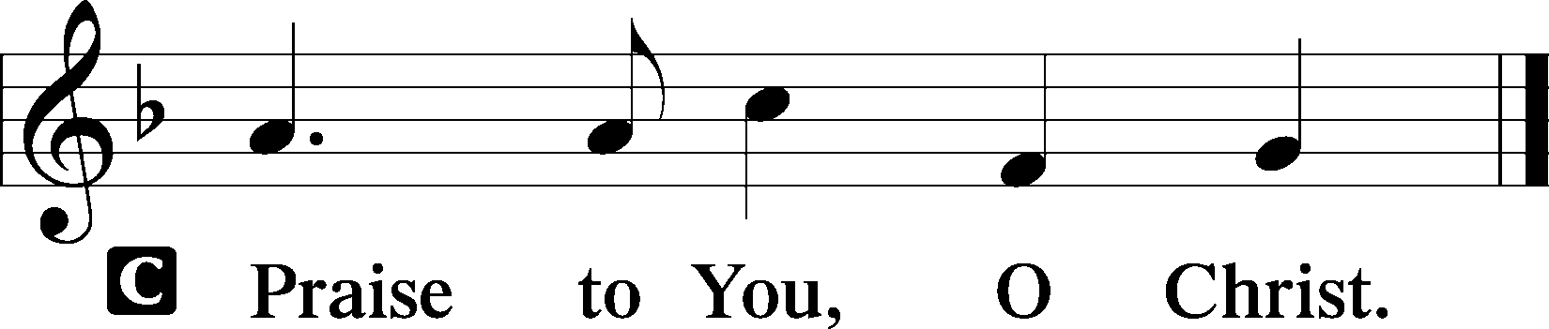

Cantor: Christ indeed from death is risen,
Our new life obtaining.
Have mercy, victor King, ever reigning!
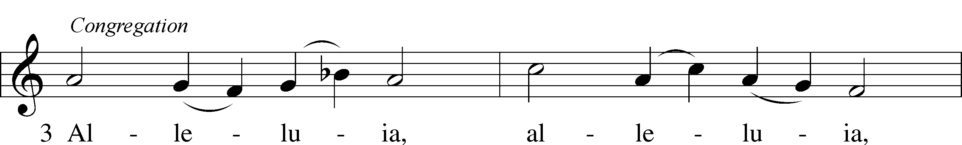
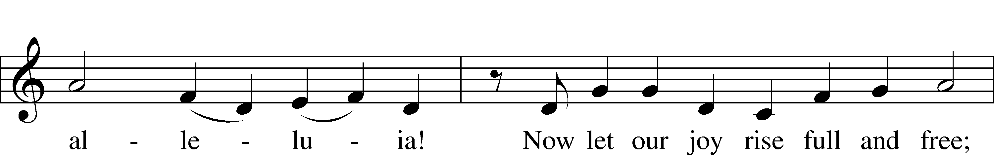
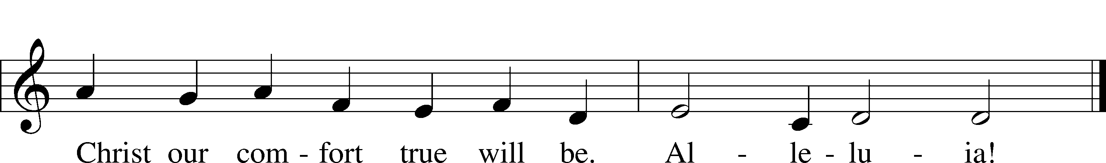

Please be seated

Office Hymn Awake, My Heart, with Gladness #467

Sermon Cleave to Me

Please stand

Nicene Creed

C | I believe in one God, (Rom 10:10; Deut 6:4)  the Father Almighty, (Mt 6:9; Ex 6:3)  maker of heaven and earth (Gen 1:1; Jn 1:1)  and of all things visible and invisible. (Col 1:16)  And in one Lord Jesus Christ, (Rom 10:9)  the only-begotten Son of God, (Jn 3:16; Mt 16:16)  begotten of His Father before all worlds, (Jn 1:2)  God of God, Light of Light, (Jn 17:22; Jn 8:12; Jn 1:1)  very God of very God, (Col 2:9) begotten, not made, (Jn 1:2)  being of one substance with the Father, (Jn 10:30)  by whom all things were made; (Heb 1:2; Jn 1:3)  who for us men and for our salvation (1 Tim 2:4; Rom 3:23)  came down from heaven (Jn 6:41; Lk 15:20)  and was incarnate by the Holy Spirit of the virgin Mary (Lk 1:34-35)  and was made man; (Jn 1:14)  and was crucified also for us under Pontius Pilate. (Mk 15:25; Jn 19:16-18)  He suffered and was buried. (Jn 19:1-3; Lk 23:53)  And the third day He rose again according to the Scriptures (1 Cor 15:4; Lk 24:6)  and ascended into heaven (Acts 1:9)  and sits at the right hand of the Father. (Acts 7:55)  And He will come again with glory (Mt 26:64)  to judge both the living and the dead, (Acts 10:42; Mt 3:12)  whose kingdom will have no end. (2 Pt 1:11)  And I believe in the Holy Spirit, (Jn 14:26; Gen 1:2; Acts 2:38)  the Lord and giver of life, (Gen 1:2; Jn 3:6)  who proceeds from the Father and the Son, (Jn 15:26)  who with the Father and the Son together is worshiped and glorified, (Mt 3:16-17)  who spoke by the prophets. (Eze 11:5)  And I believe in one holy Christian and apostolic Church, (1 Pt 2:5; Eph 2:19-22)  I acknowledge one Baptism for the remission of sins, (Eph 4:5)  and I look for the resurrection of the dead (1 Cor 15:35-49; 1 Thess 4:13-18)  and the life T of the world to come. (Mk 10:29-30; Mt 10:40-42)  Amen. (Ps 106:48)
Us men means all people.
Christian: the ancient text reads “catholic,” meaning the whole Church as it confesses the wholeness of Christian octrine

Prayer of the Church

After each petition of the prayer:
Pastor: Lord, in Your mercy,
People: hear our prayer.

For comfort, health and recovery: Mary Cornelius, Terry Gassett, Dan Hansen, Laura Oaks, Marilyn Unger;
For those who mourn: The family of William Gassett, Bill Sandidge;
For those who are ill or distressed: Stan Acey, Jenalee Adams, Kimberly Airhart, Layne Bagley, Rose Bagley, Shirley Bagley, W.L. Bagley, Sarah Bowman, Mimi Bradley, Richard Bradley, Deloris Brent, Martha Brown, Nathan Brown, Tina Burke, Wayne Burke, Paula Burkhalter, Amie Caroll, Bobby Carroll, Arthur Collins, James E. Cookston, Joan Cowards, Belinda Cowards-Gonzales, Mike Ellis, Robert (Andy) Evers, Michele Rae Fowler, Randy Fowler, Parker Haines, Dan Hansen, Paul Hansen, Tim Hansen, Valerie Henderson, Sharon Holleman, Hugh Hunt, Beth Jarratt, Jimmy Jarratt, Elaine Johnson, Joslyn Jones, Arlene Kleinschmidt, Eleanor Koster, John Koster, Sandra Landers, Katelyn Lawing, Peggy Lucky, Paul McCullough, Jerry McIntyre, Jerry McMahan, Edlia Miller, Mark Miller, Elaine Monaghan, Lindberg Moore, Jerry Mutter, Don Ochs, Mildred Odom, Janea Parker, Deborah-Annette Ried, Elmira Roever, Jon Sandberg, Noah Schultz, Johnnie Pearl Smiley, Bob Smith, Sally Smith, Sherri Smith, Deborah Springer, MariLyn Unger, Betty Venator, Leonard Watson, Dana Weaver, Cynthia Widlitze, Carol Wright, Jimmy Wright, Marshall Wright, Barbara Zeigler;
For college and graduate students: Jake Everly, Sara Fields, Keith Martin, Claudia Nelson, Roselynn Nelson, Katie Rudsenske;
For military servants and their families: Gabriel Escude, James (Glen) Hansford, Holden Hathcock, Christopher Martin, William Nelson, Steven Tatum, John Weidner Jr.;
For foreign missionaries: David and Shelee Warner;
This week’s prayer family: The Haines Family and their loved ones.

Please be seated

Offering

Please be seated

Offertory
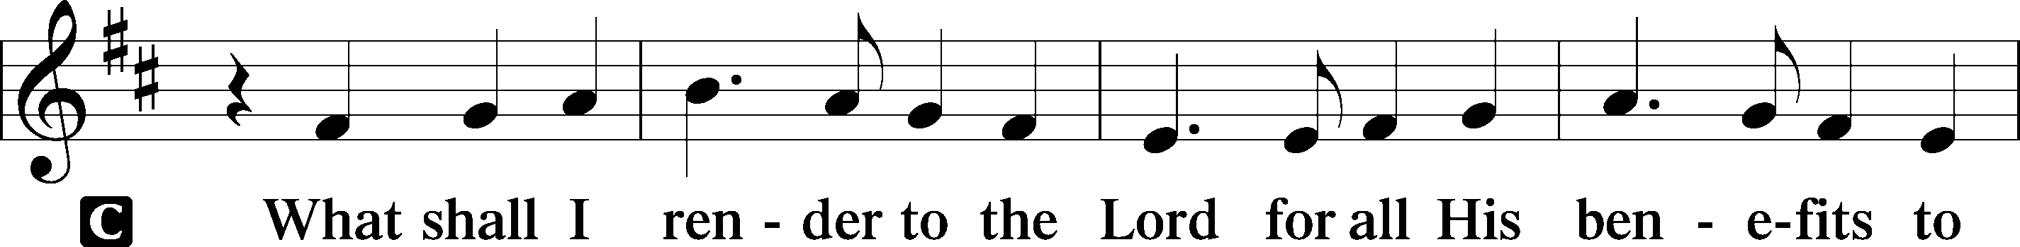
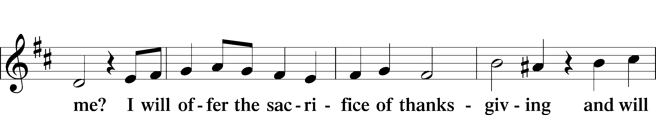
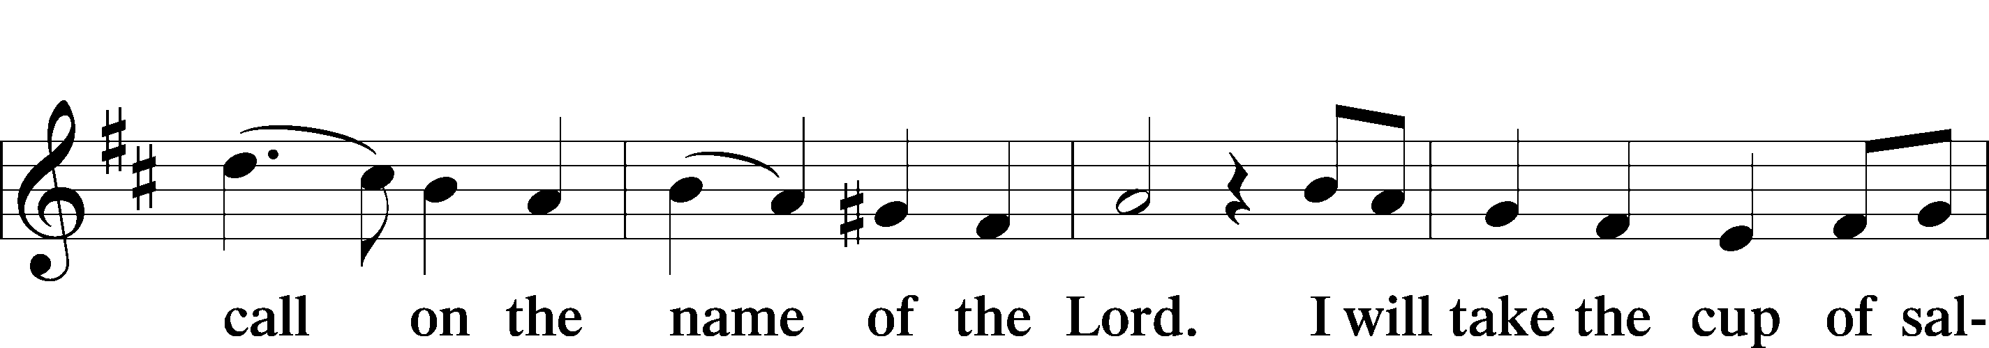
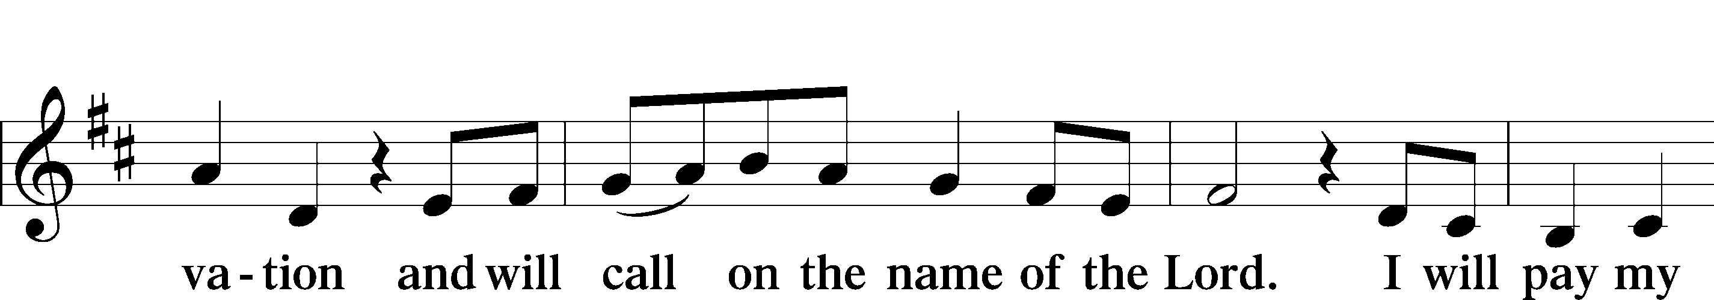
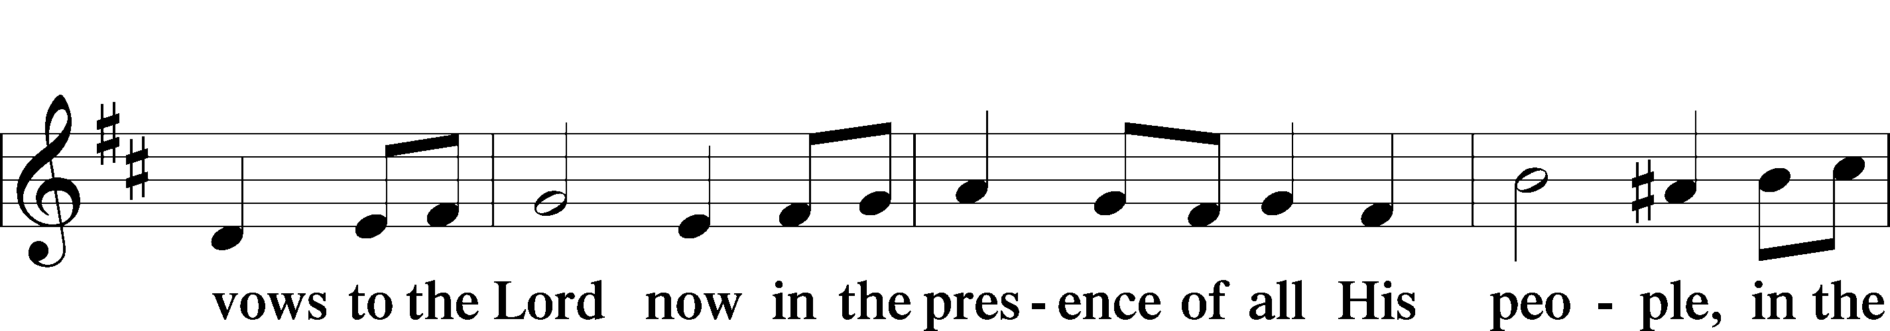
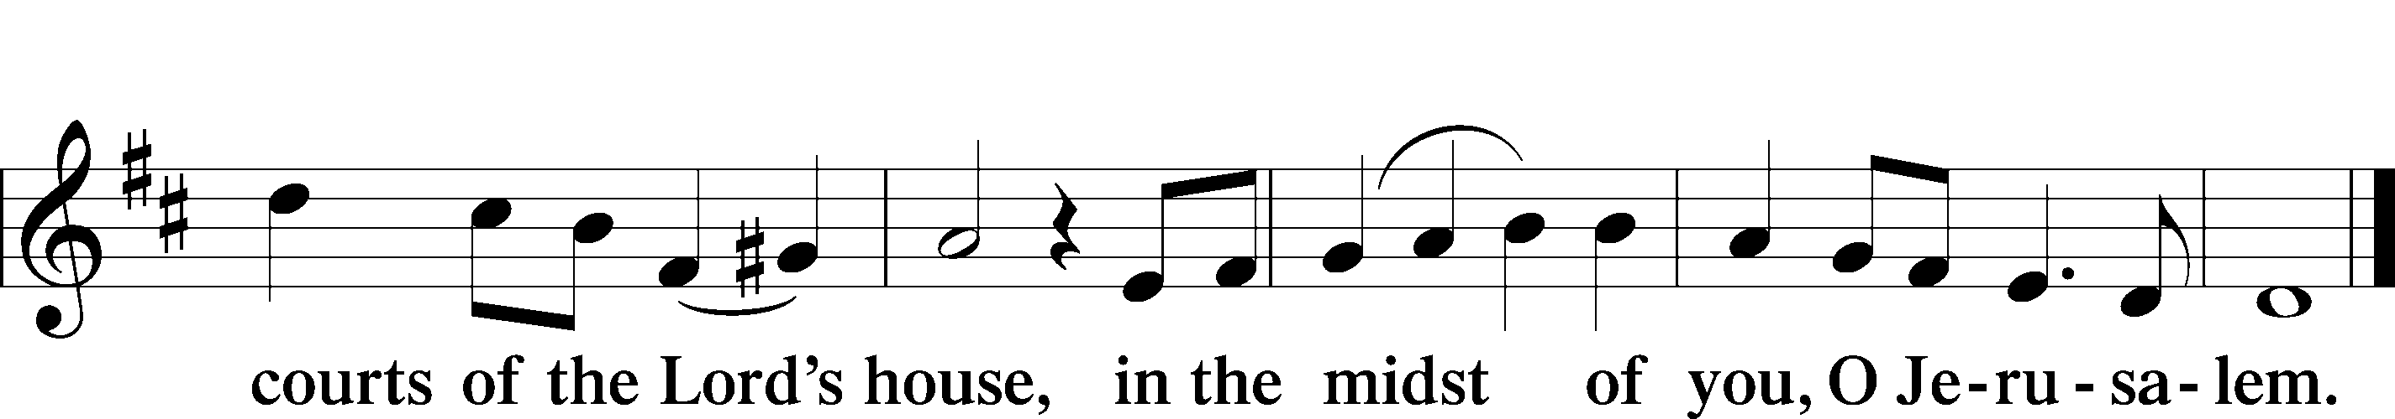

Service of the Sacrament

Preface 2 Timothy 4:22; [Colossians 3:1]; [Psalm 136]






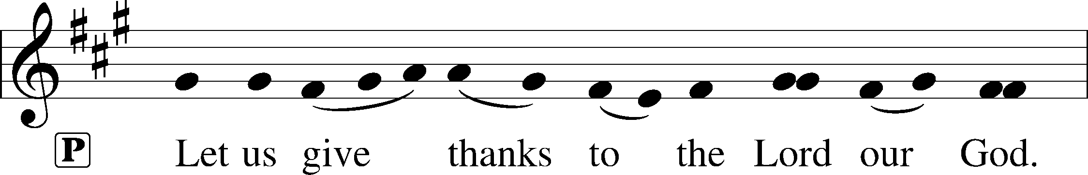
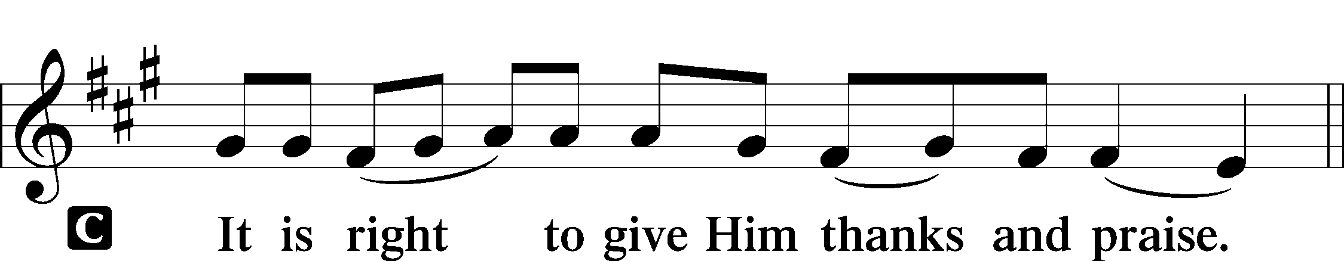

P It is truly good, right, and salutary that we should at all times and in all places give thanks to You, holy Lord, almighty Father, everlasting God. And most especially are we bound to praise You on this day for the glorious resurrection of Your Son, Jesus Christ, the very Paschal Lamb, who was sacrificed for us and bore the sins of the world. By His dying He has destroyed death, and by His rising again He has restored to us everlasting life. Therefore with Mary Magdalene, Peter and John, and with all the witnesses of the resurrection, with angels and archangels, and with all the company of heaven we laud and magnify Your glorious name, evermore praising You and saying:
Sanctus Isaiah 6:3; Matthew 21:9
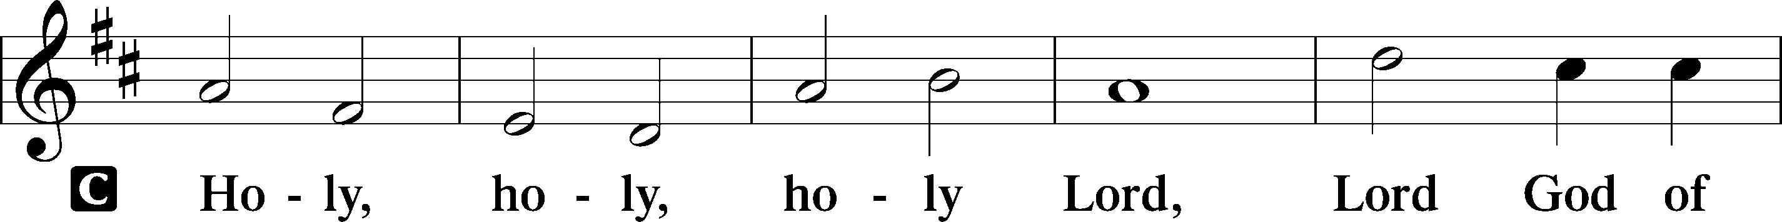
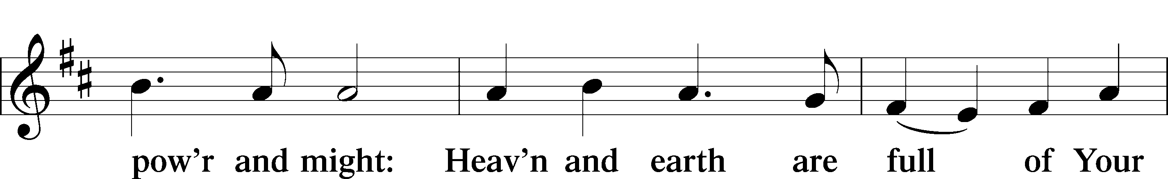
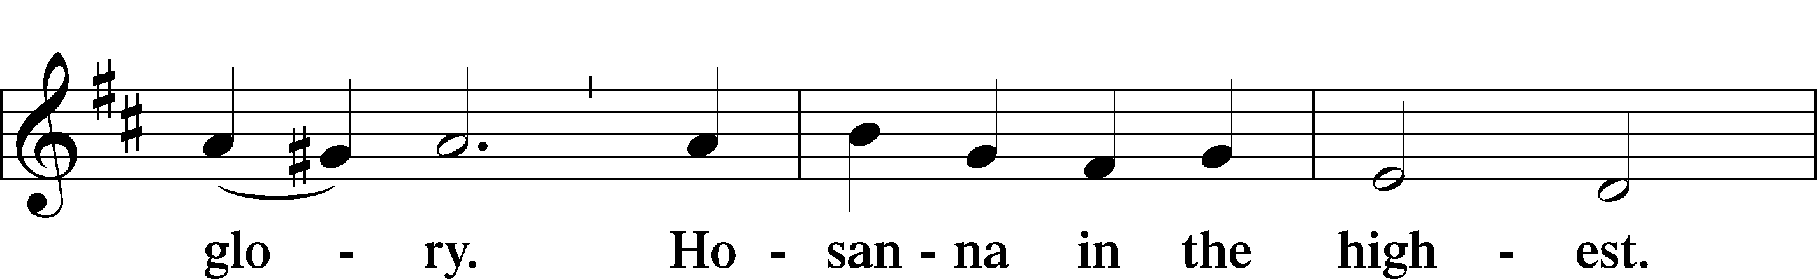
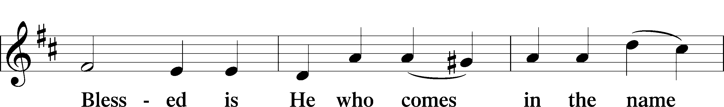
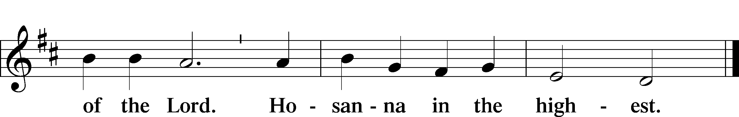

P Blessed are You, Lord of heaven and earth, for You have had mercy on those whom You created and sent Your only-begotten Son into our flesh to bear our sin and be our Savior. With repentant joy we receive the salvation accomplished for us by the all-availing sacrifice of His body and His blood on the cross.
Gathered in the name and the remembrance of Jesus, we beg You, O Lord, to forgive, renew, and strengthen us with Your Word and Spirit. Grant us faithfully to eat His body and drink His blood as He bids us do in His own testament. Gather us together, we pray, from the ends of the earth to celebrate with all the faithful the marriage feast of the Lamb in His kingdom, which has no end. Graciously receive our prayers; deliver and preserve us. To You alone, O Father, be all glory, honor, and worship, with the Son and the Holy Spirit, one God, now and forever.
C Amen.

Lord’s Prayer Matthew 6:9-13
P Lord, remember us in Your kingdom and teach us to pray:
C Our Father who art in heaven,
hallowed be Thy name,
Thy kingdom come,
Thy will be done on earth as it is in heaven;
give us this day our daily bread;
and forgive us our trespasses as we forgive those who trespass against us;
and lead us not into temptation,
but deliver T us from evil.
For Thine is the kingdom and the power and the glory forever and ever. Amen.

The Words of Our Lord Matthew 26:26–28;
Mark 14:22–24; Luke 22:19–20; 1 Corinthians 11:23–25
P Our Lord Jesus Christ, on the night when He was betrayed, took bread, and when He had given thanks, He broke it and gave it to the disciples and said: “Take, eat; this is My T body, which is given for you. This do in remembrance of Me.”
In the same way also He took the cup after supper, and when He had given thanks, He gave it to them, saying: “Drink of it, all of you; this cup is the new testament in My T blood, which is shed for you for the forgiveness of sins. This do, as often as you drink it, in remembrance of Me.”

Pax Domini John 20:19
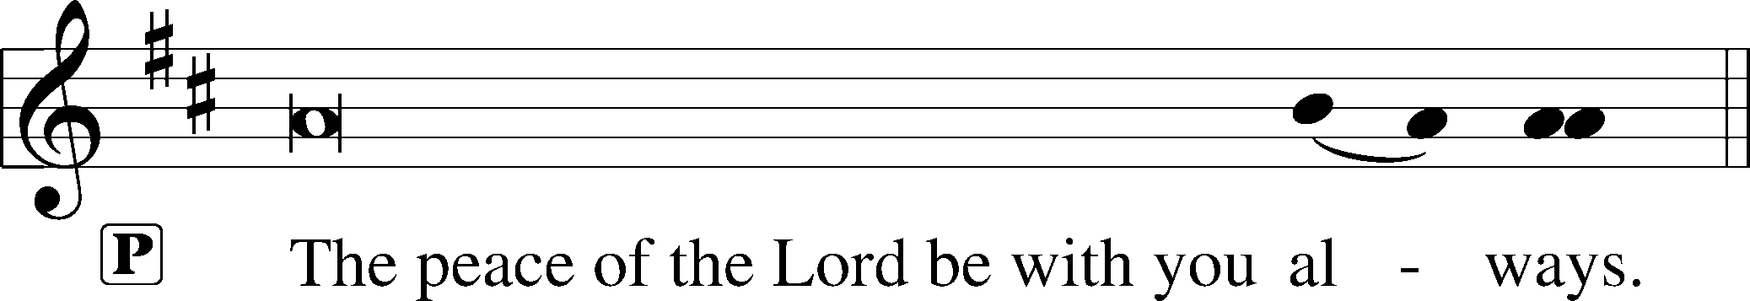


Agnus Dei John 1:29
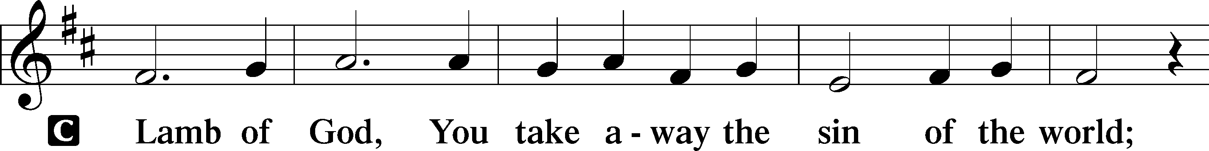
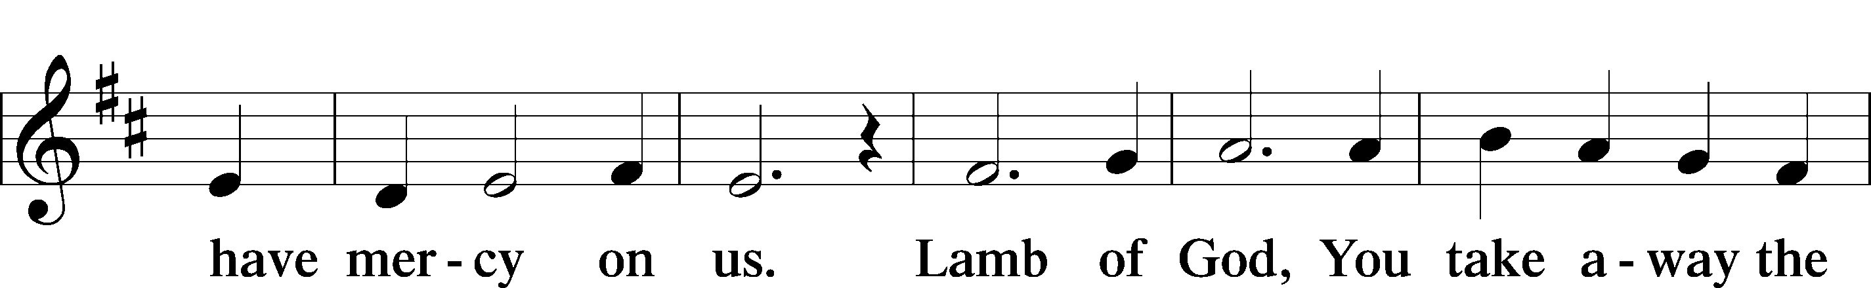
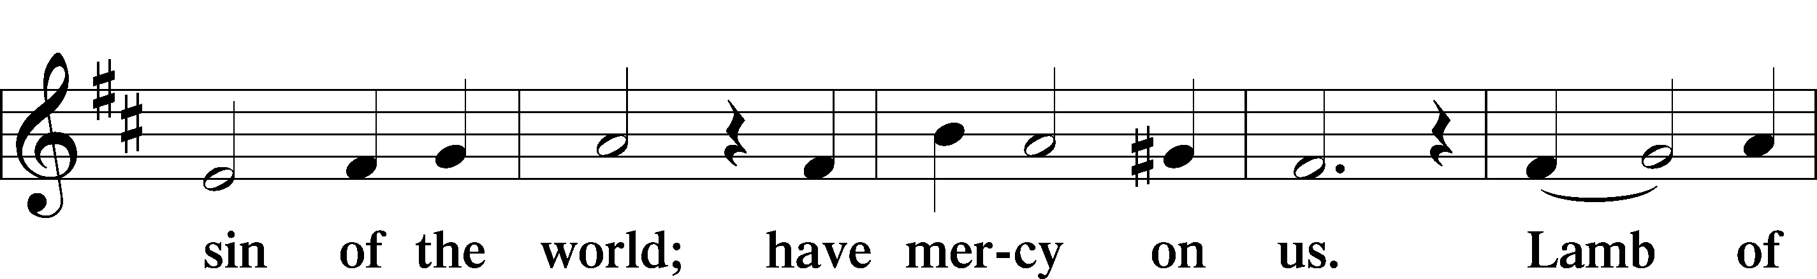
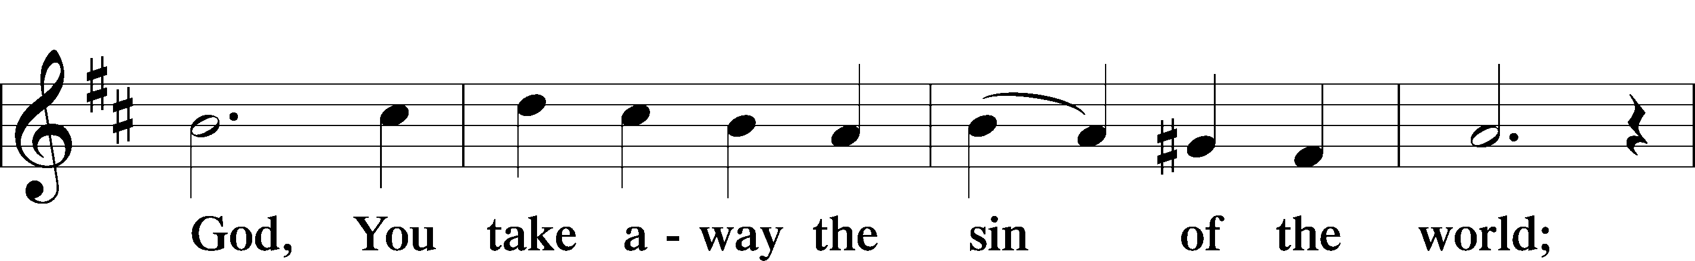
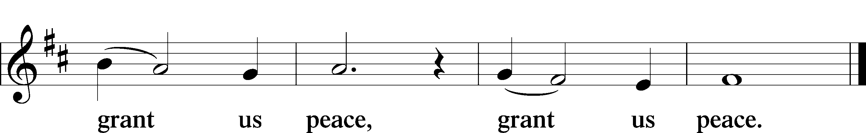

Please be seated

Distribution of the Sacrament
All who are members in good standing of the Lutheran Church - Missouri Synod and have introduced themselves to one of the pastors are welcome to partake of the Holy Communion at Christ Lutheran. If you have not spoken to a pastor, but would like to receive the Lord's blessing, you may still come to the rail and kneel, crossing one arm over the other in the shape of an 'X'. This symbolizes that one is marked by the cross and Triune name of Almighty God.

Distribution Hymns
I Know that My Redeemer Lives #461

Please stand following distribution of communion

Nunc Dimittis Luke 2:29-32
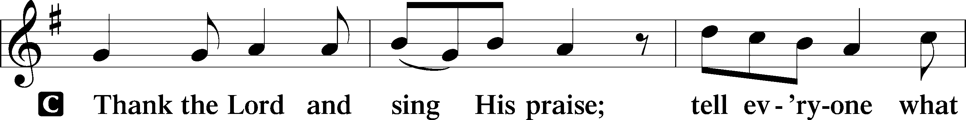
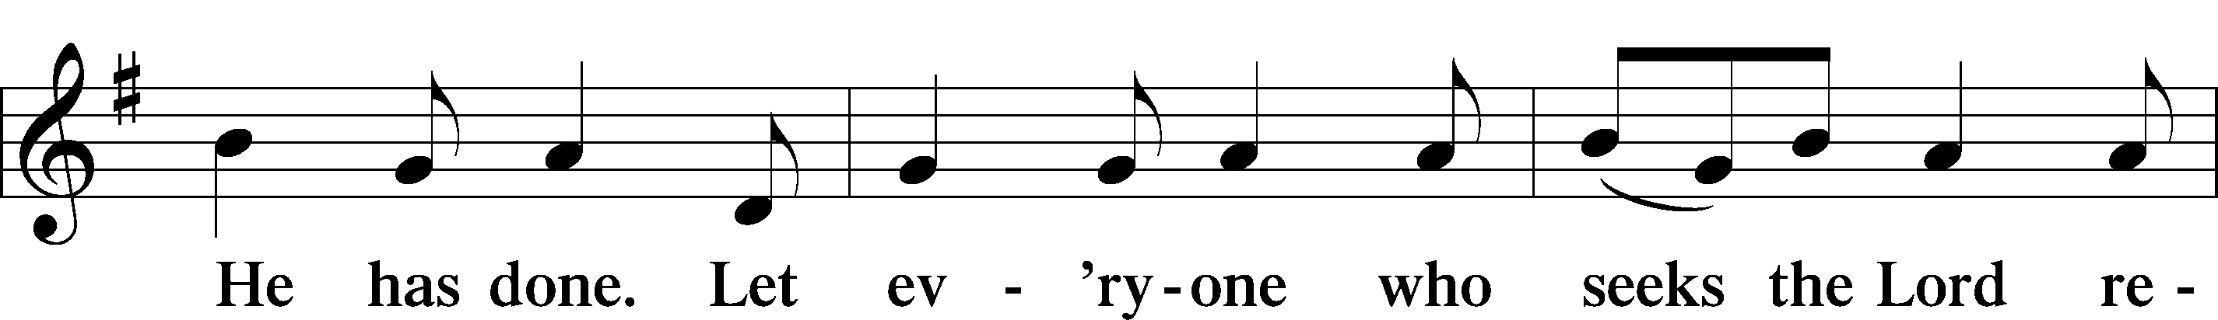

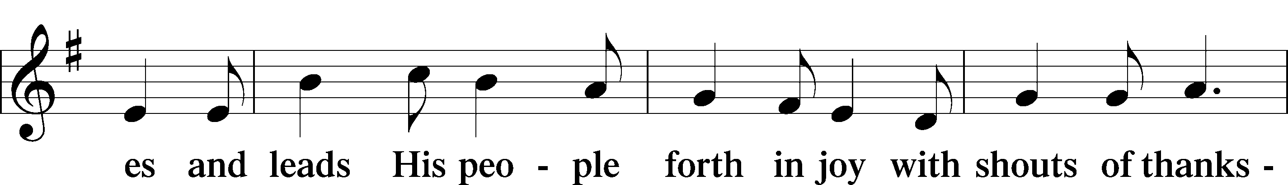
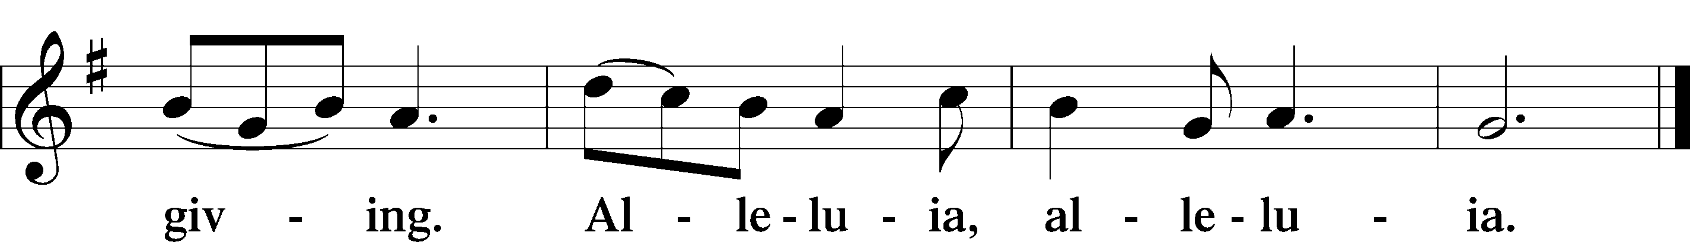

Post-Communion Collect

P We give thanks to You, almighty God, that You have refreshed us through this salutary gift, and we implore You that of Your mercy You would strengthen us through the same in faith toward You and fervent love toward one another; through Jesus Christ, Your Son, our Lord, who lives and reigns with You and the Holy Spirit, one God, now and forever.
Benediction Numbers 6:24–26
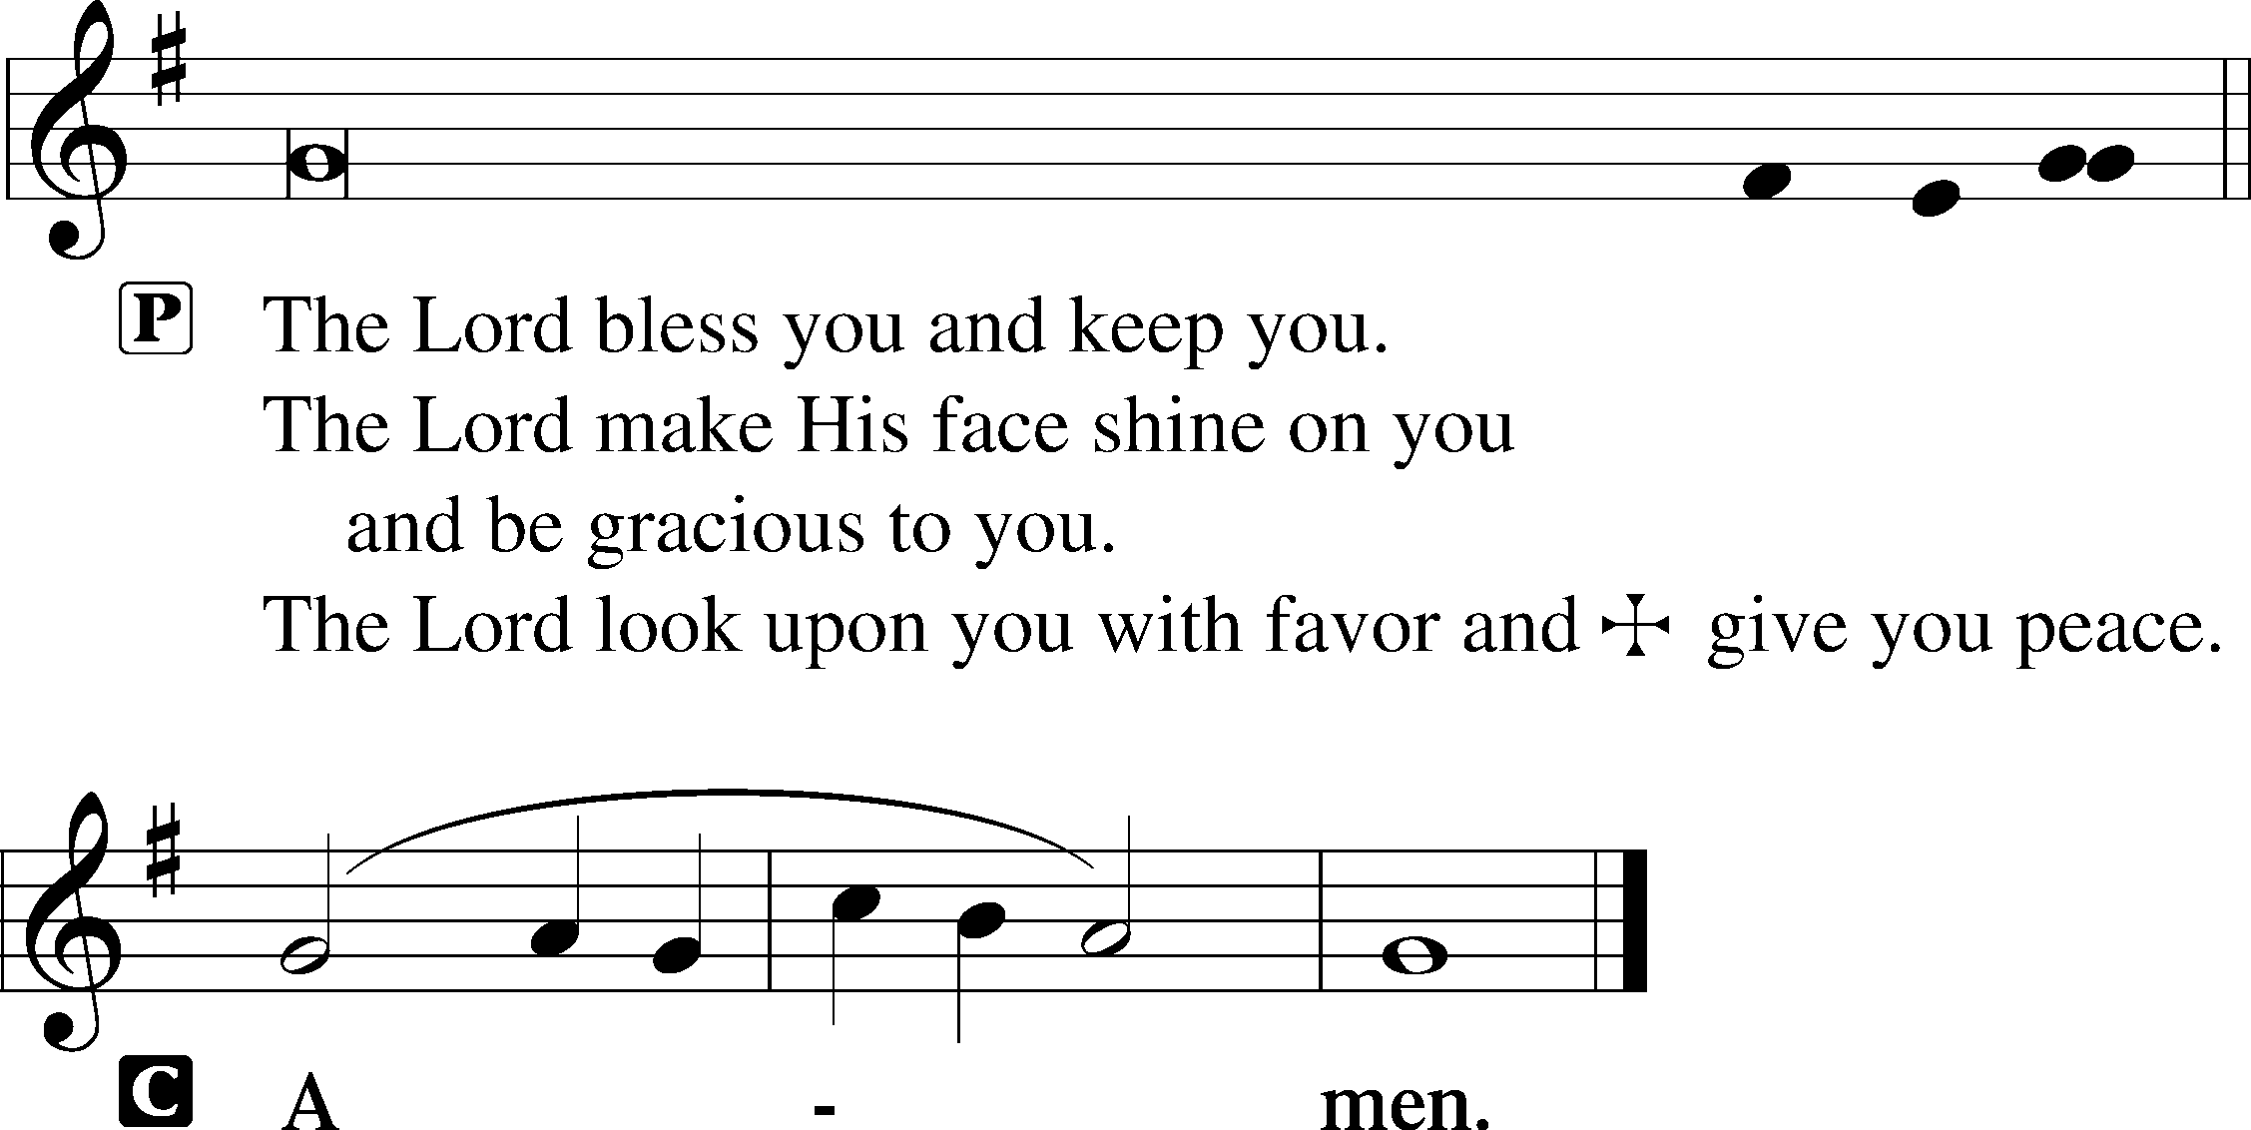

Closing Hymn Now All the Vault of Heaven Resounds #465

Postlude

Acknowledgments
Divine Service, Setting Two from Lutheran Service Book © 2006 Concordia Publishing House. Reprinted with permission. Unless otherwise indicated, all scripture quotations are from The Holy Bible, English Standard Version, copyright © 2001 by Crossway Bibles, a division of Good News Publishers. Used by permission. All rights reserved. Created by Lutheran Service Builder © 2006 Concordia Publishing House.

Today’s Worship Servants:
Celebrant: Rev. George Fields Elder: Christopher Burkhalter
Cantors: Jake Everly, Rachel Landrum Organist: Sr. Sara Fields
Interpreter: Greg Goldman

Thank You! Many thanks to all those who helped with all the various Holy Week and Easter festivities this week!

Altar Flowers: This morning’s altar flowers are given for the glory of God by Bobby and Eloise Springer in celebration of the Resurrection of Our Lord, as well as Bobby’s birthday.
John 20:16 – “Jesus said to her, ‘Mary.’ ”
Jesus is not only risen from the dead and the Victor over sin, He even calls us by name. He still calls us His friends and brothers, and He means to bring us through death to join Him in His resurrection. Christ is risen; He is risen indeed!

This week at Christ Lutheran Church: April 20 – April 26

Sunday 10:30 a.m. Divine Service Online – The Second Sunday of Easter



YOUR LIFELINE TO THE LUTHERAN WORLDVIEW…You can listen to in-depth teachings on interesting subjects like:

“Patience” in the Bible, The Book of Titus, Jesus’ Ascension, The Passover and more…

Issues, Etc. is a radio talk show produced by Lutheran Public Radio and hosted by LCMS Pastor Todd Wilken. You can listen to what you want when you want at www.issuesetc.org. Simply click on “Listen”, choose “On Demand”, then select from the vast array of speakers and topics available in the archives.



“Let no one grieve at his poverty,
for the universal kingdom has been revealed.
Let no one mourn that he has fallen again and again;
for forgiveness has risen from the grave.
Let no one fear death, for the Death of our Savior has set us free.
He has destroyed it by enduring it.
He destroyed Hell when He descended into it.
He put it into an uproar even as it tasted of His flesh.”

−St. John Chrystostom, Easter Sermon

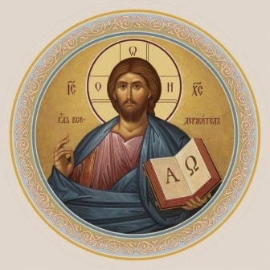


Christ Lutheran Church
Rev. Dr. James R. Holowach, Pastor
Rev. George N. Fields, Pastor
Sr. Sara E. Fields, Deaconess
4423 I-55 North, Jackson, MS 39206-6102
(601) 366-2055
www.christlutheranjacksonms.org

Matthew 26:26-29; Mark 14:22-25; Luke 22:14-20, 1 Corinthians 11:23
Matthew 26:28; 1 John 1:7; 1 Peter 1:18-19
1 Corinthians 11:28-32
1 Corinthians 10:17; 1 Corinthians 11:26

